Sodus Town Board Agenda
Regular Town Board Meeting
July 14, 2026
6:00 PM
Meeting Commences at 6:00 p.m.
Town of Sodus Courtroom
Open with Pledge Allegiance
Roll Call: (Lori Diver)
Supervisor Johnson, Councilperson Tertinek, Councilperson Pickering, Councilperson Willmott, Councilperson Conklin

LOCAL LAW #4-2026 Legal Notice:
(Lori Diver reads the following legal notice for Local Law 4-2026):

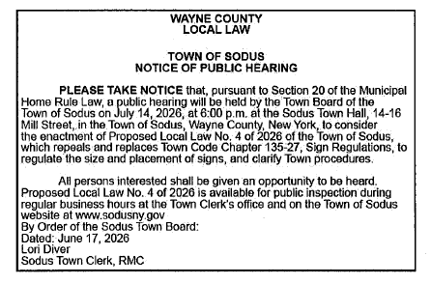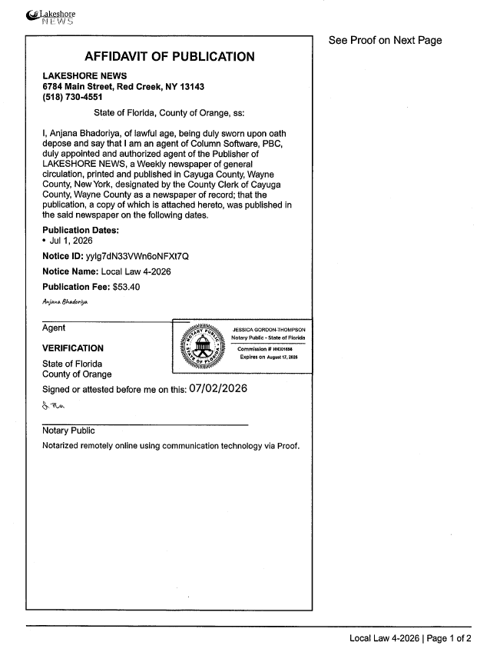

Public Hearing Local Law No. 4-2026 6:00 PM:

Motion entering into Local Law No. 4-2026 Public Hearing
- First_________________ Seconded____________________ Time____________________

Supervisor Scott Johnson asks for any public comments:

Hearing no further public comments, motion to close Public Hearing
- First_________________ Seconded____________________ Time____________________

Resolution adopting Local Law 4-2026 authorizing the Town Board of the Town of Sodus to repeal and replace Town Code Chapter 135-27, Sign Regulations, regulate the size and placement of signs, and clarify Town procedures.
- First_________________ Seconded____________________

PUBLIC SPEAKERS:
(Sue Buckley – Regarding Property 8525 Ridge Rd)

PUBLIC COMMENTS:

TOWN ATTORNEY UPDATES:
(Amy Kendall)

Resolution to approve Abstract #12-2026 bills

Correspondence & Information
- Resolution introducing proposed Local Law No. 5 of 2026 and related SEQRA EAF for review, establishing SEQRA lead agency, issuing a SEQRA negative declaration, referring to the NYSDEC for approval, referring to the Wayne County Planning Board, setting a public hearing for August 11, 2026 at 6:00 PM, and allowing Lori Diver, Sodus Town Clerk, to advertise.
First______________ Seconded_________________________________________

- Resolution to authorize Honorable Jay DeWispelaere with the Sodus Town Court to hire Emily Henderson as a fulltime court clerk at 35 hours per week, starting wage of $21.52 per hour, effective July 20, 2026 with a 6 month probationary period.
First______________ Seconded_______________________

- Resolution authorizing the Town of Sodus to take positive steps to alleviate the housing crisis by adopting the Pro Housing Communities pledge. This will allow the Town of Sodus to gain pro-housing certification by enacting policies that encourage a broad range of housing development including; multifamily housing, affordable housing, accessible housing, accessory dwelling units, and supportive housing.
First______________ Seconded_______________________

- Resolution to support the New York State Association of Towns Bill of Rights and adopt resolution for the New York State Association of Towns Legislative Meeting Delegation.
First______________ Seconded_______________________

- Resolution authorizing Sal Vittozzi to purchase a new HP 17.3 + Anti-Glare Touchscreen Laptop, AMD Ryzen 5734OU CPU in the amount of $664.99 from Walmart Business Account for Camp Beechwood.
First______________ Seconded_______________________

- Resolution authorizing Highway Superintendent Jared Laird to purchase one new H074051 Case CX85E with Standard Dozer Blade SMP1C3TZLU00239 Excavator from Monroe Tractor Sourcewell Contract 011723 State Bid with CHIPS funds in the amount of $134,970.00
First______________ Seconded_______________________

- Motion to enter into Executive Session regarding medical, financial, credit or employment history of a particular person or corporation or relating to appointment promotion demotion discipline or removal.
First______________ Seconded_______________________
Time____________

- Motion to exit out of Executive Session.
First______________ Seconded_______________________
Time____________

- Motion to adjourn meeting
First______________ Seconded_______________________
Time____________

MINUTES
Minutes of the Regular Town Board Meeting July 14, 2026 at 6:00 PM held in person at the Town of Sodus courtroom 14-16 Mill St. Sodus, NY.
All meetings are open to the public.

Present: Scott Johnson, Supervisor
Chris Tertinek, Deputy Supervisor-Councilperson
Dale Pickering, Councilperson
Cathy Willmott, Councilperson
Josh Conklin, Councilperson

Recording Secretary: Lori Diver, Town Clerk

Absent: N/A

Others Present: Frank Gahr, Code Enforcement Officer
Tammy Burns, Dog Control Officer
Kyle Kephart, Dog Control Officer
Mike & Sue Buckley-Alton, NY-complaint
Dave Fitch, Town of Sodus Resident
Amy Kendall, Town Attorney (attended by conference call)
Amanda Dorsche-Penguin Pastures

Supervisor Scott Johnson called the Regular Town Board Meeting to order commencing at 6:00 PM with the Pledge of Allegiance and Lori Diver opened with roll call. All Town Board members were present.

LOCAL LAW #4-2026 Legal Notice:
(Lori Diver read the following legal notice for Local Law 4-2026):

A motion was made by Councilperson Chris Tertinek to enter into Public Hearing Local Law 4-2026 was seconded by Councilperson Dale Pickering at 6:01 PM. Upon roll call the following votes were heard; Supervisor Scott Johnson, aye; Councilperson Chris Tertinek, aye; Councilperson Dale Pickering, aye; Councilperson Josh Conklin, aye. Motion carried.

Supervisor Scott Johnson asked for public comments. Hearing none, Councilperson Josh Conklin motioned to close the public hearing at 6:03 PM and was seconded by Councilperson Cathy Willmott. Upon roll call the following votes were heard; Supervisor Scott Johnson, aye; Councilperson Chris Tertinek, aye; Councilperson Dale Pickering, aye; Councilperson Josh Conklin, aye. Motion carried.

LOCAL LAW 4-2026 REPEALS AND REPLACES TOWN OF SODUS SIGN REGULATIONS
RESOLUTION
(01 07-2026)

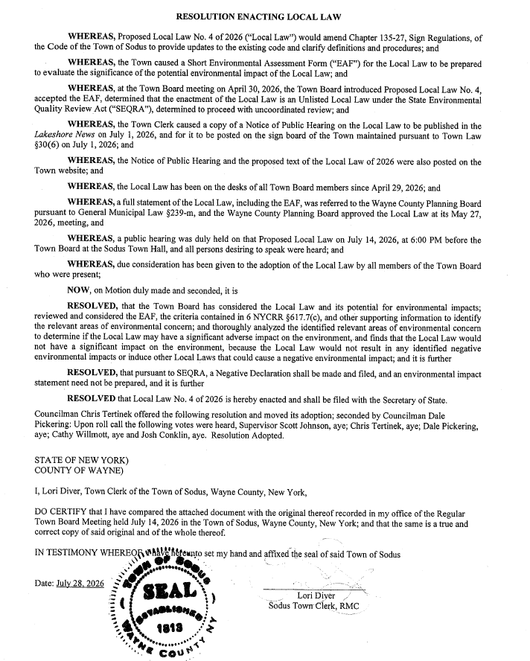

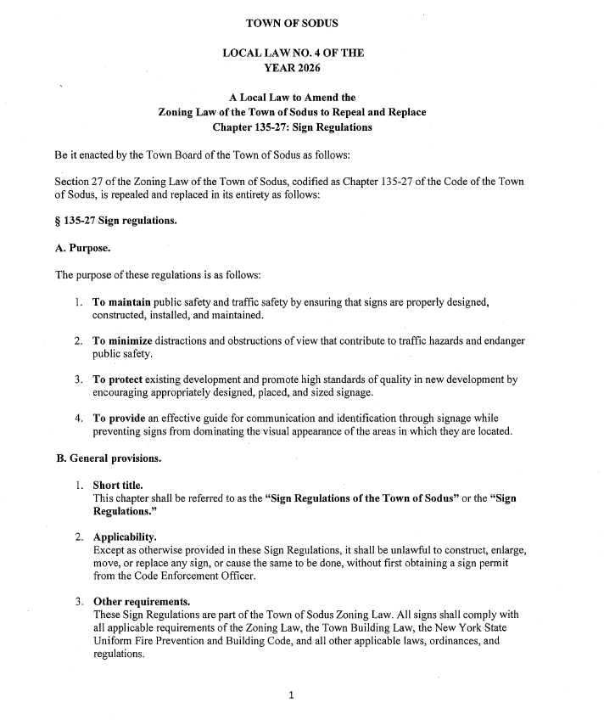

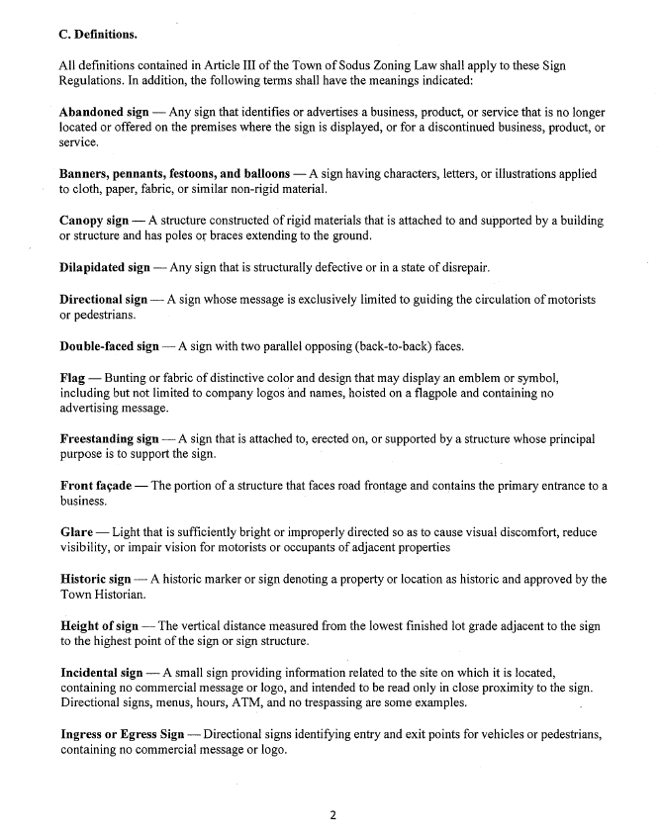

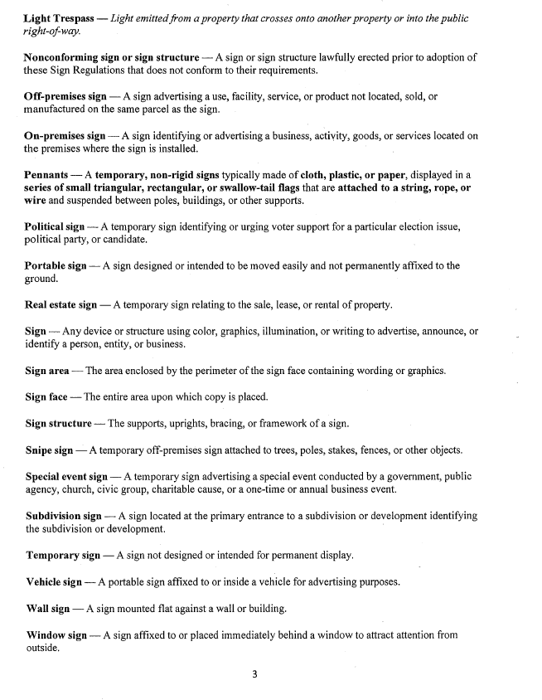
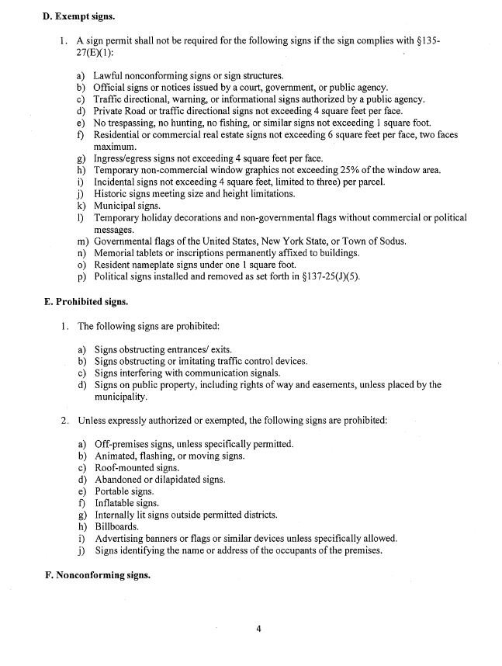
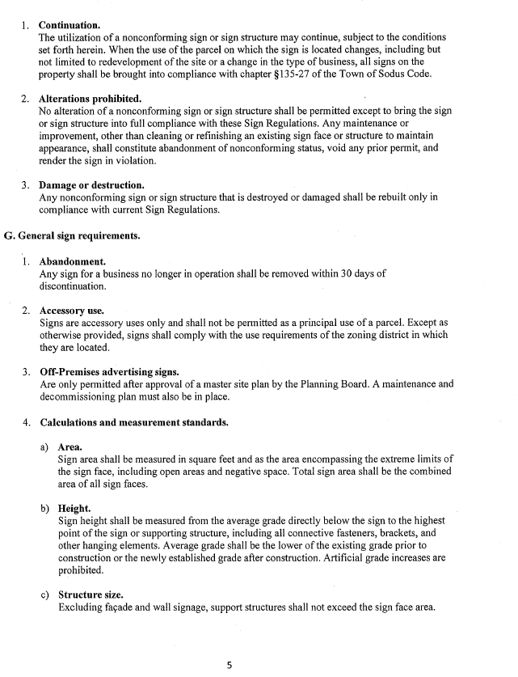

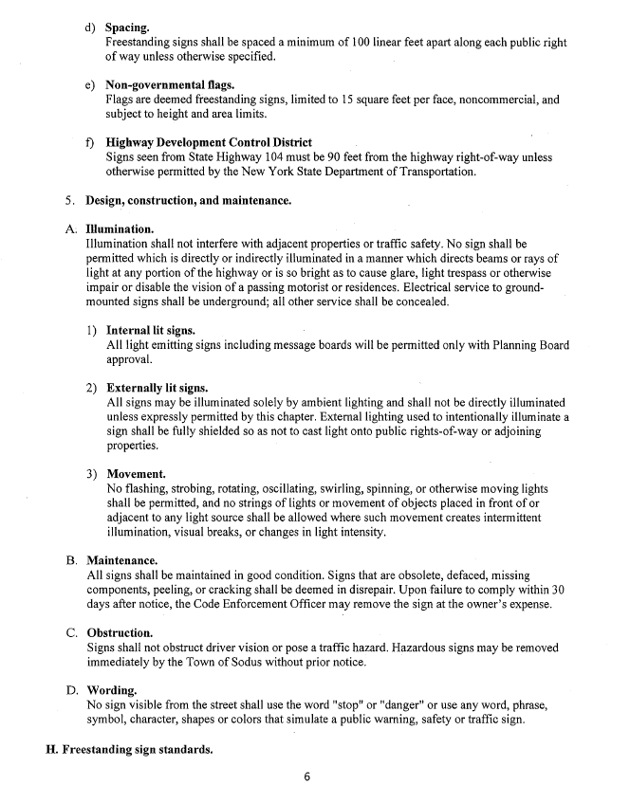

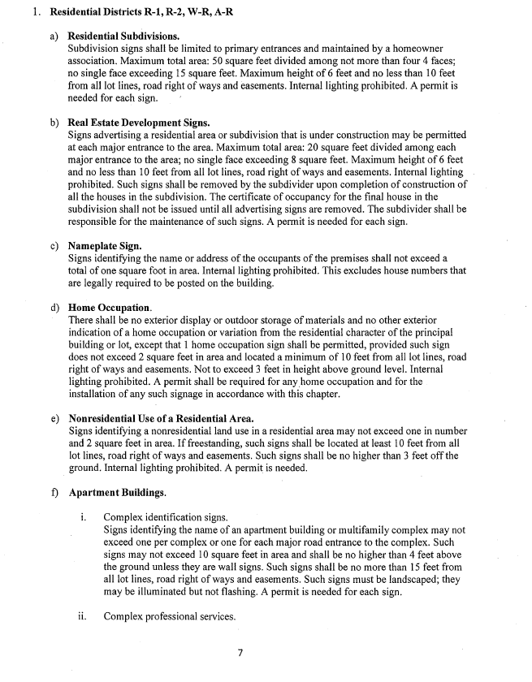
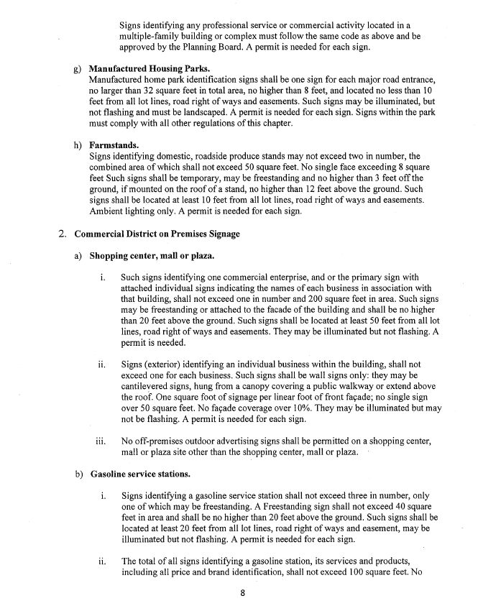

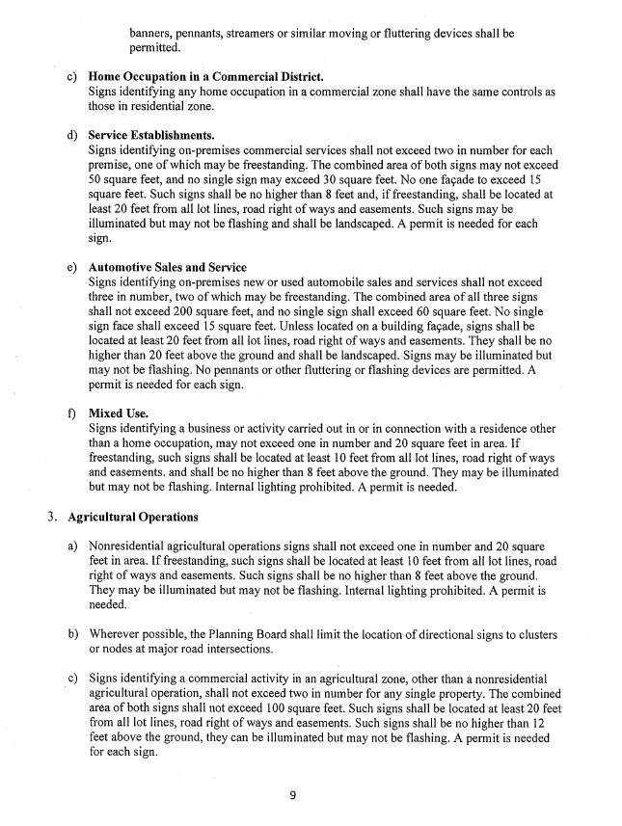

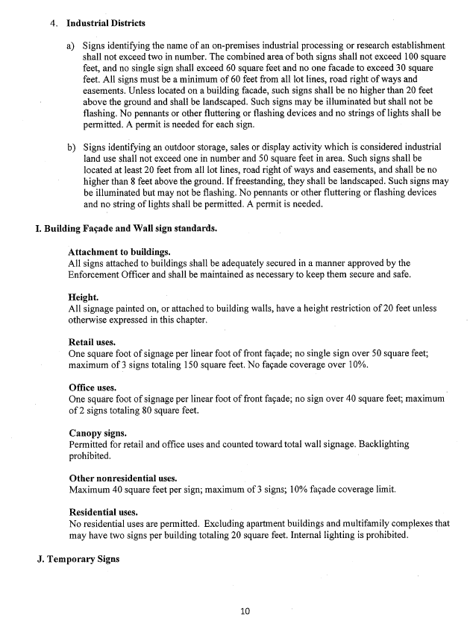
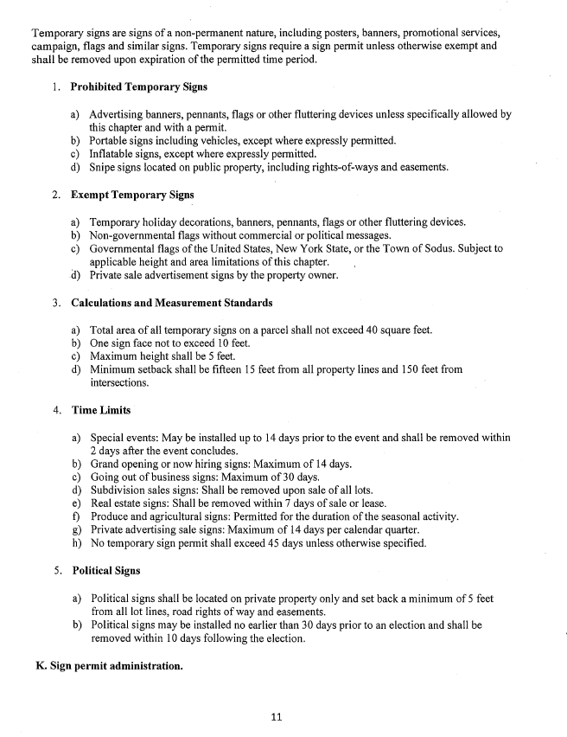
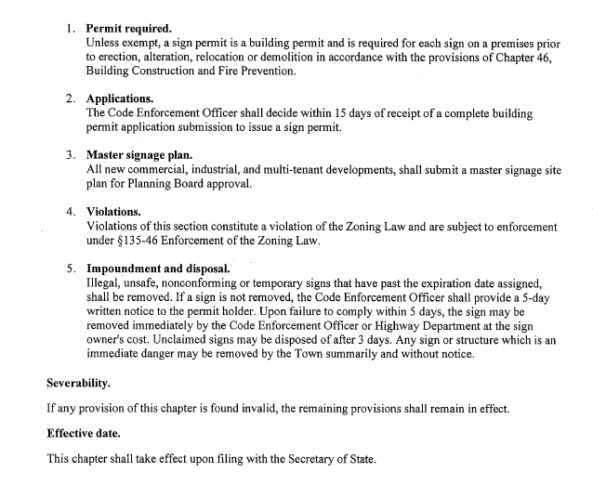

PUBLIC SPEAKERS:
(Mike & Sue Buckley)
Mike and Sue Buckley discussed with the Sodus Town Board and Code Enforcement Officer Frank Gahr the garbage on property 8525 Ridge Rd and 8533 Ridge Rd. They stated that the owner of the properties Martin Olschewske does not have garbage pickup and the garbage day after day sits and mounding without anyone cleaning it up. Photos were provided for reference (see below). Gahr stated that two letters have been mailed regarding the condition of Olschewske’s property and the ongoing garbage on the land. Gahr stated that some of the garbage has been picked up however; the Buckley’s indicated that the toters in the front and the dumpster rental with garbage keeps getting worse without anyone picking it up. They even have called the garbage company to see what the status is on the toters. The company will not come pick them up because Olschewske has not paid for the garbage pickup of the toters or dumpster. The Buckley’s claim the east side of the residence is in much worse condition. Gahr stated that he did stop several times to speak with the owner in the past however, no one has been home from those attempts. Gahr discovered from the Buckley’s that he was knocking on the wrong side of the owner’s residence and will try again. Part of the residence is rented to a tenant.
The Buckley’s stated they have been in several times within the last year complaining about these properties, but nothing seems to get resolved. Gahr explained that it is a process and determined by NY State of how the owner of the property can be held accountable for the garbage on the property. Gahr encouraged the Buckley’s to call his office to complain regarding the condition and they are free to set up a time to meet with him in person. The Buckley’s were very frustrated and said they feel they have been doing everything possible with Code Enforcement to get this addressed. Gahr stated to them, that his next step is to physically speak with the owner about the cleanup and to keep in touch with him regarding the outcome. They stated they will continue to monitor this situation and stay in touch with the Town. They asked the Town Board to look into what other Towns do for cleanup of properties such as this and consider a point system. It was explained to them that the Town of Sodus addresses such properties as this, within the NY State Code mandates and will continue to help resolve this problem. They thanked the Town Board and CEO Frank Gahr for listening to their concern.

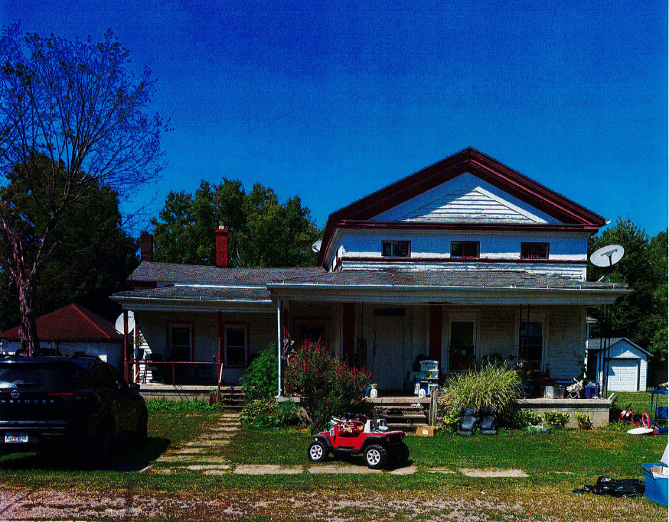

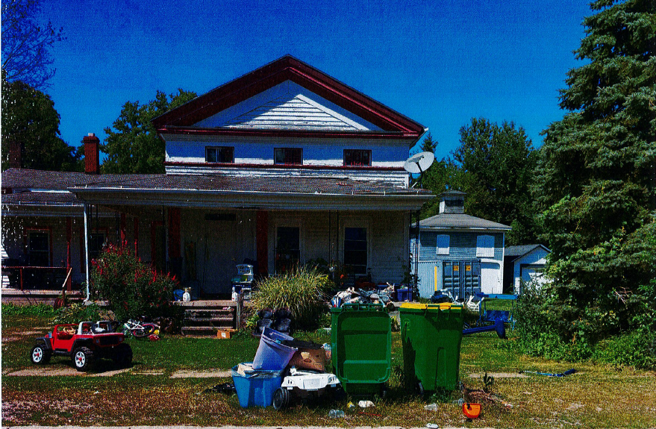

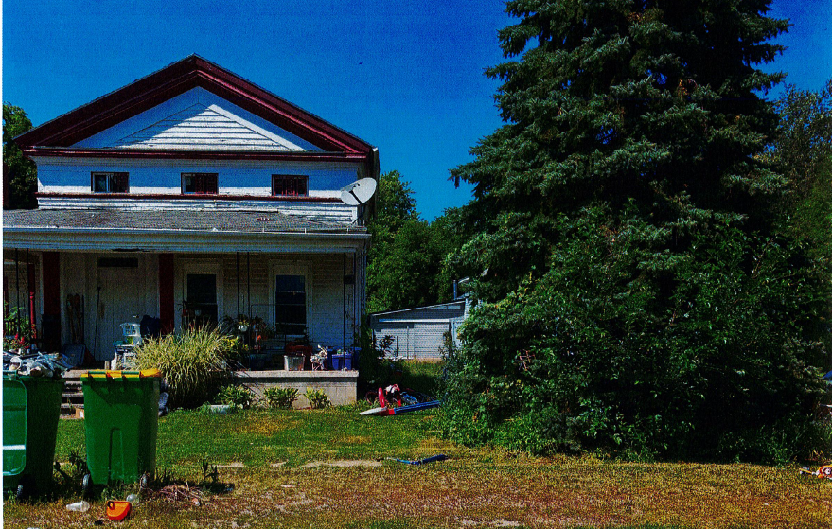

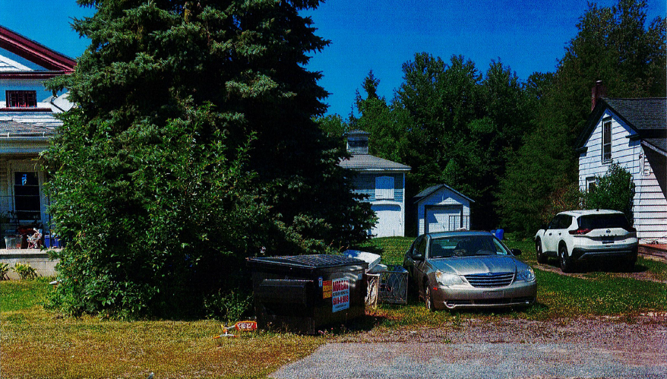

PUBLIC COMMENTS:
(Amanda Dorsche-Penguin Pastures – Town of Sodus)
Amanda Dorsche addressed the Sodus Town Board with her concern about the feral cat population. She has been very active in rescue efforts (owner of Penguin Pastures) in helping cats with the feral cat shot program, spay, neutered, fostering, adopting and recolonizing feral cats in the Town of Sodus. The feral cat population is getting worse and is becoming quite the expense trying to help as many cats as possible. She asked the Town Board for funding to help support the feral cat population getting its basic shots. With the feral cats getting fixed and its basic shots (such as its rabies shot) it prevents cats from multiplying and spreading rabies to other animals and humans. The Town Board thanked her for addressing them regarding this situation and doing all that she does to help the cats.

TOWN ATTORNEY UPDATES:
Amy Kendall- Town Attorney
Amy relayed her updates were limited this month and the Town of Sodus just passed Local Law 4-2026.
ABSTRACT
RESOLUTION TO PAY ABSTRACT NO. 12-2026
(02 07-2026)
WHEREAS, the following bills were presented for payment on Abstract 12-2026:
General 275-298 $ 22,981.80
CMI-Parks 010-010 $ 150.97
Special Districts 012-012 $ 1,181.32
Sewer District 003-003 $ 769.64
Trust & Agency 019-023 $ 5,004.90
Highway 232-244 $ 73,469.30
GRAND TOTAL: $ 103,557.93

NOW BE IT RESOLVED, Councilperson Dale Pickering authorizes payment of Abstract No. 12-2026 which was seconded by Councilperson Josh Conklin. Upon roll call the following votes were heard, Supervisor Scott Johnson, aye, Chris Tertinek aye; Dale Pickering, aye; Cathy Willmott, aye; and Josh Conklin, aye. Resolution Adopted.

FLOOD DAMAGE PREVENTION DOCUMENTS
RESOLUTION
(03 07-2026)
(Note: Draft Local Law 5-2026 behind typed minutes)
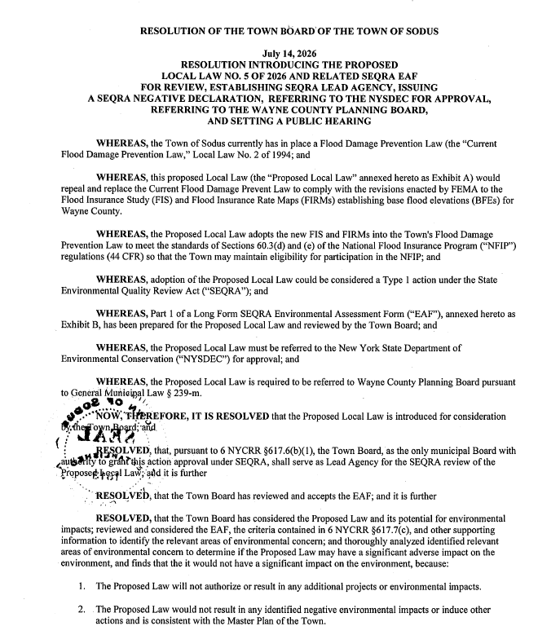

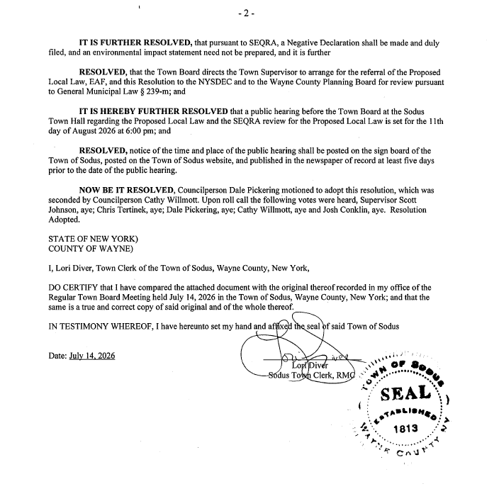

FURTHER BE IT RESOLVED, Councilperson Dale Pickering motioned to set Public Hearing for Local Law 5-2026 to be held August 11, 2026 at 6:00 PM and to allow Lori Diver Sodus Town Clerk to advertise was seconded by Councilperson Cathy Willmott. Upon roll call the following votes were heard, Supervisor Scott Johnson, aye, Chris Tertinek aye; Dale Pickering, aye; Cathy Willmott, aye; and Josh Conklin, aye. Resolution Adopted.
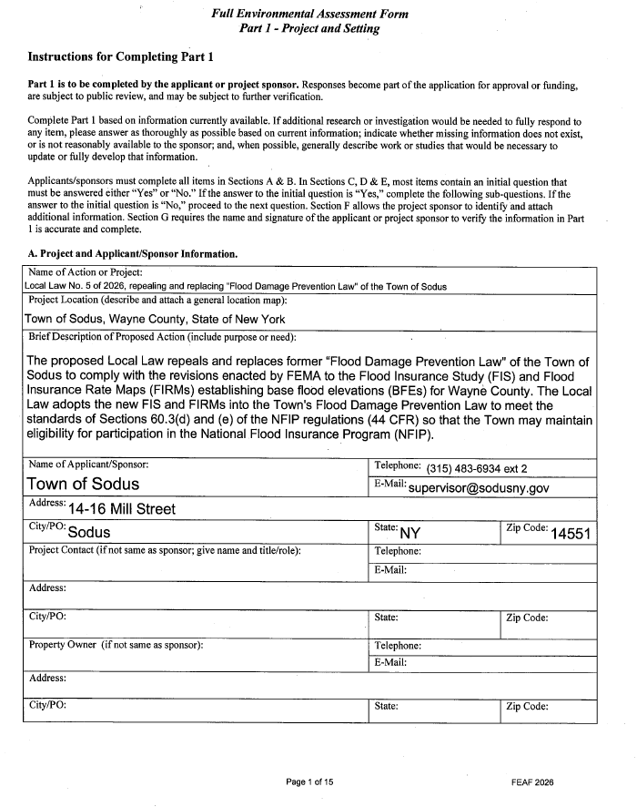

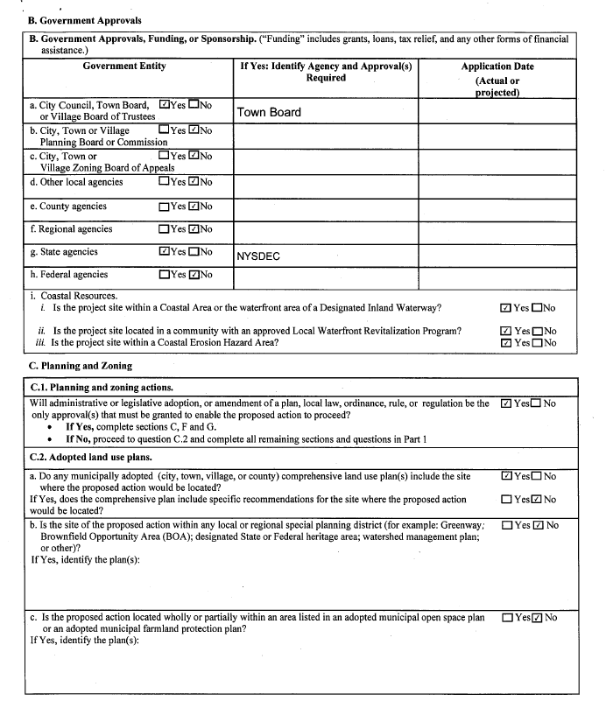

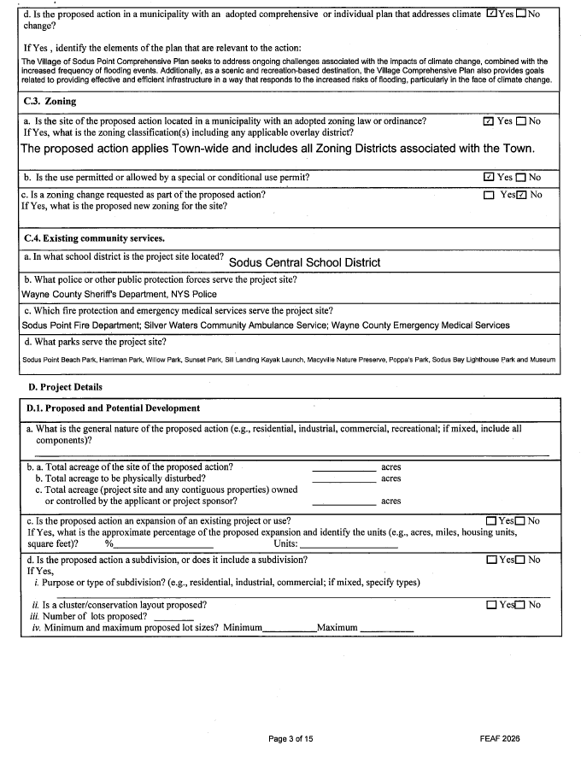
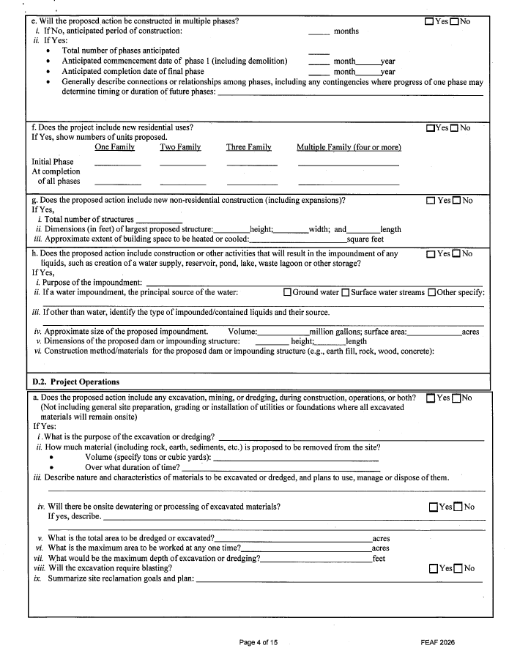
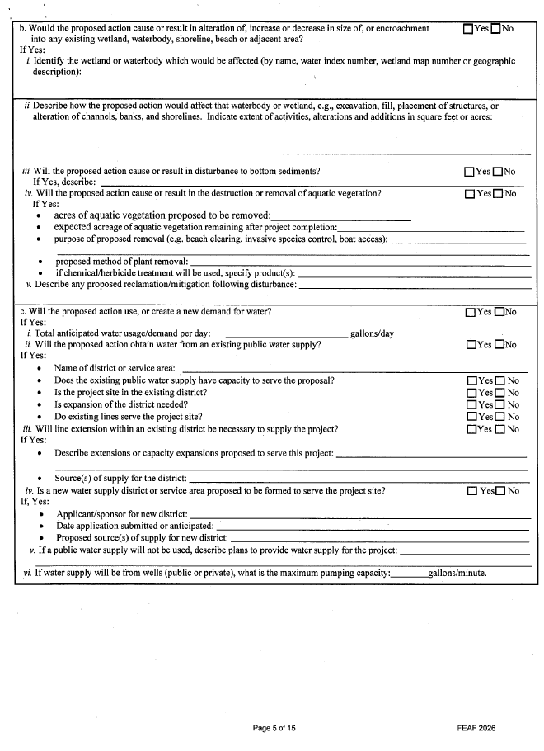

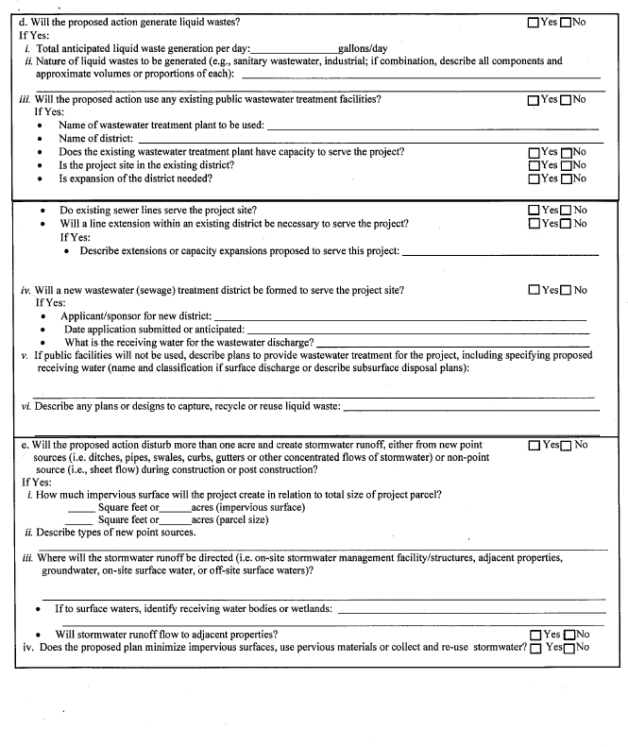

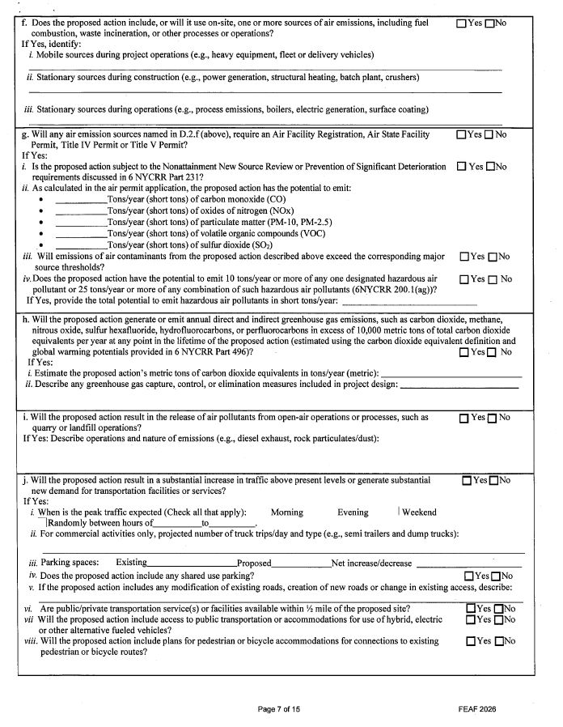

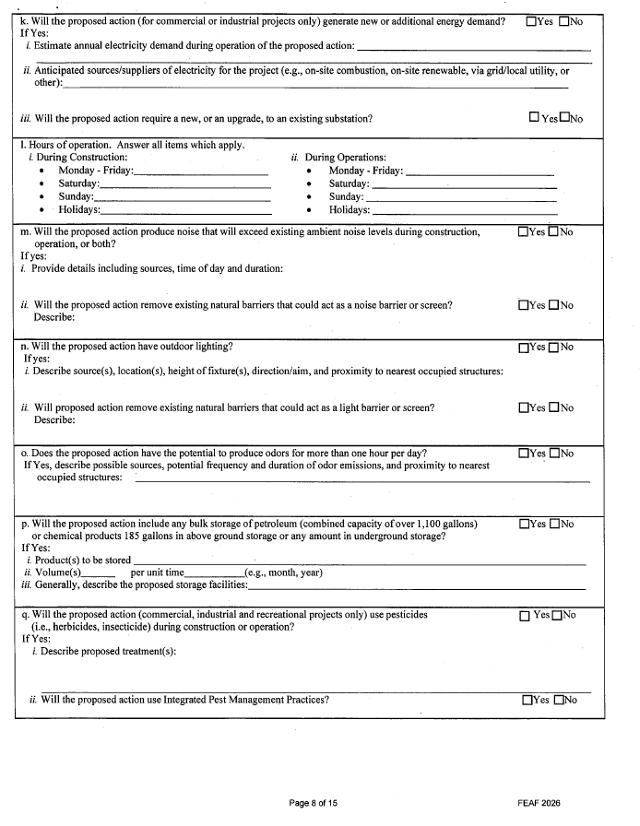

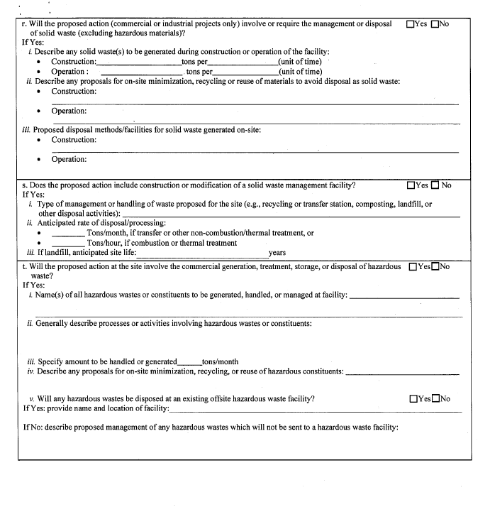

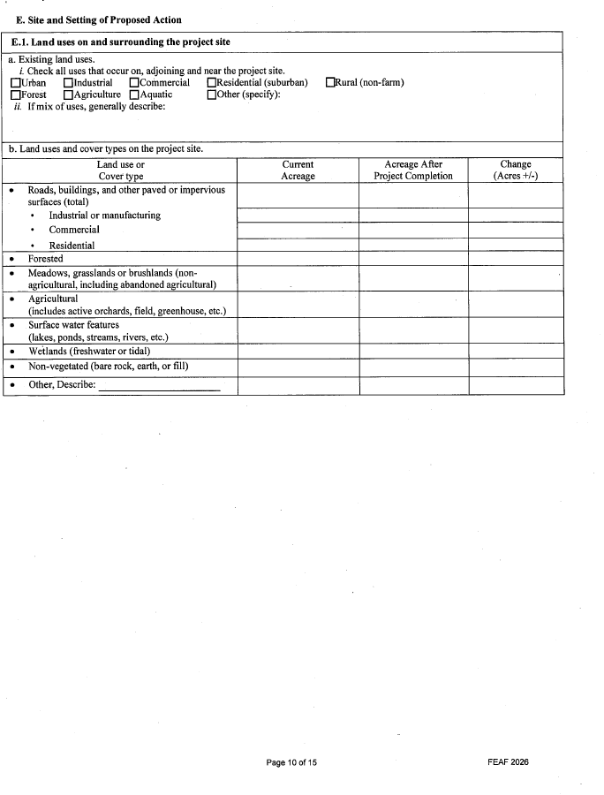
PAGE SKIPPED-INTENTIONALLY LEFT BLANK
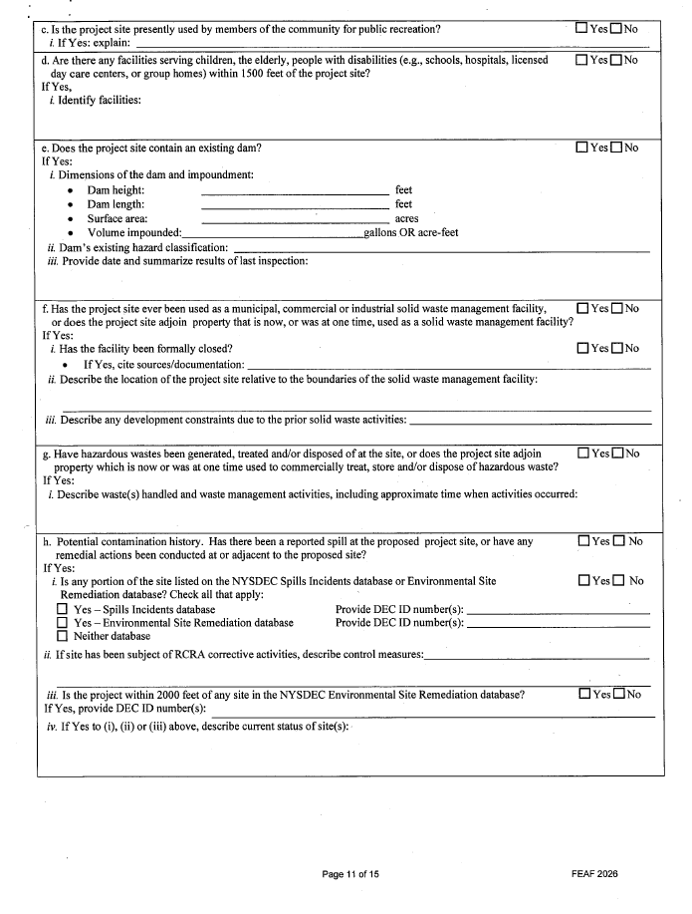

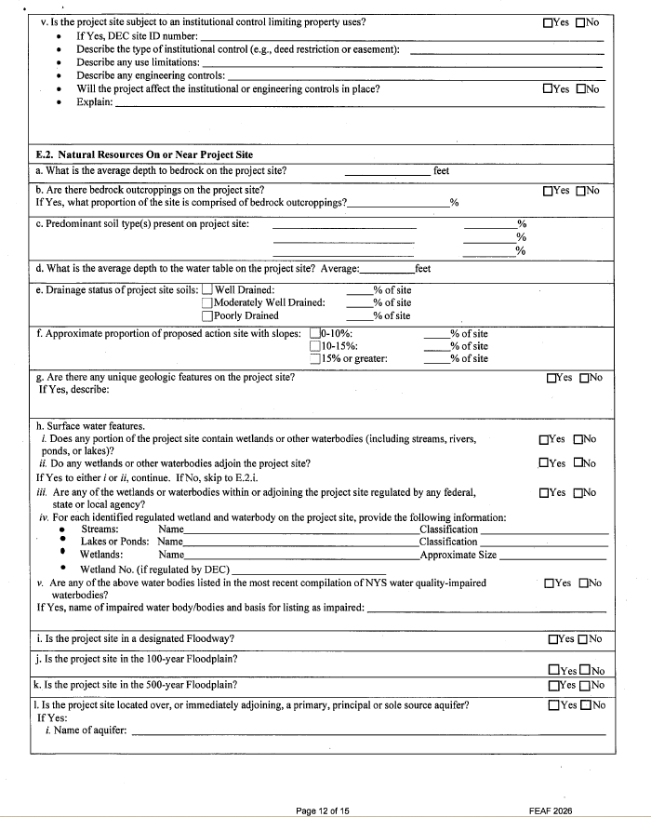
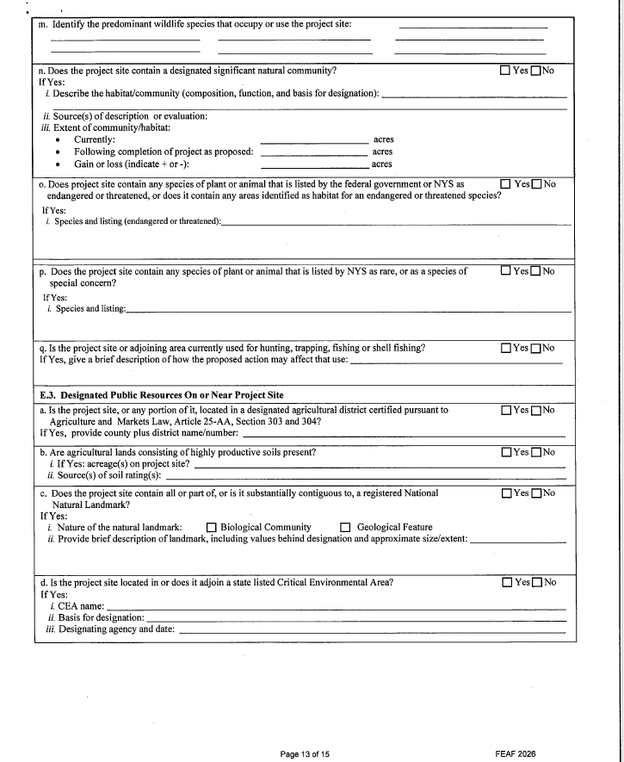

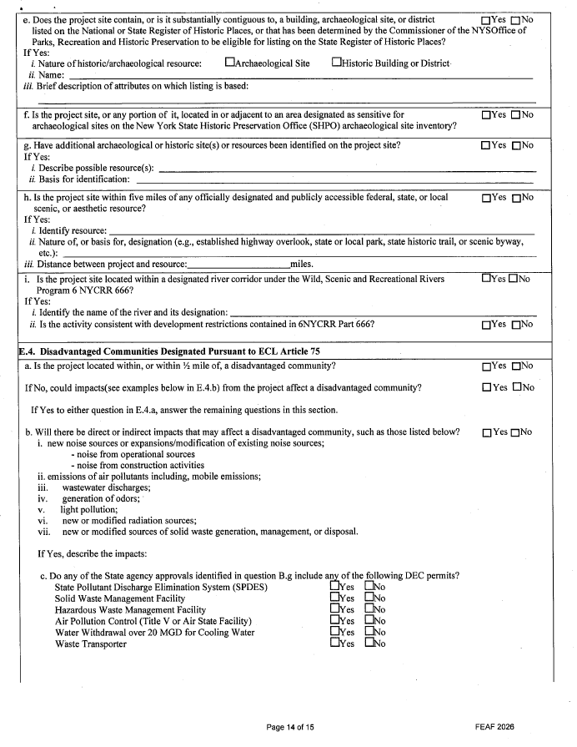

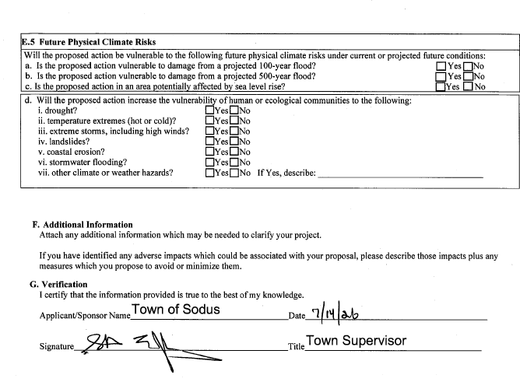

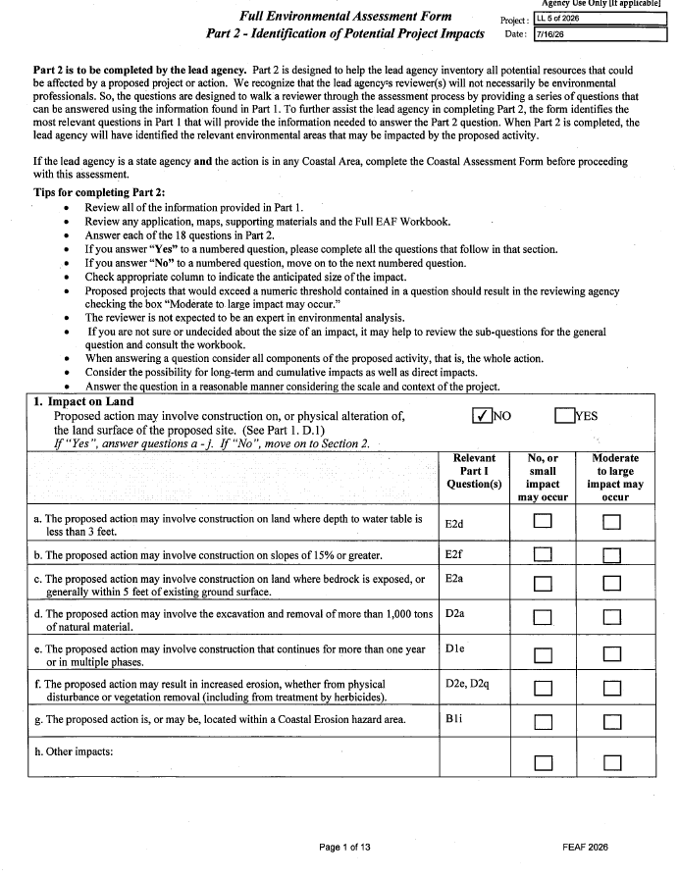
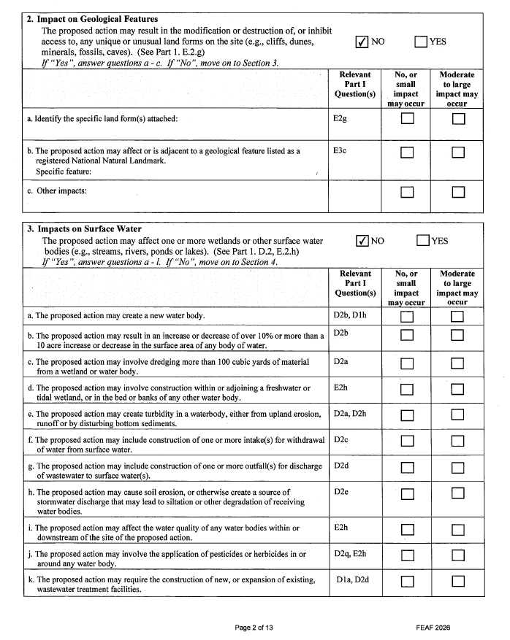

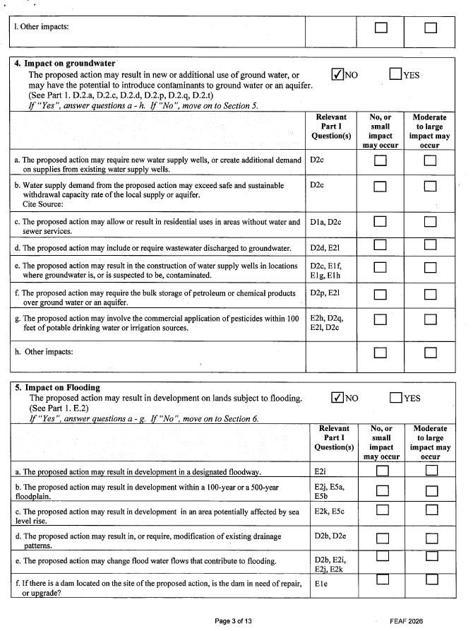

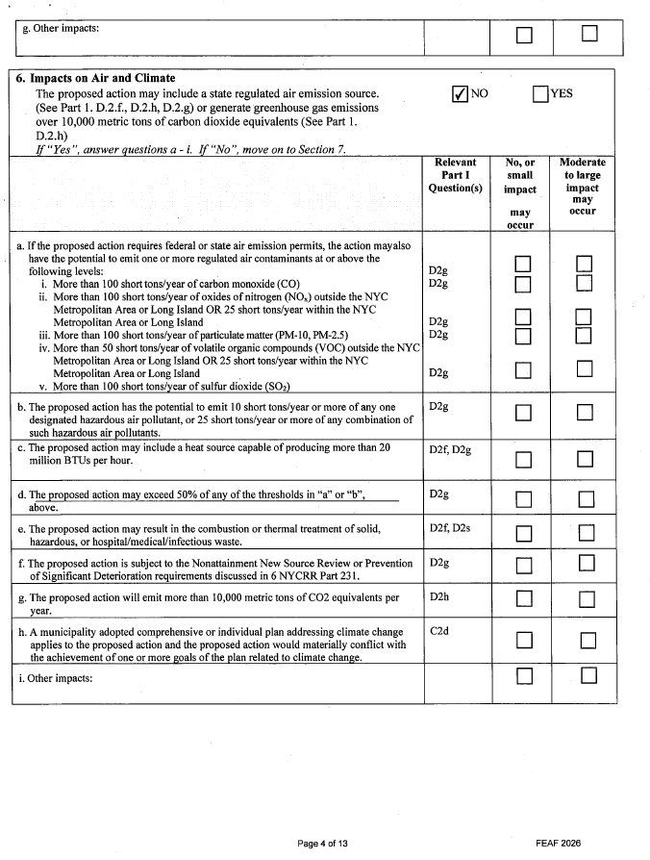

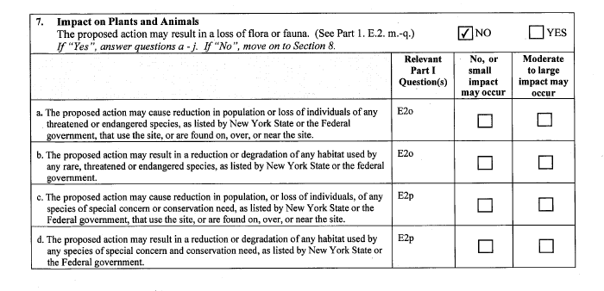

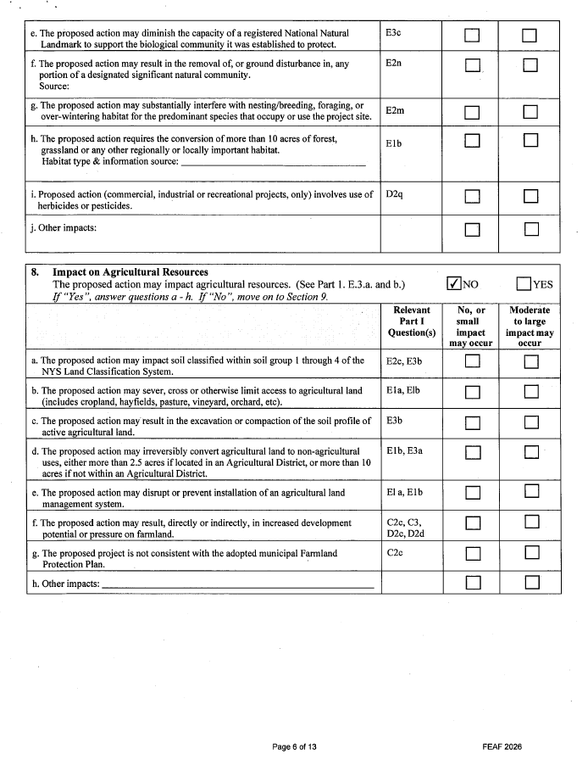

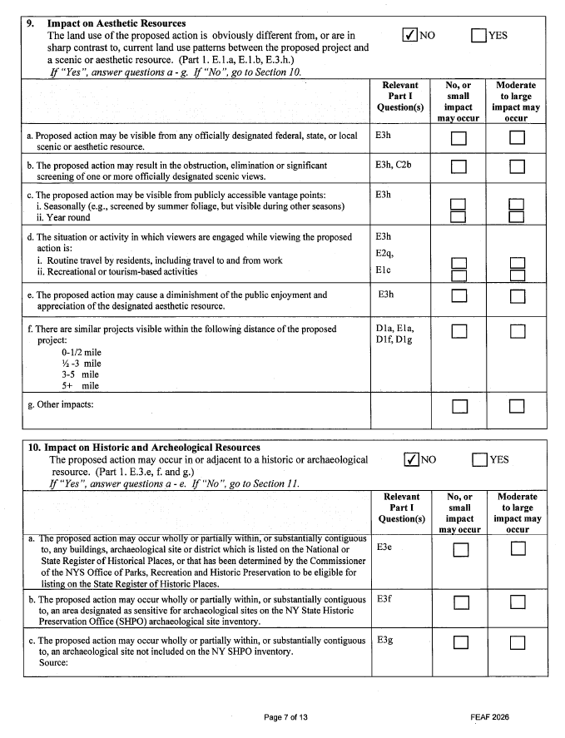

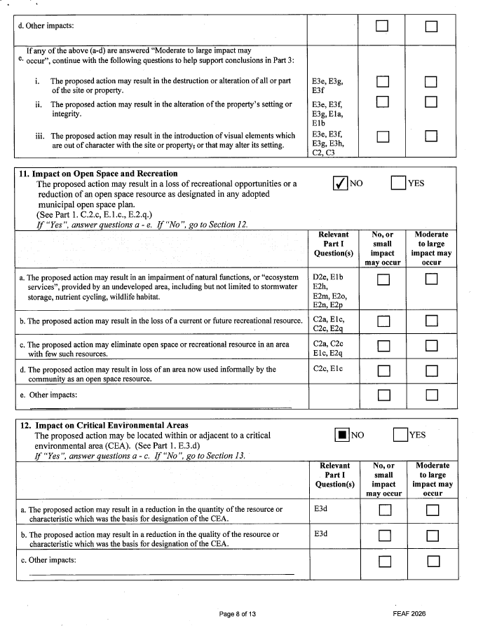

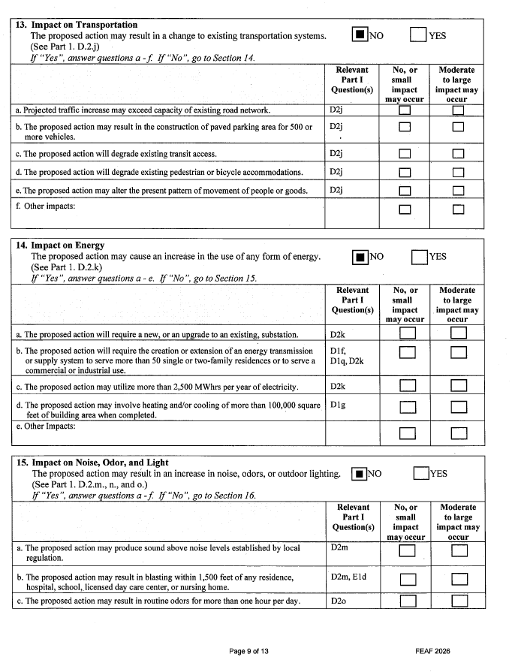
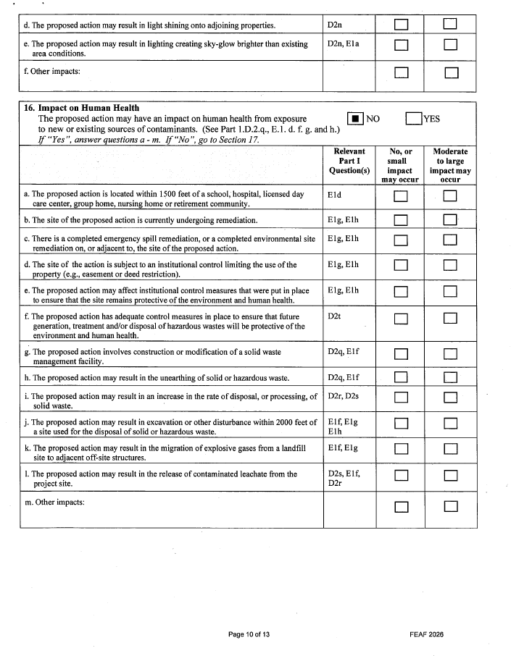
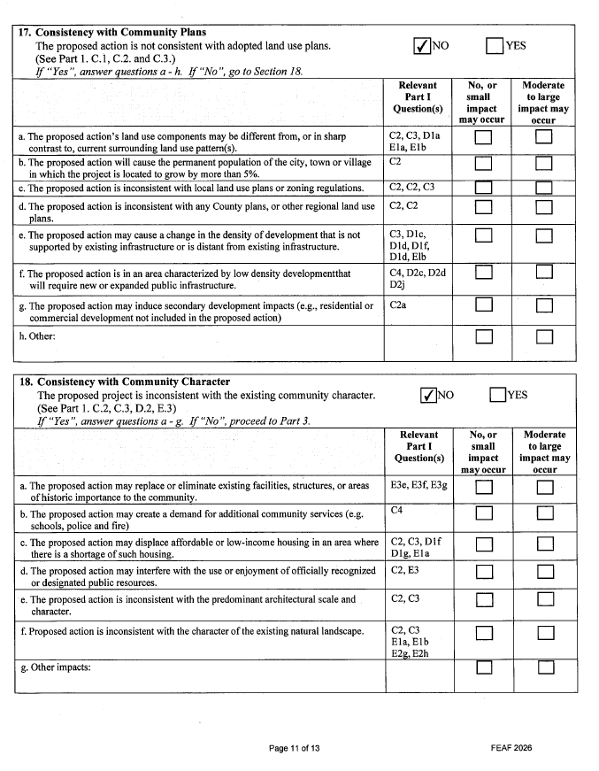
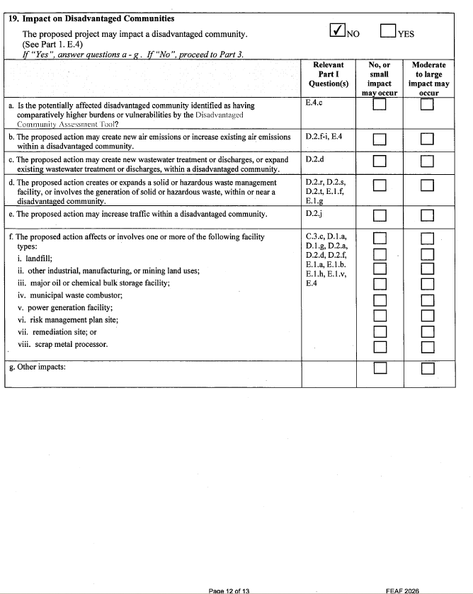

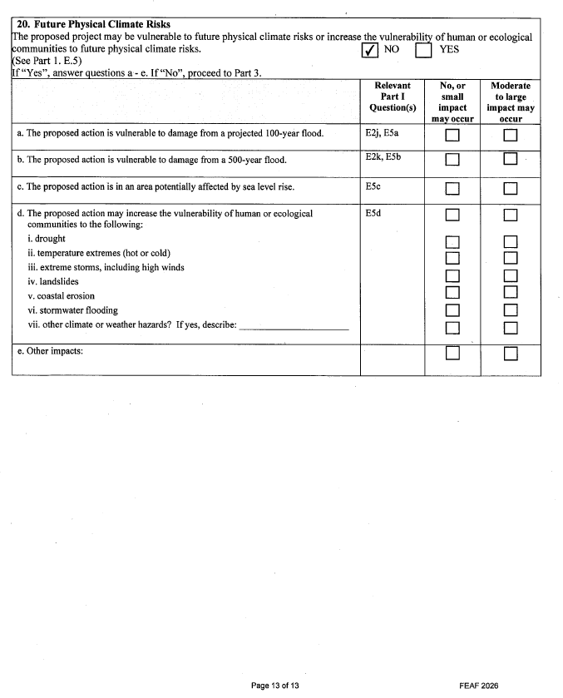

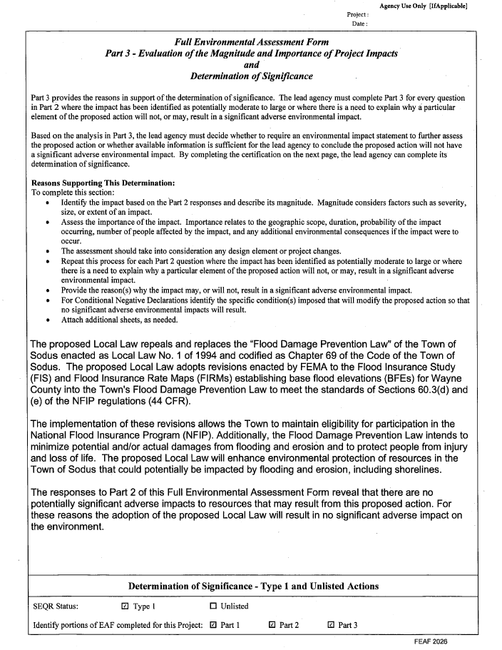
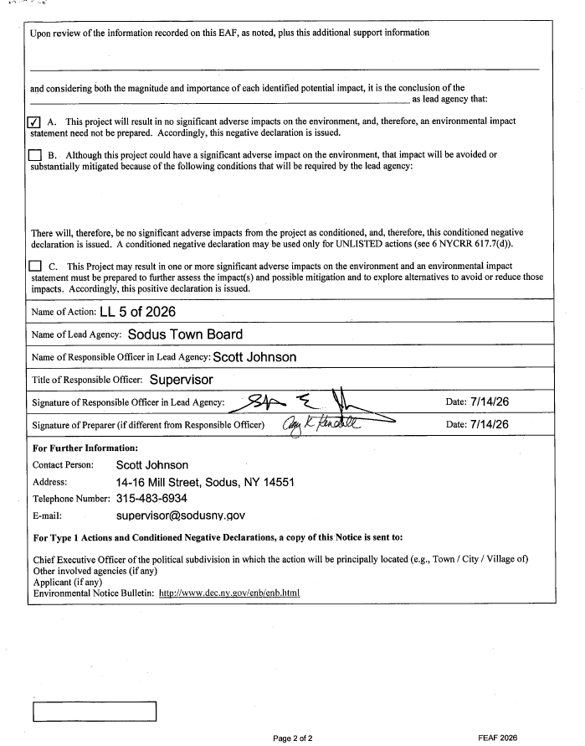
RESOLUTION
COURT CLERK EMILY HENDERSON – NEW HIRE
(04 07-2026)
NOW BE IT RESOLVED, Councilperson Josh Conklin motioned to authorize Honorable Jay DeWispelaere with the Sodus Town Court to hire Emily Henderson as a fulltime Court Clerk at 35 hours per week, starting wage of $21.52 per hour, effective July 20, 2026 with a 6 month probationary period was seconded by Councilperson Chris Tertinek. Upon roll call the following votes were heard, Supervisor Scott Johnson, aye, Chris Tertinek aye; Dale Pickering, aye; Cathy Willmott, aye; and Josh Conklin, aye. Resolution Adopted.

RESOLUTION
PRO HOUSING COMMUNITIES PLEDGE
(05 07-2026)
WHEREAS, the Town of Sodus Board believes that the lack of housing for New York residents of all ages and income levels negatively impacts the future of New York State’s economic growth and community well-being;

WHEREAS, the housing crisis has negative effects at regional and local levels, we believe that every community must do their part to contribute to housing growth and benefit from the positive impacts a healthy housing market brings to communities;

WHEREAS, we believe that supporting housing production of all kinds in our community will bring multiple benefits, including increasing housing access and choices for current and future residents, providing integrated accessible housing options that meet the needs of people with sensory and mobility disabilities, bringing economic opportunities and vitality to our communities, and allowing workers at all levels to improve their quality of life through living closer to their employment opportunities;

WHEREAS, we believe that evidence showing that infill development reduces sprawl and supports walkable communities has significant environmental and public health benefits; and

WHEREAS, we believe that affirmatively furthering fair housing and reducing segregation is not only required by law, but is essential for keeping our community strong and vibrant;

NOW, THEREFORE, IT IS HEREBY RESOLVED Town of Sodus Board, in order to take positive steps to alleviate the housing crisis, adopts the Pro-Housing Communities pledge, which will have us endeavor to take the following important steps:

NOW BE IT RESOLVED, Councilperson Josh Conklin adopts Pro Housing Communities Pledge which was seconded by Councilperson Chris Tertinek. Upon roll call the following votes were heard, Supervisor Scott Johnson, aye, Chris Tertinek aye; Dale Pickering, aye; Cathy Willmott, aye; and Josh Conklin, aye. Resolution Adopted.

RESOLUTION
NY ASSOCATION TOWNS BILL OF RIGHTS
(06 07-2026)
WHEREAS, town government provides services essential to the vitality of New York State, including not limited to maintaining and repairing roads, protecting neighborhoods and businesses, guiding economic development, and serving as the first line of defense, communication, and safety for residents every day of the year; and

WHEREAS, the 933 towns of New York State are home to more than 9.1 million New Yorkers and are diverse in population, geography, and demographics, such that decisions affecting daily life are best made at the local level by the government that best understands each community's character, challenges, and needs; and

WHEREAS, the towns of New York are partners in shaping the State's future, and a true partnership between the State and its local governments will propel the New York State forward to the benefit of all New Yorkers; and

WHEREAS, the New York Association of Towns has adopted a Bill of Rights articulating the core principles that should govern the relationship between the State and its towns; and

WHEREAS, the Town of Sodus shares and affirms those principles, namely:

- Protection and defense of municipal home rule, recognizing that towns, as the level of government closest to the people, are best positioned to balance competing interests and make decisions that shape daily life;

- Local control of land use and zoning, free from statewide zoning rules that override the voice of resident taxpayers and the officials they elect;

- Freedom from unfunded mandates, so that local taxpayers are not made to bear the cost of orders imposed by State and federal authorities without the resources to carry them out;

- Modernized transparency, accessibility, and engagement, including reform of outdated public-notice requirements that consume scarce municipal dollars on print notices often missed by the public; and

- A meaningful voice in State decisions affecting the hometowns that towns govern, so that town government is treated as a true partner rather than an afterthought or a hurdle to clear;

RESOLVED, that the Town Board of the Town of Sodus hereby endorses and adopts the New York Association of Towns Bill of Rights and affirms its commitment to the principles set forth therein; and be it further
RESOLVED, that the Town Board calls upon the Governor and the New York State Legislature to respect and uphold these principles in the enactment of legislation and the administration of State programs affecting towns; and be it further

RESOLVED, that the Town Clerk is hereby directed to transmit certified copies of this resolution to the Governor of the State of New York, the Temporary President of the Senate, the Speaker of the Assembly, the State Senator(s) and Member(s) of the Assembly representing the Town of Sodus, and the New York Association of Towns; and be it further

NOW BE IT FURTHER RESOLVED, Councilperson Chris Tertinek moved to adopt the New York State Bill of Rights which was seconded by Councilperson Cathy Willmott. Upon roll call the following votes were heard, Supervisor Scott Johnson, aye, Chris Tertinek aye; Dale Pickering, aye; Cathy Willmott, aye; and Josh Conklin, aye. Resolution Adopted.
RESOLUTION
AUTHORIZATION FOR DELEGATE TO LEGISLATIVE MEETING OF THE NEW YORK ASSOCIATION OF TOWNS
(07 07-2026)
WHEREAS, Supervisor Scott Johnson will attend the New York Association of Towns "NYAOT” Legislative Conference and Meeting on September 22- 23, 2026; and

WHEREAS, the Town of Sodus benefits from having a delegate vote on what to include in NYAOT's 2027 legislative priorities; and
WHEREAS, the Town of Sodus has the authority to designate any officer, employee, or representative of the town as a delegate for this meeting;
THEREFORE BE IT RESOLVED, Supervisor Scott Johnson be designated; as a delegate for the Town of Sodus; and
FURTHER BE IT RESOLVED, that in the absence of Supervisor Scott E. Jonson the designated delegate for the Town of Sodus will be Alternate Deputy Supervisor Chris Tertinek; and

NOW BE IT FURTHER RESOLVED, Councilperson Chris Tertinek moved to adopt Supervisor Scott E. Johnson as delegate and Deputy Supervisor Chris Tertinek as alternate to the NY Association of Towns Legislative Conference September 22-23 which was seconded by Councilperson Cathy Willmott. Upon roll call the following votes were heard, Supervisor Scott Johnson, aye, Chris Tertinek aye; Dale Pickering, aye; Cathy Willmott, aye; and Josh Conklin, aye. Resolution Adopted.

RESOLUTION
AUTHORIZATION FOR SAL VITTOZZI TO PURCHASE LAPTOP FOR BEECHWOOD
(08 07-2026)
NOW BE IT RESOLVED, Councilperson Dale Pickering motioned to adopt and authorize Sal Vittozzi Beechwood Caretaker to purchase a new HP 17.3 + Anti-Glare Touchscreen Laptop, AMD Ryzen 5734OU CPU in the amount of $664.99 from Walmart Business Account for Camp Beechwood which was seconded by Councilperson Cathy Willmott. Upon roll call the following votes were heard, Supervisor Scott Johnson, aye, Chris Tertinek aye; Dale Pickering, aye; Cathy Willmott, aye; and Josh Conklin, aye. Resolution Adopted.

RESOLUTION
AUTHORIZATION TO PURCHASE ONE NEW CASE CX85E WITH STANDARD DOZER BLADE EXCAVATOR
(09 07-2026)
NOW BE IT RESOLVED, Councilperson Josh Conklin motioned to adopt and authorize Highway Superintendent Jared Laird to purchase one new H074051 Case CX85E with Standard Dozer Blade SMP1C3TZLU00239 Excavator from Monroe Tractor Sourcewell Contract 011723 State Bid with CHIPS funds in the amount of $134,970.00 was seconded by Councilperson Dale Pickering. Upon roll call the following votes were heard, Supervisor Scott Johnson, aye, Chris Tertinek aye; Dale Pickering, aye; Cathy Willmott, aye; and Josh Conklin, aye. Resolution Adopted. (see attached)

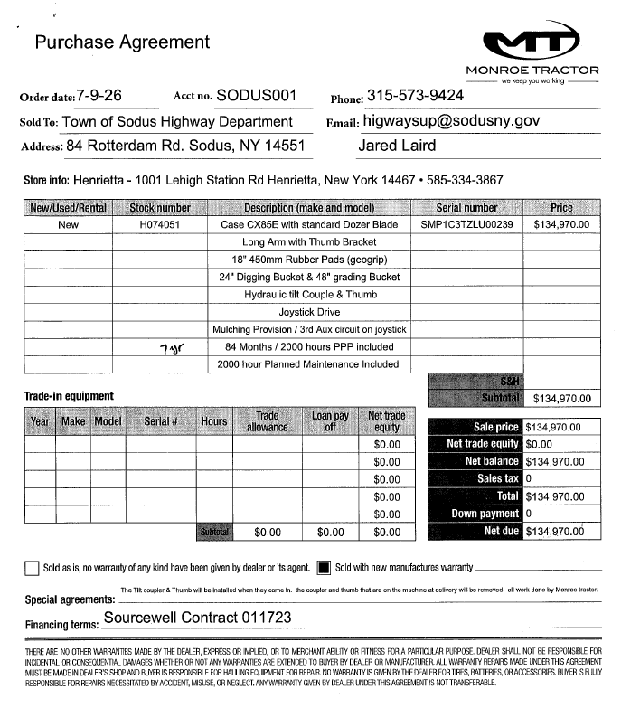

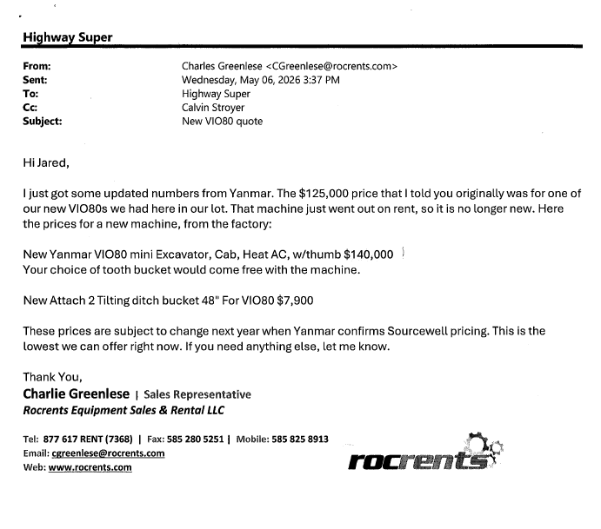

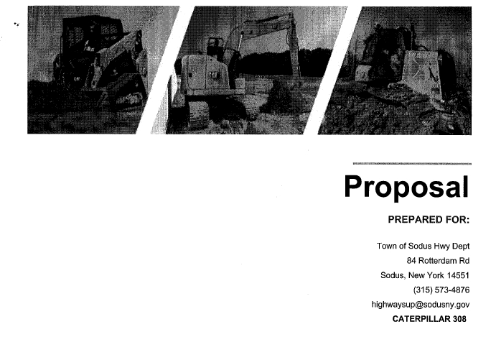

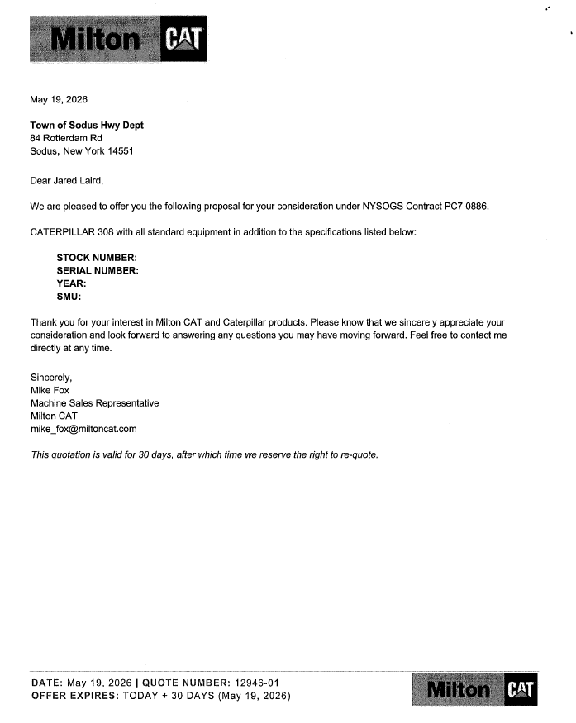

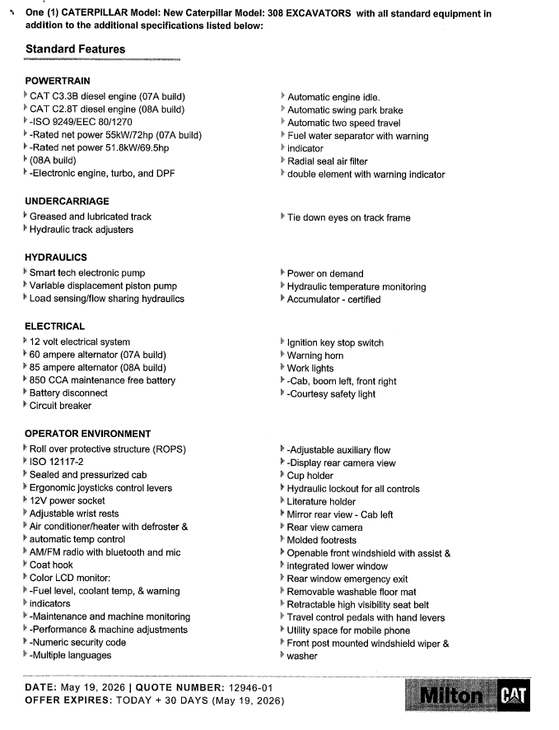
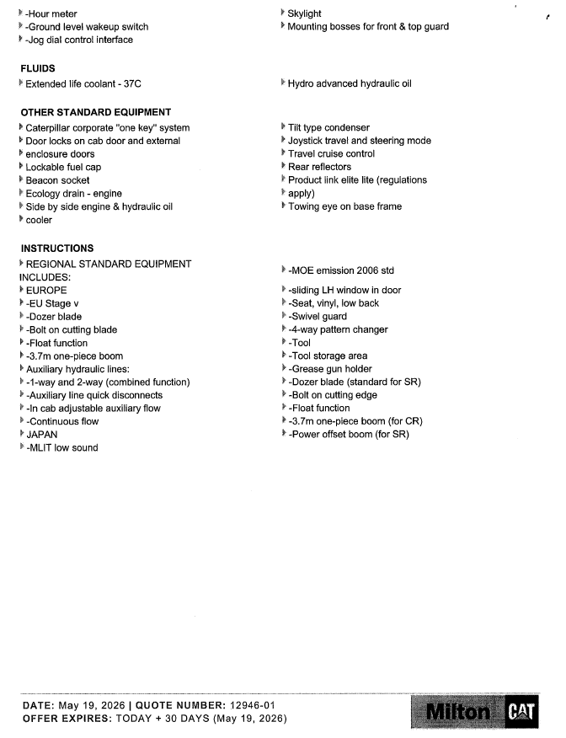

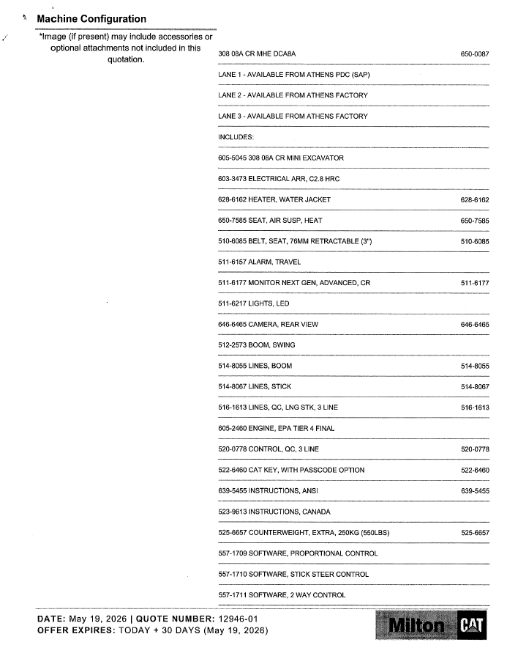

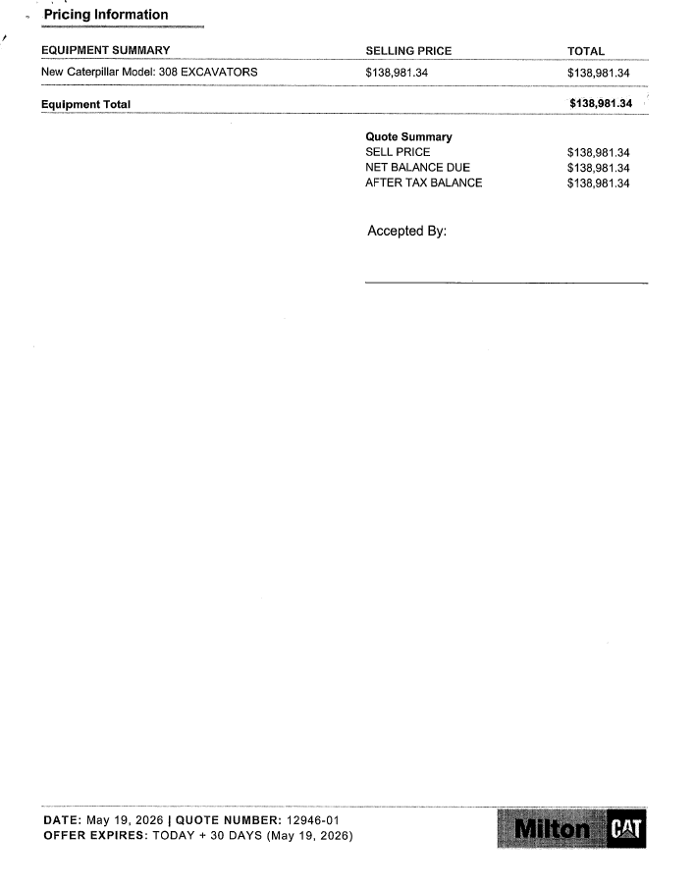
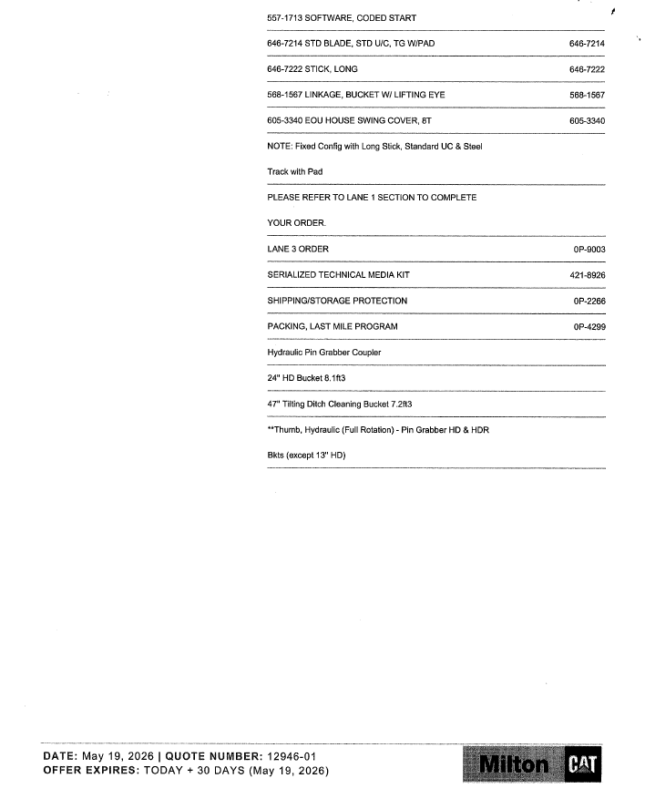


Councilperson Cathy Willmott motioned to enter into Executive Session regarding medical, financial, credit or employment history of a particular person or corporation or relating to appointment promotion demotion discipline or removal was seconded by Councilperson Dale Pickering. Upon roll call the following votes were heard, Supervisor Scott Johnson, aye, Chris Tertinek aye; Dale Pickering, aye; Cathy Willmott, aye; and Josh Conklin, aye. Motion carried.
Time: 6:50 PM

Councilperson Josh Conklin motioned to exit out of Executive Session and enter into regular session was seconded by Councilperson Dale Pickering. Upon roll call the following votes were heard, Supervisor Scott Johnson, aye, Chris Tertinek aye; Dale Pickering, aye; Cathy Willmott, aye; and Josh Conklin, aye. Motion carried.
Time: 7:46 PM

Councilperson Chris Tertinek motioned to adjourn the Regular Town Board Meeting was seconded by Councilperson Cathy Willmott. Upon roll call the following votes were heard, Supervisor Scott Johnson, aye, Chris Tertinek aye; Dale Pickering, aye; and Cathy Willmott, aye; and Josh Conklin, aye. Motion carried.

Meeting adjourned at 7:47 PM

Recording Secretary,
Lori K. Diver
Sodus Town Clerk, RMC

Note: Reports and other correspondence are attached in the order of motions and resolutions typed in Minutes.

