NOTE: There was no agenda given, it was a budget workshop-special meeting for any unknown business presented to the Town Board.

MINUTES
Minutes of the Budget Workshop – Special Town Board meeting commencing at 2:00 PM in the upstairs meeting room October 14 , 2025 located at 14-16 Mill St. Sodus, NY 14551.
All meetings are open to the public.

Scott Johnson, Supervisor
Present: Chris Tertinek, Deputy Supervisor-Councilperson
Don Ross, Councilperson
Dale Pickering, Councilperson
Cathy Willmott, Councilperson

Recording Secretary: Lori Diver, Sodus Town Clerk

Absent: N/A

Others Present: Amanda Burman, Interim Recreation Director
Jared Laird, Highway Superintendent
Roll Call:
Meeting was called to order by Supervisor Scott Johnson. All Board Members were present.

The Sodus Town Board interviewed Amanda Burman-Interim Recreation Director for the position as permanent recreation director.
Note: there were two applications received however; one was withdrawn leaving one applicant. The Sodus Town Clerk advertised in the Times of Wayne County, and it was published for 6 weeks on the sodusny.gov website and legal boards within the Town of Sodus.
RESOLUTION
RECREATION DIRECTOR-AMANDA BURMAN
(01 10-2025)
NOW BE IT RESOLVED, Councilperson Don Ross motioned to hire Amanda Burman as Recreation Director at the 2025 budgeted Recreation Director rate of pay, non-benefited with a 6 month probationary period (effective immediately) was seconded by Councilperson Dale Pickering. Upon roll call the following votes were heard, Supervisor Scott Johnson, aye; Don Ross, aye; Chris Tertinek, aye; Dale Pickering, aye; and Cathy Willmott aye. Resolution Adopted.

RESOLUTION
HIGHWAY PURCHASE CASE 821g LOADER WITH BUCKET & FORKS
(02 10-2025)
NOW BE IT RESOLVED, Councilperson Cathy Willmott motioned to approve purchase of Case 821G Loader with Bucket and forks, 5yr/Planned Maintenance, 3 year 3000 hour, full Factory Limited Warranty (as follows page 2 & 3), which was seconded by Councilperson Chris Tertinek.
Upon roll call the following votes were heard, Supervisor Scott Johnson, aye; Don Ross, aye; Chris Tertinek, aye; Dale Pickering, aye; and Cathy Willmott, aye. Resolution Adopted. (Note: Per Jared Laird this was off from State Bid. No other bids were needed per Town of Sodus Procurement Policy).

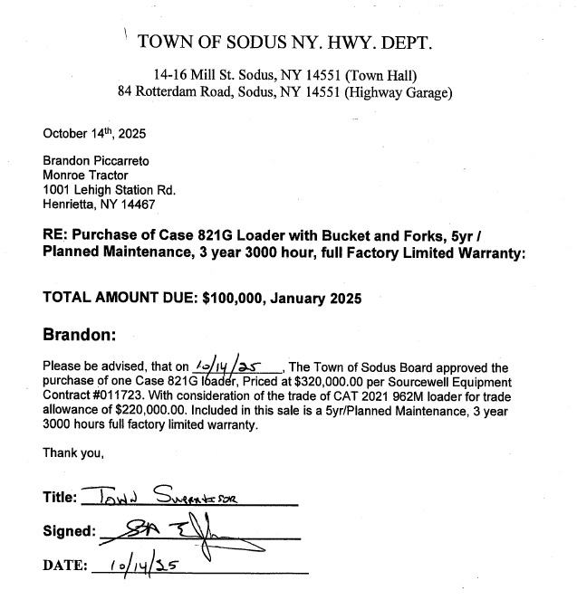

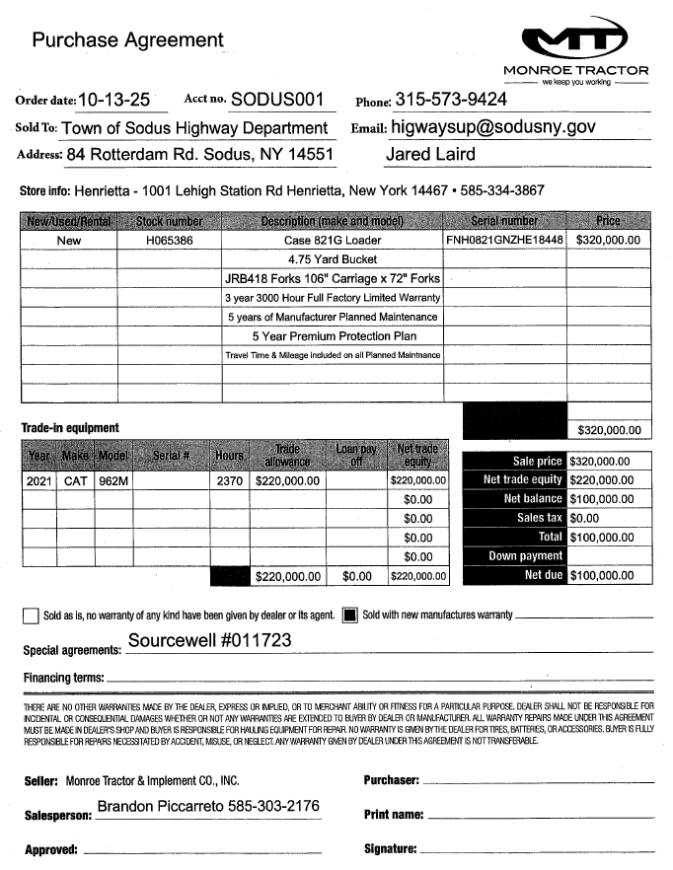
Councilperson Dale Pickering motioned to cancel and change the Town Board month end-special board - public hearings meeting from October 23, 2025 at 4:00 pm to October 30, 2025 commencing at 3:00 PM in the Sodus Town Hall was seconded by Councilperson Cathy Willmott. Upon roll call the following votes were heard, Supervisor Scott Johnson, aye, Don Ross, aye; Chris Tertinek, aye; Dale Pickering, aye and Cathy Willmott, aye. Motion carried.

Councilperson Dale Pickering motioned to adjourn the Town Board Meeting was seconded by Councilperson Chris Tertinek. Upon roll call the following votes were heard, Supervisor Scott Johnson, aye, Don Ross, aye; Chris Tertinek, aye; Dale Pickering, aye and Cathy Willmott, aye. Motion carried.
Time: 3:04 PM

Minutes Written By:
Lori K. Diver
Sodus Town Clerk, RMC

