Zone: Permit #
Zoning Board approval date: Date: Click or tap to enter a date.
TAX ID #
Instructions:
- Plot plan showing location of lot and buildings on premises, relationship to adjoining premises or public streets or areas, and giving a detailed description of layout of property must be drawn on the diagram which is part of this application.

- This application must be accompanied by two complete sets of plans showing proposed construction and two complete sets of specifications. Plans and specifications shall describe the nature of the work to be performed.

- No building shall be occupied or used in whole or in part for any purpose whatever until an application is made for and a Certificate of Occupancy shall have been granted by the Building Department.
Location:
Click here to enter text.
(Street address) (Town) (State) (Zip)
Applicant name: Click here to enter text. Property Owner: Click here to enter text.
Construction Company if applicable: Click here to enter text.
Phone number: Click here to enter text. Email: Click here to enter text.
- Nature of work: ☐Installation ☐New building ☐Addition ☐Alteration ☐Repair ☐Removal ☐Demolition ☐Replacement ☐Renewal ☐ Placement
- Description of work: Click here to enter text.
- Estimated cost $Click here to enter text. Permit Fee $
Contractor, agent, corporate officer, etc. of said owner or owners, and is duly authorized to perform or have performed the said work and to make and file this application; that all statements contained in this application are true to the best of his knowledge and belief, and that the work will be performed in the manner set forth in the application and in the plans and specifications filed therewith.
Sworn before me this ___________ day of ________________, 2022

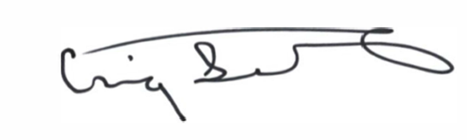
________________________________________ __________________________________________
(Building Inspector) (Applicant signature)

