The Village of Sodus, Village of Sodus Point & Town of Sodus will be conducting an
E-WASTE COLLECTION
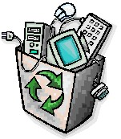

The town wide e-waste recycling event is for residents and property owners within the Town. (Proof of residency or ownership required. A driver’s license, photo ID, or tax bill/receipt are accepted)
E-waste, including televisions, will be
accepted free of charge. Reasonable limits
apply.
When:
June 8, 2019 from 9:00 AM to 2:00 PM
Where:
Village Barn - 39 Gaylord Street

