MINUTES
Minutes of the Month -End Town Board Meeting commencing at 5:00 PM in the upstairs meeting room August 25, 2020, located at 14-16 Mill St. Sodus, NY 14551. Due to Covid-19 Zoom was provided, along with detailed login information in the legal notice of this meeting.
Masks were required and social distancing was enforced.
All meetings are open to the public.

Roll Call/Present: Scott Johnson, Supervisor
David LeRoy, Councilperson/Deputy Supervisor
Don Ross, Councilperson-Zoomed
Chris Tertinek, Councilperson
Johns Faulks, Councilperson-Zoomed

Recording Secretary: Bree Crandell, Confidential Supervisor Clerk

Others Present: Amy Kendall, Town Attorney-Zoomed
Bree Crandell, Supervisor Clerk
Casey Carpenter, Times of Wayne County-Zoomed

Absent: Lori Diver, Sodus Town Clerk

Supervisor Scott Johnson called the Regular Month End Town Board Meeting to order at 5:00 PM.
ABSTRACT # 15
RESOLUTION
(04 08-2020)
WHEREAS, the following bills were presented for payment on Abstract 15:

General 350-373 $ 42,369.43
Highway 238-246 $ 21,182.01
Trust & Agency 023-024 $ 948.42
GRAND TOTAL: $ 64,499.86

NOW BE IT RESOLVED, Councilperson David LeRoy motioned to approve payment of these bills as reviewed for Abstract No. 15, which was seconded by Councilperson John Faulks. Upon roll call the following votes were heard, Supervisor Scott E. Johnson, aye; David LeRoy, aye; Chris Tertinek, aye; Don Ross, aye; and John Faulks, aye. Resolution adopted.

ELIMINATING TOWN OF SODUS TIME CLOCK POLICY
RESOLUTION
(05 08-2020)
WHEREAS, Supervisor Johnson offered the following resolution for its adoption; and

WHEREAS, the Town of Sodus Municipal Time Clock is no longer needed; and

WHEREAS, the Town of Sodus Municipal Time Clock Policy is no longer needed; and

NOW THEREFORE, it is hereby agreed that the Town of Sodus Board is in agreement that the Time Clock and Time Clock Policy will be eliminated and effective immediately; and

FURTHER BE IT RESOLVED, Councilperson David LeRoy motioned to adopt this resolution, which was seconded by Councilperson John Faulks. Upon roll call the following votes were heard, Supervisor Scott E. Johnson, aye; David LeRoy, aye; Chris Tertinek, aye; Don Ross, aye; and John Faulks, aye. Resolution adopted.

There was discussion on the pedestrian safety measures near the intersection of RT. 14 and Margaretta Rd. in the Village of Sodus Point. It was also shared that the Village of Sodus Point and The Town of Sodus need to get together to discuss.

PUBLIC HEARING 5:15 PM:
Councilperson Don Ross motioned waiving reading out loud the Regional Water Tank legal notice with Schedule A, due to the lengthy notice, which was seconded by Councilperson John Faulks. Upon roll call the following votes were heard, Supervisor Scott E. Johnson, aye; David LeRoy, aye; Chris Tertinek, aye; Don Ross, aye; and John Faulks, aye. Motion approved.
(Note: this was posted on-line on the Town of Sodus website, the Town of Sodus legal board, the Town Clerk’s legal board and the Times of Wayne County in the legal section of the paper).

LEGAL NOTICE
STATE OF NEW YORK COUNTY OF WAYNE TOWN OF SODUS TOWN BOARD
In the Matter of the Proposed Establishment ORDER
of the Regional Water Storage Improvement Area in the Town of Sodus, Wayne County Pursuant
to Article 12-C of the Town Law

- The Town Board has proposed to create the Regional Water Storage Improvement Area (the “Improvement Area”) of the Town of Sodus (the “Town”) pursuant to Article 12-C of the Town Law.
- The Wayne County Water and Sewer Authority (“Authority”), together with the Town of Arcadia, Town of Huron, Town of Lyons, Town of Marion, Town of Sodus (“Town”), and Town of Williamson (collectively “Participating Municipalities”), are in need of enhanced water supply, water storage, fire protection, redundancy, resiliency and related services.
- In lieu of working independently to meet these needs, the Participating Municipalities discussed and memorialized their intent to work together cooperatively with the Authority to develop regional water storage tank improvements with related pump station and transmission system improvements that would meet their collective needs pursuant to a Memorandum of Understanding Regarding The Wayne County Water And Sewer Authority 2017 Regional Water Storage Project (“Joint Water Project”), entered into effective as of June 23, 2017, which agreement was revised and extended by Addendum No. 1 dated as of December 30, 2017, and subsequently amended and restated by agreement dated as of September 1, 2019 (Collectively, “MOU”). The MOU of on file at the Town Clerk’s Office and is available for public inspection during regular business hours.
- The agreement between the Participating Municipalities set forth in the MOU was memorialized in the Regional Water Storage System Improvements and Services Agreement with exhibits (Intermunicipal Agreement” or “IMA”), dated and effective January 1, 2020. The IMA is on file at the Town Clerk’s Office and is available for public inspection during regular business hours.
- Pursuant to the IMA, the Authority will design, procure and finance regional water storage tank improvements, pump station improvements, transmission mains, water lines and other related improvement (collectively “Improvements”) and the Authority will construct and operate the Improvements, except that the Town of Williamson will construct and operate certain Improvements within the geographic limits of the Town of Williamson.
- The maximum cost of the Improvements (“Project Cost”) is estimated to be $10,500,000. The Authority has received various grants for the Project Costs in the amount of $4,650,000, leaving a net capital cost of $4,850,000 at this time.
- The Authority will charge an annual service fee (“Service Fee”) to the Participation Municipalities to pay for Project Costs.
- The Participating Municipalities will pay the Service Fee on a pro rate basis as determined by the number of equivalent dwelling units (“EDU”) benefitting from the Improvements in each town. The Town’s pro rata share of the Service Fees for 2021 is 13.21%, as shown as Exhibit C of the IMA.

- The Participating Municipalities have agreed to a common definition of EDU for the purpose of determining the pro rata share, as set forth in Exhibit A to the IMA.

- The Participating Municipalities have agreed to form Improvement Areas under Article 12-C of the Town Law. The purpose of the proposed Improvement Area is to facilitate the allocation of the Town’s pro rata share of Service Fee among users of the Improvements.

- Users of the Improvements that will be assessed the annual cost per EDU are users of water/owners of parcels of land with access to water that are located within districts or improvement areas and approved Authority service areas, as well as approved out-of-district users within the Participating Municipalities, in each case receiving and/or otherwise benefiting from Regional Water Storage Services during the term of the Agreement.

- The estimated annual cost per EDU is between $45 and $75. This cost will change based on a number of factors, including the financing and the number of EDUs in the Town as water services are expanded and water districts are created.

- A report entitled Engineering report for the Wayne County Regional Water and Sewer Authority Regional Storage Project, Towns of Arcadia, Huron, Lyons, Marion, Sodus and Williamson, dated July 2020 (the “Map, Plan and Report”), prepared by Derek C. Anderson, P.E. of MRB Group, Engineering Architecture & Surveying, D.P.C., a competent engineer duly licensed by the State of New York was accepted by the Town Board on July 14, 2020 and is incorporated by reference. That Map, Plan and Report details the nature and extent of the Improvements, and includes a map showing the boundaries of the proposed Regional Water Storage Improvement Area.
- A copy of the Map, Plan and Report has been filed with the Town Clerk and is available for public inspection during regular business hours at the office. It is also available on the Authority’s website at www.wcwsa.org.
- The Improvement Area is proposed to include the lands described on the annexed Schedule
- The Improvement Area intended to effectively “overlay” the Town’s existing water districts and other improvement areas, service areas and out-of-district users, so as to encompass all water Users within the boundaries of the proposed Improvement Area. The Improvement Area also encompasses areas without current access to public water, but which would be assessed a Service Fee at such time public water is available to them, in recognition of the enhanced water storage
16. The Improvements are set forth in the Map, Plan and Report, and include construction within the Town of transmission main along Route 88 and Branting Hill Road in the Town.
17. Once constructed, owners of property along the Improvements in the Town that are not in a water district (“Out-of-District Users”) can connect and obtain water upon execution of a contract with the Town and the Authority.
18. Out-of-District Users who connect to the Improvements will be charged by the Authority a one-time connection charge estimated initially to be $1,600 per standard services connection (1” service line and ¾” meter) inclusive of the meter, appurtenances, and inspection charges; and will also be responsible for the cost of their water service line between the curb stop and dwelling, including any internal plumbing modifications necessary to accommodate the installation of the water meter. Upsizing of the service line and meter, if necessary to accommodate particular properties, will incur a higher connection charge in accordance with the Authority’s then applicable connection charges.
- In addition to the connection fee, Out-of-District Users will pay $540 per year for 38 years in addition to the cost of water. This amount will be payable to the Town and used to reduced debt owned by the Town’s other water districts.
NOW, THEREFORE, IT IS ORDERED, by the Town Board as follows:

- A hearing shall be held on the 25th day of August, 2020, at 5:15 p.m., by the Town Board at 14-16 Mill Street in the Town of Sodus, County of Wayne and State of New York on the proposal to establish the Improvement Area, at which time the Town Board shall consider the Map, Plan and Report, and hear all persons interested in their subject matter or the establishment of the Improvement Area.
- It is also ordered that a certified copy of this Order shall be published in the Times of Wayne County on August 15, 2020, and the Town Clerk shall also cause a copy of this Order to be posted on the sign board of the Town maintained pursuant to Town Law §30(6) on or after August 12, 2020 and on the Town website.
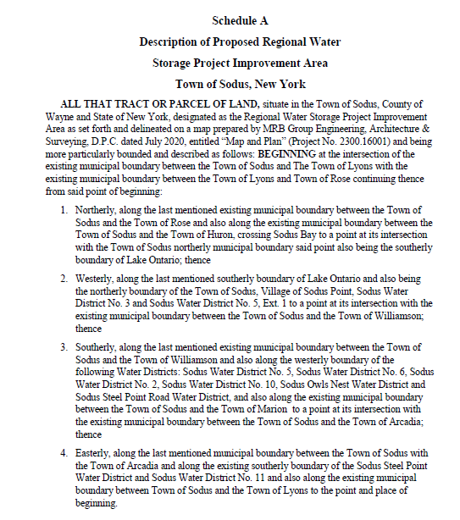
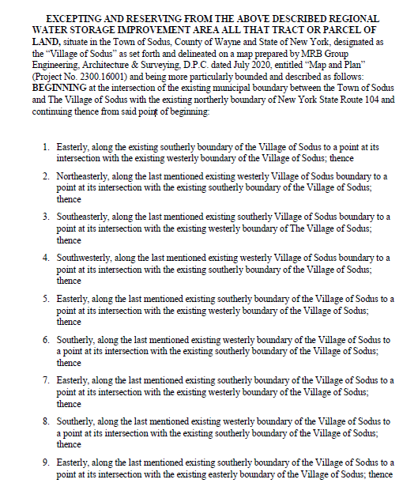
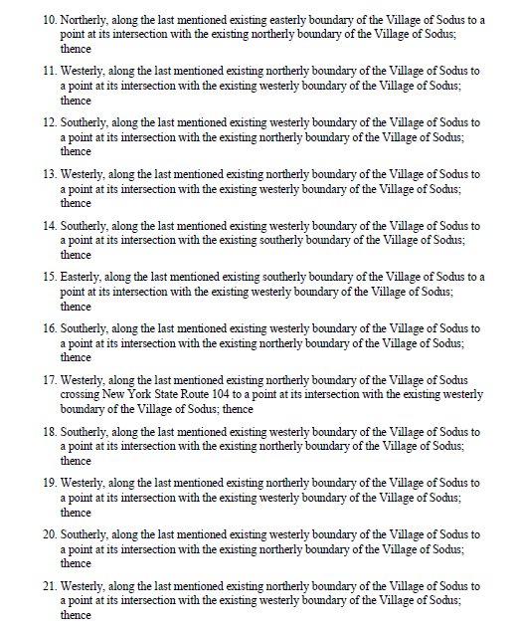
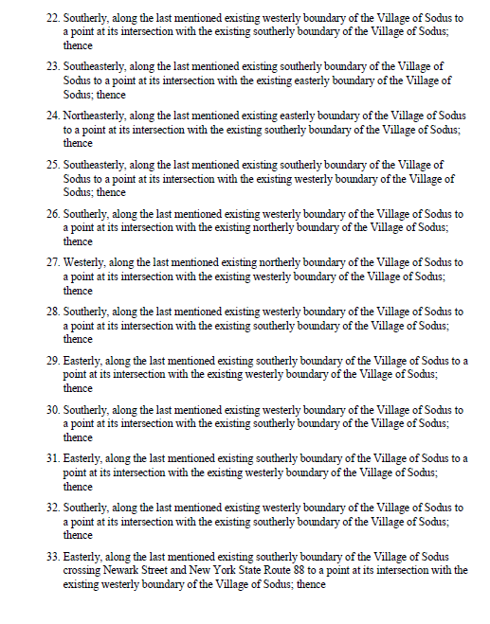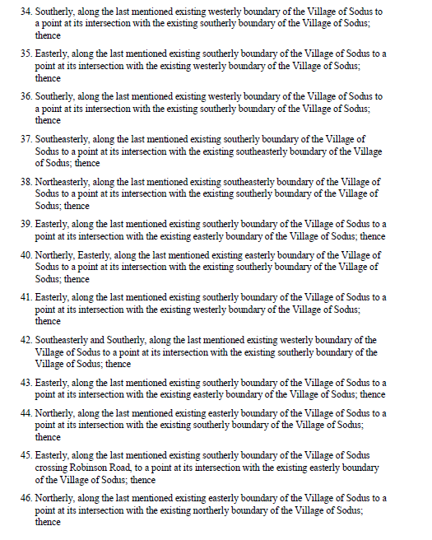
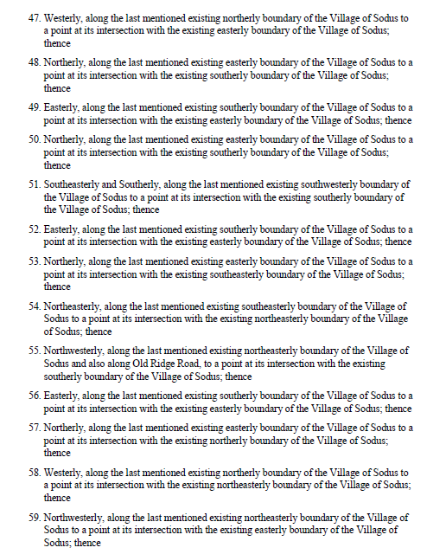
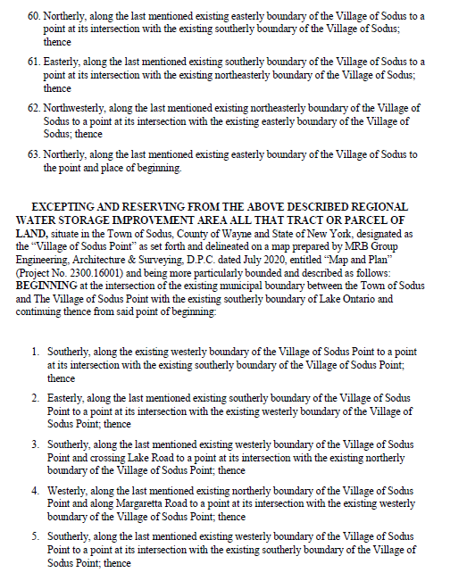
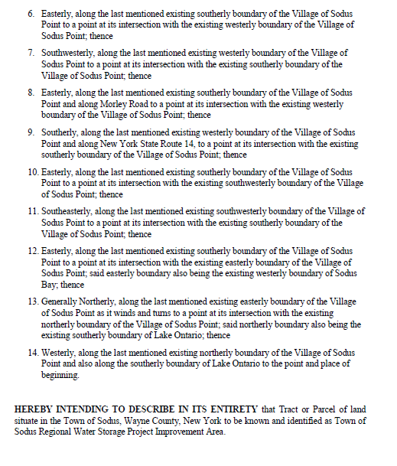
Hearing no public comments Supervisor Scott Johnson closed the Public Hearing at 5:25 PM
REGIONAL WATER STORAGE IMPROVEMENT
RESOLUTION
(06 08-2020)

At a Hearing held at a Meeting of the Sodus Town Board on the 25th day of August, 2020, at 5:15 pm, at the Sodus Town Hall, 14-16 Mill Street, in the Town of Sodus, County of Wayne and State of New York

STATE OF NEW YORK COUNTY OF WAYNE
TOWN OF SODUS TOWN BOARD
___________________________________________

Establishment ORDER AND RESOLUTION
of the Regional Water Storage Improvement Area
in the Town of Sodus, Wayne County Pursuant
to Article 12-C of the Town Law
___________________________________________

UPON MOTION OF TOWN BOARD MEMBER Don Ross,
SECONDED BY TOWN BOARD MEMBER Chris Tertinek, IT IS
UNANIMOUSLY ORDERED AND RESOLVED AS FOLLOWS:

- The Town Board has proposed to create the Regional Water Storage Improvement Area (the “Improvement Area”) of the Town of Sodus (“Town”) pursuant to Article 12-C of the Town Law.
- The Wayne County Water and Sewer Authority (“Authority”), together with the Town of Arcadia, Town of Huron, Town of Lyons, Town of Marion, Town of Sodus, and Town of Williamson (collectively “Participating Municipalities”), are in need of enhanced water supply, water storage, fire protection, redundancy, resiliency and related services.
- In lieu of working independently to meet these needs, the Participating Municipalities discussed and memorialized their intent to work together cooperatively with the Authority to develop regional water storage tank improvements with related pump station and transmission system improvements that would meet their collective needs pursuant to a Memorandum of Understanding Regarding The Wayne County Water And Sewer Authority 2017 Regional Water Storage Project (“Joint Water Project”), entered into and effective as of June 23, 2017, which agreement was revised and extended by Addendum No. 1 dated as of December 30, 2017, and subsequently amended and restated by agreement dated as of September 1, 2019 (collectively, “MOU”). The MOU is on file at the Town Clerk’s Office and is available for public inspection during regular business hours.
- The agreement between the Participating Municipalities set forth in the MOU was memorialized in the Regional Water Storage System Improvements and Services Agreement with exhibits (“Intermunicipal Agreement” or “IMA”), dated and effective January 1, 2020. The IMA is on file at the Town Clerk’s Office and is available for public inspection during regular business hours.
- Pursuant to the IMA, the Authority will design, procure and finance regional water storage tank improvements, pump station improvements, transmission mains, water lines and other related improvements (collectively “Improvements”) and the Authority will construct and operate the Improvements, except that the Town of Williamson will construct and operate certain Improvements within the geographic limits of the Town of Williamson.
- The maximum cost of the Improvements (“Project Cost”) is estimated to be $10,500,000. The Authority has received various grants for the Project Costs in the amount of $4,650,000, leaving a net capital cost of $5,850,000 at this time.
- The Authority will charge an annual service fee (“Service Fee”) to the Participating Municipalities to pay for Project Costs.
- The Participating Municipalities will pay the Service Fee on a pro rata basis as determined by the number of equivalent dwelling units (“EDU”) benefitting from the Improvements in each town. The Town’s pro rata share of the Service Fee for 2021 is 18.66%, as shown on Exhibit C of the IMA.
- The Participating Municipalities have agreed to a common definition of EDU for the purpose of determining the pro rata share, as set forth in Exhibit A to the IMA.
- The Participating Municipalities have agreed to form Improvement Areas under Article 12-C of the Town Law. The purpose of the proposed Improvement Area is to facilitate the allocation of the Town’s pro rata share of Service Fee among users of the Improvements.
- Users of the Improvements that will be assessed the annual cost per EDU are users of water/owners of parcels of land with access to water that are located within districts or improvement areas and approved Authority service areas, as well as approved out-of-district users within the Participating Municipalities, in each case receiving and/or otherwise benefiting from Regional Water Storage Services during the term of this Agreement.
- The estimated annual cost per EDU is between $45 and $75. This cost will change based on a number of factors, including the financing and the number of EDUs in the Town as water services are expanded and water districts are created.
- A report entitled Engineering Report for the Wayne County Regional Water and Sewer Authority Regional Storage Project, Towns of Arcadia, Huron, Lyons, Marion, Sodus and Williamson, dated July 2020 (the “Map, Plan and Report”), prepared by Derek C. Anderson, P.E of MRB Group, Engineering Architecture & Surveying, D.P.C., a competent engineer duly licensed by the State of New York was accepted by the Town Board on July 14, 2020, and is incorporated by reference. That Map, Plan and Report details the nature and extent of the Improvements, and includes a map showing the boundaries of the proposed Regional Water Storage Improvement Area.
- A copy of the Map, Plan and Report has been filed with the Town Clerk and is available for public inspection during regular business hours at her office. It is also available on the Authority’s website at www.wcwsa.org.
- The Improvement Area is proposed to include the lands described on the annexed Schedule A. The Improvement Area intended to effectively “overlay” the Town, including its existing water districts and other improvement areas, service areas and out-of-district users, so as to encompass all water Users within the boundaries of the proposed Improvement Area. The Improvement Area also encompasses areas without current access to public water, but which would be assessed a Service Fee at such time public water is available to them, in recognition of the enhanced water storage and/or the related redundancy and water system resiliency associated with the Project.
- The Improvements are set forth in the Map, Plan and Report, and include construction within the Town of transmission main along Route 88 and Branting Hill Road in the Town.
- Once constructed, owners of property along the Improvements in the Town that are not in a water district (“Out-of-District Users”) can connect and obtain water upon execution of a contract with the Town and the Authority.
- Out-of-District Users who connect to the Improvements will be charged by the Authority a one-time connection charge estimated initially to be $1,600 per standard service connection (1” service line and ¾” meter) inclusive of the meter, appurtenances, and inspection charges; and will also be responsible for the cost of their water service line between the curb stop and the dwelling, including any internal plumbing modifications necessary to accommodate the installation of the water meter. Upsizing of the service line and meter, if necessary to accommodate particular properties, will incur a higher connection charge in accordance with the Authority’s then applicable connection charges.
- In addition to the connection fee, Out-of-District Users will pay $540 per year for 38 years in addition to the cost of water. This amount will be payable to the Town and used to reduced debt owed by the Town’s other water districts.
- On August 11, 2020, the Town Board adopted a Negative Declaration for the Improvement Area under the State Environmental Quality Review Act, finding that creation of the Improvement Area would not have a significant adverse impact on the environment.
- An Order (the “Order for Hearing”) was duly adopted by the Town Board on August 11, 2020, setting a public hearing on the creation of the proposed Improvement Area on the August 25, 2020, at 5:15 p.m., at the Sodus Town Hall, 10880 14-16 Mill Street in the Town of Sodus, County of Wayne and State of New York.
- A certified copy of this Order was published in the Times of Wayne County on the 16th day of August, 2020, and the Town Clerk posted a copy of this Order on the sign board of the Town maintained pursuant to Town Law §30(6) on August 12, 2020.
- A hearing was held on the 25th day of August 2020, at 5:15 p.m., by the Town Board at 14-16 Mill Street in the Town of Sodus, County of Wayne and State of New York on the proposal to establish the Improvement Area, at which time the Town Board considered the Map, Plan and Report, and heard all persons who wished to speak. The hearing was held simultaneously by an in-person meeting and through videoconferencing.
- A certified copy of the Order for Hearing was filed with the State Comptroller.
NOW, THEREFORE, THE TOWN BOARD FINDS THAT:
- The Order for the hearing was published and posted as required by law for the notice of hearing and is otherwise sufficient.
- All Users as that term is defined in the IMA, including Out-of-District Users, will be benefitted by the Improvements in that the Improvements will provide enhanced water supply, water storage, fire protection, redundancy, resiliency and related services within the proposed Improvement Area.
- All Users benefited by the proposed Improvement Area are included within the limits of the proposed Improvement Area.
- Establishment of the Improvement Area is in the public interest.
IT IS THEREFORE ORDERED AND RESOLVED that the Regional Water Storage Improvement Area of the Town of Sodus is established in accordance with Map, Plan and Report, and that the Improvement Area shall be bounded and described as set forth on the attached Schedule A; and
IT IS FURTHER ORDERED AND RESOLVED that pursuant to Town Law §209-q, the Service Fee shall be assessed to Users and Out-of-District Users by the Town Board, in proportion as nearly as may be calculated to the benefit which each lot or parcel would derive from the Improvements, and pursuant to the EDU policy of the Town; and
IT IS FURTHER ORDERED AND RESOLVED that pursuant to Town Law § 209-q(11), this Order and Resolution is not subject to permissive referendum because the Service Fee is not charged to the entire area of the town; and
IT IS FURTHER ORDERED AND RESOLVED that this Order and Resolution is not subject to the state comptroller’s approval pursuant to Town Law §209-q(13) because the Town is not financing the Improvements but rather they are being financed by the Authority; and
IT IS FURTHER ORDERED AND RESOLVED that on or before August 30, 2020, the Town Clerk shall record a certified copy of this Order and Resolution with the Wayne County Clerk, and file a certified copy with the New York State Department of Audit and Control in Albany, New York.
There were questions and discussion regarding if there were grant opportunities to clean up for industrial and dilapidated properties.

Councilperson John Faulks motioned to adjourn the meeting was seconded by Councilperson Chris Tertinek. Upon roll call the following votes were heard, Supervisor Scott E. Johnson, aye; David LeRoy, aye; Chris Tertinek, aye; Don Ross, aye; and John Faulks, aye. Motion carried.

Meeting adjourned: 5:25 PM
Recording Secretary,

Lori Diver
Sodus Town Clerk, RMC

