MINUTES
Minutes of the Emergency Special Town Board Meeting held December 23, 2019 in the “Sodus Town Courtroom”, commencing at 5:30 PM located at 14-16 Mill St. Sodus, NY 14551.
Sodus Town Board Meetings are open to the public.

Roll Call/Present: Steven LeRoy, Supervisor
David LeRoy, Councilperson/Deputy Supervisor
Jim Quinn, Councilperson
Don Ross, Councilperson
Scott Johnson, Councilperson

Recording Secretary: Lori Diver, Sodus Town Clerk

Others Present: Dale Pickering, Highway Superintendent
Sal Vittozzi, Camp Beechwood
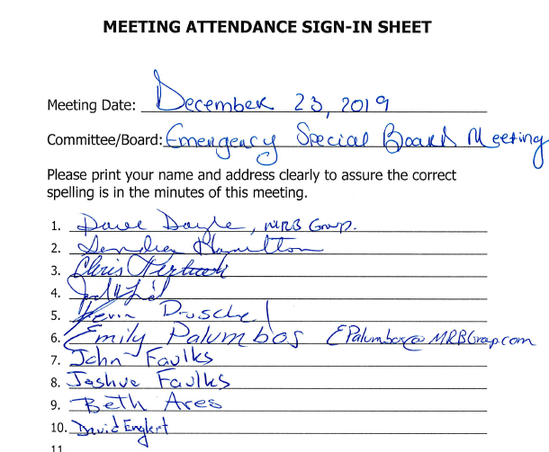

Supervisor LeRoy called the Emergency Special Board Meeting to order commencing at 5:30 PM.

Supervisor LeRoy announced that the Town of Sodus had a terrible disaster December 21st Saturday. The Town of Sodus Highway Barn burned down. Supervisor LeRoy, the Town Board and Highway Superintendent Dale Pickering thanked many fire departments and other agencies that responded and saved the west side of the building before it was totally engulfed in flames.

Dale Pickering shared that the insurance adjusters are still working on the cause of the fire. The east end of the building was the hottest point of the fire.

There was discussion on what the insurance company will cover from the fire. The Town should know in about a week what the full coverage the insurance company will pay.

Pickering stated that many neighboring Towns are helping with loaner trucks to the Town of Sodus. Town of Savannah, Town of Lyons, Town of Huron, Town of Williamson, Town of Walworth and Town of Ontario all delivered trucks to the Town of Sodus for use.

There was discussion where the Town should construct the new salt barn. One of the suggestions was the old landfill. The Town already owns the property.

Councilperson Scott Johnson motioned to adjourn the meeting was seconded by Councilperson Don Ross. Upon roll call the following votes were heard, Steven LeRoy, aye; David LeRoy, aye; Quinn, aye; Ross, aye; Johnson, aye. Motion carried.

Meeting adjourned: 6:22 PM
Recording Secretary,

Lori Diver
Sodus Town Clerk, RMC

