MINUTES
Minutes of the Regular Month End Sodus Town Board Meeting held July 23, 2019 in the, “Upstairs Conference Room”, commencing at 5:00 PM located at 14-16 Mill St. Sodus, NY 14551.
Sodus Town Board Meetings are open to the public.

Roll Call/Present: Steven LeRoy, Supervisor
David LeRoy, Councilperson/Deputy Supervisor
Jim Quinn, Councilperson
Scott Johnson, Councilperson

Recording Secretary: Lori Diver, Town Clerk

Absent: Don Ross, Councilperson (Attended WCWSA Meeting)

Others Present: N/A

Supervisor LeRoy called the Month End Town Board Meeting to order commencing at 5:00 PM.
ABSTRACT
RESOLUTION TO PAY ABSTRACT NO. 13
(05 07-2019)
WHEREAS, the following bills were presented for payment on Abstract 13:

General 285-299 $ 9,230.12
Highway 189-201 $ 69,312.17
Bridge Project 004-004 $ 126,186.00
WD No.11 020-021 $ 3,826.27
S. Geneva WD 015-015 $ 3,105.42
Trust & Agency 014-020 $ 5,125.47
GRAND TOTAL: $ 216,785.45

NOW BE IT RESOLVED, Councilperson David LeRoy motioned to approve payment of these bills as reviewed for Abstract No. 13, which was seconded by Councilperson Scott Johnson. Upon roll call the following votes were heard, Steven LeRoy, aye; David LeRoy, aye; Quinn, aye; Ross, absent; and Johnson, aye. Resolution adopted.

David LeRoy motioned to advertise for the Code Enforcement Officer Position was seconded by Councilperson Scott Johnson. Upon roll call the following votes were heard, Steven LeRoy, aye; David LeRoy, aye; Quinn, aye; Ross, absent; Johnson, aye. Motion carried.

RESOLUTION
TOWN ATTORNEY KNAUF SHAW LLP
(06 07-2019)
Supervisor LeRoy offered the following resolution for its adoption,

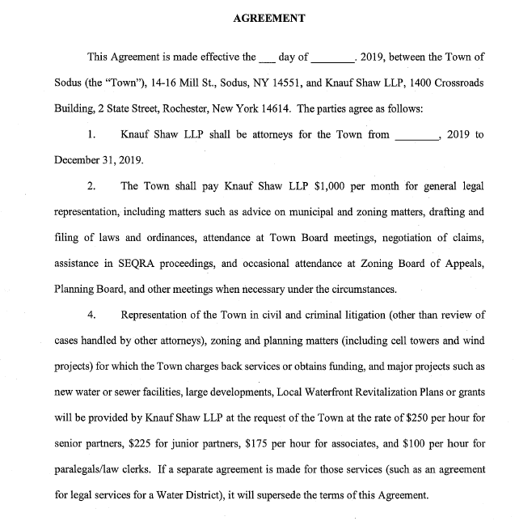
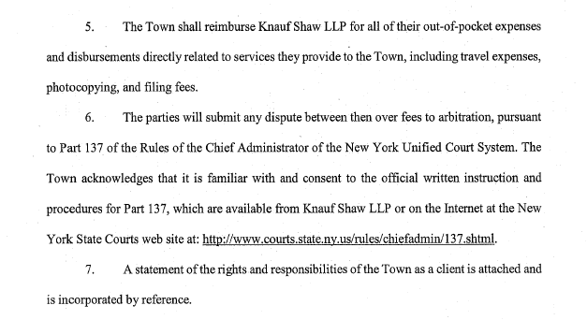
NOW BE IT RESOLVED, Councilperson Scott Johnson motioned to hire Knauf Shaw LLP as the Town of Sodus Attorney beginning August 13, 2019 which was seconded by Councilperson David LeRoy. Upon roll call the following votes were heard, Steven LeRoy, aye; David LeRoy, aye; Quinn, aye; Ross, absent; and Johnson, aye. Resolution adopted.

Councilperson Jim Quinn motioned to close the Sodus Town Board Meeting at 5:45 pm was seconded by Councilperson Scott Johnson. Upon roll call the following votes were heard, Steven LeRoy, aye; David LeRoy, aye; Quinn, aye; Ross, absent; Johnson, aye. Motion carried.

Meeting adjourned at 5:45 PM
Recording Secretary,

Lori K. Diver
Sodus Town Clerk, RMC

