MINUTES
Minutes of the Regular Month End Sodus Town Board Meeting held March 26, 2019 in the, “Upstairs Conference Room”, commencing at 5:00 PM located at 14-16 Mill St. Sodus, NY 14551.
Sodus Town Board Meetings are open to the public.

Roll Call/Present: Steven LeRoy, Supervisor
David LeRoy, Councilperson/Deputy Supervisor
Jim Quinn, Councilperson
Scott Johnson, Councilperson

Recording Secretary: Lori Diver, Town Clerk

Absent: Don Ross, Councilperson (Attended WCWSA Meeting)

Others Present: Al Hendrikse, Code Enforcement Officer
Bill Boyce, Herb Boyce Grading Co., Inc.

Supervisor Steven LeRoy called the Month End Town Board Meeting to order commencing at 5:00 PM.
ABSTRACT
RESOLUTION TO PAY ABSTRACT NO. 6
(04 03-2019)
WHEREAS, the following bills were presented for payment on Abstract 6:

General 115-134 $ 9,237.06
Highway 086-092 $ 29,676.21
Trust & Agency 006-007 $ 1,405.93
GRAND TOTAL: $ 40,319.20

NOW BE IT RESOLVED, Councilperson Jim Quinn motioned to approve payment of these bills as reviewed for Abstract No. 006, which was seconded by Councilperson David LeRoy. Upon roll call the following votes were heard, Steven LeRoy, aye; David LeRoy, aye; Quinn, aye; Ross, absent; and Johnson, aye. Resolution adopted.

RESOLUTION
CLEANUP PROPERTY 5231 RIDGE RD. SODUS, NY 14551
(05 03-2019)
Supervisor LeRoy offered the following resolution for its adoption,

NOW THEREFORE BE IT RESOLVED, Councilperson Scott Johnson motioned to allow Bill Boyce with Herb Boyce Grading Co., Inc of 673 Macedon Center Rd. Fairport, NY 14550 to call for stake outs to start the process of cleaning up the McMinn property, and,

FURTHER BE IT RESOLOVED, Herb Boyce Grading Co., Inc. will not to exceed $15, 000.00 with removal of nuisance, hazard, and litter, as defined in the Sodus Town Code Book section 95.3 was seconded by Jim Quinn. Upon roll call the following votes were heard, Steven LeRoy, aye; David LeRoy, aye; Quinn, aye; Ross, absent; and Johnson, aye. Resolution adopted.

Details on quote are below:
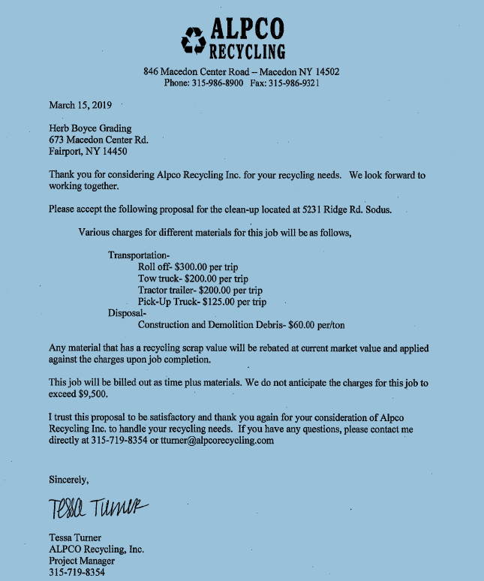

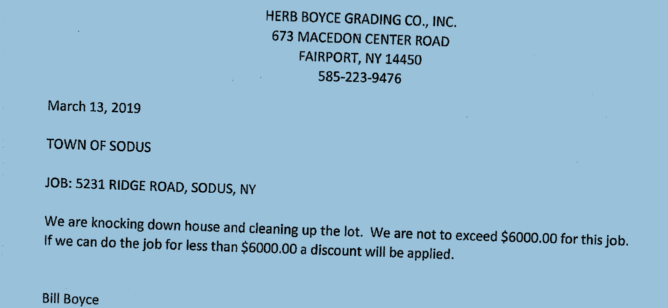

Al Hendrikse Code Enforcer will check into getting power and electric shut off.
In addition, the Board wants Hendrikse to write a letter to Gerald McMinn explaining what is about to happen before any cleanup work will happen on the current property.
Once the letter is written, Supervisor LeRoy and the Town Board will sign the letter, and then mail it to McMinn. Supervisor LeRoy will call the Sherriff’s Office to make sure Bill Boyce and his crew is protected when they remove the junk on the property. LeRoy will also make sure the water is shut off too.

Councilperson Scott Johnson motioned to adjourn the Month End Town Board Meeting was seconded by Councilperson David LeRoy. Upon roll call the following votes were heard, Steven LeRoy, absent; David LeRoy, aye; Quinn, aye; Ross, absent; Johnson, aye. Motion carried.

Meeting adjourned at 5:19 PM
Recording Secretary,

Lori K. Diver
Sodus Town Clerk, RMC

