MINUTES
Minutes of the Regular Month End Sodus Town Board Meeting held May 28, 2019 in the, “Upstairs Conference Room”, commencing at 5:00 PM located at 14-16 Mill St. Sodus, NY 14551.
Sodus Town Board Meetings are open to the public.

Roll Call/Present: Steven LeRoy, Supervisor
David LeRoy, Councilperson/Deputy Supervisor
Jim Quinn, Councilperson
Scott Johnson, Councilperson

Recording Secretary: Lori Diver, Town Clerk

Absent: Don Ross, Councilperson (Attended WCWSA Meeting)

Others Present: N/A

Supervisor LeRoy called the Month End Town Board Meeting to order commencing at 5:00 PM.
ABSTRACT
RESOLUTION TO PAY ABSTRACT NO. 10
(02 05-2019)
WHEREAS, the following bills were presented for payment on Abstract 10:

General 201-218 $ 7,948.29
Highway 143-147 $ 24,609.61
Trust & Agency 010-011 $ 1,042.80
GRAND TOTAL: $ 33,600.70

NOW BE IT RESOLVED, Councilperson Jim Quinn motioned to approve payment of these bills as reviewed for Abstract No. 10, which was seconded by Councilperson Scott Johnson. Upon roll call the following votes were heard, Steven LeRoy, aye; David LeRoy, aye; Quinn, aye; Ross, absent; and Johnson, aye. Resolution adopted.

Councilperson Jim Quinn motioned to authorize Supervisor LeRoy to sign the Williamson Law Book agreement for Municipal Accounting Software (June 1, 2019 – May 13, 2020) was seconded by Councilperson David LeRoy. Upon roll call the following votes were heard, Steven LeRoy, aye; David LeRoy, aye; Quinn, aye; Ross, absent; Johnson, aye. Motion carried.

Councilperson Jim Quinn motioned to accept Heidi Sutherland’s resignation effective May 17, 2019 was seconded by Councilperson Scott Johnson. Upon roll call the following votes were heard, Steven LeRoy, aye; David LeRoy, aye; Quinn, aye; Ross, absent; Johnson, aye. Motion carried.

Supervisor Steven LeRoy shared the legal that was publicized in the legal section of the paper for dock bids. The only two bids received for a new dock at the public boat launch located in Harriman Park, Sodus Point were from Dockside Dock Brandon Martin for a 100 foot dock in the amount of $50,000.00. The second bid received was with Tidesides Docks Lifts/Seawalls for a 60 foot dock in the amount of $35,000.00.

Councilperson Jim Quinn motioned to award the BID to Tidesides Docks and Lifts/Seawalls for a 60 foot new dock in the amount of $35,000.00 by Councilperson Scott Johnson. Upon roll call the following votes were heard, Steven LeRoy, aye; David LeRoy, aye; Quinn, aye; Ross, absent; Johnson, aye. Motion carried.

Town of Sodus– South Geneva Road Water District and Water District No. 11
Budget Modification
Resolution
(03 05-2019)

WHEREAS, the Town of Sodus developed the budget for the South Geneva Road Water District and Water District No. 11 projects based on estimates for the audit expense, and

WHEREAS, the actual costs for the audit will be $9,975, and

WHEREAS, in order to pro-rated this cost between these projects, it is necessary to adjust the budgets for both projects.

BE IT RESOLVED, that the Town Board hereby authorizes an increase in the Single Audit Expense budget line item for Water District No. 11 of $2,980, from $5,000.00 to $7,980.00 and a decrease in the Single Audit Expense budget line for the South Geneva Road Water District by $505, from $2,500.00 to $1,905.00, with corresponding adjustments to the contingencies for each project.

FURTHER BE IT RESOLVED, the Town of Sodus Board hereby adopts resolution (03 05-2019) Councilperson David LeRoy motioned to adopt this resolution was seconded by Councilperson Scott Johnson. Upon roll call the following votes were heard, Steven LeRoy, aye; David LeRoy, aye; Quinn, aye; Ross, absent; and Johnson, aye. Resolution adopted.

SOUTH GENEVA ROAD WD PROJECT AS CONSTRUCTED
RESOLUTION
(04 05-2019)
Supervisor LeRoy offered the following resolution for its adoption, and

WHEREAS, the construction of the improvements for the Town of Sodus South Geneva Road Water District have been completed and approved by the Project Engineer and the Department of Health, and

WHEREAS, the Town of Sodus has previously authorized final payment to the contractor, and

NOW THEREFORE BE IT RESOLVED, that the Town of Sodus accepts the project as constructed, and

FURTHER BE IT RESOLVED, the Town of Sodus Board hereby adopts resolution (04 05-2019) Councilperson Scott Johnson motioned to adopt this resolution was seconded by Councilperson David LeRoy. Upon roll call the following votes were heard, Steven LeRoy, aye; David LeRoy, aye; Quinn, aye; Ross, absent; and Johnson, aye. Resolution adopted.

30-DAY ADVANCED NOTICE LIQUOR LICENSE –KITCHEN’S ON THE RIDGE LLC
RESOLUTION
(05 05-2019)
Supervisor LeRoy offered the following resolution for its adoption:

WHEREAS, Joe C. & Dawn C. Kitchen (Kitchen’s on the Ridge LLC) doing business at 6968 Ridge Rd. East... Sodus, NY 14551 in the Town of Sodus intends to file for a New York State Liquor License; and

WHEREAS, pursuant to Alcohol Beverage Control Law Section 64(2A), an applicant must give the municipality thirty (30) days’ notice of the pending liquor license application unless the municipality consents to waive this thirty (30) day requirement; now therefore be it

RESOLVED, that the Town Board of the Town of Sodus hereby waives the thirty (30) days’ notice period in regard to Joe C.& Dawn M. Kitchen (Kitchen’s on the Ridge LLC) allowing an earlier submission of liquor license application.

FURTHER BE IT RESOLVED, Councilperson Jim Quinn motioned to adopt resolution (05 05-2019) was seconded by Councilperson David LeRoy. Upon roll call the following votes were heard, Supervisor Steven M. LeRoy, aye; Councilperson David LeRoy, aye; Jim Quinn, aye: and Don Ross, absent; and Scott Johnson, aye. Resolution adopted.

SEQR RESOLUTION WILLIAMSON – SODUS AIRPORT
(06 05-2019)
Supervisor LeRoy offered the following resolution for its adoption:

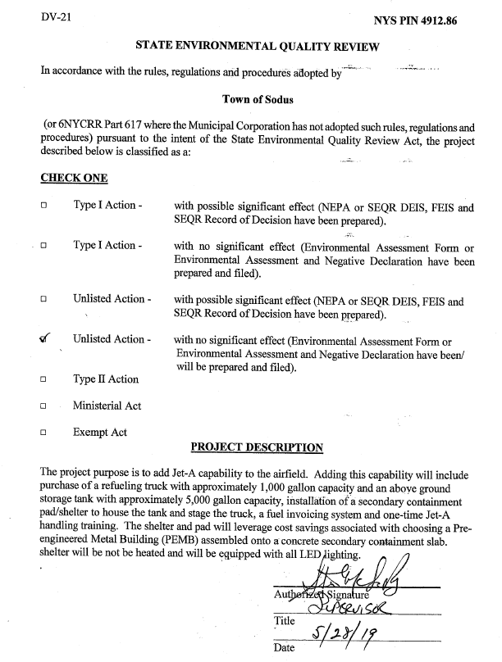
BE IT RESOLVED, Councilperson David LeRoy motioned to adopt resolution
(06 05-2019) was seconded by Councilperson Jim Quinn. Upon roll call the following votes were heard, Supervisor Steven M. LeRoy, aye; Councilperson David LeRoy, aye; Jim Quinn, aye: and Don Ross, absent; and Scott Johnson, aye. Resolution adopted.

Councilperson Jim Quinn motioned to hold an Executive Session Meeting regarding a personnel issue regarding a particular person June 4th, 2019 at 5:00 PM was seconded by Councilperson David LeRoy. Upon roll call the following votes were heard, Steven LeRoy, aye; David LeRoy, aye; Quinn, aye; Ross, absent; Johnson, aye. Motion carried.

Councilperson Jim Quinn motioned to close the Sodus Town Board Meeting at 5:26 pm was seconded by Councilperson Scott Johnson. Upon roll call the following votes were heard, Steven LeRoy, aye; David LeRoy, aye; Quinn, aye; Ross, absent; Johnson, aye. Motion carried.

Meeting adjourned at 5:26 PM
Recording Secretary,

Lori K. Diver
Sodus Town Clerk, RMC

