DRAFT MINUTES
Minutes of the Special Town Board Meeting & Budget Workshop commencing at 2:00 PM in the Sodus Town Court Room & Upstairs Meeting Room September 16, 2020, located at 14-16 Mill St. Sodus, NY 14551. Due to Covid-19 Zoom was provided, along with detailed login information in the legal notice of this meeting.
Masks were required and social distancing was enforced.
All meetings are open to the public.

Roll Call/Present: Scott Johnson, Supervisor
David LeRoy, Councilperson/Deputy Supervisor
Chris Tertinek, Councilperson
Johns Faulks, Councilperson-Zoomed

Recording Secretary: Lori Diver, Sodus Town Clerk

Absent: Don Ross, Councilperson

Others Present: Bree Crandell, Confidential Supervisor Clerk
Mike Duell, LaBella Associates | Project Architect / Project Manager
Rob Steen-LaBella Associates
Kim Leonard, Budget Assistant-Zoomed
1-585-259-5219-Zoom Login
1-315-778-9107-Zoom Login
1-585-615-7292-Zoom Login
1-585-482-0200-Zoom Login
1-585-797-9248-Zoom Login
1-585-254-8190-Zoom Login
1-704-915-2415-Zoom Login
1-585-469-9136-Zoom Login
Jcalcagno-Zoom Login
Josh Ashton-Zoom Login
Kurt VanHeusen-Zoom Login
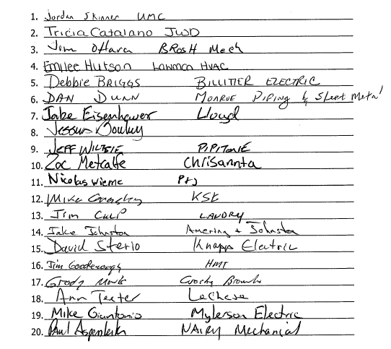
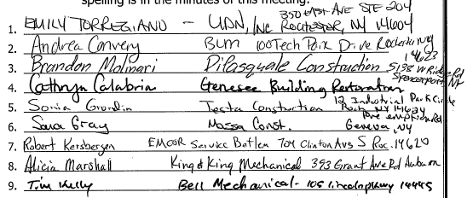

Supervisor Scott Johnson called the Special Town Board Meeting to order at 2:00 PM.

LEGAL NOTICE FOR HIGHWAY BIDS 2:00 PM:

DOCUMENT 001113 - ADVERTISEMENT FOR BIDS

PROJECT INFORMATION

Notice to Bidders: Bidders may submit bids for project as described in this Document. Submit bids according to the Instructions to Bidders.

Regulatory Requirements: Town of Sodus shall govern submittal, opening, and award of bids.

Project Identification: Town of Sodus – New Highway Garage Building.

Project Location: 84 Rotterdam Road, Sodus, NY, 14551.

Owner: Town of Sodus.

Owner's Representatives:

Mr. Scott Johnson, Town Supervisor.

Mr. Dale Pickering, Highway Department Supervisor

Architect: LaBella Associates, D.P.C., 300 State Street, Rochester, NY 14614.

Project Description: New Highway Garage Building as follows:

The new Highway Shop will be located on Rotterdam Road in the same location as the previous, and recently removed highway garage with a building footprint approximately 58’-0” x 222’-0”. The primarily use is for storage and light maintenance of highway vehicles and administration / office space for the Highway Department.

The Site Work will consist of grading, storm sewers, utilities, and concrete aprons.

The structure of the building will consist of concrete pier foundations, a concrete slab partially poured over an existing slab, and a pre-engineered structural wood framing system. The exterior building envelope will consists of metal wall and roof panel systems with batt insulation. Exterior fenestration will include hollow metal doors and frames, aluminum windows, and steel over-head doors.

Interior finishes include, but are not limited to epoxy painted and painted cmu and gypsum board walls, and interior metal wall panels, acoustical tile ceiling systems and metal panel ceilings, sealed concrete floors, and seal high performance coated floor systems.

Plumbing systems for the building consists of storm water, sanitary, waste and vent, oil waste piping and oil separator, combined water services, and natural gas piping systems. Plumbing systems will include Backflow and meter assembly, Plumbing fixtures both ADA and non-ADA, and water heater systems as indicated on drawings and specifications.

Fire Suppression Services will consist of a designated design Wet Pipe Sprinkler system in the Service Bay and Truck Bays only including backflow preventer system and riser assembly.

Mechanical work consists of providing code required ventilation, exhaust, and heating. Systems include gas fired unit heaters, gas fired radiant heaters, and electric unit heaters. There is a ducted split system with an energy recovery unit to provide heating, ventilation and cooling to the office area, and there is an energy recovery unit with an integral gas fired furnace to serve the service bay. Each truck bay will have a CO NO2 (Carbon Monoxide/Nitrogen Dioxide) Gas Detection System.

Electrical systems include, power, ligating, data, and security control.

Construction Contract: Bids will be received for the following Work:

General Construction

Plumbing Construction

Mechanical (HVAC) Construction

Electrical Construction

BID SUBMITTAL AND OPENING

Owner will receive sealed lump sum bids until the bid time and date at the location given below. Owner will consider bids prepared in compliance with the Instructions to Bidders issued by Owner, and delivered as follows:

Bid Date: Wednesday, September 16, 2020.

Bid Time: 2:00 p.m., local time.

Location: 14 - 16 Mill Street, Sodus, NY 14551.

Bids will be thereafter publicly opened and read aloud.

BID SECURITY

Bid security shall be submitted with each bid in the amount of 5 percent of the bid amount. No bids may be withdrawn for a period of 60 days after opening of bids. Owner reserves the right to reject any and all bids and to waive informalities and irregularities.

PREBID MEETING

Prebid Meeting: See Document 002513 "Prebid Meetings."

Prebid Meeting: A Prebid meeting for all bidders will be held at 84 Rotterdam Road, Sodus, NY, 14551 on Thursday, August 27, 2020 at 1:00 p.m., local time. Prospective prime bidders are requested to attend.

Bidders' Questions: Architect will provide responses at Prebid conference to bidders' questions received up to two business days prior to conference.

DOCUMENTS

Printed Procurement and Contracting Documents: Obtain on Wednesday, August 19, 2020 by contacting Data Flow. Documents will be provided to prime bidders only; only complete sets of documents will be issued.

Dataflow, Inc.
320 N. Goodman St., Suite 200
Rochester, NY 14607
(585) 271-5730

Cost for printed sets will be the responsibility of the Contractor.

Online Procurement and Contracting Documents: Obtain access after Wednesday, August 19, 2020 by contacting DataFlow at www.godataflow.com. Online access will be provided for viewing.

TIME OF COMPLETION

Successful bidder shall begin the Work on receipt of the Notice to Proceed and shall complete the Work within the Contract Time.

BIDDER'S QUALIFICATIONS

Bidders must be properly licensed under the laws governing their respective trades and be able to obtain insurance and bonds required for the Work. A Performance Bond, separate Labor and Material Payment Bond, and Insurance in a form acceptable to Owner will be required of the successful Bidder.

NOTIFICATION

This Advertisement for Bids document is issued by The Town of Sodus.

Dated: August 14, 2020

Town of Sodus

Lori Diver, Sodus Town Clerk

END NOTICE

Supervisor Scott Johnson opened BIDS for the new build of the Town of Sodus Highway Barn.

Mike Duell with LaBella read the following BIDS received out loud for the following categories:

- General Construction
- Plumbing Construction
- Electrical Construction
- HVAC (Mechanical) Construction

(Note: Contractor and BID amount is listed as follows):

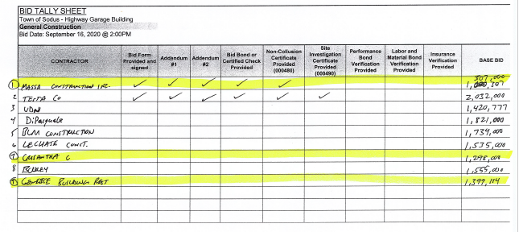

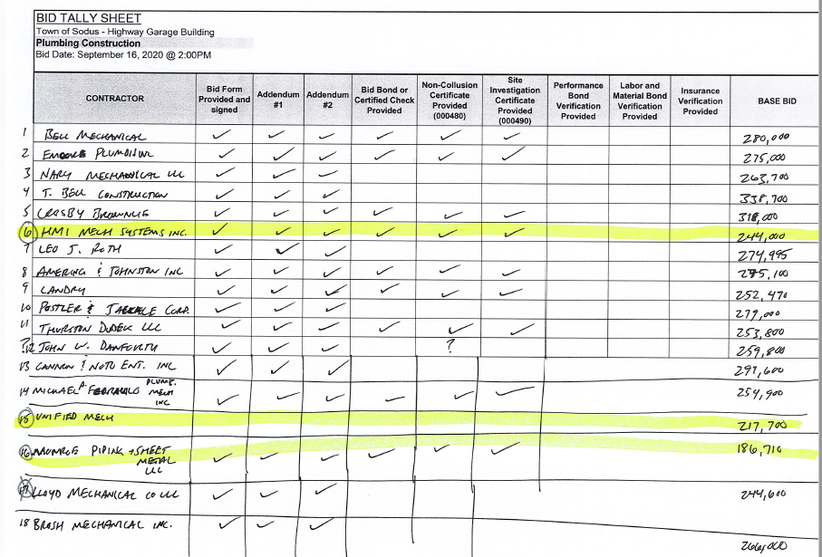
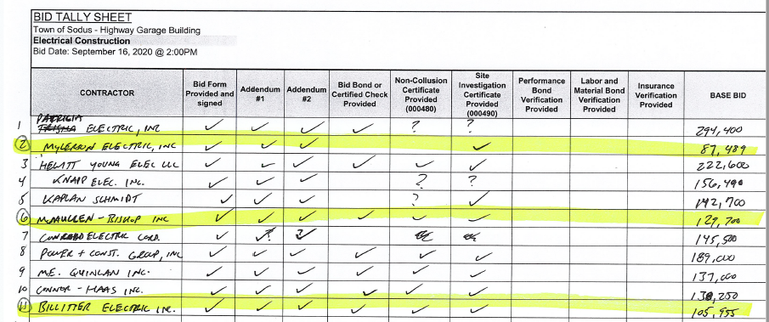
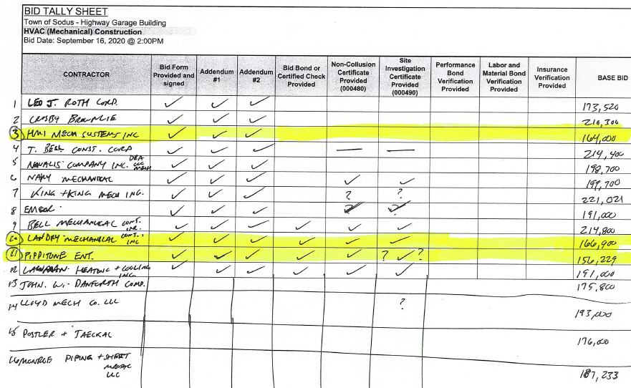
Lori Diver Sodus Town Clerk stated to the Contractors on Zoom and at the meeting attending physically, the BID submittals will be available on the Town of Sodus website (www.townofsodus.net ) under the LEGAL tab of the website. This will be made available later the following morning for everyone.

Hearing no further comments from the public, the meeting closed at 2:48 PM and resumed with the Town of Sodus Budget meeting in the upstairs meeting room.

TOWN OF SODUS BUDGET WORKSHOP FOR 2021’S BUDGET

The Sodus Town Board held budget discussions regarding the upcoming budget and the hurdles the Town is facing with Covid-19 and the Tax Cap being only at 1.56%. The Town of Sodus has asked all departments to make at least 20 % cuts in their presceptive budgets.

The Town Board went through most of the budget packets submitted by Town Departments.
Budget discussions will resume at the September 22, 2020 meeting that will be held at 5:00 PM in the upstairs meeting room.

Councilperson David LeRoy motioned to adjourn the meeting was seconded by Councilperson John Faulks. Upon roll call the following votes were heard, Supervisor Scott E. Johnson, aye; David LeRoy, aye; Chris Tertinek, aye; Don Ross, absent; and John Faulks, aye. Motion carried.

Meeting adjourned: 6:48 PM
Recording Secretary,

Lori Diver
Sodus Town Clerk, RMC

