MINUTES
Minutes of the Regular & Month End Sodus Town Board Meeting commencing at 4:30 PM in the Sodus Town Court Room April 22, 2021, located at 14-16 Mill St. Sodus, NY 14551. This meeting was an in person meeting and hybrid with Zoom. Due to Covid-19, Zoom was provided along with detailed login information in the legal notice of this meeting. Masks were required and social distancing was enforced.
All meetings are open to the public.

Present: Scott Johnson, Supervisor
David LeRoy, Councilperson/Deputy Supervisor
Don Ross, Councilperson-Zoomed
Chris Tertinek, Councilperson
Cathy Willmott, Councilperson (joined the meeting later, after adoption of her appointment).

Recording Secretary: Lori Diver, Sodus Town Clerk-RMC

Absent: Dale Pickering, Highway Superintendent

Others Present: Bree Crandell, Confidential Supervisor Clerk-Zoomed
Craig Schwartz, Code Enforcement Officer
Sheila Fisher, Recreation Director –Zoomed
Sal Vittozzi, Groundskeeper/Caretaker-Zoomed
Amy Kendall, Town Attorney-Zoomed
Rachel Partington, Town Attorney-Zoomed
Laurie Verbridge, Harriman Park
Kim Buell, Camp Beechwood
Lynda Faulks, John Faulks Proclamation
Josh Faulks, John Faulks Proclamation

Supervisor, Scott Johnson called the Regular & Month End Town Board Meeting to order commencing at 4:30 PM with the Pledge of Allegiance and Lori Diver opened with roll call.

BID Opening 4:30 PM:
- Lori Diver read legal notice below

LEGAL NOTICE
NOTICE TO BIDDERS
FOR 2021 TOWN OF SODUS CLEANUP

The Sodus Town Board will be holding its Spring Cleanup Friday June 4th – Saturday June 5th 8:30 AM to 3:30 PM and its Fall Cleanup Saturday October 2nd 8:30 AM – 3:30 PM.

NOTICE IS HEREBY GIVEN in accordance with Section 103 of the General Municipal Law, sealed bids need to be mailed or dropped off at the Sodus Town Clerk’s Office, 14-16 Mill Street, Sodus NY, 14551. Bids will be accepted up until 1:00 PM April 22, 2021. Bids will be publicly opened and read at 4:30 PM during the Thursday April 22, 2021 Month End Town Board Meeting held in the upstairs meeting room located at 14-16 Mill St., Sodus NY. Bids must be sealed and marked on the outside of the envelope “2021 Town of Sodus Cleanup Bid” and must contain a non-collusive bidding certificate. No email Bids can be accepted. Specifications are available at the Town Clerk’s Office. The Sodus Town Board reserves the right to reject any or all bids. All meetings are open to the public.

By Order of the Sodus Town Board
Lori K. Diver
Sodus Town Clerk, RMC
April 5, 2021

Supervisor Scott Johnson opened the one and only sealed bid by ALPCO as follows:

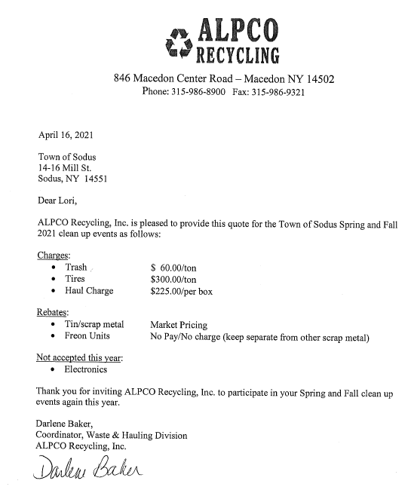

John Faulks Proclamation
Supervisor Scott Johnson presented to Lynda and Josh Faulks a proclamation on behalf of the Sodus Town Board in honor of John Faulks’s service as Sodus Town Councilman.
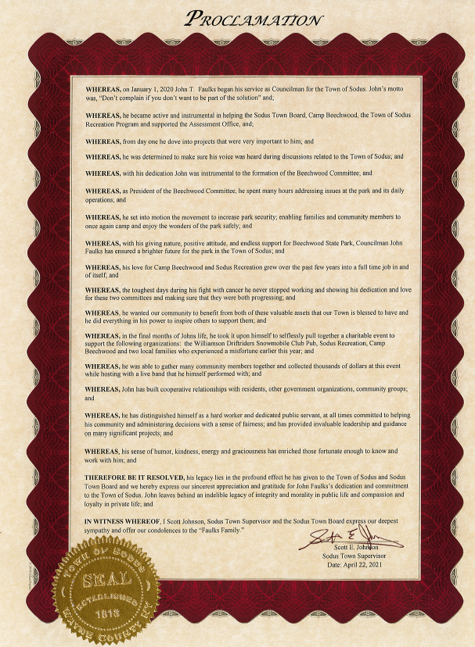

MINUTES
- March 25th, 2021 Month End Town Board Meeting Minutes
The March 25th, 2021 Month End Town Board Meeting Minutes were presented for approval. Councilperson Don Ross motioned to accept and file these Minutes, which was seconded by Councilperson David LeRoy. Upon roll call the following votes were heard, Scott Johnson, aye; David LeRoy, aye; Don Ross, aye; and Chris Tertinek, abstain; and John Faulks; (seat vacant). Motion carried.
MINUTES
- April 6, 2021 WD No. 12 Informational Minutes
The WD No. 12 Information Meeting Minutes from the April 6th, 2021 meeting was presented for approval. Councilperson David LeRoy motioned to accept and file these Minutes, which was seconded by Councilperson Chris Tertinek. Upon roll call the following votes were heard, Scott Johnson, aye; David LeRoy, aye; Don Ross, abstained; and Chris Tertinek, aye; John Faulks (seat vacant). Motion carried.

MINUTES
- April 13th, 2021 Shortened Meeting –Regular Town Board Minutes
(Councilman John Faulks passed away)
The “Brief” Regular Town Board Minutes meeting was presented for approval. Councilperson David LeRoy motioned to accept and file these Minutes, which was seconded by Councilperson Chris Tertinek. Upon roll call the following votes were heard, Scott Johnson, abstain; David LeRoy, aye; Don Ross, aye; Chris Tertinek, aye; and John Faulks (seat vacant). Motion carried.

ABSTRACT
RESOLUTION TO PAY ABSTRACT No. 8
(03 04-2021)
WHEREAS, the following bills were presented for payment on Abstract 8:

General 202-218 $ 7,048.65
Highway 099-105 $ 18,521.85
Bridge Project 011-015 $ 50,147.74
Trust & Agency 040-041 $ 1,081.14
GRAND TOTAL: $ 76.799.38

NOW BE IT RESOLVED, Councilperson David LeRoy motioned to approve payment of these bills as reviewed for Abstract No. 8, which was seconded by Councilperson Chris Tertinek. Upon roll call the following votes were heard, Scott Johnson, aye; David LeRoy, aye; Don Ross, aye; Chris Tertinek, aye; and John Faulks, (seat vacant). Resolution Adopted.

PUBLIC COMMENTS
Laurie Verbridge, Village of Sodus Point residence came before the Sodus Town Board to discuss some of the concerns she has with Harriman Park in Sodus Point. Laurie and her neighbors are concerned with the current fishing hours and tournaments taking place, power boating onto the boat ramps, derby’s being held almost every weekend, many using the ramp that are not even Sodus residents. She really would like to see signs posted and including displaying the new park rules. Laurie is aware that the Town of Sodus is working on a draft Park Law Code. The Sodus Town Board and Attorney Amy Kendall expressed that these are things that are being addressed with the upcoming Park Code for the Town of Sodus. It will be reviewed by the Town Board and any changes approved upon will be made accordingly. Laurie thanked everyone for the time invested in this and all the help regarding the current situation in Harriman Park.

RECREATION/ENVIRONMENTAL COMMITTE: Supervisor Scott Johnson (Interim)
(Recreation, Assessor, Parks, Cemeteries)
CAMP BEECHWOOD-PARKS-CEMETERIES REPORTS:
Recreation Report
(Sheila Fisher, Recreation Director)
Councilperson David LeRoy motioned to accept the monthly March 2021 Recreation Report from Sheila Fisher, Recreation Director was seconded by Councilperson Chris Tertinek. Upon roll call the following votes were heard, Scott Johnson, aye; David LeRoy, aye; Don Ross, aye; Chris Tertinek, aye; and John Faulks, (seat vacant). Motion carried.

Recreation Director Sheila Fisher stated that there will be an in person Summer Recreation Program this year for the kids. In addition, it was brought up that Kelly Grey will be doing another fund raiser this year and donating the proceeds to recreation.
Assessor’s Report
(Nathan Mack, Assessor)
Councilperson Chris Tertinek motioned to accept and file the monthly March 2021 Assessor’s Report from Sole Assessor, Nathan Mack was seconded by Councilperson David LeRoy. Upon roll call the following votes were heard, Scott Johnson, aye; David LeRoy, aye; Don Ross, aye; Chris Tertinek, aye; and John Faulks, (seat vacant). Motion carried.
Camp Beechwood/Sodus Groundskeeper Report
(Sal Vittozzi-Caretaker-Sodus Town Groundkeeper)
Councilperson David LeRoy motioned to accept the monthly March 2021 Camp Beechwood-Parks & Cemeteries Report from Sal Vittozzi, Sodus Town Groundskeeper-Caretaker was seconded by Councilperson Don Ross. Upon roll call the following votes were heard, Scott Johnson, aye; David LeRoy, aye; Don Ross, aye; Chris Tertinek, aye; and John Faulks, (seat vacant). Motion carried.

Supervisor Scott Johnson discussed a fundraiser he would like to start for Beechwood. In addition the Town is working on a grant for Beechwood.

PUBLIC WORKS COMMITTEE: Councilperson David LeRoy, Chair
(Highway, Drainage - Deputy Town Supervisor)
HIGHWAY REPORT:
(Dale Pickering – Highway Superintendent)
Councilperson Don Ross motioned to accept and file the monthly March 2021 Highway Report from Dale Pickering Highway Superintendent was seconded by Councilperson Chris Tertinek. Upon roll call the following votes were heard, Scott Johnson, aye; David LeRoy, aye; Don Ross, aye; Chris Tertinek, aye; and John Faulks, aye; (seat vacant).
TOWN BARN FINANCES:
Councilman David LeRoy discussed that the completion date for the new highway barn should be the end of May of 2021.
SALT BARN UPDATE:
Currently paperwork is being submitted to DEC for the new salt barn and the expected completion date of the salt barn itself should be the end of 2022.
DRAINAGE:
(N/A)

BUILDINGS AND GROUNDS COMMITTEE: Councilperson Chris Tertinek, Chair
(Town Property, Animal Control, Flood Damage Prevention)
CODE ENFORCEMENT REPORT:
Craig Schwartz- CEO
Councilperson Chris Tertinek motioned to accept the monthly March 2021 Code Enforcement Report as written was seconded by Councilperson David LeRoy. Upon roll call the following votes were heard, Scott Johnson, aye; David LeRoy, aye; Don Ross, aye; Chris Tertinek, aye; and John Faulks, (seat vacant). Motion carried.
ANIMAL CONTROL REPORT:
Tracy Brown, Primary DCO
Craig Schwartz- Secondary DCO
Councilperson David LeRoy motioned to accept the monthly March 2021 Dog Control Report as written was seconded by Councilperson Don Ross. Upon roll call the following votes were heard, Scott Johnson, aye; David LeRoy, aye; Don Ross, aye; Chris Tertinek, aye; and John Faulks, (seat vacant). Motion carried
FLOOD DAMAGE PREVENTION REPORT-Code 69:
Chris Tertinek, Councilperson
Councilperson Chris Tertinek shared; the levels on Lake Ontario haven’t changed much since February of 2021.

PUBLIC SAFETY/DRAINAGE/ENVIRONMENT COMMITTEE: Councilperson Don Ross, Chair (Fire, Ambulance, Emergency Preparedness)
Councilperson Don Ross gave his committee reports.

TOWN HALL COMMITTEE: Scott Johnson, Supervisor
(Personnel, Clerks, Justices, Assessor, Building Inspector, Town Council, Boards, Insurances, Finance)
N/A

CORRESPONDENCE & INFORMATION

Councilperson Don Ross motioned declaring Councilman John Faulk’s Town Board seat vacant was seconded by Councilperson Chris Tertinek. Upon roll call the following votes were heard, Scott Johnson, aye; David LeRoy, aye; Don Ross, aye; and Chris Tertinek, aye.

Councilperson David LeRoy motioned appointing Cathy Willmott (Town of Sodus resident) as Sodus Town Board Councilperson effective immediately; filling John Faulks vacant seat was seconded by Councilperson Chris Tertinek. Upon roll call the following votes were heard, Scott Johnson, aye; David LeRoy, aye; Don Ross, aye; and Chris Tertinek, aye.

Note: Cathy Willmott appointed Councilperson and joined the Sodus Town Board for the remainder of the meeting.

Code Enforcement Officer Craig Schwartz and Lori Diver Sodus Town Clerk discussed the Sodus Town Code Book and the revisions it is in desperate need of. Attorney Amy Kendall will help assist with records that may have been destroyed in the fire. This will be tabled for discussion at future meetings.

Code Enforcement Officer Craig Schwartz discussed with the Town Board ways to address abandoned properties that are run down and the owners do not reside in the Town of Sodus. Amy Kendall, Town Attorney stated this will be discussed in future meetings when more information can be given at that time.

There was conversation on ownership of cemeteries. There was an email sent by the Assessor’s Office showing the rights of ownership and the Town of Sodus cemeteries.

Councilperson Don Ross motioned to hold a Public Hearing and allow Lori Diver Sodus Town Clerk to advertise for the Public Hearing on May 11, 2021 at 6:30 PM in the Sodus Town Court Room for Local Law No. 2-2021 was seconded by Councilperson Chris Tertinek. Upon roll call the following votes were heard, Scott Johnson, aye; David LeRoy, aye; Don Ross, aye; and Chris Tertinek, aye; Cathy Willmott, aye. Motion carried.

RESOLUTION
PLANNING BOARD AD-HOC MEMBER APPOINTMENT- STACY
(04 04-2021)
Supervisor Scott Johnson offered the following resolution for its adoption, and

WHEREAS, Nancy Ross Planning Board Member resigned with the Planning Board as Member, and

BE IT RESOLVED, the Sodus Town Board appointed Ray Stacy to the Planning Board as Ad-Hoc Member, and

FURTHER BE IT RESOLVED, the term begins effective immediately and ends December 31, 2021.
Councilperson Don Ross motioned to appoint Ray Stacy to the Planning Board as Ad-Hoc Member was seconded by Councilperson David LeRoy. Upon roll call the following votes were heard, Scott Johnson, aye; David LeRoy, aye; Don Ross, aye; and Chris Tertinek, abstain; Cathy Willmott, abstained. Resolution adopted.

Supervisor Scott Johnson, the Sodus Town Board, and Amy Kendall Town of Sodus Attorney discussed the new Marijuana Law. Some questions were asked by Amy Kendall to the Town Board. Does the Town want Marijuana businesses in the Town of Sodus, if the Town wants the businesses the Zoning Law will need to be updated, obtain Planning Board recommendations, and possibly setting up a committee for updating these new laws in the Town of Sodus would need to be looked at within time limits restrictions of the law.

Councilperson Chris Tertinek motioned to set the Town Clerk’s Office hours from 9:00 AM – 5:00 PM Monday through Friday January 1st, - December 31st. In the event there is not coverage for the lunch hour when the Town Clerk is out of the office because of sickness, conferences, meetings, or vacations; the Town Clerk’s Office will be allowed to close from 12:00 PM – 1:00 PM. This will allow the Deputy Clerk to have an unpaid lunch hour (in the Town of Sodus Handbook) and a notice will be posted on the front door of the office when closed was seconded by Councilperson David LeRoy. Upon roll call the following votes were heard, Scott Johnson, aye; David LeRoy, aye; Don Ross, aye; and Chris Tertinek, aye; Cathy Willmott, aye. Motion carried.

RESOLUTION
WD No. 11 AND S. GENEVA WD GRANT FUNDS
(05 04-2021)
Supervisor Scott Johnson offered the following resolution for its adoption, and

WHEREAS, the Town of Sodus received approval for loan and grant funding from USDA Rural Development in the amounts of $1,224,000 and $309,000 for the construction of Water District No. 11 and the South Geneva Road Water District, respectively; and

WHEREAS, both projects have been completed and all costs have been incurred; and

WHEREAS, the total project costs for both projects are less than the approved funding, as follows:

 | Water District No. 11 | South Geneva Rd. WD
Total Loan/Grant Award | $1,224,000.00 | $309,000.00
Total Expenditures | $1,054,487.29 | $275,783.73
Grant Balance | $169,512.71 | $33,216.27

BE IT RESOLVED, that the Town Board of the Town of Sodus hereby authorizes Rural Development to recapture the balances of the RD grant funds allocated to each project as shown above.

Councilperson David LeRoy motioned to adopt this resolution was seconded by Councilperson Cathy Willmott. Upon roll call the following votes were heard, Scott Johnson, aye; David LeRoy, aye; Don Ross, aye; and Chris Tertinek, aye; Cathy Willmott, aye. Resolution adopted.

“MOORE THAN A RACE”
(06 04-2021)
Supervisor Scott Johnson offered the following resolution for its adoption,

WHEREAS, Reliant Community Federal Credit Union is asking the Town of Sodus permission to utilize Town of Sodus Roads for “Moore than a Race” 5K race on October 17, 2021 starting at 12:00 PM, and

FURTHER BE IT RESOLVED, Councilperson Don Ross motioned to adopt this resolution, which was seconded by Councilperson David LeRoy. Upon roll call the following votes were heard, Scott Johnson, aye; David LeRoy, aye; Don Ross, aye; Chris Tertinek, aye, and Cathy Wilmott, aye. Resolution Adopted.

Councilperson David LeRoy motioned to authorize the Sodus Point Fire Department to reserve the Town of Sodus Park (lot across from the Fire Department) May 9th, 2021, June 5th, 2021, and August 7th, 2021 for events and parking was seconded by Councilperson Chris Tertinek. Upon roll call the following votes were heard, Scott Johnson, aye; David LeRoy, aye; Don Ross, aye; and Chris Tertinek, aye; Cathy Willmott, aye. Motion carried.

Councilperson David LeRoy motioned approving the bid to ALPCO Recycling for the Town of Sodus Cleanup Friday June 4th- Saturday June 5th 8:30 AM to 3:30 PM and its Fall Cleanup Saturday October 2nd 8:30 AM to 3:30 PM was seconded by Councilperson Cathy Willmott. Upon roll call the following votes were heard, Scott Johnson, aye; David LeRoy, aye; Don Ross, aye; and Chris Tertinek, aye; Cathy Willmott, aye. Motion carried.

Discussion:
Councilperson David LeRoy discussed updating the Comprehensive Plan for the Town of Sodus. The last one completed was 2005-2006.

Councilperson David LeRoy motioned to adjourn the meeting was seconded by Councilperson Cathy Don Ross. Upon roll call the following votes were heard, Scott Johnson, aye; David LeRoy, aye; Don Ross, aye; and Chris Tertinek, aye; Cathy Willmott, aye. Motion carried.

Meeting adjourned at 6:15 PM
Recording Secretary,

Lori K. Diver
Sodus Town Clerk, RMC

