AGENDA

Sodus Town Board Agenda
Regular Month End-Town Board Meeting
August 25, 2022 4:30 PM
Roll Call: (Lori Diver)
Supervisor Johnson, Councilperson LeRoy, Councilperson Ross, Councilperson Tertinek, Councilperson Willmott

4:30 PM Public Hearing:
(Lori Diver reads legal notice)

TOWN OF SODUS
NOTICE OF PUBLIC HEARING

PLEASE TAKE NOTICE that, pursuant to Section 20 of the Municipal Home Rule Law, a public hearing will be held by the Town Board of the Town of Sodus on August 25, 2022, at 4:30 PM. at the Town Hall, 14-16 Mill Street, in the Town of Sodus, Wayne County, New York, to consider the adoption of Local Law No.1 of 2022 of the Town of Sodus, a local law to authorize members of the Town Board to participate in Town Board meetings via videoconference from locations outside of the Town of Sodus geographical limits.

All persons interested shall be given an opportunity to be heard. Local Law No. 1of 2022 is available for public inspection during regular business hours at the Town Clerk’s office and on the Town of Sodus website at https://townofsodus.net.

By Order of the Sodus Town Board
Dated: August 11, 2022
LORI DIVER
Sodus Town Clerk

Motion to open Public Hearing
First_________________ Seconded____________________ Time____________________

Ask for public discussion __________________________________________________________________________________________________________________________________________________________________________________________________________________________________________________________________________________________________________________________________________

Motion to close Public Hearing
First_________________ Seconded____________________ Time____________________

Resolution to adopt Local Law 1 of 2022
First_________________ Seconded____________________

Agenda:
- Motion to accept Assessor Clerk Kayla Sturgill’s resignation, submitted August 12, 2022. Kayla’s last day is Monday August 29, 2022 (provided-Nathan Mack discussion).
First_________________ Seconded____________________

- Resolution to authorize payment of Abstract 15-2022.

- Discussion regarding Digital Clerk position (Lori).

- Discussion regarding Terry Reynolds (Dave)

- Motion to approve purchase of Zoom Pro subscription of $14.99 monthly for budget season months with Susie Jacobs.
First_________________ Seconded____________________

- Discussion RG&E (Dave)

- Motion acknowledging Town Clerk Lori Diver sent the Town Board notification by email on August 18, 2022 that the 2018 yearly audit findings paper copy is available for public inspection at the Town Clerk’s office from Mengel, Metzger, and Barr & Co.LLP Certified Public Accountants.

- Discussion regarding DEC email (Dave)

- Motion to move September’s Regular Town Board Meeting from September 13, 2022 at 6:00 PM to Tuesday September 20, 2022 at 6:00 PM. (Lori)

MINUTES
Minutes of the Month End Town Board Meeting commencing at 4:30 PM in the upstairs meeting room August 25, 2022 located at 14-16 Mill St. Sodus, NY 14551.
All meetings are open to the public.
In addition this meeting was available through Zoom. Legal Notices were published and posted accordingly.

Present: Scott Johnson, Supervisor
David LeRoy, Councilperson/Deputy Supervisor Don Ross, Councilperson
Chris Tertinek, Councilperson

Recording Secretary: Lori Diver, Sodus Town Clerk-RMC

Absent: Cathy Willmott, Councilperson

Others Present: Bree Crandell- Supervisor Clerk
Nathan Mack, Assessor
Amy Kendall, Town Attorney (Zoom)
Casey Carpenter, Times of Wayne County (Zoom)

Supervisor Scott Johnson called the Month End Town Board Meeting to order commencing at 4:30 PM and Lori Diver opened with roll call. All were present with the exception of Councilperson Cathy Willmott.

Public Hearing 4:30 PM:
(Local Law 1-2022)
Councilperson David LeRoy motioned to open the public hearing at 4:30 PM for Local Law 1-2022 was seconded by Councilperson Don Ross. Upon roll call the following votes were heard, Scott Johnson, aye; David LeRoy, aye; Don Ross, aye; Chris Tertinek, aye; and Cathy Willmott; absent. Motion carried.

Lori Diver Sodus Town Clerk read the legal notice below…….

TOWN OF SODUS
NOTICE OF PUBLIC HEARING
PLEASE TAKE NOTICE that, pursuant to Section 20 of the Municipal Home Rule Law, a public hearing will be held by the Town Board of the Town of Sodus on August 25, 2022, at 4:30 PM. at the Town Hall, 14-16 Mill Street, in the Town of Sodus, Wayne County, New York, to consider the adoption of Local Law No. 1 of 2022 of the Town of Sodus, a local law to authorize members of the Town Board to participate in Town Board meetings via videoconference from locations outside of the Town of Sodus geographical limits.
All persons interested shall be given an opportunity to be heard. Local Law No. 1of 2022 is available for public inspection during regular business hours at the Town Clerk’s office and on the Town of Sodus website at https://townofsodus.net.

By Order of the Sodus Town Board
Dated: August 11, 2022
LORI DIVER
Sodus Town Clerk

Public Comments Local Law 1-2022:
Town Attorney Amy Kendall recapped what Local Law 1-2022 referenced too.
No other public comments.

Councilperson Don Ross motioned to close the public hearing at 4:35 PM for Local Law 1-2022 was seconded by Councilperson Chris Tertinek. Upon roll call the following votes were heard, Scott Johnson, aye; David LeRoy, aye; Don Ross, aye; Chris Tertinek, aye; and Cathy Willmott; absent. Motion carried.

RESOLUTION
LOCAL LAW 1-2022-VIDEOCONFERENCING
(01 08-2022)
TOWN OF SODUS

A Local Law to Authorize Members of the Town Board to Participate in
Town Board Meetings via Videoconference from Locations Outside of
The Town of Sodus Geographical Limits

Be it enacted by the Town Board of the Town of Sodus as follows:

- Legislative Intent. It is the intent of this local law to give Town Board members the authority to participate in Town Board meetings via videoconference from locations that fall outside the Town’s geographical boundaries. Videoconferencing has proven to be an effective and useful tool for Town Board meetings that allows members to participate despite issues such as inclement weather, illness, or travel plans. Videoconferencing also helps ameliorate potential quorum issues so that the town is able to address business and matters in a timely fashion. Although Public Officers Law § 102 expressly allows members of a public body to attend and participate in meetings using videoconferencing, Town Law § 62 states that Town Board meetings must take place within the Town thereby making it unclear if a Town Board member may participate via videoconference from a location outside the Town’s boundaries. This local law is meant to expressly provide that authority to members of the Town Board.

- Authority. This local law is adopted pursuant to Municipal Home Rule Law § 10 which expressly authorizes the Town Board to adopt a local law superseding any provision of Town Law relating to the property, affairs or government of the Town.

- Videoconferencing from Outside Town Limits. The Town Board of the Town of Sodus hereby supersedes Town Law § 62 to expressly allow Town Board members to participate in Town Board meetings using videoconferencing from locations that fall outside the geographical limitations of the Town.

- Severability. If any provision of this Local Law is determined to be unconstitutional or invalid, the validity and enforceability of the remainder shall not be affected.

- Effective Date. This Local Law shall take effect immediately upon filing with the Secretary of State.

NOW BE IT RESOLVED, Councilperson David LeRoy motioned to adopt local law 1-2022 was seconded by Councilperson Don Ross. Upon roll call, the following votes were heard Supervisor Scott Johnson, aye; LeRoy, aye; Ross, aye; Tertinek, aye; and Willmott, absent. Resolution Adopted.

Amy Kendall discussed that she is almost finished working on the Intermunicipal Agreement with connecting Towns & Highway Departments regarding plowing roads.

Councilperson Don Ross motioned to accept Assessor Clerk Kayla Sturgill’s written resignation (submitted August 12, 2022) was seconded by Councilperson Chris Tertinek. Kayla’s last day is Monday August 29, 2022. Upon roll call the following votes were heard, Scott Johnson, aye; David LeRoy, aye; Don Ross, aye; Chris Tertinek, aye; and Cathy Willmott; absent. Motion carried.

Nathan Mack discussed with the Sodus Town Board the Assessor Clerk position opening and what he is looking into for his office. Nathan Mack will address the Board at our next meeting after he has completed a little more research and the ability to provide them with more information.

ABSTRACT
RESOLUTION TO PAY ABSTRACT No. 015
(02 08-2022)
WHEREAS, the following bills were presented for payment on Abstract 015:

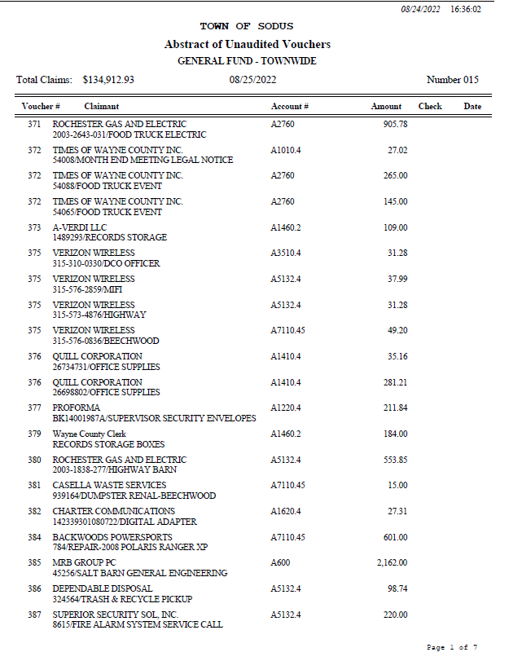

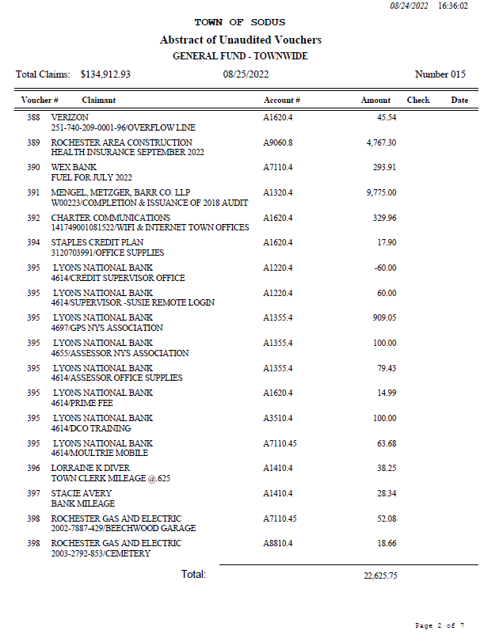
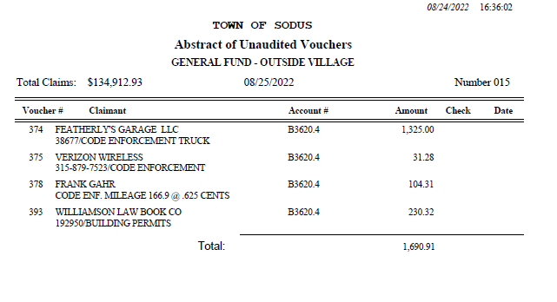

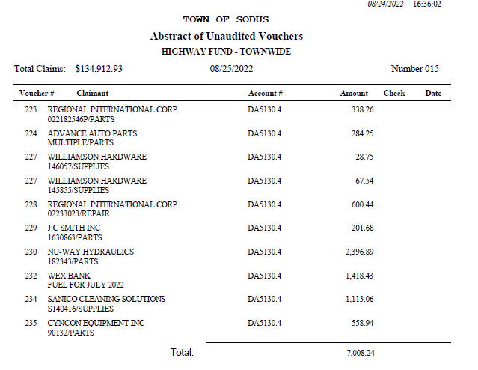

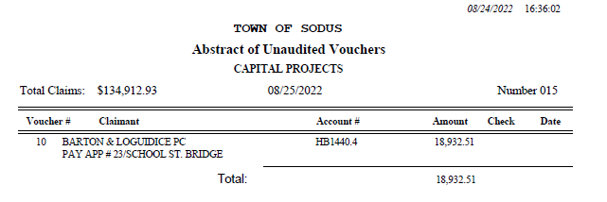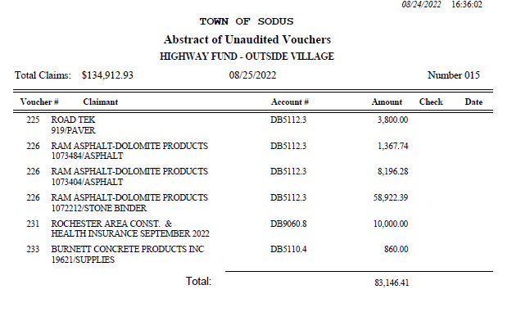

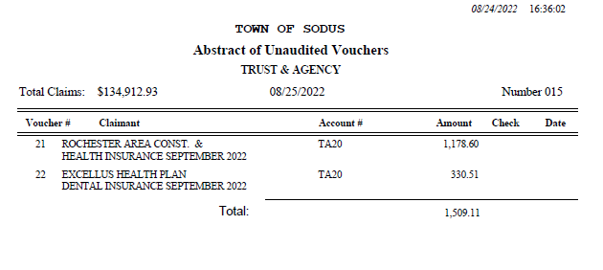
Councilperson Don Ross motioned to adopt this resolution which was seconded by Councilperson Chris Tertinek. Upon roll call the following votes were heard, Scott Johnson, aye; David LeRoy, aye; Don Ross, aye; Chris Tertinek, aye; and Cathy Willmott; absent. Resolution Adopted.

Lori Diver discussed with the Town Board the opening for the Digital Clerk position. This discussion will be tabled until our next Regular Town Board Meeting.

There was discussion regarding Terry Reynolds property. Councilperson David LeRoy shared with the Board that Dale Pickering Highway Superintendent has plan on how to address his drainage issues he is having.

Councilperson Chris Tertinek motioned to approve purchase of Zoom Pro subscription of $14.99 monthly for budget meetings was seconded by Councilperson David LeRoy. Upon roll call the following votes were heard, Scott Johnson, aye; David LeRoy, aye; Don Ross, aye; Chris Tertinek, aye; and Cathy Willmott; absent. Motion carried.

Councilperson David LeRoy discussed concern over the RG&E bill regarding the Town of Sodus Highway Department. LeRoy is working with RG&E Customer Service.

Councilperson Don Ross motioned acknowledging Town Clerk Lori Diver sent the Town Board notification by email on August 18, 2022 that the 2018 yearly audit findings paper copy is available for public inspection at the Town Clerk’s office from Mengel, Metzger and Barr Co. LLP Certified Public Accountants was seconded by Councilperson Chris Tertinek. Upon roll call the following votes were heard, Scott Johnson, aye; David LeRoy, aye; Don Ross, aye; Chris Tertinek, aye; and Cathy Willmott; absent. Motion carried.

Councilperson David LeRoy discussed email he received from DEC.

Councilperson Don Ross motioned to move September 13, 2022 Regular Town Board Meeting to Tuesday September 20, 2022 at 6:00 PM in the Sodus Town Court Room and allow Lori Diver to advertise was seconded by Councilperson David LeRoy. Upon roll call the following votes were heard, Scott Johnson, aye; David LeRoy, aye; Don Ross, aye; Chris Tertinek, aye; and Cathy Willmott; absent. Motion carried.

Chris Tertinek did a webinar with NY State and the Cannabis laws.

Councilperson Don Ross motioned to adjourn the Month End Town Board Meeting was seconded by Councilperson Chris Tertinek. Upon roll call the following votes were heard, Scott Johnson, aye; David LeRoy, aye; Don Ross, aye; Chris Tertinek, aye; and Cathy Willmott; absent. Motion carried.

Minutes Written By:
Lori K. Diver
Sodus Town Clerk, RMC

