MINUTES
Minutes of the Month End Town Board Meeting commencing at 5:30 PM in the Sodus Town Courtroom December 22, 2020, located at 14-16 Mill St. Sodus, NY. Commencing at 6:00 PM in the Sodus Town Courtroom was the, “Informational Meeting for Buerman Rd, Barclay Rd, and Burlee Rd Water District”. Due to Covid-19 Zoom was provided, along with detailed login information in the legal notice of this meeting.
Masks were required and social distancing was enforced.
All meetings are open to the public.

Roll Call/Present: Scott Johnson, Supervisor
David LeRoy, Councilperson/Deputy Supervisor
Don Ross, Councilperson-Zoomed
Chris Tertinek, Councilperson
John Faulks, Councilperson-Zoomed

Recording Secretary: Lori Diver, Sodus Town Clerk

Others Present: Bree Crandell, Supervisor Clerk-Zoomed
Amy Kendall, Town Attorney-Zoomed
Dave Doyle, MRB Group
Marty Aman, Wayne County Water & Sewer Authority
Wayne Vermuelen, Bond Rd. Resident
Ray E. Woodhams III, Barclay Rd. Resident
Other Public- Zoomed

Absent: N/A

Supervisor Scott Johnson called the Month End Town Board Meeting to order at 5:30 PM with the pledge allegiance and had Sodus Town Clerk Lori Diver do roll call.

ABSTRACT
RESOLUTION TO PAY ABSTRACT NO. 24
(05 12-2020)
WHEREAS, the following bills were presented for payment on Abstract 24:

General 529-551 $ 13,523.52
Highway 349-362 $ 23,143.62
Trust & Agency 031-032 $ 948.42
GRAND TOTAL: $ 37,615.56

NOW BE IT RESOLVED, Councilperson David LeRoy motioned to approve payment of these bills as reviewed for Abstract No. 24, which was seconded by Councilperson Chris Tertinek. Upon roll call the following votes were heard, Scott Johnson, aye; David LeRoy, aye; Don Ross, aye; Chris Tertinek, aye; and John Faulks, aye. Resolution adopted.

WAIVE RENEWAL REQUIREMENTS FOR SENIOR CITIZENS EXEMPTIONS & INDIVIDUALS WITH DISABILITIES & LIMITED INCOME FOR 1 YEAR
(06 12-2020)
Supervisor Scott Johnson offered the following resolution for its adoption:

WHEREAS, on March 7, 2020, Governor Andrew M. Cuomo issued Executive Order Number
202, declaring a State disaster emergency for the entire State of New York, and

WHEREAS, on December 18, 2020 said declaration was extended to include: Subdivisions 7, 7-a and 8 of section 459-c of the Real Property Tax Law, and subdivisions 5, 5-a, 5-b, 5-c and 6 of section 467 of the Real Property Tax Law, which permits the governing body of an assessing unit to adopt a resolution directing the assessor to grant exemptions pursuant to such section on the 2021 assessment roll to all property owners who received that exemption on the 2020 assessment roll, thereby dispensing with the need for renewal applications from such persons, and further dispensing with the requirement for assessors to mail renewal applications to such persons, and

WHEREAS, the Town of Sodus is desirous in adopting such resolution while also allowing the assessor to require a renewal application to be filed when he or she has reason to believe that an owner who qualified for the exemption on the 2020 assessment roll may have since changed his or her primary residence, added another owner to the deed, transferred the property to a new owner, or died, now, therefore, be it

RESOLVED, that the Town Board is authorized to pass such resolution, and that the assessor is instructed to take any such necessary actions in the above-described directives.
FURTHER BE IT RESOLVED, Councilperson David LeRoy motioned to adopt this resolution which was seconded by Councilperson Chris Tertinek. Upon roll call the following votes were heard, Scott Johnson, aye; David LeRoy, aye; Don Ross, aye; Chris Tertinek, aye; and John Faulks, aye. Resolution adopted.

Councilperson David LeRoy discussed the Town of Sodus Highway Barn and its progression in the new build.

Councilperson David LeRoy motioned to adjourn the meeting was seconded by Councilperson Don Ross. Upon roll call the following votes were heard, Supervisor Scott E. Johnson, aye; David LeRoy, aye; Chris Tertinek, aye; Don Ross, aye; and John Faulks, aye. Motion carried.

Meeting adjourned: 5:45 PM
Recording Secretary,

Lori Diver
Sodus Town Clerk, RMC

Informational Public Water Meeting “3B’s”
Meeting commenced at 6:00 PM with Dave Doyle, P.E. Vice President with MRB Engineering
& Marty Aman, Executive Director with Wayne County Water & Sewer Authority.
Due to Covid-19 Zoom was provided, along with detailed login information in the legal notice of this meeting.
Masks were required and social distancing was enforced.
All meetings are open to the public.

Supervisor Johnson shared with the public, this meeting was being held regarding public water for Buerman, Barclay, & Burlee Road.

The following information was passed out to the public and given through Zoom from Dave Doyle with MRB Group.

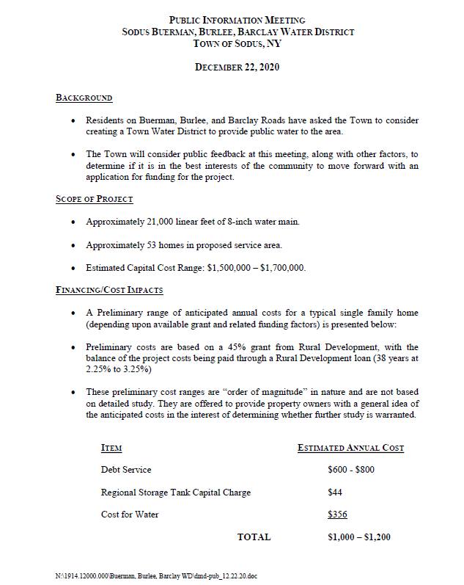
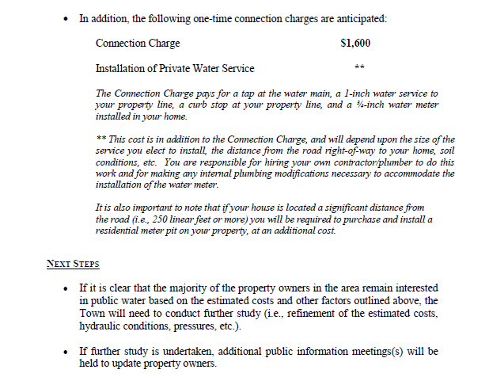
Water District Schematic
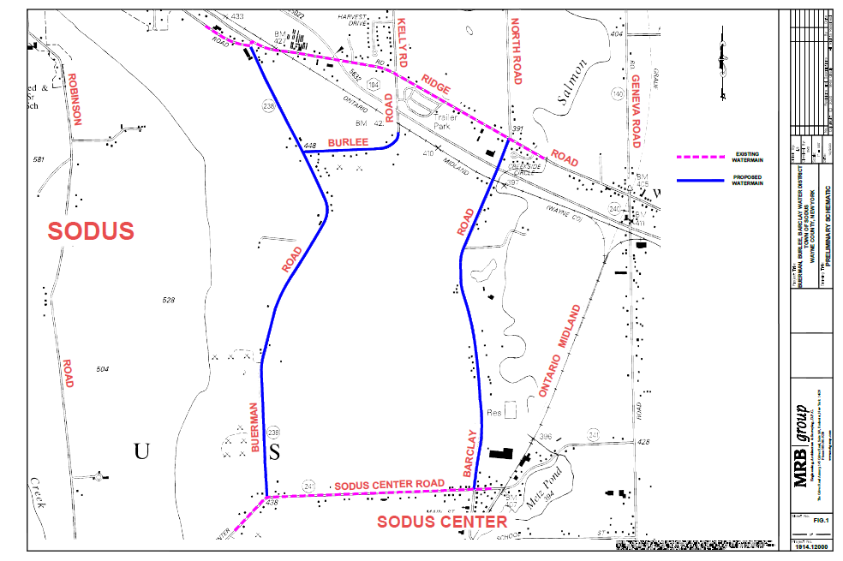

Discussion from the public took place in person and by Zoom regarding possibly getting public water on Buerman Rd. Barclay Rd. Burlee Rd. In addition, Wayne Vermuelen discussed including water on Bond Rd. and also York Settlement Rd was brought up through a letter written to the Board.

Dave Doyle, with MRB will get back in touch with the Sodus Town Board after a further engineering report is complete with additional roads and the costs have been reevaluated.

With no further discussion, Councilperson Chris Tertinek motioned to close the Public Water Meeting was seconded by Councilperson John Faulks. Upon roll call the following votes were heard, Supervisor Scott E. Johnson, aye; David LeRoy, aye; Chris Tertinek, aye; Don Ross, aye; and John Faulks, aye. Motion carried.

Meeting Adjourned
7:10 PM

