MINUTES
Minutes of the Year End-Month End Town Board Meeting commencing at 4:00 PM; located in the upstairs meeting room 14-16 Mill St. Sodus, NY 14551 on December 28, 2021.
All meetings are open to the public and Zoom.

Present: David LeRoy, Councilperson/Deputy Supervisor
Don Ross, Councilperson Zoom
Chris Tertinek, Councilperson
Cathy Willmott, Councilperson

Recording Secretary: Lori Diver, Sodus Town Clerk-RMC

Absent: N/A

Others Present: Bree Crandell, Confidential Supervisor Clerk
Casey Carpenter, Times of Wayne County
Amy Kendall, Town Attorney

Roll Call:
Supervisor Scott Johnson, Councilperson LeRoy, Councilperson Ross (Zoom), Councilperson Tertinek, Councilperson Willmott were all present.
Supervisor Scott Johnson called the meeting to order commencing at 4:00 PM.

BID:
Lori Diver Town Clerk read legal notice for the Highway Garage Roof Snow Guards.
LEGAL NOTICE
TOWN OF SODUS
NOTICE TO BIDDERS
Highway Garage Roof Snow Guards

PLEASE TAKE NOTICE: The Town Board of the Town of Sodus is seeking bids for the installation of Snow Guards on the North roof of the Highway Garage located @ 84 Rotterdam Rd. in the Town of Sodus.
The snow guards will be bid from FABRAL “Color Gard S-5!” system and color is “Charcoal Gray (851)”.
Two Color Gard “Charcoal Gray (851)” continuous length guards 222 feet in length each to be installed on the North roof and location to match the snow guards currently installed on the South roof of the highway garage. We are requiring “Color Gard S-5!” brackets to be installed on every standing seam panel on each row. Installation, fasteners & hardware will be installed to the manufacturer’s recommendations.
Specifications are listed above and the Non-Collusive Bidding Certificate may be picked up at the Sodus Town Clerk’s Office, 14-16 Mill St. Sodus, NY 14551. All bids must be in a sealed envelope and marked “BID-Town of Sodus”, needs to be written on outside of sealed envelope. The sealed bids will be opened and read at the Month End Town Board Meeting in the upstairs meeting room at 4:00 PM December 28, 2021 located at 14-16 Mill St. Sodus, NY. Sealed Bids must be received by 12:00 PM on December 28, 2021, at the Sodus Town Clerks Office. The Sodus Town Board and the Superintendent of Highways reserves the right to reject any or all bids received. Please note: the bid spec packet may also be downloaded at www.townofsodus.net under the LEGAL NOTICE section.

By Order of the Sodus Town Board and the Superintendent of Town of Sodus Highway
Lori Diver
Sodus Town Clerk, RMC
Dated: December 9, 2021

Supervisor Scott Johnson opened the one and only bid received from Martin Builders Enterprise, LLC located at 10110 Miner Rd. North Rose, NY 14516.
The bid received was as follows:
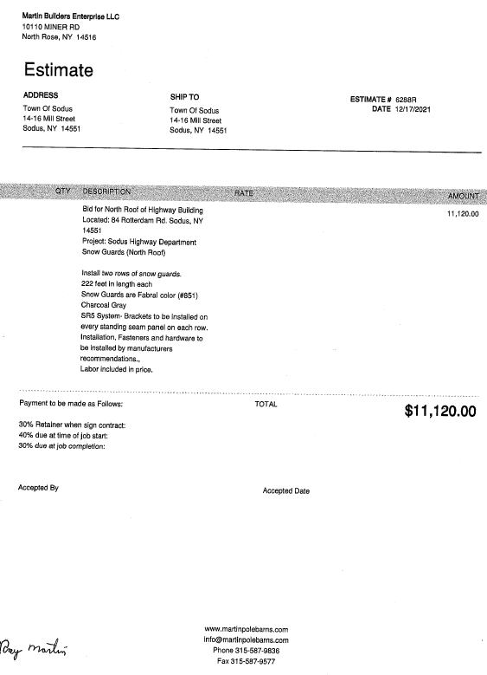
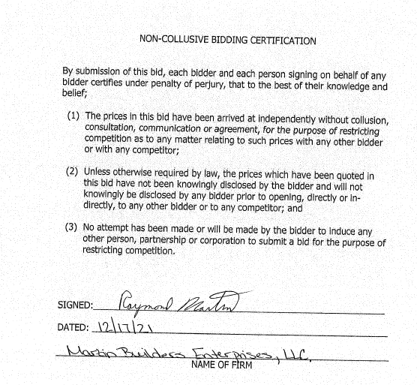
Councilperson David LeRoy motioned to award the bid to Martin Builders Enterprise LLC to install snow guards on the Town of Sodus Highway Barn roof in the amount of $11,120.00 was seconded by Councilperson Cathy Willmott. Upon roll call the following votes were heard, Scott Johnson, aye; David LeRoy, aye; Don Ross, aye; Chris Tertinek, aye; and Cathy Willmott, aye. Motion carried.

ABSTRACT
RESOLUTION TO PAY ABSTRACT No. 25
(3 12-2021)
WHEREAS, the following bills were presented for payment on Abstract 25:
General 554-577 $ 22,100.91
Highway 301-314 $ 49,719.34
Bridge Project 025-025 $ 2,949.25
Trust & Agency 062-063 $ 1,385.17
GRAND TOTAL: $ 76,154.67

NOW BE IT RESOLVED, Councilperson Chris Tertinek motioned to approve payment of these bills as reviewed for Abstract No. 25, which was seconded by Councilperson Don Ross. Upon roll call the following votes were heard, Scott Johnson, aye; David LeRoy, aye; Don Ross, aye; Chris Tertinek, aye; and Cathy Willmott, aye. Resolution Adopted.

Councilperson Chris Tertinek motioned to hire Susie Jacobs as Temporary Internal Auditor for the Town of Sodus at $20.00 per hour and hours will be determined per work load was seconded by Councilperson Cathy Willmott. Upon roll call the following votes were heard, Scott Johnson, aye; David LeRoy, aye; Don Ross, aye; Chris Tertinek, aye; and Cathy Willmott, aye. Motion carried.

Discussion was held regarding water fountain and flag pole in the Sodus Rural Cemetery. When the Town of Sodus suspended the water fountain service for the winter, it also suspended the lighting on the flag per Phil at the Country Hardware. Councilperson Cathy Willmott motioned to remove the flag for the winter was seconded by Councilperson David LeRoy. Councilperson David LeRoy will remove the flag. Upon roll call the following votes were heard, Scott Johnson, aye; David LeRoy, aye; Don Ross, aye; Chris Tertinek, aye; and Cathy Willmott, aye. Motion carried.

Councilperson Cathy Willmott notified the Board that the supplies for the roof at Beechwood came to $1,568.00. The invoice will be submitted to the Town from Plassche Lumber.

Councilperson Chris Tertinek discussed design, specs and bidding for floating dock at Harriman Park.

Councilperson Cathy Willmott motioned to adjourn the Year End-Month End Town Board Meeting was seconded by Councilperson Chris Tertinek. Upon roll call the following votes were heard, Scott Johnson, aye; David LeRoy, aye; Don Ross, aye; Chris Tertinek, aye; and Cathy Willmott, aye. Motion carried.

Meeting adjourned at 4:20 PM
Recording Secretary,

Lori K. Diver
Sodus Town Clerk, RMC

