Sodus Town Board Agenda
February 14, 2023
Meeting Commencing at 5:30 p.m. with Town of Sodus Recreation Committee for questions and answers.
Open with Pledge Allegiance
Roll Call: (Lori Diver)
Supervisor Johnson, Councilperson LeRoy, Councilperson Ross (Zoom), Councilperson Tertinek, Councilperson Willmott

Public Hearing Local Law 2-2023 6:00 PM

- Motion to enter into a Public Hearing for Local Law No. 2-2023
First____________________ Second___________________ Time ___________________

Lori Diver reads the following legal notice:

TOWN OF SODUS
NOTICE OF PUBLIC HEARING

PLEASE TAKE NOTICE that, pursuant to Section 20 of the Municipal Home Rule Law, a public hearing will be held by the Town Board of the Town of Sodus on February 14, 2023, at 6:00 p.m. at the Sodus Town Hall, 14-16 Mill Street, in the Town of Sodus, Wayne County, New York in the downstairs courtroom, to consider the adoption of Local Law No. 2 of 2023 of the Town of Sodus, amending Town Code §114-1 to increase the income qualification of the Aged Persons’ Realty Exemption from $7,200 in 12 consecutive months to a schedule determining the maximum income exemption eligibility levels and the associated exemption percentages.

All persons interested shall be given an opportunity to be heard. Local Law No. 2 of 2023 is available for public inspection during regular business hours at the Town Clerk’s office and on the Town of Sodus website at townofsodus.net.

Dated: January 10, 2023
LORI DIVER
Sodus Town Clerk, RMC

Ask for public comments
__________________________________________________________________________________________
____________________________________________________________________________________________________________________________________________________________________________________

- Motion to close Public Hearing
First____________________ Second___________________ Time ___________________

- Resolution adopting Local Law 2-2023 as listed below.
- First____________________ Second___________________ Time ___________________

TOWN OF SODUS
Proposed Local Law No. 2 of 2023
A Local Law to Amend the Aged Persons’ Realty Exemption to adjust for inflation
Be it Enacted by the Town Board of the Town of Sodus as follows:
- Legislative Intent. It is the intent of this Local Law to amend the Town of Sodus Code to increase the income qualification of Aged Persons’ Realty Exemption from $7,200 in 12 consecutive months to a schedule determining maximum income exemption eligibility levels.

- Authority. This Local Law is adopted pursuant to Municipal Home Rule Law §10, Town Law §271(7), and Section 467 of the Real Property Tax Law.

- Section 114-1 of the Town Code of the Town of Sodus is hereby amended to read as follows:
§114-1. Exemption stated; qualifications:
Real property located in the Town of Sodus owned by one or more persons, each of whom is 65 years of age or over, shall be exempt from taxation by the Town of Sodus for Town purposes to the extent of a percentage of the assessed valuation thereof, provided that the owner or owners meets or meet the following qualifications:
- The income of the owner or the combined income of the owners, and where title is vested in either the husband or the wife, their combined income, which income shall include social security and retirement benefits, interest, dividends, rental income, salary or earnings and income from self-employment, but shall not include gifts or inheritances, must not exceeded the scheduled amount for the 12 consecutive months immediately preceding the date of making application for exemption.

- The income schedule applies as follows: The income schedule applies as follows:

Annual Income Range | Exemption Percentage
$16,100 or less | 50% Exemption
More than $16,100, but less than $17,100 | 45% Exemption
$17,100 or more, but less than $18,100 | 40% Exemption
$18,100 or more, but less than $19,100 | 35% Exemption
$19,100 or more, but less than $20,000 | 30% Exemption
$20,000 or more, but less than $20,900 | 25% Exemption
$20,900 or more, but less than $21,800 | 20% Exemption
$21,800 or more, but less than $22,700 | 15% Exemption
$22,700 or more, but less than $23,600 | 10% Exemption
$23,600 or more, but less than $24,500 | 5% Exemption
$24,500 or more | Not Eligible

- Title to the property must have been vested in the owner or, if more than one, on all of the owners of the property for at least 24 consecutive months prior to the date of making application for exemption.

- The property must be used exclusively for residential purposes.

- The property must be the legal residence of and occupied in whole or in part by the owner or, if more than one owner, by all of the owners of the property.

- Severability. If any provision of this Local Law is determined to be unconstitutional or invalid, the validity and enforceability of the remainder shall not be affected.

- Effective Date. This Local Law shall take effect immediately upon filing with the Secretary of State.

EXECUTIVE SESSION (AFTER PUBLIC HEARING AT 6:00 PM):
- Motion to enter into Executive Session regarding medical, financial, credit or employment history of a particular person or corporation or relating to appointment promotion demotion discipline or removal.
Time_________________

- Motion to exit out of Executive Session and enter back into regular session.
Time _________________
Agenda:
Minutes:
January 10, 2023 (Don Ross has to abstain-zoom location not advertised)
January 26, 2023 (Chris has to abstain-absent)
- Supervisor’s Report

- Town Clerk’s Report

- Tax Collection Report

- Resolution to Approve Bills 3-2023

- Public Works Committee: Councilperson David LeRoy
(Highway, Drainage)
- Highway Superintendent’s Report

- Salt Barn:

- Drainage N/A

- Buildings and Grounds Committee: Councilperson Chris Tertinek
(Town Property, Animal Control, Code Enforcement, Flood Damage)
- Code Enforcement Report – Frank Gahr
- Dog Control Officer Report– Robert Snyder
- Flood Damage Prevention – Chris Tertinek

- Recreation/Environmental Committee: Councilperson Cathy Willmott
(Recreation, Assessor, Parks, Cemeteries)
- Sodus Recreation Report-Sheila Fisher
- Assessor’s Report – Nathan Mack
- Camp Beachwood/Sodus Groundskeeper Report – Sal Vittozzi

- Public Safety Committee: Councilperson Don Ross
(Fire, Ambulance, Emergency Preparedness - WC, Water Authority - WC)

- Town Hall Committee: Supervisor Scott Johnson
(Personnel, Town Council, Court, Assessor, Building Inspector, Boards/Committees, Insurances, Finance, Environmental)
Correspondence & Information
- Motion to change month end board meeting from Thursday February 23, 2023 to Tuesday February 28, 2023 at 4:00 PM and allow Lori Diver Sodus Town Clerk to advertise.

- The Joy Community Center payment of $1,000.00 was tabled at our Organizational Meeting because Bill Hoot needed to be contacted first. Motion to pay the Joy Community Center $1,000.00?

- Resolution to sign and pay Williamson Law Book Company for the Annual Software Support Contract in the amount of $1,093.00.

- Resolution allowing the Highway Superintendent Dale Pickering to purchase 150 Poly Wafers and 144 Wire Wafers at a total cost of $3,469.50 from Tracey Road Equipment in Rochester, NY. Note: Three vendors submitted quotes and Tracey was the lowest. Tracey was a written quote and two were verbal quotes.

- Resolution authorizing a “Piggy Back BID” from Wayne County Highway’s tree bid. This BID would allow us to hire Arnold Tree Service at the County’s given bid rate of $1,400.00/per day & $2,500.00/Weekend-Holiday Rate for Emergencies.

- Resolution authorizing 2023 budget modification creating revenue account codes as defined by The Office of the NY State Comptroller.

- Resolution authorizing the Town of Sodus Recreation Department the use of Venmo as a source of the Recreation Program user fee payments.

- Town of Sodus owned cemeteries- Dave LeRoy

  - South Sodus Cemetery- Teresa Youngs & Gregory Youngs will be purchasing with the Town of Sodus two burial plots next too Orpha Youngs, Vernon Youngs and Harold Youngs at the rate of $600.00 per plot.

  - Phil Tinklepaugh witch the family plots to see if two free spaces were available for full burials, they are.

  - Resolution in 2015 of Town of Sodus Fee Schedule (below):

RESOLUTION
TOWN OF SODUS CEMETERY FEE SCHEDULE
(2 09-2015)
Supervisor Steve LeRoy offered the following resolution for its adoption:

WHEREAS, the Town of Sodus owns and is responsible for maintaining several cemeteries; and

WHEREAS, the Town must charge an amount for the sale of cemetery lots and services sufficient to cover overhead; now, therefore, be it,

RESOLOVED, the Town of Sodus adopts the following rate schedule for all Town owned properties, and
$600.00 for purchase of single lot
$650.00 for grave opening ($150.00 additional if opening on a weekend)
$400.00 for burial of cremains

Councilperson DeBadts motioned to adopt Resolution (02 09-2015) was seconded by Councilperson Pickering. Upon roll call, the following votes were heard Supervisor Steven LeRoy, aye; DeBadts, aye; Pickering, aye; Grey, aye; Councilperson David LeRoy, aye. Resolution adopted.

  - Town Clerk Lori Diver will issue two deeds for the plots once they are paid for.

  - Teresa would like to know if she can pay for the grave opening in advance (note this has never been done in the past)? The grave opening was paid for at the time of death and dependent upon if the person is being buried during the week or on the weekend. There is a price difference (see resolution above).
In addition, Lancaster’s (if we use them for burials) may be a lot more expensive today then back, when this was done in 2015.

  - Amy Kendall Town Attorney has suggested we form a cemetery committee. We need a local law in place for future burials at Town of Sodus Cemeteries. Who on the Board, would like to be on this committee?

  - A Local Law needs to be enacted and we need to hold a public hearing for Town of Sodus Cemeteries (see email sent).

- Resolution authorizing the Town of Sodus to pay for Amazon Prime Subscription Annually ($139.00 yearly) or monthly at $14.99 a year (179.88 yearly currently).

- Resolution adopting Electronic Fee Policy (see email)

- Resolution adopting Whistle Blower Policy (see email)

- Motion to adjourn meeting.
Time _________________

MINUTES
Minutes of the Regular Town Board Meeting/Organizational Meeting February 14, 2023 held in person at the Town of Sodus courtroom 14-16 Mill St. Sodus, NY.
All meetings are open to the public and by Zoom.

Present: Scott Johnson, Supervisor
David LeRoy, Councilperson/Deputy Supervisor
Don Ross, Councilperson-Zoom
Chris Tertinek, Councilperson
Cathy Willmott, Councilperson

Recording Secretary: Lori Diver, Town Clerk

Absent: N/A

Others Present: Sal Vittozzi, Groundskeeper-Zoom
Bree Crandell, Supervisor Clerk
Susie Jacobs-Zoom
Dale Pickering, Highway Superintendent
Knauf and Shaw, Town Attorney-Zoom
Casey Carpenter, Times of Wayne County-Zoom
Sheila Fisher, Recreation Director
Lyn VanLare, Recreation Committee
Jennifer Davis, Recreation Committee
Mary Zecher Patton, Recreation Committee
Dave Fitch, Sodus Resident

Supervisor Scott Johnson called the Regular Town Board Meeting to order commencing at 5:30 PM with the Pledge of Allegiance and Lori Diver opened with roll call.
Supervisor Johnson, Councilperson LeRoy, Councilperson Ross-Zoom, Councilperson Tertinek and Councilperson Willmott were all present.

Recreation Committee 5:30 PM:
Recreation Director Sheila Fisher introduced to the Sodus Town Board the Recreation Committee which consist of herself, Lyn VanLare, Jennifer Davis and Mary Zecher Patton (Also Tom Miller and Laurie McFaul – were absent). Councilperson Cathy Willmott explained to the Board that the Committee has been working on the By-Laws for the Town of Sodus Recreation and Sheila Fisher has made available the live site for Sodus parents to register students for the 2023 Winter Rec. Bree Crandell, Susie Jacobs, Sheila Fisher, Lori Diver and Cathy Willmott have been working on the process of changing how money is deposited to Sodus Town Recreation. Internal Town of Sodus accounts have been created, Venmo has been set into place and a procedure has been created for collecting registration money at the Town Clerk’s Office. The Recreation Committee thanked the Town Board for their time.

EXECUTIVE SESSION:
- Councilperson Don Ross motioned to enter into Executive Session regarding medical, financial, credit or employment history of a particular person or corporation or relating to appointment promotion demotion discipline or removal was seconded by Councilperson Chris Tertinek. Upon roll call the following votes were heard, Supervisor Scott Johnson, aye; David LeRoy, aye; Don Ross, aye; (Zoom) Chris Tertinek, aye; and Cathy Willmott; aye. Motion carried.
Time: 5:39 PM

- Councilperson Cathy Willmott motioned to exit out of Executive Session and enter back into regular session was seconded by Councilperson David LeRoy. Upon roll call the following votes were heard, Supervisor Scott Johnson, aye; David LeRoy, aye; Don Ross, aye (Zoom); Chris Tertinek, aye; and Cathy Willmott; aye. Motion carried.
Time: 6:04 PM

Public Hearing Local Law No. 1- 2023 6:06 PM:
Councilperson Cathy Willmott motioned to enter into public hearing local law 2-2023 at 6:06 PM, which was seconded by Councilperson Cathy David LeRoy. Upon roll call the following votes were heard, Supervisor Scott Johnson, aye; David LeRoy, aye; Don Ross, aye (Zoom); Chris Tertinek, aye; and Cathy Willmott; aye. Motion carried.

Councilperson Cathy Willmott read the following legal notice in place of Lori Diver (sick):
TOWN OF SODUS
NOTICE OF PUBLIC HEARING
TOWN OF SODUS
NOTICE OF PUBLIC HEARING

PLEASE TAKE NOTICE that, pursuant to Section 20 of the Municipal Home Rule Law, a public hearing will be held by the Town Board of the Town of Sodus on February 14, 2023, at 6:00 p.m. at the Sodus Town Hall, 14-16 Mill Street, in the Town of Sodus, Wayne County, New York in the downstairs courtroom, to consider the adoption of Local Law No. 2 of 2023 of the Town of Sodus, amending Town Code §114-1 to increase the income qualification of the Aged Persons’ Realty Exemption from $7,200 in 12 consecutive months to a schedule determining the maximum income exemption eligibility levels and the associated exemption percentages.

All persons interested shall be given an opportunity to be heard. Local Law No. 2 of 2023 is available for public inspection during regular business hours at the Town Clerk’s office and on the Town of Sodus website at townofsodus.net.

Dated: January 10, 2023
LORI DIVER
Sodus Town Clerk, RMC

LOCAL LAW 2-2023
RESOLUTION
(01 02-2023)
TOWN OF SODUS
Proposed Local Law No. 2 of 2023
A Local Law to Amend the Aged Persons’ Realty Exemption to adjust for inflation
Be it Enacted by the Town Board of the Town of Sodus as follows:
- Legislative Intent. It is the intent of this Local Law to amend the Town of Sodus Code to increase the income qualification of Aged Persons’ Realty Exemption from $7,200 in 12 consecutive months to a schedule determining maximum income exemption eligibility levels.

- Authority. This Local Law is adopted pursuant to Municipal Home Rule Law §10, Town Law §271(7), and Section 467 of the Real Property Tax Law.

- Section 114-1 of the Town Code of the Town of Sodus is hereby amended to read as follows:
§114-1. Exemption stated; qualifications:
Real property located in the Town of Sodus owned by one or more persons, each of whom is 65 years of age or over, shall be exempt from taxation by the Town of Sodus for Town purposes to the extent of a percentage of the assessed valuation thereof, provided that the owner or owners meets or meet the following qualifications:
- The income of the owner or the combined income of the owners, and where title is vested in either the husband or the wife, their combined income, which income shall include social security and retirement benefits, interest, dividends, rental income, salary or earnings and income from self-employment, but shall not include gifts or inheritances, must not exceeded the scheduled amount for the 12 consecutive months immediately preceding the date of making application for exemption.

- The income schedule applies as follows: The income schedule applies as follows:

Annual Income Range | Exemption Percentage
$16,100 or less | 50% Exemption
More than $16,100, but less than $17,100 | 45% Exemption
$17,100 or more, but less than $18,100 | 40% Exemption
$18,100 or more, but less than $19,100 | 35% Exemption
$19,100 or more, but less than $20,000 | 30% Exemption
$20,000 or more, but less than $20,900 | 25% Exemption
$20,900 or more, but less than $21,800 | 20% Exemption
$21,800 or more, but less than $22,700 | 15% Exemption
$22,700 or more, but less than $23,600 | 10% Exemption
$23,600 or more, but less than $24,500 | 5% Exemption
$24,500 or more | Not Eligible

- Title to the property must have been vested in the owner or, if more than one, on all of the owners of the property for at least 24 consecutive months prior to the date of making application for exemption.

- The property must be used exclusively for residential purposes.

- The property must be the legal residence of and occupied in whole or in part by the owner or, if more than one owner, by all of the owners of the property.

- Severability. If any provision of this Local Law is determined to be unconstitutional or invalid, the validity and enforceability of the remainder shall not be affected.

- Effective Date. This Local Law shall take effect immediately upon filing with the Secretary of State.
Supervisor Scott Johnson asked for public comments, hearing no public comments Councilperson Don Ross motioned to close the public hearing for local law 2-2023 at 6:09 PM was seconded by Councilperson Chris Tertinek. Upon roll call the following votes were heard, Supervisor Scott Johnson, aye; David LeRoy, aye; Don Ross, aye (Zoom); Chris Tertinek, aye; and Cathy Willmott; aye. Motion carried.

Councilperson Chris Tertinek motioned to adopt local law 2-2023 was seconded by Councilperson David LeRoy. Upon roll call the following votes were heard, Supervisor Scott Johnson, aye; David LeRoy, aye; Don Ross, aye (Zoom); Chris Tertinek, aye; and Cathy Willmott; aye. Local Law-Resolution Adopted.

MINUTES
Minutes from January 10, 2023 was presented to the Town Board for approval. Councilperson Cathy Willmott motioned to accept and file these Minutes, which was seconded by Councilperson David LeRoy. Upon roll call the following votes were heard, Supervisor Scott Johnson, aye; David LeRoy, aye; Don Ross, abstained (Zoom location was not advertised-unable to vote); Chris Tertinek, aye; and Cathy Willmott; aye. Motion carried.

Minutes from January 26, 2023 was presented to the Town Board for approval. Councilperson Don Ross motioned to accept and file these Minutes, which was seconded by Councilperson David LeRoy. Upon roll call the following votes were heard, Supervisor Scott Johnson, aye; David LeRoy, aye; Don Ross, aye (Zoom); Chris Tertinek, abstain-absent; and Cathy Willmott; aye. Motion carried.

SUPERVISOR’S REPORT
The Supervisor’s monthly report was presented for January 2023. Councilperson Cathy Willmott motioned to accept and file this report, which was seconded by Councilperson David LeRoy. Upon roll call the following votes were heard, Supervisor Scott Johnson, aye; David LeRoy, aye; Don Ross, aye (Zoom); Chris Tertinek, aye; and Cathy Willmott; aye. Motion carried.

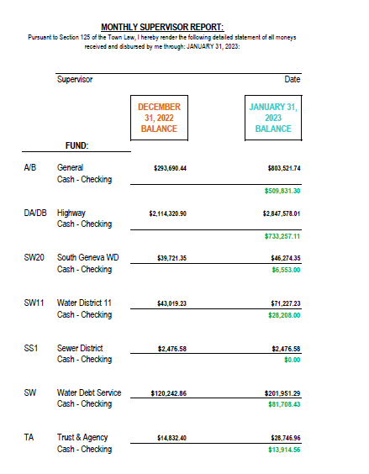

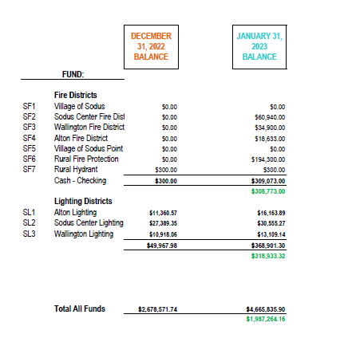

TOWN CLERK’S REPORT
The Town Clerk’s Reports, Town Clerk’s bank statements for audit and bank register for January 2023 was presented.
Note: bank statement and bank register are listed in detail with Town Clerk cash book for 2023. For security reasons and confidentiality, it cannot be published in Minutes. Councilperson Chris Tertinek motioned to accept and file these reports, which was seconded by Councilperson Don Ross. Upon roll call the following votes were heard, Supervisor Scott Johnson, aye; David LeRoy, aye; Don Ross, aye (Zoom); Chris Tertinek, aye; and Cathy Willmott; aye. Motion carried.

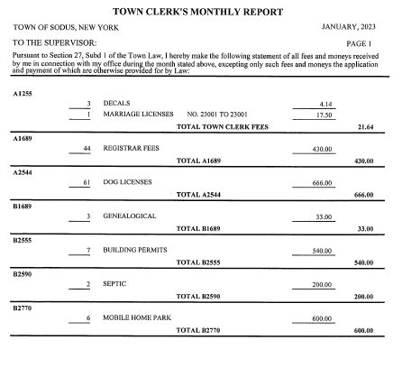

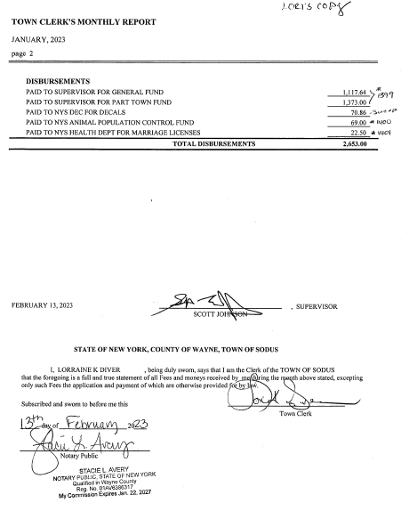

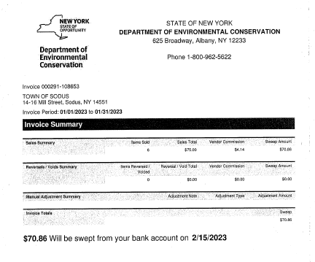

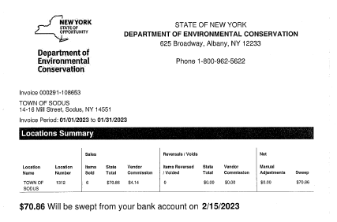

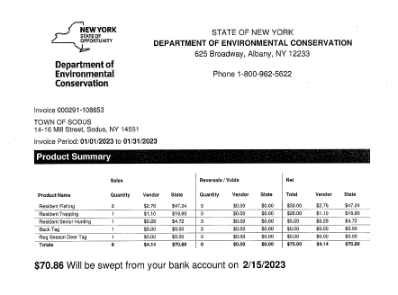
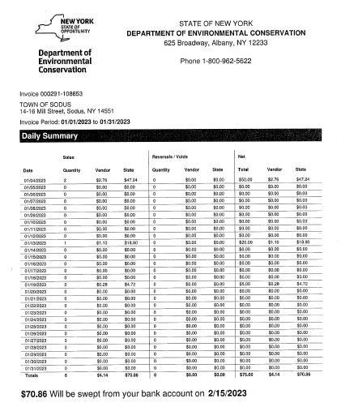

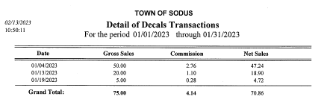

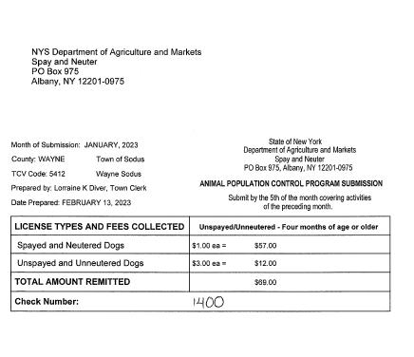
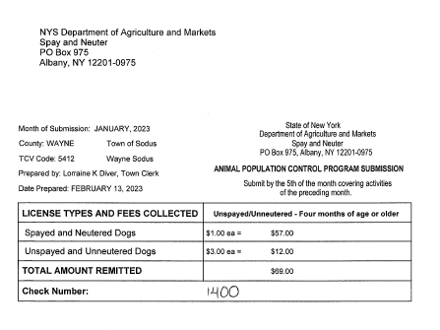
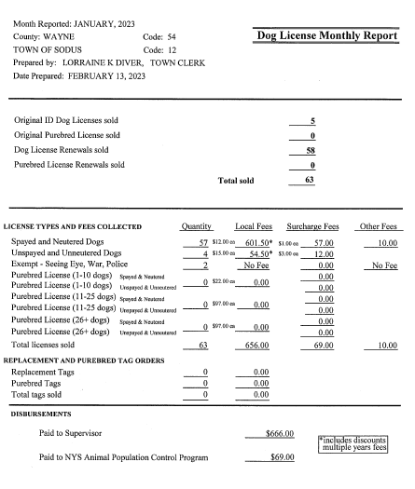

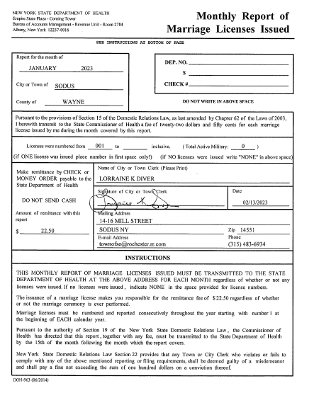

TAX COLLECTION REPORT
The Tax Collection Report, Tax Collector bank statements for audit and bank register for January 2023 was presented. Councilperson David LeRoy motioned to accept and file this report, which was seconded by Councilperson Chris Tertinek. Upon roll call the following votes were heard, Supervisor Scott Johnson, aye; David LeRoy, aye; Don Ross, aye (Zoom); Chris Tertinek, aye; and Cathy Willmott; aye. Motion carried.
Note: bank statement and bank register are listed in detail with Tax Collection cash book for 2023. For security reasons and confidentiality, it cannot be published in Minutes.

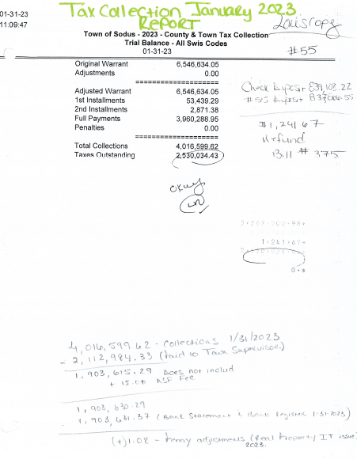

ABSTRACT
RESOLUTION TO PAY ABSTRACT NO. 03
(02 02-2023)
WHEREAS, the following bills were presented for payment on Abstract 03:

General 049-084 $ 34,883.71
Highway 026-049 $ 74,396.35
Special District 002-002 $ 964.16
Capital Projects 018-018 $ 291,783.00
GRAND TOTAL: $ 402,027.22

NOW BE IT RESOLVED, Councilperson Don Ross motioned to approve payment of these bills as reviewed for Abstract No. 03, which was seconded by Councilperson Chris Tertinek. Upon roll call the following votes were heard, Supervisor Scott Johnson, aye; David LeRoy, aye; Don Ross, aye (Zoom); Chris Tertinek, aye; and Cathy Willmott; aye. Resolution Adopted.

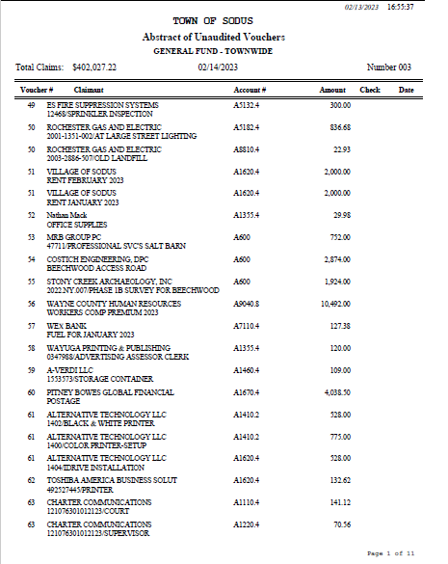

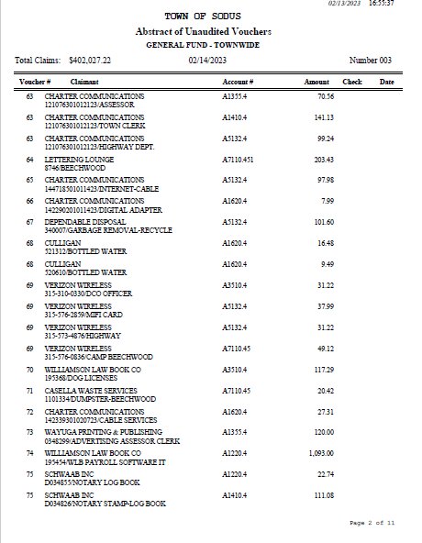

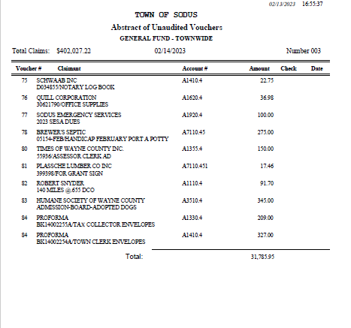

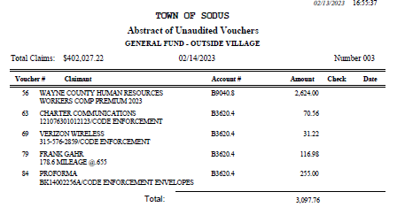

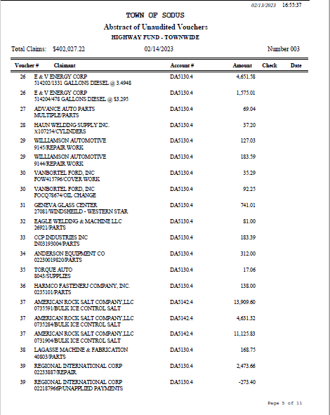

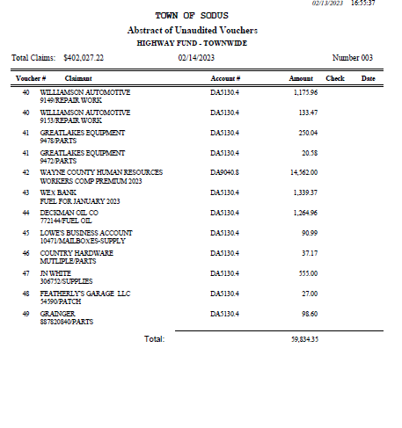

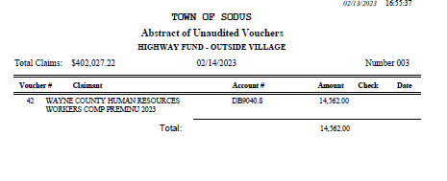

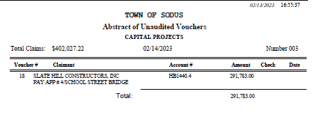

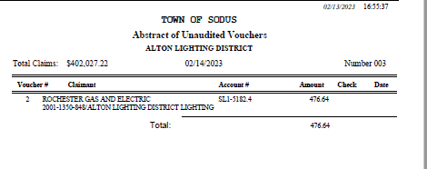

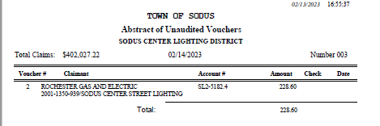

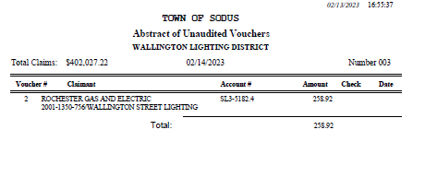
PUBLIC COMMENTS
Dave Fitch, Sodus Resident
Dave Fitch asked the Town Board if they are aware of any Zoning laws in the Town of Sodus for Airbnb’s. Apparently, the Airbnb across from his property on Sprongs Bluff is a year around one. It is causing some issues including, parking. There is not sufficient enough parking for these small properties and the amount of people allotted to come in at one time is more than what should be allowed. Supervisor Scott Johnson stated he will talk with our Town Attorney Amy Kendall regarding code for Airbnb’s.

PUBLIC WORKS COMMITTEE: Councilperson David LeRoy, Chair
(Highway, Drainage - Deputy Town Supervisor)
HIGHWAY REPORT:
(Dale Pickering – Highway Superintendent)
Councilperson Dave LeRoy motioned to accept and file the monthly Highway January 2023 report from Dale Pickering Highway Superintendent was seconded by Councilperson Chris Tertinek. Upon roll call the following votes were heard, Supervisor Scott Johnson, aye; David LeRoy, aye; Don Ross, aye (Zoom); Chris Tertinek, aye; and Cathy Willmott; aye. Motion carried.

Councilperson David LeRoy gave the Town Board an update on the Salt Barn (see below).

- Salt Barn:
  - BID openings for the Salt Barn will be opened March 2, 2023 at 10:00 AM in the Sodus Town Courtroom.
- RG&E N/A

- Drainage N/A

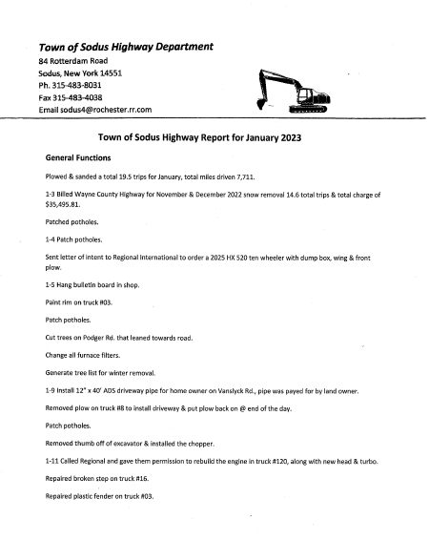

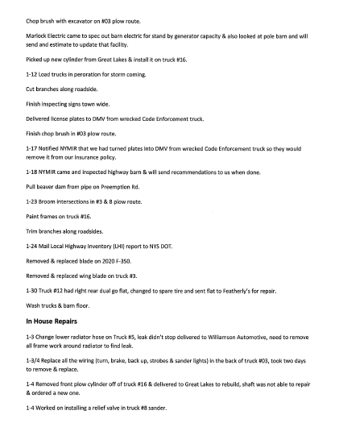

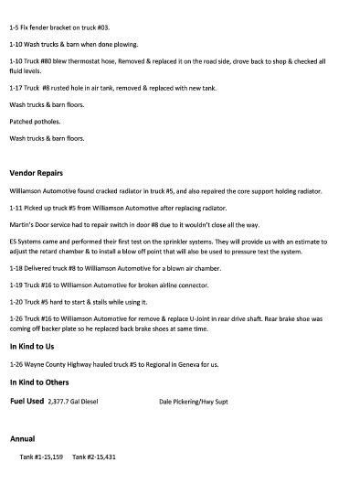

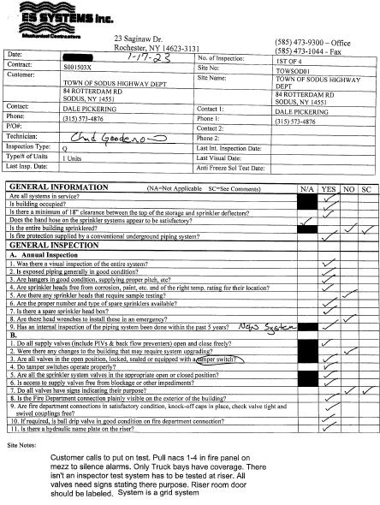

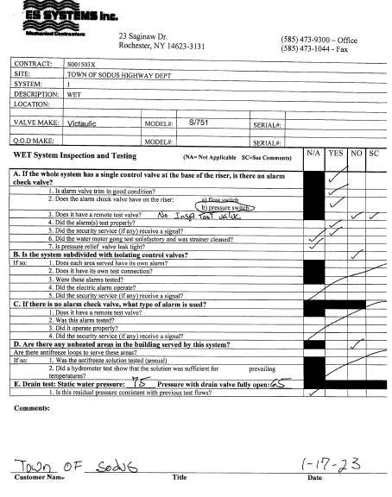

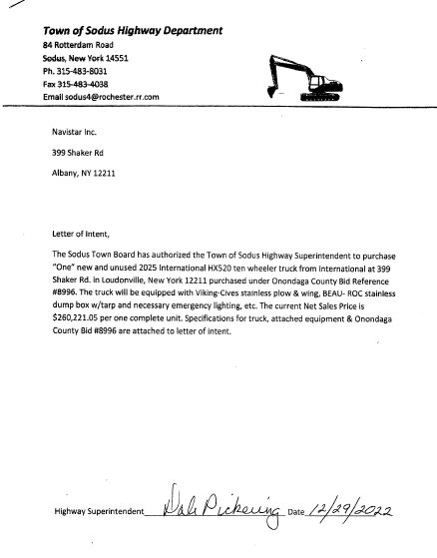

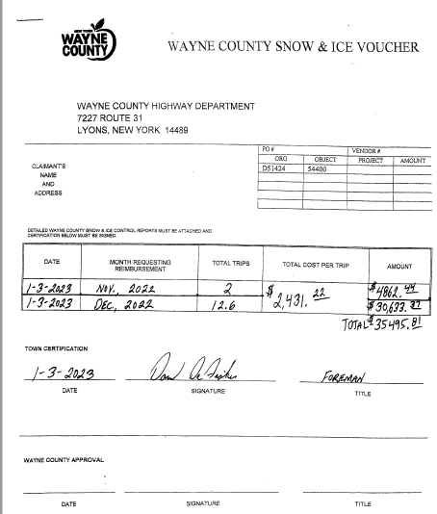

BUILDINGS AND GROUNDS COMMITTEE: Councilperson Chris Tertinek, Chair
(Town Property, Animal Control, Flood Damage Prevention)
CODE ENFORCEMENT REPORT:
Frank Gahr- CEO
Councilperson David LeRoy motioned to accept the monthly January 2023 Code Enforcement Report as written, was seconded by Councilperson Cathy Willmott. Upon roll call the following votes were heard, Supervisor Scott Johnson, aye; David LeRoy, aye; Don Ross, aye (Zoom); Chris Tertinek, aye; and Cathy Willmott; aye. Motion carried.

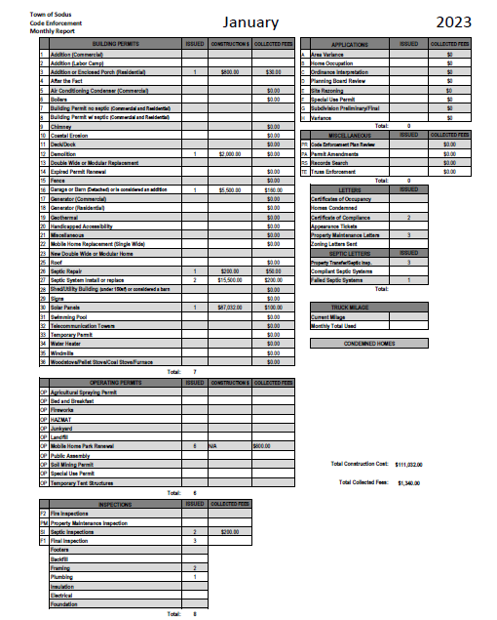

DOG CONTROL REPORT:
Robert Snyder, Primary DCO
Vacant- Secondary DCO
Councilperson Don Ross motioned to accept the monthly January 2023 Dog Control report as written, was seconded by Councilperson Chris Tertinek. Upon roll call the following votes were heard, Supervisor Scott Johnson, aye; David LeRoy, aye; Don Ross, aye (Zoom); Chris Tertinek, aye; and Cathy Willmott; aye. Motion carried.

January 2023 Dog Control Report
01-02-2023 911 Call- Dog running at large in Alton on Ridge Rd. I picked the dog up and transported it to the Wayne County Humane Society. 2:00 PM
01-10-2023 911 Call- Dog in apartment, owner was not found. The police and neighbors requested the dog to taken to the Humane Society. There was no food or water for the dog.
01-11-2023 Dog Complaint-Ridge Rd. Owner of the trailer park licensed the dog.
01-15-2023 Dog Running at Large-Picked the dog up and returned to the owner at 5555 Main St. in Sodus Center.
1-25-2023 Dog Complaint-Briarwood Trailer Park. Owner was out walking the dog.
1-25-2023 Dog Running at Large-South Geneva Rd by Limekiln Rd. Drove around and there was no dog spotted.
1-18-203 Dog Complaint- York Settlement Rd, dog was on neighbor’s property. The neighbors wanted the owner to remove the dog. Went to the house and no one came to the door.

Mileage: 140 miles
Robert Snyder, DCO

FLOOD DAMAGE PREVENTION REPORT-Code 69:
Chris Tertinek, Councilperson
Councilperson Chris Tertinek shared his flood damage prevention report. The Lake is at 245.3 ft ASL; up about ½ foot from last month. Presently slightly above long-time average. The long term forecast for mid-June is still close to the long-time average, when water is expected to crest at about 246.3 Ft ASL. About a foot higher than now.

RECREATION/ENVIRONMENTAL COMMITTE: Councilwoman Cathy Willmott
(Recreation, Assessor, Parks, Cemeteries)
CAMP BEECHWOOD-PARKS-CEMETERIES REPORTS:
Recreation Report
(Sheila Fisher, Recreation Director)
Councilperson David LeRoy motioned to accept the monthly January 2023 Recreation report from Sheila Fisher, Recreation Director was seconded by Councilperson Chris Tertinek. Upon roll call the following votes were heard, Supervisor Scott Johnson, aye; David LeRoy, aye; Don Ross, aye (Zoom); Chris Tertinek, aye; and Cathy Willmott; aye. Motion carried.

Director’s Report
Sodus Recreation Board Meeting
February 7, 2023

Programs:
- Soccer and Swim lessons will be held starting March 11th and running on Saturdays through April 4th. Registration is beginning this week.
- We are accepting volunteer and employee applications at this time.

Recreation Board:
- Recreation Board members have been invited to attend the February 14th meeting for introductions to the Town Board. Committee Members are below:
  - Laurie McFaul Frey- Current President
  - Tom Miller – Current Treasurer
  - Lyn VanLare- Current Board Member
  - Jen Davis – New Member
  - Mary Zecher Paton – New Member

- Sheila, Cathy, Bree & Lori met in January and made decisions on registrations, payments and other details for future programming.

- Cathy was able to complete the process of the final Bylaw's with Amy. We do have those now.
- We will continue to work together to build the Recreations new Board format & processes as we progress through the next few months.

No Budget updates currently.

Assessor’s Report
(Nathan Mack, Assessor)
Councilperson Chris Tertinek motioned to accept and file the monthly January 2023 report from Sole Assessor Nathan Mack was seconded by Councilperson David LeRoy. Upon roll call the following votes were heard, Supervisor Scott Johnson, aye; David LeRoy, aye; Don Ross, aye (Zoom); Chris Tertinek, aye; and Cathy Willmott; aye. Motion carried.

tOWN OF sODUS

ASSESSOR’S OFFICE
February 7, 2023 Respectfully Submitted by: Nathan Mack
AROUND THE OFFICE
- All exemptions that require renewals have been mailed out. We will do our best effort to provide reminders to those with renewals who have yet to return
- The deadline to file for exemptions and exemption renewals is March 1st.
- The office has mailed out notices to Seniors who already have the Enhanced star of an additional income-based exemption called the Senior citizens exemption with instructions on who might qualify and how to apply.
- I have placed an ad in the papers regarding the open clerk position. I hope to review all applicants by the end of the month and interview for the position.
- The office is diligently entering all of the exemptions and fielding all sorts of questions regarding the STAR program.
- We have been assisting any taxpayers who have questions regarding their tax bill and explaining the assessment process.
Camp Beechwood/Sodus Groundskeeper Report
(Sal Vittozzi-Caretaker-Sodus Town Groundkeeper)
Councilperson Cathy Willmott motioned to accept the monthly January 2023 report of Camp Beechwood-Parks & Cemeteries from Sal Vittozzi, Sodus Town Groundskeeper-Caretaker was seconded by Councilperson Don Ross. Upon roll call the following votes were heard, Supervisor Scott Johnson, aye; David LeRoy, aye; Don Ross, aye (Zoom); Chris Tertinek, aye; and Cathy Willmott; aye. Motion carried.

January 2023 Beechwood Report

January was a fairly slow month here at the park. We still are seeing daily dog walkers and hikers due to mild weather. Fishermen are using our east entrance daily to fish for trout as well. We did have our first 3 sets of campers for the year and brought in $45 to the camping fund. We did see a few more trees come down on the pine forest trail and they were quickly taken care of. Removal of trail debris is being done on a daily basis as well. Extreme cold at the end of the month also refroze our skating rink for a couple days and community members were making use of it. All in all, another positive month here at the park.

Respectfully Submitted,
Sal Vittozzi
Caretaker

PUBLIC SAFETY/DRAINAGE/ENVIRONMENT COMMITTEE: Councilperson Don Ross, Chair (Fire, Ambulance, Emergency Preparedness)
Councilperson Don Ross gave his committee reports. Ross reported the Wayne County Water and Sewer Authority Board has been working vigilantly at doing what they can to keep the water rates and other prices down.

TOWN HALL COMMITTEE: Scott Johnson, Supervisor
(Personnel, Clerks, Justices, Assessor, Building Inspector, Town Council, Boards, Insurances, Finance)
N/A
CORRESPONDENCE & INFORMATION
Motion by Councilperson Chris Tertinek to change the Month End Town Board Meeting from Thursday February 23, 2023 at 4:00 PM to Tuesday February 28, 2023 at 4:00 PM in the upstairs meeting room and to allow Lori Diver Sodus Town Clerk to advertise was seconded by Councilperson Cathy Willmott. Upon roll call the following votes were heard, Supervisor Scott Johnson, aye; David LeRoy, aye; Don Ross, aye (Zoom); Chris Tertinek, aye; and Cathy Willmott; aye. Motion carried.

Motion by Councilperson Chris Tertinek to table annual donation payment to the Joy Community Center in the amount of $1,000.00 until the Town Board hears the Joy Community Center Association has a grant or obtaining funding to fix the damage of the roof and building was seconded by Councilperson Cathy Willmott. Upon roll call the following votes were heard, Supervisor Scott Johnson, aye; David LeRoy, aye; Don Ross, aye (Zoom); Chris Tertinek, aye; and Cathy Willmott; aye. Motion carried.

RESOLUTION
WILLIAMSON LAW BOOK COMPANY ANNUAL SOFTWARE SUPPORT PAYROLL
(03 02-2023)
The following resolution was presented for its adoption,
(See page 40)
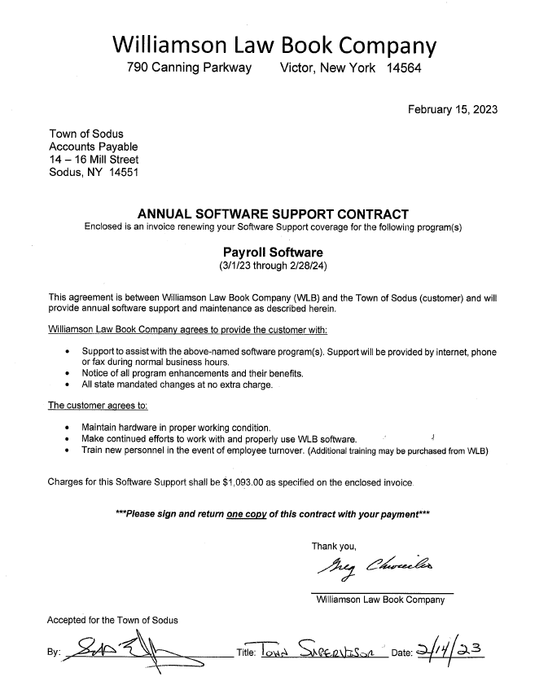
Councilperson David LeRoy motioned to adopt resolution (03 02-2023) was seconded by Councilperson Chris Tertinek. Upon roll call the following votes were heard, Supervisor Scott Johnson, aye; David LeRoy, aye; Don Ross, aye (Zoom); Chris Tertinek, aye; and Cathy Willmott; aye. Resolution Adopted.

RESOLUTION
POLY WAFERS & WIRE WAFERS PURCHASE-HIGHWAY
(04 02-2023)
The following resolution was presented for its adoption,

BE IT RESOLVED, the Sodus Town Board has moved to allow Highway Superintendent Dale Pickering to purchase 150 Poly Wafers and 144 Wire Wafers at a total cost of $3,469.50 from Tracey Road Equipment in Rochester, NY. Note: Three vendors submitted quotes according to Dale Pickering and Tracey was the lowest. Tracey was a written quote and the other two were verbal.

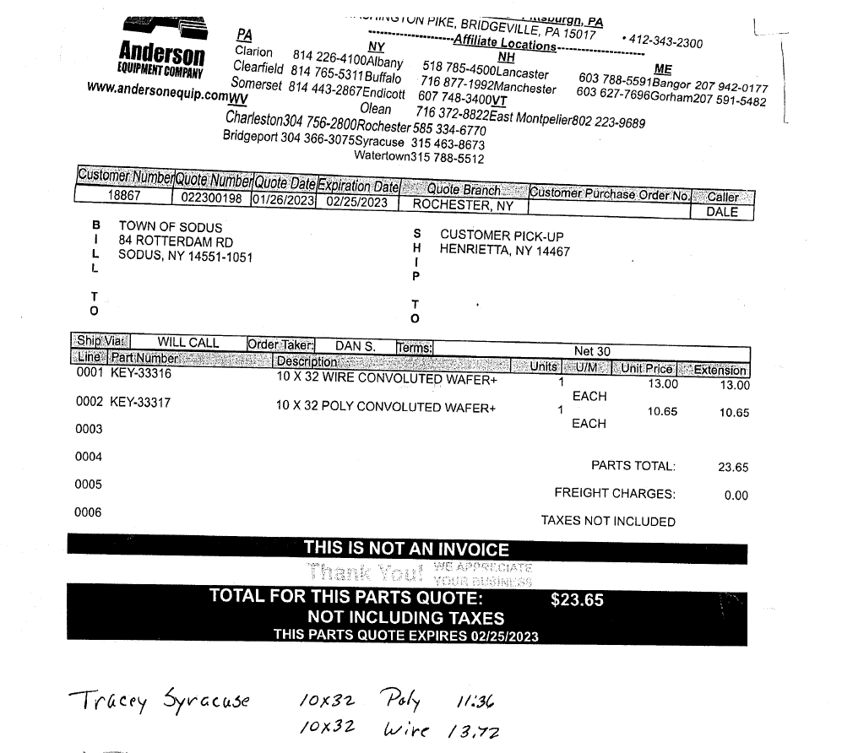
FURTHER BE IT RESOLVED, Councilperson Cathy Willmott motioned to adopt resolution (04 02-2023) was seconded by Councilperson David LeRoy. Upon roll call the following votes were heard, Supervisor Scott Johnson, aye; David LeRoy, aye; Don Ross, aye (Zoom); Chris Tertinek, aye; and Cathy Willmott; aye. Resolution Adopted.

RESOLUTION
PIGGY BACK BID-WAYNE COUNTY HIGHWAY DEPT.
(05 02-2023)
The following resolution was presented for its adoption,

WHEREAS, Highway Superintendent Dale Pickering offered the Town of Sodus to Piggy Back off the resolution from Wayne County Highway’s Tree Bid, and

WHEREAS, This BID will allow the Town of Sodus to hire Arnold Tree Service at the County’s given bid rate of $1,400.00/per day & $2,500.00/weekend-holiday rate for emergencies, and
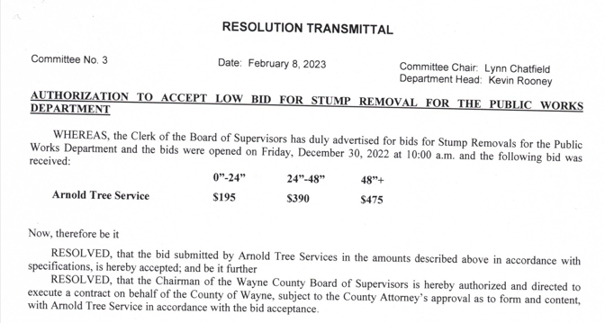

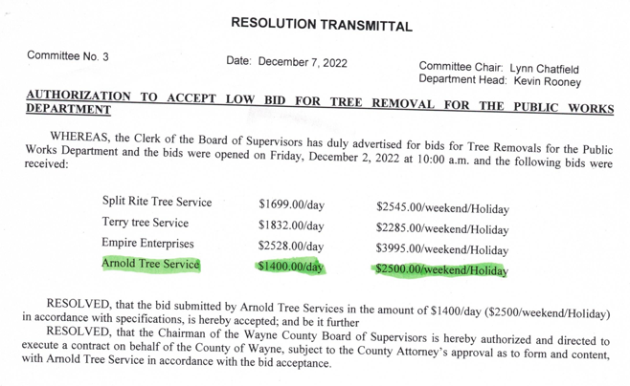

RESOLVED, Councilperson David LeRoy motioned to adopt resolution (05 02-2023) was seconded by Councilperson Chris Tertinek. Upon roll call the following votes were heard, Supervisor Scott Johnson, aye; David LeRoy, aye; Don Ross, aye (Zoom); Chris Tertinek, aye; and Cathy Willmott; aye. Resolution Adopted.

RESOLUTION
AUTHORIZING 2023 BUDGET MODIFICATION CREATING REVENUE ACCOUNT CODES AS DEFINED BY THE OFFICE OF THE NEW YORK STATE COMPTROLLER
(06 02-2023)

WHEREAS, Revenue Account Codes A2001 Culture & Recreation – Parks and Recreation Charges & A2089 Culture and Recreation – Other Culture and Recreation Income, do not exist in the 2023 Budget, and

WHEREAS, the 2023 Town Budget does reflect A2351 Revenue Account Codes for the collection of Recreation Revenue Fees however, the correct NYS OSC Revenue Account Code should be A2001, and

BE IT RESOLVED, the 2023 Budget is modified to reflect the creation of Revenue Account Code A2001 Culture and Recreation – Parks and Recreation Charges and A2089 Culture and Recreation – Other Culture and Recreation Income, and

BE IT FURTHER RESOLVED, that any 2023 Revenue in A2351 is transferred to A2001.
Adopted this 14th day February, 2023 at a meeting of the Sodus Town Board.
Councilperson Cathy Willmott motioned to this resolution was seconded by Councilperson David LeRoy. Upon roll call, the following votes were heard Supervisor Scott Johnson, aye; LeRoy, aye; Ross (Zoom) aye; Tertinek, aye; and Willmott, aye. Resolution Adopted.

RESOLUTION
AUTHORIZING THE TOWN OF SODUS RECREATION DEPARTMENT, THE USE OF VENMO AS A SOURCE OF RECREATION PROGRAM USER FEE PAYMENTS
(07 02-2023)

WHEREAS, the Town of Sodus Recreation Department wishes to establish a Venmo Account providing convenience for payment for recreation programs user fees; and

WHEREAS, the office of the NYS Comptroller has authorized that Local Governments can use third-party cash transfer applications to accept payment., and

BE IT RESOLVED, the Town Board agrees that the use of a third-party cash transfer known a Venmo would provide a convenience to those using the Town of Sodus Recreation programs and pay user fees; and authorizes the Recreation Director to establish Venmo Account for this purpose; and
BE IT FURTHER RESOLVED, that the Venmo Account will be titled SODUS RECREATION; with the revenues made with a Bank ACH payment credited to the TOWN CLERK ACCOUNT, with the funds paid to the Supervisor monthly.

Adopted this 14th day February, 2023 at a meeting of the Sodus Town Board.
Councilperson David LeRoy motioned to this resolution was seconded by Councilperson Cathy Willmott. Upon roll call, the following votes were heard Supervisor Scott Johnson, aye; LeRoy, aye; Ross (Zoom) aye; Tertinek, aye; and Willmott, aye. Resolution Adopted.

Discussion was held regarding Teresa Youngs wanting to purchase two burial plots for her and her husband Gregory Youngs from the Town of Sodus in the South Sodus Cemetery next to Orpha Youngs, Vernon Youngs and Harold Youngs. Sandy Hopkins stated she believed Jay Denosky turned the cemetery records over to the Town of Sodus somewhere around the year 2009. The records were nowhere to be found. Diver contacted Councilperson David LeRoy to help locate the family plots. LeRoy went out to South Sodus Cemetery and identified the three headstones Teresa Youngs and her husband want to be buried next to. Then LeRoy met with Phil Tinklepaugh to help locate if there was free space available for two burials. Tinklepaugh stated there were spaces available. The Town Board has agreed to sell Youngs the two burial plots at the old resolution fee (see below) at $600.00 for a single plot each. Town Clerk Lori Diver will draft up a cemetery deed for the Youngs. First, Diver will contact Phil Tinklepaugh with Sodus Rural Cemetery Association to identify the location number that should be put on the deed for both plots purchased. The Town Board was not in agreement of selling in advance the digging service at the fee in 2015. This will be done at the time the person is deceased.
Amy Kendall stated the Town Board should form a committee for cemeteries. Councilperson Dave LeRoy offered to be one committee member. The Town needs to create a local law and hold a public hearing for the Town owned cemeteries and come up with rules and regulations for each. The last known fee schedule adopted for the Town of Sodus cemetery burials was in September 2015 (see below).

RESOLUTION
TOWN OF SODUS CEMETERY FEE SCHEDULE
(2 09-2015)
Supervisor Steve LeRoy offered the following resolution for its adoption:

WHEREAS, the Town of Sodus owns and is responsible for maintaining several cemeteries; and

WHEREAS, the Town must charge an amount for the sale of cemetery lots and services sufficient to cover overhead; now, therefore, be it,

RESOLOVED, the Town of Sodus adopts the following rate schedule for all Town owned properties, and
$600.00 for purchase of single lot
$650.00 for grave opening ($150.00 additional if opening on a weekend)
$400.00 for burial of cremains

Councilperson DeBadts motioned to adopt Resolution (02 09-2015) was seconded by Councilperson Pickering. Upon roll call, the following votes were heard Supervisor Steven LeRoy, aye; DeBadts, aye; Pickering, aye; Grey, aye; Councilperson David LeRoy, aye. Resolution adopted.

RESOLUTION
AMAZON PRIME FEE
(08 02-2023)
RESOLVED, Councilperson Cathy Willmott motioned to authorize Lori Diver Sodus Town Clerk to switch Amazon Prime fee from paying a monthly subscription fee of $14.99 and upgrading to a yearly annual subscription fee of $139.00 was seconded by Councilperson David LeRoy. It would save the town $40.88 a year. Upon roll call, the following votes were heard Supervisor Scott Johnson, aye; LeRoy, aye; Ross (Zoom) aye; Tertinek, aye; and Willmott, aye. Resolution Adopted.

RESOLUTION
(08 02-2023)
ELECTRONIC BANKING POLICY

POLICY STATEMENT

The Town of Sodus recognizes the use of various electronic banking transactions as a faster, easier, and more efficient substitute for paper transactions. Electronic banking uses computer and electronic technology to streamline the processing and recording of receipts and disbursements, while reducing the cost of processing these transactions. Receipts, disbursements and transfers in proper circumstances can be processed via electronic funds transfer (EFT) services, whether transferring funds from a savings to a checking account at the same bank, or making a payment to a vendor’s bank across the country. Internal controls, such as written policies and procedures, authorizations, segregation of duties and monitoring, however, are still important.

The Town of Sodus also recognizes that most banking institutions no longer provide cancelled paper checks to their customers, abut instead offer an electronic image obtained online. As such, the Town Board authorizes the acceptance of these electronic images in lieu of cancelled checks as required by General Municipal Law Section 99-b(2).

SCOPE
Electronic banking activities will be used for, but not limited to, to the following:
- Online banking services (reviewing account balances, retrieving bank statements, downloading copies of cancelled checks, making stop payments, etc.);
- Electronic depositing of checks received;
- Pre-authorized debit payments (Complete Payroll Processing & the NYS Retirement System);
- EFT, ACH or Wire Transfers.
Online banking services are recognized as standard practice and procedure for maintaining an effective cash management program. Access to any of the Town of Sodus online bank accounts will be managed by the Town Supervisor to allow other users restricted access as necessary for banking functions as needed.
All Accounts: Town Supervisor and Town Supervisor’s Clerk
Town Clerk Account and Tax Collection Account: Town Clerk
(Examples of various online banking functions include monitoring account balances, submitting payroll direct deposits, paying bills, transferring money to cover payroll and bills, issuing stop payment orders, retrieving copies of cancelled checks, ordering deposit slips, etc.)
Electronic Funds Transfers (EFT’s), ACH transactions and Wire Payments can only be initiated by the Town Supervisor or the Clerk to the Supervisor. The recording of such transactions will be captured manually by the Clerk to the Supervisor through the use of journal entries. Dual approvals are required for any transaction with an end recipient not in a Town of Sodus account or in a different financial institution.
Pre-authorized Debit Payments are authorized by the Town Supervisor or Clerk to the Supervisor and restricted to payroll-related deduction payments. Any such debit payment must be taken from the Payroll bank account, or Trust and Agency account. Recording of such transactions will be captured through the payroll system or manually by the Clerk to the Supervisor through the use of journal entries.
Revenue Collection
- Electronic Deposits of Checks by means of utilizing a secure banking check scanning device for checks received are authorized as delegated by the Town Supervisor. The use of an electronic scanning device helps improve security, efficiency and cost effectiveness of making deposits. Recording of such deposits will be the responsibility of the department in which the transaction occurred through the standard posting of the cash receipts monthly journal.
- Electronic payments received from customers are acceptable and may be recorded via manual journal entries or through the regular cash receipts transaction journal.
Monitoring: The Town Board is responsible for implementing adequate internal controls for each of the electronic banking methods utilized. An effective internal control system includes, but is not limited to, segregation of duties, proper authorization, and adequate documentation for all electronic transactions.

Councilperson Cathy Willmott motioned to this resolution was seconded by Councilperson David LeRoy. Upon roll call, the following votes were heard Supervisor Scott Johnson, aye; LeRoy, aye; Ross aye (Zoom) aye; Tertinek, aye; and Willmott, aye. Resolution Adopted.

RESOLUTION
(09 02-2023)
WHISTLEBLOWER POLICY

POLICY STATEMENT

The Town of Sodus is committed to conducting its business with honesty and integrity at all times. If, at any time, this commitment is not respected or appears to be in question, the Town of Sodus will endeavor to identify and remedy such situations. Therefore, it is the company's policy to ensure that when a person has reasonable grounds to believe that an employee, manager or any other person related to the company has committed, or is about to commit, an offence that could harm the company's business or reputation, it denounces the wrongdoers in question.

The whistleblowing policy has been put in place to:

- Encourage employees, partners or managers to disclose this information or behavior;
- Protecting complainants from reprisals;
- Treated all parties to an investigation in a fair and equitable manner;
- To ensure confidentiality as much as possible;
- Take corrective and disciplinary action if wrongdoing is discovered.

PURPOSE

The purpose of this whistleblowing policy is to encourage current and former employees, contractual third parties or partners to communicate events that raise serious concerns about the Town of Sodus. The Town of Sodus encourages and will support staff who report illegal practices or individuals who violate the organization's policies.

SCOPE

This policy applies to all employees of the Town of Sodus, as well as contractual third parties or partners doing business with the company.

DUTY TO REPORT MISCONDUCT

It is the duty of all employees, contractual third parties or partners to report misconduct or suspected misconduct, including fraud and financial impropriety to the board. This includes misconduct such as but not limited to:

- Providing false or misleading information, or withholding material information on the Town of Sodus financial statements, accounting, auditing or other financial reporting fraud or misrepresentation;
- Pursuit of material benefit or advantage in violation of the Town of Sodus’s Conflict of Interest Policy;
- Misappropriation or misuse of the Town of Sodus resources such as funds, supplies or other assets;
- Unauthorized alteration or manipulation of computer files
- Destroying, altering, mutilating, concealing, covering up, falsifying, or making a false entry in any records that may be connected to an official proceeding, in violation of federal, provincial or state law or regulations or otherwise obstructing, influencing, or impeding any official proceeding, in violation of federal, provincial or state law or regulations
- Violations of federal or state laws that could result in fines or civil damages payable by the Town of Sodus, or that could otherwise significantly harm the Town of Sodus’s reputation or public image;
- Unethical business conduct in violation of any Town of Sodus policies and/or Town of Sodus Code of Conduct;
- Danger to the health, safety, or well-being of employees and/or the general public
- Forgery or alteration of documents
- Authorizing or receiving compensation for goods not received or services not performed, or paying for services or goods that are not rendered or delivered
- Authorizing or receiving compensation for hours not worked
- Embezzling, self-dealing, or otherwise obtaining an unlawful private benefit (i.e., the Town of Sodus assets being used by anyone in the organization improperly for personal gain).

- ACTING IN GOOD FAITH

Any person who files a complaint alleging misconduct must act in good faith and have reasonable grounds to believe that the information disclosed indicates wrongdoing.

No employee, third party contractor or partner who makes a denunciation in good faith will be subject to retaliation. Retaliation is any direct or indirect harmful action that threatens a person or is taken against a person who has reported an event or action. Anyone who retaliates against a person who has made a report in good faith is subject to disciplinary action up to and including dismissal.

However, making allegations that are deemed unfounded and malicious or knowingly false may result in disciplinary action up to and including termination of employment.

- PROCEDURE

A complaint may be submitted in writing to the Town Supervisor’s Office.

The written statement must include the following information:

- Description of the offence
- Date on which the complainant became aware of the offense
- Name of the person suspected of the offense
- Actions taken (if applicable) before filing a complaint or allegation (i.e. talk to the supervisor)

  - The declaration must be sent in writing to the Town Supervisor’s Office by e-mail or by post. The complainant should expect to receive confirmation of receipt of the complaint within ten working days.

  - The complainant will not be dismissed, demoted, suspended, threatened, harassed or otherwise discriminated against because of the communication of a genuine concern. Any employee of the Town of Sodus who contravenes this policy when dealing with a complainant may be terminated. Similarly, any member of the Board who violates this policy in his or her dealings with a complainant may have his or her relationship with the Town of Sodus terminated.

  - A person is not required to prove the truth of an allegation but is required to act in good faith and provide sufficient evidence to the person contacted to demonstrate that there are sufficient grounds for concern. The number of contacts between the complainant and the investigative body will depend on the nature of the question and the clarity of the information provided. The investigating body may request additional information from the complainant.

  - All complaints will be treated in a confidential and sensitive manner. In addition, the complainant must be able to remain anonymous, except in cases where the nature of the disclosure and/or resulting investigation makes it necessary to disclose his or her identity (e. g. investigations or judicial proceedings). In such cases, all reasonable measures must be taken to protect the complainant from any prejudice resulting from a disclosure.

INVESTIGATION

All relevant cases, including suspicious but unproven cases, will be reviewed and analyzed by a competent person designated by the Town Supervisor’s Office. In some cases, this may involve an investigation by a legal adviser or an accountant. All investigations will be kept confidential to the extent possible. Appropriate corrective action will be taken, if necessary, and the findings will be communicated to the whistleblower and his or her supervisor.

Councilperson Cathy Willmott motioned to this resolution was seconded by Councilperson David LeRoy. Upon roll call, the following votes were heard Supervisor Scott Johnson, aye; LeRoy, aye; Ross (Zoom), aye Tertinek, aye; and Willmott, aye. Resolution Adopted.

A motion by Councilperson Chris Tertinek to adjourn the Regular Town Board Meeting was seconded by Councilperson Cathy Willmott. Upon roll call, the following votes were heard Supervisor Scott Johnson, aye; LeRoy, aye; Ross (Zoom) aye; Tertinek, aye; and Willmott, aye. Motion carried.

Meeting adjourned at 7:01 PM

Recording Secretary,
Lori K. Diver
Sodus Town Clerk, RMC

