Sodus Town Board Agenda
Regular Month End-Year End Town Board Meeting
February 29, 2024
Pledge of Allegiance 4:00 PM
Roll Call: (Lori Diver)
Supervisor Johnson-absent, Councilperson LeRoy, Councilperson Ross-Zoom, Councilperson Tertinek, Councilperson Pickering

BID Opening for Camp Beechwood Caretaker’s House-Bilco Door 4:00 PM:
Lori reads following legal notice:
WAYNE COUNTY BID NOTICE Town of Sodus BID 7423 Lake Rd. Sodus, NY 14551 The Town Board of the Town of Sodus will receive BIDS for Removal of old bulkhead (Bilco style) door and replacing it with new metal bulkhead door at 7423 Lake Road, Sodus NY 14551. Include finish paint, locking latch and weather strip seal s. Seal all openings that may allow water to enter. Specify warranty period. Remove all construction debris at the conclusion of work. For inspection of work site please coordinate with Sal Vittozzi at 315- 576-0836. You may visit the Town of Sodus website https sodusny.gov and click on the more information tab and then click on the legals resolutions agendas tab or email the Sodus Town Clerk at townclerk@sodusny.gov or visit the Sodus Town Clerk's Office Monday- Friday from 9 00 AM to 5 00 PM located at 14-16 Mill St. Sodus, NY 14551 for the non-collusive bid certificate that must be submitted with this bid. All bids must be in a sealed envelope and marked BID Town of Sodus needs to be written on outside of sealed envelope. Please note NO email BIDS will be allowed. Sealed bids will be opened and read at the Month End Town Board Meeting Thursday February 29, 2024 at 4 00 PM in upstairs meeting room located at 14-16 Mill St. Sodus, NY 14551. Sealed BIDS must be received by 5 00 PM Wednesday February 28, 2024 at the Sodus Town Clerk's Office. The Sodus Town Board and the Sodus Town Supervisor reserves the right to reject any or all BIDS. Dated February 5, 2024
By Order of the Sodus Town Board
Lori Diver
Sodus Town Clerk, RMC

Open BIDS received:
Discussion/decision/motion to approve __________________ in the amount of ___________________ for the Bilco Door at Camp Beechwood
First _________________________ Seconded_____________________________

Public Speaker:
Robbie Williamson – Advanced Energy Solutions, Inc.-Presentation
Mike Garlock – Advanced Energy Solutions, Inc.-Presentation

Public Comments:

Month End Town Board Meeting Agenda
- Resolution approving Abstract #4-2024
First_________________ Seconded____________________

- Resolution to surplus truck # 21 “2011 International 760 Dump Truck VIN# 1HTWXSHT9BJ377281” and to send to Auction’s International.
First_________________ Seconded____________________

- Resolution to surplus “Fuel Tank” #004 300 Gallons with 270 Gallons Working Capacity for Low Grade Gas” located
at Town of Sodus Highway Barn and to send to Auction’s International.
First_________________ Seconded____________________

- Discussion/decision regarding EGS Advanced Energy Solutions, Inc.
First_________________ Seconded____________________

- Motion to authorize Supervisor Scott Johnson to sign Annual Software Support Contract with Williamson Law Book Company for Payroll in the amount of $1,148.00.
First_________________ Seconded____________________

- Resolution to hire Mike Crandell as a per diem plow driver for the Town of Sodus Highway Department, at an hourly wage of $20.00, no benefits and beginning with a 6-month probation period.
First_________________ Seconded____________________

- Resolution adopting Agreement to Exempt Referral of Certain Local Applications with the Wayne County Planning Board and authorize Supervisor Scott Johnson to sign agreement.
First_________________ Seconded____________________

- Resolution adopting new Town of Sodus “Covid Paid Sick Leave Policy” effective January 1, 2024.
First_________________ Seconded____________________

- Discussion regarding Lemcke property (update from CEO Frank Gahr)
First_________________ Seconded____________________

- Motion to allow Lori Diver Sodus Town Clerk to advertise in the Times of Wayne County for the Town of Sodus Recreation to hire staff.
First_________________ Seconded____________________

- Motion to enter into Executive Session regarding medical, financial, credit or employment history of a particular person or corporation or relating to appointment promotion demotion discipline or removal.
First______________ Seconded____________________
Time______________

- Motion to exit out of Executive Session and enter back into regular session.
First______________ Seconded____________________
Time______________

- Motion to adjourn.
First________________ Seconded____________________
Time _______________

MINUTES
Minutes of the Month End Town Board Meeting commencing at 4:00 PM in the upstairs meeting room February 29, 2024 located at 14-16 Mill St. Sodus, NY 14551.
All meetings are open to the public.

Present: David LeRoy, Councilperson/Deputy Supervisor
Don Ross, Councilperson-Zoom
Dale Pickering, Councilperson
Chris Tertinek, Councilperson

Recording Secretary: Lori Diver, Sodus Town Clerk

Absent: Scott Johnson, Absent (conferenced called- was not able to vote).

Others Present: Bree Crandell, Supervisor Clerk
Sal Vittozzi, Camp Beechwood Caretaker
Paulina Anderson, Recreation Director
Hobie Williamson, EGS Advanced Energy Solutions, Inc. Business Development Manager
Mike Garlock, (with Hobie Williamson)
Karen Cline, Village of Sodus Clerk

Deputy Supervisor David LeRoy called the Month End Town Board Meeting to order commencing at 4:00 PM and Lori Diver opened with roll call. All Board Members were present with the exception of Supervisor Scott Johnson (conferenced called in-unable to vote) who was absent.

BID Opening for Camp Beechwood Caretaker’s House-Bilco Door 4:00 PM:
Lori read the following legal notice:
WAYNE COUNTY BID NOTICE Town of Sodus BID 7423 Lake Rd. Sodus, NY 14551 The Town Board of the Town of Sodus will receive BIDS for Removal of old bulkhead (Bilco style) door and replacing it with new metal bulkhead door at 7423 Lake Road, Sodus NY 14551. Include finish paint, locking latch and weather strip seal s. Seal all openings that may allow water to enter. Specify warranty period. Remove all construction debris at the conclusion of work. For inspection of work site please coordinate with Sal Vittozzi at 315- 576-0836. You may visit the Town of Sodus website https sodusny.gov and click on the more information tab and then click on the legals resolutions agendas tab or email the Sodus Town Clerk at townclerk@sodusny.gov or visit the Sodus Town Clerk's Office Monday- Friday from 9 00 AM to 5 00 PM located at 14-16 Mill St. Sodus, NY 14551 for the non-collusive bid certificate that must be submitted with this bid. All bids must be in a sealed envelope and marked BID Town of Sodus needs to be written on outside of sealed envelope. Please note NO email BIDS will be allowed. Sealed bids will be opened and read at the Month End Town Board Meeting Thursday February 29, 2024 at 4 00 PM in upstairs meeting room located at 14-16 Mill St. Sodus, NY 14551. Sealed BIDS must be received by 5 00 PM Wednesday February 28, 2024 at the Sodus Town Clerk's Office. The Sodus Town Board and the Sodus Town Supervisor reserves the right to reject any or all BIDS. Dated February 5, 2024
By Order of the Sodus Town Board
Lori Diver
Sodus Town Clerk, RMC

Town Clerk Lori Diver stated there were no bids received.

Discussion was held that no-one bid on the Bilco door for Camp Beechwood Caretaker’s House when submitted to the Lakeshore News. Town Clerk Lori Diver stated that it was also advertised on our website under legals and on the Town of Sodus legal board in the hallway.
Councilperson David LeRoy motioned to authorize Lori Diver Sodus Town Clerk to advertise public notice for bid regarding Camp Beechwood Caretaker’s House-Bilco Door replacement in the Times of Wayne County for the Month End Town Board Meeting March 28, 2024 at 4:00 PM which was seconded by Councilperson Don Ross. Upon roll call the following votes were heard, Scott Johnson, absent; David LeRoy, aye; Don Ross, aye; Chris Tertinek, aye; and Dale Pickering; aye. Motion carried.

PUBLIC SPEAKER:
- Hobbie Williamson
Advanced Energy Solutions, Inc.-Presentation
Business Development Manager
- Mike Garlock (with Hobbie)
Hobbie Williamson presented to the Sodus Town Board cost savings the Town of Sodus could be saving with energy rates with EGS Advanced Energy Solutions, INC. The presentation information is included at the end of the Minutes. Hobbie Williamson has asked for 3 months of past bills that the Town of Sodus has incurred. Lori Diver Sodus Town Clerk will submit them to Hobbie for his official cost analysis the Town could be saving. Once this is finished, he will contact the Town.

ABSTRACT
RESOLUTION TO PAY ABSTRACT No. 4-2024
(09 02-2024)
WHEREAS, the following bills were presented for payment on Abstract 4:
General 095-111 $ 13,036.97
CM1-Parks 004-004 $ 154.09
Highway 050-061 $ 40,976.41
Capital Projects 004-004 $ 102,897.98
Trust & Agency 003-004 $ 2,106.04
GRAND TOTAL: $ 151,171.49

NOW BE IT RESOLVED, Councilperson Dale Pickering motioned to authorize payment for Abstract # 4 as listed and adopt this resolution which was seconded by Councilperson Don Ross. Upon roll call the following votes were heard, Scott Johnson, absent; David LeRoy, aye; Don Ross, aye; Chris Tertinek, aye; and Dale Pickering; aye. Resolution Adopted.
(See report inserted-end of minutes)

SURPLUS AND TO SELL TO AUCTIONS INTERNATIONAL
RESOLUTION
(10 02-2024)
WHEREAS, truck #21 “2011 International 760 Dump Truck VIN#1HTWXSHT9BJ377281 needs to be surplus and send to Auctions International, and

NOW BE IT RESOLVED; Councilperson Chris Tertinek motioned to adopt this resolution was seconded by Councilperson Dale Pickering. Upon roll call the following votes were heard, Scott Johnson, absent; David LeRoy, aye; Don Ross, aye; Chris Tertinek, aye; and Dale Pickering; aye. Resolution Adopted.

SURPLUS AND TO SELL TO AUCTIONS INTERNATIONAL
RESOLUTION
(11 02-2024)
WHEREAS, “Fuel Tank” #004-300 Gallons with 270 Gallons Working Capacity for Low Grade Gas located at the Town of Sodus Highway Barn needs to be surplus and send to Auctions International, and

NOW BE IT RESOLVED; Councilperson Dave LeRoy motioned to adopt this resolution was seconded by Councilperson Dale Pickering. Upon roll call the following votes were heard, Scott Johnson, absent; David LeRoy, aye; Don Ross, aye; Chris Tertinek, aye; and Dale Pickering; aye. Resolution Adopted.

Councilmember Dave LeRoy motioned to authorize Supervisor Scott Johnson to sign Annual Software Support Contract with Williamson Law Book Company for Payroll in the amount of $1,148.00 was seconded by Councilmember Dale Pickering. Upon roll call the following votes were heard, Scott Johnson, absent; David LeRoy, aye; Don Ross, aye; Chris Tertinek, aye; and Dale Pickering; aye. Motion carried (see page 5).
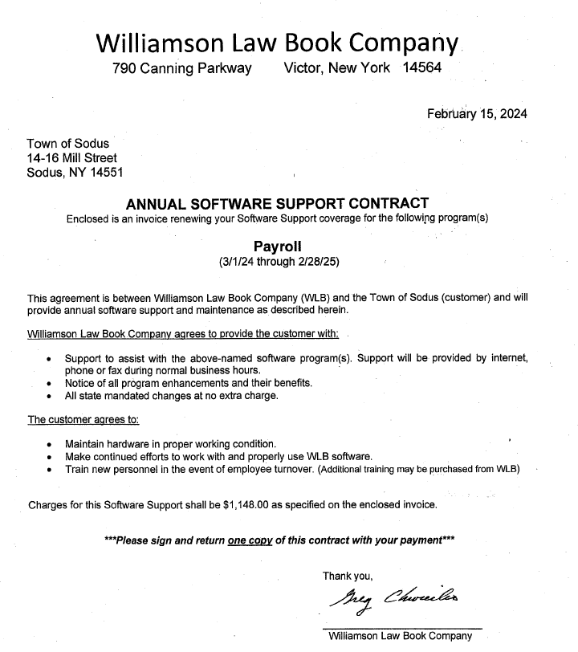

Discussion was held on item #6 on agenda. This item has been tabled.

- Resolution to hire Mike Crandell as a per diem plow driver for the Town of Sodus Highway Department, at an hourly wage of $20.00, no benefits and beginning with a 6-month probation period.

AGREEMENT TO EXEMPT REFERRAL OF CERTAIN LOCAL APPLICATIONS
RESOLUTION
(12 02-2024)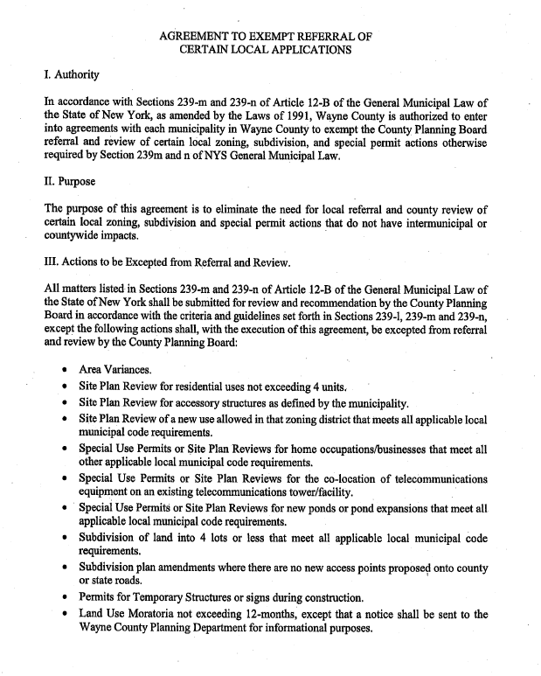

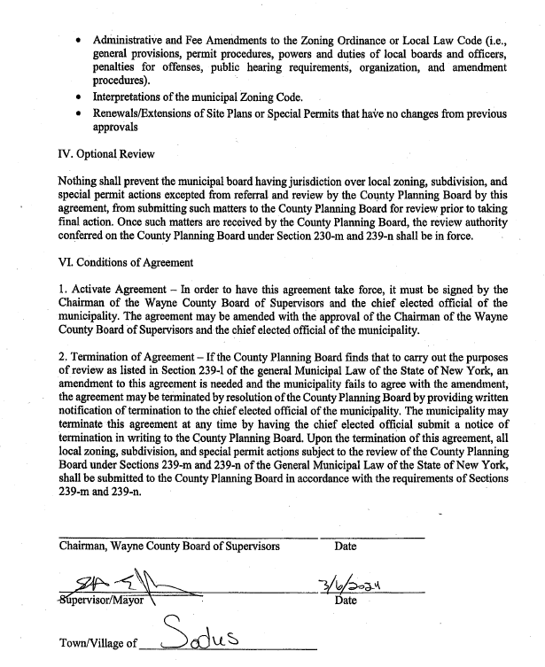

NOW BE IT RESOLVED; Councilperson Dave LeRoy motioned to adopt this resolution was seconded by Councilperson Dale Pickering. Upon roll call the following votes were heard, Scott Johnson, absent; David LeRoy, aye; Don Ross, aye; Chris Tertinek, aye; and Dale Pickering; aye. Resolution Adopted.

COVID SICK LEAVE POLICY EFFECTIVE JANUARY 1, 2024
RESOLUTION
(13 02-2024)
COVID PAID SICK LEAVE POLICY

COVID RAPID ANTIGEN OR PCR TEST REQUIRED: In order to receive COVID Emergency Sick Leave Pay, an employee MUST provide documentation of his/her POSITIVE PCR Test or Rapid Antigen Test performed by a medical provider (pharmacy, Urgent care, etc.) and complete the COVID Emergency Paid Sick Leave Form upon return to work. AT HOME TEST RESULTS WILL NOT BE ACCEPTED.
The Department of Health has adjusted isolation period to five (5) days. Anyone who receives a positive COVID-10 test result is to self-isolate for 5 days from onset of symptoms. If you have no symptoms or your symptoms are resolving after 5 days you can leave your home and return to work but continue to wear a well-fitting mask for an additional 5 calendar days. If your symptoms are not improving, or you have a fever, continue to stay home. After the first 5 days of isolation if you are unable to return to work you will be required to seek medical attention and provide documentation to remain out of work an additional 5 days.
During this public health crisis, employee health and safety is of paramount importance. Therefore, Federal, State, and Town governments are working together to slow person to person transmission and stop the spread of the COVID virus. The COVID provisions of the New York State Paid Sick Leave Policy temporarily supplement the existing Wayne Town leave of absence, sick leave and contractual benefits and accounts for the new state sick leave law. This description addresses Town obligations and employee benefits for COVID-19 related isolation leave.

An employee may be entitled to paid leave if: (1) the employee has tested COVID positive; (2) a health care provider has advised the employee to self-isolate due to positive COVID results; or (3) the employee is ill after receiving COVID vaccination and/or boosters shot.

In the event that an employee is not eligible under the New York State EPSL, but has a public health concern, the Town will work with a concerned employee to accommodate application of the employee’s accrued time or unpaid time under the Family Medical Leave Act and/or Disability as applicable.

THE FOLLOWING DOCUMENTATION MUST BE RETURNED TO YOUR DEPARTMENT HEAD/SUPERVISOR:

- MUST provide documentation for his/her POSITIVE Rapid Antigen or PCR Test that was conducted by a facility (pharmacy, urgent care, etc.) – HOME TESTS RESULTS WILL NOT BE ACCEPTED.
- Complete the COVID EPSL Form in its entirety. Any submissions can be done electronically/remotely. Employees should not physically bring forms in if the employee is ill.
- The Town may grant leave pending receipt of supporting documentation as necessary.
- Once the documentation supporting the employee request is submitted, the Town will review and make a determination granting the request, denying the request due to lack of eligibility, or determining a need for more information/documentation, as soon as possible.
- If the employee exhausts paid sick leave under the state sick leave employee benefits laws, or is ineligible, the employee may use sick and/or leave or other qualifying accruals and may apply for FMLA and Disability benefits if applicable.

NEW YORK EMERGENCY PAID SICK LEAVE ELIGIBILITY & PROCESS
In no event shall an employee qualify for sick leave under New York’s COVID-19 sick leave law for more than three orders of isolation from the onset of COVID. The second and third orders must be based on the employee’s positive COVID test in accordance to the guidelines.

If an employee experiences residual effects from the original COVID infection, the employee would not be eligible for additional paid time off once employee has returned to work, employee will be entitled to use accruals and may be required to present medical documentation. The Public Health Department will be consulted and will determine, after consulting with the NYS Department of Health and with the employee’s medical provider, if the reoccurrence of symptoms is a new COVID-19 infection.
If a holiday is within the 5- or 10-day period of isolation the holiday will be coded as holiday but is and will be counted as COVID time.

EMPLOYEE OBLIGATION TO NOTIFY TOWN OF EXPOSURE AND TEST RESULTS
An employee who receives a positive test result under any circumstances must notify their Department Head/Supervisor and shall not report to work.

Dated: February 29, 2024

TOWN OF SODUS
14-16 Mill Street
Sodus, NY 14

Employee Request for Paid Sick Leave under NY Emergency Paid Sick Leave Law

Employee Name: Department: .

The Department of Health has adjusted isolation period to five (5) days. Anyone who receives a positive COVID-10 test result, either from a lab, pharmacy, medical office is to self-isolate for 5 days. If you have no symptoms or your symptoms are resolving after 5 days you can leave your home and return to work but continue to wear a well-fitting mask for an additional 5 days. If your symptoms are not improving, or you have a fever, continue to stay home. After the first 5 days of isolation if you are unable to return to work you will be required to seek medical attention and provide documentation to remain out of work an additional 5 days.

THE FOLLOWING DOCUMENTATION MUST BE RETURNED TO YOUR DEPARTMENT HEAD/SUPERVISOR:

- Positive Covid test from medical provider: HOME TEST WILL NOT BE ACCEPTED
- Complete this form in its entirety

If you fail to provide proper documentation you will be denied NYS Emergency Paid Sick Leave until documentation is received and your sick accruals will be used for the period of time you are out of work.

I request leave for the following dates: _____________________ thru _____________________

I understand if I am out for more than five (5) days I must provide a medical statement with my return date of: ________________

Signature: ________________________________________
Date: ____________________________

An employee is NOT eligible for NYSPSL:
- If required documentation is not submitted
- If the employee has requested COVID paid time off, mandatory that the 2nd & 3rd occurrence is with employee positive.
- Depending on circumstances an essential employee subject to COVID positive isolation to work from home with approval of the County COVID telework policy and County Administrator approval.
- Any false information provided may result in disciplinary action.

NOW BE IT RESOLVED; Councilperson Dale Pickering motioned to adopt this resolution was seconded by Councilperson Dave LeRoy. Upon roll call the following votes were heard, Scott Johnson, absent; David LeRoy, aye; Don Ross, aye; Chris Tertinek, aye; and Dale Pickering; aye. Resolution Adopted.

Motion by Councilperson Chris Tertinek to enter into Executive Session regarding medical, financial, credit or employment history of a particular person or corporation or relating to appointment promotion demotion discipline or removal was seconded by Councilperson Dale Pickering. Upon roll call the following votes were heard, Supervisor Scott Johnson, absent, David LeRoy, aye; Don Ross, aye; Chris Tertinek, aye and Dale Pickering, aye. Motion carried.
Time: 4:45 PM
MIKE CRANDELL-PLOW DRIVER
RESOLUTION
(14 02-2024)
NOW BE IT RESOLVED; Councilperson Dave LeRoy motioned to hire Mike Crandell as a part-time Snow Plow Driver for the Town of Sodus Highway Department, non-benefited with a 6-month probationary period was seconded by Chris Tertinek. Upon roll call the following votes were heard, Scott Johnson, absent; David LeRoy, aye; Don Ross, aye; Chris Tertinek, aye; and Dale Pickering; abstained. Resolution Adopted.

Motion by Councilperson Chris Tertinek to advertise for part-time Snow Plow Drivers was seconded by Councilperson Dale Pickering. Upon roll call the following votes were heard, Supervisor Scott Johnson, absent, David LeRoy, aye; Don Ross, aye; Chris Tertinek, aye and Dale Pickering, aye. Motion carried.

Motion by Councilperson Dave LeRoy to exit out of Executive Session and enter into Regular Session was seconded by Councilperson Chris Tertinek. Upon roll call the following votes were heard, Supervisor Scott Johnson, absent, David LeRoy, aye; Don Ross, aye; Chris Tertinek, aye and Dale Pickering, aye. Motion carried.
Time: 5:25 PM

Councilperson Dave LeRoy motioned to adjourn the Town Board Meeting was seconded by Councilperson Chris Tertinek. Upon roll call the following votes were heard, Supervisor Scott Johnson, absent, David LeRoy, aye; Don Ross, aye; Chris Tertinek, aye and Dale Pickering, aye. Motion carried.
Time: 5:26 PM

Minutes Written By:
Lori K. Diver
Sodus Town Clerk, RMC

