MINUTES
Minutes of the Regular Town Board Meeting commencing at 6:30 PM in the downstairs courtroom February 8, 2022 located at 14-16 Mill St. Sodus, NY 14551.
All meetings are open to the public.
In addition this meeting was available through Zoom. Legal Notices were published and posted accordingly.

Present: Scott Johnson, Supervisor
David LeRoy, Councilperson/Deputy Supervisor
Don Ross, Councilperson Zoom
Chris Tertinek, Councilperson
Cathy Willmott, Councilperson

Recording Secretary: Lori Diver, Sodus Town Clerk-RMC

Absent: N/A

Others Present: Dale Pickering, Highway Superintendent
Sal Vittozzi- Camp Beechwood Zoom
Julia O’Sullivan- Town Attorney Zoom
Bree Crandell- Supervisor Clerk
Nathan Mack-Assessor
Bruce Beal- Public Speaker
Wanda Beal- Public Speaker
Gary Munson – Public Speaker

Supervisor Scott Johnson called the Regular Town Board Meeting to order commencing at 6:30 PM with the Pledge of Allegiance and Lori Diver opened with roll call. All were present.

BID OPENING:
Supervisor Scott Johnson asked Lori Diver Sodus Town Clerk to read legal notice as follows for Harriman Park Bid.

LEGAL NOTICE
TOWN OF SODUS
BID NOTICE:
Town of Sodus Harriman Park Floating Dock
NYS Route 14, Sodus Point NY

PLEASE TAKE NOTICE: The Town Board of the Town of Sodus is seeking bids RFQ for design, build and install floating dock on the north side of the Harriman Park ramp located NYS Route 14, Sodus Point, NY.

Specifications, floating dock site-plan and the Non-Collusive Bidding Certificate may be picked up at the Sodus Town Clerk’s Office, 14-16 Mill St. Sodus, NY 14551. All bids must be in a sealed envelope and marked “BID-Town of Sodus”, needs to be written on outside of sealed envelope. The sealed bids will be opened and read at the Regular Town Board Meeting February 8, 2022 at 6:30 PM in the downstairs courtroom located at 14-16 Mill St. Sodus, NY. Sealed Bids must be received by 4:00 PM on Monday February 7, 2022, at the Sodus Town Clerks Office. The Sodus Town Board reserves the right to reject any or all bids received. Please note: the bid spec packet may also be downloaded at www.townofsodus.net under the LEGAL NOTICES section on the website.

By Order of the Sodus Town
Lori K. Diver
Sodus Town Clerk, RMC
Dated: January 20, 2022

No bids were received. The Sodus Town Board will table the Harriman Park bid until further notice.

Nathan Mack, Assessor spoke with the Town Board concerning postponing the Town-Wide revaluation until 2023. Kayla Sturgill has been out of the office because of a prolonged medical issue. Councilperson David LeRoy motioned to approve Nathan Mack postponing the revaluation until 2023 was seconded by Councilperson Cathy Willmott. Upon roll call the following votes were heard, Supervisor Scott Johnson, aye; David LeRoy, aye; Don Ross aye Chris Tertinek, aye; and Cathy Willmott; aye. Motion carried.

PUBLIC SPEAKER:
(Bruce Beal-Wanda Beal-Gary Munson-Lancaster Truck Wash Station)
Bruce Beal discussed with the Town Board concerns that he has regarding the Lancaster Truck Wash Station across from their property on Route 14. Given what the Beal’s have seen, there are violations with the Special Use Permit granted to the Lancaster’s for the truck wash. The concerns (presented in writing by Bruce Beal) are listed as followed and were presented individually to the Sodus Town Board:
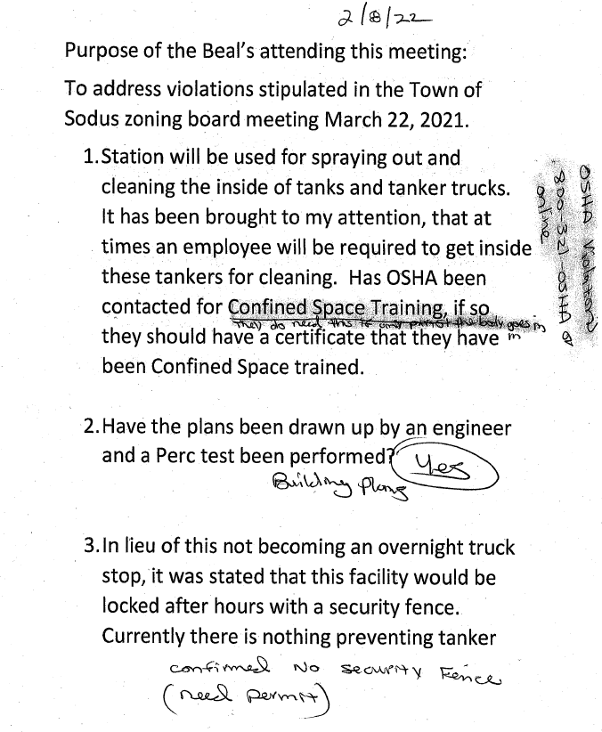
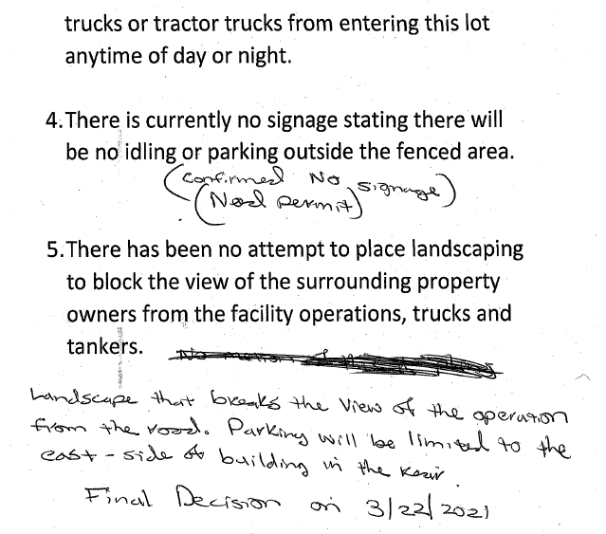
There was a lot of discussion on each item from the Beal’s, Munson, and the Sodus Town Board. Councilperson David LeRoy stated this needs to be addressed with Planning and Zoning right away. The Board as a whole (in particular Councilperson LeRoy) asked the Beal’s if they could give the Town a week to look into this and follow through. It was stated more research needed to be done and someone would follow up with them. The Beal’s and Munson were in agreement with the Town Board and appreciated everyone’s time and looking into this matter further. There were no further public comments.

SUPERVISOR’S REPORT
The Supervisor’s report was presented for January 2022. Councilperson Don Ross motioned to accept and file this report, which was seconded by Councilperson Chris Tertinek. Upon roll call the following votes were heard, Scott Johnson, aye; David LeRoy, aye; Don Ross, aye; Chris Tertinek, aye; and Cathy Willmott; aye. Motion carried.

MINUTES
Minutes from January 18, 2022 was presented to the Town Board for approval. Councilperson David LeRoy motioned to accept and file these Minutes, which was seconded by Councilperson Chris Tertinek. Upon roll call the following votes were heard, Supervisor Scott Johnson, aye; David LeRoy, aye; Don Ross aye Chris Tertinek, aye; and Cathy abstain (was absent); aye. Motion carried.

Minutes from January 25, 2022 was presented to the Town Board for approval. Councilperson David LeRoy motioned to accept and file these Minutes, which was seconded by Councilperson Don Ross. Upon roll call the following votes were heard, Supervisor Scott Johnson, aye; David LeRoy, aye; Don Ross aye Chris Tertinek, aye; and Cathy Willmott; aye. Motion carried.

TOWN CLERK’S REPORT
The Town Clerk’s Report, Town Clerk’s bank statements for audit, and bank register for January 2022 were presented. Councilperson Chris Tertinek motioned to accept and file these reports, which was seconded by Councilperson Cathy Willmott. Upon roll call the following votes were heard, Scott Johnson, aye; David LeRoy, aye; Don Ross, aye; Chris Tertinek, aye; and Cathy Willmott; aye. Motion carried.
TAX COLLECTION REPORT
The Tax Collection Report, Tax Collection bank statements for audit, and bank register for January 2022 were presented. Councilperson David LeRoy motioned to accept and file these reports, which was seconded by Councilperson Chris Tertinek. Upon roll call the following votes were heard, Scott Johnson, aye; David LeRoy, aye; Don Ross, aye; Chris Tertinek, aye; and Cathy Willmott; aye. Motion carried.

ABSTRACT
RESOLUTION TO PAY ABSTRACT No. 2
(01 02-2022)
WHEREAS, the following bills were presented for payment on Abstract 2:

General 026-062 $ 50,004.04
Highway 026-048 $ 54.805.42
Bridge Project 001-001 $ 3,092.85
Trust & Agency 003-003 $ 24,209.00
Sodus Center Fire 005-005 $ 99,040.00
Wallington Fire 003-003 $ 74,000.00
Alton Fire 004-004 $ 55,733.00
Special St. Lighting 002-002 $ 1,147.17
GRAND TOTAL: $ 362,031.48
Councilperson Chris Tertinek motioned to adopt this resolution which was seconded by Councilperson Cathy Willmott. Upon roll call the following votes were heard, Scott Johnson, aye; David LeRoy, aye; Don Ross, aye; Chris Tertinek, aye; and Cathy Willmott; aye. Resolution Adopted.

RECREATION/ENVIRONMENTAL COMMITTE: Cathy Willmott, Councilperson
(Recreation, Assessor, Parks, Cemeteries)
Recreation Report
(Sheila Fisher, Recreation Director)
Sheila Fisher had no activity to report.

Assessor’s Report
(Nathan Mack, Assessor)
Councilperson David LeRoy motioned to accept and file the monthly January 2022 Assessor’s Report from Sole Assessor, Nathan Mack was seconded by Councilperson Cathy Willmott. Upon roll call the following votes were heard, Scott Johnson, aye; David LeRoy, aye; Don Ross, aye; Chris Tertinek, aye; and Cathy Willmott; aye. Motion carried.

Camp Beechwood/Sodus Groundskeeper Report
(Sal Vittozzi-Caretaker-Sodus Town Groundkeeper)
Councilperson Don Ross motioned to accept the monthly January Camp Beechwood-Parks & Cemeteries Report from Sal Vittozzi; Sodus Town Groundskeeper-Caretaker was seconded by Councilperson Chris Tertinek. Upon roll call the following votes were heard, Scott Johnson, aye; David LeRoy, aye; Don Ross, aye; Chris Tertinek, aye; and Cathy Willmott; aye. Motion carried.

PUBLIC WORKS COMMITTEE: Councilperson David LeRoy, Chair
(Highway, Drainage - Deputy Town Supervisor)
HIGHWAY REPORT:
(Dale Pickering – Highway Superintendent)
Councilperson Cathy Willmott motioned to accept and file the monthly January 2022 Highway Report from Dale Pickering Highway Superintendent was seconded by Councilperson David LeRoy. Upon roll call the following votes were heard, Scott Johnson, aye; David LeRoy, aye; Don Ross, aye; Chris Tertinek, aye; and Cathy Willmott; aye. Motion carried.

There was discussion on the current LaBella invoice from Mike Duell. Councilperson David LeRoy discussed he will call Duell regarding the invoice. The Town Board is in agreement that the invoice is way overcharged for the final payment they are requesting. Supervisor Johnson offered to write a letter if necessary. More research and discussion needs to happen with LaBella before any invoice should be paid to them for final payment.

The Town Board is not in agreement with the recent Mylerson invoice. Mylerson came in way over the quote on their bills and the original quote given. Again, more research needs to be done regarding the most current pay app submitted. The Board will be holding off on payment until further notice.

Councilperson David LeRoy motioned reject the Pipitone proposal was seconded by Councilperson Chris Tertinek. Upon roll call the following votes were heard, Scott Johnson, aye; David LeRoy, aye; Don Ross, aye; Chris Tertinek, aye; and Cathy Willmott; aye. Motion carried.

SALT BARN UPDATE:
MRB Proposal-see “Correspondence Section – # 5”

DRAINAGE:
(N/A)

BUILDINGS AND GROUNDS COMMITTEE: Councilperson Chris Tertinek, Chair
(Town Property, Animal Control, Flood Damage Prevention)
CODE ENFORCEMENT REPORT:
Craig Schwartz- CEO
Councilperson David LeRoy motioned to accept the monthly January 2022 Code Enforcement Report as written was seconded by Councilperson Cathy Willmott. Upon roll call the following votes were heard, Scott Johnson, aye; David LeRoy, aye; Don Ross, aye; Chris Tertinek, aye; and Cathy Willmott; aye. Motion carried.

DOG CONTROL REPORT:
Tracy Brown, Primary DCO
Craig Schwartz- Secondary DCO
No activity

FLOOD DAMAGE PREVENTION REPORT-Code 69:
Chris Tertinek, Councilperson
Chris gave his Flood Damage Prevention Report.

PUBLIC SAFETY/DRAINAGE/ENVIRONMENT COMMITTEE: Councilperson Don Ross, Chair (Fire, Ambulance, Emergency Preparedness)
Councilperson Don Ross discussed the next upcoming SESA meeting and WCWSA meeting.

TOWN HALL COMMITTEE: Scott Johnson, Supervisor
(Personnel, Clerks, Justices, Assessor, Building Inspector, Town Council, Boards, Insurances, Finance)

CORRESPONDENCE & INFORMATION

SCHOOL STREET BRIDGE
AUTHORIZATION TO SIGN INTER-MUNICIPAL AGREEMENT WITH TOWN OF SODUS
RESOLUTION
(02 02-2022)

WHEREAS, The Town of Sodus is progressing a bridge rehabilitation project utilizing Federal and State funding, and

WHEREAS, the design of the project will extend the limit of work outside of the town road highway boundary and into a property owned by Wayne County, and

WHEREAS, in lieu of a formal filed easement to perform this work, the NYSDOT will accept an inter-municipal agreement authorizing the Town of Sodus’ project to utilize Wayne County property while completing the work, now, therefore be it

RESOLVED, Councilperson David LeRoy motioned to adopt this resolution which was seconded by Councilperson Cathy Willmott that the Sodus Town Supervisor Scott Johnson is authorized to sign an inter-municipal agreement with the Town of Sodus .Upon roll call the following votes were heard, Scott Johnson, aye; David LeRoy, aye; Don Ross, aye; Chris Tertinek, aye; and Cathy Willmott; aye. Resolution Adopted.

TOWN OF SODUS COURT FISCAL EXAMINATION -2021
(03 02-2022)
Supervisor Johnson offered the following resolution for its adoption:

WHEREAS, The NYS Unified Court System requires that the Town of Sodus Court’s records are examined for each fiscal year and that the Town of Sodus notifies accordingly that it was conducted, and

NOW THEREFORE BE IT RESOLVED, Deputy Supervisor David LeRoy conducted the examination of the Town of Sodus Court fiscal records for 2021 and found the review of records in good standing, and

FURTHER BE IT RESOLVED, Councilperson Chris Tertinek motioned to adopt this resolution was seconded by Councilperson Cathy Willmott. Upon roll call the following votes were heard, Supervisor Scott E. Johnson, aye; David LeRoy, aye; Don Ross, aye; Chris Tertinek, aye; and Cathy Willmott, aye. Resolution adopted.

Councilperson Cathy Willmott motioned to approve the Town of Sodus to purchase from Alternative Technology one new an unused server in the amount of $1,765.00 for the Town of Sodus and approve labor at $60.00 per hour was seconded by Councilperson Chris Tertinek. Upon roll call, the following votes were heard Supervisor Scott Johnson, aye; LeRoy, aye; Ross, aye; Tertinek, aye; and Willmott, aye. Motion carried.

Councilperson Don Ross motioned to allow Supervisor Scott Johnson to sign “Proposal for Professional Services for the Highway Department Salt Barn-Rotterdam Rd. Design, Bidding and Construction Phase Services” with MRB Group was seconded by Councilperson Chris Tertinek. Upon roll call, the following votes were heard Supervisor Scott Johnson, aye; LeRoy, aye; Ross, aye; Tertinek, aye; and Willmott, aye. Motion carried.
RETENTION AND DISPOSTION SCHEDULE FOR NYLGR-LGS-1 SCHEDULE
RESOLUTION
(04 02-2022)
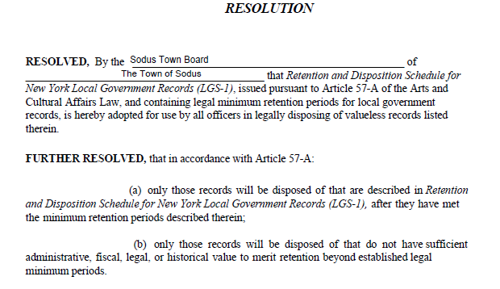
FURTHER BE IT RESOLVED, Councilperson Cathy Willmott motioned to adopt this resolution was seconded by Councilperson David LeRoy. Upon roll call the following votes were heard, Supervisor Scott E. Johnson, aye; David LeRoy, aye; Don Ross, aye; Chris Tertinek, aye; and Cathy Willmott, aye. Resolution Adopted.

AKNOWLEDGING NYS LGS-1 AS THE FREEDOM OF INFORMATION (FOIL) DOCUMENTS TO THE PUBLIC UPON REQUEST
(05 02-2022)
FURTHER BE IT RESOLVED, Councilperson Don Ross motioned to acknowledge the NYS LGS-1 as the Freedom of Information Law documents to the public upon request was seconded by Councilperson Cathy Willmott. Upon roll call the following votes were heard, Supervisor Scott E. Johnson, aye; David LeRoy, aye; Don Ross, aye; Chris Tertinek, aye; and Cathy Willmott, aye. Resolution Adopted.
The Justice Court Assistance Program JCAP grant award for the Sodus Town Court was awarded in the amount of $14,178.07.

Councilperson Chris Tertinek motioned to approve Amy Kendall’s letter to send out to John La Clair was seconded by Councilperson Don Ross. Upon roll call, the following votes were heard Supervisor Scott Johnson, aye; LeRoy, aye; Ross, aye; Tertinek, aye; and Willmott, aye. Motion carried.

DISCUSSION:
Councilperson Cathy Willmott would like to discuss soon the paid FMLA plan for the Town of Sodus.

Councilperson Cathy Willmott discussed the Beechwood Committee and who can be on the committee itself.

Councilperson Don Ross motioned to adjourn the meeting was seconded by Councilperson Cathy Willmott. Upon roll call the following votes were heard, Scott Johnson, aye; David LeRoy, aye; Don Ross, aye; Chris Tertinek, aye; and Cathy Willmott; aye. Motion carried.

Meeting adjourned at 8:12 PM
Recording Secretary,

Minutes Written By:
Lori Diver Sodus Town Clerk, RMC

