AGENDA
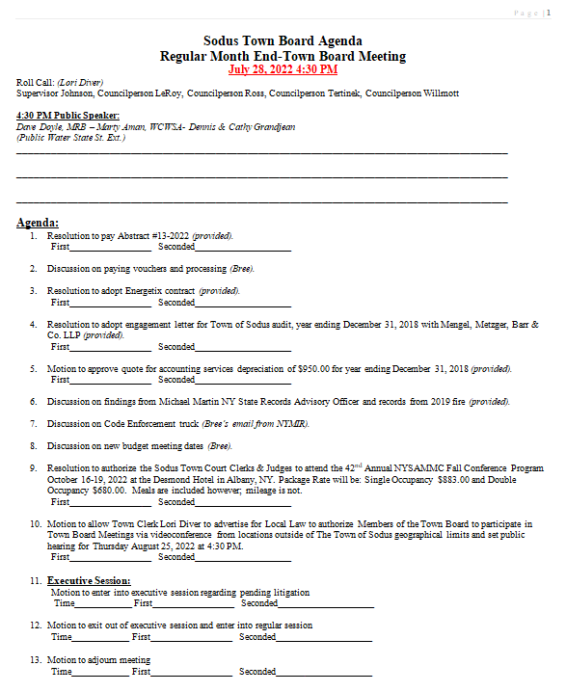

MINUTES
Minutes of the Month End Town Board Meeting commencing at 4:30 PM in the upstairs meeting room July 28, 2022 located at 14-16 Mill St. Sodus, NY 14551.
All meetings are open to the public.
In addition this meeting was available through Zoom. Legal Notices were published and posted accordingly.

Present: Scott Johnson, Supervisor
David LeRoy, Councilperson/Deputy Supervisor Don Ross, Councilperson (Zoom)
Chris Tertinek, Councilperson
Cathy Willmott, Councilperson

Recording Secretary: Lori Diver, Sodus Town Clerk-RMC

Absent: N/A

Others Present: Bree Crandell- Supervisor Clerk
Cathy Grandjean, State St. Ext. Public Water
Dennis Grandjean, State St. Ext. Public Water
Dave Doyle, MRB
Marty Aman, WCWSA
Amy Kendall, Town Attorney (Zoom)
Casey Carpenter, Times of Wayne County (Zoom)

Supervisor Scott Johnson called the Month End Town Board Meeting to order commencing at 4:30 PM and Lori Diver opened with roll call. All were present with the exception of Councilperson Chris Tertinek.

Public Speaker:
(Dennis and Cathy Grandjean State St. Ext. Public Water)
Dennis and Cathy Grandjean were asked to be present at this meeting to talk about their request of public water on State St. Extension. Discussion was held with the Grandjean’s Marty Aman with WCWSA, Dave Doyle with MRB and the Town Board. It was stated it might be possible to hook State Street Extension into proposed WD No. 12.

The Grandjean’s stated at the Regular Meeting last month (July 12, 2022) that there is not enough interest alone on State Street Extension to get public water. They were informed they could hook into public water as a, “Out of District User” however; the Grandjean’s would really like to see water on the road as well as their neighbor the Lesniak’s. The Grandjean’s would like to retire and build on the property they own and explained that the current well would not have enough pressure or water to supply the house.

Dave Doyle will look into the potential of adding State Street Extension to the proposed WD No. 12. The Grandjean’s thanked everyone for the time involved in making this possibly work.

Dave Doyle shared the plans are 98% complete for the Salt Barn. Councilperson David LeRoy stated he would like the bid process to start in early spring of 2023.

ABSTRACT
RESOLUTION TO PAY ABSTRACT No. 013
(06 07-2022)
WHEREAS, the following bills were presented for payment on Abstract 013:

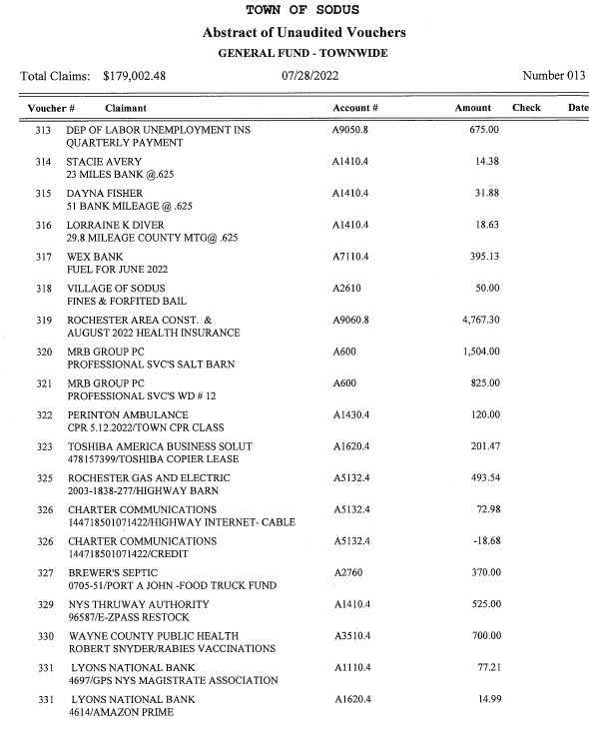
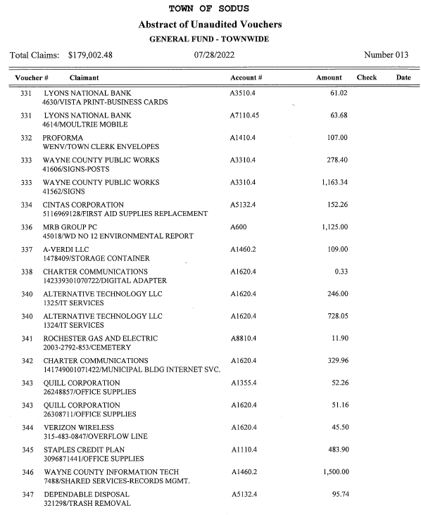

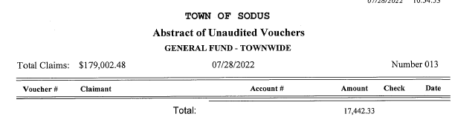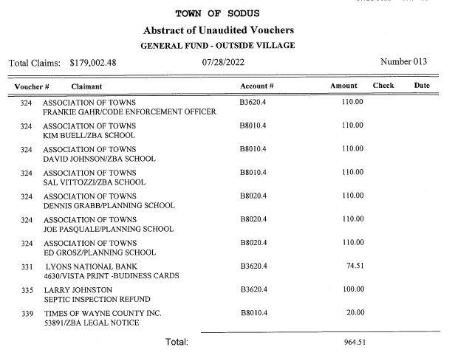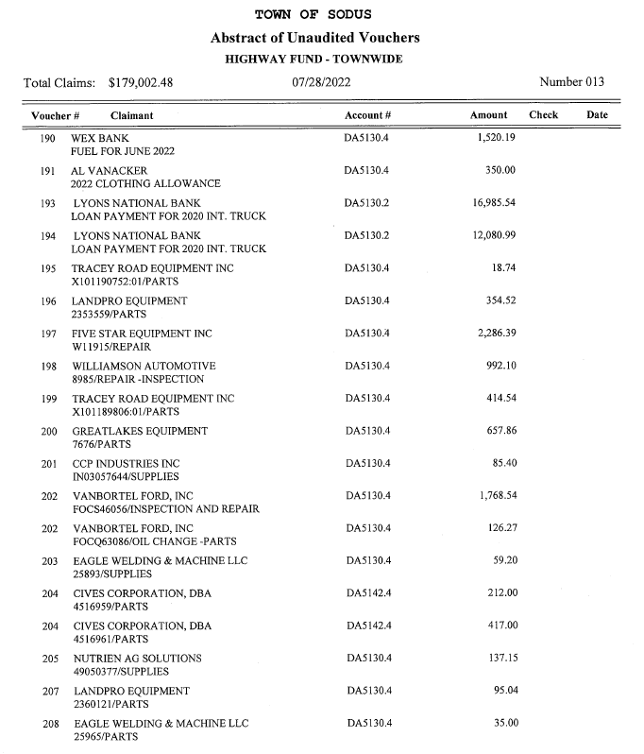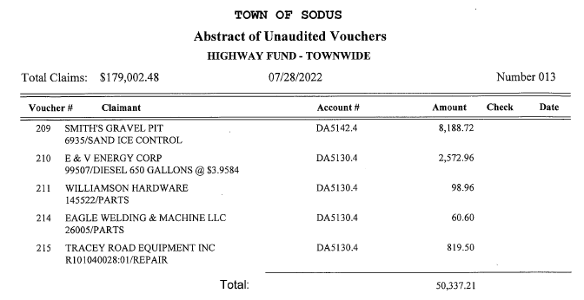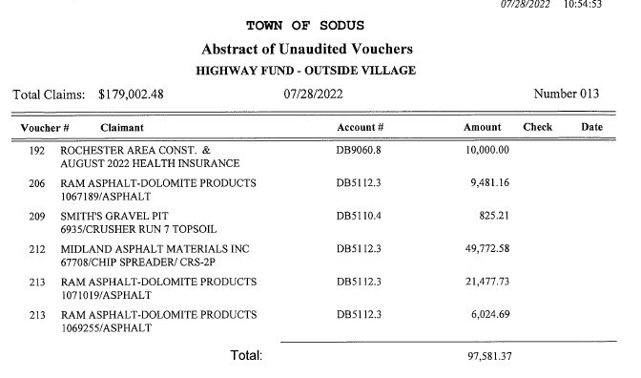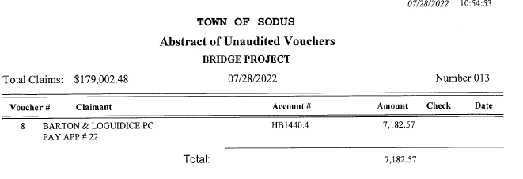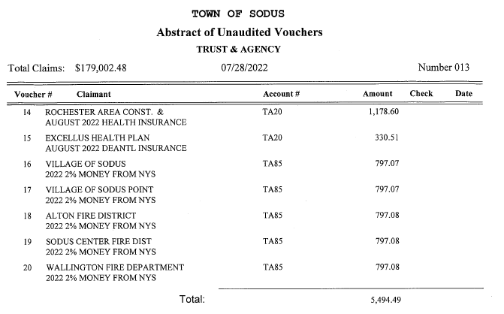
Councilperson David LeRoy motioned to adopt this resolution which was seconded by Councilperson Cathy Willmott. Upon roll call the following votes were heard, Scott Johnson, aye; David LeRoy, aye; Don Ross, aye; Chris Tertinek, aye; and Cathy Willmott; aye. Resolution Adopted.

Supervisor Clerk Bree Crandell discussed with the Board the current payment process for all the Town’s bills. Since 2020, there have been three different completed abstracts of vouchers (paid checks for bills) that have come up missing within the US Postal Office. Bree informed the Board that the Town could start paying bills through on-line bill pay and by credit card. It was noted, not all vendors will participate but, those that do offer this option will allow the payments to be posted almost immediately and with confirmation. This process will be slow to set up but, Bree will start working on what needs to be done to make this happen (most likely after budget season).

ENERGETIX AGREEMENT
RESOLUTION
(07 07-2022)
Supervisor Scott Johnson offered the following resolution for its adoption;
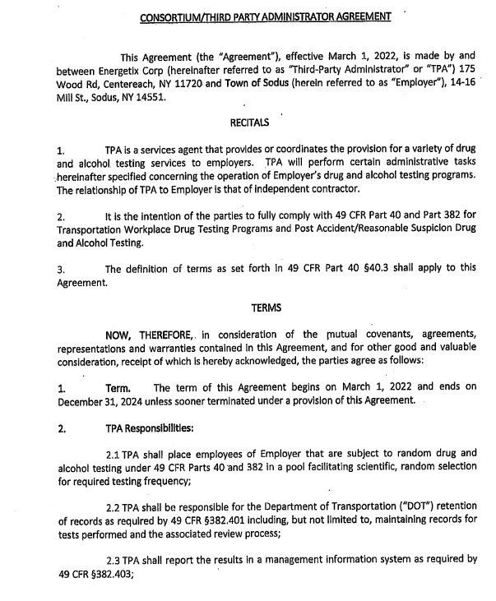
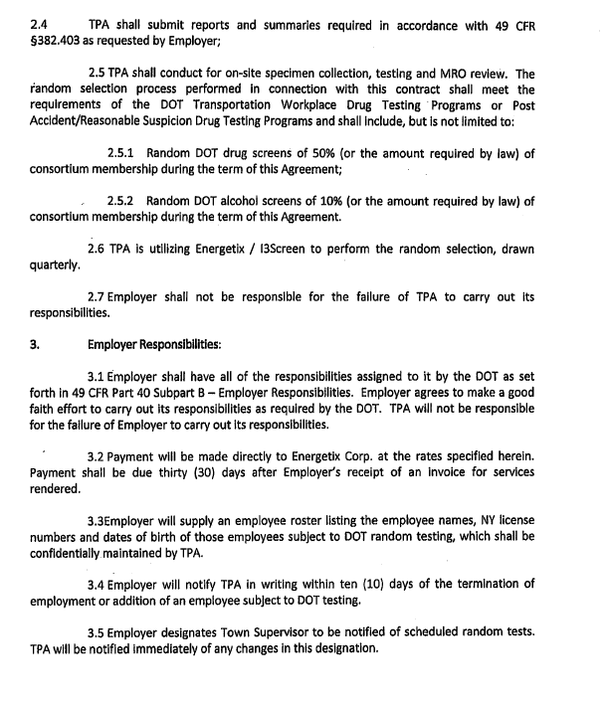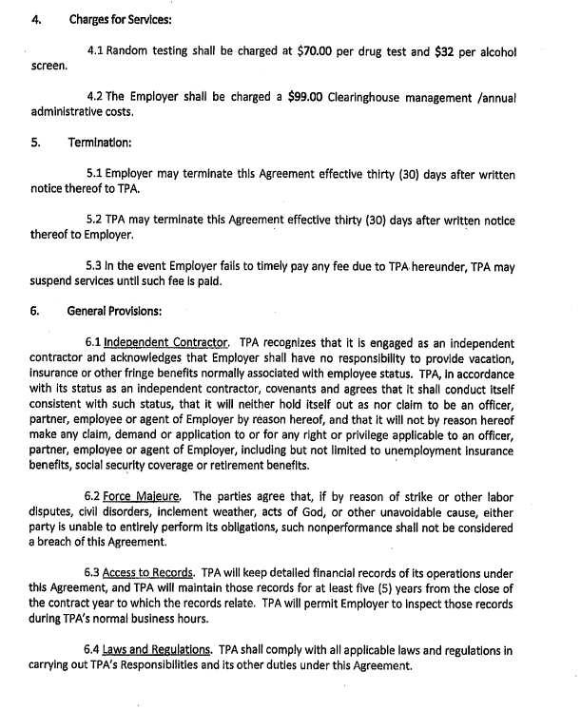
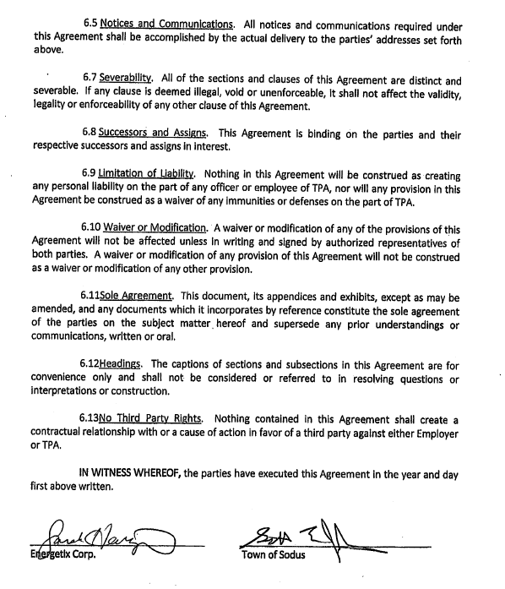
RESOLVED, Councilperson David LeRoy motioned to adopt the Energetix agreement resolution was seconded by Councilperson Don Ross. Upon roll call the following votes were heard, Scott Johnson, aye; David LeRoy, aye; Don Ross, aye; Chris Tertinek, aye; and Cathy Willmott; abstain. Resolution Adopted.

MENGEL, METZGER, BARR, & CO. LLP 2018 AUDIT
RESOLUTION
(08 07-2022)
Supervisor Scott Johnson offered the following resolution for its adoption; 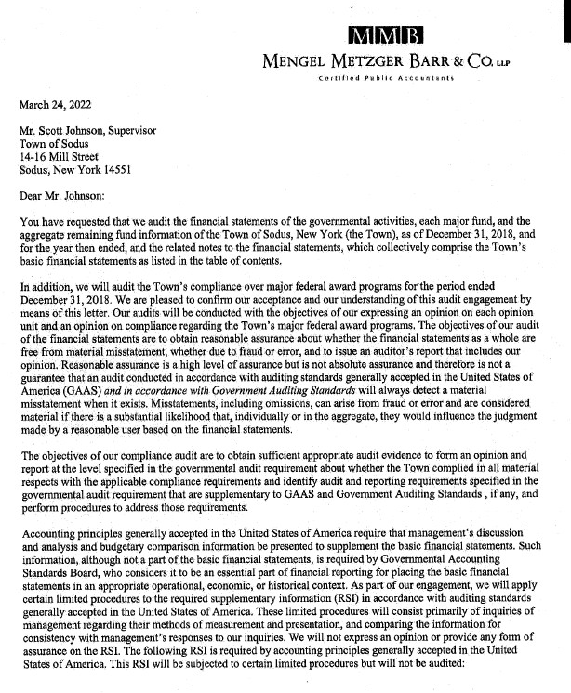
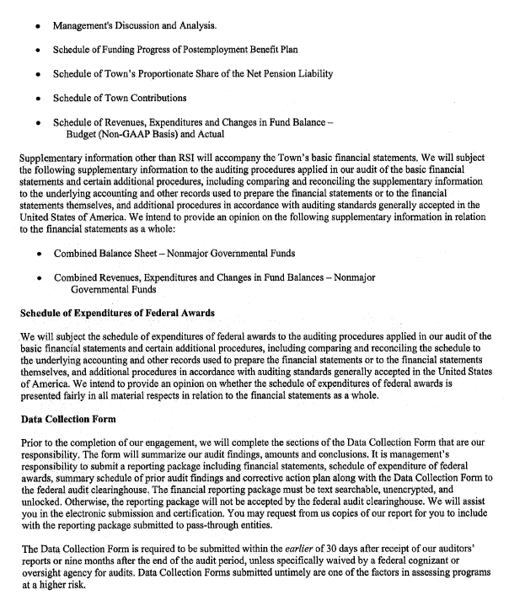
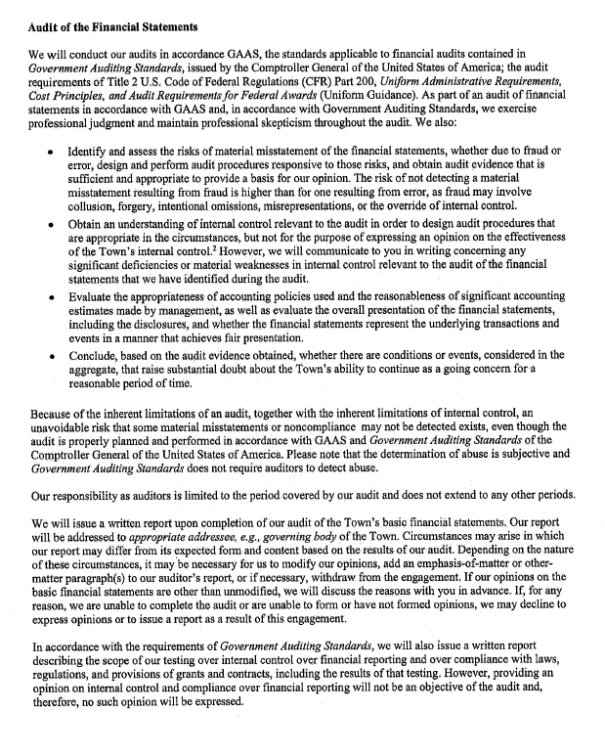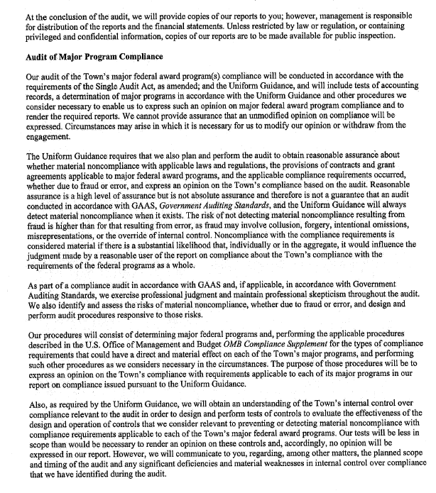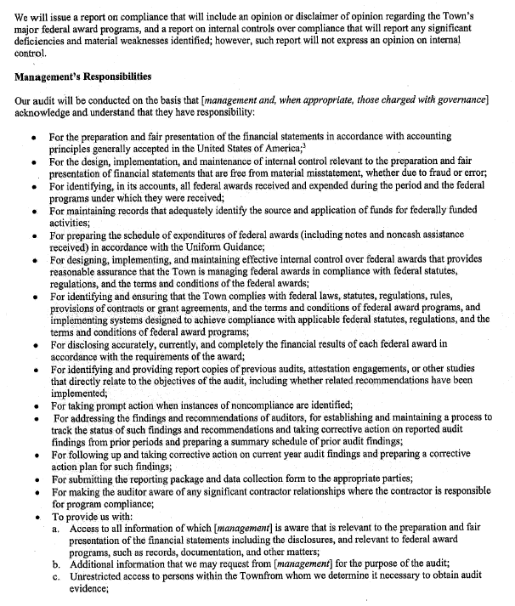
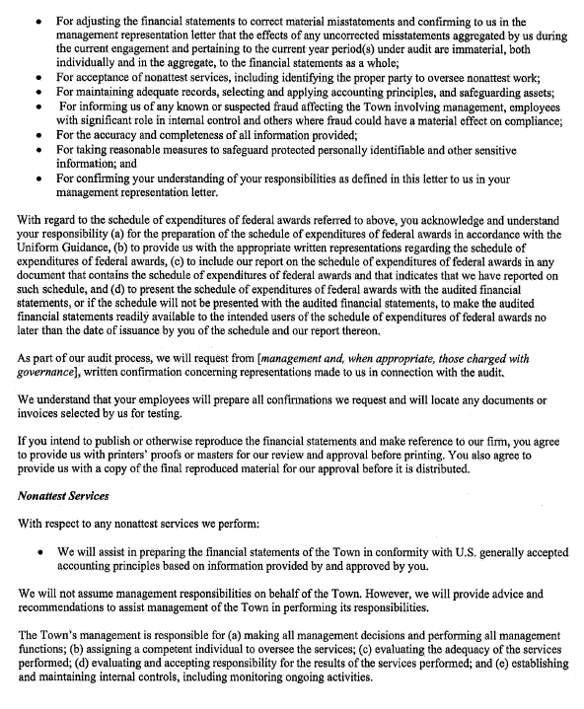
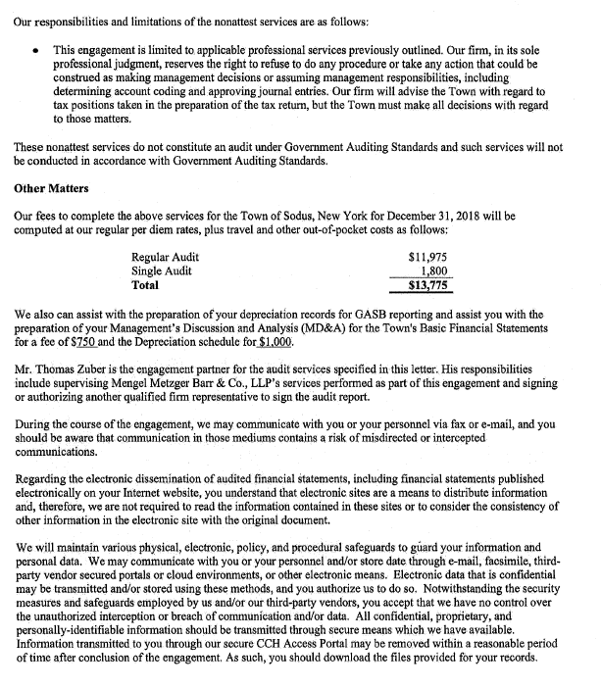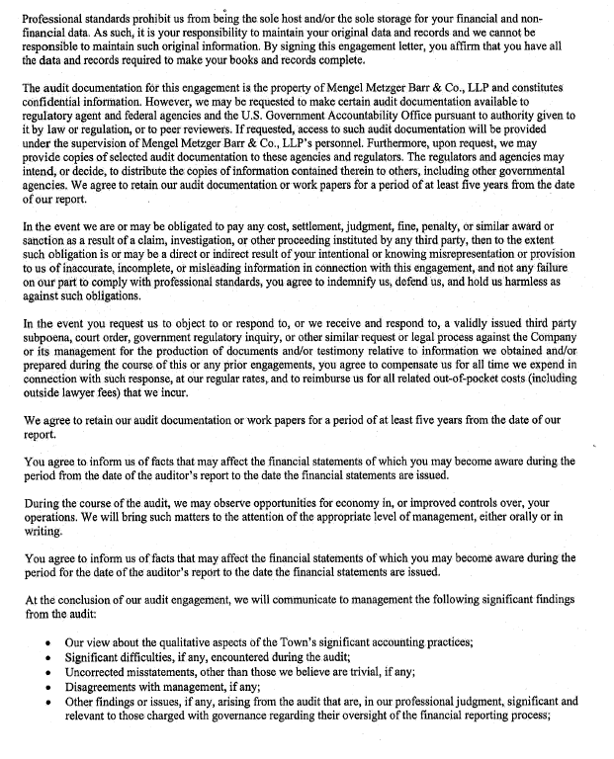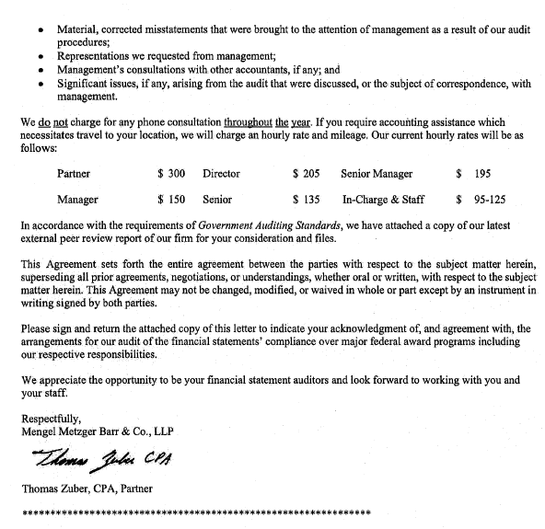
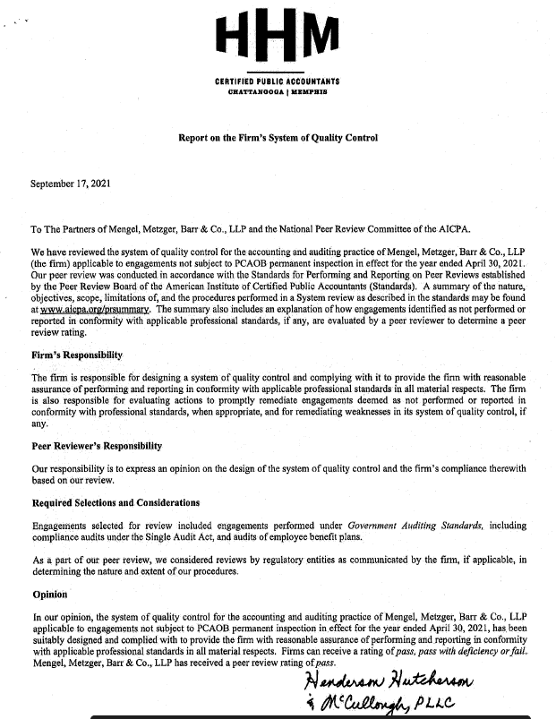

BE IT RESOLVED, Councilperson Cathy Willmott motioned to adopt engagement letter for Town of Sodus audit, year ending December 31, 2018 with Mengel, Metzger, Barr & Co. LLP which was seconded by Councilperson David LeRoy. Upon roll call the following votes were heard, Scott Johnson, aye; David LeRoy, aye; Don Ross, aye; Chris Tertinek, aye; and Cathy Wilmott, aye. Resolution Adopted.

MENGEL, METZGER, BARR & CO. LLP DEPRECIATION AUDIT
RESOLUTION
(09 07-2022)
Supervisor Scott Johnson offered the following resolution for its adoption;
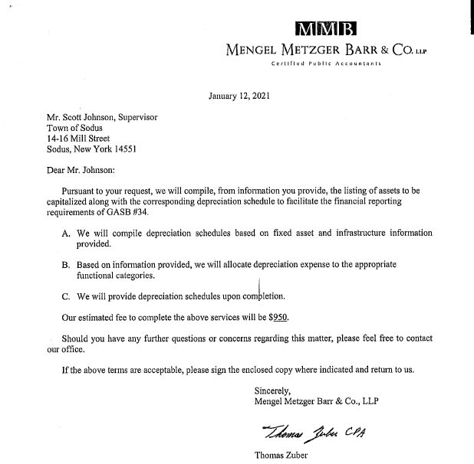

BE IT RESOLVED, Councilperson Cathy Willmott motioned to adopt quote for accounting services depreciation of $950.00 for year ending December 31, 2018 with Mengel, Metzger, Barr & Co. LLP was seconded by Councilperson David LeRoy. Upon roll call the following votes were heard, Scott Johnson, aye; David LeRoy, aye; Don Ross, aye; Chris Tertinek, aye; and Cathy Wilmott, aye. Resolution Adopted.

Lori Diver Town Clerk discussed with the Board the records that were involved in the fire of 2019 at the Highway Barn. Michael Martin from NY State Records and Archives came out for a site visit at my request to see if the records were salvageable. The damage to the records was only to the outside of the boxes with mold spores on them. The records can be saved. Currently they are at the Highway Barn in a A-Verdi container.

Letter from Michael Martin and his report as submitted:
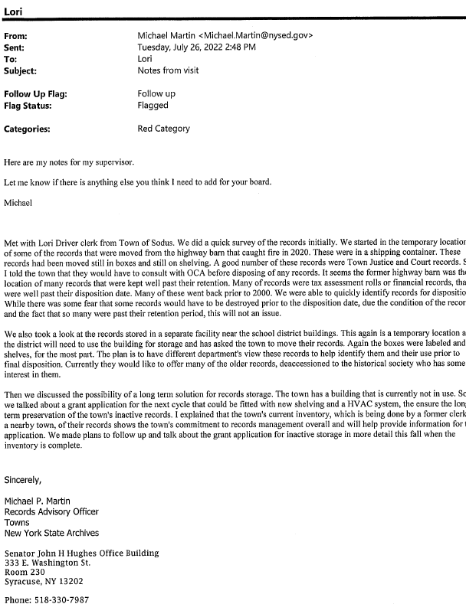

Lori Diver shared the issue with the current records located at the Sodus Central Elementary School is not in good shape. Mice and possible other rodents are eating them. There is no climate control. The School has asked us to relocate our records as well but, has not put a time frame on when we need to move them.

Susie Jacobs, Lori Diver, Dale Pickering and David LeRoy took a tour to the old landfill site and building. There is potential of relocating the records in this building with a possible grant and some building modifications in the future. In the meantime, Dale Pickering needs the A-Verdi container relocated because of limited space at the Town Highway Barn property.

Councilperson Don Ross motioned to authorize Dale Pickering to contact A-Verdi to relocate storage container full of records from the 2019 fire to the old landfill site as soon as possible was seconded by Councilperson Cathy Willmott. Upon roll call the following votes were heard, Scott Johnson, aye; David LeRoy, aye; Don Ross, aye; Chris Tertinek, aye; and Cathy Willmott; aye. Motion carried.

Councilperson Don Ross motioned to authorize Lori Diver to purchase to trail cams and put on the Moultrie Plan (Sal uses at Beechwood) for the records container at the old landfill site was seconded by Councilperson Cathy Willmott. Upon roll call the following votes were heard, Scott Johnson, aye; David LeRoy, aye; Don Ross, aye; Chris Tertinek, aye; and Cathy Willmott; aye. Motion carried.

The Board discussed the Code Enforcement truck that was totaled in an accident recently that Code Enforcement Officer Frankie Gahr was driving. The Town Board discussed and decided that they will not be replacing the vehicle. Supervisor Scott Johnson will inform Frankie Gahr that he will need to use his own personal vehicle for transportation.

Bree Crandell Supervisor Clerk discussed with the Sodus Town Board that the Budget Meeting Workshops will not be scattered on dates throughout September and October as usual. The Board agreed with Crandell that the Budget Workshops will be held September 12th – September 16th from 9:00 AM – 5:00 PM.

COURT CLERKS & JUDGES CONFERENCE
RESOLUTION
(09 07-2022)
Supervisor Scott Johnson offered the following resolution for its adoption;

BE IT RESOLVED, Councilperson David LeRoy motioned to authorize and allow the Sodus Town Court Clerks & Judges to attend the 42nd Annual NYSAMMC Fall Conference Program October 16-19, 2022 at the Desmond Hotel in Albany, NY. Package rate will be single occupancy $883.00 and double occupancy $680.00. Meals are included however; mileage is not was seconded by Councilperson Cathy Willmott. Upon roll call the following votes were heard, Scott Johnson, aye; David LeRoy, aye; Don Ross, aye; Chris Tertinek, aye; and Cathy Willmott; aye. Resolution Adopted.

Councilperson Don Ross motioned to authorize Lori Diver to advertise for Local Law that will authorize members of the Town Board to participate in Town Board meetings via videoconference from locations outside of the Town of Sodus geographical limits and set public hearing for Thursday August 25th, 2022 at 4:30 PM was seconded by Councilperson Cathy Willmott. Upon roll call the following votes were heard, Scott Johnson, aye; David LeRoy, aye; Don Ross, aye; Chris Tertinek, aye; and Cathy Willmott; aye. Motion carried.

Town Attorney Amy Kendall notified the Board that she is working on revamping Property Maintenance Law to repeal and replace Chapter 95 altogether. She shared that she is almost complete and will present a draft copy to the Board once complete.

Councilperson Cathy Willmott motioned to enter into executive session at 5:20 PM regarding a personnel issue with a particular person was seconded by Councilperson Don Ross. Upon roll call, the following votes were heard Supervisor Scott Johnson, aye; LeRoy, aye; Ross, aye; Tertinek, aye; and Willmott, aye. Motion carried.

Councilperson Don Ross motioned to exit out of executive session at 5:27 PM and enter into its regular session was seconded by Councilperson Cathy Willmott. Upon roll call, the following votes were heard Supervisor Scott Johnson, aye; LeRoy, aye; Ross, aye; Tertinek, aye; and Willmott, aye. Motion carried.

Councilperson Cathy Willmott motioned to adjourn the meeting was seconded by Councilperson Don Ross. Upon roll call the following votes were heard, Scott Johnson, aye; David LeRoy, aye; Don Ross, aye; Chris Tertinek, aye; and Cathy Willmott; aye. Motion carried.

Meeting adjourned at 5:27 PM
Recording Secretary,
Minutes Written By:
Lori Diver Sodus Town Clerk, RMC

