MINUTES
Minutes of the Sodus Town Board Executive Session Meeting commencing at 5:00 PM in the Upstairs Meeting Room July 9, 2019, located at 14-16 Mill St. Sodus, NY 14551.
All meetings are open to the public.

Present: Steven LeRoy, Supervisor
David LeRoy, Councilperson/Deputy Supervisor
Jim Quinn, Councilperson
Don Ross, Councilperson
Scott Johnson, Councilperson

Recording Secretary: Lori Diver, Town Clerk

EXECUTIVE SESSION MEETING:
Supervisor, Steve LeRoy called the meeting to order with a motion by Jim Quinn to enter into Executive Session at 5:00 PM regarding a personnel issue relative to a particular person was seconded by Councilperson David LeRoy. Upon roll call the following votes were heard, Supervisor Steven LeRoy, aye; David LeRoy, aye; Quinn, aye; Ross, aye; Johnson, aye. Motion carried.

Councilperson Jim Quinn motioned to exit out of Executive Session and enter into Regular Session at 6:46 PM was seconded by Councilperson David LeRoy. Upon roll call the following votes were heard, Supervisor Steven LeRoy, aye; David LeRoy, aye; Quinn, aye; Ross, aye; Johnson, aye. Motion carried.

Councilperson Scott Johnson motioned to adjourn the Executive Session Meeting was seconded by Councilperson Jim Quinn. Upon roll call the following votes were heard, Steven LeRoy, aye; David LeRoy, aye; Quinn, aye; Ross, aye; Johnson, aye. Motion carried.

Meeting adjourned at 6:46 PM
Recording Secretary,

Lori K. Diver
Sodus Town Clerk, RMC

MINUTES
Minutes of the Regular Sodus Town Board Meeting held in the Sodus Town Court Room July 9, 2019, 14-16 Mill St. Sodus, NY 14551, commencing at 7:00 PM.
All meetings are open to the public.

Present: Steven LeRoy, Supervisor
David LeRoy, Councilperson/Deputy Supervisor
Jim Quinn, Councilperson
Don Ross, Councilperson
Scott Johnson, Councilperson

Recording Secretary: Lori Diver, Town Clerk

Absent: N/A

Others Present: Dale Pickering, Highway Superintendent
Sal Vittozzi, Sodus Town Groundskeeper
Josh Faulks, Sun & Record
Kevin Schulte, Greenspark Solar
Chris Tertinek, Former Sodus Point Mayor
Kim Buell, T/Sodus Zoning Board Member
Tony Villani, Town Attorney
Sharon Purdy, “Santa Comes to Town Donation”
Craig Wollesen, “State Street Complaint”

Supervisor, Steve LeRoy called the Regular Town Board Meeting to order commencing at 7:00 PM with the Pledge of Allegiance and Lori Diver opened with roll call.

MINUTES
Councilperson Jim Quinn motioned to approve the Minutes of the June 18, 2019
Regular Town Board Meeting was seconded by Councilperson Don Ross. Upon roll call the following votes were heard, Steven LeRoy, aye; David LeRoy, aye; Quinn, aye; Ross, aye; Johnson, aye. Motion carried.

SUPERVISOR’S REPORT
The Supervisor’s Report for June 2019 was tabled until the next board meeting.

TOWN CLERK’S REPORT
The Town Clerk’s Reports, Town Clerk’s bank statements for audit, and bank register for June 2019 were presented. Councilperson David LeRoy motioned to accept and file these reports, which was seconded by Councilperson Scott Johnson. Upon roll call the following votes were heard, Steven LeRoy, aye; David LeRoy, aye; Quinn, aye; Ross, aye; Johnson, aye. Motion carried.

ABSTRACT
RESOLUTION TO PAY ABSTRACT NO #12
(01 07-2019)
WHEREAS, the following bills were presented for payment on Abstract 12:

General 256-284 $ 21,985.16
Highway 171-187 $ 67,223.45
Special Districts 028-028 $ 893.64
Water District #5-1 001-001 $ 672.86
Sewer Districts 011-011 $ 700.50
GRAND TOTAL: $ 91,475.61

NOW BE IT RESOLVED, Councilperson David LeRoy motioned to approve payment of these bills as reviewed for Abstract No. 12, which was seconded by Councilperson Don Ross. Upon roll call the following votes were heard, Steven LeRoy, aye; David LeRoy, aye; Quinn, aye; Ross, aye; Johnson, aye. Resolution adopted.

PUBLIC COMMENTS
(Craig Wollesen)
Craig Wollesen owner of 7352 State St. Sodus, NY 14551 came to the Town Board complaining about large hole that is in his front yard (on his private property).
Dale Pickering Highway Superintendent shared with Craig that there is a catch basin west of Craig’s property. Craig claims that the catch basin is too high and needs to be trimmed down causing part of the issue. Dale stated that Craig’s has a dilapidated pipe system buried underground on his property. The pipe has Mirafi wrapped around it, is migrating and is buried on Craig’s private property.
Craig claims when Harvest Drive was built up many years ago, this is what started the problems with the flooding in the road (in front of his property). Craig provided pictures to the Town Board of his front yard; the damage the water has caused with the recent rainfall. Craig claims this has been going on for 20 years and the underdrain put in to help with the drainage is not perforated pipe.
Craig disagreed with Dale regarding pipe buried in his front yard. Dale reassured Craig he will find 12” galvanize pipe if he digs a bit more in that hole. Dale stated he tried to notify Craig of the pipe but, was unable to reach him several times. Craig claimed the non-perforated pipe in front of the road is causing a significant amount of the problem. Dale claims even if he fixes the pipe and the catch basin it is not going to fix the hole and water problem in his front yard. However, it will address the water collecting in the road though. Dale will repair those two issues as soon as possible (after paving many town roads is finished) and email Craig photos of the pipe buried in his front yard. Craig states he is tired of his tractor breaking because of this issue. Dale said that he will contact Craig to help the best he can with what he can.

BID OPENENING 7:15 PM
(Compaction Test/Study –Salt Barn)

Lori Diver, Sodus Town Clerk read the following legal notice:

LEGAL NOTICE
NOTICE TO BIDDERS
PLEASE TAKE NOTICE: The Town Board of the Town of Sodus will receive sealed bids for a “Compaction-Test/Study” for approximately a 72 foot by 152 foot Salt Barn. We are storing approximately 10,000 tons of sand/salt mixture outside in the elements.

BID notices may be picked up at the Sodus Town Clerk’s Office, 14-16 Mill St. Sodus, NY 14551. The sealed bids will be opened and read at the Regular Town Board Meeting at 7:15 PM July 9, 2019, located at 14-16 Mill St. Sodus, NY. Sealed Bids must be received by 5:00 PM on July 9, 2019 at the Sodus Town Clerks Office. The Sodus Town Board and the Superintendent of Highways reserves the right to reject any or all bids received.

By Order of the Sodus Town Board
Lorraine Diver, Sodus Town Clerk
Dated: June 19, 2019

Supervisor LeRoy read the following BIDS submitted to the Town Board as follows:

- New York State Woman Business Enterprises
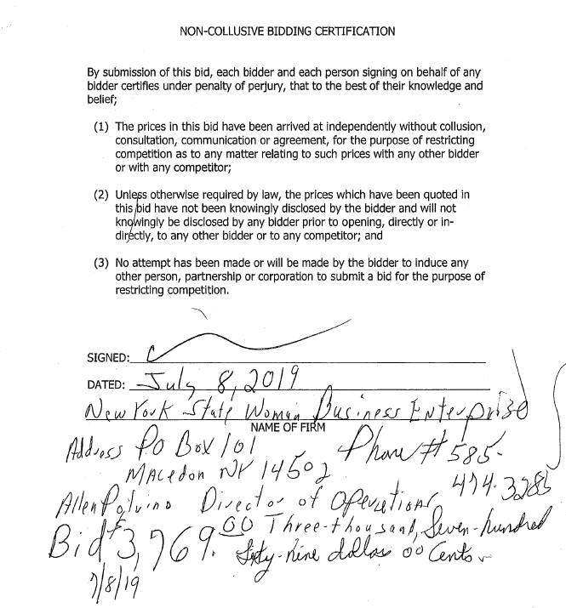

- PA Passero Associates
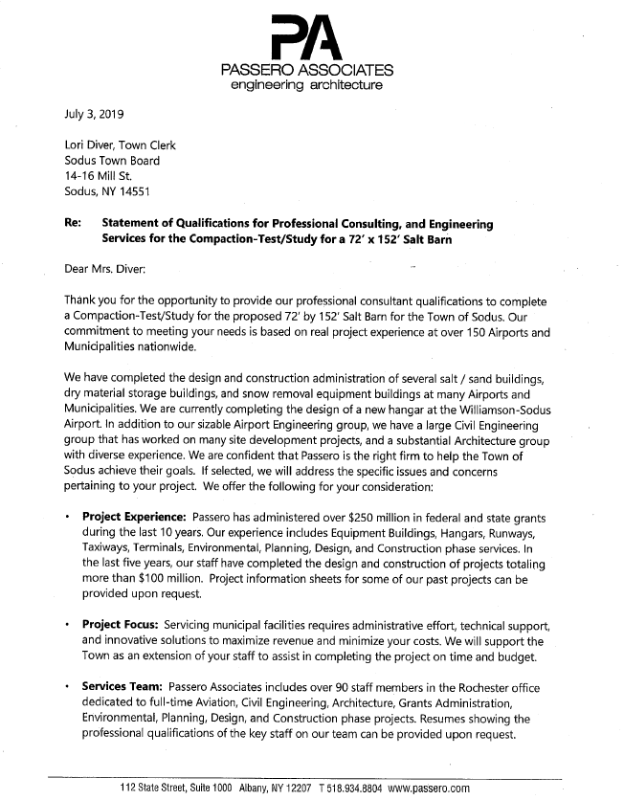
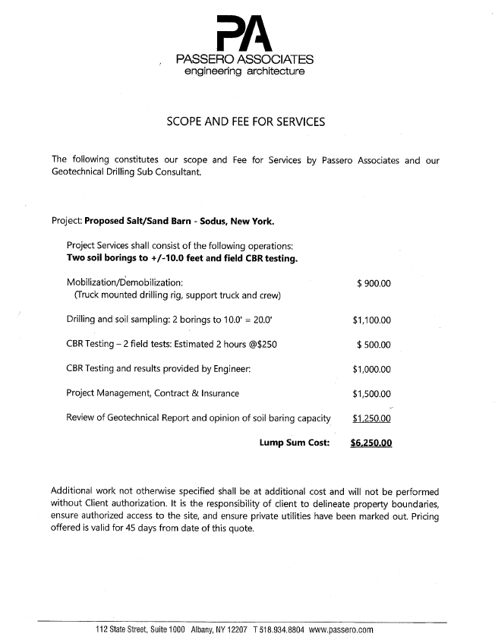

- SJB Services, Inc.
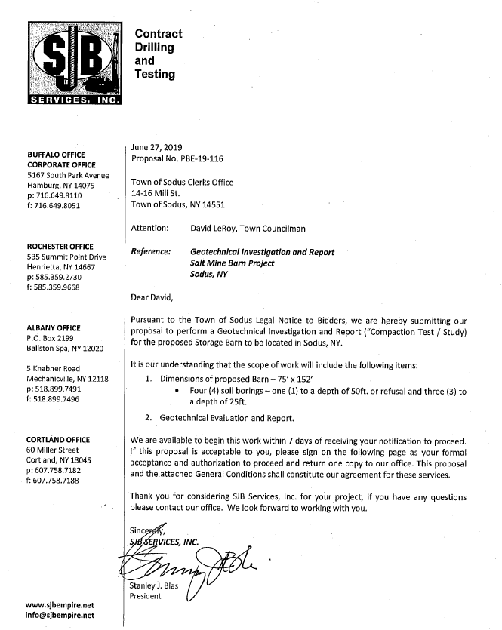
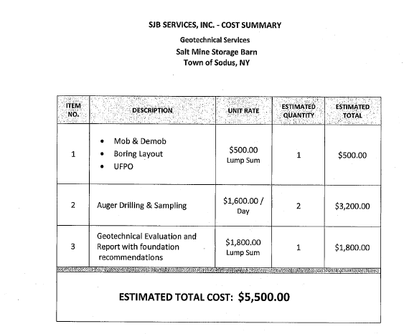

Supervisor LeRoy, the Board, and Highway Superintendent discussed the submitted quotes. Highway Superintendent Dale Pickering discussed with Councilperson David LeRoy and the Board the NYS Woman Business Enterprise was incomplete. With the one bid being incomplete and the lowest bidder was SJB Services, Inc. at an estimated cost of $5,500.00.

Councilperson Scott Johnson motioned to award the BID to SJB Services Inc. at an estimated total cost of $5,500.00 was seconded by Councilperson David LeRoy. Upon roll call the following votes were heard, Steven LeRoy, aye; David LeRoy, aye; Quinn, aye; Ross, aye; and Johnson, aye. Motion carried.

PUBLIC COMMENTS
(Kevin Schulte-Greenspark Solar)
Kevin discussed with the Town Board the opportunity available to the Town of Sodus to tie into the solar project offered at the Homer Wang property on N. Geneva Rd. The RG&E billing gathered over the last year and provided to Kevin showed the Town spent around $36,000 to $37,000 annually. This particular project is a little smaller than what they are currently doing. With the analysis sent, it has been determined that the Town of Sodus does not need the output from the project in Huron and the Homer Wang property. The Town would benefit from just the output of the Homer Wang solar project. The output would be 40% and would save the Town around $5,400.00 a year. The savings would be about 90% of the current electric bill which would be reduced about 18% with a net savings of about 15%. The types of reduction would be in street lighting, garages, etc. with the Town of Sodus. The Town would be locked into a rate with the solar project vs. a jump of escalating rates with RG&E. This is a benefit the town would get from being a solar customer.

Kevin explained to the Board that this is a cash transaction for the Town. The rate of compensation for the Town of Sodus would be locked into a 25 year agreement, it is fixed rate and they cannot change that rate by law. This solar project with the Town of Sodus provides a performance guarantee and a performance bond. 60% of the project is residential.

Councilperson David LeRoy would like to see the numbers on paper before any decision is made. The Town will be using exactly 40% of the solar power. Schulte stated the special permit is already done for the Homer Wang property however; they will need the building permit from the Town of Sodus.

Supervisor LeRoy stated that the Town of Sodus would require a decommissioning permit. Kevin does not know the exact terms of the permit. This is a relative smaller solar project. The solar fields have a fixed ground mount and the produce ½ megawatt of a/c.

Greenspark has proposed this project to additional municipalities, including the Village of Sodus Point and the Village of Sodus. Kevin will send the contract and the analysis to the Board electronically and will meet in two weeks with the Board again after they have a chance to review the material.

PUBLIC SAFETY/DRAINAGE/ENVIRONMENT COMMITTEE: Councilperson Don Ross, Chair (Fire, Ambulance, Emergency Preparedness)
Councilperson Don Ross shared that the next SESA meeting will be July 21st at the Sodus Town Ambulance Corp. Ross attended the WCWSA meeting and the Planning Board. They had a farewell cake for Holly Warner to wish her well with her retirement.

BUILDINGS AND GROUNDS COMMITTEE: Councilperson Jim Quinn, Chair
(Town Property, Parks, Animal Control, Cemeteries)
CODE ENFORCEMENT REPORT: (vacant)

CAMP BEECHWOOD-PARKS-CEMETERIES REPORTS:
(Sal Vittozzi-Sodus Town Groundkeeper)
Councilperson Scott Johnson motioned to accept the monthly June 2019 Camp Beechwood-Parks & Cemeteries written report from Sal Vittozzi, Sodus Town Groundskeeper was seconded by Councilperson Don Ross. Upon roll call the following votes were heard, Steven LeRoy, aye; David LeRoy, aye; Quinn, aye; Ross, aye; and Johnson, aye. Motion carried.

DOG CONTROL OFFICER REPORT:
Craig Schwartz- Primary DCO
Shane Martin- Secondary DCO
Councilperson Scott Johnson motioned to accept and file the monthly June 2019 DCO Report from Craig Schwartz, DCO Officer was seconded by Councilperson Don Ross. Upon roll call the following votes were heard, Steven LeRoy, aye; David LeRoy, aye; Quinn, aye; Ross, aye; and Johnson, aye. Motion carried.

PUBLIC WORKS COMMITTEE: Councilperson David LeRoy, Chair
(Highway, Drainage - Deputy Town Supervisor)
HIGHWAY REPORT:
(Dale Pickering – Highway Superintendent)
Councilperson Scott Johnson motioned to accept and file the monthly June 2019 Highway Report from Dale Pickering Highway Superintendent was seconded by Councilperson Don Ross. Upon roll call the following votes were heard, Steven LeRoy, aye; David LeRoy, aye; Quinn, aye; Ross, aye; and Johnson, aye. Motion carried.

RECREATION & ASSESSOR COMMITTEE: Councilperson (Councilperson Scott Johnson Chair)
(Recreation, Assessor)
Councilperson Scott Johnson stated that they have raised the fee for out of town residents attending the Sodus Town Recreation Program. Johnson will be attending a recreation meeting tomorrow.

Recreation Report
(Sheila Fisher, Director)
Councilperson Don Ross motioned to accept and file the monthly June 2019 Recreation Report submitted by Sheila Fisher, Recreation Director was seconded by Councilperson Jim Quinn. Upon roll call the following votes were heard, Steven LeRoy, aye; David LeRoy, aye; Quinn, aye; Ross, aye; and Johnson, aye. Motion carried.
Assessor’s Report
(Nathan Mack, Assessor)
Councilperson David LeRoy motioned to accept and file the monthly June 2019 Assessor’s Report from Sole Assessor, Nathan Mack was seconded by Councilperson Jim Quinn. Upon roll call the following votes were heard, Steven LeRoy, aye; David LeRoy, aye; Quinn, aye; Ross, aye; and Johnson, aye. Motion carried.

Councilperson Scott Johnson stated that the Assessor’s Office is continually working on scanning records into digital imaging for the Town of Sodus assessment records.

TOWN HALL COMMITTEE: Supervisor LeRoy, Chair
(Personnel, Clerks, Justices, Assessor, Building Inspector, Town Council, Boards, Insurances, Finance)
N/A
CORRESPONDENCE & INFORMATION
Resolution
Senior Citizen Partial Tax Exemption
(02 07-2019)
WHEREAS, the Board of Education has heretofore adopted the provisions of Section 467 of the Real Property Tax Law, as amended, regarding the granting of a partial exemption from taxation for school district purposes of real property situated in the School District and owned by a person or persons 65 years of age or older; and
WHEREAS, the Board desires to amend such previous resolution consistent with such law;
NOW, THEREFORE, BE IT RESOLVED, that the Board hereby establishes the maximum income eligibility limits for the partial real property tax exemption applicable to otherwise qualified taxpayers over the age of 65, regarding assessment rolls prepared on the basis of the taxable status date occurring on or after January 1, 2019, as follows:
Annual Income Range Exemption Percentage
$13,500 or less 50% exemption
More than $13,500, but less than $14,500 45% exemption
$14,500 or more, but less than $15,500 40% exemption
$15,500 or more, but less than $16,500 35% exemption
$16,500 or more, but less than $17,400 30% exemption
$17,400 or more, but less than $18,300 25% exemption
$18,300 or more, but less than $19,200 20% exemption
$19,200 or more, but less than $20,100 15% exemption
$20,100 or more, but less than $21,000 10% exemption
$21,000 or more, but less than $21,900 5% exemption
$21,900 or more Not Eligible
FURTHER BE IT RESOLVED, the Town of Sodus Board hereby adopts resolution (02 07-2019). Councilperson Scott Johnson motioned to adopt this resolution was seconded by Councilperson Don Ross. Upon roll call the following votes were heard, Steven LeRoy, aye; David LeRoy, aye; Quinn, aye; Ross, aye; and Johnson, aye. Resolution adopted.

RESOLUTION
Memorandum of Understanding relative to the Regional Water Storage Project
(03 07-2019)

Supervisor LeRoy offered the following resolution for its adoption,
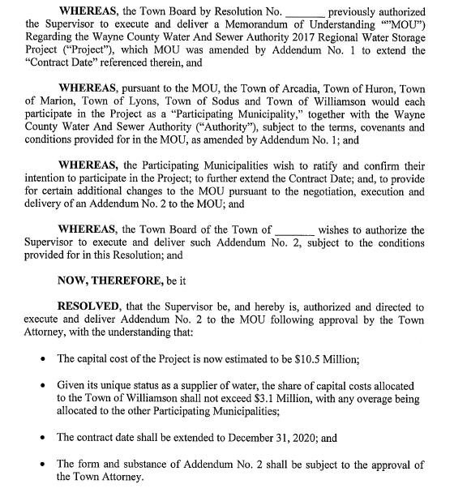
FURTHER BE IT RESOLVED, Councilperson Don Ross motioned to allow Steve Leroy Town Supervisor to sign Memorandum of Understanding relative to the Regional Water Storage Project which was seconded by Councilperson Scott Johnson. Upon roll call the following votes were heard, Steven LeRoy, aye; David LeRoy, aye; Quinn, aye; Ross, aye; Johnson, aye. Resolution adopted.

RESOLUTION
Consenting to the request from the Sodus Central School District that the Board of Education act as Lead Agency in the 2019 Capital Improvements Project
(04 07-2019)
Supervisor LeRoy offered the following resolution for its adoption,

FURTHER BE IT RESOLVED, Councilperson Jim Quinn motioned to allow Steve Leroy Town Supervisor to sign the request from the Sodus Central School District acknowledging the Board of Education act as Lead Agency in the 2019 Capital Improvements Project which was seconded by Councilperson Scott Johnson. Upon roll call the following votes were heard, Steven LeRoy, aye; David LeRoy, aye; Quinn, aye; Ross, aye; Johnson, aye. Resolution adopted.

Councilperson Scott Johnson motioned to allow Lori Diver Town Clerk to sign paperwork with WC Workforce Development allowing Kezia Palmer to assist with the digital scanning project/shared services was seconded by Councilperson Dave LeRoy. Upon roll call the following votes were heard, Steven LeRoy, aye; David LeRoy, aye; Quinn, aye; Ross, aye; and Johnson, aye. Motion carried.

Councilperson Jim Quinn motioned authorizing the payment of $30.00 per month to Shane martin (Animal Control Officer) for town use of his personal cell phone services was seconded by Councilperson Dave LeRoy. Upon roll call the following votes were heard, Steven LeRoy, aye; David LeRoy, aye; Quinn, aye; Ross, aye; and Johnson, aye. Motion carried.

RESOLUTION
“Out of District/Out of Town” Water Service Memorandum of Understanding JPF Properties, LLC
(04 07-2019)
(See page 13)

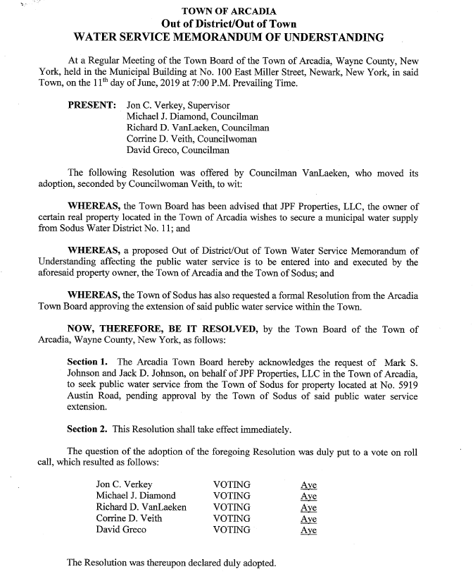

FURTHER BE IT RESOLVED, Councilperson David LeRoy motioned to allow Steve Leroy Town Supervisor to sign “Out of District/Out of Town” Water Service Memorandum of Understanding JPF Properties, LLC which was seconded by Councilperson Scott Johnson. Upon roll call the following votes were heard, Steven LeRoy, aye; David LeRoy, aye; Quinn, aye; Ross, aye; Johnson, aye. Resolution adopted.

Councilperson David LeRoy motioned to hire Ed DeWolf (Arcadia Code Enforcement Officer) to fill in part-time, performing inspections and issuing permits, at a rate of $21.00 per hour, until a permanent hire is made. In addition, Ed will be paid mileage of .58 cents per mile for the use of his personal vehicle and allow use of Town truck when appropriate was seconded by Councilperson Scott Johnson. Upon roll call the following votes were heard, Steven LeRoy, aye; David LeRoy, aye; Quinn, aye; Ross, aye; and Johnson, aye. Motion carried.

DISCUSSION:
- Councilperson Jim Quinn motioned to approve the request from Ron Reynolds to purchase approximately ½ acre (68’) owned by the Town of Sodus on Rotterdam Rd. of $500.00. Reynolds must pay all closing costs and attorney fees and this transaction is subject to Permissive Referendum was seconded by Councilperson Scott Johnson. Upon roll call the following votes were heard, Steven LeRoy, aye; David LeRoy, aye; Quinn, aye; Ross, aye; and Johnson, aye. Motion carried.
Note: The property is in the Village of Sodus and is a DEC wetland. It cannot be subdivided.

- Supervisor LeRoy discussed Sutherland DHR Complaints. Out of 5 total complaints made, the Department of Human Rights found, “No probable cause” on all 5 complaints submitted over the last several years.

- Supervisor LeRoy discussed the update on the lake levels and the IJC Board’s current standing.

- Councilperson Jim Quinn discussed that he will provide our Town Attorney Katie Villani with a new map on the Fairways Subdivision. The retention pond can be dedicated to the Town of Sodus.

- KUDOS to Sal Vittozzi. Supervisor LeRoy received a very nice phone call from a resident.

- Councilperson David LeRoy discussed the Quarry blasting. Councilperson LeRoy contacted Mike Virts (owner of quarry). LeRoy asked Virts to notify the Town when blasting occurs for residents that live in the area of the quarry.

FYI
- Minutes of Zoning/and or Planning Board Meetings (provided).

- Monthly Report from Wayne County Sheriff’s Office (provided).

- Thank You letter from the Baptist Rural Cemetery of Sodus Center.

EXECUTIVE SESSION MEETING:
Councilperson Jim Quinn motioned to enter into Executive Session at 8:39 PM regarding pending litigation was seconded by Councilperson David LeRoy. Upon roll call the following votes were heard, Supervisor Steven LeRoy, aye; David LeRoy, aye; Quinn, aye; Ross, aye; Johnson, aye. Motion carried.

Councilperson Jim Quinn motioned to exit out of Executive Session and enter into Regular Session at 9:15 PM was seconded by Councilperson David LeRoy. Upon roll call the following votes were heard, Supervisor Steven LeRoy, aye; David LeRoy, aye; Quinn, aye; Ross, aye; Johnson, aye. Motion carried.

A motion by Councilperson Scott Johnson to adjourn the Regular Town Board Meeting was seconded by Councilperson Don Ross. Upon roll call the following votes were heard, Steven LeRoy, aye; David LeRoy, aye; Quinn, aye; Ross, aye; Johnson, aye. Motion carried.

Meeting adjourned at 9:16 PM
Recording Secretary,

Lori K. Diver
Sodus Town Clerk

