MINUTES
Minutes of the Sodus Town Board Executive Session Meeting commencing at 5:00 PM in the Upstairs Meeting Room June 18, 2019, located at 14-16 Mill St. Sodus, NY 14551.
All meetings are open to the public.

Present: Steven LeRoy, Supervisor
David LeRoy, Councilperson/Deputy Supervisor
Jim Quinn, Councilperson
Don Ross, Councilperson
Scott Johnson, Councilperson

Recording Secretary: Lori Diver, Town Clerk

EXECUTIVE SESSION MEETING:
Supervisor, Steve LeRoy called the meeting to order with a motion by Councilman Scott Johnson to enter into Executive Session at 5:01 PM regarding a personnel issue relative to a particular person was seconded by Councilperson David LeRoy. Upon roll call the following votes were heard, Supervisor Steven LeRoy, aye; David LeRoy, aye; Quinn, aye; Ross, aye; Johnson, aye. Motion carried.

Councilperson Jim Quinn motioned to exit out of Executive Session and enter into Regular Session at 6:35 PM was seconded by Councilperson David LeRoy. Upon roll call the following votes were heard, Supervisor Steven LeRoy, aye; David LeRoy, aye; Quinn, aye; Ross, aye; Johnson, aye. Motion carried.

Councilperson Scott Johnson motioned to adjourn the Executive Session Meeting was seconded by Councilperson David LeRoy. Upon roll call the following votes were heard, Steven LeRoy, aye; David LeRoy, aye; Quinn, aye; Ross, aye; Johnson, aye. Motion carried.

Meeting adjourned at 6:36 PM
Recording Secretary,

Lori K. Diver
Sodus Town Clerk, RMC

MINUTES
Minutes of the Regular Sodus Town Board Meeting held in the Sodus Town Court Room June 18, 2019, 14-16 Mill St. Sodus, NY 14551, commencing at 7:00 PM.
All meetings are open to the public.

Present: Steven LeRoy, Supervisor
David LeRoy, Councilperson/Deputy Supervisor
Jim Quinn, Councilperson
Don Ross, Councilperson
Scott Johnson, Councilperson

Recording Secretary: Lori Diver, Town Clerk

Absent: Al Hendrikse, Code Enforcement Officer
Others Present: Dale Pickering, Highway Superintendent
Sal Vittozzi, Sodus Town Groundskeeper
Josh Faulks, Sun & Record
Kevin Schulte, Greenspark Solar
Chris Tertinek, Former Sodus Point Mayor
Kim Buell, T/Sodus Zoning Board Member
Peter Bump, T/Sodus Resident
David Fitch, T/Sodus Resident
Gary Wahl, T/Sodus Resident
Jim Russell, T/Sodus Zoning Board Member

Supervisor, Steve LeRoy called the Regular Town Board Meeting to order commencing at 7:00 PM with the Pledge of Allegiance and Lori Diver opened with roll call.

MINUTES
Councilperson Scott Johnson motioned to approve the Minutes of the May 14, 2019
Regular Town Board Meeting was seconded by Councilperson David LeRoy. Upon roll call the following votes were heard, Steven LeRoy, aye; David LeRoy, aye; Quinn, aye; Ross, aye; Johnson, aye. Motion carried.

Councilperson David LeRoy motioned to approve the Minutes of the May 28, 2019 Month End Town Board Meeting was seconded by Councilperson Jim Quinn. Upon roll call the following votes were heard, Steven LeRoy, abstained; David LeRoy, aye; Quinn, aye; Ross, abstained; Johnson, aye. Motion carried.

SUPERVISOR’S REPORT
The Supervisor’s Report for May 2019 was presented. Councilperson David LeRoy motioned to accept and file this report, which was seconded by Councilperson Scott Johnson. Upon roll call the following votes were heard, Steven LeRoy, aye; David LeRoy, aye; Quinn, aye; Ross, aye; Johnson, aye. Motion carried.

TOWN CLERK’S REPORT
The Town Clerk’s Reports, Town Clerk’s bank statements for audit, and bank register for May 2019 were presented. Councilperson Jim Quinn motioned to accept and file these reports, which was seconded by Councilperson Scott Johnson. Upon roll call the following votes were heard, Steven LeRoy, aye; David LeRoy, aye; Quinn, aye; Ross, aye; Johnson, aye. Motion carried.

ABSTRACT
RESOLUTION TO PAY ABSTRACT NO #11
(01 06-2019)
WHEREAS, the following bills were presented for payment on Abstract 09:

General 219-254 $ 19,722.16
Highway 150-161 $ 92,305.19
Special Districts 028-028 $ 887.25
Trust & Agency 012-013 $ 710.76
GRAND TOTAL: $ 113,625.36

NOW BE IT RESOLVED, Councilperson David LeRoy motioned to approve payment of these bills as reviewed for Abstract No. 11, which was seconded by Councilperson Scott Johnson. Upon roll call the following votes were heard, Steven LeRoy, aye; David LeRoy, aye; Quinn, aye; Ross, aye; Johnson, aye. Resolution adopted.

PUBLIC COMMENTS
(Kevin Schulte) 8:00 PM
Kevin Schulte presented to the Sodus Town Board:

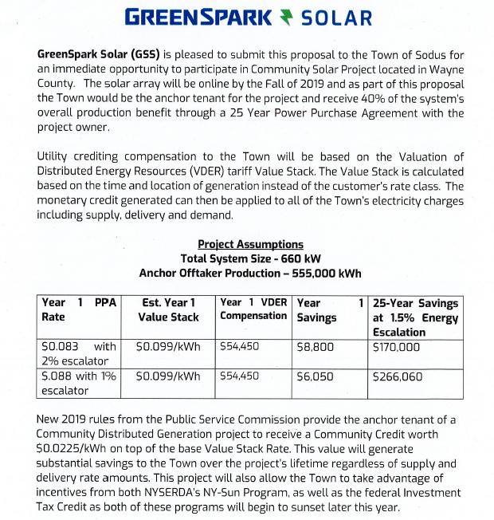

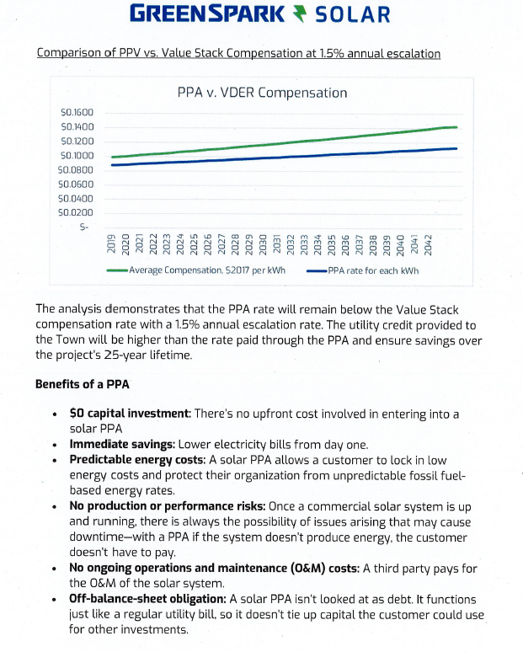
Kevin stated he will be back at the July 9, 2019 Regular Town Board Meeting at 7:30 PM to discuss current Town accounts with RG&E and its analysis comparison with Greenspark Solar.
PUBLIC COMMENTS
(David Fitch)
David asked about the removal of old decrepit buildings in Beechwood and if there were any plans for their removal. Supervisor LeRoy explained that the NY State is supposed to assist with this and other debris in the park. Highway Superintendent Dale Pickering will take a look at a tree in Beechwood.

PUBLIC SAFETY/DRAINAGE/ENVIRONMENT COMMITTEE: Councilperson Don Ross, Chair (Fire, Ambulance, Emergency Preparedness)
Councilperson Don Ross shared that the SESA meeting was cancelled. Ross attended the WCWSA meeting. Ross discussed Special Use Permits and SEQR in the Town of Sodus.

BUILDINGS AND GROUNDS COMMITTEE: Councilperson Jim Quinn, Chair
(Town Property, Parks, Animal Control, Cemeteries)
CODE ENFORCEMENT REPORT:
(Al Hendrikse, Code Enforcement Office)-Absent
Councilperson Don Ross motioned to accept and file the monthly May 2019 Code Enforcement Report was seconded by Councilperson David LeRoy. Upon roll call the following votes were heard, Steven LeRoy, aye; David LeRoy, aye; Quinn, aye; Ross, aye; and Johnson, aye. Motion carried.

CAMP BEECHWOOD-PARKS-CEMETERIES REPORTS:
(Sal Vittozzi-Sodus Town Groundkeeper)
Councilperson Scott Johnson motioned to accept the monthly May 2019 Camp Beechwood-Parks & Cemeteries written report from Sal Vittozzi, Sodus Town Groundskeeper was seconded by Councilperson David LeRoy. Upon roll call the following votes were heard, Steven LeRoy, aye; David LeRoy, aye; Quinn, aye; Ross, aye; and Johnson, aye. Motion carried.

Sal discussed that the mower was down and is currently being repaired at Paige Equipment.

DOG CONTROL OFFICER REPORT:
Craig Schwartz- Primary DCO
Shane Martin- Secondary DCO
Councilperson David LeRoy motioned to accept and file the monthly May 2019 DCO Report from Craig Schwartz, DCO Officer was seconded by Councilperson Scott Johnson. Upon roll call the following votes were heard, Steven LeRoy, aye; David LeRoy, aye; Quinn, aye; Ross, aye; and Johnson, aye. Motion carried.

PUBLIC WORKS COMMITTEE: Councilperson David LeRoy, Chair
(Highway, Drainage - Deputy Town Supervisor)
HIGHWAY REPORT:
(Dale Pickering – Highway Superintendent)
Councilperson Scott Johnson motioned to accept and file the monthly May 2019 Highway Report from Dale Pickering Highway Superintendent was seconded by Councilperson David LeRoy. Upon roll call the following votes were heard, Steven LeRoy, aye; David LeRoy, aye; Quinn, aye; Ross, aye; and Johnson, aye. Motion carried.

Councilperson David LeRoy discussed where the Town stands with the grant process of the proposed salt barn for the Highway Department. Councilperson LeRoy stated that he had received a couple quotes for the Compaction Study Test. Supervisor LeRoy stated that before any quotes can be accepted that they would need to be advertised for BID.

Councilperson Scott Johnson motioned to allow Town Clerk Lori Diver to advertise for BIDS regarding the Compaction Study Test for the Town of Sodus Salt Barn was seconded by Councilperson David LeRoy. Upon roll call the following votes were heard, Steven LeRoy, aye; David LeRoy, aye; Quinn, aye; Ross, aye; and Johnson, aye. Motion carried.

RECREATION & ASSESSOR COMMITTEE: Councilperson (Councilperson Scott Johnson Chair)
(Recreation, Assessor)
Councilperson Scott Johnson stated that the Recreation Department is training staff for the 2019 Town of Sodus Recreation program to begin July 8, 2019. Johnson also shared that Sheila is back to work on a part-time basis.

Recreation Report
(Sheila Fisher, Director)
Councilperson Don Ross motioned to accept and file the monthly May 2019 Recreation Report submitted by Sheila Fisher, Recreation Director was seconded by Councilperson Jim Quinn. Upon roll call the following votes were heard, Steven LeRoy, aye; David LeRoy, aye; Quinn, aye; Ross, aye; and Johnson, aye. Motion carried.

Assessor’s Report
(Nathan Mack, Assessor)
Councilperson Don Ross motioned to accept and file the monthly May 2019 Assessor’s Report from Sole Assessor, Nathan Mack was seconded by Councilperson David LeRoy. Upon roll call the following votes were heard, Steven LeRoy, aye; David LeRoy, aye; Quinn, aye; Ross, aye; and Johnson, aye. Motion carried.

TOWN HALL COMMITTEE: Supervisor LeRoy, Chair
(Personnel, Clerks, Justices, Assessor, Building Inspector, Town Council, Boards, Insurances, Finance)
N/A
CORRESPONDENCE & INFORMATION

Councilperson David LeRoy discussed that he will be doing the Town Clerk Audit in July of 2019.

RESOLUTION
LOAN RESOLUTION WD NO. 11
(02 06-2019)
RESOLVED, Councilperson Scott Johnson motioned to adopt resolution (02 06-2019), which was seconded by Councilperson Don Ross. Upon roll call the following votes were heard, Steven LeRoy, aye; David LeRoy, aye; Quinn, aye; Ross, aye; Johnson, aye. Resolution adopted (see pages 7-9).

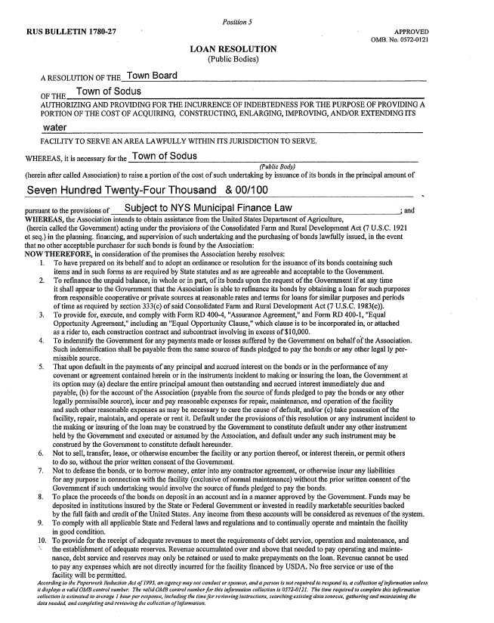
FYI: 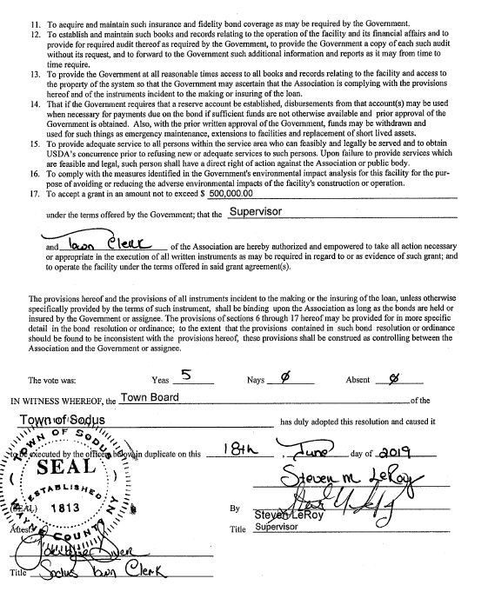
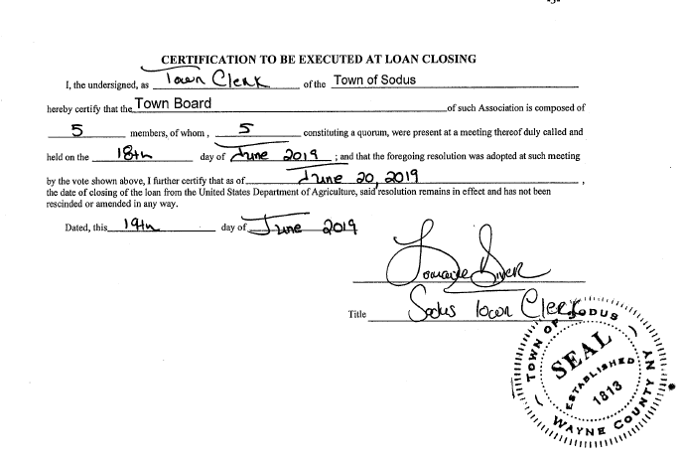
RESOLUTION
LOAN RESOLUTION S. GENEVA WD PROJECT
(03 06-2019)
RESOLVED, Councilperson David LeRoy motioned to adopt resolution (03 06-2019), which was seconded by Councilperson Scott Johnson. Upon roll call the following votes were heard, Steven LeRoy, aye; David LeRoy, aye; Quinn, aye; Ross, aye; Johnson, aye. Resolution adopted (see pages 9-11). 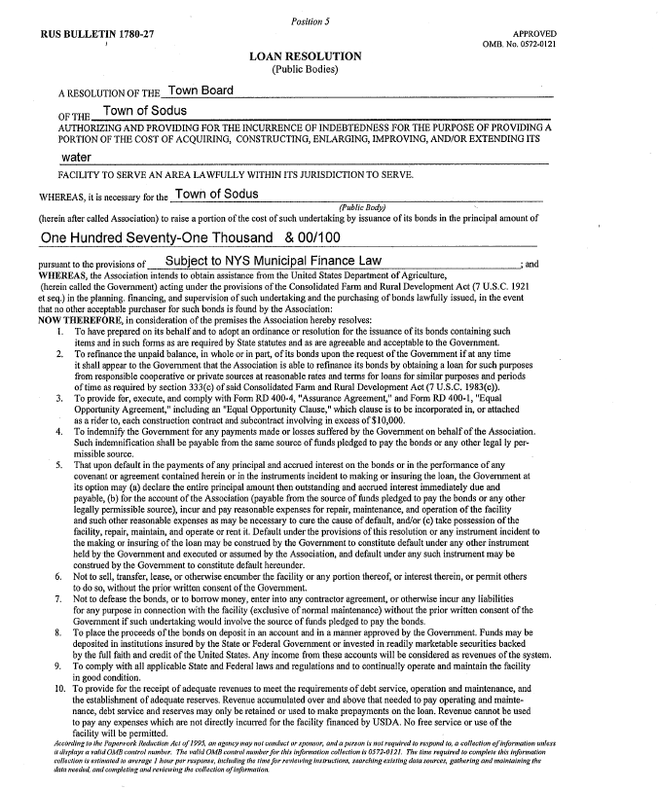
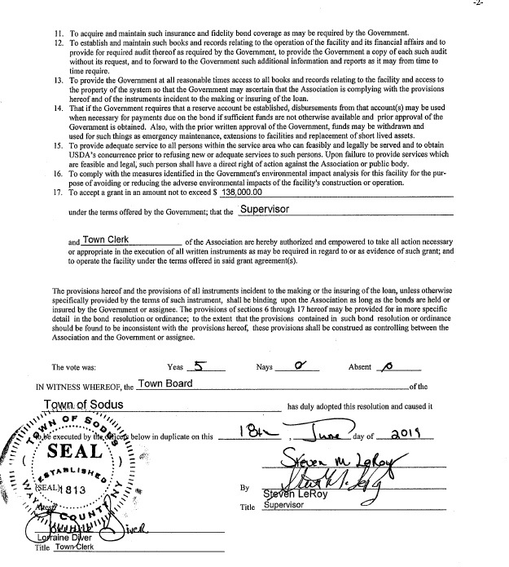
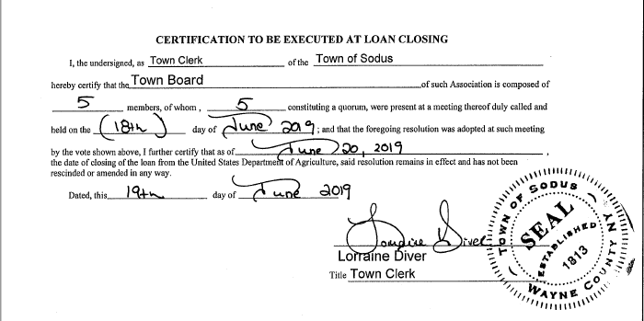

Councilperson David LeRoy motioned to allow the Town Clerk’s Office to begin Dog Enumeration was seconded by Councilperson Scott Johnson. Upon roll call the following votes were heard, Supervisor Steven LeRoy, aye; David LeRoy, aye; Quinn, aye; Ross, aye; Johnson, aye. Motion carried.

Councilperson David LeRoy motioned to allow Town Clerk Lori Diver to advertise for 4th of July Office Closing was seconded by Councilperson Scott Johnson. Upon roll call the following votes were heard, Supervisor Steven LeRoy, aye; David LeRoy, aye; Quinn, aye; Ross, aye; Johnson, aye. Motion carried.

Councilperson Scott Johnson motioned to allow Town Clerk Lori Diver to hire Joan Drury on an “as needed” basis to fill in during the lunch hour at times when Lori is on vacation, conferences, etc. was seconded by Councilperson Don Ross. Upon roll call the following votes were heard, Supervisor Steven LeRoy, aye; David LeRoy, aye; Quinn, aye; Ross, aye; Johnson, aye. Motion carried.

Councilperson David LeRoy motioned to allow Highway Superintendent Dale Pickering to surplus and auction items as follows to Auctions International was seconded by Councilperson Scott Johnson. Upon roll call the following votes were heard, Supervisor Steven LeRoy, aye; David LeRoy, aye; Quinn, aye; Ross, aye; Johnson, aye. Motion carried.
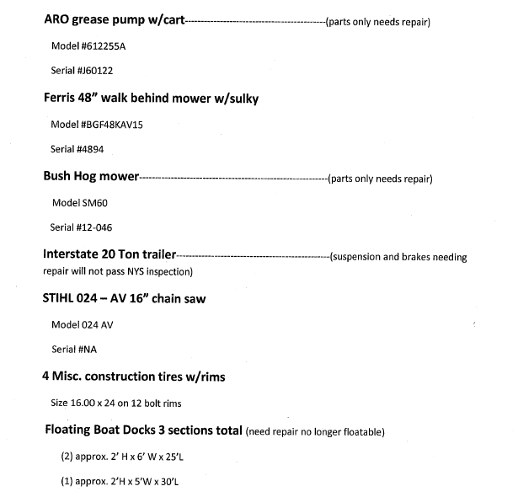
RESOLUTION
“MOORE THAN A RACE”
(04 06-2019)
Supervisor LeRoy offered the following resolution for its adoption,

WHEREAS, Reliant Community Federal Credit Union is asking the Town of Sodus permission to utilize Town of Sodus Roads for “Moore than a Race” 5K run on October 20, 2019, and

NOW BE IT RESOLVED, the Sodus Town Board approves of Reliant Community Credit Union to utilize Town Roads and for Supervisor LeRoy to sign municipal approval for the single county speed race on October 20, 2019 starting at 12:00 pm for the 5K race, and

FURTHER BE IT RESOLVED, Councilperson David LeRoy motion to adopt the resolution (04 06-2019), which was seconded by Councilperson Don Ross. Upon roll call the following votes were heard, Steven LeRoy, aye; David LeRoy, aye; Quinn, aye; Ross, absent, and Johnson, aye. Resolution Adopted.

Councilperson Don Ross motioned to approve travel request for Nathan Mack, Assessor to attend Agriculture Property Valuation & Assessment Training was seconded by Councilperson Scott Johnson. Upon roll call the following votes were heard, Supervisor Steven LeRoy, aye; David LeRoy, aye; Quinn, aye; Ross, aye; Johnson, aye. Motion carried.

Councilperson Jim Quinn motioned to approve travel request for Supervisor LeRoy to attend Comptroller Seminar for Local Officials was seconded by Councilperson Scott Johnson. Upon roll call the following votes were heard, Supervisor Steven LeRoy, aye; David LeRoy, aye; Quinn, aye; Ross, aye; Johnson, aye. Motion carried.

Councilperson Jim Quinn motioned to approve travel request for Bree Crandell to attend Comptroller Seminar for Local Training was seconded by Councilperson Scott Johnson. Upon roll call the following votes were heard, Supervisor Steven LeRoy, aye; David LeRoy, aye; Quinn, aye; Ross, aye; Johnson, aye. Motion carried.

Councilperson Don Ross motioned to accept Al Hendrikse, Code Enforcement Officer’s written resignation effective July 1, 2019 was seconded by Councilperson Jim Quinn. Upon roll call the following votes were heard, Supervisor Steven LeRoy, aye; David LeRoy, aye; Quinn, aye; Ross, aye; Johnson, aye. Motion carried.

Councilperson Scott Johnson motioned to allow Supervisor Clerk to transfer money from the General Fund to pay for the electric work at Beechwood and to pay for the new docks at Harriman Park public boat launch was seconded by Councilperson Jim Quinn. Upon roll call the following votes were heard, Supervisor Steven LeRoy, aye; David LeRoy, aye; Quinn, aye; Ross, aye; Johnson, aye. Motion carried.

Councilperson Scott Johnson motioned to allow Supervisor LeRoy to sign Joy Bridge contract was seconded by Councilperson David LeRoy. Upon roll call the following votes were heard, Supervisor Steven LeRoy, aye; David LeRoy, aye; Quinn, aye; Ross, aye; Johnson, aye. Motion carried.

DISCUSSION:
- Discussion regarding Ron Reynolds to purchase approximately ½ acre (68’) owned by the Town of Sodus on Rotterdam Rd. Supervisor LeRoy asked the Town Board to take a look at the property and table the discussion until the next meeting.

- Councilperson Don Ross motioned to split the Village of Sodus traffic fines equally with the Town of Sodus was seconded by Councilperson Scott Johnson. Upon roll call the following votes were heard, Supervisor Steven LeRoy, aye; David LeRoy, aye; Quinn, aye; Ross, aye; Johnson, aye. Motion carried.

- Supervisor LeRoy discussed that the Town has been given the blessing to open Camp Beechwood. Councilperson Jim Quinn motioned to open the park July 1, 2019 from Dusk to Dawn (except registered campers) was seconded by Councilperson Scott Johnson. Upon roll call the following votes were heard, Supervisor Steven LeRoy, aye; David LeRoy, aye; Quinn, aye; Ross, aye; Johnson, aye. Motion carried.

- GREAT NEWS, after many years of hard work from Supervisor Steve LeRoy and other entities; the Sodus Center Bridge will be funded for rebuilding. The preliminary engineering will begin in 2020-2021. The construction will begin in 2022. The Genesee Transportation Council-SHIPO –Federal Funds handled by NYSDOT.

FYI
- Minutes of Zoning/and or Planning Board Meetings (provided).

- Monthly Report from Wayne County Sheriff’s Office (provided).

- Current Army Corps. Bulletin of lake levels (provided).

A motion by Councilperson Scott Johnson to adjourn the Regular Town Board Meeting was seconded by Councilperson Don Ross. Upon roll call the following votes were heard, Steven LeRoy, aye; David LeRoy, aye; Quinn, aye; Ross, aye; Johnson, aye. Motion carried.

Meeting adjourned at 8:17 PM
Recording Secretary,

Lori K. Diver
Sodus Town Clerk

