MINUTES
Minutes of the Regular Sodus Town Board Meeting commencing at 6:30 PM in the Sodus Town Court Room June 8, 2021, located at 14-16 Mill St. Sodus, NY 14551.
All meetings are open to the public.

Present: Scott Johnson, Supervisor
David LeRoy, Councilperson/Deputy Supervisor
Chris Tertinek, Councilperson
Cathy Willmott, Councilperson

Recording Secretary: Bree Crandell, Confidential Supervisor Clerk

Absent: Lori Diver, Sodus Town Clerk-RMC
Don Ross, Councilperson

Others Present: Dale Pickering, Highway Superintendent
Sal Vittozzi, Groundskeeper/Caretaker
Rachel Partington, Town Attorney

Supervisor Scott Johnson called the Regular Town Board Meeting to order commencing at 6:30 PM with the Pledge of Allegiance and Bree Crandell opened with roll call.

6:30 PM PUBLIC HEARING:
- Supervisor Johnson asked Bree Crandell, Supervisor Clerk to read legal notice below……

TOWN OF SODUS
NOTICE OF PUBLIC HEARING
PLEASE TAKE NOTICE that, pursuant to Section 198 of the Town Law, a public hearing will be held by the Town Board of the Town of Sodus on June 8, 2021, at 6:30 p.m. at the Town Hall, 14-16 Mill Street, in the Town of Sodus, Wayne County, New York, to consider the proposed dedication to the Village of Sodus of a water line extending from the Town’s new highway barn at 84 Rotterdam Road in the Village of Sodus to the Village’s water system; and to consider granting the Village of Sodus a permanent easement to access, repair and maintain that water line.

All persons interested shall be given an opportunity to be heard. The proposed Easement is available for public inspection during regular business hours at the Town Clerk’s office and on the Town of Sodus website at townofsodus.net.

Dated: May 19, 2021

- (Supervisor Scott Johnson opened the public hearing for discussion)
Johnson asked for discussion regarding the dedication of the water line to the Village of Sodus and granting the Village of Sodus a permanent easement to access, repair and maintain the water line.

- Johnson stated, given there was no discussion he asked for a motion to close the public hearing. Councilperson David LeRoy motioned to close the public hearing was seconded by Councilperson Cathy Willmott. Upon roll call the following votes were heard, Scott Johnson, aye; David LeRoy, aye; Don Ross, absent; Chris Tertinek, aye; and Cathy Willmott; aye. Motion carried.

PERMANENT WATER LINE EASEMENT
RESOLUTION ENACTING LOCAL LAW
- 06-2021)

THIS INDENTURE is made this 8th day of June, 2021, by and between THE TOWN OF SODUS (“Town”), a municipal corporation, located in the County of Wayne, in the State of New York, with principal offices located at 14-16 Mill Street, Sodus, New York 14551; and THE VILLAGE OF SODUS (“Village”), a municipal corporation, located in the County of Wayne, in the State of New York, with principal offices located at Village Hall, 14-16 Mill Street, Sodus, New York 14551.

WITNESS that the Town, in consideration of One Dollar ($1.00) and other goods and valuable consideration paid by the Village, the receipt of which is hereby acknowledged, hereby grants to the Village, and their successors and assigns,

A PERMANENT EASEMENT to construct, reconstruct, operate, maintain, repair and improve an underground water line with fixtures and appurtenances (the “Water Improvements”), with free ingress and egress for those purposes, including the right to trim and/or remove trees, shrubs or other obstructions and to store, pile, and remove material or fill, in and over certain land (the “Easement Premises”) in the Town of Sodus, Wayne County, New York, being designated as the Water Main Easement, as shown on the Map attached as Schedule A, titled Map of Water Main Easement Thru Lands Owned by Town of Sodus Being Known as 84 Rotterdam Road, dated May 4, 2021 and better described in the proposed water main easement description attached as Schedule B. Further, the Town conveys to the Village all right, title and interest in and to such Water Improvements.

TAX MAP PARCEL NO. # 69118-17-045095

The Village shall restore the Easement Premises to the same state, with the same materials, as now found to the extent reasonably feasible, following completion of any construction, reconstruction, operation, maintenance and/or improvement of the Water Improvements.

This Easement shall be binding upon the parties to this Indenture, their heirs, successors, and assigns.

TOWN OF SODUS

FURTHER BE IT RESOLVED, Councilperson David LeRoy motioned to adopt this resolution was seconded by Councilperson Chris Tertinek. Upon roll call the following votes were heard, Scott Johnson, aye; David LeRoy, aye; Don Ross, absent; Chris Tertinek, aye; and Cathy Willmott; aye. Resolution Adopted.

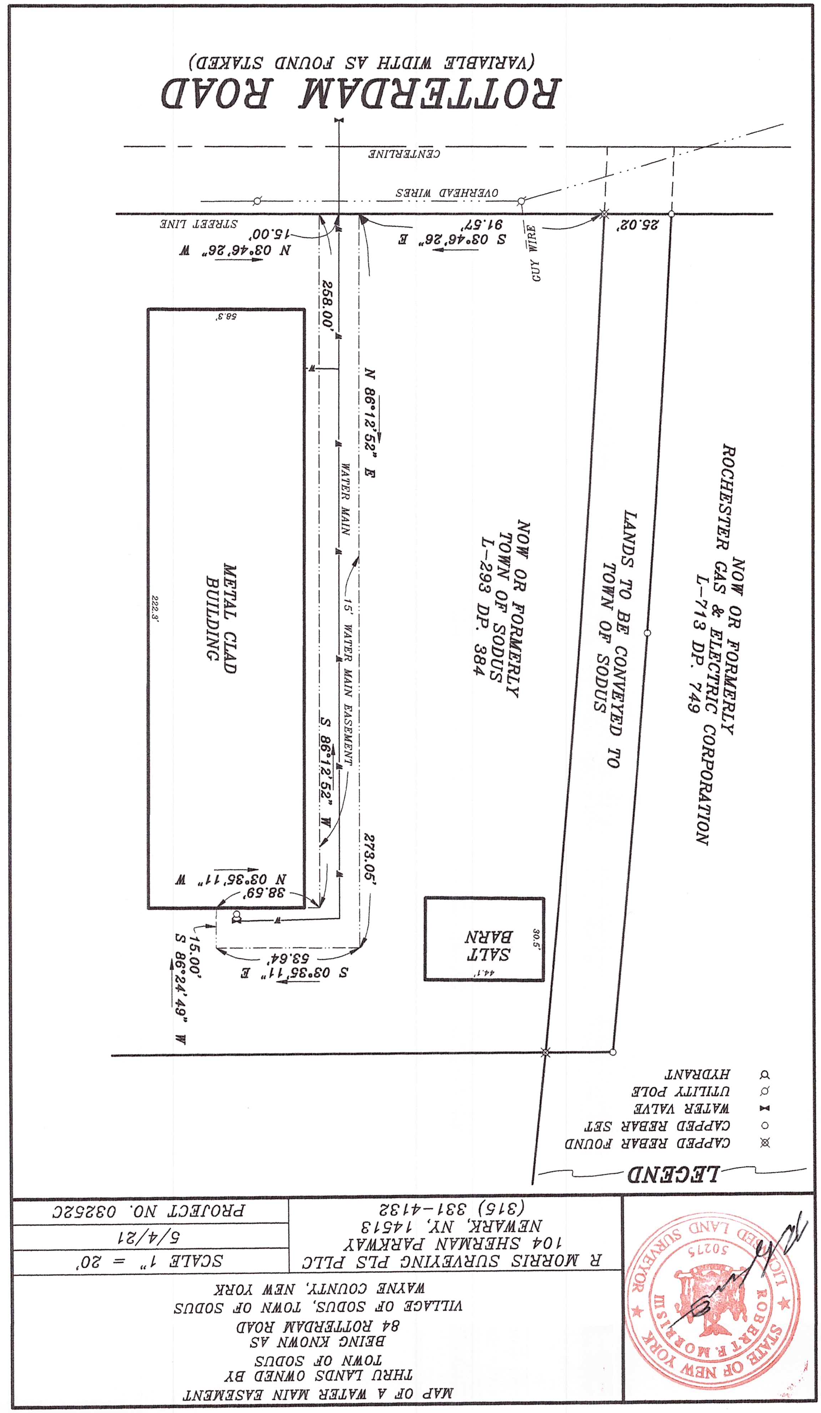
SCHEDULE “A”

SCHEDULE “B”

Proposed Water Main Easement

ALL THAT TRACT OR PARCEL OF LAND situated in the Village of Sodus, Town of Sodus, County of Wayne and State of New York, bounded and described as follows:

Commencing at a capped rebar found marking the intersection of the east street line of Rotterdam Road, the north line of lands now or formerly owned by the Town of Sodus, as recorded in the Wayne County Clerk’s Office in Liber 293 of deeds, at page 384 and the south line of lands now or formerly owned by Rochester Gas & Electric Corporation, as recorded in the Wayne County Clerk’s Office in Liber 713 of deeds, at page 749; thence S 03° 46’ 26” E. along the east street line of Rotterdam Road, a distance of 91.57 feet to a point marking the true point and place of beginning; running thence the following courses and distances thru lands owned by the Town of Sodus, N 86° 12’ 52” E a distance of 273.05 feet to a point, S 03° 35’ 11” E a distance of 53.64 feet to a point, S 86° 24’ 49” W a distance of 15.00 feet to a point, N 03° 35’ 11” W a distance of 38.59 feet to a point and S 86° 12’ 52” W a distance of 258.00 feet to a point on the east street line of Rotterdam Road; thence N 03° 46’ 26” W, along the east street line of Rotterdam Road, a distance of 15.00 feet to the point of and place of beginning.

MINUTES
- May 11, 2021 Regular Town Board Meeting Minutes
The May 11, 2021 Regular Town Board Meeting Minutes were presented for approval. Councilperson Chris Tertinek motioned to accept and file these Minutes, which was seconded by Councilperson Cathy Willmott. Upon roll call the following votes were heard, Scott Johnson, aye; David LeRoy, aye; Don Ross, absent; Chris Tertinek, aye; and Cathy Willmott; aye. Motion carried.

- May 17, 2021 Special Town Board Meeting Minutes
The May 17, 2021 Special Town Board Meeting Minutes were presented for approval. Councilperson David LeRoy motioned to accept and file these Minutes, which was seconded by Councilperson Chris Tertinek. Upon roll call the following votes were heard, Scott Johnson, aye; David LeRoy, aye; Don Ross, absent; Chris Tertinek, aye; and Cathy Willmott; aye. Motion carried.

- May 27, 2021 Regular Month End Town Board Meeting Minutes
The May 27, 2021 Regular Month End Town Board Meeting Minutes were presented for approval. Councilperson David LeRoy motioned to accept and file these Minutes, which was seconded by Councilperson Cathy Willmott. Upon roll call the following votes were heard, Scott Johnson, aye; David LeRoy, aye; Don Ross, absent; Chris Tertinek, aye; and Cathy Willmott; aye. Motion carried.

TOWN CLERK’S REPORT
The Town Clerk’s Report, Town Clerk’s bank statements for audit, and bank register for May 2021 were presented. Councilperson Chris Tertinek motioned to accept and file these reports, which was seconded by Councilperson David LeRoy. Upon roll call the following votes were heard, Scott Johnson, aye; David LeRoy, aye; Don Ross, absent; Chris Tertinek, aye; and Cathy Willmott; aye. Motion carried.
SUPERVISOR’S REPORT
The Supervisor’s report was presented for May 2021. Councilperson David LeRoy motioned to accept and file this report, which was seconded by Councilperson Cathy Willmott. Upon roll call the following votes were heard, Scott Johnson, aye; David LeRoy, aye; Don Ross, absent; Chris Tertinek, aye; and Cathy Willmott; aye. Motion carried.
ABSTRACT
RESOLUTION TO PAY ABSTRACT No. 11
(02 06-2021)
WHEREAS, the following bills were presented for payment on Abstract 11:

General 278-291 $ 134,560.59
Highway 136-145 $ 3,373.90
Bridge Project 017-017 $ 9,159.89
Special St. Lighting 011-011 $ 1,012.75
GRAND TOTAL: $ 148,107.13
NOW BE IT RESOLVED, Councilperson David LeRoy motioned to approve payment of these bills as reviewed for Abstract No. 11, which was seconded by Councilperson Cathy Willmott. Upon roll call the following votes were heard, Scott Johnson, aye; David LeRoy, aye; Don Ross, absent; Chris Tertinek, aye; and Cathy Willmott; aye. Resolution Adopted.

PUBLIC COMMENTS
N/A

PUBLIC WORKS COMMITTEE: Councilperson David LeRoy, Chair
(Highway, Drainage - Deputy Town Supervisor)
HIGHWAY REPORT:
(Dale Pickering – Highway Superintendent)
Councilperson Cathy Willmott motioned to accept and file the monthly May 2021 Highway Report from Dale Pickering Highway Superintendent was seconded by Councilperson Chris Tertinek. Upon roll call the following votes were heard, Scott Johnson, aye; David LeRoy, aye; Don Ross, absent; Chris Tertinek, aye; and Cathy Willmott; aye. Motion carried.
TOWN BARN FINANCES:
Councilman David LeRoy shared that the Town will be going over the 1.7 million dollar budget. There are some change orders in dispute including, some credits. The biggest change order was the three additional fans. There is a 20K hit from the waterline issue. The Town should not be responsible for bearing this cost.
SALT BARN UPDATE:
N/A
DRAINAGE:
(N/A)

Councilman David LeRoy motioned to approve surplus items located at the Town of Sodus Highway Barn to go through Auctions International was seconded by Councilperson Cathy Willmott. Upon roll call the following votes were heard, Scott Johnson, aye; David LeRoy, aye; Don Ross, absent; Chris Tertinek, aye; and Cathy Willmott; aye. Motion carried.

BUILDINGS AND GROUNDS COMMITTEE: Councilperson Chris Tertinek, Chair
(Town Property, Animal Control, Flood Damage Prevention)
CODE ENFORCEMENT REPORT:
Craig Schwartz- CEO
Councilperson David LeRoy motioned to accept the monthly May 2021 Code Enforcement Report as written was seconded by Councilperson Cathy Willmott. Upon roll call the following votes were heard, Scott Johnson, aye; David LeRoy, aye; Don Ross, absent; Chris Tertinek, aye; and Cathy Willmott; aye. Motion carried.
ANIMAL CONTROL REPORT:
Tracy Brown, Primary DCO
Craig Schwartz- Secondary DCO
Councilperson Cathy Willmott motioned to accept the monthly May 2021 Dog Control Report as written was seconded by Councilperson David LeRoy. Upon roll call the following votes were heard, Scott Johnson, aye; David LeRoy, aye; Don Ross, absent; Chris Tertinek, aye; and Cathy Willmott; aye. Motion carried.
FLOOD DAMAGE PREVENTION REPORT-Code 69:
Chris Tertinek, Councilperson
N/A

RECREATION/ENVIRONMENTAL COMMITTE: Cathy Willmott, Councilperson
(Recreation, Assessor, Parks, Cemeteries)
Recreation Report
(Sheila Fisher, Recreation Director)
Councilperson David LeRoy motioned to accept the monthly May 2021 Recreation Report from Sheila Fisher, Recreation Director was seconded by Councilperson Chris Tertinek. Upon roll call the following votes were heard, Scott Johnson, aye; David LeRoy, aye; Don Ross, absent; Chris Tertinek, aye; and Cathy Willmott; aye. Motion carried.
Assessor’s Report
(Nathan Mack, Assessor)
Councilperson David LeRoy motioned to accept and file the monthly May 2021 Assessor’s Report from Sole Assessor, Nathan Mack was seconded by Councilperson Chris Tertinek. Upon roll call the following votes were heard, Scott Johnson, aye; David LeRoy, aye; Don Ross, absent; Chris Tertinek, aye; and Cathy Willmott; aye. Motion carried.
Camp Beechwood/Sodus Groundskeeper Report
(Sal Vittozzi-Caretaker-Sodus Town Groundkeeper)
Councilperson Chris Tertinek motioned to accept the monthly May 2021 Camp Beechwood-Parks & Cemeteries Report from Sal Vittozzi, Sodus Town Groundskeeper-Caretaker was seconded by Councilperson Cathy Willmott. Upon roll call the following votes were heard, Scott Johnson, aye; David LeRoy, aye; Don Ross, absent; Chris Tertinek, aye; and Cathy Willmott; aye. Motion carried.

PUBLIC SAFETY/DRAINAGE/ENVIRONMENT COMMITTEE: Councilperson Don Ross, Chair (Fire, Ambulance, Emergency Preparedness)
Councilperson Don Ross (absent) submitted the 911 and SESA report to the Sodus Town Board for their review by email.

TOWN HALL COMMITTEE: Scott Johnson, Supervisor
(Personnel, Clerks, Justices, Assessor, Building Inspector, Town Council, Boards, Insurances, Finance)
N/A
CORRESPONDENCE & INFORMATION

Councilperson David LeRoy motioned to accept Mary Jane Mumby’s resignation from the Board of Assessment Review effective immediately was seconded by Councilperson Chris Tertinek. Upon roll call the following votes were heard, Scott Johnson, aye; David LeRoy, aye; Don Ross, absent; Chris Tertinek, aye; and Cathy Willmott; aye. Motion carried.

Cathy Willmott was appointed as Town Board Member on April 22, 2021. Councilwoman Willmott has disclosed in writing to the Town that she, doing business as “Advanced Occupational Services”, has an interest in a contract with the Town of Sodus by which she facilitates random drug and alcohol testing for Sodus employees. Under the terms of the contract, Willmott receives $120 per year from the Town of Sodus. The contract was entered with the Town of Sodus prior to her appointment to the Town Board. The contract expires on December 31, 2021. Pursuant to General Municipal Law §802(h), Councilwoman Willmott is permitted to serve out the term of the contract, but the contract cannot be renewed so long as she is serving on the Town Board. This will be entered into the Minutes.
Councilperson David LeRoy motioned to acknowledge this disclosure for the Minutes was seconded by Councilperson Chris Tertinek. Upon roll call the following votes were heard, Scott Johnson, aye; David LeRoy, aye; Don Ross, absent; Chris Tertinek, aye; and Cathy Willmott; abstain. Motion carried.

Discussion was held on the Town of Sodus, “Painted Horse” that has been in storage and was painted by former Town Councilman Michael Boone. The horse used to be displayed at Heluva Good Cheese. When Heluva Good Cheese left Sodus, the horse was placed in storage. No decision was made on where to place the horse.

At the next Town Board Meeting the Board will discuss when they should hold a public hearing for the, “Marijuana Law”, advertise, etc...

Councilperson Chris Tertinek motioned to adjourn the meeting was seconded by Councilperson David LeRoy. Upon roll call the following votes were heard, Scott Johnson, aye; David LeRoy, aye; Don Ross, absent; Chris Tertinek, aye; and Cathy Willmott; aye. Motion carried.

Meeting adjourned at 7:20 PM
Recording Secretary,

Breynn Crandell, Supervisor Clerk
Minutes Written By:

Lori Diver Sodus Town Clerk, RMC

