MINUTES
Minutes of the Bid Opening Salt Storage Shed meeting commencing at 10:00 AM in the downstairs courtroom March 2, 2023 located at 14-16 Mill St. Sodus, NY 14551.
All meetings are open to the public.

Present: Scott Johnson, Supervisor
David LeRoy, Councilperson/Deputy Supervisor

Recording Secretary: Lori Diver Sodus Town Clerk

Others Present: Bree Crandell, Supervisor Clerk
Dave Doyle, MRB
Park Lane Construction, LLC
WD Malone Trucking and Excavating, Inc.

Legal Notice was published as follows:

TOWN OF SODUS NEW SALT STORAGE BUILDING
MRB PROJECT NO. 1914.22001.000 JANUARY 2023
SECTION 00 11 13 ADVERTISEMENT FOR BIDS

EJCDC® C-111, Advertisement for Bids for Construction Contract.
Copyright© 2018 National Society of Professional Engineers, American Council of Engineering Companies,
and American Society of Civil Engineers. All rights reserved.

ADVERTISEMENT FOR BIDS
TOWN OF SODUS
SODUS, NEW YORK
NEW SALT STORAGE BUILDING

General Notice
Town of Sodus (Owner) is requesting Bids for the construction of the following Project:
New Salt Storage Building
In accordance with Section 103 of Article 5-A of the General Municipal Law, sealed Bids for the construction of the Project will be received at the office of the Town of Sodus, located at 14-16 Mill Street, Sodus, New York 14551, until March 2, 2023, at 10:00 AM local time. At that time the Bids received will be publicly opened and read downstairs in the Sodus Town Courtroom.
The Project includes the following Work:
Construction of a new pre-engineered salt storage structure, approximately 12,100 s.f. and associated site work for asphalt pavement, guiderails/bollards, and utilities. The salt storage structure will be a pre-engineered, pole-barn style structure with wood trusses, columns, bracing, and barrier walls supported by a shallow foundation system. The salt storage structure will be open on one side for operations. The Work does not include any mechanical, electrical, or plumbing work.
Sealed Bids are requested for the following Contract: Contract #1: General
Project has an expected duration of 150 days.

Obtaining the Bidding Documents
Information and Bidding Documents for the Project can be found at the following designated website:
www.avalonroch-planroom.com
Bidding Documents may be downloaded from the designated website for a non-refundable fee of $49.00. Prospective Bidders are urged to register with the designated website as a plan holder, even if Bidding Documents are obtained from a plan room or source other than the designated website in either electronic or paper format. The designated website will be updated periodically with addenda, lists of registered plan holders, reports, and other information relevant to submitting a Bid for the Project. All official notifications, addenda, and other Bidding Documents will be offered only through the designated website. Neither Owner nor Engineer will be responsible for Bidding Documents, including addenda, if any, obtained from sources other than the designated website.
Bidding Documents may be examined at the offices of MRB Group (145 Culver Road, Suite 160, Rochester, NY 14620), and the Town of Sodus (14-16 Mill Street, Sodus, New York 14551), on Mondays through Fridays between the hours of 9:00 AM and 3:30 PM. Bidding Documents will not be available from MRB Group or the Owner.
Instructions to Bidders
The Town of Sodus, Wayne County, New York, reserves the right to reject any or all bids, or to waive any informalities, or to make an award to other than the low bidder. It further reserves the right to limit the amount of the award.
Attention of the bidders is particularly directed to the requirements of the conditions of employment to be observed and minimum Wage Rates to be paid under the Contract.
The Town of Sodus does not discriminate on the basis of handicapped status in admission or access to, or treatment or employment in, its programs and activities.
Bid security shall be furnished in accordance with the Instructions to Bidders.
For all further requirements regarding bid submittal, qualifications, procedures, and contract award, refer to the Instructions to Bidders that are included in the Bidding Documents.

This Advertisement is issued by:

Owner: Town of Sodus
By: Lori K. Diver

Title: Sodus Town Clerk, RMC
Date: January 25, 2023

Dave Doyle, MRB opened the two sealed bids received as follows: 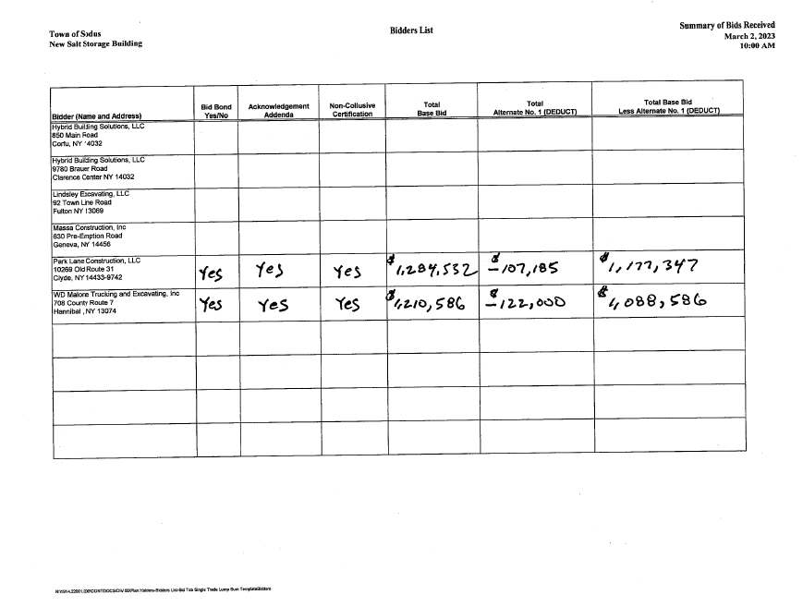
Bids will be reviewed by Dave Doyle, MRB Engineers and the Sodus Town Board for a decision.

Meeting Adjourned at 10:10 AM and minutes were written by: Lori Diver Sodus Town Clerk, RMC

