MINUTES
Minutes of the Month End Town Board Meeting commencing at 4:30 PM in the upstairs meeting room March 24, 2022 located at 14-16 Mill St. Sodus, NY 14551.
All meetings are open to the public.
In addition this meeting was available through Zoom. Legal Notices were published and posted accordingly.

Present: Scott Johnson, Supervisor
David LeRoy, Councilperson/Deputy Supervisor
Don Ross, Councilperson Zoom
Chris Tertinek, Councilperson
Cathy Willmott, Councilperson

Recording Secretary: Lori Diver, Sodus Town Clerk-RMC

Absent: N/A

Others Present: Bree Crandell- Supervisor Clerk
Casey Carpenter, Times of Wayne County
Julia O’Sullivan, Town Attorney

Supervisor Scott Johnson called the Month End Town Board Meeting to order commencing at 4:30 PM and Lori Diver opened with roll call. All were present.

BID-Harriman Park Floating Dock (4:30 PM):

Lori Diver Sodus Town Clerk read the following legal notice:
LEGAL NOTICE
TOWN OF SODUS
BID NOTICE:
Town of Sodus Harriman Park Floating Dock
NYS Route 14, Sodus Point NY

PLEASE TAKE NOTICE: The Town Board of the Town of Sodus is seeking bids RFQ for design, build and install floating dock on the north side of the Harriman Park ramp located NYS Route 14, Sodus Point, NY.

Specifications, floating dock site-plan and the Non-Collusive Bidding Certificate may be picked up at the Sodus Town Clerk’s Office, 14-16 Mill St. Sodus, NY 14551. All bids must be in a sealed envelope and marked “BID-Town of Sodus”, needs to be written on outside of sealed envelope. The sealed bids will be opened and read at the Month End Town Board Meeting March 24, 2022 at 4:30 PM in the downstairs courtroom located at 14-16 Mill St. Sodus, NY. Sealed Bids must be received by 4:00 PM on Wednesday March 23, 2022, at the Sodus Town Clerks Office. The Sodus Town Board reserves the right to reject any or all bids received. Please note: the bid spec packet may also be downloaded at www.townofsodus.net under the LEGAL NOTICES section on the website.
By Order of the Sodus Town
Lori K. Diver
Sodus Town Clerk, RMC
Dated: March 3, 2022
Deputy Supervisor Dave LeRoy opened the one bid received by Martin Custom Tidesides Docks Lifts/Seawalls. The quote was read as follows:

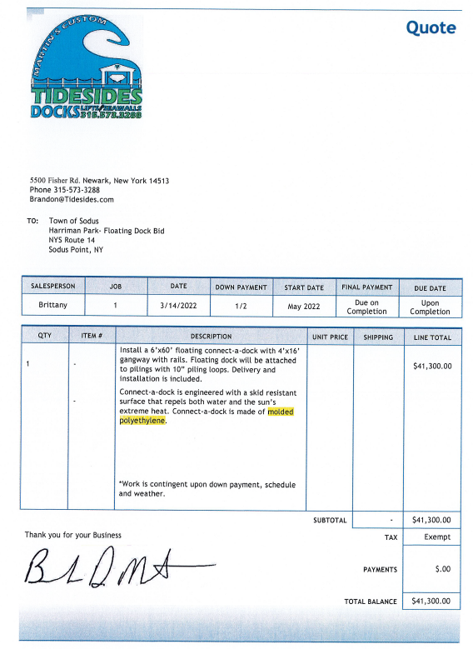

Councilperson David LeRoy motioned to table this decision until further notice was seconded by Councilperson Cathy Willmott. Upon roll call, the following votes were heard Supervisor Scott Johnson, aye; LeRoy, aye; Ross, aye; Tertinek, aye; and Willmott, aye. Motion carried.

ABSTRACT
RESOLUTION TO PAY ABSTRACT No. 5
(02 03-2022)
WHEREAS, the following bills were presented for payment on Abstract 5:

General 121-146 $ 31,211.51
Highway 090-107 $ 26,010.60
Regional Storage 001-001 $ 68,559.00
Bridge Project 003-004 $ 14,883.84
Trust & Agency 006-007 $ 1,467.80
GRAND TOTAL: $ 142,132.75
Councilperson Don Ross motioned to adopt this resolution which was seconded by Councilperson Chris Tertinek. Upon roll call the following votes were heard, Scott Johnson, aye; David LeRoy, aye; Don Ross, aye; Chris Tertinek, aye; and Cathy Willmott; aye. Resolution Adopted.

RESOLUTION
WEED HARVESTING PROGRAM
(03 03-2022)
NOW THEREFORE BE IT RESOLVED, Councilperson Don Ross motioned to allow Supervisor Scott Johnson to sign agreement with Wayne County Weed Harvesting Program January 1, 2022 to December 31, 2022 which was seconded by Councilperson David LeRoy. Upon roll call the following votes were heard, Scott Johnson, aye; David LeRoy, aye; Don Ross, aye; Chris Tertinek, aye; and Cathy Willmott; aye. Resolution Adopted.

RESOLUTION
TOSHIBA FINANCIAL SERVICES
(04 03-2022)
NOW THEREFORE BE IT RESOLVED, Councilperson Cathy Willmott motioned to allow Supervisor Scott Johnson to sign agreement with Toshiba Financial Services for a new copier/printer/scanner at $75.92 a month FMV Buyout at lease end TQS service and all images will be billed quarterly at $.00517 which was seconded by Councilperson Chris Tertinek. Upon roll call the following votes were heard, Scott Johnson, aye; David LeRoy, aye; Don Ross, aye; Chris Tertinek, aye; and Cathy Willmott; aye. Resolution Adopted.

RESOLUTION
ALTERNATIVE TECHNOLOGY
(05 03-2022)
NOW THEREFORE BE IT RESOLVED, Councilperson David LeRoy motioned to approve the quote from Alternative Technology, LLC for Stacie Avery Deputy Clerk and Nathan Mack Assessor’s new computer in the amount of $1,350.00 each plus labor which was seconded by Councilperson Chris Tertinek. Upon roll call the following votes were heard, Scott Johnson, aye; David LeRoy, aye; Don Ross, aye; Chris Tertinek, aye; and Cathy Willmott; aye. Resolution Adopted.

RESOLUTION
SURPLUS CODE ENFORCEMENT CLERK’S COMPUTER
(06 03-2022)
NOW THEREFORE BE IT RESOLVED, Councilperson David LeRoy motioned to surplus Chandra Jensen Code Enforcement Clerk’s computer serial no. 2UA049237N Windows 7 Pro OA computer, destroy the hard drive and allow Nathan Mack Assessor to take the body of the computer and components for his own personal use which was seconded by Councilperson Cathy Willmott. Upon roll call the following votes were heard, Scott Johnson, aye; David LeRoy, aye; Don Ross, aye; Chris Tertinek, aye; and Cathy Willmott; aye. Resolution Adopted.

Councilperson Chris Tertinek motioned to allow Lori Diver Sodus Town Clerk to advertise to hire for Planning and Zoning Board Ad-Hoc Members. Note: Chandra stated they could possibly have 3 members resigning soon was seconded by Councilperson Cathy Wilmott. Upon roll call, the following votes were heard Supervisor Scott Johnson, aye; LeRoy, aye; Ross, aye; Tertinek, aye; and Willmott, aye. Motion carried.

Councilperson Cathy Willmott motioned to adjourn the meeting was seconded by Councilperson Don Ross. Upon roll call the following votes were heard, Scott Johnson, aye; David LeRoy, aye; Don Ross, aye; Chris Tertinek, aye; and Cathy Willmott; aye. Motion carried.

Meeting adjourned at 4:45 PM
Recording Secretary,

Minutes Written By:
Lori Diver Sodus Town Clerk, RMC

