MINUTES
Minutes of the Special Town Board Meeting commencing at 10:30 AM in the upstairs meeting room held March 6, 2023 located at 14-16 Mill St. Sodus, NY 14551.
All meetings are open to the public.

In addition, this meeting was available through Zoom. Legal Notices were published and posted accordingly.

Present: Scott Johnson, Supervisor
David LeRoy, Councilperson/Deputy Supervisor
Don Ross, Councilperson (Zoom)
Cathy Willmott, Councilperson (Zoom)-unable to vote

Recording Secretary: Lori Diver Sodus Town Clerk

Absent: N/A

Others Present: Amy Kendall, Town Attorney
Susie Jacobs, (Zoom)
Bree Crandell, Supervisor Clerk
Dave Doyle, MRB (Zoom)

Supervisor Scott Johnson called the Special Town Board Meeting to order commencing at 10:30 AM and Lori Diver opened with roll call. All were present.

Dave Doyle discussed the bids received as follows:

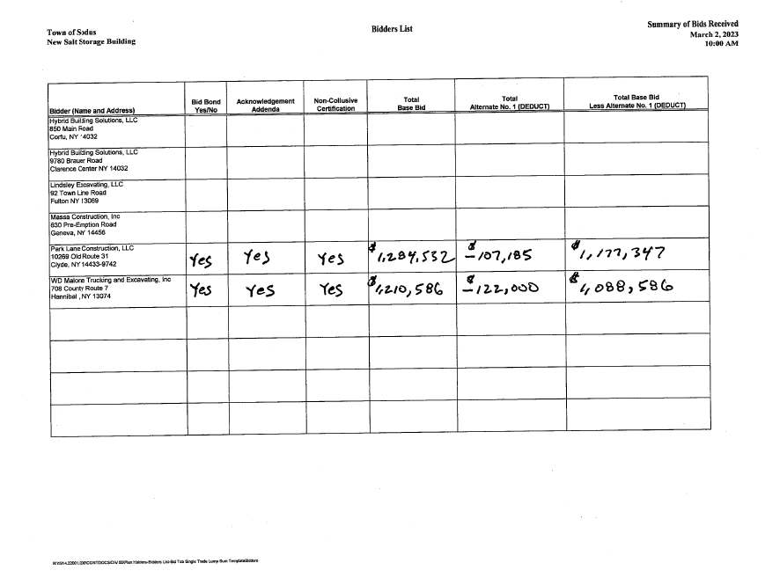

Supervisor Scott Johnson discussed his concern with the amount this project will cost and does not want to see a lot of overages at the end of the project; increasing the price significantly.
Supervisor Clerk Bree Crandell and Susie Jacobs explained the funding already available for this project. Crandell provided the following info:

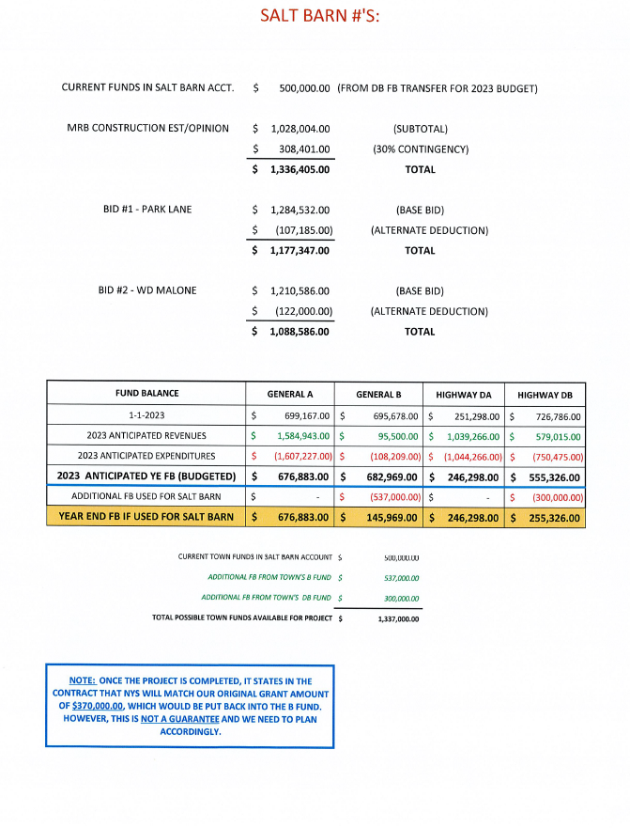

Councilperson Cathy Willmott had questions regarding some aspects of the footage the salt shed is proposed as. Councilperson Dave LeRoy discussed why the increase in square footage was made. In 2019 it was proposed as 72’ wide x 152’ long. Now the new length is 72’ wide x 168’ long for 2023. When it was surveyed it was found that there was additional footage that could be added for the salt barn build.

Councilperson Chris Tertinek motioned to tentatively award the bid to the lowest bidder, WD Malone was seconded by Councilperson David LeRoy. Dave Doyle, MRB will send over an official resolution to award the bid at our regular meeting March 14, 2023. Upon roll call the following votes were heard, Scott Johnson, aye; David LeRoy, aye; Don Ross, aye; Chris Tertinek, aye; and Cathy Willmott; unable to vote-location of zoom was last minute. Motion carried.

Councilperson Chris Tertinek motioned to adjourn meeting was seconded by Councilperson David LeRoy. Upon roll call the following votes were heard, Scott Johnson, aye; David LeRoy, aye; Don Ross, aye; Chris Tertinek, aye; and Cathy Willmott; unable to vote-location of zoom was last minute. Motion carried.
Adjourned: 11:05 AM

Minutes Written By:
Lori Diver
Sodus Town Clerk, RMC

