MINUTES
Minutes of the Regular Town Board Meeting commencing at 6:00 PM in the downstairs courtroom March 8, 2022 located at 14-16 Mill St. Sodus, NY 14551.
All meetings are open to the public.
In addition this meeting was available through Zoom.
Legal Notices were published and posted accordingly.

Present: Scott Johnson, Supervisor
David LeRoy, Councilperson/Deputy Supervisor
Don Ross, Councilperson Zoom
Chris Tertinek, Councilperson
Cathy Willmott, Councilperson

Recording Secretary: Lori Diver, Sodus Town Clerk-RMC

Absent: N/A

Others Present: Dale Pickering, Highway Superintendent
Sal Vittozzi- Camp Beechwood
Sheila Fisher, Recreation Director Zoom
Amy Kendall, Town Attorney Zoom
Julia O’Sullivan- Town Attorney Zoom
Dave Doyle, MRB

Supervisor Scott Johnson called the Regular Town Board Meeting to order commencing at 6:00 PM with the Pledge of Allegiance and Lori Diver opened with roll call. All were present.

PUBLIC SPEAKER:
(Dave Doyle-MRB Group)
Dave Doyle discussed with the Board the Town of Sodus “Salt Barn Project”. He discussed that this project comes with a challenging deadline completion date. The timeframe of the tasks requirements to be completed does not include much of a buffer for any delays. (See page 2 for schedule)

Adam Jordan-Rotterdam Rd. Issue; was unable to attend this meeting because of his job. The Board tabled his discussion to the regular meeting in April.
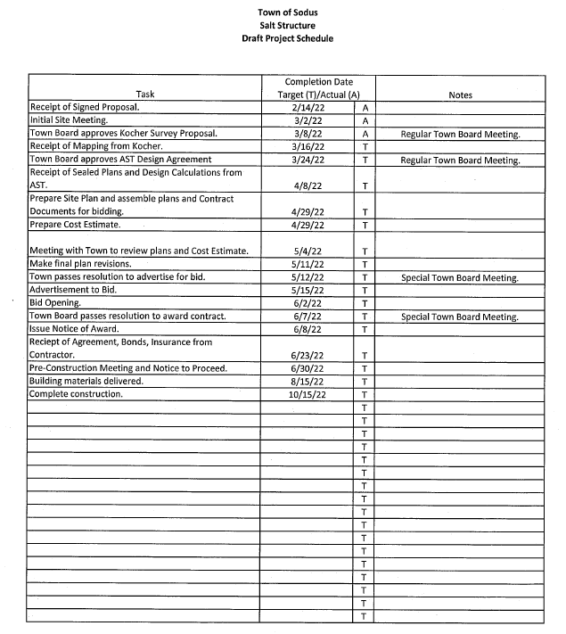
Councilperson David LeRoy motioned to approve the proposal from Kocher Surveying, P.C. for land surveying services as directed by Tom Fromberger of MRB Group and authorize Supervisor Scott Johnson to sign the agreement was seconded by Councilperson Chris Tertinek. Upon roll call the following votes were heard, Scott Johnson, aye; David LeRoy, aye; Don Ross, aye; Chris Tertinek, aye; and Cathy Willmott; aye. Motion carried. (See page 3 for the proposal)

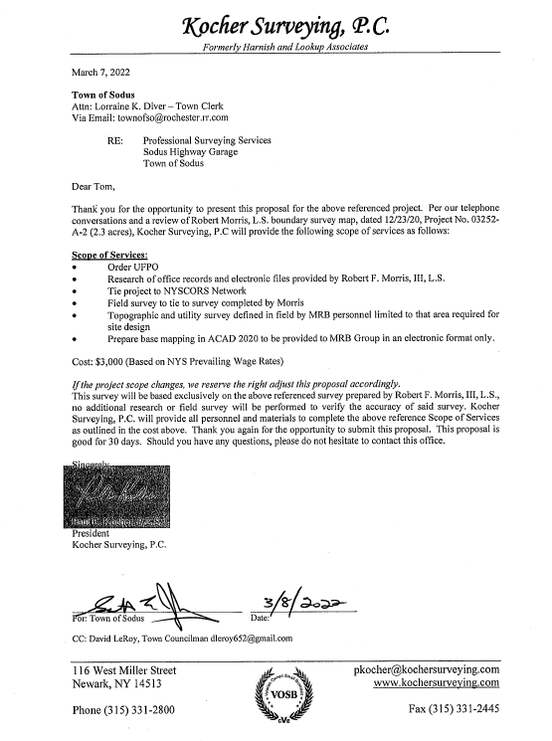
Councilperson Cathy Willmott motioned to approve the agreement with AST Advanced Storage Technology and authorize Supervisor Scott Johnson to sign the agreement subject to attorney approval was seconded by Councilperson Chris Tertinek. Upon roll call the following votes were heard, Scott Johnson, aye; David LeRoy, aye; Don Ross, aye; Chris Tertinek, aye; and Cathy Willmott; aye. Motion carried. (See page 4 for the agreement)

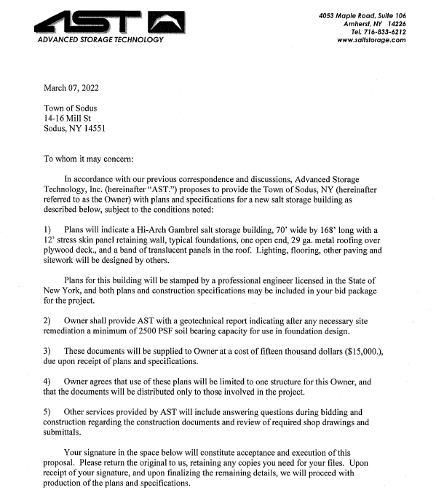
SUPERVISOR’S REPORT
The Supervisor’s report was presented for February 2022. Councilperson Don Ross motioned to accept and file this report, which was seconded by Councilperson David LeRoy. Upon roll call the following votes were heard, Scott Johnson, aye; David LeRoy, aye; Don Ross, aye; Chris Tertinek, aye; and Cathy Willmott; aye. Motion carried.

TOWN CLERK’S REPORT
The Town Clerk’s Report, Town Clerk’s bank statements for audit, and bank register for February 2022 were presented. Councilperson Cathy Willmott motioned to accept and file these reports, which was seconded by Councilperson Don Ross. Upon roll call the following votes were heard, Scott Johnson, aye; David LeRoy, aye; Don Ross, aye; Chris Tertinek, aye; and Cathy Willmott; aye. Motion carried.
TAX COLLECTION REPORT
The Tax Collection Report, Tax Collection bank statements for audit, and bank register for February 2022 were presented. Councilperson David LeRoy motioned to accept and file these reports, which was seconded by Councilperson Don Ross. Upon roll call the following votes were heard, Scott Johnson, aye; David LeRoy, aye; Don Ross, aye; Chris Tertinek, aye; and Cathy Willmott; aye. Motion carried.

MINUTES
Minutes from February 8, 2022 was presented to the Town Board for approval. Councilperson Don Ross motioned to accept and file these Minutes, which was seconded by Councilperson Cathy Willmott. Upon roll call the following votes were heard, Supervisor Scott Johnson, aye; David LeRoy, aye; Don Ross aye Chris Tertinek, aye; and Cathy aye. Motion carried.

Minutes from February 24, 2022 was presented to the Town Board for approval. Councilperson Don Ross motioned to accept and file these Minutes, which was seconded by Councilperson Cathy Willmott. Upon roll call the following votes were heard, Supervisor Scott Johnson, aye; David LeRoy, aye; Don Ross aye Chris Tertinek, aye; and Cathy Willmott; aye. Motion carried.

ABSTRACT
RESOLUTION TO PAY ABSTRACT No. 4
(01 03-2022)
WHEREAS, the following bills were presented for payment on Abstract 4:

General 102-120 $ 7,285.45
Highway 075-088 $ 71,484.97
Bridge Project 002-022 $ 4,082.49
Special St. Lighting 008-008 $ 1,047.16
GRAND TOTAL: $ 83,900.07
Councilperson David LeRoy motioned to adopt this resolution which was seconded by Councilperson Chris Tertinek. Upon roll call the following votes were heard, Scott Johnson, aye; David LeRoy, aye; Don Ross, aye; Chris Tertinek, aye; and Cathy Willmott; aye. Resolution Adopted.

PUBLIC WORKS COMMITTEE: Councilperson David LeRoy, Chair
(Highway, Drainage - Deputy Town Supervisor)
HIGHWAY REPORT:
(Dale Pickering – Highway Superintendent)
Councilperson Cathy Willmott motioned to accept and file the monthly February 2022 Highway Report from Dale Pickering Highway Superintendent was seconded by Councilperson Chris Tertinek. Upon roll call the following votes were heard, Scott Johnson, aye; David LeRoy, aye; Don Ross, aye; Chris Tertinek, aye; and Cathy Willmott; aye. Motion carried.

SALT BARN UPDATE:
Councilperson David LeRoy discussed completing the Salt Barn in September-October time frame. The schedule for this to happen is going to be very tight.

DRAINAGE:
(N/A)

RECREATION/ENVIRONMENTAL COMMITTE: Cathy Willmott, Councilperson
(Recreation, Assessor, Parks, Cemeteries)
Recreation Report
Councilperson David LeRoy motioned to accept and file the monthly February 2022 Town Recreation Report from Director, Sheila Fisher was seconded by Councilperson Don Ross. Upon roll call the following votes were heard, Scott Johnson, aye; David LeRoy, aye; Don Ross, aye; Chris Tertinek, aye; and Cathy Willmott; aye. Motion carried.

Assessor’s Report
(Nathan Mack, Assessor)
Councilperson Chris Tertinek motioned to accept and file the monthly February 2022 Assessor’s Report from Sole Assessor, Nathan Mack was seconded by Councilperson David LeRoy. Upon roll call the following votes were heard, Scott Johnson, aye; David LeRoy, aye; Don Ross, aye; Chris Tertinek, aye; and Cathy Willmott; aye. Motion carried.

Camp Beechwood/Sodus Groundskeeper Report
(Sal Vittozzi-Caretaker-Sodus Town Groundkeeper)
Councilperson Cathy Willmott motioned to accept the monthly February 2022 Camp Beechwood-Parks & Cemeteries Report from Sal Vittozzi; Sodus Town Groundskeeper-Caretaker was seconded by Councilperson David LeRoy. Upon roll call the following votes were heard, Scott Johnson, aye; David LeRoy, aye; Don Ross, aye; Chris Tertinek, aye; and Cathy Willmott; aye. Motion carried.

On June 18th, 2022 at Camp Beechwood, there will be a ribbon cutting ceremony for former Councilperson John Faulks’s “Sunset Pavilion”. The time is yet to be determined.

BUILDINGS AND GROUNDS COMMITTEE: Councilperson Chris Tertinek, Chair
(Town Property, Animal Control, Flood Damage Prevention)
CODE ENFORCEMENT REPORT:
Craig Schwartz- CEO
Councilperson David LeRoy motioned to accept the monthly February 2022 Code Enforcement Report as written was seconded by Councilperson Cathy Willmott. Upon roll call the following votes were heard, Scott Johnson, aye; David LeRoy, aye; Don Ross, aye; Chris Tertinek, aye; and Cathy Willmott; aye. Motion carried.

DOG CONTROL REPORT:
Tracy Brown, Primary DCO
Craig Schwartz- Secondary DCO
Councilperson Cathy Willmott motioned to accept and file the monthly February 2022 Assessor’s Report from Dog Control Officer, Tracy Brown was seconded by Councilperson Don Ross. Upon roll call the following votes were heard, Scott Johnson, aye; David LeRoy, aye; Don Ross, aye; Chris Tertinek, aye; and Cathy Willmott; aye. Motion carried.

FLOOD DAMAGE PREVENTION REPORT-Code 69:
Chris Tertinek, Councilperson
Chris gave his Flood Damage Prevention Report. There is a huge concern that report is off from what the current water levels actually are. The reports are not correct. With the water levels the way they are; there could be flooding this year.

PUBLIC SAFETY/DRAINAGE/ENVIRONMENT COMMITTEE: Councilperson Don Ross, Chair (Fire, Ambulance, Emergency Preparedness)
Councilperson Don Ross shared that the Wayne County Water & Sewer Authority website is being redesigned and will be up and running shortly.
The next SESA Meeting is March 20th at 8:30 PM at the Sodus Point Fire Department.
There was discussion from Ross regarding response times in the 911 report.

TOWN HALL COMMITTEE: Scott Johnson, Supervisor
(Personnel, Clerks, Justices, Assessor, Building Inspector, Town Council, Boards, Insurances, Finance)

CORRESPONDENCE & INFORMATION

Councilperson Don Ross motioned to accept Pat Allen’s written resignation effective March 18, 2022 was seconded by Councilperson Cathy Willmott. Upon roll call, the following votes were heard Supervisor Scott Johnson, aye; LeRoy, aye; Ross, aye; Tertinek, aye; and Willmott, aye. Motion carried.

Councilperson David LeRoy motioned to allow Lori Diver Sodus Town Clerk to advertise for the position of Full-Time Motor Equipment Operator for the Town of Sodus Highway Department was seconded by Councilperson Chris Tertinek. Upon roll call, the following votes were heard Supervisor Scott Johnson, aye; LeRoy, aye; Ross, aye; Tertinek, aye; and Willmott, aye. Motion carried.

Councilperson David LeRoy motioned approving The Procurement Policy (February 2022) with changes made by Amy Kendall Town Attorney and Supervisor Scott Johnson will be responsible for the compliance of this policy was seconded by Councilperson Chris Tertinek. Upon roll call, the following votes were heard Supervisor Scott Johnson, aye; LeRoy, aye; Ross, aye; Tertinek, aye; and Willmott, aye. Motion carried.

DISCUSSION:
Councilperson Cathy Willmott and Councilperson Chris Tertinek discussed the work they have put into updating the Town of Sodus Employee Handbook.

There was discussion on who would be interested from the Town of Sodus for CPR Basic First Aid training. Town Clerk Lori Diver will send out an email and keep a list of those interested.

The April 12th, 2022 Meeting will start at 5:00 PM with a Client Attorney Privilege Information Session and the Regular Town Board Meeting will start at its regular time of 6:00 PM.

Councilperson Chris Tertinek motioned to adjourn the meeting was seconded by Councilperson David LeRoy. Upon roll call the following votes were heard, Scott Johnson, aye; David LeRoy, aye; Don Ross, aye; Chris Tertinek, aye; and Cathy Willmott; aye. Motion carried.

Meeting adjourned at 7:12 PM
Recording Secretary,

Minutes Written By:
Lori Diver Sodus Town Clerk, RMC

