MINUTES
Minutes of the Regular Town Board Meeting commencing at 4:30 PM in the downstairs courtroom May 10, 2022 located at 14-16 Mill St. Sodus, NY 14551.
All meetings are open to the public.
In addition this meeting was available through Zoom.
Legal Notices were published and posted accordingly.

Present: Scott Johnson, Supervisor
David LeRoy, Councilperson/Deputy Supervisor
Don Ross, Councilperson
Chris Tertinek, Councilperson
Cathy Willmott, Councilperson

Recording Secretary: Lori Diver, Sodus Town Clerk-RMC

Absent: N/A

Others Present: Dale Pickering, Highway Superintendent
Sal Vittozzi- Camp Beechwood
Julia O’Sullivan- Town Attorney Zoom
Dave Fitch-Sodus Resident

Supervisor Scott Johnson called the Regular Town Board Meeting to order commencing at 4:30 PM with the Pledge of Allegiance and Lori Diver opened with roll call. All were present.

PUBLIC SPEAKER:
Rob Richardson-Clean Energy Communities Coordinator
Rob Richardson presented to the Town Board the, “Clean Energy Communities 2.0 the Leadership Round” as follows: There was much discussion regarding Rob’s presentation. Rob will follow through with the emails.
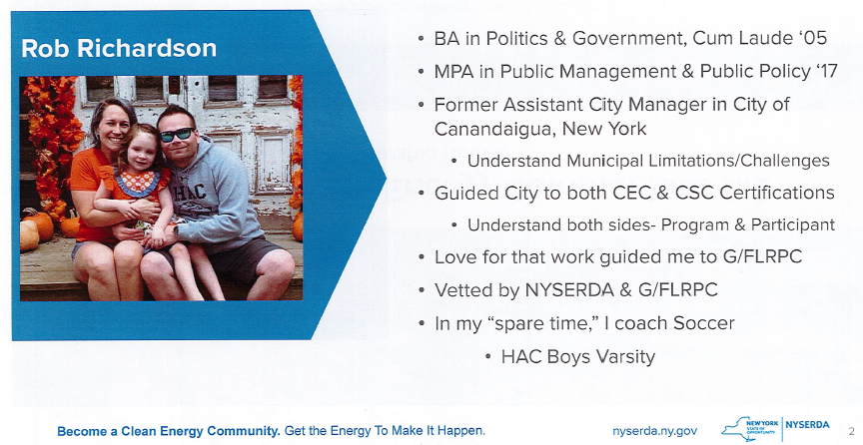

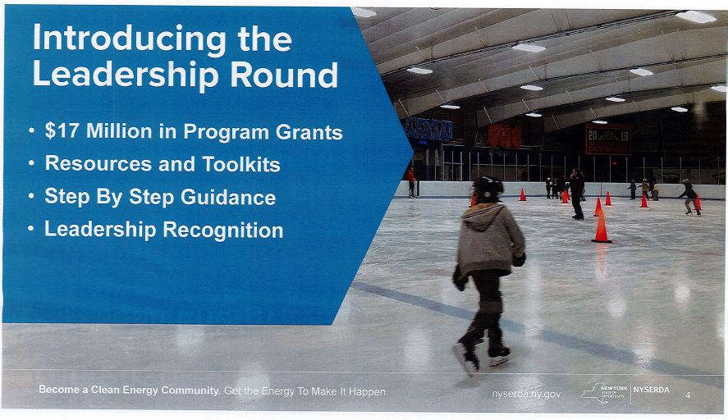

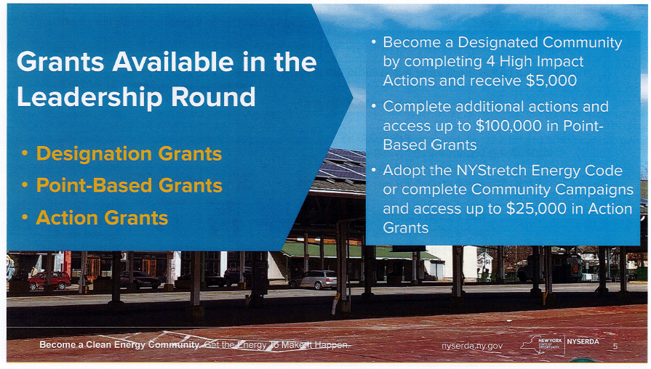
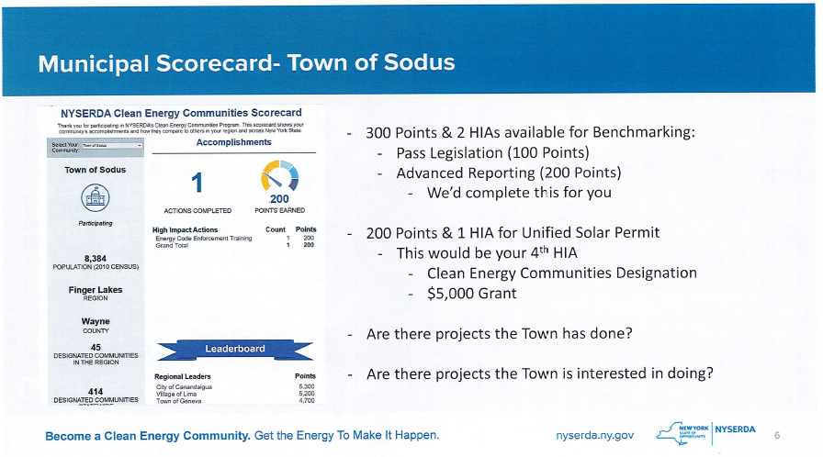

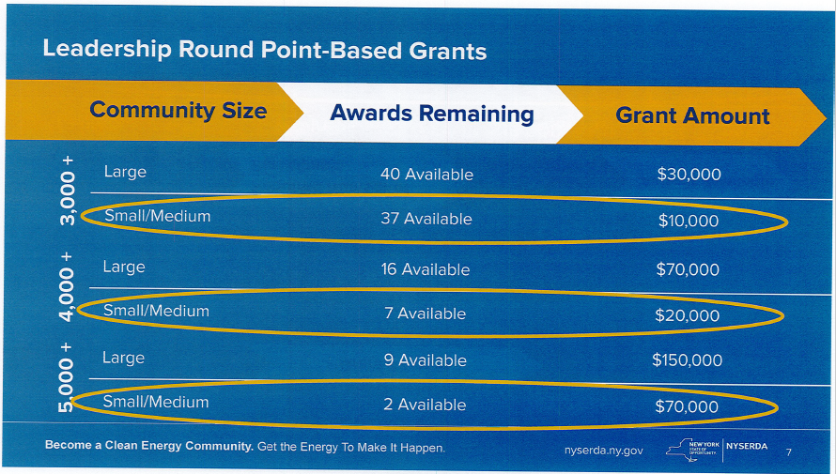

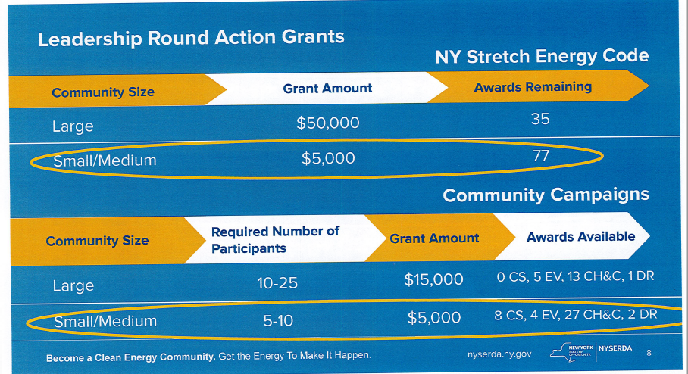

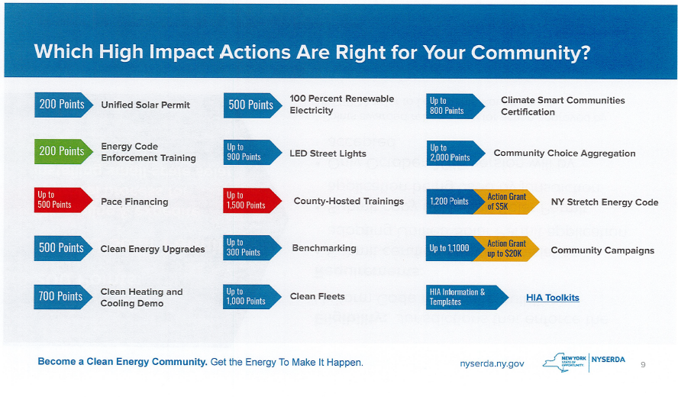
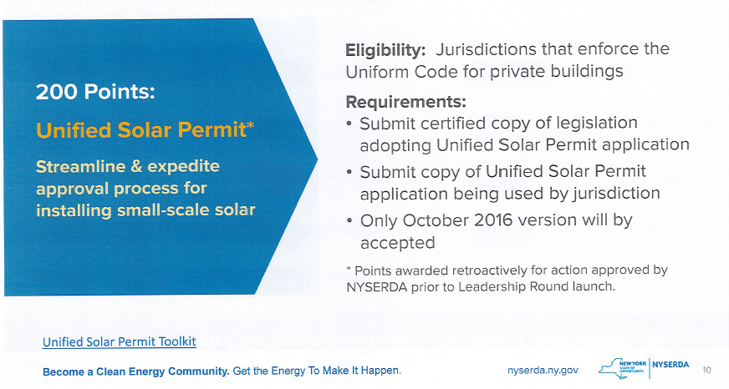

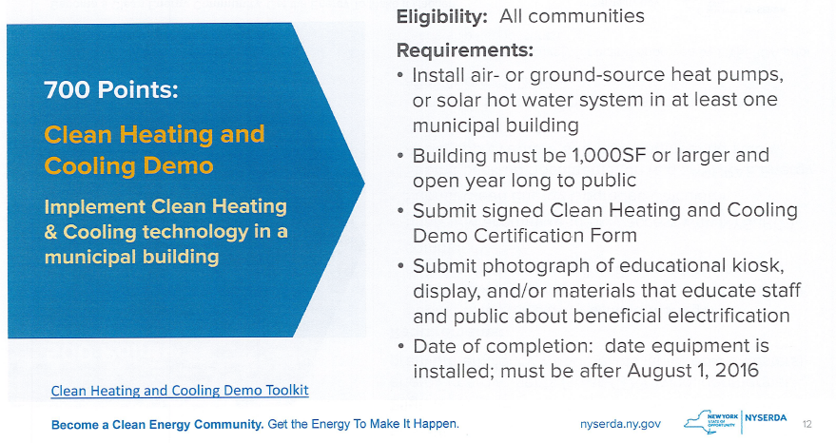

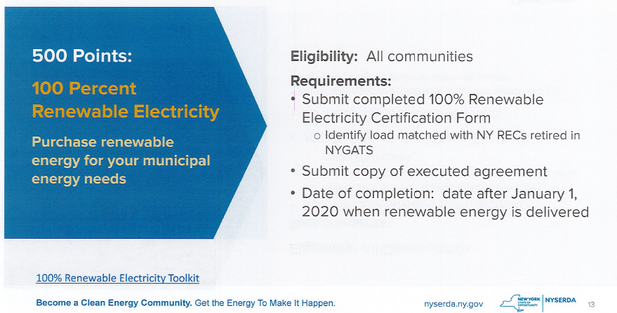

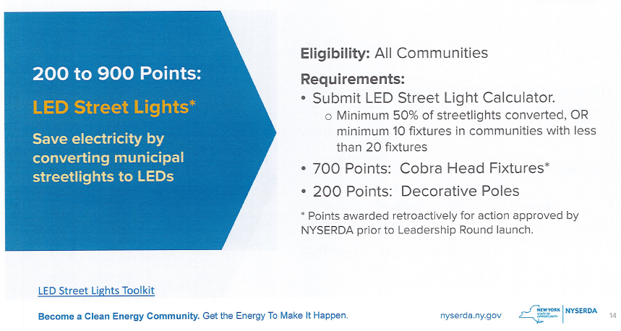

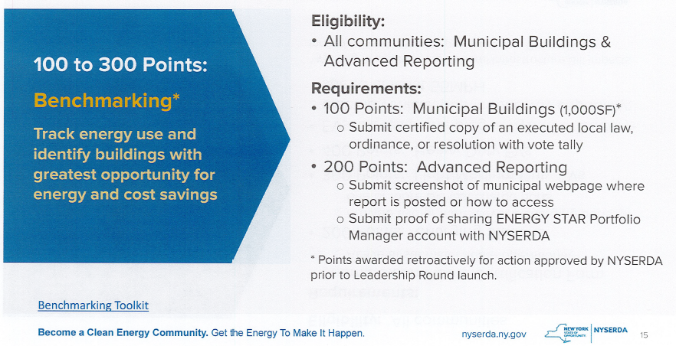

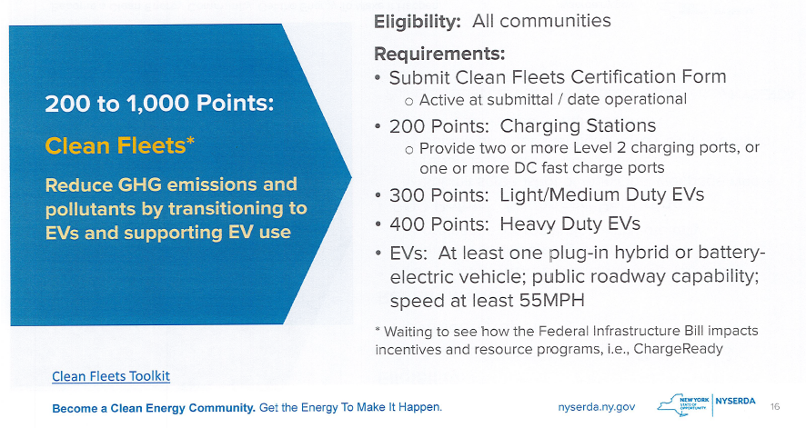

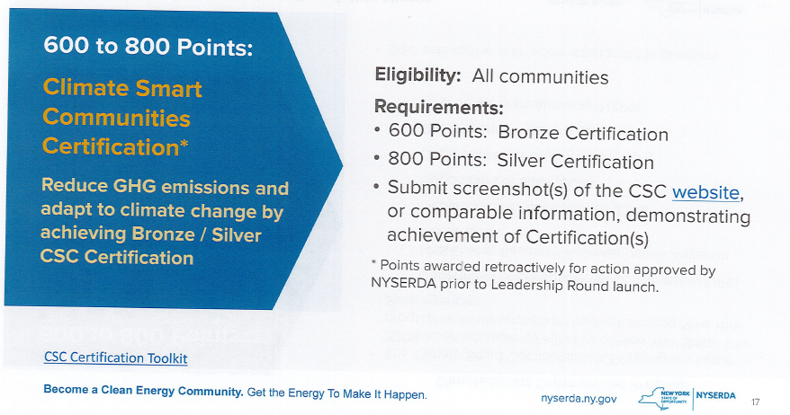

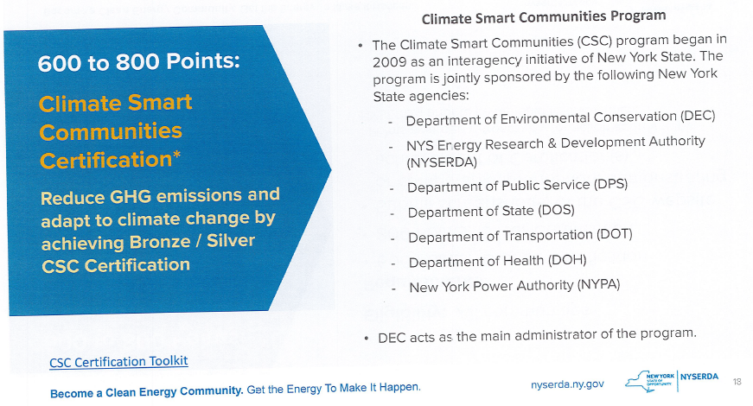

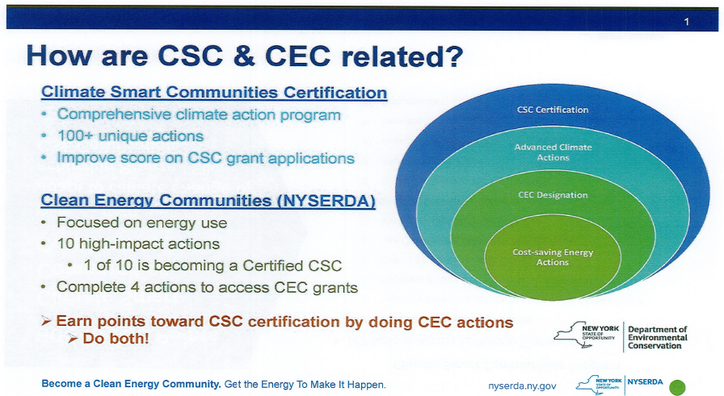

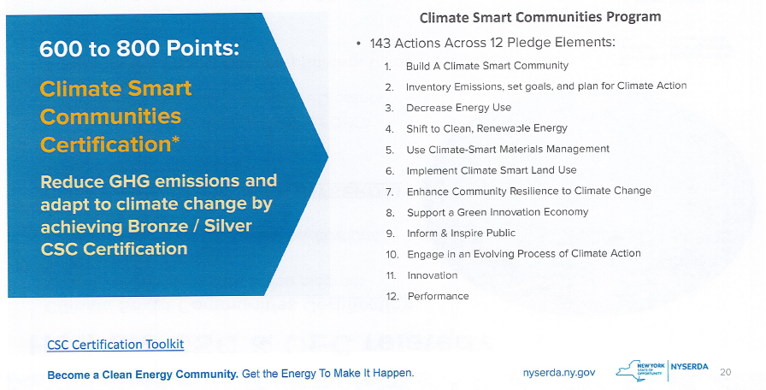

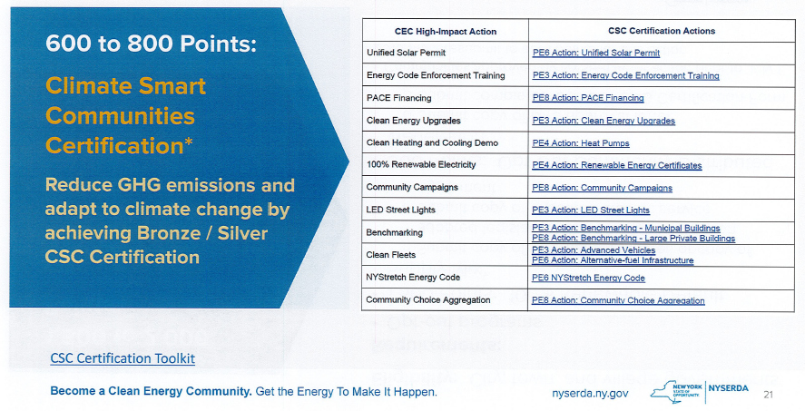
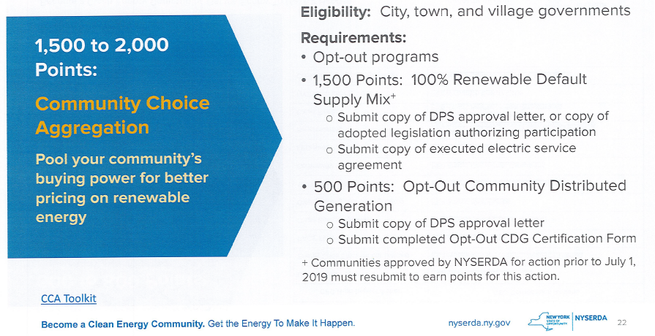

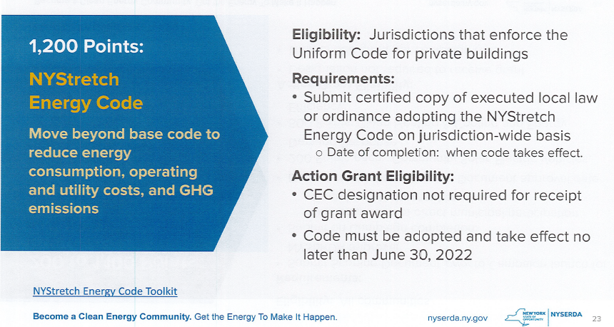

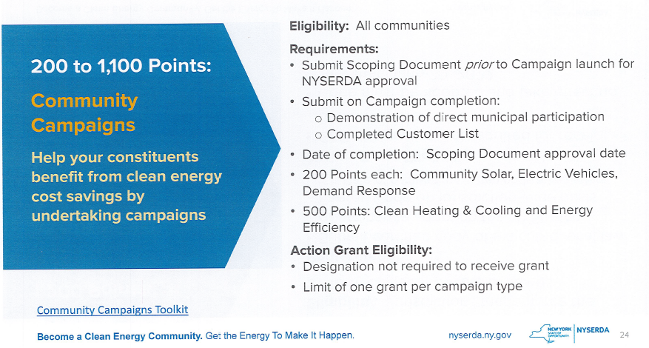

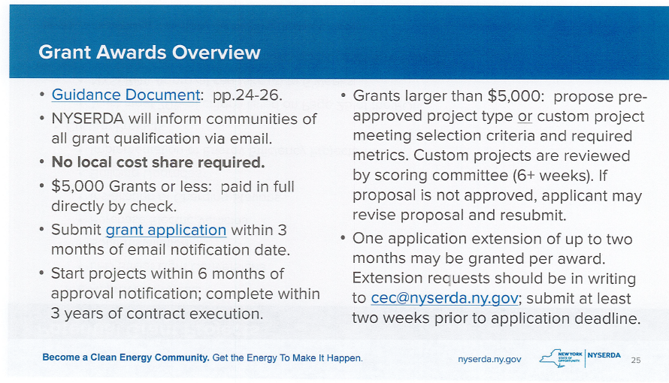

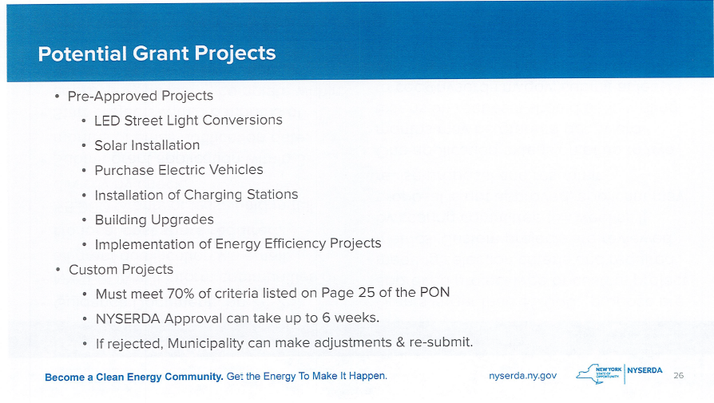
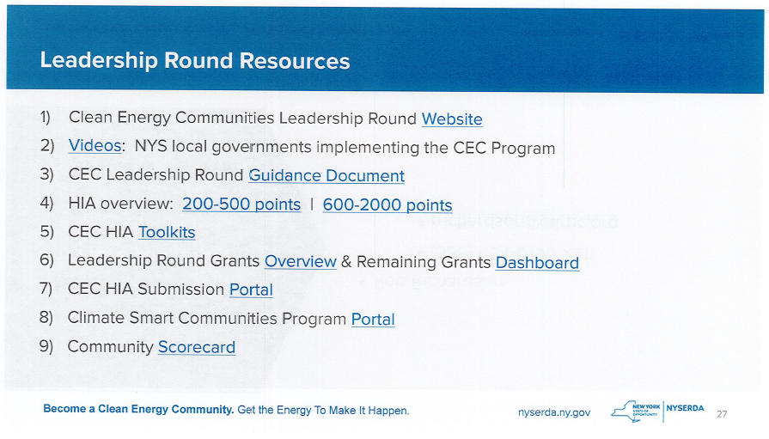

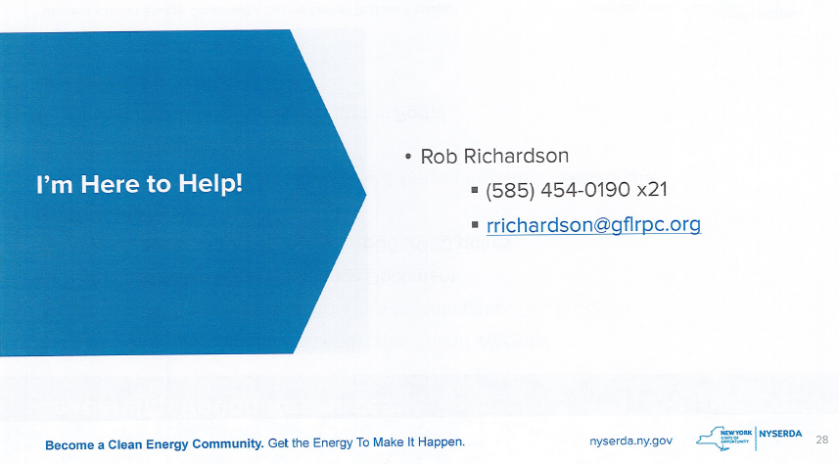

SUPERVISOR’S REPORT
The Supervisor’s report was presented for April 2022. Councilperson Don Ross motioned to accept and file this report, which was seconded by Councilperson Cathy Willmott. Upon roll call the following votes were heard, Scott Johnson, aye; David LeRoy, aye; Don Ross, aye; Chris Tertinek, aye; and Cathy Willmott; aye. Motion carried.

TOWN CLERK’S REPORT
The Town Clerk’s Report, Town Clerk’s bank statements for audit, and bank register for April 2022 were presented. Councilperson Chris Tertinek motioned to accept and file these reports, which was seconded by Councilperson Cathy Willmott. Upon roll call the following votes were heard, Scott Johnson, aye; David LeRoy, aye; Don Ross, aye; Chris Tertinek, aye; and Cathy Willmott; aye. Motion carried.

TAX COLLECTION REPORT
The Tax Collection Report, Tax Collection bank statements for audit, and bank register for April 2022 were presented. Councilperson Cathy Willmott motioned to accept and file these reports, which was seconded by Councilperson Chris Tertinek. Upon roll call the following votes were heard, Scott Johnson, aye; David LeRoy, aye; Don Ross, aye; Chris Tertinek, aye; and Cathy Willmott; aye. Motion carried.

MINUTES
Minutes from April 12, 2022 was presented to the Town Board for approval. Councilperson David LeRoy motioned to accept and file these Minutes, which was seconded by Councilperson Cathy Willmott. Upon roll call the following votes were heard, Supervisor Scott Johnson, aye; David LeRoy, aye; Don Ross aye Chris Tertinek, aye; and Cathy aye. Motion carried.

Minutes from April 28, 2022 was presented to the Town Board for approval. Councilperson Cathy Willmott motioned to accept and file these Minutes, which was seconded by Councilperson Chris Tertinek. Upon roll call the following votes were heard, Supervisor Scott Johnson, aye; David LeRoy, aye; Don Ross aye Chris Tertinek, aye; and Cathy Willmott; aye. Motion carried.
ABSTRACT
RESOLUTION TO PAY ABSTRACT No. 8
(01 5-2022)
WHEREAS, the following bills were presented for payment on Abstract 8:
General 192-214 $ 16,518.18
Highway 136-144 $ 4,398.36
Bridge Project 006-006 $ 7,022.99
Special St. Lighting 010-010 $ 1,054.53
GRAND TOTAL: $ 28,994.06
Councilperson Don Ross motioned to adopt this resolution which was seconded by Councilperson Cathy Willmott. Upon roll call the following votes were heard, Scott Johnson, aye; David LeRoy, aye; Don Ross, aye; Chris Tertinek, aye; and Cathy Willmott; aye. Resolution Adopted.

PUBLIC WORKS COMMITTEE: Councilperson David LeRoy, Chair
(Highway, Drainage - Deputy Town Supervisor)
HIGHWAY REPORT:
(Dale Pickering – Highway Superintendent)
Councilperson Don Ross motioned to accept and file the monthly April 2022 Highway Report from Dale Pickering Highway Superintendent was seconded by Councilperson Cathy Willmott. Upon roll call the following votes were heard, Scott Johnson, aye; David LeRoy, aye; Don Ross, aye; Chris Tertinek, aye; and Cathy Willmott; aye. Motion carried.

Councilperson David LeRoy stated that Dan Dunn is working on water pressure issues at the Highway Barn. In addition, LeRoy will speak with Brandon Martin about lowering dock at Harriman Park. Also, there was discussion on the Town of Sodus records that were badly water damaged with mold on them from the fire in 2019. Town Clerk Lori Diver will contact NYS Records to see what can be done with them. Note: there was no index done of these records from 50 plus years ago.

SALT BARN UPDATE:
N/A

DRAINAGE
N/A

RECREATION/ENVIRONMENTAL COMMITTE: Cathy Willmott, Councilperson
(Recreation, Assessor, Parks, Cemeteries)
Recreation Report
Councilperson Chris Tertinek motioned to accept and file the monthly April 2022 Town Recreation Report from Director, Sheila Fisher was seconded by Councilperson David LeRoy. Upon roll call the following votes were heard, Scott Johnson, aye; David LeRoy, aye; Don Ross, aye; Chris Tertinek, aye; and Cathy Willmott; aye. Motion carried.

Assessor’s Report
(Nathan Mack, Assessor)
Councilperson David LeRoy motioned to accept and file the monthly April 2022 Assessor’s Report from Sole Assessor, Nathan Mack was seconded by Councilperson Don Ross. Upon roll call the following votes were heard, Scott Johnson, aye; David LeRoy, aye; Don Ross, aye; Chris Tertinek, aye; and Cathy Willmott; aye. Motion carried.

Camp Beechwood/Sodus Groundskeeper Report
(Sal Vittozzi-Caretaker-Sodus Town Groundkeeper)
Councilperson David LeRoy motioned to accept the monthly April 2022 Camp Beechwood-Parks & Cemeteries Report from Sal Vittozzi; Sodus Town Groundskeeper-Caretaker was seconded by Councilperson Don Ross. Upon roll call the following votes were heard, Scott Johnson, aye; David LeRoy, aye; Don Ross, aye; Chris Tertinek, aye; and Cathy Willmott; aye. Motion carried.

BUILDINGS AND GROUNDS COMMITTEE: Councilperson Chris Tertinek, Chair
(Town Property, Animal Control, Flood Damage Prevention)
CODE ENFORCEMENT REPORT:
Craig Schwartz- CEO
Councilperson Chris Tertinek motioned to accept the monthly April 2022 Code Enforcement Report as written was seconded by Councilperson Cathy Willmott. Upon roll call the following votes were heard, Scott Johnson, aye; David LeRoy, aye; Don Ross, aye; Chris Tertinek, aye; and Cathy Willmott; aye. Motion carried.

DOG CONTROL REPORT:
Tracy Brown, Primary DCO
Craig Schwartz- Secondary DCO
There was no Primary DCO Report for April 2022-report was not submitted by Tracy Brown.

Councilperson David LeRoy motioned to accept the monthly April 2022 Alternate DCO Report from Craig Schwartz as written was seconded by Councilperson Don Ross. Upon roll call the following votes were heard, Scott Johnson, aye; David LeRoy, aye; Don Ross, aye; Chris Tertinek, aye; and Cathy Willmott; aye. Motion carried.

FLOOD DAMAGE PREVENTION REPORT-Code 69:
Chris Tertinek, Councilperson
Chris gave his Flood Damage Prevention Report.

PUBLIC SAFETY/DRAINAGE/ENVIRONMENT COMMITTEE: Councilperson Don Ross, Chair (Fire, Ambulance, Emergency Preparedness)
Councilperson Don Ross gave his monthly report.

TOWN HALL COMMITTEE: Scott Johnson, Supervisor
(Personnel, Clerks, Justices, Assessor, Building Inspector, Town Council, Boards, Insurances, Finance)

CORRESPONDENCE & INFORMATION

Councilperson Chris Tertinek motioned to approve emailed resignation from Primary DCO Tracy Brown effective May 18, 2022 was seconded by Councilperson Don Ross. Upon roll call, the following votes were heard Supervisor Scott Johnson, aye; LeRoy, aye; Ross, aye; Tertinek, aye; and Willmott, aye. Motion carried.

Councilperson David LeRoy motioned to remove Shane Martin as Alternate DCO was seconded by Councilperson Cathy Willmott. Note: Per phone conversation he told Town Clerk Lori Diver he cannot do the job anymore and needed to resign. Diver asked for a written resignation several times and he did not submit one. He has been getting paid $31.00 monthly regardless if he responds to a call or not. Upon roll call, the following votes were heard Supervisor Scott Johnson, aye; LeRoy, aye; Ross, aye; Tertinek, aye; and Willmott, aye. Motion carried.

WILLIAMSON FLYING CLUB, INC.
WILLIAMSON –SODUS AIRPORT (KSDC)
RESOLUTION
(02 05-2022)
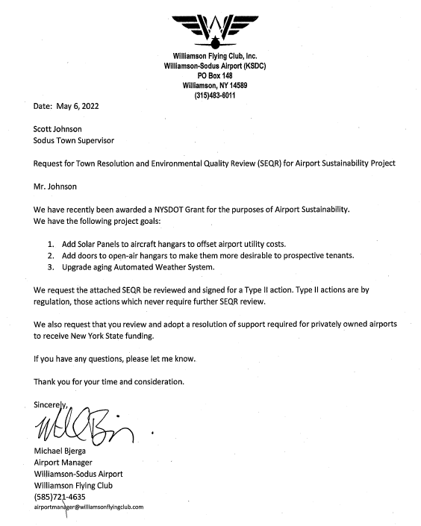

Supervisor Johnson offered the following resolution for its adoption,

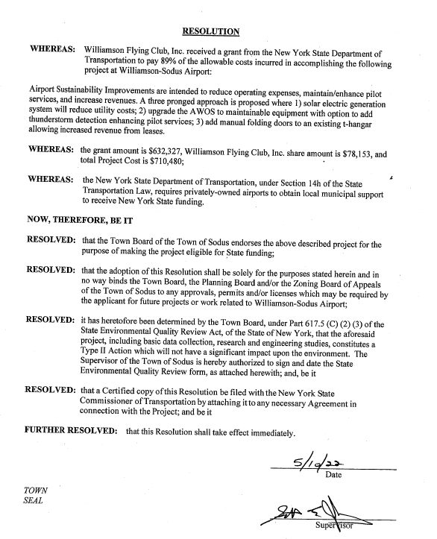
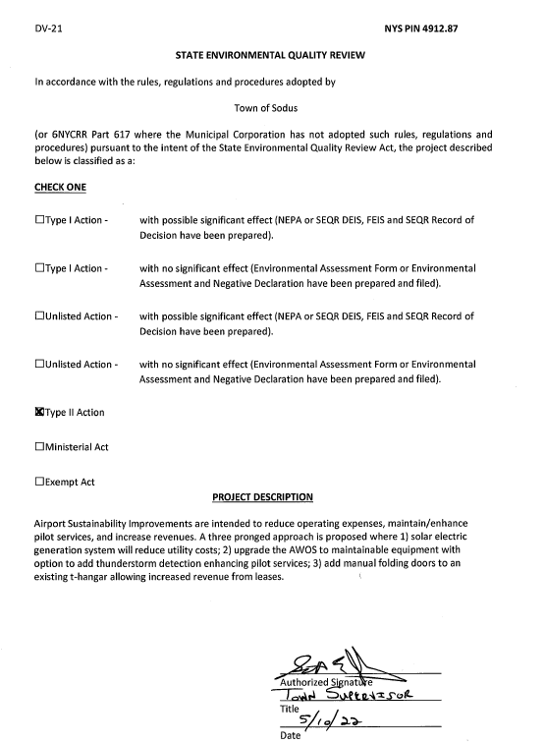

FURTHER BE IT RESOLVED, Councilperson David LeRoy motioned to adopt this resolution which was seconded by Councilperson Cathy Willmott. Upon roll call the following votes were heard, Scott Johnson, aye; David LeRoy, aye; Don Ross, aye; Chris Tertinek, aye; and Cathy Willmott; aye. Resolution Adopted.

HIGHWAY – JAMES MICHALKE FULL-TIME MOTOR EQUIPMENT OPERATOR
RESOLUTION
(04 05-2022)
Supervisor Scott Johnson offered the following resolution for its adoption,

RESOLVED, Councilperson Don Ross motioned to hire James Michalke full-time for the Town of Sodus Highway Department effective as soon as possible pending alcohol and drug pre-employment testing results for the position of Motor Equipment was seconded by Councilperson Chris Tertinek. The compensation and benefits are based on the current union contract with the Town of Sodus Highway employees.

FUTHER BE IT RESOLVED, upon roll call the following votes were heard, Supervisor Scott Johnson, aye; David LeRoy, aye; Don Ross, aye; Cathy Willmott, aye; Chris Tertinek, aye. Resolution Adopted.

HIGHWAY – JASON SHULTZ MOTOR EQUIPMENT OPERATOR
RESOLUTION
(05 05-2022)
Supervisor Scott Johnson offered the following resolution for its adoption,

RESOLVED, Councilperson Don Ross motioned to hire Jason Shultz for the Town of Sodus Highway Department with a start date of July 1, 2022 pending alcohol and drug pre-employment testing results for the position of Motor Equipment was seconded by Councilperson Cathy Willmott. The compensation and benefits are based on the current union contract with the Town of Sodus Highway employees.

FUTHER BE IT RESOLVED, upon roll call the following votes were heard, Supervisor Scott Johnson, aye; David LeRoy, aye; Don Ross, aye; Cathy Willmott, aye; Chris Tertinek, aye. Resolution Adopted.

Councilperson Don Ross motioned to adjourn the meeting was seconded by Councilperson David LeRoy. Upon roll call the following votes were heard, Scott Johnson, aye; David LeRoy, aye; Don Ross, aye; Chris Tertinek, aye; and Cathy Willmott; aye. Motion carried.

Meeting adjourned at 6:55 PM
Recording Secretary,

Minutes Written By:
Lori Diver Sodus Town Clerk, RMC

