Sodus Town Board Agenda
May 16, 2023
6:00 PM
Open with Pledge Allegiance
Roll Call: (Lori Diver)
Supervisor Johnson, Councilperson LeRoy, Councilperson Ross, Councilperson Tertinek, Councilperson Willmott

Bid Opening 6:00 PM (Lori to read the following);

LEGAL NOTICE
TOWN OF SODUS
BID NOTICE:
“Related Gravel Products”

PLEASE TAKE NOTICE: The Town Board of the Town of Sodus will receive BIDS for: “Related Gravel Products.” Please see BID specifications for detailed information. You may visit the Town of Sodus website https://townofsodus.net and click on the more information tab and then click on the legals/resolutions/agendas tab, email: townofso@rochester.rr.com or visit the Sodus Town Clerk’s Office Monday-Friday located at 14-16 Mill St. Sodus, NY 14551.

All bids must be in a sealed envelope and “BID-Town of Sodus” needs to be written on outside of sealed envelope. Please note: NO email BIDS will be allowed. The sealed bids will be opened and read at the Regular Town Board Meeting in the Sodus Town Courtroom at 6:00 PM Tuesday May 16, 2023 located at 14-16 Mill St. Sodus, NY 14551. Sealed BIDS must be received by 5:00 PM Monday May 15, 2023 at the Sodus Town Clerk’s Office. The Sodus Town Board and the Superintendent of Highways reserves the right to reject any or all BIDS.

By Order of the Sodus Town Board:
Lori K. Diver
Sodus Town Clerk, RMC
Dated: April 19, 2023

- Motion to accept bid from __________________ in the amount of ________________.

Public Speakers:
(Robert Fratangelo/Tom Putnam)

- Resolution to hire Terry Ryan effective June 5, 2023 to fulfil the vacant full-time Court Clerk position, beginning with a 6-month probationary period and hourly rate of $19.50 per hour.

Agenda:
Minutes: Motion to file the following minutes:
- April 11, 2023 Regular Town Board Meeting (Councilperson LeRoy and Councilperson Ross must abstain)
- April 20, 2023 Special Town Board Meeting (Councilperson LeRoy must abstain)
- April 27, 2023 Month End Town Board Meeting

- Supervisor’s Report

- Town Clerk’s Report

- Tax Collection Report

- Resolution to Approve Bills 8-2023

- Public Works Committee: Councilperson David LeRoy
(Highway, Drainage)
- Motion to file Highway Superintendent’s Report

- Salt Barn:

- Drainage N/A

- Buildings and Grounds Committee: Councilperson Chris Tertinek
(Town Property, Animal Control, Code Enforcement, Flood Damage)
- Motion to file Code Enforcement Report – Frank Gahr
- Motion to file Dog Control Officer Report– Robert Snyder
- Flood Damage Prevention – Chris Tertinek

- Recreation/Environmental Committee: Councilperson Cathy Willmott
(Recreation, Assessor, Parks, Cemeteries)
- Motion to file Sodus Recreation Report-Sheila Fisher
- Motion to file Assessor’s Report – Nathan Mack
- Motion to file Camp Beachwood/Sodus Groundskeeper Report – Sal Vittozzi

- Public Safety Committee: Councilperson Don Ross
(Fire, Ambulance, Emergency Preparedness - WC, Water Authority - WC)

- Town Hall Committee: Supervisor Scott Johnson
(Personnel, Town Council, Court, Assessor, Building Inspector, Boards/Committees, Insurances, Finance, Environmental)
Correspondence & Information
- Motion to raise reimbursement for veterans’ flags placed at the Sodus Rural Cemetery from .50 cents per flag to $1.00 per flag effective immediately. Reimbursement is paid to the Sodus Rural Cemetery yearly before Memorial Day.

- Motion to allow Sodus Center Fire Department the use of the Sodus Center Town Park on the corner of South Street and School Street August 5, 2023 for public parking.

- Sodus Center Fire Department is turning 100 Years old! The event will be August 5, 2023. Parade lines up at 5 PM at the corner of Sodus Center Road and Buerman Rd (proceeding east on Sodus Center Rd to Main St. and ending at the fire station). Who from the Town Board wants to attend (registration form needs to be filled out and returned)?

- Motion to advertise and hold Public Hearing for Local Law 3-2023 Building Code June 13th, 2023 at 6:00 PM (Amy).

- Resolution to pay a stipend for part-time employees of $100.00 and $200.00 for full-time employees the first paycheck of each month. This is a stipend issued to Town of Sodus employees from ARPA funds and is effective April 2023 and terminates December 2023 (Bree Crandell).

- Resolution authorizing Assessor Nathan Mack to purchase one Lenovo PC with a 13-12th generation processor. It has 8GB of ram and 256 GB SSD in the amount of $1324.00 an additional cost of $75.00 for Office and additional labor to install. Estimated delivery is May 10-May 12th. Supervisor Johnson authorized the purchase prior to board meeting given Mack’s computer failed immediately.

- Resolution authorizing Reliant Credit Union to use Town Roads for the “Moore than a Race” Sunday October 15, 2023 at Noon. This is a 5K race and the same route will be used as in previous years.

EXECUTIVE SESSION:
- Motion to enter into Executive Session regarding medical, financial, credit or employment history of a particular person or corporation or relating to appointment promotion demotion discipline or removal.
Time_________________

- Motion to exit out of Executive Session and enter back into regular session.
Time _________________

- Motion to adjourn meeting.
Time _________________

MINUTES
Minutes of the Regular Town Board Meeting commencing at 6:00 PM in the courtroom held May 16, 2023 located at 14-16 Mill St. Sodus, NY 14551.
All meetings are open to the public.

In addition, this meeting was available through Zoom. Legal Notices were published and posted accordingly.

Present: Scott Johnson, Supervisor
David LeRoy, Councilperson/Deputy Supervisor Don Ross, Councilperson
Chris Tertinek, Councilperson
Cathy Willmott, Councilperson

Recording Secretary: Lori Diver Sodus Town Clerk

Absent: N/A

Others Present: Amy Kendall, Town Attorney
Tom Putnam, Town Justice
Robert Fratangelo, Town Justice
Bree Crandell, Supervisor Clerk
Dale Pickering, Highway Superintendent
Sal Vittozzi, Camp Beechwood Caretaker
Sheila Fisher, Recreation Director

Supervisor Scott Johnson called the Regular Town Board Meeting to order commencing at 6:00 PM and Lori Diver opened with roll call. All Board Members were present.

Bid Opening 6:00 PM (Lori to read the following);

LEGAL NOTICE
TOWN OF SODUS
BID NOTICE:
“Related Gravel Products”

PLEASE TAKE NOTICE: The Town Board of the Town of Sodus will receive BIDS for: “Related Gravel Products.” Please see BID specifications for detailed information. You may visit the Town of Sodus website https://townofsodus.net and click on the more information tab and then click on the legals/resolutions/agendas tab, email: townofso@rochester.rr.com or visit the Sodus Town Clerk’s Office Monday-Friday located at 14-16 Mill St. Sodus, NY 14551.

All bids must be in a sealed envelope and “BID-Town of Sodus” needs to be written on outside of sealed envelope. Please note: NO email BIDS will be allowed. The sealed bids will be opened and read at the Regular Town Board Meeting in the Sodus Town Courtroom at 6:00 PM Tuesday May 16, 2023 located at 14-16 Mill St. Sodus, NY 14551. Sealed BIDS must be received by 5:00 PM Monday May 15, 2023 at the Sodus Town Clerk’s Office. The Sodus Town Board and the Superintendent of Highways reserves the right to reject any or all BIDS.

By Order of the Sodus Town Board:
Lori K. Diver
Sodus Town Clerk, RMC
Dated: April 19, 2023

Only one bid was received from Crushmore, LLC Po Box 172 Pultneyville, NY 14538.
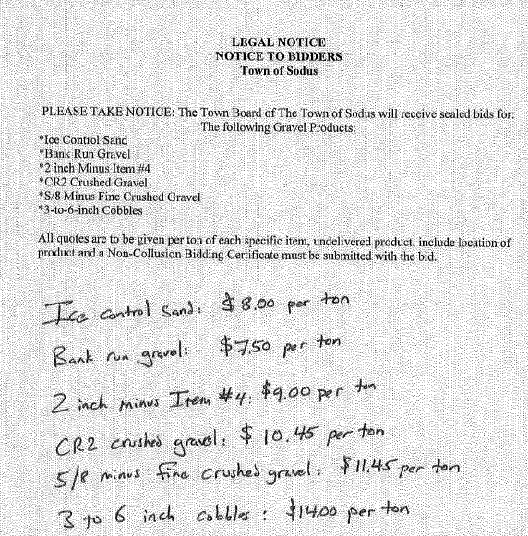

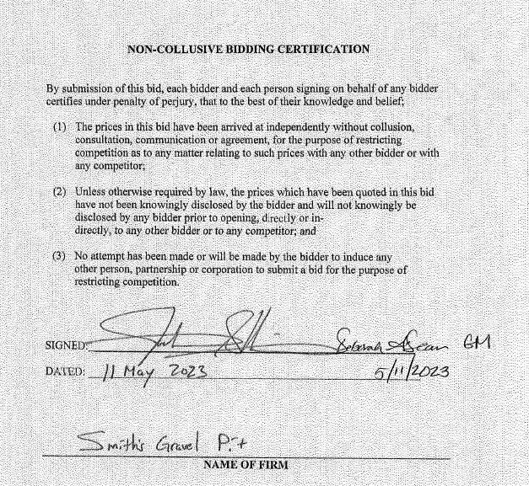

Councilperson Cathy Willmott motioned to accept BID from Crushmore LLC Po Box 172 Pultneyville, NY 14358 as listed above was seconded by Councilperson Chris Tertinek. Upon roll call the following votes were heard, Scott Johnson, aye; David LeRoy, aye; Don Ross, aye; Chris Tertinek, aye; and Cathy Willmott; aye. Motion carried.

Public Speakers:
Town Justices Thomas Putnam and Robert Fratangelo discussed with the Board that they finally found an experienced Court Clerk to fulfil the vacant full-time position in Court.

RESOLUTION
COURT- NEW HIRE TERRY RYAN
(01 05-2023)
NOW BE IT RESOLVED; Councilperson Don Ross motioned to authorize Town Justices Robert Fratangelo and Tom Putnam to hire Terry Ryan as a Full Time-benefited Court Clerk, beginning with a 6-month probationary period and her hourly rate will start at $19.50. Exact hire date is yet to be determined which was seconded by Councilperson David LeRoy. Upon roll call the following votes were heard, Scott Johnson, aye; David LeRoy, aye; Don Ross, aye; Chris Tertinek, aye; and Cathy Willmott; aye. Resolution Adopted.

MINUTES
Minutes from April 11, 2023 was presented to the Town Board to be filed. Councilperson Cathy Willmott motioned to file these Minutes, which was seconded by Councilperson Chris Tertinek. Upon roll call the following votes were heard, Scott Johnson, aye; David LeRoy, abstain; Don Ross, abstain; Chris Tertinek, aye; and Cathy Willmott; aye. Motion carried.

Minutes from April 20, 2023 was presented to the Town Board to be filed. Councilperson Cathy Willmott motioned to file these Minutes, which was seconded by Councilperson Don Ross. Upon roll call the following votes were heard, Scott Johnson, aye; David LeRoy, abstain; Don Ross, aye; Chris Tertinek, aye; and Cathy Willmott; aye. Motion carried.

Minutes from April 27, 2023 was presented to the Town Board to be filed. Councilperson David LeRoy motioned to file these Minutes, which was seconded by Councilperson Chris Tertinek. Upon roll call the following votes were heard, Scott Johnson, aye; David LeRoy, aye; Don Ross, aye; Chris Tertinek, aye; and Cathy Willmott; aye. Motion carried.

SUPERVISOR’S REPORT
The Supervisor’s monthly report was presented for April 2023. Councilperson David LeRoy motioned to file this report, which was seconded by Councilperson Chris Tertinek. Upon roll call the following votes were heard, Scott Johnson, aye; David LeRoy, aye; Don Ross, aye; Chris Tertinek, aye; and Cathy Willmott; aye. Motion carried.

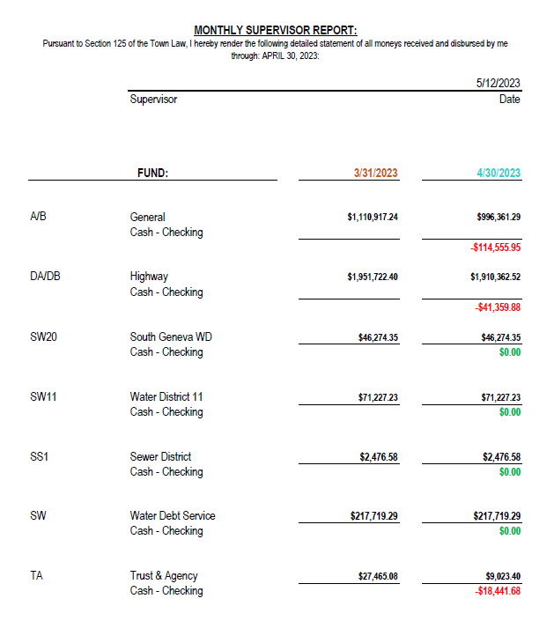

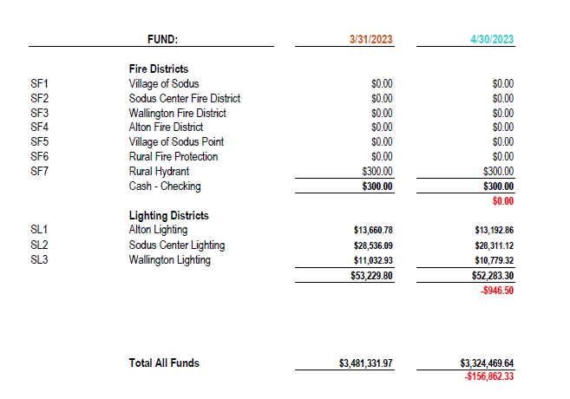

TOWN CLERK’S REPORT
The Town Clerk’s Reports, Town Clerk’s bank statements for audit and bank register for April 2023 was presented. Note: bank statement and bank register are listed in detail with Town Clerk cash book for 2023. For security reasons and confidentiality, it cannot be published in Minutes. Councilperson Cathy Willmott motioned to file these reports, which was seconded by Councilperson Don Ross. Upon roll call the following votes were heard, Scott Johnson, aye; David LeRoy, aye; Don Ross, aye; Chris Tertinek, aye; and Cathy Willmott; aye. Motion carried.

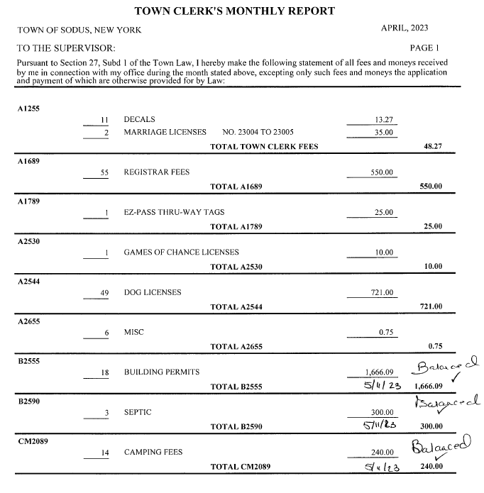

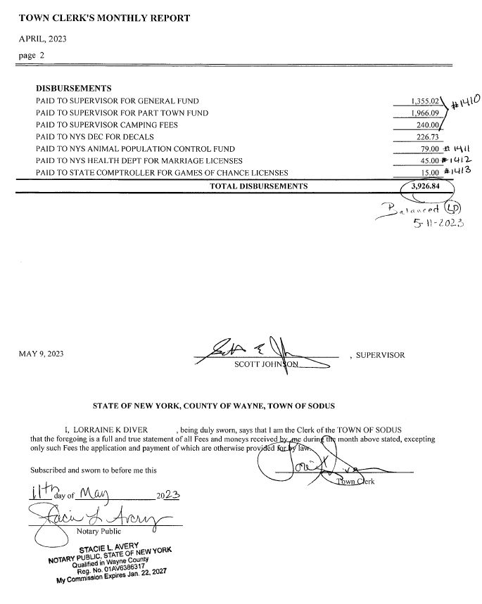

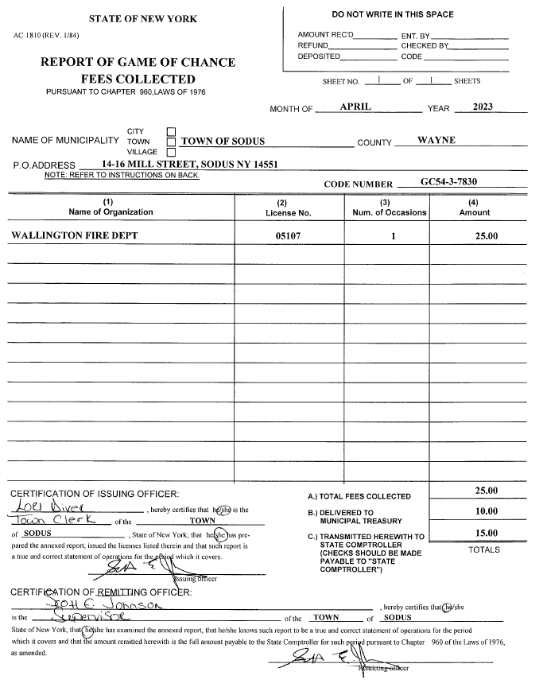

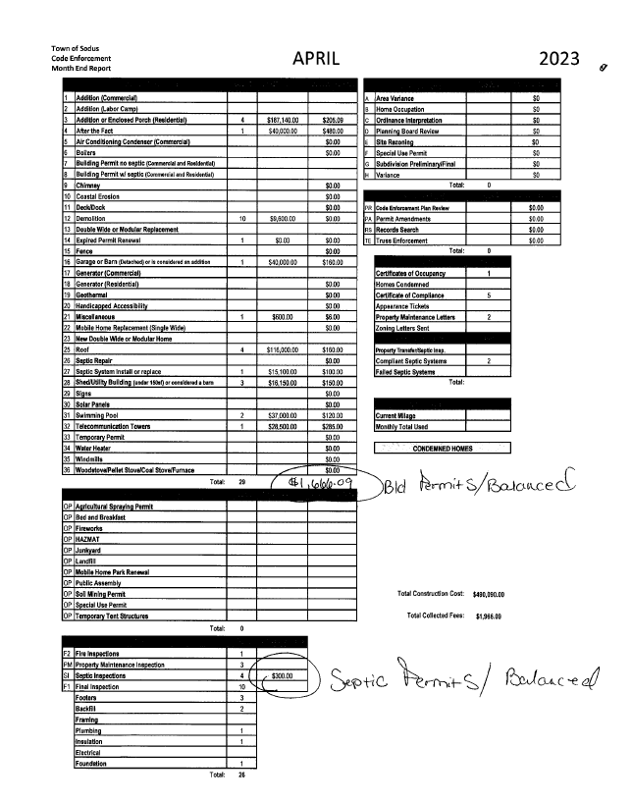

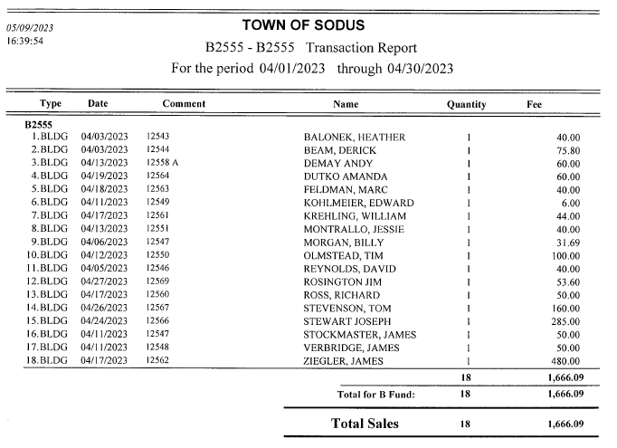

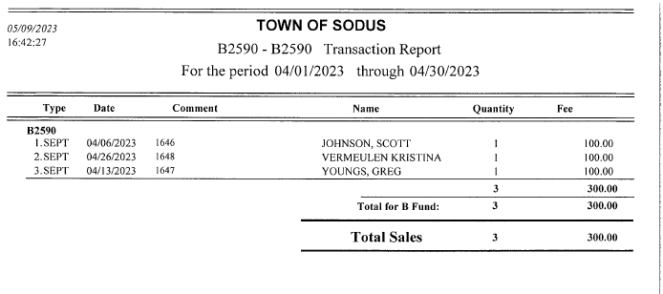

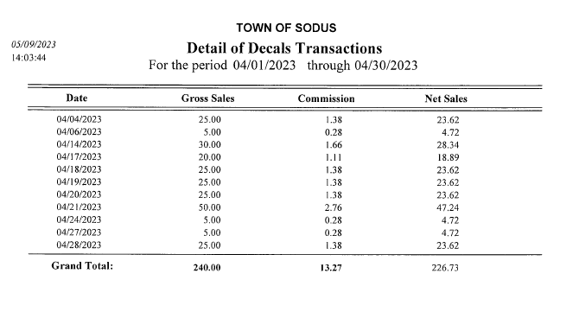
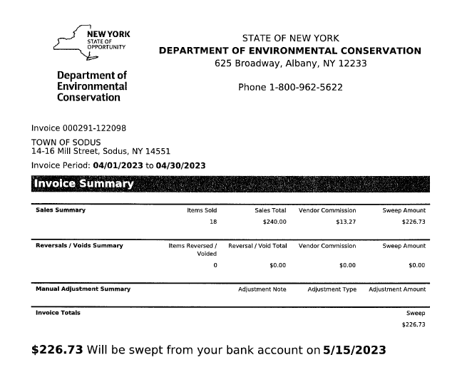
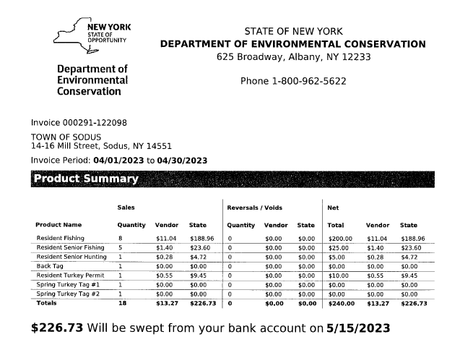

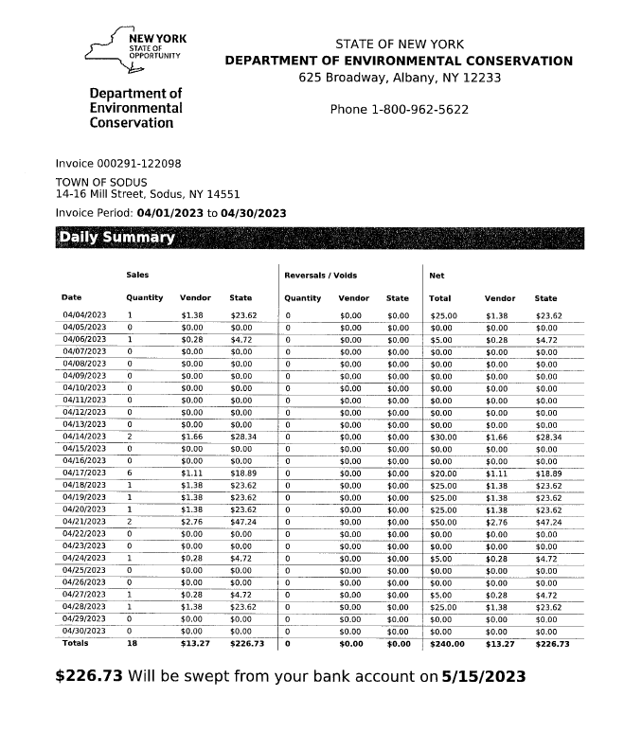

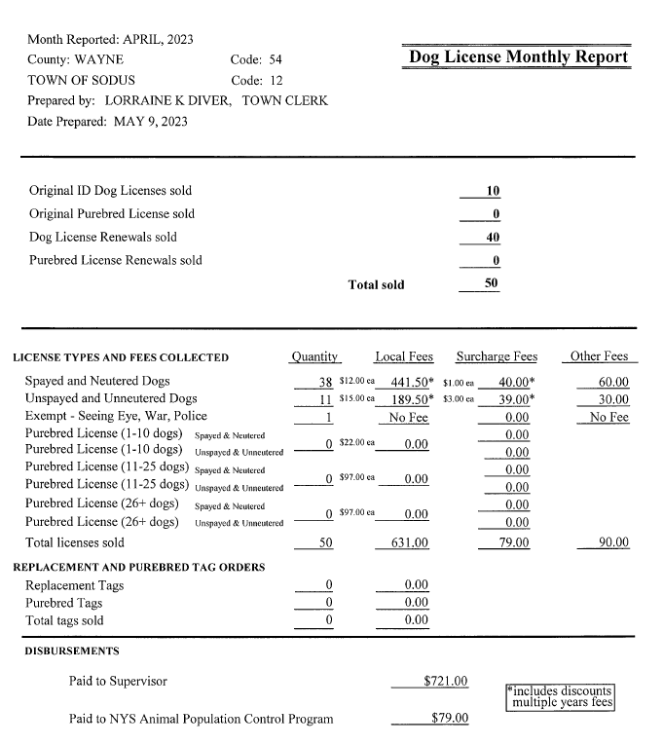

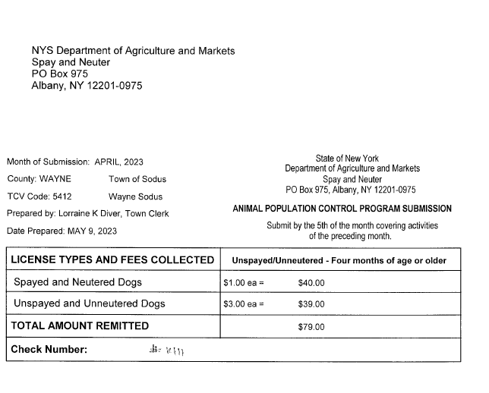

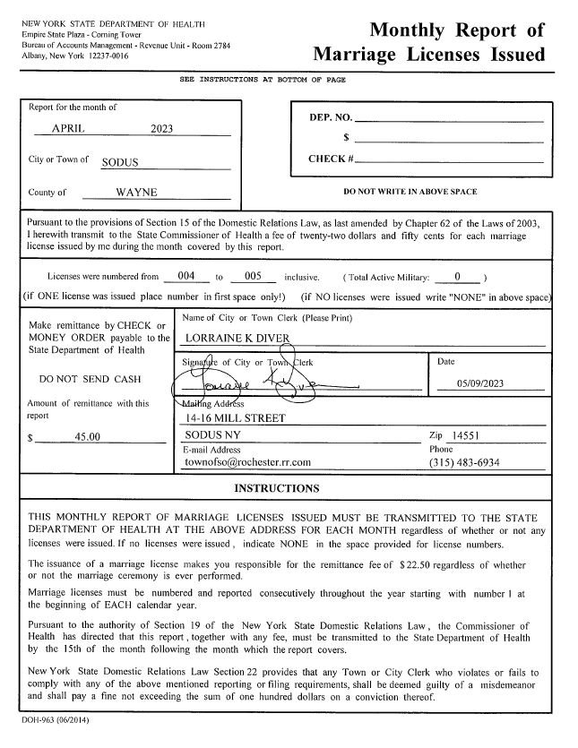

TAX COLLECTION REPORT
The Tax Collection Report, Tax Collector bank statements for audit and bank register for April 2023 was presented. Councilperson David LeRoy motioned to file this report, which was seconded by Councilperson Cathy Willmott. Upon roll call the following votes were heard, Scott Johnson, aye; David LeRoy, aye; Don Ross, aye; Chris Tertinek, aye; and Cathy Willmott; aye. Motion carried.
Note: bank statement and bank register are listed in detail with Tax Collection cash book for 2023. For security reasons and confidentiality, it cannot be published in Minutes.
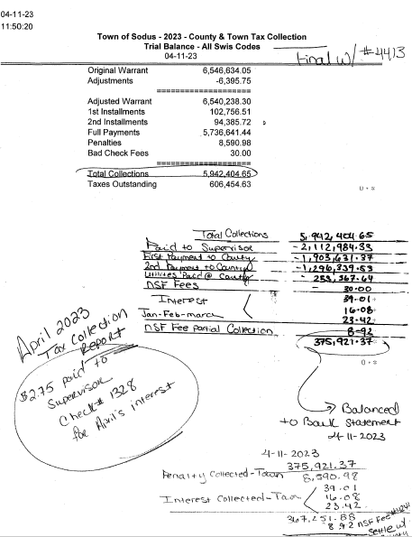

ABSTRACT
RESOLUTION TO PAY ABSTRACT NO. 08
(02 05-2023)
WHEREAS, the following bills were presented for payment on Abstract 08:

General 201-228 $ 12,009.93
Highway 114-126 $ 4,758.26
Special District 012-012 $ 885.33
Capital Projects 027-027 $ 3,101.07
GRAND TOTAL: $ 20,754.59

NOW BE IT RESOLVED, Councilperson Chris Tertinek motioned to approve payment of these bills as reviewed for Abstract No. 08, which was seconded by Councilperson Don Ross. Upon roll call the following votes were heard, Scott Johnson, aye; David LeRoy, aye; Don Ross, aye; Chris Tertinek, aye; and Cathy Willmott; aye. Resolution Adopted.
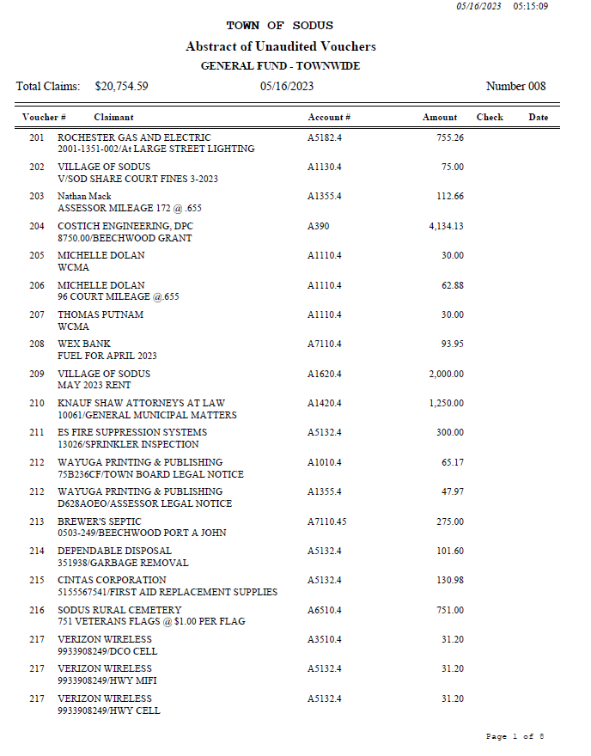

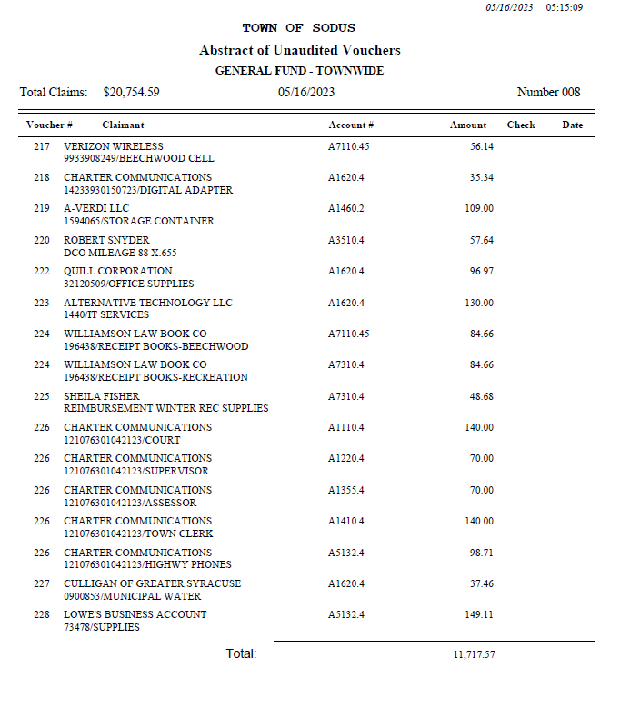

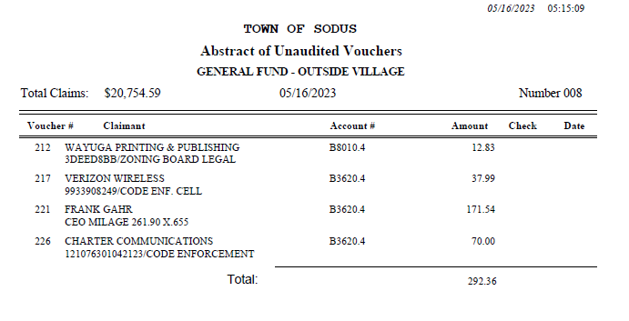

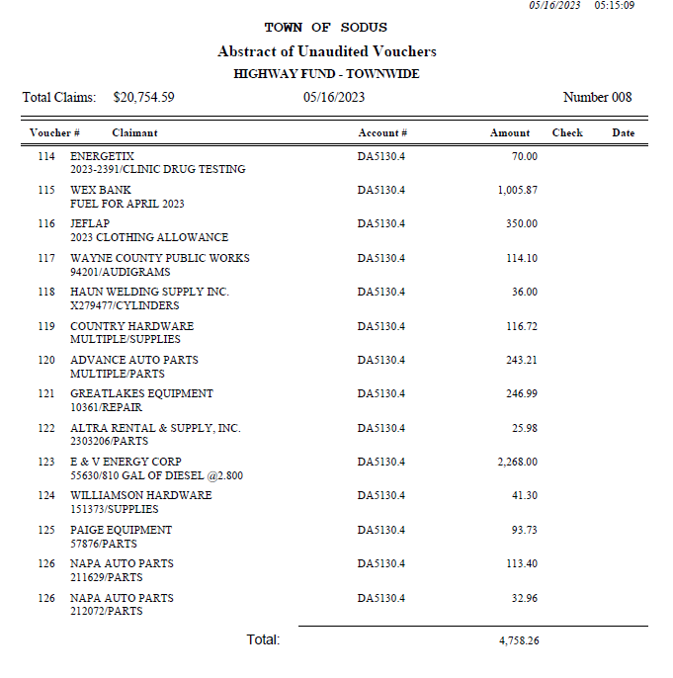

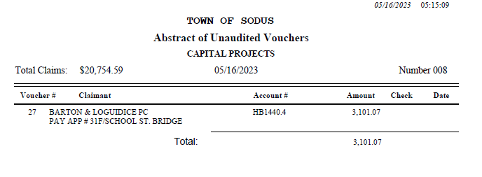

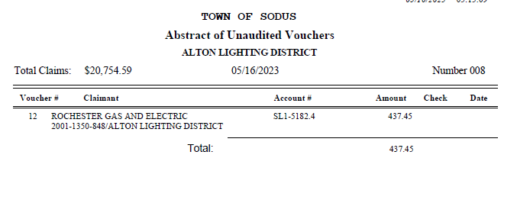

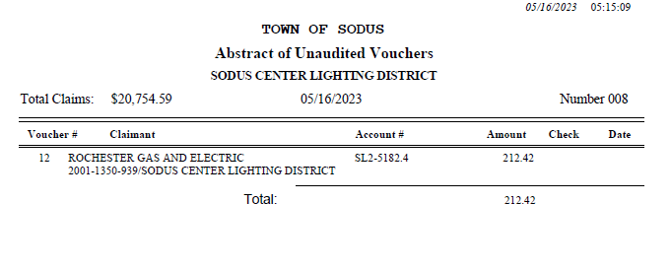

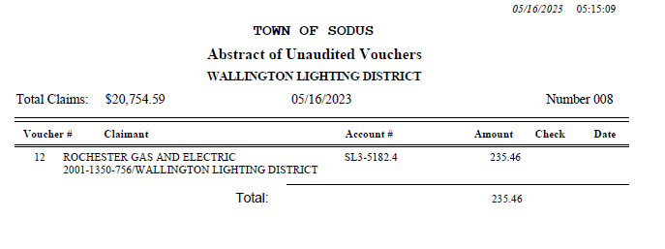

PUBLIC WORKS COMMITTEE: Councilperson David LeRoy, Chair
(Highway, Drainage - Deputy Town Supervisor)
HIGHWAY REPORT:
(Dale Pickering – Highway Superintendent)
Councilperson Cathy Willmott motioned to file the monthly Highway April 2023 report from Dale Pickering Highway Superintendent was seconded by Councilperson Chris Tertinek. Upon roll call the following votes were heard, Scott Johnson, aye; David LeRoy, aye; Don Ross, aye; Chris Tertinek, aye; and Cathy Willmott; aye. Motion carried.

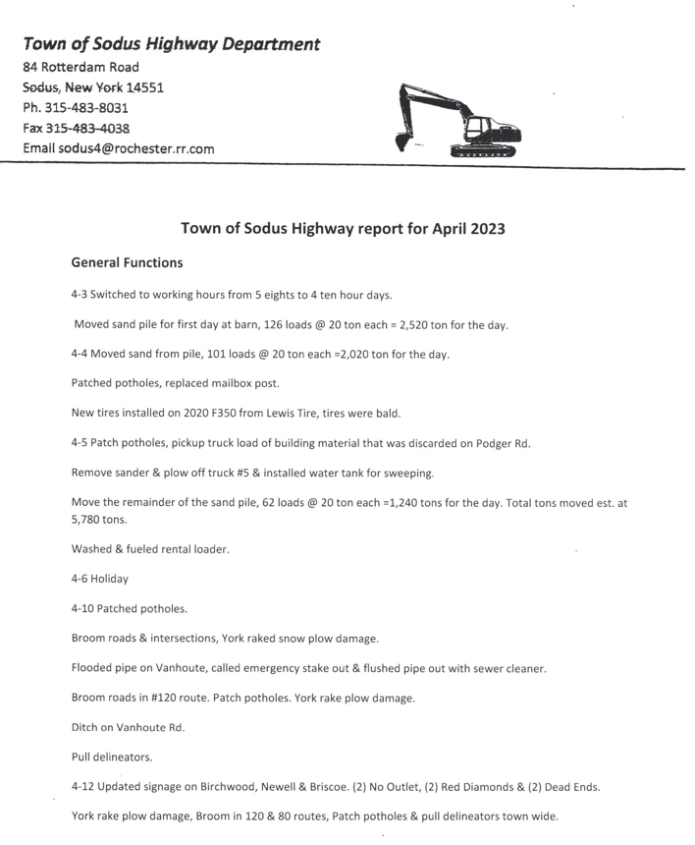
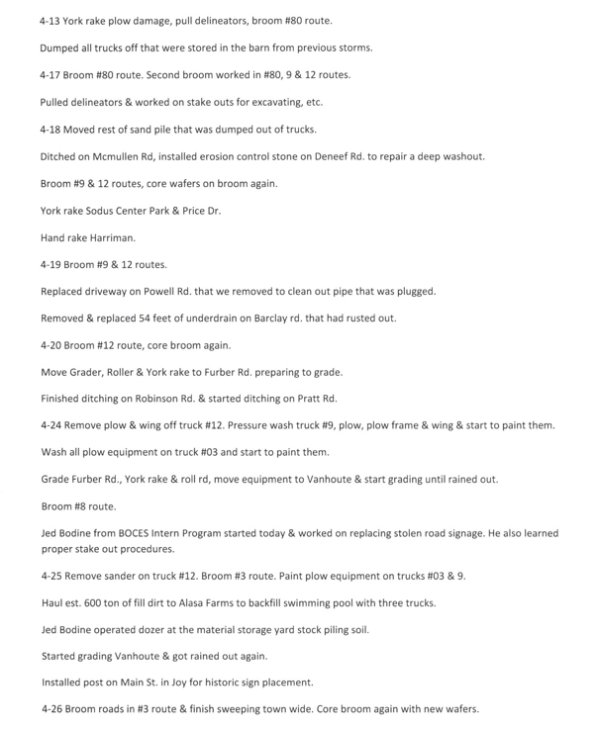
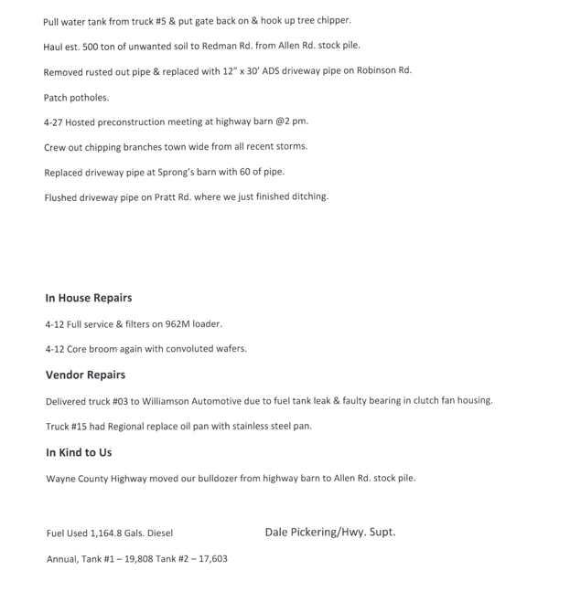
- Salt Barn: N/A

- RG&E N/A

- Drainage N/A

BUILDINGS AND GROUNDS COMMITTEE: Councilperson Chris Tertinek, Chair
(Town Property, Animal Control, Flood Damage Prevention)
CODE ENFORCEMENT REPORT:
Frank Gahr- CEO
Councilperson Chris Tertinek motioned to file the monthly April 2023 Code Enforcement Report as written, was seconded by Councilperson Cathy Willmott. Upon roll call the following votes were heard, Scott Johnson, aye; David LeRoy, aye; Don Ross, aye; Chris Tertinek, aye; and Cathy Willmott; aye. Motion carried.

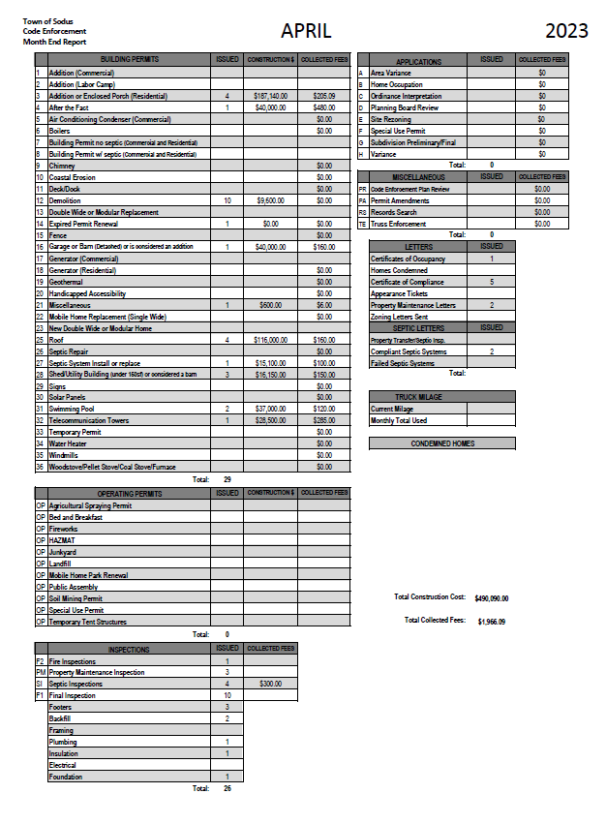
DOG CONTROL REPORT:
Robert Snyder, Primary DCO
Vacant- Secondary DCO
Councilperson Chris Tertinek motioned to file the monthly April 2023 Dog Control report as written, was seconded by Councilperson David LeRoy. Upon roll call the following votes were heard, Scott Johnson, aye; David LeRoy, aye; Don Ross, aye; Chris Tertinek, aye; and Cathy Willmott; aye. Motion carried.

April 2023 Dog Control Report
04-01-2023 Dog complaint on Old Lyons Rd. Dog was transported to the Humane Society. In kind service -Lyons. 7:00 PM
04-09-2023 Dog complaint on Pulver Rd. Neighbor said dog ran towards her. Owner was able to get dog back on leash. 4:00 PM
04-12-2023 Had meeting with Aysal about dog issue on Pulver Rd. Stacie Avery (Deputy Clerk) and Cathy Willmott (Town Councilwoman) attended meeting as witnesses. 10:00 AM
04-14-2023 911 call, dog ran over to neighbor’s yard. Dog returned home and I spoke with owners. Met with dog owner (Gail) to do paperwork. Completed at a later date.
04-18-2023 911 call, dog owner walking dog at Beechwood and dog had fishing lure stuck in leg and tail. Owner took dog to the Vet.
Mileage: 88 miles traveled
Respectfully Submitted,
Robert Snyder, DCO

FLOOD DAMAGE PREVENTION REPORT-Code 69:
Chris Tertinek, Councilperson
Councilperson Chris Tertinek shared his flood damage prevention report as follows:

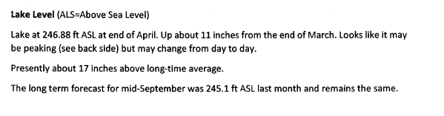
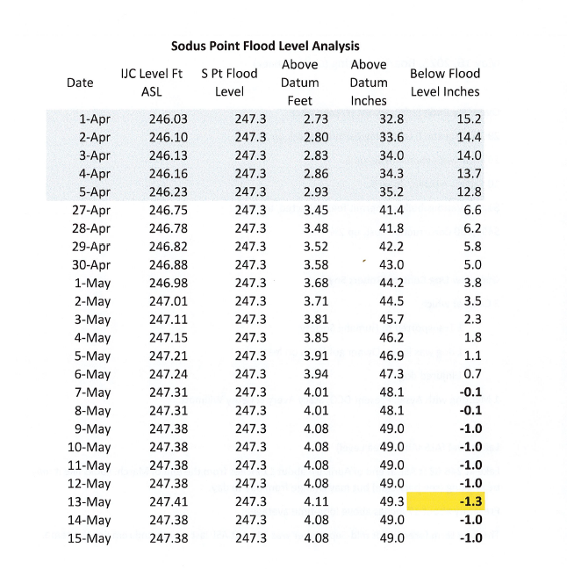

RECREATION/ENVIRONMENTAL COMMITTE: Councilwoman Cathy Willmott
(Recreation, Assessor, Parks, Cemeteries)
CAMP BEECHWOOD-PARKS-CEMETERIES REPORTS:
Recreation Report
(Sheila Fisher, Recreation Director)
Councilperson David LeRoy motioned to file the monthly April 2023 Recreation report from Sheila Fisher, Recreation Director was seconded by Councilperson Cathy Willmott. Upon roll call the following votes were heard, Scott Johnson, aye; David LeRoy, aye; Don Ross, aye; Chris Tertinek, aye; and Cathy Willmott; aye. Motion carried.

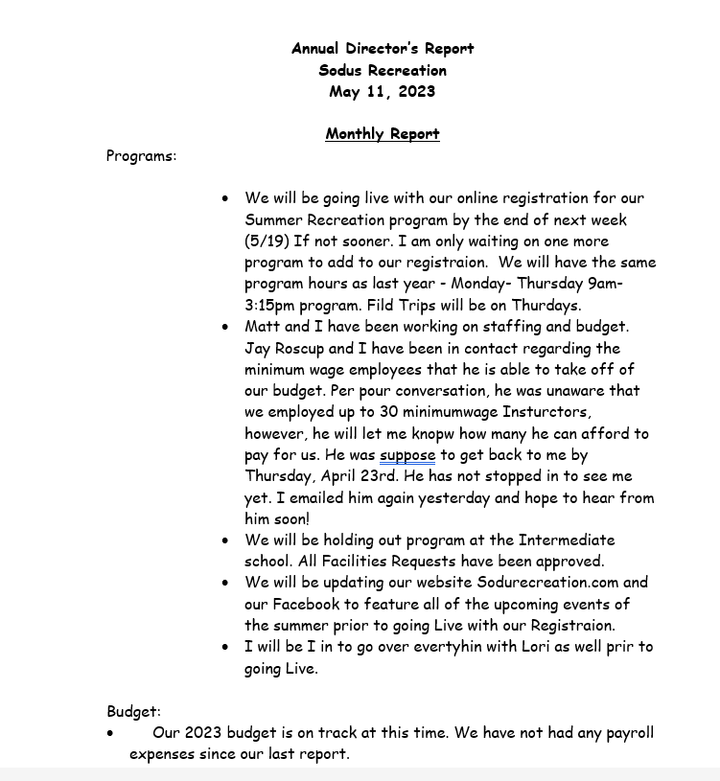
Assessor’s Report
(Nathan Mack, Assessor)
Councilperson Chris Tertinek motioned to file the monthly April 2023 report from Sole Assessor Nathan Mack was seconded by Councilperson Cathy Don Ross. Upon roll call the following votes were heard, Scott Johnson, aye; David LeRoy, aye; Don Ross, aye; Chris Tertinek, aye; and Cathy Willmott; aye. Motion carried.

tOWN OF sODUS

ASSESSOR’S OFFICE
Date: May 11, 2023 Respectfully Submitted by: Nathan Mack

AROUND THE OFFICE
- The Tentative assessment roll has been turned into the County.
- Based on the data from New York State, our level of assessment will be 71 on the 2023 assessment roll.
- Change of assessment notices have been mailed to Taxpayers.
- Legal notices concerning the completion of the Tentative assessment roll and notice regarding the Board of Assessment Review was posted in the in the paper and on the Town website.
- The Assessor will be in attendance with the Tentative roll in person by appointment on:
  - Friday May 12, 2023 9:00am to 1:00pm
  - Monday May 15, 2023 4:00pm to 8:00pm
  - Tuesday May 16, 2023 1:00pm to 5:00pm
  - Saturday May 20, 2023 9:00am to 1:00pm
- Grievance Day has been scheduled for Tuesday May 23rd from 2:00pm to 4:00pm and 6:00pm-8:00pm. The location in the Fire Hall meeting room located on the bottom floor of the Town Hall.
Camp Beechwood Report
(Sal Vittozzi, Caretaker)
Councilperson David LeRoy motioned to file the monthly April 2023 Camp Beechwood report from Sal Vittozzi, Caretaker was seconded by Councilperson Don Ross. Upon roll call the following votes were heard, Scott Johnson, aye; David LeRoy, absent; Don Ross, absent; Chris Tertinek, aye; and Cathy Willmott; aye. Motion carried.

April 2023 Beechwood-Groundskeeper Report
April was a "back to business" type month here at the park. Milder weather the first half of the month enabled all the mowing, weed whipping, and trail maintenance to get done. All of the cemeteries have been gone through as well. Daily attendance numbers were up and camping is still on the slow side, but should pick up quite a bit in May. We also hosted 4 camping trips for the scouts. 2 boy scout troops and 2 girl scout troops. All in all, it was a great start to the beginning of another green season here at the park.

Respectfully Submitted,
Sal Vittozzi
Groundskeeper

PUBLIC SAFETY/DRAINAGE/ENVIRONMENT COMMITTEE: Councilperson Don Ross, Chair (Fire, Ambulance, Emergency Preparedness)
Councilperson Don Ross attended the WCWSA meeting. The next SESA Meeting is May 21, 2023 at Sodus Point Silver Waters. The meeting starts at 8:30 AM.

TOWN HALL COMMITTEE: Scott Johnson, Supervisor
(Personnel, Clerks, Justices, Assessor, Building Inspector, Town Council, Boards, Insurances, Finance)
N/A

CORRESPONDENCE & INFORMATION
Councilperson David LeRoy motioned to raise reimbursement amount for veterans’ flags purchased from the Sodus Rural Cemetery Association from .50 cents per flag to $1.00 per flag effective immediately. Reimbursement is paid yearly before Memorial Day was seconded by Councilperson Cathy Willmott. Upon roll call the following votes were heard, Scott Johnson, aye; David LeRoy, aye; Don Ross, aye; Chris Tertinek, aye; and Cathy Willmott; aye. Motion carried.

Councilperson David LeRoy motioned to allow the Sodus Center Fire Department use of the Town of Sodus Park on the corner of South Street and School Street, August 5, 2023 for public parking. This is for the 100th Anniversary of Sodus Center Fire Department was seconded by Councilperson Don Ross. Upon roll call the following votes were heard, Scott Johnson, aye; David LeRoy, aye; Don Ross, aye; Chris Tertinek, aye; and Cathy Willmott; aye. Motion carried.

Sodus Center Fire Department is turning 100 years old! They will be holding an event August 5, 2023. It will start with a parade and the lineup is at 5:00 PM at the corner of Sodus Center Road and Buerman Rd (proceeding east on Sodus Center Rd to Main St. which will end at the fire station). The Supervisor, Town Board and Town Clerk will be walking in the parade. Councilperson Don Ross will be with the Wallington Fire Department marching. Town Clerk, Lori Diver will return submission request form to Chief Jim Pettit of the Sodus Center Fire Department.

Councilperson David LeRoy motioned to allow Lori Diver Sodus Town Clerk to advertise and to hold a public hearing for Local Law 3-2023 Building Code on June 13, 2023 at 6:00 PM was seconded by Cathy Willmott. Upon roll call the following votes were heard, Scott Johnson, aye; David LeRoy, aye; Don Ross, aye; Chris Tertinek, aye; and Cathy Willmott; aye. Motion carried.

RESOLUTION
ARPA FUNDS STIPEND -TOWN OF SODUS EMPLOYEES
(03 05-2023)
BE IT RESOLVED, the Town of Sodus will pay a stipend for employees that started before April 1, 2023 from ARPA (American Rescue Plan Act) funds, and
FURTHER BE IT RESOLVED, part-time employees will receive $100.00 the first pay period of each month and $200.00 for each full-time employee the first pay period of each month, and
FURTHER BE IT RESOLVED; this stipend will be issued to Town of Sodus employees once a month from April 2023 to December 2023.
NOW BE IT RESOLVED; Councilperson Cathy Willmott motioned to adopt this resolution which was seconded by Councilperson Dave LeRoy. Upon roll call the following votes were heard, Scott Johnson, aye; David LeRoy, aye; Don Ross, aye; Chris Tertinek, aye; and Cathy Willmott; aye. Resolution Adopted.

RESOLUTION
ASSESSOR-NEW COMPUTER
(04 05-2023)
BE IT RESOLVED, Councilperson David LeRoy motioned to adopt resolution (04 05-2023) authorizing Assessor Nathan Mack to purchase one Lenovo PC with a 13-12th generation processor. It has 8 GB of ram and 256 GB SSD in the amount of $1,324.00 and additional cost of $75.00 for Office and additional labor to install. Estimated delivery is May 10- May 12. Supervisor Johnson authorized the purchase prior to board meeting given Mack’s computer failed immediately which was seconded by Councilperson Cathy Willmott. Upon roll call the following votes were heard, Scott Johnson, aye; David LeRoy, aye; Don Ross, aye; Chris Tertinek, aye; and Cathy Willmott; aye. Resolution adopted.
RESOLUTION
“MOORE THAN A RACE”
(05 05-2023)
Supervisor Scott Johnson offered the following resolution for its adoption,

WHEREAS, Reliant Community Federal Credit Union is asking the Town of Sodus permission to utilize Town of Sodus Roads for “Moore than a Race” 5K race on October 15, 2023 starting at 12:00 PM, and

FURTHER BE IT RESOLVED, Councilperson Don Ross motioned to adopt resolution (05 05-2023), which was seconded by Councilperson David LeRoy. Upon roll call the following votes were heard, Scott Johnson, aye; David LeRoy, aye; Don Ross, aye; Chris Tertinek, aye, and Cathy Wilmott, aye. Resolution Adopted.

Motion by Councilmember David LeRoy to enter into Executive Session regarding medical, financial, credit or employment history of a particular person or corporation or relating to appointment promotion demotion discipline or removal was seconded by Councilmember Don Ross. Upon roll call the following votes were heard, Scott Johnson, aye; David LeRoy, aye; Don Ross, aye; Chris Tertinek, aye; and Cathy Willmott; aye. Motion carried.
Time 7:13 PM

Motion by Councilmember Cathy Willmott to exit out of Executive Session and to enter into Regular Session was seconded by Councilmember Chris Tertinek. Upon roll call the following votes were heard, Scott Johnson, aye; David LeRoy, aye; Don Ross, aye; Chris Tertinek, aye; and Cathy Willmott; aye. Motion carried.
Time 7:46 PM

A motion by Councilperson Chris Tertinek to adjourn the Regular Town Board Meeting was seconded by Councilperson David LeRoy. Upon roll call the following votes were heard, Scott Johnson, aye; David LeRoy, aye; Don Ross, aye; Chris Tertinek, aye; and Cathy Willmott; aye. Resolution adopted.

Meeting adjourned at 7:46 PM

Recording Secretary,
Lori K. Diver
Sodus Town Clerk, RMC

