Sodus Town Board Agenda
Regular Month End-Town Board Meeting
May 30, 2023
4:00 PM
Roll Call: (Lori Diver)
Supervisor Johnson, Councilperson LeRoy, Councilperson Ross-Zoom, Councilperson Tertinek, Councilperson Willmott

Agenda:

- Resolution authorizing payment of Abstract # 09-2023 for payment.
First_________________ Seconded____________________ (emailed).

- Motion to change the Regular Town Board meeting from Tuesday June 13, 2023 at 6:00 PM to Thursday June 15, 2023 at 4:00 PM and allow Lori Diver to advertise.
First_________________ Seconded____________________

- Motion to move Public Hearing for Local Law 03-2023 Building Code from June 13, 2023 at 6:00 PM to June 15, 2023 at 4:00 PM.
First_________________ Seconded____________________

- Resolution adopting Annual Software Support Contract from Williamson Law Book for Municipal Accounting & Budget Preparation Software IT (6/1/23 through 5/31/24) in the amount of $1,366.00.
First_________________ Seconded____________________

- Resolution authorizing Highway Superintendent Dale Pickering to hire Al VanAcker as a seasonal summer employee to mow, per diem at $20.00 hourly effective immediately.
First_________________ Seconded____________________

- Resolution to authorize Supervisor Clerk Bree Crandell to do budgetary transfers from the Contingent Account A1990.9 to the Cemetery Contractual Account A8810.4.
First_________________ Seconded____________________

- Resolution to authorize Supervisor Clerk Bree Crandell to do a budgetary transfer from the Contingent Account A1990.9 to the Veterans Services Account A6510.4 for the increase cost of veterans’ flags.
First_________________ Seconded____________________

- Motion to adjourn meeting
First_________________ Seconded____________________

MINUTES
Minutes of the Month End Town Board Meeting commencing at 4:00 PM in the upstairs meeting room May 30, 2023 at 4:00 PM located at 14-16 Mill St. Sodus, NY 14551.
All meetings are open to the public.
In addition, this meeting was available through Zoom. Legal Notices were published and posted accordingly.

Present: David LeRoy, Councilperson/Deputy Supervisor
Don Ross, Councilperson
Chris Tertinek, Councilperson
Cathy Willmott, Councilperson

Recording Secretary: Lori Diver Sodus Town Clerk

Absent: Scott Johnson, Supervisor

Others Present: Amy Kendall, Town Attorney

Deputy Supervisor David LeRoy called the Month End Town Board Meeting to order commencing at 4:00 PM and Lori Diver opened with roll call. All were present with the exception of Supervisor Scott Johnson.

ABSTRACT
RESOLUTION TO PAY ABSTRACT No. 09
(06 05-2023)

WHEREAS, the following bills were presented for payment on Abstract 09:

General 229-250 $ 16,489.56
Highway 128-133 $ 12,893.25
Trust Agency 040-041 $ 2,923.24
Capital Projects 028-028 $ 4,737.50
GRAND TOTAL: $ 37,043.55

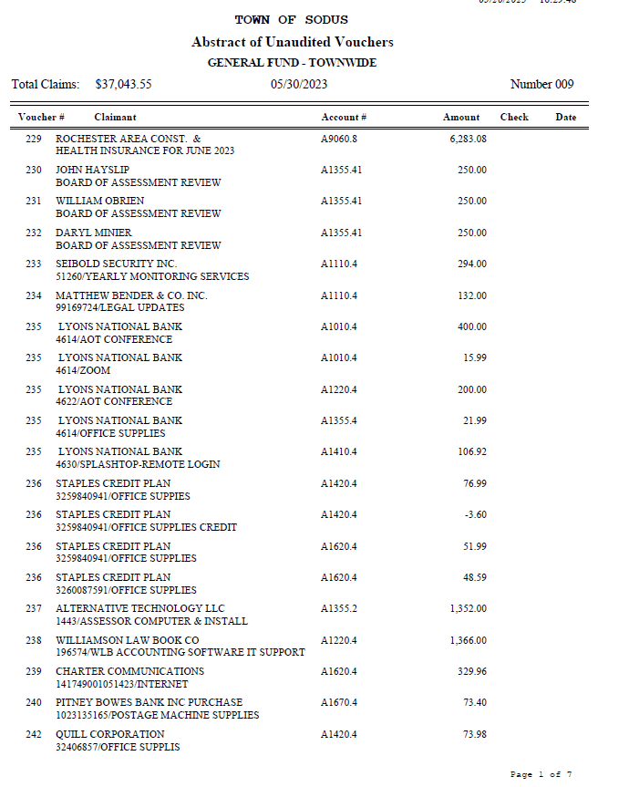

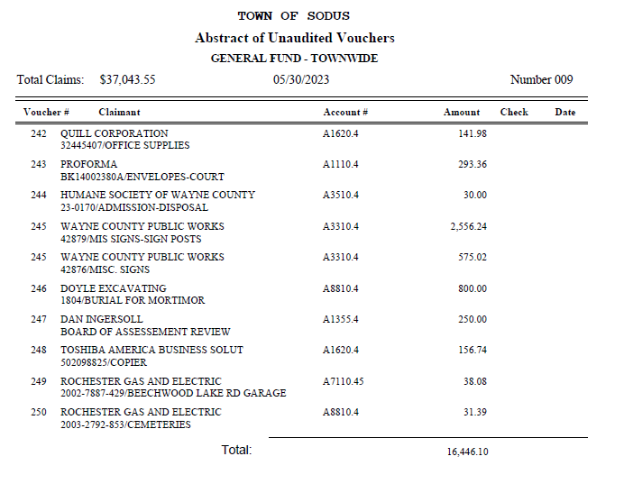

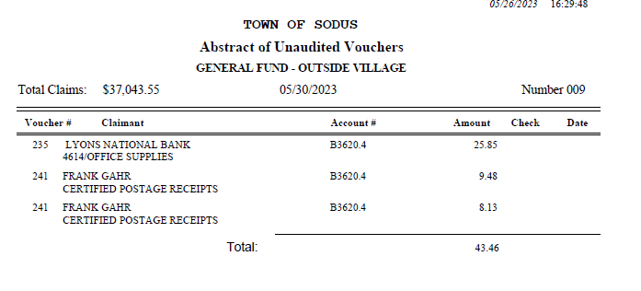

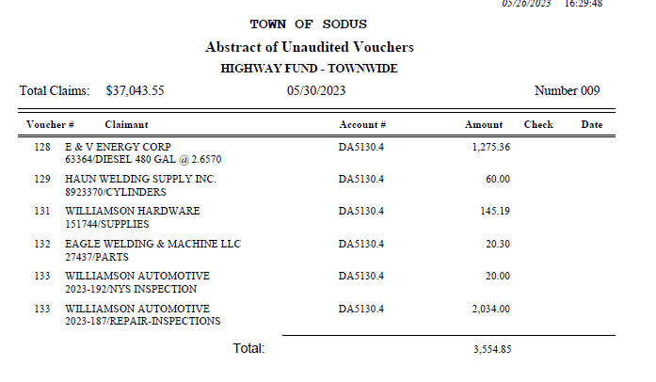

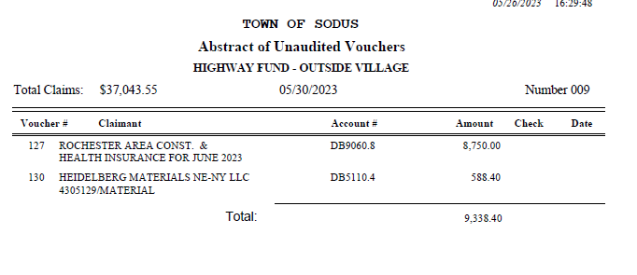
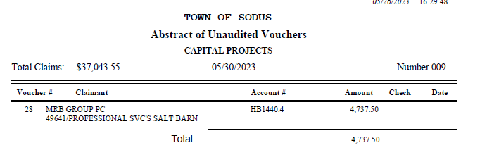

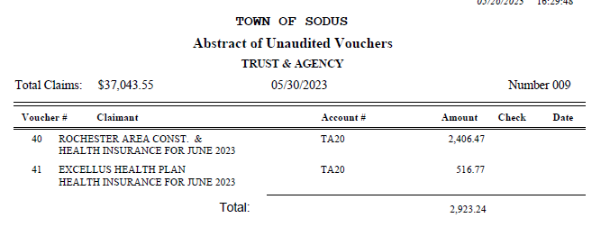

NOW BE IT RESOLVED, Councilperson Cathy Willmott motioned to authorize payment for Abstract # 9 as listed and adopt this resolution which was seconded by Councilperson Chris Tertinek. Upon roll call the following votes were heard, Scott Johnson, absent; David LeRoy, aye; Don Ross, aye; Chris Tertinek, aye; and Cathy Willmott; aye. Resolution Adopted.

Councilperson Don Ross motioned to move the regular town board meeting from Tuesday June 13, 2023 at 6:00 PM to Thursday June 15, 2023 at 4:00 PM and allow Lori Diver to advertise which was seconded by Councilperson Cathy Willmott. Upon roll call the following votes were heard, Scott Johnson, absent; David LeRoy, aye; Don Ross, aye; Chris Tertinek, aye; and Cathy Willmott; aye. Motion carried.

Councilperson Don Ross motioned to move the public hearing for Local Law 03-2023 Building Code from June 13, 2023 at 6:00 PM to Thursday June 15, 2023 at 4:00 PM which was seconded by Councilperson Cathy Willmott. Upon roll call the following votes were heard, Scott Johnson, absent; David LeRoy, nay; Don Ross, aye; Chris Tertinek, aye; and Cathy Willmott; aye. Motion carried.

RESOLUTION
WILLIAMSON LAW BOOK ANNUAL SOFTWARE SUPPORT CONTRACT
(07 05-2023)
NOW BE IT RESOLVED; Councilperson Don Ross motioned to authorize Supervisor Scott Johnson to sign the Annual Software Contract from Williamson Law Book for Municipal Accounting & Budget Preparation Software IT (6/1/2023 through 5/31/2024) in the amount of $1,366.00 which was seconded by Councilperson Cathy Willmott. Upon roll call the following votes were heard, Scott Johnson, absent; David LeRoy, aye; Don Ross, aye; Chris Tertinek, aye; and Cathy Willmott; aye. Resolution Adopted.

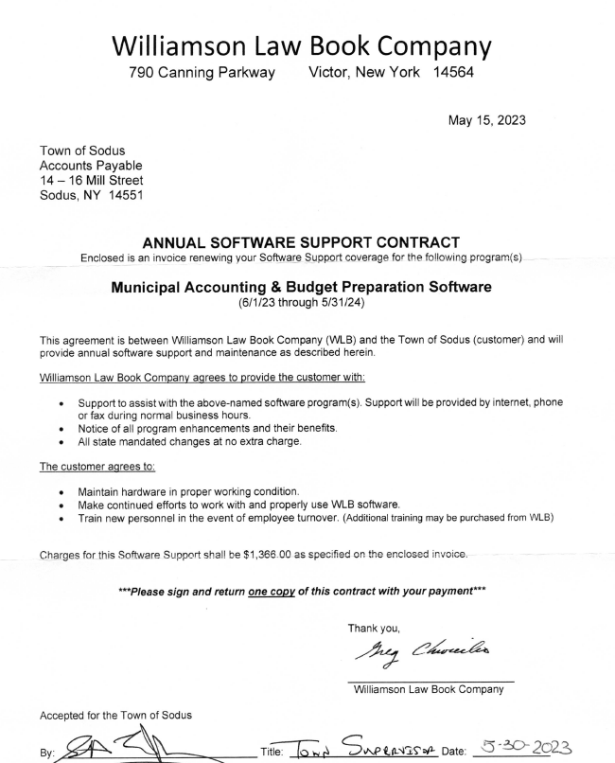

RESOLUTION
HIGHWAY- NEW HIRE AL VANACKER SEASONAL EMPLOYEE
(08 05-2023)
NOW BE IT RESOLVED; Councilperson Don Ross motioned to authorize Highway Superintendent Dale Pickering to hire Al VanAcker as a seasonal summer employee to mow, pier diem at $20.00 hourly; effective immediately which was seconded by Councilperson Chris Tertinek. Upon roll call the following votes were heard, Scott Johnson, absent; David LeRoy, aye; Don Ross, aye; Chris Tertinek, aye; and Cathy
Willmott; aye. Resolution Adopted.

RESOULTION
BUDGETARY TRANSFER -CEMETERIES
(09 05-2023)
NOW BE IT RESOLVED; Councilperson Chris Tertinek motioned to authorize Supervisor Clerk Bree Crandell to do a budgetary transfer from the Contingent Account A1990.9 to the Cemetery Contractual Account A8810.4 was seconded by Councilperson Don Ross. Upon roll call the following votes were heard, Scott Johnson, absent; David LeRoy, aye; Don Ross, aye; Chris Tertinek, aye; and Cathy Willmott; aye. Resolution Adopted.

RESOULTION
BUDGETARY TRANSFER -VETERANS SERVICES
(10 05-2023)
NOW BE IT RESOLVED; Councilperson Don Ross motioned to authorize Supervisor Clerk Bree Crandell to do a budgetary transfer from the Contingent Account A1990.9 to the Cemetery Contractual Account A6510.4 for the increase cost of veterans’ flags was seconded by Councilperson Cathy Willmott. Upon roll call the following votes were heard, Scott Johnson, absent; David LeRoy, aye; Don Ross, aye; Chris Tertinek, aye; and Cathy Willmott; aye. Resolution Adopted.

Motion by Councilmember Cathy Willmott to enter into Executive Session regarding medical, financial, credit or employment history of a particular person or corporation or relating to appointment promotion demotion discipline or removal was seconded by Councilmember Chris Tertinek. Upon roll call the following votes were heard, Scott Johnson, absent; David LeRoy, aye; Don Ross, aye; Chris Tertinek, aye; and Cathy Willmott; aye. Motion carried.
Time 4:50 PM

Motion by Councilmember Don Ross to exit out of Executive Session and to enter into Regular Session was seconded by Councilmember Cathy Willmott. Upon roll call the following votes were heard, Scott Johnson, absent; David LeRoy, aye; Don Ross, aye; Chris Tertinek, aye; and Cathy Willmott; aye. Motion carried.
Time 5:16 PM

Councilperson Don Ross motioned to adjourn the Month End Town Board Meeting was seconded by Councilperson Chris Tertinek. Upon roll call the following votes were heard, Scott Johnson, absent; David LeRoy, aye; Don Ross, aye; Chris Tertinek, aye; and Cathy Willmott; aye. Motion carried. 5:17 PM

Minutes Written By:
Lori K. Diver
Sodus Town Clerk, RMC

