Sodus Town Board Agenda
Regular Month End-Town Board Meeting
November 29, 2022
4:00 PM
Pledge of Allegiance
Roll Call: (Lori Diver)
Supervisor Johnson, Councilperson LeRoy, Councilperson Ross, Councilperson Tertinek, Councilperson Willmott

Public Hearing Local Law No. 3- 2022 4:00 PM:

- Motion entering into Local Law No. 3-2022 Public Hearing
First_________________ Seconded____________________ Time____________________

Lori Diver reads the following legal notice:
LEGAL NOTICE
TOWN OF SODUS
NOTICE OF PUBLIC HEARING
LOCAL LAW NO #3 - 2022

PLEASE TAKE NOTICE that, pursuant to Section 20 of the Municipal Home Rule Law, a public hearing will be held by the Town Board of the Town of Sodus on November 29, 2022, at 4:00 p.m. at the Sodus Town Hall, 14-16 Mill Street, in the Town of Sodus, Wayne County, New York in the upstairs meeting room, to consider the adoption of Local Law No. 3 of 2022 of the Town of Sodus, amending Town Code §4-4 to specify the number of members of the Planning Board, and to reduce the number of Planning board Members from 7 to 5 following the expiration of the next two terms.

All persons interested shall be given an opportunity to be heard. Local Law No. 3 of 2022 is available for public inspection during regular business hours at the Town Clerk’s office and on the Town of Sodus website at townofsodus.net.

Dated: November 4, 2022
By Order of the Sodus Town Board
Lori K. Diver
Sodus Town Clerk, RMC

Ask for public comments:
________________________________________________________________________________________________________________________________________________________________________________________

- Motion to close Public Hearing
First_________________ Seconded____________________ Time____________________

- Resolution adopting Local Law 3-2022 authorizing the Town Board of the Town of Sodus to amend Town Code §4-4 to specify the number of members of the Planning Board, and to reduce the number of Planning board Members from 7 to 5 following the expiration of the next two terms.
First_________________ Seconded____________________ Time____________________

Public Hearing Local Law No. 4-2022 4:15 PM:

- Motion entering into Local Law No. 4-2022 Public Hearing
First_________________ Seconded____________________ Time____________________

Lori Diver reads the following legal notice:
LEGAL NOTICE
TOWN OF SODUS
NOTICE OF PUBLIC HEARING
LOCAL LAW No. 04 (2022)

PLEASE TAKE NOTICE that a public hearing will be held by the Town Board of the Town of Sodus on the 29th day of November 2022 at 4:15 p.m. in the upstairs meeting room at the Sodus Town Hall, 14-16 Mill Street, Sodus, New York to hear and consider comments from the public in regard to Local Law No. # 04-2022
TOWN OF SODUS
LOCAL LAW NO.4 OF 2022

A LOCAL LAW RESCINDING LOCAL LAW NO.2 OF THE
YEAR 2022 RELATING TO THE OVERRIDE OF THE TAX LEVY LIMIT FOR FISCAL YEAR 2023 PURSUANT TO GENERAL MUNICIPAL LAW § 3-c

IT IS HEREBY ENACTED by the Town Board of the Town of Sodus as follows:

SECTION 1. TITLE.

This local law shall be known and cited as “Town of Sodus Local Law No 4 of the year 2022 Rescinding Local Law No. 2 of the Year 2022 Overriding the Tax Levy Limit for Fiscal Year 2023 pursuant to General Municipal Law §3-c”.

SECTION 2. LEGISLATIVE INTENT

The Town Board adopted Local Law No. 2-2022 which Local Law overrode the tax levy limit for fiscal year 2023 pursuant to General Municipal Law §3-c. This Local Law was enacted as a precautionary measure. The Town Board has determined that as a result of the 2022 budget process for the budget for 2023 will be kept within the tax levy limit as provided in General Municipal Law §3-c. Accordingly, in order to insure that the qualifying taxpayers of the Town of Sodus receive their rebates from New York State granted to qualified taxpayers within municipalities that stay within the tax cap the Town Board needs to rescind Local Law No. 2 of 2022.

SECTION 3. AUTHORITY

This local law is adopted pursuant to General Municipal Law §3-c and to the provisions of the Municipal Home Rule Law.

SECTION 4. RESCISSION OF LOCAL LAW NO.2 of 2022

Local Law No. 4 of 2022 adopted on November 29th, 2022 and filed in the office of the Department of State on November 8, 2022 hereby is rescinded.

SECTION 5. EFFECTIVE DATE

This Local Law shall take effect immediately upon filing in the Office of the New York State Department of State in accordance with Section 27 of the Municipal Home Rule.

Ask for public comments:
________________________________________________________________________________________________________________________________________________________________________________________

- Motion to close Public Hearing
First_________________ Seconded____________________ Time____________________

- Resolution adopting “Town of Sodus Local Law No 4 of the year 2022 Rescinding Local Law No. 2 of the Year 2022 Overriding the Tax Levy Limit for Fiscal Year 2023 pursuant to General Municipal Law §3-c”.
First_________________ Seconded____________________
Agenda:

- Resolution authorizing payment of Abstract # 20-2022 for payment.
First_________________ Seconded____________________ (emailed).

- Resolution adopting and authorizing Dale Pickering Highway Superintendent to hire Ronald Sedore Jr. as Full-Time Motor Equipment Operator effective December 12, 2022. His hourly starting wage will be $19.00 per hour. All employee requirements for Sedore’s Town of Sodus obligations are stated within the Town of Sodus Highway Union Contract.
First_________________ Seconded____________________

- Motion allowing Frank Gahr Code Enforcement Officer to surplus Hewlett Packard Windows 7 (serial number 2UA23702KK) and Monitor (serial number 1908FPt) (emailed).
First_________________ Seconded____________________

- Resolution authorizing Sal Vittozzi Caretaker for Beechwood to receive Hewlett Packard Windows 7 and Monitor from Code Enforcement Office for basic administrative functions for Beechwood (emailed).
First_________________ Seconded____________________

- Motion cancelling RG&E for the old landfill.
First_________________ Seconded____________________

- Resolution authorizing Dale Pickering to purchase 780’ of 12” diameter ADS plain end pipe from Chemung Supply at a cost of $6.35 per foot, at a total cost of $4,953.00 and pay for it out of our drainage fund account A8540.4 which has a current balance of $5,000.00.
First_________________ Seconded____________________

- Motion to adjourn meeting
First_________________ Seconded____________________

MINUTES
Minutes of the Month End Town Board Meeting commencing at 4:00 PM in the upstairs meeting room November 29, 2022 at 4:00 PM located at 14-16 Mill St. Sodus, NY 14551.
All meetings are open to the public.
In addition this meeting was available through Zoom. Legal Notices were published and posted accordingly.

Present: David LeRoy, Councilperson/Deputy Supervisor Don Ross, Councilperson
Chris Tertinek, Councilperson
Cathy Willmott, Councilperson

Recording Secretary: Lori Diver Sodus Town Clerk

Absent: Scott Johnson, Supervisor

Others Present: Town of Sodus Attorney

Deputy Supervisor David LeRoy called the Month End Town Board Meeting to order commencing at 4:00 PM and Lori Diver opened with roll call. All Board Members were present. Supervisor Scott Johnson was absent.

Public Hearing Local Law No. 3- 2022 4:00 PM:
Councilperson Don Ross motioned to enter into the public hearing was seconded by Councilperson Chris Tertinek. Upon roll call the following votes were heard, Scott Johnson, absent; David LeRoy, aye; Don Ross, aye; Chris Tertinek, aye, Cathy Willmott; aye, Motion carried. Time 4:02 PM

Lori Diver read the following legal notice:
PLEASE TAKE NOTICE that, pursuant to Section 20 of the Municipal Home Rule Law, a public hearing will be held by the Town Board of the Town of Sodus on November 29, 2022, at 4:00 p.m. at the Sodus Town Hall, 14-16 Mill Street, in the Town of Sodus, Wayne County, New York in the upstairs meeting room, to consider the adoption of Local Law No. 3 of 2022 of the Town of Sodus, amending Town Code §4-4 to specify the number of members of the Planning Board, and to reduce the number of Planning board Members from 7 to 5 following the expiration of the next two terms.

All persons interested shall be given an opportunity to be heard. Local Law No. 3 of 2022 is available for public inspection during regular business hours at the Town Clerk’s office and on the Town of Sodus website at townofsodus.net.

Dated: November 4, 2022
By Order of the Sodus Town Board
Lori K. Diver
Sodus Town Clerk, RMC

Deputy Supervisor David LeRoy asked for any public comments, hearing none LeRoy asked for a motion to close the public hearing.

Councilperson Chris Tertinek motioned to close the public hearing was seconded by Councilperson Cathy Willmott. Upon roll call the following votes were heard, Scott Johnson, absent; David LeRoy, aye; Don Ross, aye; Chris Tertinek, aye, Cathy Willmott; aye, Motion carried. Time 4:05 PM

Deputy Supervisor David LeRoy offered the following Local Law 3-2022 and resolution for its adoption, and
PLANNING BOARD LOCAL LAW -AMENDED
RESOLUTION
(06 11-2022)

TOWN OF SODUS

Proposed Local Law No. 3-2022
of the year 2022

A Local Law to Reduce the Number of Planning Board Members in the Town of Sodus

Be it enacted by the Town Board of the Town of Sodus as follows:

- Legislative Intent. It is the intent of this local law to amend Town of Sodus Code to reduce the number of members of the planning board from seven (7) to five (5), which is to take effect upon the next two expirations of terms of the current planning board members.

- Authority. This local law is adopted pursuant to Municipal Home Rule Law §10 and Town Law §271(7).

- Section 4-4 of the Town Code of the Town of Sodus is hereby amended to read as follows:

§ 4-4.Number and Term of Appointment, Planning Board
The number of members of the planning board is reduced from seven (7) to five (5). In accordance with Town Law §271(7), the reduction is to take effect upon the next two expirations of terms of the current planning board members after the date of enactment of this law. Subsequent to the members of the Planning Board first appointed, their successor(s) shall be appointed for the term of two years from and after the expiration of the terms of their predecessors in office.

- Severability. If any provision of this Local Law is determined to be unconstitutional or invalid, the validity and enforceability of the remainder shall not be affected.

- Effective Date. This Local Law shall take effect immediately upon filing with the Secretary of State.

Motion by Councilperson Chris Tertinek to adopt this resolution into local law 3-2022 was seconded by Councilperson Cathy Willmott. Upon roll call the following votes were heard, Scott Johnson, absent; David LeRoy, aye; Don Ross, nay; Chris Tertinek, aye, Cathy Willmott; aye, Resolution Adopted

Public Hearing Local Law No. 4- 2022 4:15 PM:
Councilperson David LeRoy motioned to enter into the public hearing was seconded by Councilperson Chris Tertinek. Upon roll call the following votes were heard, Scott Johnson, absent; David LeRoy, aye; Don Ross, aye; Chris Tertinek, aye, Cathy Willmott; aye, Motion carried. Time 4:15 PM

LEGAL NOTICE
TOWN OF SODUS
NOTICE OF PUBLIC HEARING
LOCAL LAW No. 04 (2022)

PLEASE TAKE NOTICE that a public hearing will be held by the Town Board of the Town of Sodus on the 29th day of November 2022 at 4:15 p.m. in the upstairs meeting room at the Sodus Town Hall, 14-16 Mill Street, Sodus, New York to hear and consider comments from the public in regard to Local Law No. # 04-2022
TOWN OF SODUS
LOCAL LAW NO.4 OF 2022

A LOCAL LAW RESCINDING LOCAL LAW NO.2 OF THE
YEAR 2022 RELATING TO THE OVERRIDE OF THE TAX LEVY LIMIT FOR FISCAL YEAR 2023 PURSUANT TO GENERAL MUNICIPAL LAW § 3-c

IT IS HEREBY ENACTED by the Town Board of the Town of Sodus as follows:

SECTION 1. TITLE.

This local law shall be known and cited as “Town of Sodus Local Law No 4 of the year 2022 Rescinding Local Law No. 2 of the Year 2022 Overriding the Tax Levy Limit for Fiscal Year 2023 pursuant to General Municipal Law §3-c”.

SECTION 2. LEGISLATIVE INTENT

The Town Board adopted Local Law No. 2-2022 which Local Law overrode the tax levy limit for fiscal year 2023 pursuant to General Municipal Law §3-c. This Local Law was enacted as a precautionary measure. The Town Board has determined that as a result of the 2022 budget process for the budget for 2023 will be kept within the tax levy limit as provided in General Municipal Law §3-c. Accordingly, in order to insure that the qualifying taxpayers of the Town of Sodus receive their rebates from New York State granted to qualified taxpayers within municipalities that stay within the tax cap the Town Board needs to rescind Local Law No. 2 of 2022.

SECTION 3. AUTHORITY

This local law is adopted pursuant to General Municipal Law §3-c and to the provisions of the Municipal Home Rule Law.

SECTION 4. RESCISSION OF LOCAL LAW NO.2 of 2022

Local Law No. 4 of 2022 adopted on November 29th, 2022 and filed in the office of the Department of State on November 8, 2022 hereby is rescinded.

SECTION 5. EFFECTIVE DATE

This Local Law shall take effect immediately upon filing in the Office of the New York State Department of State in accordance with Section 27 of the Municipal Home Rule.

Deputy Supervisor David LeRoy asked for any public comments, hearing none LeRoy asked for a motion to close the public hearing.

Councilperson Cathy Willmott motioned to close the public hearing was seconded by Councilperson Chris Tertinek. Upon roll call the following votes were heard, Scott Johnson, absent; David LeRoy, aye; Don Ross, aye; Chris Tertinek, aye, Cathy Willmott; aye, Motion carried. Time 4:18 PM

RESCINDING TAX CAP LOCAL LAW
RESOLUTION
(07 11-2022)

TOWN OF SODUS

LOCAL LAW NO.4 OF 2022

A LOCAL LAW RESCINDING LOCAL LAW NO.2 OF THE
YEAR 2022 RELATING TO THE OVERRIDE OF THE TAX LEVY LIMIT FOR FISCAL YEAR 2023 PURSUANT TO GENERAL MUNICIPAL LAW § 3-c

IT IS HEREBY ENACTED by the Town Board of the Town of Sodus as follows:

SECTION 1. TITLE.

This local law shall be known and cited as “Town of Sodus Local Law No 4 of the year 2022 Rescinding Local Law No. 2 of the Year 2022 Overriding the Tax Levy Limit for Fiscal Year 2023 pursuant to General Municipal Law §3-c”.

SECTION 2. LEGISLATIVE INTENT

The Town Board adopted Local Law No. 2-2022 which Local Law overrode the tax levy limit for fiscal year 2023 pursuant to General Municipal Law §3-c. This Local Law was enacted as a precautionary measure. The Town Board has determined that as a result of the 2022 budget process for the budget for 2023 will be kept within the tax levy limit as provided in General Municipal Law §3-c. Accordingly, in order to insure that the qualifying taxpayers of the Town of Sodus receive their rebates from New York State granted to qualified taxpayers within municipalities that stay within the tax cap the Town Board needs to rescind Local Law No. 2 of 2022.

SECTION 3. AUTHORITY

This local law is adopted pursuant to General Municipal Law §3-c and to the provisions of the Municipal Home Rule Law.

SECTION 4. RESCISSION OF LOCAL LAW NO.2 of 2022

Local Law No. 4 of 2022 adopted on November 29th, 2022 and filed in the office of the Department of State on December 12, 2022 hereby is rescinded.

SECTION 5. EFFECTIVE DATE

This Local Law shall take effect immediately upon filing in the Office of the New York State Department of State in accordance with Section 27 of the Municipal Home Rule.

Motion by Councilperson Cathy Willmott to adopt this resolution into local law 4-2022 was seconded by Councilperson Don Ross. Upon roll call the following votes were heard, Scott Johnson, absent; David LeRoy, aye; Don Ross, aye; Chris Tertinek, aye, Cathy Willmott; aye, Resolution Adopted

ABSTRACT
RESOLUTION TO PAY ABSTRACT No. 20
(08 11-2022)

WHEREAS, the following bills were presented for payment on Abstract 20:

(SEE PAGE 8)

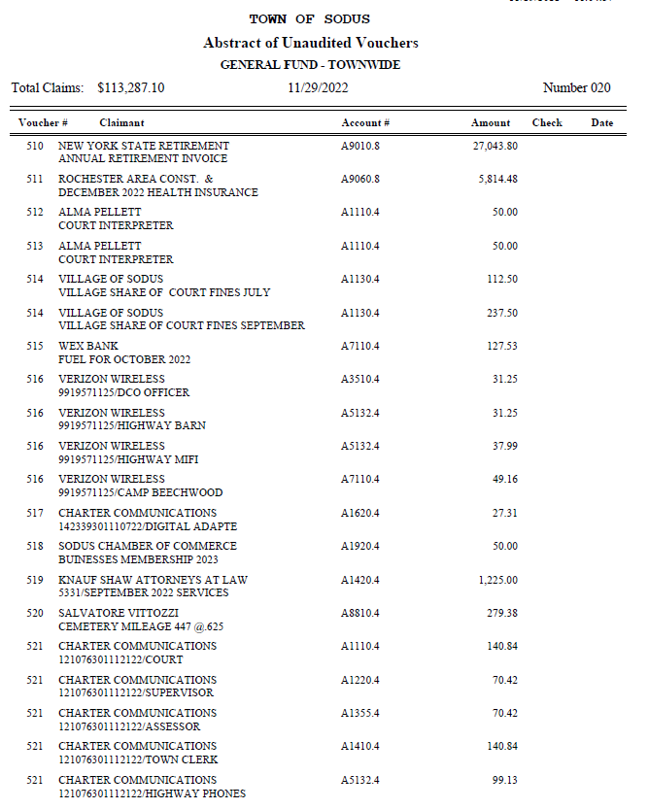
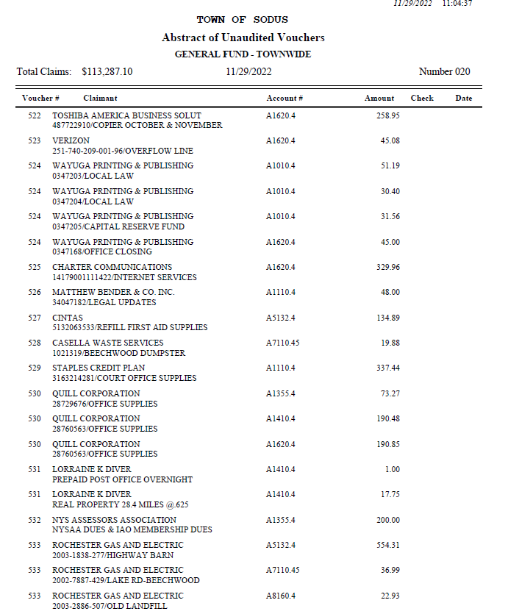
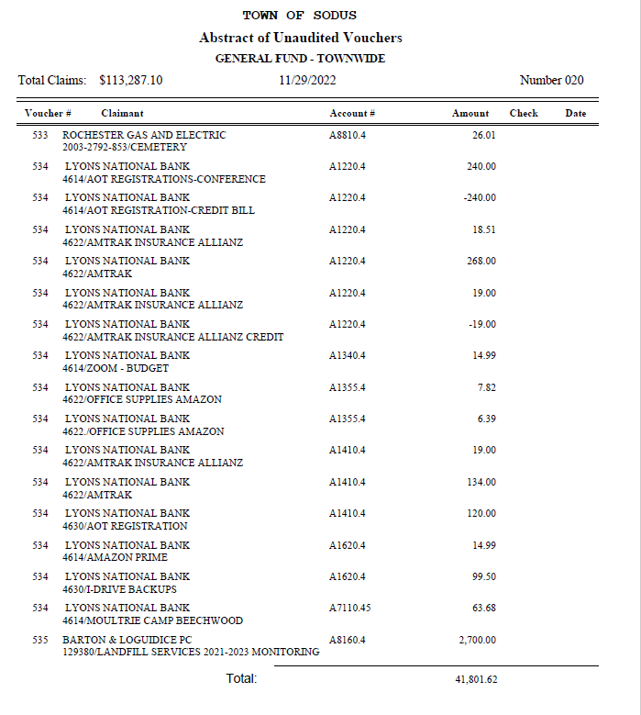
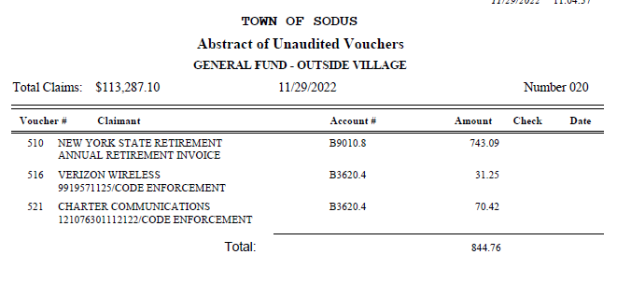
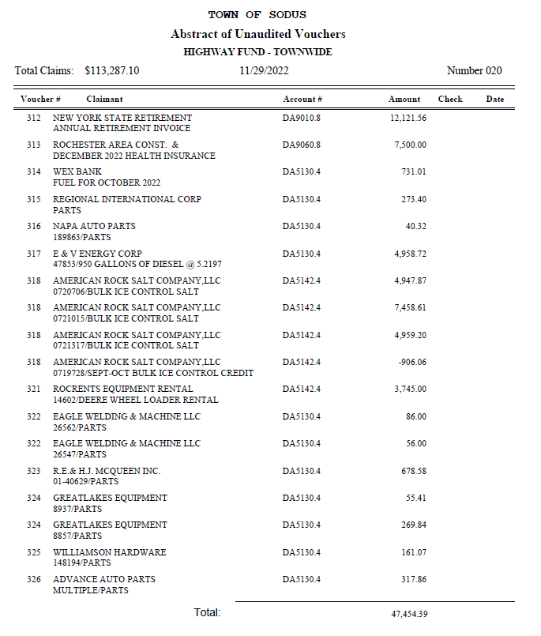
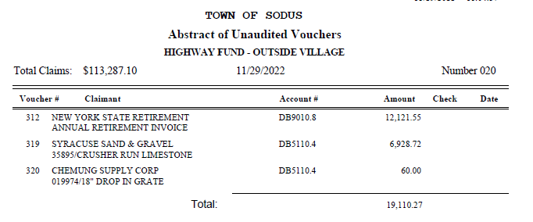
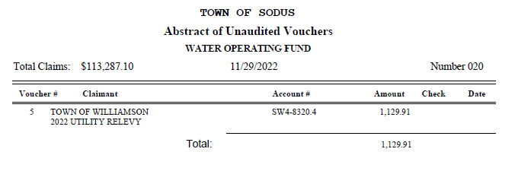
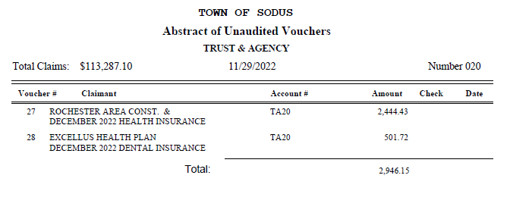
NOW BE IT RESOLVED, Councilperson Don Ross motioned to authorize payment for Abstract # 20 as listed and adopt this resolution which was seconded by Councilperson Cathy Willmott. Upon roll call the following votes were heard, Scott Johnson, absent; David LeRoy, aye; Don Ross, aye; Chris Tertinek, aye; and Cathy Willmott; aye. Resolution Adopted.

RONALD SEDORE-MOTOR EQUIPMENT OPERATOR
RESOLUTION
(09 11-2022)

NOW BE IT RESOLVED, Councilperson Cathy Willmott motioned authorizing Dale Pickering Highway Superintendent to hire Ronald Sedore Jr. as Full-Time Motor Equipment Operator effective December 12, 2022. Sedore’s starting hourly wage will be $19.00 per hour. All employee requirements for Sedore’s Town of Sodus obligations are stated within the Town of Sodus Highway Union Contract which was seconded by Councilperson Don Ross. Upon roll call the following votes were heard, Scott Johnson, absent; David LeRoy, aye; Don Ross, aye; Chris Tertinek, aye; and Cathy Willmott; aye. Resolution Adopted.

Motion by Councilperson Chris Tertinek allowing Frank Gahr Code Enforcement Officer to surplus Hewlett Packard Windows 7 (serial number 2UA23702KK) and Monitor (serial number 1908FPt) was seconded by Councilperson Cathy Willmott. Upon roll call the following votes were heard, Scott Johnson, absent; David LeRoy, aye; Don Ross, aye; Chris Tertinek, aye, Cathy Willmott; aye. Motion carried.

SAL VITTOZZI –CAMP BEECHWOOD COMPUTER
RESOLUTION
(10 11-2022)

NOW BE IT RESOLVED, Councilperson Chris Tertinek motioned authorizing Sal Vittozzi Caretaker for Beechwood to receive Hewlett Packard Windows 7 and Monitor from Code Enforcement Office for basic administrative functions for Beechwood which was seconded by Councilperson Don Ross. Upon roll call the following votes were heard, Scott Johnson, absent; David LeRoy, aye; Don Ross, aye; Chris Tertinek, aye; and Cathy Willmott; aye. Resolution Adopted.

Motion by Councilperson Cathy Willmott allowing Lori Diver Sodus Town Clerk to cancel the RG&E service for the old landfill was seconded by Councilperson Chris Tertinek. Upon roll call the following votes were heard, Scott Johnson, absent; David LeRoy, aye; Don Ross, aye; Chris Tertinek, aye, Cathy Willmott; aye. Motion carried.

HIGHWAY PURCHASE
RESOLUTION
(11 11-2022)

NOW BE IT RESOLVED, Councilperson David LeRoy motioned authorizing Dale Pickering Highway Superintendent to purchase 780’ of 12” diameter ADS plain end pipe from Chemung Supply at a cost of $6.35 per foot, at a total cost of $4,953.00 which was seconded by Councilperson Don Ross. Upon roll call the following votes were heard, Scott Johnson, absent; David LeRoy, aye; Don Ross, aye; Chris Tertinek, aye; and Cathy Willmott; aye. Resolution Adopted.

Motion by Councilperson Chris Tertinek to enter into Executive Session regarding medical, financial, credit or employment history of a particular person or corporation or relating to appointment promotion demotion discipline or removal was seconded by Councilperson Cathy Willmott. Upon roll call the following votes were heard, Scott Johnson, absent; David LeRoy, aye; Don Ross, aye; Chris Tertinek, aye, Cathy Willmott; aye, Motion carried. Time: 4:30 PM

Motion by Councilperson Chris Tertinek to exit out of Executive Session and enter into Regular Session was seconded by Councilperson Cathy Willmott. Upon roll call the following votes were heard, Scott Johnson, absent; David LeRoy, aye; Don Ross, aye; Chris Tertinek, aye, Cathy Willmott; aye, Motion carried.
Time: 4:35 PM

Councilperson Cathy Willmott motioned to adjourn the Month End Town Board Meeting was seconded by Councilperson Chris Tertinek. Upon roll call the following votes were heard, Scott Johnson, absent; David LeRoy, aye; Don Ross, aye; Chris Tertinek, aye; and Cathy Willmott; aye. Motion carried. 4:35 PM

Minutes Written By:
Lori K. Diver
Sodus Town Clerk, RMC

