Sodus Town Board Agenda
Note: Agenda is subject to change at any time and will be updated accordingly.
November 8, 2022
Regular Meeting Commences at 6:00 p.m.
Open with Pledge of Allegiance

Roll Call: (Lori Diver)
Supervisor Johnson, Councilperson LeRoy, Councilperson Ross, Councilperson Tertinek, Councilperson Willmott
Public Speaker or Public Comments:
N/A
Committees and Monthly Reports
- Supervisor’s monthly report

- Town Clerk’s monthly report

- Approval of Minutes

    - October 11, 2022 –Minutes(Cathy Willmott abstain-absent)
    - October 27, 2022-Minutes

- Resolution to Approve Bills –Abstract #19-2022

- Public Works Committee: Councilperson David LeRoy
(Highway, Drainage)
- Highway Superintendent’s monthly report – Dale Pickering
- Salt Barn update
- LED Street Lighting
- Drainage

- Recreation/Environmental Committee: Councilperson Cathy Willmott
(Recreation, Assessor, Parks, Cemeteries)
- Sodus Recreation monthly report – Sheila Fisher
- Assessor’s monthly report – Nathan Mack
- Camp Beachwood monthly report– Sal Vittozzi

- Buildings and Grounds Committee: Councilperson Chris Tertinek
(Town Property, Animal Control, Code Enforcement, Flood Damage)
- Code Enforcement monthly report – Frankie Gahr
- DCO Report – Robert Snyder
- Flood Damage Prevention – Code 69

- Public Safety Committee: Councilperson Don Ross
(Fire, Ambulance, Emergency Preparedness - WC, Water Authority - WC)

- Town Hall Committee: Supervisor Scott Johnson
(Personnel, Town Council, Court, Assessor, Building Inspector, Boards/Committees, Insurances, Finance, Environmental)

Correspondence & Information
- Resolution adopting designating delegate Supervisor Scott Johnson and alternate delegate Breynn Crandell for the Association of Town annual business meeting held in February 2023.

- School Street Bridge (Sodus Center Bridge)-Scott Johnson

- Resolution hiring Lillian M. Mein as part-time Digital Clerk effective December 1, 2022 with a starting wage of $13.20 per hour (minimum wage) for 2022 and then $14.20 per hour (minimum wage) beginning January 1, 2023. Lillian will be working 20 hours per week, non-benefited with a 6 month probationary period.

- Resolution accepting Jim Paprocki as a VOLUNTEER ONLY for a secondary Digital Clerk without pay, 20 hours per week, non –benefited including; a 6 month probationary period. Note: Jim has asked to volunteer as long as we need him to help complete the scanning and records project.

- Discussion regarding Robert Snyder as a credit card member holder with LNB –Lori Diver

- Resolution adding Robert Snyder and Frank Gahr to the LNB credit card and removing Craig Schwartz.

- Resolution rescinding the October 27, 2022 Preliminary and Adopted 2023 Town of Sodus Budget and amending the attached Preliminary Budget to the Adopted 2023 Town of Sodus budget November 8, 2022.

Motion to Adjourn:

MINUTES
Minutes of the Regular Town Board Meeting commencing at 6:00 PM in the downstairs courtroom November 8, 2022 located at 14-16 Mill St. Sodus, NY 14551.
All meetings are open to the public.
In addition this meeting was available through Zoom. Legal Notices were published and posted accordingly.

Present: Scott Johnson, Supervisor
David LeRoy, Councilperson/Deputy Supervisor
Don Ross, Councilperson
Chris Tertinek, Councilperson
Cathy Willmott, Councilperson

Recording Secretary: Lori Diver, Sodus Town Clerk-RMC

Absent: N/A

Others Present: Sal Vittozzi, Camp Beechwood
Dave Fitch, Camp Beechwood
Bree Crandell, Supervisor Clerk (Zoom)
Sheila Fisher, Recreation Director (Zoom)
Casey Carpenter, Times of Wayne County (Zoom)
Amy Kendall, Town Attorney

Supervisor Scott Johnson called the Regular Town Board Meeting to order commencing at 6:00 PM with the Pledge of Allegiance and Lori Diver opened with roll call. All were present.

PUBLIC SPEAKER:
N/A

SUPERVISOR’S REPORT
The Supervisor’s report was presented for October 2022. Councilperson Cathy Willmott motioned to accept and file this report, which was seconded by Councilperson Don Ross. Upon roll call the following votes were heard, Scott Johnson, aye; David LeRoy, aye; Don Ross, aye; Chris Tertinek, aye; and Cathy Willmott; aye. Motion carried.

MONTHLY SUPERVISOR REPORT:
Pursuant to Section 125 of the Town Law, I hereby render the following detailed statement of all moneys received and disbursed by me through: OCTOBER 31, 2022:
 | Supervisor |  |  | Date
 |  | SEPTEMBER 30, 2022 BALANCE |  | OCTOBER 31, 2022 BALANCE
FUND:
A/B | General | $494,044.76 |  | $390,316.81
 | Cash - Checking
 |  |  | Monthly ? or ? | -$103,727.95
DA/DB | Highway | $2,136,738.10 |  | $1,915,503.56
 | Cash - Checking
 |  |  | Monthly ? or ? | -$221,234.54
SW20 | South Geneva WD | $44,521.35 |  | $44,521.35
 | Cash - Checking |  | Monthly ? or ? | $0.00
SW11 | Water District 11 | $63,624.23 |  | $63,624.23
 | Cash - Checking |  | Monthly ? or ? | $0.00
SS1 | Sewer District | $2,476.58 |  | $2,476.58
 | Cash - Checking |  | Monthly ? or ? | $0.00
SW4 | Water Operating | $120,242.86 |  | $120,242.86
 | Cash - Checking |  | Monthly ? or ? | $0.00
TA | Trust & Agency | $39,674.01 |  | $12,249.26
 | Cash - Checking |  | Monthly ? or ? | -$27,424.75
 |  | SEPTEMBER 30, 2022 BALANCE |  | OCTOBER 31, 2022 BALANCE
FUND:
 | Fire Districts
SF1 | Village of Sodus | $0.00 |  | $0.00
SF2 | Sodus Center Fire District | $0.00 |  | $0.00
SF3 | Wallington Fire District | $0.00 |  | $0.00
SF4 | Alton Fire District | $0.00 |  | $0.00
SF5 | Village of Sodus Point | $0.00 |  | $0.00
SF6 | Rural Fire Protection | $0.00 |  | $0.00
SF7 | Rural Hydrant | $300.00 |  | $300.00
 | Cash - Checking | $300.00 |  | $300.00
 |  |  | Monthly ? or ? | $0.00
 | Lighting Districts
SL1 | Alton Lighting | $13,162.26 |  | $12,588.81
SL2 | Sodus Center Lighting | $28,390.97 |  | $28,076.34
SL3 | Wallington Lighting | $11,844.81 |  | $11,551.14
 |  | $53,398.04 |  | $52,216.29
 |  |  | Monthly ? or ? | -$1,181.75
 | Total All Funds | $2,955,019.93 |  | $2,601,450.94
 |  |  | Monthly ? or ? | -$353,568.99

TOWN CLERK’S REPORT
The Town Clerk’s Report, Town Clerk’s bank statements for audit, and bank register for October 2022 were presented. Councilperson Chris Tertinek motioned to accept and file these reports, which was seconded by Councilperson Don Ross. Upon roll call the following votes were heard, Scott Johnson, aye; David LeRoy, aye; Don Ross, aye; Chris Tertinek, aye; and Cathy Willmott; aye. Motion carried.
Note: Town Clerk bank register and bank statement made available upon request with banking detailed info to be redacted. Not published for security reasons.

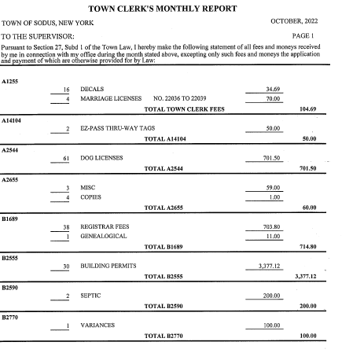
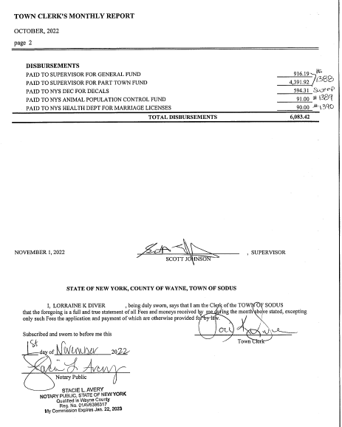

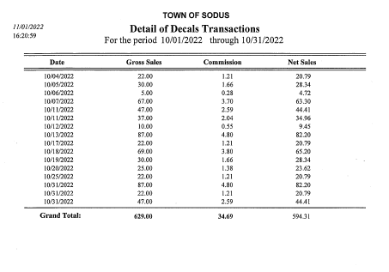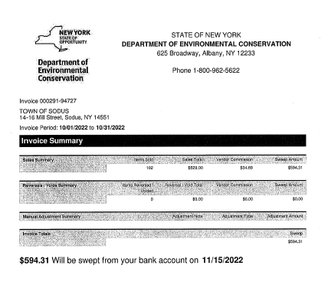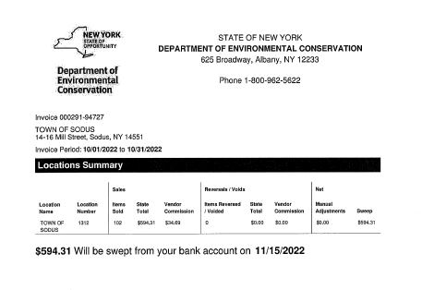
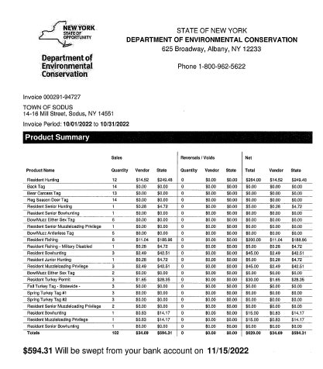

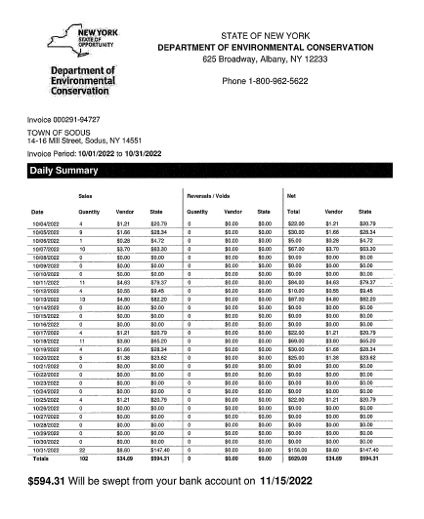

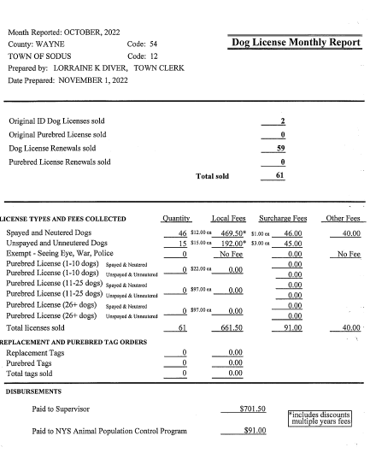
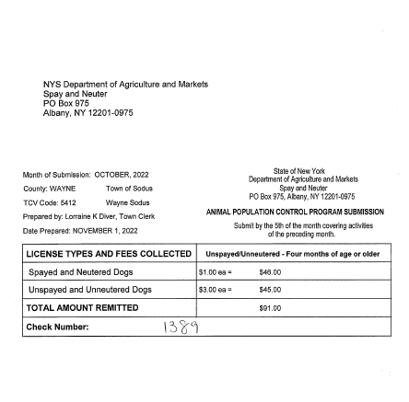
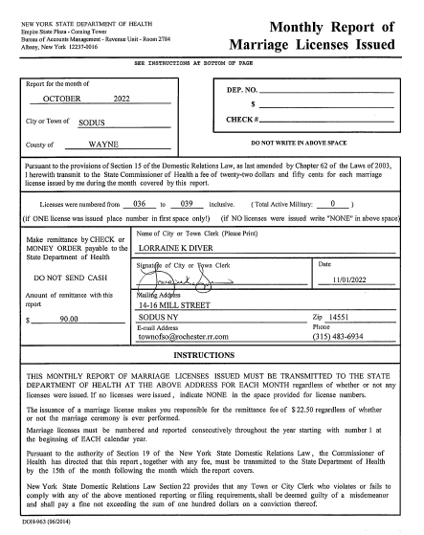

MINUTES
Minutes from October 11, 2022 was presented to the Town Board for approval. Councilperson David LeRoy motioned to accept and file these Minutes, which was seconded by Councilperson Don Ross. Upon roll call the following votes were heard, Scott Johnson, aye; David LeRoy, aye; Don Ross, aye; Chris Tertinek, aye; and Cathy Willmott; abstained (was absent). Motion carried.

Minutes from October 27, 2022 was presented to the Town Board for approval. Councilperson Cathy Willmott motioned to accept and file these Minutes, which was seconded by Councilperson Don Ross. Upon roll call the following votes were heard, Scott Johnson, aye; David LeRoy, aye; Don Ross, aye; Chris Tertinek, aye; and Cathy Willmott; aye. Motion carried.

ABSTRACT
RESOLUTION TO PAY ABSTRACT No. 19
- 11-2022)
WHEREAS, the following bills were presented for payment on Abstract 19:

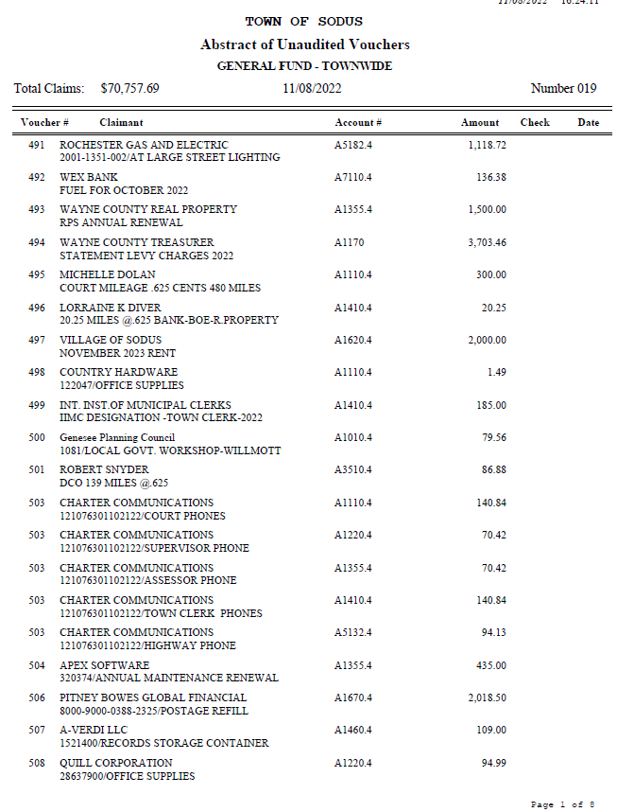

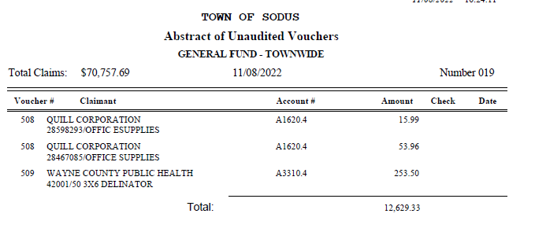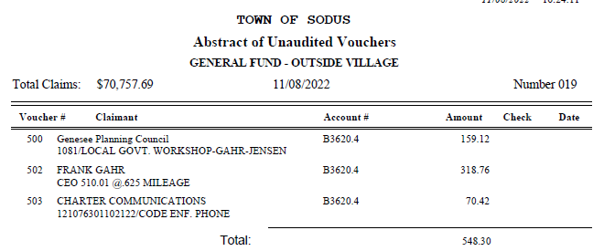

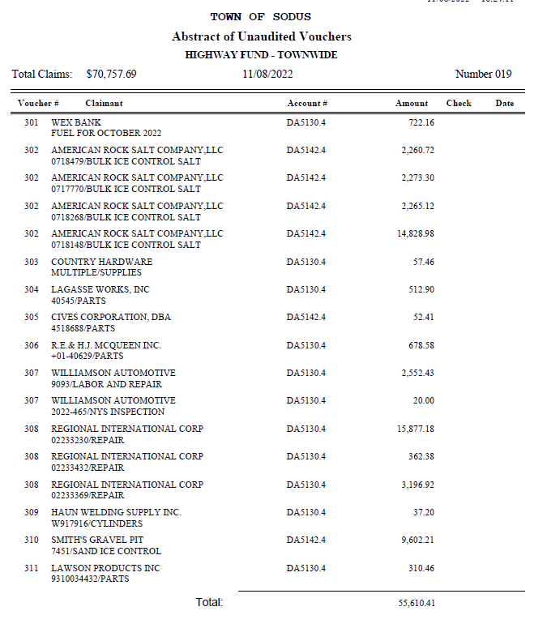

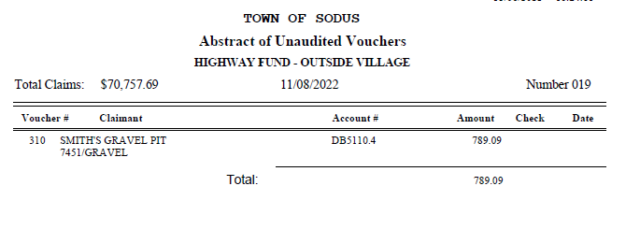
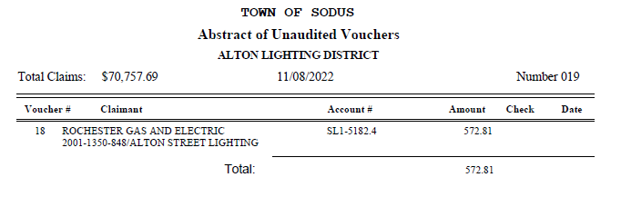
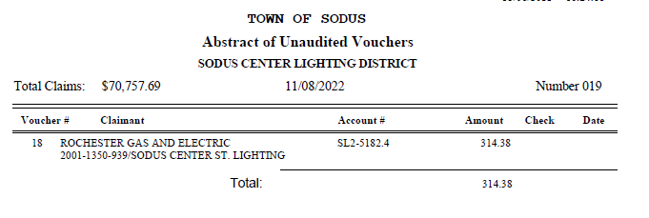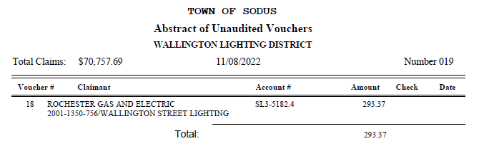

NOW BE IT RESOLVED, Councilperson David LeRoy motioned to authorize payment for Abstract # 19 as listed and adopt this resolution which was seconded by Councilperson Chris Tertinek. Upon roll call the following votes were heard, Scott Johnson, aye; David LeRoy, aye; Don Ross, aye; Chris Tertinek, aye; and Cathy Willmott; aye. Resolution Adopted.

PUBLIC WORKS COMMITTEE: Councilperson David LeRoy, Chair
(Highway, Drainage - Deputy Town Supervisor)
HIGHWAY REPORT:
(Dale Pickering – Highway Superintendent)
Councilperson Cathy Willmott motioned to accept and file the monthly October 2022 Highway Report from Dale Pickering Highway Superintendent was seconded by Councilperson Chris Tertinek. Upon roll call the following votes were heard, Scott Johnson, aye; David LeRoy, aye; Don Ross, aye; Chris Tertinek, aye; and Cathy Willmott; aye. Motion carried.

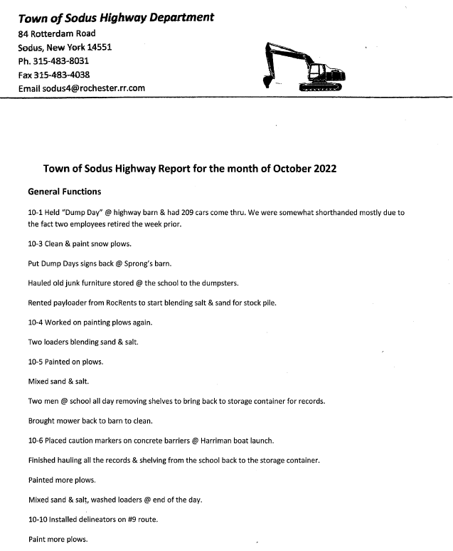
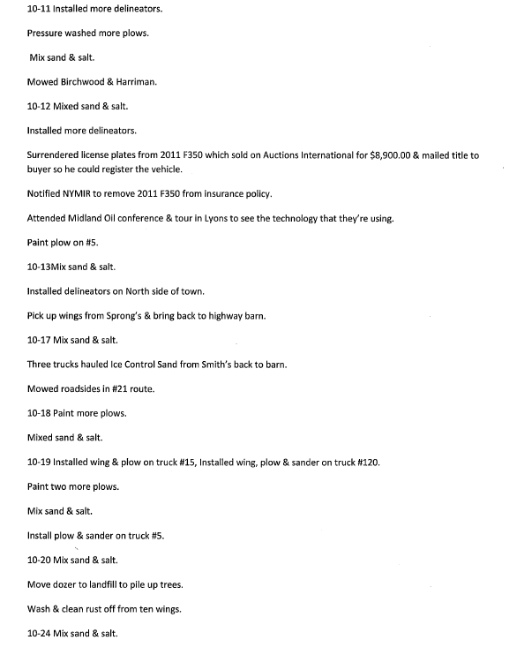
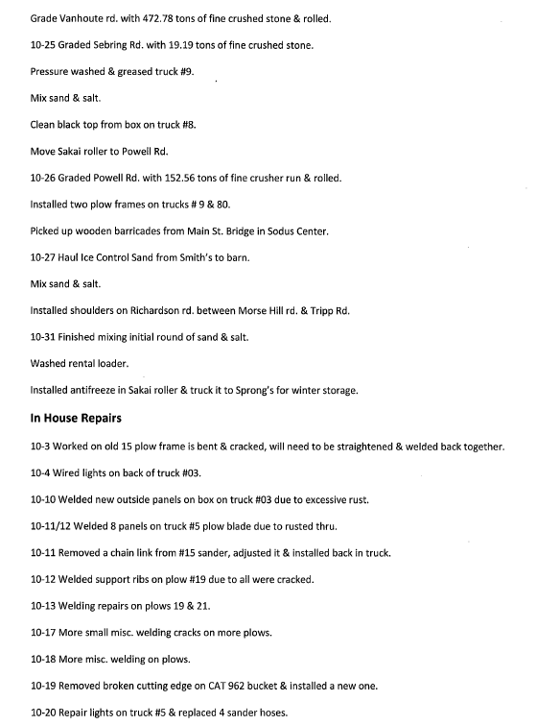

LED STREET LIGHTING:
Councilperson David LeRoy said the LED Lighting Project is on hold until further notice.

SALT BARN UPDATE:
Councilperson David LeRoy stated that Dave Doyle with MRB now has all documents regarding the Salt Barn.

DRAINAGE
N/A

RECREATION/ENVIRONMENTAL COMMITTE: Cathy Willmott, Councilperson
(Recreation, Assessor, Parks, Cemeteries)
Recreation Report
Councilperson David LeRoy motioned to accept and file the monthly October 2022 Town Recreation Report from Director, Sheila Fisher was seconded by Councilperson Cathy Willmott. Upon roll call the following votes were heard, Scott Johnson, aye; David LeRoy, aye; Don Ross, aye; Chris Tertinek, aye; and Cathy Willmott; aye. Motion carried.

Director’s Report
Sodus Recreation Board Meeting
November 1, 2022

Programs:
- Currently we have a girl’s travel basketball program being coached by Katie Hall. They began in Mid-October and will practice on Tuesday & Thursday evenings. Games will be held on Saturdays within Wayne County and travel to and from games will be the responsibility of the parents.
Budget:
- Nothing to report at this time.

Assessor’s Report
(Nathan Mack, Assessor)
Councilperson Chris Tertinek motioned to accept and file the monthly October 2022 Assessor’s Report was seconded by Councilperson Don Ross. Upon roll call the following votes were heard, Scott Johnson, aye; David LeRoy, aye; Don Ross, aye; Chris Tertinek, aye; and Cathy Willmott; aye. Motion carried.

tOWN OF sODUS

ASSESSOR’S OFFICE
Date: November 1, 2022
Respectfully Submitted by: Nathan Mack

AROUND THE OFFICE
- Renewals for the Agricultural land exemption will be mailed out at the end of November/ early December.
- Programs that require information for the 2021 income tax year will be mailed closer to January.
- As in the recent years, no Enhanced stars renewals are required as New York State is now in charge of verifying future eligibility.
- Our office will assist the Town Clerk in providing property transfers and address changes that occur after the file has be turned into the County to print the bills.
Camp Beechwood/Sodus Groundskeeper Report
(Sal Vittozzi-Caretaker-Sodus Town Groundkeeper)
Councilperson Cathy Willmott motioned to accept the monthly October 2022 Camp Beechwood-Parks & Cemeteries Report from Sal Vittozzi; Sodus Town Groundskeeper-Caretaker was seconded by Councilperson Chris Tertinek. Upon roll call the following votes were heard, Scott Johnson, aye; David LeRoy, aye; Don Ross, aye; Chris Tertinek, aye; and Cathy Willmott; aye. Motion carried.

October 2022 Camp Beechwood

October was another positive month here at the park. The onset of fall weather has slowed both daily traffic in the park and camping as well. We collected $135 in camping fees in October. Mowing and trail trimming is still being done on a weekly basis. With attendance slowing down, it is giving me a chance to get some extra work done in the park as well. I am currently working on plans for the upcoming winter sport season to show the community that cold weather does not stop work and activities here at the park. The two main ideas that I am working on right now is the addition of a skating rink to the west entrance area and lighting up the park for the holidays. I would like to use some of the money collected from camping to bring these projects to fruition. Most of the building supplies for the rink will be repurposed from the bridge that was replaced in August, but a large liner and some lighting will need to be purchased. I'll also be compiling a list of tools and materials to continue park improvements throughout the winter and will include that in next month's report.

Submitted By Sal Vittozzi,
Groundskeeper

BUILDINGS AND GROUNDS COMMITTEE: Councilperson Chris Tertinek, Chair
(Town Property, Animal Control, Flood Damage Prevention)
CODE ENFORCEMENT REPORT:
(Frankie Gahr- CEO)
Councilperson Cathy Willmott motioned to accept the monthly October 2022 Code Enforcement Report was seconded by Councilperson David LeRoy. Upon roll call the following votes were heard, Scott Johnson, aye; David LeRoy, aye; Don Ross, aye; Chris Tertinek, aye; and Cathy Willmott; aye. Motion carried.

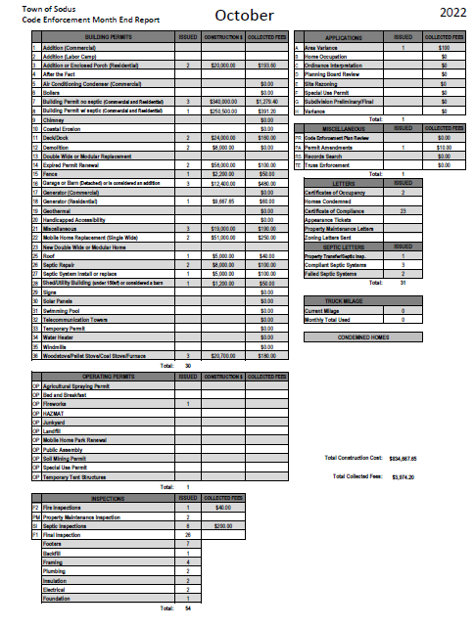

DOG CONTROL REPORT:
(Robert Snyder, Primary DCO)
(Vacant Position- Secondary DCO)
Councilperson Cathy Willmott motioned to accept the monthly October 2022 Dog Control Report was seconded by Councilperson David LeRoy. Upon roll call the following votes were heard, Scott Johnson, aye; David LeRoy, aye; Don Ross, aye; Chris Tertinek, aye; and Cathy Willmott; aye. Motion carried.
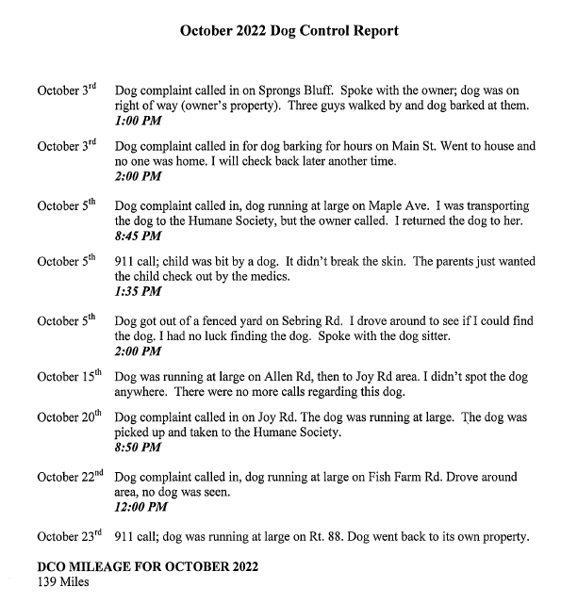

FLOOD DAMAGE PREVENTION REPORT-Code 69:
(Chris Tertinek, Councilperson)
Councilperson Chris Tertinek gave his monthly Flood Damage Prevention Report.
Lake Level
- The lake is about at 244.0 feet ASL (above sea level). About 0.2 feet below last month and 0.5 feet below long-term average.
- Expect level to be nearly the same through December then slowly rising to about long-term average at the end of April 2023.
- Unless the Ottawa River basin gets a huge snowpack, rapid melting of snow and rain in the spring, no flooding is expected in 2023.

PUBLIC SAFETY/DRAINAGE/ENVIRONMENT COMMITTEE: Councilperson Don Ross, Chair (Fire, Ambulance, Emergency Preparedness)
Councilperson Don Ross gave his monthly report. Ross is a part of the audit committee for Wayne County Water Sewer Authority. Ross sent the entire Board the 911 report.
Please note: Report has confidential information in it (not included in the minutes).

TOWN HALL COMMITTEE: Scott Johnson, Supervisor –
(Personnel, Clerks, Justices, Assessor, Building Inspector, Town Council, Boards, Insurances, Finance)

CORRESPONDENCE & INFORMATION

CERTIFICATE OF DESIGNATION –NY STATE ASSOCIATION OF TOWNS
RESOLUTION
- 11-2022)
WHEREAS, the following resolution was presented for adoption, and
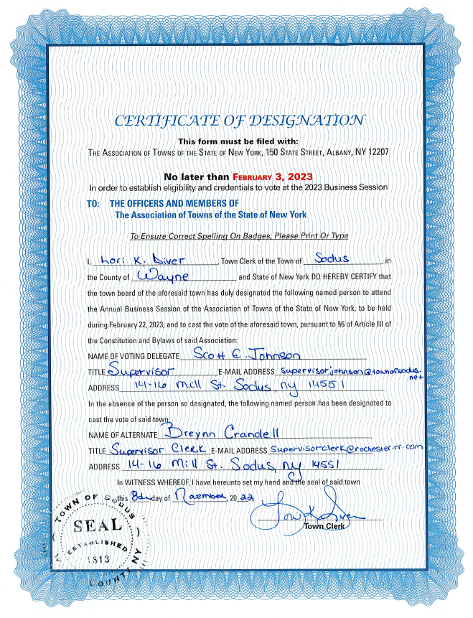
NOW BE IT RESOLVED, Councilperson David LeRoy motioned to adopt this resolution which was seconded by Councilperson Chris Tertinek. Upon roll call the following votes were heard, Scott Johnson, aye; David LeRoy, aye; Don Ross, aye; Chris Tertinek, aye; and Cathy Willmott; aye. Resolution Adopted.

Sodus Town Supervisor shared that finally after many years the School Street Bridge in Sodus Center is finally open for all traffic. There was a small ribbon cutting ceremony at 1:40 PM today to open the bridge. The full ceremony with the dedication will most likely be in the spring of 2023.

PRIMARY DIGITAL CLERK POSITION-MEIN
RESOLUTION
- 11-2022)
WHEREAS, the following resolution was presented for adoption, and

NOW BE IT RESOLVED, Councilperson David LeRoy authorized Lori Diver Sodus Town Clerk to hire Lillian M. Mein as the Primary “part-time” Digital Clerk to perform the duty of digital scanning in the Town Clerk’s office, not to exceed 20 hours, non-benefited and a 6 month probation beginning December 1, 2022 with a starting wage of $13.20 hourly for 2022 and then $14.20 per hour when the minimum wage increases in 2023 was seconded by Councilperson Chris Tertinek. Upon roll call the following votes were heard, Scott Johnson, aye; David LeRoy, aye; Don Ross, aye; Chris Tertinek, aye; and Cathy Willmott; aye. Resolution Adopted.

VOLUNTEER DIGITAL CLERK POSITION-PAPROCKI
RESOLUTION
- 11-2022)
WHEREAS, the following resolution was presented for adoption, and

NOW BE IT RESOLVED, Councilperson Chris Tertinek authorized Lori Diver Sodus Town Clerk to allow Jim Paprocki to volunteer at the Sodus Town Clerk’s Office without pay as a, “Volunteer Digital Clerk” up to 20 hours per week with NO benefits was seconded by Councilperson Don Ross. Upon roll call the following votes were heard, Scott Johnson, aye; David LeRoy, aye; Don Ross, aye; Chris Tertinek, aye; and Cathy Willmott; aye. Resolution Adopted.

Discussion was held regarding Robert Snyder DCO as a cardholder member with the Town’s credit card. Lori Diver explained that she spoke with Mark Plyter, Wayne County Director of the Humane Society regarding dogs injured in the Town of Sodus. Plyter informed Diver that if a dog is injured in its own community it is the responsibility of the DCO Officer to get the dog help immediately. This could be very costly especially, in the middle of the night or early hours of the morning and the dog has to be transported to an emergency hospital. The Town Board agreed he should have a card specific to this need.

TOWN OF SODUS CREDIT CARDS-LNB
RESOLUTION
- 11-2022)

WHEREAS, the Town of Sodus has two new employees, and

WHEREAS, the Town of Sodus has one employee who has resigned, and

NOW BE IT RESOLVED, Supervisor Scott Johnson has authority on behalf of the Town Board and the Town of Sodus to open the following credit cards at LNB bank for the Town of Sodus individuals and departments and remove the following employee given his resignation, and

FURTHER BE IT RESOLVED, the credit limit for each employee shall be set at $4,000.00 for
Frank Gahr, Code Enforcement Officer
Robert Snyder, Dog Control Officer

FURTHER BE IT RESOLVED, the Town of Sodus needs to remove Craig Schwartz from the LNB Town of Sodus credit card, and

RESOLVED, the Town of Sodus Board hereby adopts resolution (05 11-2022). Councilperson David LeRoy motioned to adopt this resolution which was seconded by Councilperson Cathy Willmott. Upon roll call the following votes were heard, Scott Johnson, aye; David LeRoy, aye; Don Ross, aye; Chris Tertinek, aye; and Cathy Willmott; aye. Resolution Adopted.

RESCINDING THE OCTOBER 27, 2022 PRELIMINARY & ADOPTED TOWN OF SODUS BUDGET & AMENDING WITH ITS NEW ADOPTION
RESOLUTION
- 11-2022)

(SEE PAGES 27-28 FOR RESOLUTION)
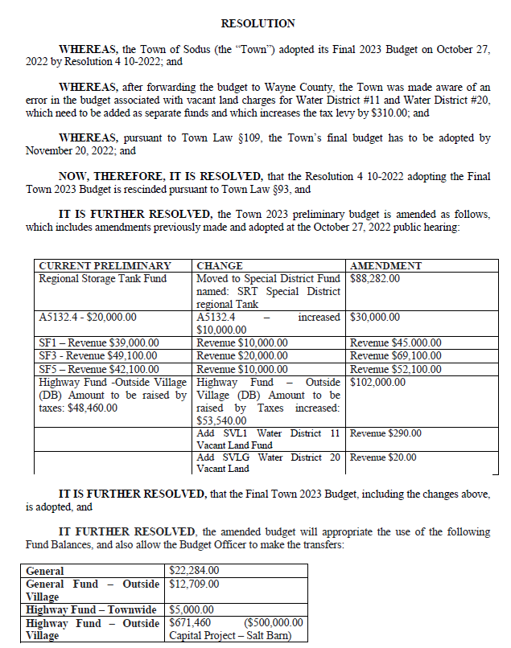

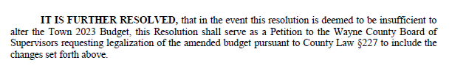

RESOLVED, the Town of Sodus Board hereby adopts resolution (06 11-2022). Councilperson David LeRoy motioned to adopt this resolution which was seconded by Councilperson Chris Tertinek. Upon roll call the following votes were heard, Scott Johnson, aye; David LeRoy, aye; Don Ross, aye; Chris Tertinek, aye; and Cathy Willmott; aye. Resolution Adopted.

Councilperson David LeRoy motioned to adjourn the meeting was seconded by
Councilperson Don Ross. Upon roll call the following votes were heard, Scott Johnson, aye; David LeRoy, aye; Don Ross, aye; Chris Tertinek, aye; and Cathy Willmott; aye. Motion carried.

Meeting adjourned at 6:54 PM
Recording Secretary,

Minutes Written By:
Lori Diver
Sodus Town Clerk, RMC

