MINUTES
Minutes of the Regular Sodus Town Board Meeting commencing at 5:00 PM in the Upstairs Meeting Room October 22, 2019, located at 14-16 Mill St. Sodus, NY 14551.
All meetings are open to the public.

Present: Steven LeRoy, Supervisor
David LeRoy, Councilperson/Deputy Supervisor
Jim Quinn, Councilperson
Don Ross, Councilperson
Scott Johnson, Councilperson

Recording Secretary: Lori Diver, Sodus Town Clerk-RMC

Absent: Craig Schwartz, DCO

Others Present: Rachel Pardington, Alan Knauf Attorneys At Law
Chris Tertinek- Candidate for Sodus Town Board
Chandra Jensen- Assistant to the Code Enforcer
Dale Pickering- Highway Superintendent
Casey Carpenter- Times of Wayne County
Sal Vittozzi- Groundskeeper
Ethan Winter, CCR
Corey Auerbach, CCR

Supervisor, Steve LeRoy called the Regular Town Board Meeting to order commencing at 7:00 PM with the Pledge of Allegiance and Lori Diver opened with roll call.

MINUTES
Councilperson Jim Quinn motioned to approve the Minutes of the September 10, 2019
Regular Town Board Meeting was seconded by Councilperson Scott Johnson. Upon roll call the following votes were heard, Steven LeRoy, aye; David LeRoy, aye; Quinn, aye; Ross, aye; Johnson, aye. Motion carried.

MINUTES
Councilperson Scott Johnson motioned to approve the Minutes of the September 23, 2019 Budget/Special Town Board Meeting was seconded by Councilperson Don Ross. Upon roll call the following votes were heard, Steven LeRoy, aye; David LeRoy, aye; Quinn, aye; Ross, aye; Johnson, aye. Motion carried.

MINUTES
Councilperson Jim Quinn motioned to approve the Minutes of the October 10, 2019 Budget/Special Town Board Meeting was seconded by Councilperson David LeRoy. Upon roll call the following votes were heard, Steven LeRoy, aye; David LeRoy, aye; Quinn, aye; Ross, abstain; Johnson, aye. Motion carried.

MINUTES
Councilperson David LeRoy motioned to approve the Minutes of the October 16, 2019 Budget/Special Town Board Meeting was seconded by Councilperson Scott Johnson. Upon roll call the following votes were heard, Steven LeRoy, aye; David LeRoy, aye; Quinn, aye; Ross, aye; Johnson, aye. Motion carried.

SUPERVISOR’S REPORT
The Supervisor’s Report for September 2019 was presented. Councilperson Scott Johnson motioned to accept and file this report, which was seconded by Councilperson Don Ross. Upon roll call the following votes were heard, Steven LeRoy, aye; David LeRoy, aye; Quinn, aye; Ross, aye; Johnson, aye. Motion carried.

TOWN CLERK’S REPORT
The Town Clerk’s Reports, Town Clerk’s bank statements for audit, and bank register for September 2019 were presented. Councilperson Don Ross motioned to accept and file these reports, which was seconded by Councilperson Scott Johnson. Upon roll call the following votes were heard, Steven LeRoy, aye; David LeRoy, aye; Quinn, aye; Ross, aye; Johnson, aye. Motion carried.

ABSTRACT
RESOLUTION TO PAY ABSTRACT NO #18
(02 10-2019)
WHEREAS, the following bills were presented for payment on Abstract 18:

General 413-435 $ 10,832.16
Highway 268-278 $ 32,895.37
Trust & Agency 025-026 $ 635.44
Water District # 11 027-027 $ 1,700.00
GRAND TOTAL: $ 46,062.97

NOW BE IT RESOLVED, Councilperson David LeRoy motioned to approve payment of these bills as reviewed for Abstract No. 18, which was seconded by Councilperson Scott Johnson. Upon roll call the following votes were heard, Steven LeRoy, aye; David LeRoy, aye; Quinn, aye; Ross, aye; Johnson, aye. Resolution adopted.

PUBLIC COMMENTS
Ethan Winter & Corey Auerbach (Cypress Creek) discussed with the Sodus Town Board opinion of probable cost- PV Plant decomissioning-SAT-2Mwac of the Brick Church Solar LLC. Project as follows:
(See pages 3-7)

Supervisor Steve LeRoy has asked the Sodus Town Board to review the information provided by Cypress Creek and further discussion/decision will be tabled until the November 12, 2019 meeting.
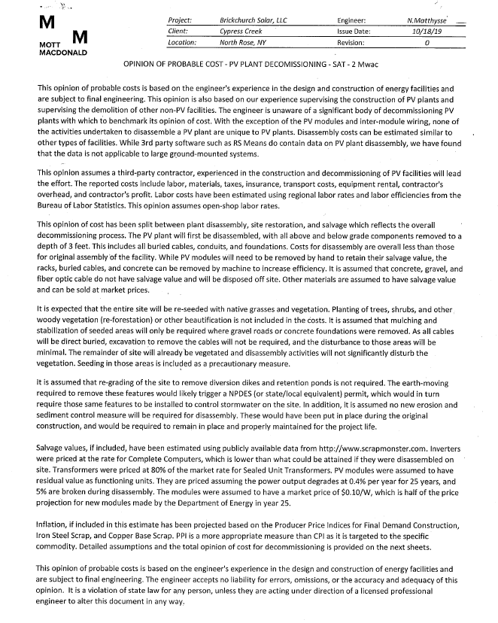
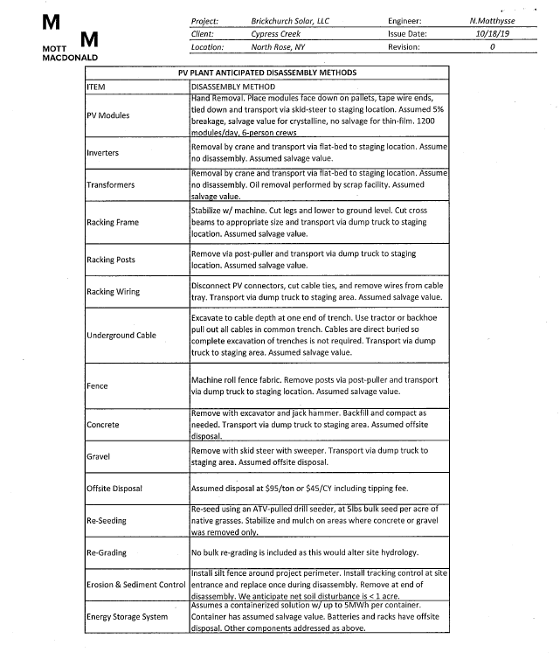
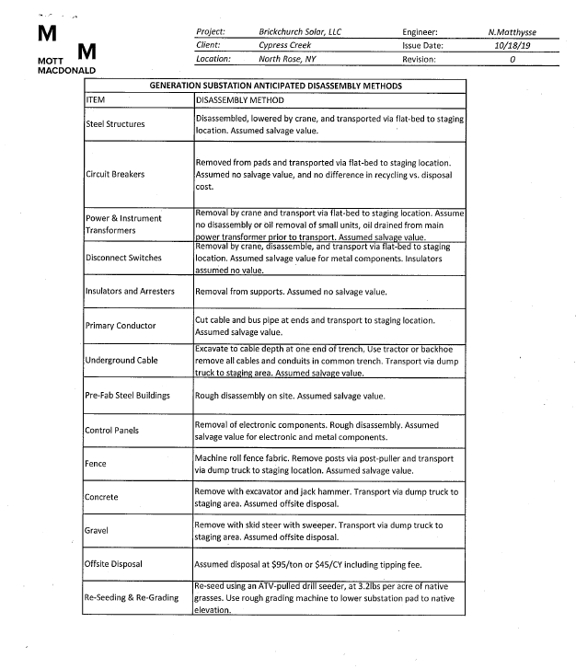
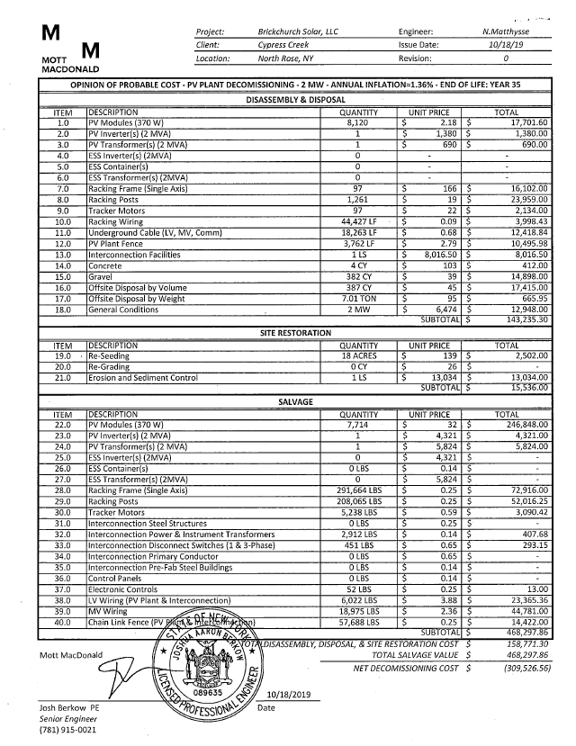
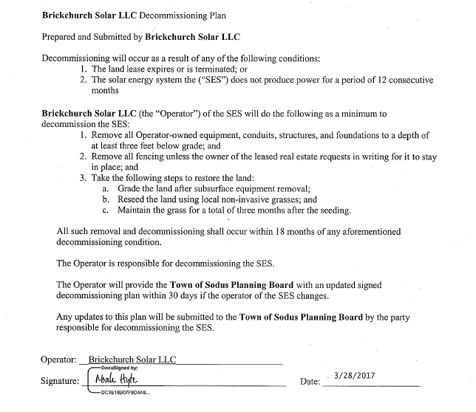
PUBLIC HEARING:
(Local Law No. 1-2019) 5:05 PM
Lori Diver Sodus Town Clerk read the following legal notice:

LEGAL NOTICE
TOWN OF SODUS
NOTICE OF PUBLIC HEARING
LOCAL LAW NO. 1- 2019
REVISED

PLEASE TAKE NOTICE that a public hearing will be held by the Town Board of the Town of Sodus on the 22nd day of October, 2019 at 5:05 p.m. in the Sodus Town Court Room at the Sodus Town Hall, 14-16 Mill Street, Sodus, New York to hear and consider comments from the public in regard to Local Law No.1 of 2019:

Local Law No. 1 - 2019 Authorizes the Town Board of the Town of Sodus
to adopt a budget for the fiscal year 2020 that requires a real property tax levy in excess
of the limit specified in General Municipal Law, §3-c.

Copies of the entire Local Law No. 1 - 2019 are available for review at the Town Clerks Office during regular business hours.

BY ORDER OF THE TOWN BOARD
OF THE TOWN OF SODUS

Lori K. Diver, Town Clerk, RMC

Dated: October 10, 2019

Councilperson Scott Johnson motioned to open the Public Hearing for Local Law No. 1-2019 was seconded by Councilperson Don Ross. Upon roll call the following votes were heard, Steven LeRoy, aye; David LeRoy, aye; Quinn, aye; Ross, aye; Johnson, aye. Motion carried.

Hearing no public comments Supervisor LeRoy closed the Public Hearing.

Councilperson David LeRoy motioned to close the Public Hearing for Local Law No. 1-2019 was seconded by Councilperson Scott Johnson. Upon roll call the following votes were heard, Steven LeRoy, aye; David LeRoy, aye; Quinn, aye; Ross, aye; Johnson, aye. Motion carried.

PUBLIC SAFETY/DRAINAGE/ENVIRONMENT COMMITTEE: Councilperson Don Ross, Chair (Fire, Ambulance, Emergency Preparedness)
Councilperson Don Ross gave his committee reports.

BUILDINGS AND GROUNDS COMMITTEE: Councilperson Jim Quinn, Chair
(Town Property, Parks, Animal Control, Cemeteries)
CODE ENFORCEMENT REPORT:
Craig Schwartz- CEO
Councilperson Scott Johnson motioned to accept the monthly September 2019 Code Enforcement Report as written was seconded by Councilperson David LeRoy. Upon roll call the following votes were heard, Steven LeRoy, aye; David LeRoy, aye; Quinn, aye; Ross, aye; and Johnson, aye. Motion carried.

CAMP BEECHWOOD-PARKS-CEMETERIES REPORTS:
(Sal Vittozzi-Sodus Town Groundkeeper)
Councilperson Scott Johnson motioned to accept the monthly September 2019 Camp Beechwood-Parks & Cemeteries written report from Sal Vittozzi, Sodus Town Groundskeeper was seconded by Councilperson Don Ross. Upon roll call the following votes were heard, Steven LeRoy, aye; David LeRoy, aye; Quinn, aye; Ross, aye; and Johnson, aye. Motion carried.

Supervisor LeRoy stated he received a BID from Innovative for the security camera installation at Beechwood.

DOG CONTROL OFFICER REPORT:
Craig Schwartz- Primary DCO
Shane Martin- Secondary DCO
Councilperson David LeRoy motioned to accept and file the monthly September 2019 DCO Report from Craig Schwartz, DCO Officer was seconded by Councilperson Jim Quinn. Upon roll call the following votes were heard, Steven LeRoy, aye; David LeRoy, aye; Quinn, aye; Ross, aye; and Johnson, aye. Motion carried.

PUBLIC WORKS COMMITTEE: Councilperson David LeRoy, Chair
(Highway, Drainage - Deputy Town Supervisor)
HIGHWAY REPORT:
(Dale Pickering – Highway Superintendent)
Councilperson Scott Johnson motioned to accept and file the monthly September 2019 Highway Report from Dale Pickering Highway Superintendent was seconded by Councilperson Don Ross. Upon roll call the following votes were heard, Steven LeRoy, aye; David LeRoy, aye; Quinn, aye; Ross, aye; and Johnson, aye. Motion carried.

RECREATION & ASSESSOR COMMITTEE: Councilperson (Councilperson Scott Johnson Chair)
(Recreation, Assessor)
Recreation Report
(Sheila Fisher, Director)
Councilperson Don Ross motioned to accept and file the monthly September 2019 Recreation Report submitted by Sheila Fisher, Recreation Director was seconded by Councilperson David LeRoy. Upon roll call the following votes were heard, Steven LeRoy, aye; David LeRoy, aye; Quinn, aye; Ross, aye; and Johnson, aye. Motion carried.

Assessor’s Report
(Nathan Mack, Assessor)
Councilperson David LeRoy motioned to accept and file the monthly September 2019 Assessor’s Report from Sole Assessor, Nathan Mack was seconded by Councilperson Jim Quinn. Upon roll call the following votes were heard, Steven LeRoy, aye; David LeRoy, aye; Quinn, aye; Ross, aye; and Johnson, aye. Motion carried.

TOWN HALL COMMITTEE: Supervisor LeRoy, Chair
(Personnel, Clerks, Justices, Assessor, Building Inspector, Town Council, Boards, Insurances, Finance)
N/A

CORRESPONDENCE & INFORMATION

LOCAL LAW 1-2019
RESOLUTION
(03 10-2019)

TOWN OF SODUS
LOCAL LAW
TAX CAP OVERRIDE FOR 2020 BUDGET

Local Law Filing New York State Department of State
41 State Street, Albany, NY 12231

Town of Sodus
County of Wayne

Local Law No. 1 of the year 2019

A Local Law to override the tax levy limit established in General Municipal Law § 3-c

Be it enacted by the Town Board of the Town of Sodus, in the County of Wayne, as follows:

SECTION 1: LEGISLATIVE INTENT

It is the intent of this local law to override the limit on the amount of real property taxes that may be levied by the Town of Sodus, County of Wayne pursuant to General Municipal Law
§ 3-c, and to allow the Town of Sodus, County of Wayne to adopt a town budget for (a) town purposes (b) fire protection districts and (c) any other special or improvement district governed by the town board for the fiscal year 2020 that requires a real property tax levy in excess of the “tax levy limit” as defined by General Municipal Law § 3-c.

The Town of Sodus is concerned about uncertainties in the existing tax cap law, including how uncertain expenditures mandated by law and uncertain expenditures and revenues controlled by the county and the state interact with the tax cap. The town board is obligated to prepare a responsible budget, which meets the Town’s mandated obligations and provides beneficial services, while minimizing the tax burden on Town citizens.

SECTION 2: AUTHORITY

This local law is adopted pursuant to subdivision 5 of General Municipal Law § 3-c, which expressly authorizes the town board to override the tax levy limit by the adoption of a local law approved by a vote of sixty percent (60%) of the town board.

Local Law Filing New York State Department of State
41 State Street, Albany, NY 12231

SECTION 3: TAX LEVY LIMIT OVERRIDE

The Town Board of the Town of Sodus, County of Wayne is hereby authorized to adopt a budget for the fiscal year 2020 that requires a real property tax levy in excess of the linnet specified in General Municipal Law § 3-c.

SECTION 4: SEVERABILITY

If any clause, sentence, paragraph, subdivision, or part of this Local Law or the application thereof to any person, firm or corporation, or circumstance, shall be adjusted by any court of competent jurisdiction to be invalid or unconstitutional; such order or judgment shall not affect, impair, or invalidate the remainder thereof, but shall be confined in its operation to the clause, sentence, paragraph, subdivision, or part of this Local Law or in its application to the person, individual, firm or corporation or circumstance, directly involved in the controversy in which such judgment or order shall be rendered.

SECTION 5: EFFECTIVE DATE

This local law shall take effect immediately upon filing with the Secretary of State.

Local Law Filing New York State Department of State
41 State Street, Albany, NY 12231

I hereby certify that the Local Law annexed hereto, designated as of Local Law No.1 of
2019, of the Town of Sodus was duly passed by the Town Board on 22ND Day of October, 2019, in accordance with the applicable provisions of law.

NOW BE IT RESOLVED, Councilperson David LeRoy motioned to adopt Local Law No. 1 - 2019, which was seconded by Councilperson Scott Johnson. Upon roll call the following votes were heard, Steven LeRoy, aye; David LeRoy, aye; Quinn, aye; Ross, aye; Johnson, aye. Resolution adopted.

SEQR WILLIAMSON FLYING CLUB TREE REMOVAL PROJECT
RESOLUTION
(04 10-2019)

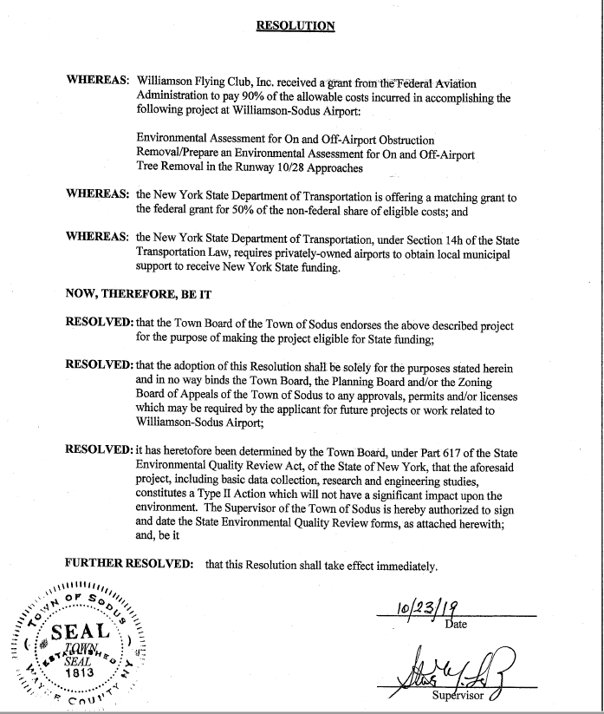

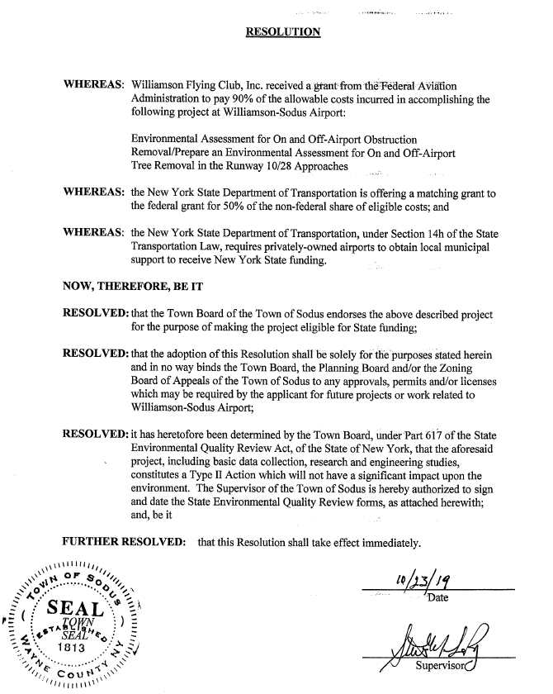

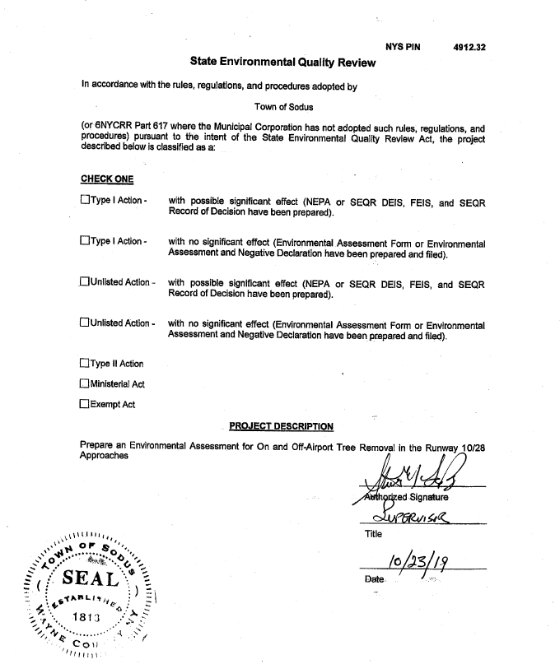

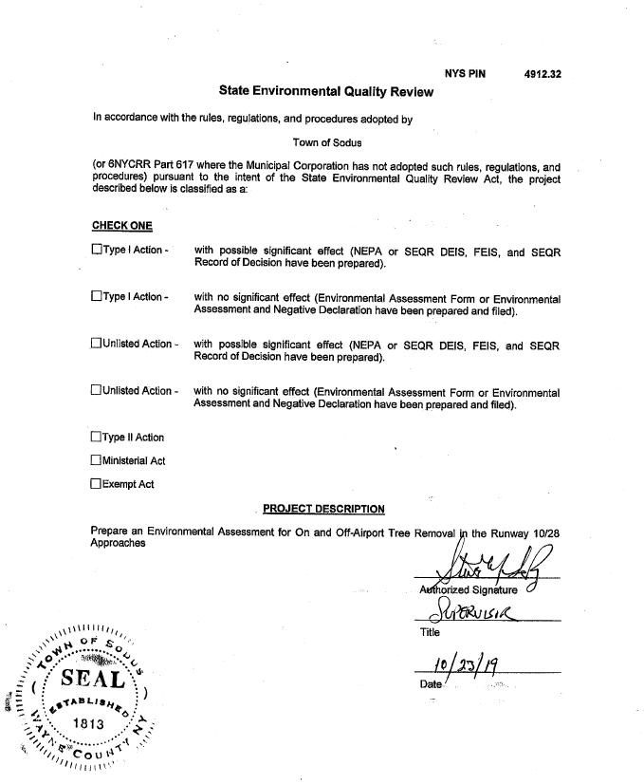

NOW BE IT RESOLVED, Councilperson David LeRoy motioned to adopt resolution (04-10 2019) which was seconded by Councilperson Scott Johnson. Upon roll call the following votes were heard, Steven LeRoy, aye; David LeRoy, aye; Quinn, aye; Ross, aye; Johnson, aye. Resolution adopted.

SALT STORAGE SHED BOND RESOLTUION
RESOLUTION
(05 10-2019)

EXTRACT OF MINUTES OF MEETING OF THE TOWN BOARD
ADOPTING BOND RESOLUTION

At a meeting of the Town Board of the Town of Sodus, Wayne County, New York, held at the Town Offices in Sodus, New York, on the 22nd day of October, 2019:

PRESENT: Supervisor Steven M. LeRoy
Councilperson David LeRoy
Councilperson Jim Quinn
Councilperson Don Ross
Councilperson Scott Johnson

ABSENT: N/A

Councilperson Jim Quinn presented the following resolution and duly moved that it be adopted and was seconded by Councilperson Scott Jonson:

BOND RESOLUTION DATED OCTOBER 22, 2019 OF THE TOWN BOARD OF THE TOWN OF SODUS, NEW YORK, AUTHORIZING GENERAL OBLIGATION SERIAL BONDS TO FINANCE CERTAIN CAPITAL IMPROVEMENTS CONSISTING OF ACQUISITION AND CONSTRUCTION OF A SALT STORAGE SHED, AUTHORIZING THE ISSUANCE OF BOND ANTICIPATION NOTES IN CONTEMPLATION THEREOF, THE EXPENDITURE OF SUMS FOR SUCH PURPOSE, AND DETERMINING OTHER MATTERS IN CONNECTION THEREWITH.

WHEREAS, the Town, acting as lead agency under the State Environmental Quality Review Act and the applicable regulations promulgated thereunder (“SEQRA”), has completed its environmental review and, on October 22, 2019, has duly issued a negative declaration and has determined that the implementation of the unlisted action as proposed will not result in any significant adverse environmental impacts; now therefor, be it

RESOLVED BY THE TOWN BOARD OF THE TOWN OF SODUS, NEW YORK (hereinafter referred to as the “Town”), by the favorable vote of not less than two-thirds of all of the members of such Board, as follows:

Section 1. The Town of Sodus shall undertake certain capital improvements consisting of the acquisition and construction of a Salt Storage Shed, various site and other incidental improvements in connection therewith and the acquisition of original furnishings, equipment, machinery or apparatus that may be required in connection therewith for such construction and Town use (hereinafter referred to as “purpose”), and general obligation serial bonds in an aggregate principal amount not to exceed $720,000 and bond anticipation notes in anticipation thereof (and renewals thereof) of the Town are hereby authorized to be issued to finance said purpose, and such amount is hereby appropriated therefor.

Section 2. The estimated maximum aggregate cost of said purpose, which may include preliminary costs and costs incidental thereto and costs of the financing thereof, is estimated to be $720,000. The plan for financing of said purpose is to provide all of such maximum cost by issuance of bonds or bond anticipation notes as herein authorized, to be offset and reduced dollar for dollar by the amount of grant funds received.

Section 3. It is hereby determined and declared that (a) such building shall be a class “C” building as defined in Subdivision 11 of Paragraph a of Section 11.00 of the Local Finance Law, and said purpose is one of the class of objects or purposes described in Subdivision 11 of Paragraph (a) of Section 11.00 of the Local Finance Law, and that the period of probable usefulness of said purpose is fifteen (15) years, (b) the proposed maximum maturity of said bonds authorized by this resolution will be in excess of five years, (c) current funds required to be provided prior to the issuance of the bonds or notes herein authorized, pursuant to Section 107.00 of the Local Finance Law, to the extent applicable, if any, will be provided, (d) the notes herein authorized are not issued in anticipation of bonds for an assessable improvement, and (e) there are presently no outstanding bond anticipation notes issued in anticipation of the sale of said bonds.

Section 4. The bonds and notes authorized by this resolution shall contain the recital of validity prescribed in Section 52.00 of the Local Finance Law and such bonds and notes shall be general obligations of the Town and all the taxable real property in the Town is subject to the levy of ad valorem taxes to pay the principal thereof, and interest thereon, without limitation as to rate or amount, subject to applicable statutory limitations, if any, sufficient to pay the principal of and interest on said bonds and notes.

Section 5. It is hereby determined and declared that the Town reasonably expects to reimburse the general fund, or such other fund as may be utilized, not to exceed the maximum amount authorized herein, from the proceeds of the obligations authorized hereby for expenditures, if any, from such fund that may be made for the purpose prior to the date of the issuance of such obligations. This is a declaration of official intent under Treasury Regulation §1.150-2.

Section 6. The power to further authorize the sale, issuance and delivery of said bonds and notes and to prescribe the terms, form and contents of said bonds and notes, including, without limitation, the consolidation with other issues, the determination to issue bonds with substantially level or declining annual debt service, all contracts for, and determinations with respect to, credit or liquidity enhancements, if any, and to sell and deliver said bonds and notes, subject to the provisions of this resolution and the provisions of the Local Finance Law, including without limitation, the authority to determine whether to accept bids electronically to the extent allowed by the Local Finance Law, is hereby delegated to the Town Supervisor, the Town’s chief fiscal officer. The Town Supervisor and the Town Clerk or Deputy Clerk are hereby authorized to sign by manual or facsimile signature and attest any bonds and notes issued pursuant to this resolution, and are hereby authorized to affix to such bonds and notes the corporate seal of the Town of Sodus.

Section 7. The faith and credit of the Town of Sodus, New York, are hereby irrevocably pledged for the payment of the principal of and interest on such bonds and notes as the same respectively become due and payable. An annual appropriation shall be made in each year sufficient to pay the principal of and interest on such obligations becoming due and payable in such year.

Section 8. After compliance with Section 9 hereof, this resolution shall be published in full by the Town Clerk of the Town of Sodus together with a notice in substantially the form prescribed by Section 81.00 of said Local Finance Law, and such publication shall be in each official newspaper of the Town, in the manner prescribed by law. The validity of said bonds and bond anticipation notes issued in anticipation of the sale of said serial bonds, may be contested only if such obligations are authorized for an object or purpose for which said Town is not authorized to expend money, or the provisions of law which should be complied with, at the date of publication of this resolution are not substantially complied with, and an action, suit or proceeding contesting such validity is commenced within twenty (20) days after the date of such publication; or if said obligations are authorized in violation of the provisions of the Constitution.

Section 9. This resolution is subject to a permissive referendum of the qualified electors of the Town of Sodus, pursuant to Section 35.00 of the Local Finance Law.

The motion having been duly seconded, it was adopted and the following votes were cast:

AYES NAYS
5 0

SALT STORAGE FACILITY RESOLTUION
RESOLUTION
(06 10-2019)

At a Meeting of the Sodus Town Board held on the ^{22nd} day of October, 2019, at 7:00 pm, at the Sodus Town Hall, 14-16 Mill St. Sodus, NY 14551 in the Town of Sodus, County of Wayne and State of New York.

STATE OF NEW YORK COUNTY OF WAYNE
TOWN OF SODUS TOWN BOARD

In the Matter of the Proposed Adoption of the RESOLUTION
Salt Storage Facility Plan
in the Town of Sodus, Wayne County
____________________________________________

UPON MOTION OF COUNCILPERSON SCOTT JOHNSON, SECONDED BY COUNCILMEMBER DON ROSS, IT IS UNANIMOUSLY RESOLVED THAT:

WHEREAS, the Town of Sodus (the “Town”) plans to construct a Salt Storage Facility (“Action”) on property owned by the Town located at 84 Rotterdam Road in the Village of Sodus; and

WHEREAS, in accordance with the New York State Environmental Quality Review Act (“SEQRA”) and its implementing regulations, the Town must undertake an environmental review of the Action;

NOW, THEREFORE, IT IS RESOLVED the Town Board has determined that the proposed Action is an “Unlisted Action” as defined by SEQRA, and that the Town will undertake uncoordinated review and act as lead agency, pursuant to 6 N.Y.C.R.R. §617.6(b)(4); and it is further

RESOLVED, that the Town has caused a short environmental assessment from (“EAF”) for the Action to be prepared to evaluate the significance of potential environmental impact of the Action, which the Town Board hereby accepts; and it is further

RESOLVED that the Town Board has considered the proposed Action and its potential for environmental impacts; reviewed and considered the EAF, the criteria contained in 6 N.Y.C.R.R. §617.7(c), and other supporting information to identify the relevant areas of environmental concern; and taken a hard look at the identified relevant areas of environmental concern to determine if the Action may have a significant adverse impact on the environment, and makes the following findings:

- That the Action will result in a benefit to the environment, because the improved facilities for salt storage will prevent unintended releases of salt into the environment, including into nearby wetlands.

- Construction activities will result in only minor temporary impacts of no significant consequence, including noise, dust and traffic disruption along affected roadways. All standard construction practices will be used to minimize ground disturbance, erosion and drainage problems until ground cover has been re-established.

- The Project is consistent with local and regional long-range highway maintenance planning. Construction of the Salt Barn will eliminate a safety and environmental problem which results from poor storage of salt that is imperative to mitigating the effects of precipitation in cold weather.

- The creation of the Salt Barn will not impact vegetation or fauna, fish, shellfish or wildlife species, significant habitats, or threatened or endangered species.

- Although the construction of the Project will consume energy resources, the total amount of energy likely to be consumed is not significant.

- No potentially significant adverse environmental impacts have been identified.

NOW THEREFORE IT IS FURTHER RESOLVED that pursuant to SEQRA, the Town Board finds that the proposed Action will not have a significant impact on the environment, so that a Negative Declaration shall be made and duly filed, and an environmental impact statement will not be required.

NOW THEREFORE IT IS FURTHER RESOLVED FURTHER BE IT RESOLVED, the Sodus Town Board hereby adopts resolution (06 10-2019). Councilperson Scott Johnson motioned to adopt this resolution was seconded by Councilperson Don Ross. Upon roll call the following votes were heard, Steven LeRoy, aye; David LeRoy, aye; Quinn, aye; Ross, aye; and Johnson, aye. Resolution adopted.

A motion by Councilperson Jim Quinn to allow Town Clerk Lori Diver to advertise for Permissive Referendum notice relative to Salt Storage Barn was seconded by Councilperson David LeRoy. Upon roll call the following votes were heard, Steven LeRoy, aye; David LeRoy, aye; Quinn, aye; Ross, aye; Johnson, aye. Motion carried.

SOUTH GENEVA ROAD WATER DISTRICT BUDGET MODIFICATION
RESOLUTION
(07 10-2019)

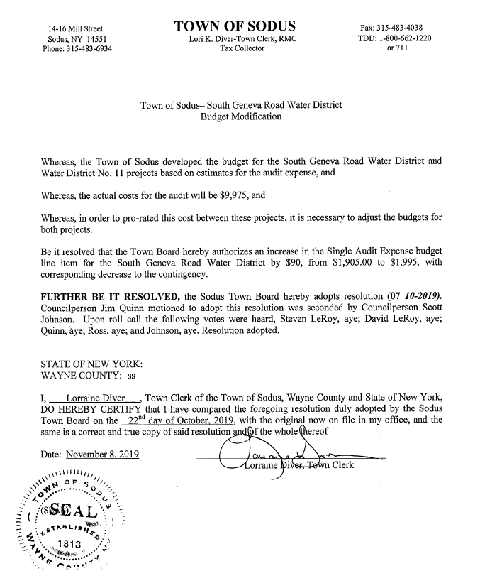

WATER DISTRICT # 11 BUDGET MODIFICATION
RESOLUTION
(08 10-2019)

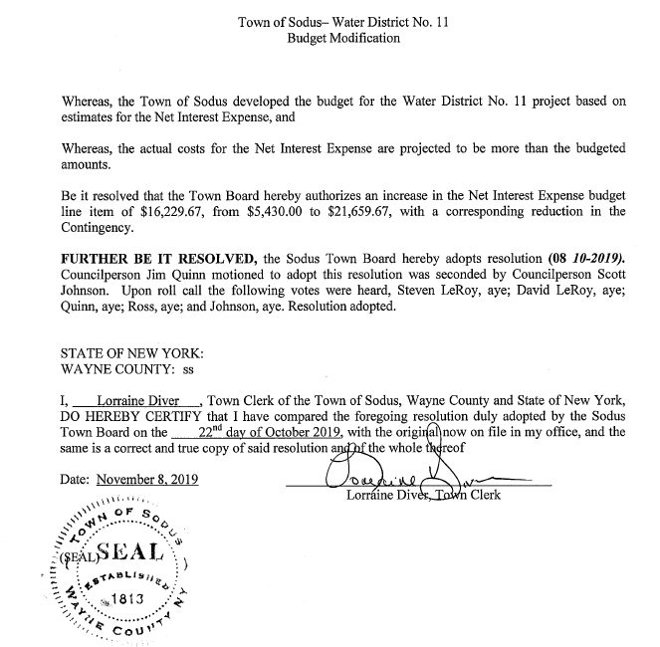

SOUTH GENEVA ROAD WATER DISTRICT BUDGET MODIFICATION NET INTEREST
RESOLUTION
(09 10-2019)

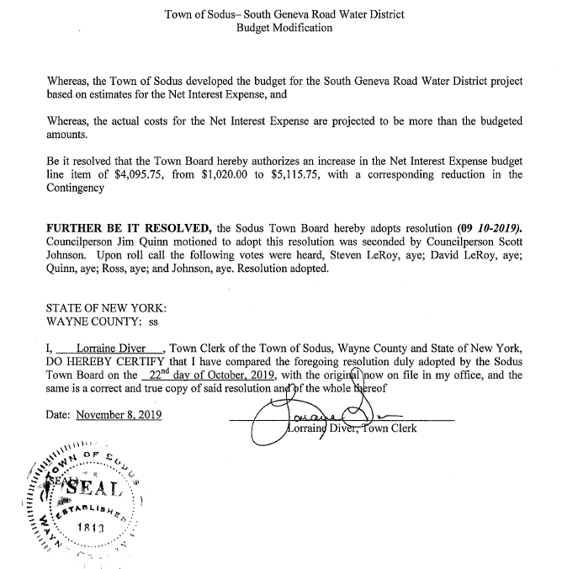

A motion by Councilperson Scott Johnson to allow Town Clerk Lori Diver to advertise “No Parking on Town Roads” from November 1, 2019 till April 1, 2020 was seconded by Councilperson Don Ross. Upon roll call the following votes were heard, Steven LeRoy, aye; David LeRoy, aye; Quinn, aye; Ross, aye; Johnson, aye. Motion carried.

Councilperson David LeRoy motioned to approve Nathan Mack to attend NYSAA one day seminar was seconded by Councilperson Scott Johnson. Upon roll call the following votes were heard, Steven LeRoy, aye; David LeRoy, aye; Quinn, aye; Ross, aye; Johnson, aye. Motion carried

Councilperson David LeRoy motioned to approve Nathan Mack to attend Mini Storage Valuation one day seminar was seconded by Councilperson Scott Johnson. Upon roll call the following votes were heard, Steven LeRoy, aye; David LeRoy, aye; Quinn, aye; Ross, aye; Johnson, aye. Motion carried

A motion by Councilperson Don Ross to hire Holly Warner to help out Chandra Jensen in the Code Enforcement Office not to exceed 5 days or 25 hours; paying Holly at her rate of pay when she retired in July 2019 was seconded by Councilperson David LeRoy. Upon roll call the following votes were heard, Steven LeRoy, aye; David LeRoy, aye; Quinn, aye; Ross, aye; Johnson, aye. Motion carried.

DISCUSSION
- Discussion was held regarding Tony Villani wishing to “handoff” any further legal representation to Knauf Shaw relative to stone quarry dispute

- Discussion was held regarding Mayor Englert notification of possible change in Code Enforcement/ Building Inspector office space.

FYI
- Minutes of Zoning/and or Planning Board Meetings (provided).

- Monthly Report from Wayne County Sheriff’s Office (provided).

A motion by Councilperson Don Ross to adjourn the Regular Town Board Meeting was seconded by Councilperson Scott Johnson. Upon roll call the following votes were heard, Steven LeRoy, aye; David LeRoy, aye; Quinn, aye; Ross, aye; Johnson, aye. Motion carried.

Meeting adjourned at 6:12 PM
Recording Secretary,

Lori K. Diver
Sodus Town Clerk

STATE OF NEW YORK)
COUNTY OF WAYNE)

I, Lorraine Diver, Town Clerk of the Town of Sodus, Wayne County, New York,

DO CERTIFY that I have compared the attached document with the original thereof recorded in my office within the minutes of the October 22, 2019 Regular Town Board Meeting, in the Town of Sodus, Wayne County, New York; and that the same is a true and correct copy of said original and of the whole thereof.

IN TESTIMONY WHEREOF, I have hereunto set my hand and affixed the seal of said Town of Sodus

Date: November 14, 2019 _______________________
Lori Diver, Town Clerk

