Sodus Town Board Agenda
Regular Month End-Town Board Meeting
October 27, 2022
4:30 PM
Pledge of Allegiance
Roll Call: (Lori Diver)
Supervisor Johnson (Zoom-unable to vote), Councilperson LeRoy, Councilperson Ross, Councilperson Tertinek, Councilperson Willmott

Public Hearing Local Law No. 2- 2022 4:35 PM:

- Motion entering into Local Law No. 2-2022 Public Hearing
First_________________ Seconded____________________ Time____________________

Lori Diver reads the following legal notice:

LEGAL NOTICE
TOWN OF SODUS
NOTICE OF PUBLIC HEARING
LOCAL LAW NO #2 - 2022

PLEASE TAKE NOTICE that a public hearing will be held by the Town Board of the Town of Sodus on the 27th day of October, 2022 at 4:35 p.m. in the upstairs meeting room at the Sodus Town Hall, 14-16 Mill Street, Sodus, New York to hear and consider comments from the public in regard to Local Law No.2 of 2022:

Local Law No. 2 – 2022 Authorizes the Town Board of the Town of Sodus
to adopt a budget for the fiscal year 2023 that requires a real property tax levy in excess
of the limit specified in General Municipal Law, §3-c.

Copies of the entire Local Law No.2- 2022 are available for review at the Town Clerks Office during regular business hours and located on the Town of Sodus website: www.townofsodus.net , under the MORE tab, then select LEGALS/RESOLUTIONS-LOCAL LAWS/AGENDA tab.

BY ORDER OF THE TOWN BOARD
OF THE TOWN OF SODUS

Lori K. Diver
Sodus Town Clerk, RMC
Dated: October 6, 2022

Supervisor Scott Johnson asks for public comments:
________________________________________________________________________________________________________________________________________________________________________________________

- Motion to close Public Hearing
First_________________ Seconded____________________ Time____________________

- Resolution adopting Local Law 2-2022 Authorizing the town Board of the Town of Sodus to adopt a budget for the fiscal year 2023 that requires a real property tax levy in excess of the limit specified in General Municipal Law, section 3-c.
First_________________ Seconded____________________
- Note: The status of the Tax Cap Form for Town of Sodus, fiscal year ending 12/31/2023, has been changed to submitted. This email was shared from Breynn Crandell and LGSA Monitoring 10-26-2022.

Public Hearing 2023 Fire Contracts 4:40 PM:

- Motion entering into 2023 Fire Contracts Public Hearing
First_________________ Seconded____________________ Time____________________

Lori Diver reads the following legal notice:

TOWN OF SODUS
LEGAL NOTICE

PUBLIC HEARING FOR:
“2023 FIRE CONTRACTS”

NOTICE IS HEREBY GIVEN, that the preliminary budget for the Town of Sodus , New York, for the fiscal year beginning January 1, 2023 has been completed and filed in the office of the Town Clerk of the Town of Sodus, and

FURTHER NOTICE, the 2023 Town of Sodus fire contracts are available for inspection by any interested person at all reasonable hours; and

FURTHER NOTICE, is hereby given that the Town Board of the Town of Sodus will meet to review said fire protection amounts for the fire districts and fire departments and hold a Public Hearing on Thursday October 27, 2022 starting at 4:40 p.m., and

FURTHER NOTICE, the public hearing for the Village of Sodus Fire Department will be held at 4:40 p.m., Sodus Center Fire District 4:45 p.m., the Wallington Fire District 4:50 p.m., the Alton Fire District 4:55 p.m., and the Village of Sodus Point Fire Department will be at 5:00 p.m. in the upstairs meeting room, 14-16 Mill Street, Sodus, NY 14551, at which time and place any persons may be heard in favor or against any items therein contained; and

WHEREAS, the proposed allocated amounts for the fire protection line are hereby specified as follows:
Village of Sodus Fire Dept. $39,000.00
Sodus Center Fire District $19,000.00
Wallington Fire District $49,100.00
Alton Fire District $45,100.00
Village of Sodus Point Fire Dept. $42,100.00

NOW BE IT RESOLVED, the Sodus Town Board will then adjourn from the public hearing and enter into its regular session to review and propose adoption of the 2023 fire protection amounts and contracts for adoption, and

FURTHER BE IT RESOLVED, the Sodus Town Board authorizes Supervisor Scott Johnson to sign all five fire contracts in the Town of Sodus.

All meetings are open to the public.

Date: October 6, 2022
By Order of the Sodus Town Board,
Lori Diver
Sodus Town Clerk, RMC

- Village of Sodus Public Hearing 4:40 PM
- Sodus Center Public Hearing 4:45 PM
- Wallington Fire District Public Hearing 4:50 PM
- Alton Fire District Public Hearing 4:55 PM
- Village of Sodus Point Fire Dept. 5:00 PM

Supervisor Scott Johnson asks for public comments:
________________________________________________________________________________________________________________________________________________________________________________________

- Motion to close open and close all five Public Hearings.
First_________________ Seconded____________________ Time____________________

- Resolution adopting and authorizing Supervisor Scott Johnson to sign 2023 fire districts and fire departments contracts.
First_________________ Seconded____________________

Public Hearing “2023 Preliminary Budget” 5:05 PM:

- Motion entering into 2023 Preliminary Budget Public Hearing
First_________________ Seconded____________________ Time____________________

Lori Diver reads the following legal notice:
TOWN OF SODUS
LEGAL NOTICE

PUBLIC HEARING FOR:
“THE 2023 PRELIMINARY BUDGET”

NOTICE IS HEREBY GIVEN, that the Preliminary Budget for the Town of Sodus , New York, for the fiscal year beginning January 1, 2023 has been completed and filed in the office of the Town Clerk of the Town of Sodus where it is available for inspection by any interested person at all reasonable hours; and

FURTHER NOTICE, is hereby given that the Town Board of the Town of Sodus will meet to review said budget and hold a Public Hearing on Thursday October 27, 2022 at 5:05 p.m. in the upstairs meeting room, 14-16 Mill Street, Sodus, NY 14551, at which time and place any persons may be heard in favor or against any items therein contained; and

WHEREAS, pursuant to Town Law, the proposed salaries of the following officers are hereby specified as follows:
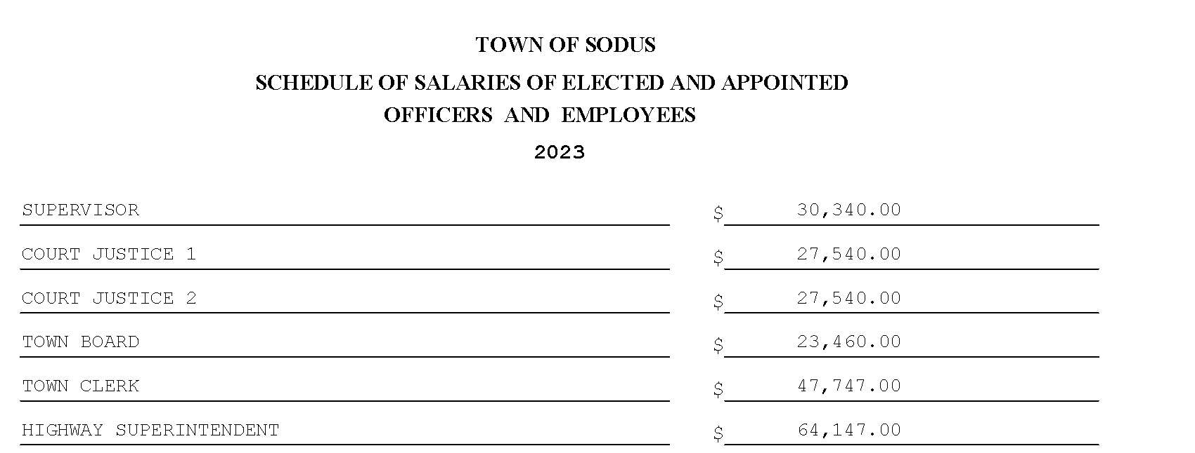
The Sodus Town Board will then meet; immediately following the Public Hearing, to review and propose adoption of the 2023 Town of Sodus Preliminary Budget to the 2023 Town of Sodus Adopted Budget.

All meetings are open to the public.

Date: October 6, 2022
By Order of the Sodus Town Board,
Lori Diver
Sodus Town Clerk, RMC

Supervisor Scott Johnson asks for public comments:
________________________________________________________________________________________________________________________________________________________________________________________

- Motion to close Public Hearing
First_________________ Seconded____________________ Time____________________

- Resolution adopting the 2023 Preliminary Budget into the 2023 Adopted Budget with the listed amendments in the resolution. The amended budget will appropriate the use of the following Fund Balances, and also allow the Budget Officer to make the transfers.
First_________________ Seconded____________________
Agenda:

- Discussion on letter regarding the Town Court records and docket are available to be presented for examination and audit. A date needs to be set with the Court for the audit and reported back to the Town Board once complete (emailed.)

- Resolution authorizing payment of Abstract # 18-2022 for payment.
First_________________ Seconded____________________ (emailed).

- Resolution adopting and authorizing Supervisor Scott Johnson to sign the 2023 Snow and Ice Contract with Wayne County (emailed).
First_________________ Seconded____________________

- Motion allowing Lori Diver Sodus Town Clerk to advertise for a public hearing and to hold the hearing on Tuesday November 29, 2022 at 4:00 PM for Local Law No. 3-2022 to reduce the number of Planning Board Members in the Town of Sodus (emailed).
First_________________ Seconded____________________

- Motion allowing Supervisor Scott Johnson, Supervisor Clerk Bree Crandell and Town Clerk Lori Diver to travel and attend the 2023 Annual Meeting Association of Towns & Training School February 18, 2023 to February 22, 2023 (emailed).
First_________________ Seconded____________________

- Resolution authorizing adoption and authorizing Supervisor Scott Johnson to sign Agreement to Exempt Referral of Certain Local Applications from Wayne County Planning Board (emailed).
First_________________ Seconded____________________

- Resolution adopting and authorizing Supervisor Scott Johnson to sign the 2023 Village of Sodus Rental Agreement (emailed)
First_________________ Seconded____________________

- Motion allowing Lori Diver Sodus Town Clerk to advertise for a public hearing and to hold the hearing on Tuesday November 29, 2022 at 4:15 PM for Local Law No. 4-2022 to Rescind Local Law 2-2022 of the Year 2022; Relating to the Override of the Tax Levy Limit for Fiscal Year 2023 Pursuant to General Municipal Law section 3-c (emailed).
First_________________ Seconded____________________

- Resolution adopting and creating Highway Equipment Capital Reserve Fund to finance the cost of acquisition of highway equipment. This resolution is subject to a 30 day permissive referendum and will be published in the Town of Sodus legal paper and on the Town of Sodus website (emailed).
First_________________ Seconded____________________

- Resolution to adopt a fund balance transfer from the Highway DA fund to the A fund for $275,000.00 (emailed).
First_________________ Seconded____________________

- Resolution adopting and authorizing the Town Board of the Town of Sodus to establish a Reserve Fund to deposit and separately account for dog licensing fees, penalties and fines, as well other animal control fees, penalties and fines, and to pay from those funds costs incurred for animal control (emailed).
First_________________ Seconded____________________

- Resolution adopting and authorizing Sodus Town Supervisor to sign the Agreement Regarding Maintenance of Preemption Road between the Town of Sodus, Town of Huron and Town of Rose (emailed).
First_________________ Seconded____________________

- Motion to enter into Executive Session regarding a personnel issue with a particular person.
First_________________ Seconded____________________ Time____________________

- Motion to exit out of Executive Session and enter into Regular Session.
First_________________ Seconded____________________ Time____________________

- Motion to adjourn meeting
First_________________ Seconded____________________

MINUTES
Minutes of the Month End Town Board Meeting commencing at 4:30 PM in the downstairs fireman’s room October 27, 2022 located at 14-16 Mill St. Sodus, NY 14551.
All meetings are open to the public.
In addition this meeting was available through Zoom. Legal Notices were published and posted accordingly.

Present: Scott Johnson, Supervisor (Zoom)
David LeRoy, Councilperson/Deputy Supervisor Don Ross, Councilperson
Chris Tertinek, Councilperson
Cathy Willmott, Councilperson

Recording Secretary: Lori Diver Sodus Town Clerk

Absent: N/A

Others Present: Lori Diver, Sodus Town Clerk
Bree Crandell- Supervisor Clerk
Amy Kendall, Town Attorney (Zoom)
Dale Pickering, (Zoom)
Casey Carpenter, Times of Wayne County (Zoom)

Deputy Supervisor David LeRoy called the Month End Town Board Meeting to order commencing at 4:30 PM and Lori Diver opened with roll call. All Board Members were present.

Public Hearing Local Law No. 2- 2022 4:35 PM:
Councilperson Cathy Willmott motioned to enter into the public hearing was seconded by Councilperson Don Ross. Upon roll call the following votes were heard, Scott Johnson, abstained; David LeRoy, aye; Don Ross, aye; Chris Tertinek, aye, Cathy Willmott; aye, Motion carried. Time 4:35 PM

Lori Diver read the following legal notice:
LEGAL NOTICE
TOWN OF SODUS
NOTICE OF PUBLIC HEARING
LOCAL LAW NO #2 - 2022

PLEASE TAKE NOTICE that a public hearing will be held by the Town Board of the Town of Sodus on the 27th day of October, 2022 at 4:35 p.m. in the upstairs meeting room at the Sodus Town Hall, 14-16 Mill Street, Sodus, New York to hear and consider comments from the public in regard to Local Law No.2 of 2022:

Local Law No. 2 – 2022 Authorizes the Town Board of the Town of Sodus
to adopt a budget for the fiscal year 2023 that requires a real property tax levy in excess
of the limit specified in General Municipal Law, §3-c.

Copies of the entire Local Law No.2- 2022 are available for review at the Town Clerks Office during regular business hours and located on the Town of Sodus website: www.townofsodus.net , under the MORE tab, then select LEGALS/RESOLUTIONS-LOCAL LAWS/AGENDA tab.

BY ORDER OF THE TOWN BOARD
OF THE TOWN OF SODUS

Lori K. Diver
Sodus Town Clerk, RMC
Dated: October 6, 2022

Deputy Supervisor David LeRoy asked for any public comments, hearing none LeRoy asked for a motion to close the public hearing.

Councilperson Cathy Willmott motioned to close the public hearing was seconded by Councilperson Don Ross. Upon roll call the following votes were heard, Scott Johnson, abstained; David LeRoy, aye; Don Ross, aye; Chris Tertinek, aye, Cathy Willmott; aye, Motion carried. Time 4:36 PM

Deputy Supervisor David LeRoy offered the following Local Law 2-2022 and resolution for its adoption, and
TAX CAP OVERRIDE
RESOLUTION
(02 10-2022)

TOWN OF SODUS
LOCAL LAW
TAX CAP OVERRIDE FOR 2023 BUDGET

Local Law Filing New York State Department of State
41 State Street, Albany, NY 12231

Town of Sodus
County of Wayne

Local Law No. 2 of the year 2022

A Local Law to override the tax levy limit established in General Municipal Law § 3-c

Be it enacted by the Town Board of the Town of Sodus, in the County of Wayne, as follows:

SECTION 1: LEGISLATIVE INTENT

It is the intent of this local law to override the limit on the amount of real property taxes that may be levied by the Town of Sodus, County of Wayne pursuant to General Municipal Law
§ 3-c, and to allow the Town of Sodus, County of Wayne to adopt a town budget for (a) town purposes (b) fire protection districts and (c) any other special or improvement district governed by the town board for the fiscal year 2023 that requires a real property tax levy in excess of the “tax levy limit” as defined by General Municipal Law § 3-c.

The Town of Sodus is concerned about uncertainties in the existing tax cap law, including how uncertain expenditures mandated by law and uncertain expenditures and revenues controlled by the county and the state interact with the tax cap. The town board is obligated to prepare a responsible budget, which meets the Town’s mandated obligations and provides beneficial services, while minimizing the tax burden on Town citizens.

SECTION 2: AUTHORITY

This local law is adopted pursuant to subdivision 5 of General Municipal Law § 3-c, which expressly authorizes the town board to override the tax levy limit by the adoption of a local law approved by a vote of sixty percent (60%) of the town board.

Local Law Filing New York State Department of State
41 State Street, Albany, NY 12231

SECTION 3: TAX LEVY LIMIT OVERRIDE

The Town Board of the Town of Sodus, County of Wayne is hereby authorized to adopt a budget for the fiscal year 2023 that requires a real property tax levy in excess of the linnet specified in General Municipal Law § 3-c.

SECTION 4: SEVERABILITY

If any clause, sentence, paragraph, subdivision, or part of this Local Law or the application thereof to any person, firm or corporation, or circumstance, shall be adjusted by any court of competent jurisdiction to be invalid or unconstitutional; such order or judgment shall not affect, impair, or invalidate the remainder thereof, but shall be confined in its operation to the clause, sentence, paragraph, subdivision, or part of this Local Law or in its application to the person, individual, firm or corporation or circumstance, directly involved in the controversy in which such judgment or order shall be rendered.

Motion by Councilperson Don Ross to adopt this resolution into local law 2-2022 was seconded by Councilperson Chris Tertinek. Upon roll call the following votes were heard, Scott Johnson, abstain; David LeRoy, aye; Don Ross, aye; Chris Tertinek, aye, Cathy Willmott; aye, Resolution Adopted.

SECTION 5: EFFECTIVE DATE

This local law shall take effect immediately upon filing with the Secretary of State.

Motion by Councilperson Don Ross to adopt this resolution was seconded by Councilperson Chris Tertinek. Upon roll call the following votes were heard, Scott Johnson, abstained; David LeRoy, aye; Don Ross, aye; Chris Tertinek, aye, Cathy Willmott; aye, Resolution Adopted.

Public Hearing 2023 Fire Contracts 4:40 PM:
Councilperson Cathy Willmott motioned to enter into the public hearing for the Village of Sodus Fire Department was seconded by Councilperson Don Ross. Upon roll call the following votes were heard, Scott Johnson, abstained; David LeRoy, aye; Don Ross, aye; Chris Tertinek, aye, Cathy Willmott; aye, Motion carried. Time 4:40 PM

Lori Diver read the following legal notice:

TOWN OF SODUS
LEGAL NOTICE

PUBLIC HEARING FOR:
“2023 FIRE CONTRACTS”

NOTICE IS HEREBY GIVEN, that the preliminary budget for the Town of Sodus , New York, for the fiscal year beginning January 1, 2023 has been completed and filed in the office of the Town Clerk of the Town of Sodus, and

FURTHER NOTICE, the 2023 Town of Sodus fire contracts are available for inspection by any interested person at all reasonable hours; and

FURTHER NOTICE, is hereby given that the Town Board of the Town of Sodus will meet to review said fire protection amounts for the fire districts and fire departments and hold a Public Hearing on Thursday October 27, 2022 starting at 4:40 p.m., and

FURTHER NOTICE, the public hearing for the Village of Sodus Fire Department will be held at 4:40 p.m., Sodus Center Fire District 4:45 p.m., the Wallington Fire District 4:50 p.m., the Alton Fire District 4:55 p.m., and the Village of Sodus Point Fire Department will be at 5:00 p.m. in the upstairs meeting room, 14-16 Mill Street, Sodus, NY 14551, at which time and place any persons may be heard in favor or against any items therein contained; and

WHEREAS, the proposed allocated amounts for the fire protection line are hereby specified as follows:
Village of Sodus Fire Dept. $39,000.00
Sodus Center Fire District $19,000.00
Wallington Fire District $49,100.00
Alton Fire District $45,100.00
Village of Sodus Point Fire Dept. $42,100.00

NOW BE IT RESOLVED, the Sodus Town Board will then adjourn from the public hearing and enter into its regular session to review and propose adoption of the 2023 fire protection amounts and contracts for adoption, and

FURTHER BE IT RESOLVED, the Sodus Town Board authorizes Supervisor Scott Johnson to sign all five fire contracts in the Town of Sodus.

All meetings are open to the public.

Date: October 6, 2022
By Order of the Sodus Town Board,
Lori Diver
Sodus Town Clerk, RMC

- Village of Sodus Public Hearing 4:40 PM
- Sodus Center Public Hearing 4:45 PM
- Wallington Fire District Public Hearing 4:50 PM
- Alton Fire District Public Hearing 4:55 PM
- Village of Sodus Point Fire Dept. 5:00 PM

TOWN OF SODUS
FIRE CONTRACT AGREEMENT-Village of Sodus Fire Department
Made this 1st day of January 2023 between the Town of Sodus; a municipal corporation in Wayne County, New York, hereinafter called “Town” and the Village of Sodus a municipal corporation in the Town of Sodus, Wayne County, New York; hereinafter called “Village of Sodus Fire Rural Protection”.
WHEREAS, there has heretofore been duly established in the Town of Sodus,
Wayne County, New York, a fire protection known as the Village of Sodus Fire Protection, hereinafter called “Rural Fire Protection”, embracing all of the territory of the Town of Sodus not included within the limits of the Village of Sodus
Point, the Village of Sodus, Sodus Center Fire District, Alton Fire District, Wallington
Fire District; and
WHEREAS, the Village of Sodus has established and maintained at an expense, a duly organized volunteer fire department; and
WHEREAS, the Town, after public hearing held in pursuant to Article II of the
Town Law has duly authorized a contract with the Village of Sodus for fire protection to the aforesaid Fire Protection upon the terms and conditions herein set forth.
NOW, THEREFORE, the Town does hereby engage the Village of Sodus to furnish fire protection to the Rural Fire Protection Areas and agrees to furnish such fire protection in accordance with the following terms and conditions:

FIRST: The Fire Department of the Village of Sodus Fire Department shall at all times during the period of this agreement be subject to call for attendance upon any fire occurring in the Fire Protection Area, and when notified by alarm or telephone call for any person within the Fire Protection Area of a fire within the Fire Protection Area, such department shall respond and attend upon the fire without delay with one or more companies and with suitable ladder, pumping and hose apparatus of the Rural Area. Upon arriving at the scene of the fire, the firemen of the Village of Sodus attending shall proceed diligently and in every way reasonably suggested to the extinguishment of the fire, and the saving of life and property in connection therewith.
SECOND: the Town shall pay to the Village of Sodus Fire Department for such fire protection the sum of $ 39,000.00 for the year 2023. The aforesaid payments shall by due and payable in full on the first day of March of each year during the term of this contract.
THIRD: The parties hereby mutually covenant and agree that any loss or damage
to, or expense incurred in the operation of fire apparatus or other equipment of the Rural Area answering a call for service under and pursuant to the provisions of this agreement in the territory of the Fire Protection Area, notwithstanding any of the provisions of Section Two Hundred Nine of the General Municipal Law of the State of New York, it being the intention and understanding of the parties that the expressed consideration for the services agreed to be rendered by the Village of Sodus Rural Fire Protection contemplates and comprehends the risks, hazards and costs of such loss or damage and materials.
FOURTH: The District hereby covenants and agrees to indemnify and save
harmless the Town and the Rural Fire Protection Area or Any District against any and all claims authorized by law for medical expenses, loss of wages, compensation, benefits or other claims arising by reason of the injury or death of a fireman, or of a member of a fire department, emergency relief squad, a fire police squad, or a fire patrol, sustained while answering, attending upon or returning from any call for services under and pursuant to the provisions in this agreement.
FIFTH: All moneys agreed to be paid to the Village of Sodus Fire Department hereunder shall be a charge upon the Fire Protection Area and shall be assessed and levied upon the taxable property in said Fire Protection Area and collected in the same manner, at the same time and by the same officers as are the taxes of said Town of Sodus assessed, levied and collected and, when collected, shall be paid to the Supervisor of the said Town of Sodus, to be by him paid to the Fire Protection Area as herein provided.
SIXTH: Members of the fire department of the Village of Sodus while engaged in the performance of their duties in answering, attending upon or returning from any call provided for by this contract shall have the same rights, privileges and immunities as if performing the same in Town of Sodus Fire Districts and Rural Fire Protection Areas, Wayne County, New York.
SEVENTH: This agreement shall continue for a period of one (1) year and shall end on December 31, 2023, providing, however, that this agreement shall be subject to cancellation by either party on delivery of written notice to that effect to the other party, which cancellation shall be effective on the 1st day of the year which shall begin no more than nine (9) months after such notice is delivered.

EIGHT: The parties hereby mutually covenant and agree that notwithstanding the execution simultaneously herewith of similar agreements with other fire districts within the Town of Sodus, Wayne County, New York, nothing in said agreement contained nor
any modification thereof nor an terms thereof, either singly or collectively shall be deemed to affect in any way the rights or obligations of either of the parties in this agreement.
NINTH: It is mutually understood, covenanted and agreed that the Chief or other executive officer of the Fire Department of the Village of Sodus be and hereby is authorized, acting in concert with Chiefs or other executive officers of the Fire Departments of the Rural Fire Areas embraced in the said Town of Sodus, to make such rules and regulations for the rendering of the services hereby contracted for as shall be consistent with the spirit and letter of this agreement, the provisions of law and the interest of public safety generally.
IN WITNESS WHEREOF, the parties have executed this agreement and have caused their respective hands and seals hereunto to be set as of the day and year first above written

Deputy Supervisor David LeRoy asked for any public comments on the Village of Sodus Fire Department public hearing, hearing none LeRoy asked for a motion to close the public hearing.

Councilperson Don Ross motioned to close the public hearing for the Village of Sodus Fire Department was seconded by Councilperson Chris Tertinek. Upon roll call the following votes were heard, Scott Johnson, abstained; David LeRoy, aye; Don Ross, aye; Chris Tertinek, aye, Cathy Willmott; aye, Motion carried. Time 4:44 PM

Councilperson Cathy Willmott motioned to enter into the public hearing for the Sodus Center Fire Department was seconded by Councilperson Don Ross. Upon roll call the following votes were heard, Scott Johnson, abstained; David LeRoy, aye; Don Ross, aye; Chris Tertinek, aye, Cathy Willmott; aye, Motion carried. Time 4:45 PM

TOWN OF SODUS
FIRE CONTRACT AGREEMENT-Sodus Center Fire Department
Made this 1st day of January 2023, between the Town of Sodus, a municipal
corporation in Wayne County, New York, hereinafter called “Town” and the Sodus Center Fire District, a municipal corporation in the Town of Sodus, Wayne County, New York, hereinafter called “District”.
WHEREAS, there has heretofore been duly established in the Town of Sodus,
Wayne County, New York, a fire protection district known as the Town of Sodus Fire Protection District No. 2, hereinafter called “Fire Protection District”, embracing all of
the territory of the Town of Sodus not included within the limits of the Village of Sodus
Point, the Village of Sodus, Sodus Center Fire District, Alton Fire District, Wallington
Fire District; and
WHEREAS, the District has established and maintained at District expense, a
duly organized volunteer fire department; and
WHEREAS, the Town, after public hearing held in pursuant to Article II of the
Town Law, has duly authorized a contract with the District for fire protection to the
aforesaid Fire Protection District upon the terms and conditions herein set forth.
NOW, THEREFORE, the Town does hereby engage the District to furnish fire
protection to the Fire Protection District and the District agrees to furnish such fire protection in accordance with the following terms and conditions:

FIRST: The Fire Department of the District shall at all times during the period of this agreement be subject to call for attendance upon any fire occurring in the Fire
Protection District, and when notified by alarm or telephone call for any person within
the Fire Protection District of a fire within the Fire Protection District, such department shall respond and attend upon the fire without delay with one or more companies and with suitable ladder, pumping and hose apparatus of the District. Upon arriving at the scene of the fire, the firemen of the District attending shall proceed diligently and in every way reasonably suggested to the extinguishment of the fire, and the saving of life and property in connection therewith.
SECOND: the Town shall pay to the District for such fire protection the sum of $ 19,000.00 for the year 2023. The aforesaid payments shall by due and payable in full on the first day of March of each year during the term of this contract.
THIRD: The parties hereby mutually covenant and agree that any loss or damage
to, or expense incurred in the operation of fire apparatus or other equipment of the District answering a call for service under and pursuant to the provisions of this agreement in the territory of the Fire Protection District, notwithstanding any of the provisions of Section Two Hundred Nine of the General Municipal Law of the State of New York, it being the intention and understanding of the parties that the expressed
consideration for the services agreed to be rendered by the District contemplates and
comprehends the risks, hazards and costs of such loss or damage and materials.
FOURTH: The District hereby covenants and agrees to indemnify and save
harmless the Town and the Fire Protection District against any and all claims authorized by law for medical expenses, loss of wages, compensation, benefits or other claims arising by reason of the injury or death of a fireman, or of a member of a fire department, emergency relief squad, a fire police squad, or a fire patrol, sustained while answering, attending upon or returning from any call for services under and pursuant to the provisions in this agreement.
FIFTH: All moneys agreed to be paid to the District hereunder shall be a charge
upon the Fire Protection District and shall be assessed and levied upon the taxable property in said Fire Protection District and collected in the same manner, at the same
time and by the same officers as are the taxes of said Town of Sodus assessed, levied and collected and, when collected, shall be paid to the Supervisor of the said Town of Sodus, to be by him paid to the District as herein provided.
SIXTH: Members of the fire department of the Sodus Center Fire District while engaged in the performance of their duties in answering, attending upon or returning from any call provided for by this contract shall have the same rights, privileges and immunities as if performing the same in any Fire District or Rural Fire Protection Area, Wayne County, New York.
SEVENTH: This agreement shall continue for a period of one (1) year and shall end on December 31, 2023, providing, however, that this agreement shall be subject to cancellation by either party on delivery of written notice to that effect to the other party, which cancellation shall be effective on the 1st day of the year which shall begin no more than nine (9) months after such notice is delivered.

EIGHT: The parties hereby mutually covenant and agree that notwithstanding the execution simultaneously herewith of similar agreements with other fire districts within the Town of Sodus, Wayne County, New York, nothing in said agreement contained nor
any modification thereof nor an terms thereof, either singly or collectively shall be deemed to affect in any way the rights or obligations of either of the parties in this agreement.
NINTH: It is mutually understood, covenanted and agreed that the Chief or other executive officer of the Fire Department of the District be and hereby is authorized, acting in concert with Chiefs or other executive officers of the Fire Departments of the Fire Districts embraced in the said Town of Sodus, to make such rules and regulations for the rendering of the services hereby contracted for as shall be consistent with the spirit and letter of this agreement, the provisions of law and the interest of public safety generally.
IN WITNESS WHEREOF, the parties have executed this agreement and have caused their respective hands and seals hereunto to be set as of the day and year first above written.
Deputy Supervisor David LeRoy asked for any public comments on the Sodus Center Fire District public hearing, hearing none LeRoy asked for a motion to close the public hearing.

Councilperson Don Ross motioned to close the public hearing for the Sodus Center Fire District was seconded by Councilperson Chris Tertinek. Upon roll call the following votes were heard, Scott Johnson, abstained; David LeRoy, aye; Don Ross, aye; Chris Tertinek, aye, Cathy Willmott; aye, Motion carried. Time 4:50 PM

Councilperson Don Ross motioned to enter into the public hearing for the Wallington Fire District was seconded by Councilperson Chris Tertinek. Upon roll call the following votes were heard, Scott Johnson, abstained; David LeRoy, aye; Don Ross, aye; Chris Tertinek, aye, Cathy Willmott; aye, Motion carried. Time 4:52 PM

TOWN OF SODUS
FIRE CONTRACT AGREEMENT-Wallington Fire District
Made this 1st day of January 2023, between the Town of Sodus, a municipal
corporation in Wayne County, New York, hereinafter called “Town” and the Wallington
Fire District, a municipal corporation in the Town of Sodus, Wayne County, New York,
hereinafter called “District”.
WHEREAS, there has heretofore been duly established in the Town of Sodus,
Wayne County, New York, a fire protection district known as the Town of Sodus Fire Protection District No. 3, hereinafter called “Fire Protection District”, embracing all of
the territory of the Town of Sodus not included within the limits of the Village of Sodus
Point, the Village of Sodus, Sodus Center Fire District, Alton Fire District, Wallington
Fire District; and
WHEREAS, the District has established and maintained at District expense, a
duly organized volunteer fire department; and
WHEREAS, the Town, after public hearing held in pursuant to Article II of the
Town Law, has duly authorized a contract with the District for fire protection to the
aforesaid Fire Protection District upon the terms and conditions herein set forth.
NOW, THEREFORE, the Town does hereby engage the District to furnish fire
protection to the Fire Protection District and the District agrees to furnish such fire protection in accordance with the following terms and conditions:

FIRST: The Fire Department of the District shall at all times during the period of this agreement be subject to call for attendance upon any fire occurring in the Fire
Protection District, and when notified by alarm or telephone call for any person within
the Fire Protection District of a fire within the Fire Protection District, such department shall respond and attend upon the fire without delay with one or more companies and with suitable ladder, pumping and hose apparatus of the District. Upon arriving at the scene of the fire, the firemen of the District attending shall proceed diligently and in every way reasonably suggested to the extinguishment of the fire, and the saving of life and property in connection therewith.
SECOND: the Town shall pay to the District for such fire protection the sum of $ 49,100.00 for the year 2023. The aforesaid payments shall by due and payable in full on the first day of March of each year during the term of this contract.
THIRD: The parties hereby mutually covenant and agree that any loss or damage
to, or expense incurred in the operation of fire apparatus or other equipment of the District answering a call for service under and pursuant to the provisions of this agreement in the territory of the Fire Protection District, notwithstanding any of the provisions of Section Two Hundred Nine of the General Municipal Law of the State of New York, it being the intention and understanding of the parties that the expressed
consideration for the services agreed to be rendered by the District contemplates and
comprehends the risks, hazards and costs of such loss or damage and materials.
FOURTH: The District hereby covenants and agrees to indemnify and save
harmless the Town and the Fire Protection District against any and all claims authorized by law for medical expenses, loss of wages, compensation, benefits or other claims arising by reason of the injury or death of a fireman, or of a member of a fire department, emergency relief squad, a fire police squad, or a fire patrol, sustained while answering, attending upon or returning from any call for services under and pursuant to the provisions in this agreement.
FIFTH: All moneys agreed to be paid to the District hereunder shall be a charge
upon the Fire Protection District and shall be assessed and levied upon the taxable property in said Fire Protection District and collected in the same manner, at the same
time and by the same officers as are the taxes of said Town of Sodus assessed, levied and collected and, when collected, shall be paid to the Supervisor of the said Town of Sodus, to be by him paid to the District as herein provided.
SIXTH: Members of the fire department of the Wallington Fire District while engaged in the performance of their duties in answering, attending upon or returning from any call provided for by this contract shall have the same rights, privileges and immunities as if performing the same in any Fire District or any Rural Fire Protection Area Wayne County, New York.
SEVENTH: This agreement shall continue for a period of one (1) year and shall end on December 31, 2023, providing, however, that this agreement shall be subject to cancellation by either party on delivery of written notice to that effect to the other party, which cancellation shall be effective on the 1st day of the year which shall begin no more than nine (9) months after such notice is delivered.
EIGHT: The parties hereby mutually covenant and agree that notwithstanding the execution simultaneously herewith of similar agreements with other fire districts within the Town of Sodus, Wayne County, New York, nothing in said agreement contained nor
any modification thereof nor an terms thereof, either singly or collectively shall be deemed to affect in any way the rights or obligations of either of the parties in this agreement.
NINTH: It is mutually understood, covenanted and agreed that the Chief or other executive officer of the Fire Department of the District be and hereby is authorized, acting in concert with Chiefs or other executive officers of the Fire Departments of the Fire Districts embraced in the said Town of Sodus, to make such rules and regulations for the rendering of the services hereby contracted for as shall be consistent with the spirit and letter of this agreement, the provisions of law and the interest of public safety generally.
IN WITNESS WHEREOF, the parties have executed this agreement and have caused their respective hands and seals hereunto to be set as of the day and year first above written.
Deputy Supervisor David LeRoy asked for any public comments on the Wallington Fire District public hearing, hearing none LeRoy asked for a motion to close the public hearing.

Councilperson Chris Tertinek motioned to close the public hearing for the Wallington Fire District was seconded by Councilperson Don Ross. Upon roll call the following votes were heard, Scott Johnson, abstained; David LeRoy, aye; Don Ross, aye; Chris Tertinek, aye, Cathy Willmott; aye, Motion carried. Time 4:55 PM

Councilperson Chris Tertinek motioned to enter into the public hearing for the Alton Fire District was seconded by Councilperson Don Ross. Upon roll call the following votes were heard, Scott Johnson, abstained; David LeRoy, aye; Don Ross, aye; Chris Tertinek, aye, Cathy Willmott; aye, Motion carried. Time 4:56 PM

TOWN OF SODUS
FIRE CONTRACT AGREEMENT-Alton Fire District
Made this 1st day of January 2023, between the Town of Sodus, a municipal
corporation in Wayne County, New York, hereinafter called “Town” and the Alton
Fire District, a municipal corporation in the Town of Sodus, Wayne County, New York,
hereinafter called “District”.
WHEREAS, there has heretofore been duly established in the Town of Sodus,
Wayne County, New York, a fire protection district known as the Town of Sodus Fire Protection District No. 1, hereinafter called “Fire Protection District”, embracing all of
the territory of the Town of Sodus not included within the limits of the Village of Sodus
Point, the Village of Sodus, Sodus Center Fire District, Alton Fire District, Wallington
Fire District; and
WHEREAS, the District has established and maintained at District expense, a
duly organized volunteer fire department; and
WHEREAS, the Town, after public hearing held in pursuant to Article II of the
Town Law, has duly authorized a contract with the District for fire protection to the
aforesaid Fire Protection District upon the terms and conditions herein set forth.
NOW, THEREFORE, the Town does hereby engage the District to furnish fire
protection to the Fire Protection District and the District agrees to furnish such fire protection in accordance with the following terms and conditions:
FIRST: The Fire Department of the District shall at all times during the period of this agreement be subject to call for attendance upon any fire occurring in the Fire
Protection District, and when notified by alarm or telephone call for any person within
the Fire Protection District of a fire within the Fire Protection District, such department shall respond and attend upon the fire without delay with one or more companies and with suitable ladder, pumping and hose apparatus of the District. Upon arriving at the scene of the fire, the firemen of the District attending shall precede diligently and in every way reasonably suggested to the extinguishment of the fire and the saving of life and property in connection therewith which include; water and ice rescue on Sodus Bay.

SECOND: the Town shall pay to the District for such fire protection the sum of $ 45,100.00 for the year 2023. The aforesaid payments shall by due and payable in full on the first day of March of each year during the term of this contract.
THIRD: The parties hereby mutually covenant and agree that any loss or damage
to, or expense incurred in the operation of fire apparatus or other equipment of the District answering a call for service under and pursuant to the provisions of this agreement in the territory of the Fire Protection District, notwithstanding any of the provisions of Section Two Hundred Nine of the General Municipal Law of the State of New York, it being the intention and understanding of the parties that the expressed
consideration for the services agreed to be rendered by the District contemplates and
comprehends the risks, hazards and costs of such loss or damage and materials.
FOURTH: The District hereby covenants and agrees to indemnify and save
harmless the Town and the Fire Protection District against any and all claims authorized by law for medical expenses, loss of wages, compensation, benefits or other claims arising by reason of the injury or death of a fireman, or of a member of a fire department, emergency relief squad, a fire police squad, or a fire patrol, sustained while answering, attending upon or returning from any call for services under and pursuant to the provisions in this agreement.
FIFTH: All moneys agreed to be paid to the District hereunder shall be a charge
upon the Fire Protection District and shall be assessed and levied upon the taxable property in said Fire Protection District and collected in the same manner, at the same
time and by the same officers as are the taxes of said Town of Sodus assessed, levied and collected and, when collected, shall be paid to the Supervisor of the said Town of Sodus, to be by him paid to the District as herein provided.
SIXTH: Members of the fire department of the Alton Fire District while engaged in the performance of their duties in answering, attending upon or returning from any call provided for by this contract shall have the same rights, privileges and immunities as if performing the same in any Fire District or Rural Fire Protection Area, Wayne County, New York.
SEVENTH: This agreement shall continue for a period of one (1) year and shall end on December 31, 2023, providing, however, that this agreement shall be subject to cancellation by either party on delivery of written notice to that effect to the other party, which cancellation shall be effective on the 1st day of the year which shall begin no more than nine (9) months after such notice is delivered.
EIGHT: The parties hereby mutually covenant and agree that notwithstanding the execution simultaneously herewith of similar agreements with other fire districts within the Town of Sodus, Wayne County, New York, nothing in said agreement contained nor
any modification thereof nor an terms thereof, either singly or collectively shall be deemed to affect in any way the rights or obligations of either of the parties in this agreement.
NINTH: It is mutually understood, covenanted and agreed that the Chief or other executive officer of the Fire Department of the District be and hereby is authorized, acting in concert with Chiefs or other executive officers of the Fire Departments of the Fire Districts embraced in the said Town of Sodus, to make such rules and regulations for the rendering of the services hereby contracted for as shall be consistent with the spirit and letter of this agreement, the provisions of law and the interest of public safety generally.
IN WITNESS WHEREOF, the parties have executed this agreement and have caused their respective hands and seals hereunto to be set as of the day and year first above written.
Deputy Supervisor David LeRoy asked for any public comments on the Alton Fire District public hearing, hearing none LeRoy asked for a motion to close the public hearing.

Councilperson Cathy Willmott motioned to close the public hearing for the Alton Fire District was seconded by Councilperson Don Ross. Upon roll call the following votes were heard, Scott Johnson, abstained; David LeRoy, aye; Don Ross, aye; Chris Tertinek, aye, Cathy Willmott; aye, Motion carried. Time 5:02 PM

Councilperson Chris Tertinek motioned to enter into the public hearing for the Village of Sodus Point Fire Department was seconded by Councilperson Don Ross. Upon roll call the following votes were heard, Scott Johnson, abstained; David LeRoy, aye; Don Ross, aye; Chris Tertinek, aye, Cathy Willmott; aye, Motion carried. Time 5:02 PM

TOWN OF SODUS
FIRE CONTRACT AGREEMENT-Village of Sodus Point
Made this 1st day of January 2023 between the Town of Sodus; a municipal corporation in Wayne County, New York, hereinafter called “Town” and the Village of Sodus Point a municipal corporation in the Town of Sodus, Wayne County, New York; hereinafter called “Village of Sodus Point Fire Rural Protection”.
WHEREAS, there has heretofore been duly established in the Town of Sodus,
Wayne County, New York, a fire protection known as the Village of Sodus Point Fire Protection, hereinafter called “Rural Fire Protection”, embracing all of the territory of the Town of Sodus not included within the limits of the Village of Sodus
Point, the Village of Sodus, Sodus Center Fire District, Alton Fire District, Wallington
Fire District; and
WHEREAS, the Village of Sodus Point has established and maintained at an expense, a duly organized volunteer fire department; and
WHEREAS, the Town, after public hearing held in pursuant to Article II of the
Town Law has duly authorized a contract with the Village of Sodus Point for fire protection to the aforesaid Fire Protection upon the terms and conditions herein set forth.
NOW, THEREFORE, the Town does hereby engage the Village of Sodus Point to furnish fire protection to the Rural Fire Protection Areas and agrees to furnish such fire protection in accordance with the following terms and conditions:
FIRST: The Fire Department of the Village of Sodus Point Fire Department shall at all times during the period of this agreement be subject to call for attendance upon any fire occurring in the Fire Protection Area, and when notified by alarm or telephone call for any person within the Fire Protection Area of a fire within the Fire Protection Area, such department shall respond and attend upon the fire without delay with one or more companies and with suitable ladder, pumping and hose apparatus of the Rural Area. Upon arriving at the scene of the fire, the firemen of the Village of Sodus Point attending shall proceed diligently and in every way reasonably suggested to the extinguishment of the fire, and the saving of life and property in connection therewith.
SECOND: the Town shall pay to the Village of Sodus Point Fire Department for such fire protection the sum of $ 42,100.00 for the year 2023. The aforesaid payments shall by due and payable in full on the first day of March of each year during the term of this contract.
THIRD: The parties hereby mutually covenant and agree that any loss or damage
to, or expense incurred in the operation of fire apparatus or other equipment of the Rural Area answering a call for service under and pursuant to the provisions of this agreement in the territory of the Fire Protection Area, notwithstanding any of the provisions of Section Two Hundred Nine of the General Municipal Law of the State of New York, it being the intention and understanding of the parties that the expressed consideration for the services agreed to be rendered by the Village of Sodus Point Rural Fire Protection contemplates and comprehends the risks, hazards and costs of such loss or damage and materials.
FOURTH: The District hereby covenants and agrees to indemnify and save
harmless the Town and the Rural Fire Protection Area or Any District against any and all claims authorized by law for medical expenses, loss of wages, compensation, benefits or other claims arising by reason of the injury or death of a fireman, or of a member of a fire department, emergency relief squad, a fire police squad, or a fire patrol, sustained while answering, attending upon or returning from any call for services under and pursuant to the provisions in this agreement.
FIFTH: All moneys agreed to be paid to the Village of Sodus Point Fire Department hereunder shall be a charge upon the Fire Protection Area and shall be assessed and levied upon the taxable property in said Fire Protection Area and collected in the same manner, at the same time and by the same officers as are the taxes of said Town of Sodus assessed, levied and collected and, when collected, shall be paid to the Supervisor of the said Town of Sodus, to be by him paid to the Fire Protection Area as herein provided.
SIXTH: Members of the fire department of the Village of Sodus Point while engaged in the performance of their duties in answering, attending upon or returning from any call provided for by this contract shall have the same rights, privileges and immunities as if performing the same in Town of Sodus Fire Districts and Rural Fire Protection Areas, Wayne County, New York.
SEVENTH: This agreement shall continue for a period of one (1) year and shall end on December 31, 2023, providing, however, that this agreement shall be subject to cancellation by either party on delivery of written notice to that effect to the other party, which cancellation shall be effective on the 1st day of the year which shall begin no more than nine (9) months after such notice is delivered.
EIGHT: The parties hereby mutually covenant and agree that notwithstanding the execution simultaneously herewith of similar agreements with other fire districts within the Town of Sodus, Wayne County, New York, nothing in said agreement contained nor
any modification thereof nor an terms thereof, either singly or collectively shall be deemed to affect in any way the rights or obligations of either of the parties in this agreement.
NINTH: It is mutually understood, covenanted and agreed that the Chief or other executive officer of the Fire Department of the Village of Sodus Point be and hereby is authorized, acting in concert with Chiefs or other executive officers of the Fire Departments of the Rural Fire Areas embraced in the said Town of Sodus, to make such rules and regulations for the rendering of the services hereby contracted for as shall be consistent with the spirit and letter of this agreement, the provisions of law and the interest of public safety generally.
IN WITNESS WHEREOF, the parties have executed this agreement and have caused their respective hands and seals hereunto to be set as of the day and year first above written.
Deputy Supervisor David LeRoy asked for any public comments on the Village of Sodus Fire Department public hearing, hearing none LeRoy asked for a motion to close the public hearing.

Councilperson Chris Tertinek motioned to close the public hearing for the Village of Sodus Fire Department was seconded by Councilperson Cathy Willmott. Upon roll call the following votes were heard, Scott Johnson, abstained; David LeRoy, aye; Don Ross, aye; Chris Tertinek, aye, Cathy Willmott; aye, Motion carried. Time 5:05 PM

Councilperson Chris Tertinek motioned to close the public hearing for the Village of Sodus Fire Department was seconded by Councilperson Cathy Willmott. Upon roll call the following votes were heard, Scott Johnson, abstained; David LeRoy, aye; Don Ross, aye; Chris Tertinek, aye, Cathy Willmott; aye, Motion carried. Time 5:05 PM

FIRE CONTRACTS SIGNED
RESOLUTION
(03 10-2022)

NOW THEREFORE BE IT RESOLVED, a motion by Councilperson Don Ross to adopt and authorize Supervisor Scott Johnson to sign all five fire contracts was seconded by Councilperson Chris Tertinek. Upon roll call the following votes were heard, Scott Johnson, abstained; David LeRoy, aye; Don Ross, aye; Chris Tertinek, aye, Cathy Willmott; aye. Resolution Adopted.

Public Hearing “2023 Preliminary Budget” 5:05 PM:

Lori Diver read the following legal notice:
Councilperson Cathy Willmott motioned to enter into the public hearing for the 2023 Preliminary Budget for the Town of Sodus was seconded by Councilperson Don Ross. Upon roll call the following votes were heard, Scott Johnson, abstained; David LeRoy, aye; Don Ross, aye; Chris Tertinek, aye, Cathy Willmott; aye, Motion carried.
Time 5:06 PM

TOWN OF SODUS
LEGAL NOTICE

PUBLIC HEARING FOR:
“THE 2023 PRELIMINARY BUDGET”

NOTICE IS HEREBY GIVEN, that the Preliminary Budget for the Town of Sodus , New York, for the fiscal year beginning January 1, 2023 has been completed and filed in the office of the Town Clerk of the Town of Sodus where it is available for inspection by any interested person at all reasonable hours; and

FURTHER NOTICE, is hereby given that the Town Board of the Town of Sodus will meet to review said budget and hold a Public Hearing on Thursday October 27, 2022 at 5:05 p.m. in the upstairs meeting room, 14-16 Mill Street, Sodus, NY 14551, at which time and place any persons may be heard in favor or against any items therein contained; and

WHEREAS, pursuant to Town Law, the proposed salaries of the following officers are hereby specified as follows:
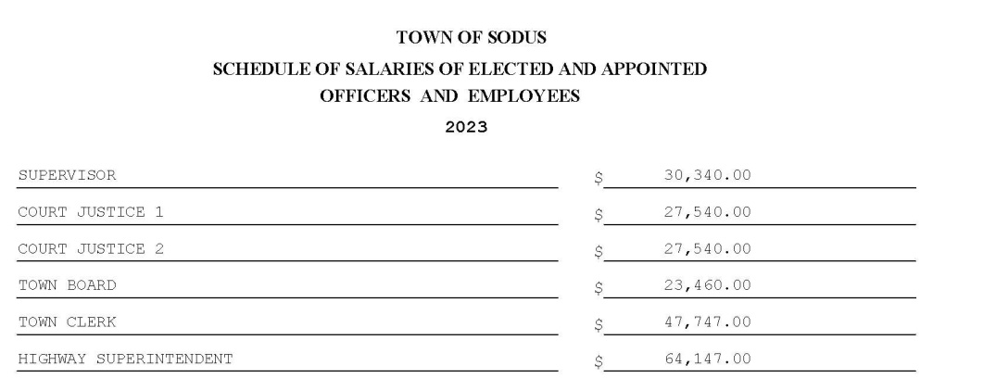
The Sodus Town Board will then meet; immediately following the Public Hearing, to review and propose adoption of the 2023 Town of Sodus Preliminary Budget to the 2023 Town of Sodus Adopted Budget.

All meetings are open to the public.

Date: October 6, 2022
By Order of the Sodus Town Board,
Lori Diver
Sodus Town Clerk, RMC
Councilperson Chris Tertinek motioned to close the public hearing for the 2023 Town of Sodus Preliminary Budget was seconded by Councilperson Cathy Willmott. Upon roll call the following votes were heard, Scott Johnson, abstained; David LeRoy, aye; Don Ross, aye; Chris Tertinek, aye, Cathy Willmott; aye, Motion carried. Time 5:09 PM

2023 TOWN OF SODUS BUDGET ADOPTION
RESOLUTION
(04 10-2022)
Deputy Supervisor David LeRoy offered the following resolution for its adoption,

WHEREAS, the Town Board of the Town of Sodus, County of Wayne, acknowledges that budget preparation meetings were held in September, 2022 to gather information in the preparation of the 2023 Budget; participants: Council Members, Town Supervisor, Department Heads, Budget Officer/Clerk to the Supervisor, Town Clerk, members of the Fire Department Community, along with Community Organizations along with others, and.

WHEREAS, at a public meeting of the Town Board on September 29, 2022 the Town Board Adopted the Tentative Budget making it the 2023 Preliminary Budget and available to the public, and.

WHEREAS, on October 27, 2022 at a public hearing of the board the following Preliminary Budget changes were proposed to the Town Board:

CURRENT PRELIMINARY | CHANGE | AMENDMENT
Regional Storage Tank Fund | Moved to Special District Fund named: SRT Special District regional Tank | $88,282.00
A5132.4 - $20,000.00 | A5132.4 – increased $10,000.00 | $30,000.00
SF1 – Revenue $39,000.00 | Revenue $10,000.00 | Revenue $45.000.00
SF3 - Revenue $49,100.00 | Revenue $20,000.00 | Revenue $69,100.00
SF5 – Revenue $42,100.00 | Revenue $10,000.00 | Revenue $52,100.00
Highway Fund -Outside Village (DB) Amount to be raised by taxes: $48,460.00 | Highway Fund – Outside Village (DB) Amount to be raised by Taxes increased: $53,540.00 | $102,000.00

RESOLVED, the Sodus Town Board motioned to adopt the 2023 Preliminary Budget into the 2023 Adopted Budget with the above amendments; and

BE IT FURTHER RESOLVED, the amended budget will appropriate the use of the following Fund Balances, and also allow the Budget Officer to make the transfers:

General | $22,284.00
General Fund – Outside Village | $12,709.00
Highway Fund – Townwide | $5,000.00
Highway Fund – Outside Village | $671,460 ($500,000.00 Capital Project – Salt Barn)

Councilperson Tertinek motioned to adopt this resolution was seconded by Councilperson Willmott. Upon roll call the following votes were heard, Scott Johnson, abstained; David LeRoy, aye; Don Ross aye; Chris Tertinek, aye; and Cathy Willmott, aye. Resolution Adopted.

Discussion was held on letter regarding the Town Court records and docket that are available to be presented for examination and audit. A date needs to be set with the court for the audit and reported back to the Town Board once complete. Councilperson Dave LeRoy shared he spoke with Michelle regarding doing the audit on behalf of the Town Board. He is just waiting on a date.

ABSTRACT
RESOLUTION TO PAY ABSTRACT No. 18
- 10-2022)
WHEREAS, the following bills were presented for payment on Abstract 18:

NOW BE IT RESOLVED, Councilperson Don Ross motioned to authorize payment for Abstract # 18 as listed and adopt this resolution which was seconded by Councilperson Cathy Willmott. Upon roll call the following votes were heard, Scott Johnson, abstain; David LeRoy, aye; Don Ross, aye; Chris Tertinek, aye; and Cathy Willmott; aye. Resolution Adopted.

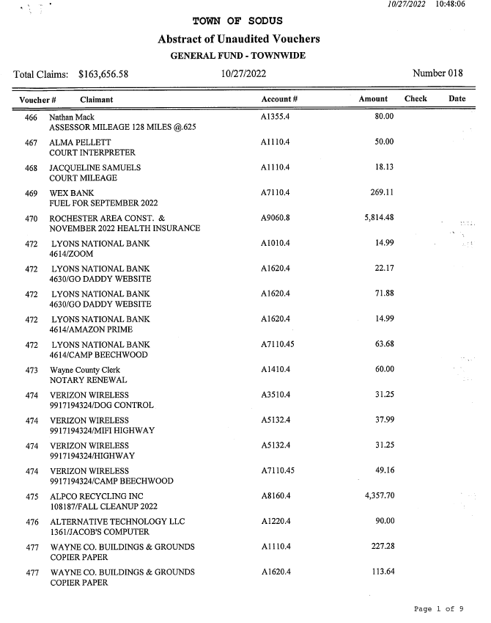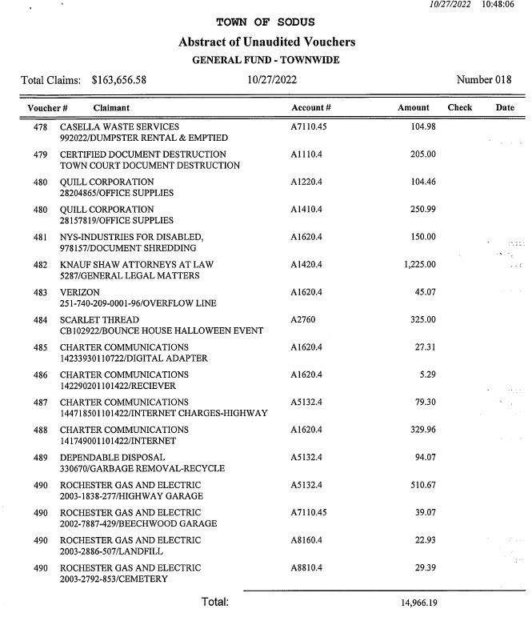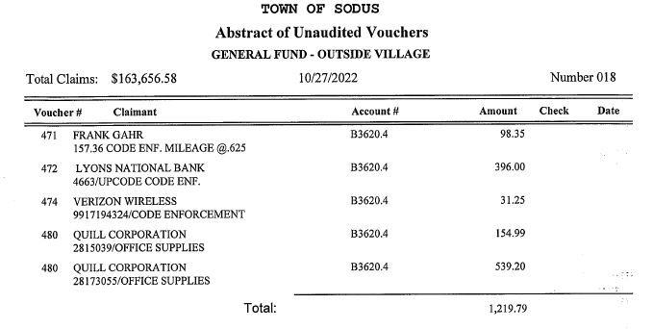
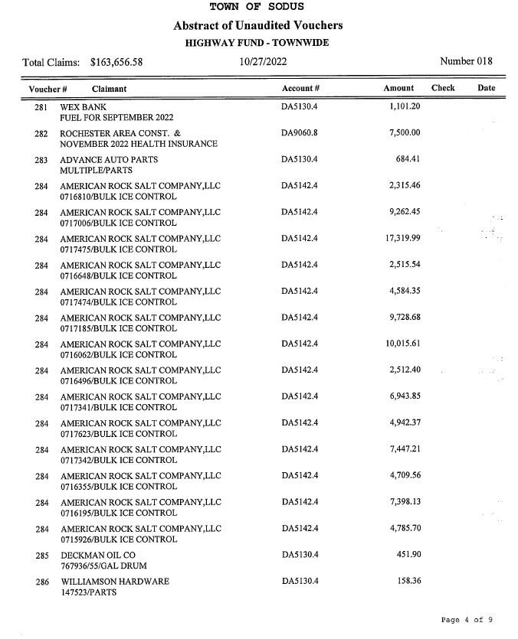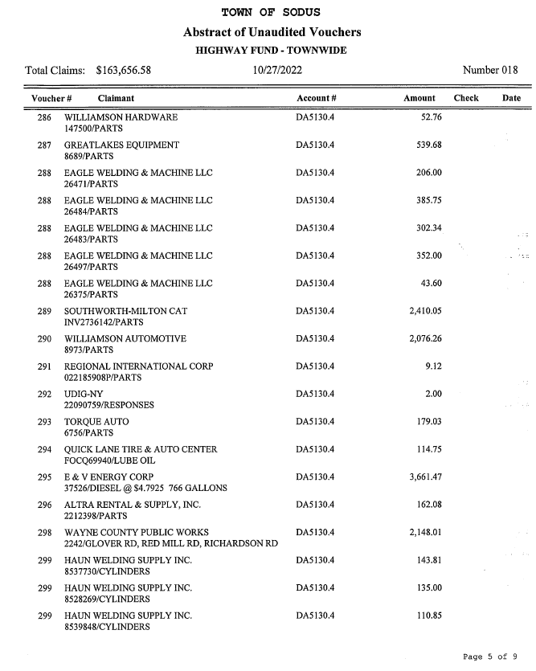
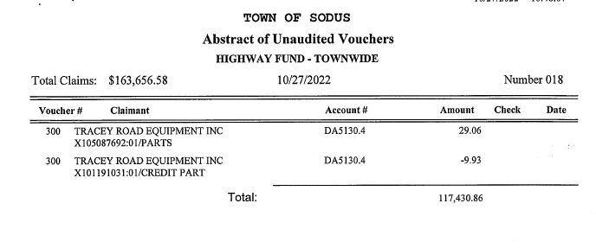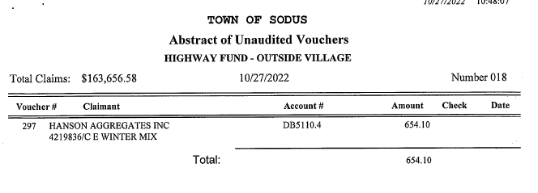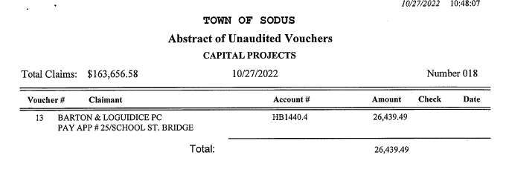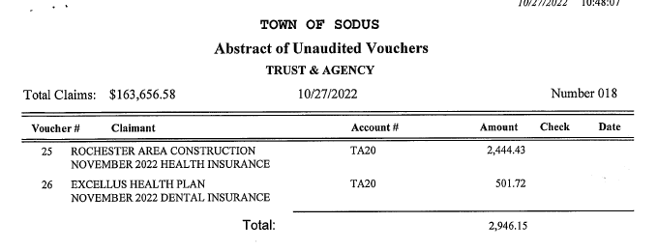

2023 SNOW AND ICE CONTRACT WAYNE COUNTY
RESOLUTION
(6 10-2022)
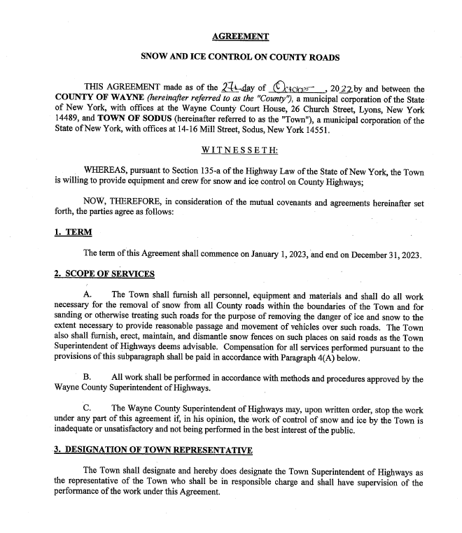

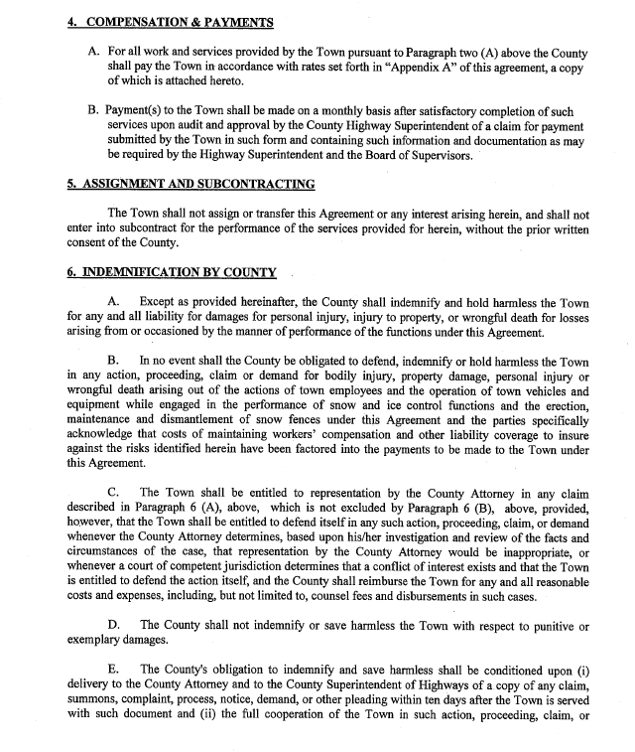

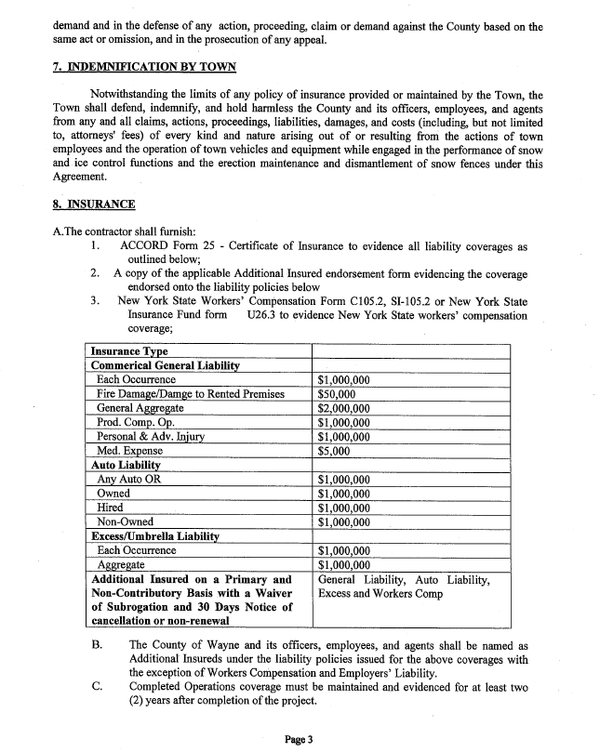

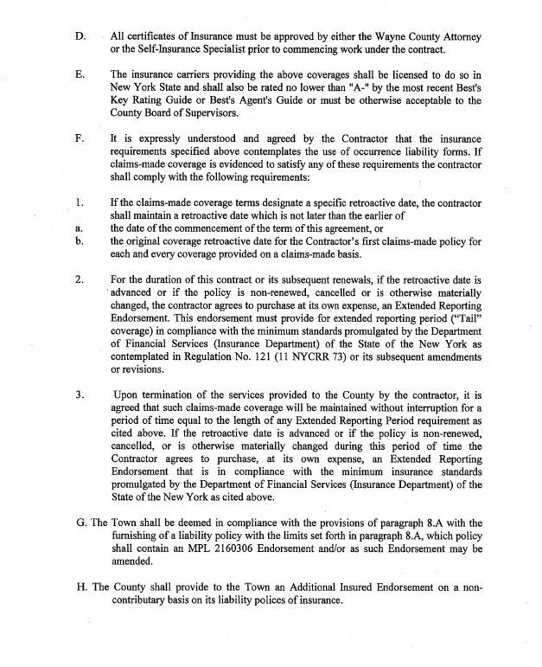BE IT RESOLVED, Motion by Councilperson Cathy Willmott to adopt this resolution was seconded by Councilperson Don Ross.
Upon roll call the following votes were heard, Scott Johnson, abstained; David LeRoy, aye; Don Ross, aye; Chris Tertinek, aye, Cathy Willmott; aye, Resolution Adopted.

Councilperson Chris Tertinek motioned to allow Town Clerk Lori Diver to advertise for a public hearing and to hold the public hearing on Tuesday November 29, 2022 at 4:00 PM for Local Law No. 3-2022 to reduce the number of Planning Board Members in the Town of Sodus was seconded by Councilperson Willmott. Upon roll call the following votes were heard, Scott Johnson, abstained; David LeRoy, aye; Don Ross, aye; Chris Tertinek, aye; and Cathy Willmott; aye. Motion carried.

Councilperson Chris Tertinek motioned to allow Supervisor Scott Johnson, Supervisor Clerk Bree Crandell and Town Clerk Lori Diver to travel and attend the 2023 Annual Meeting of the Association of Towns & Training School February 18- February 22, 2023 was seconded by Councilperson Willmott. Upon roll call the following votes were heard, Scott Johnson, abstained; David LeRoy, aye; Don Ross, aye; Chris Tertinek, aye; and Cathy Willmott; aye. Motion carried.

AGREEMENT TO EXEMPT REFERRAL OF CERTAIN LOCAL APPLICATIONS
RESOLUTION
(7 10-2022)
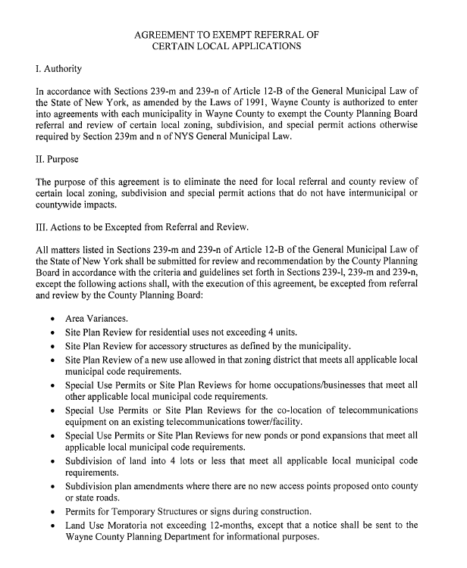
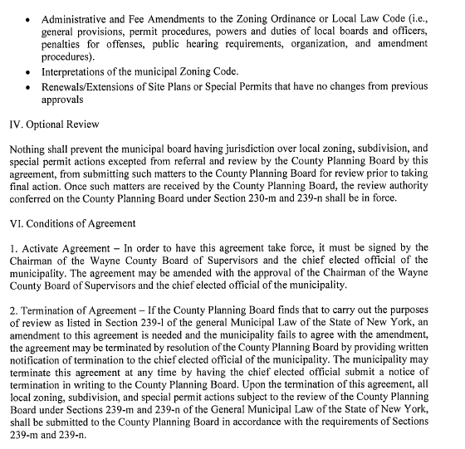

BE IT RESOLVED, Motion by Councilperson Cathy Willmott to adopt this resolution was seconded by Councilperson Don Ross. Upon roll call the following votes were heard, Scott Johnson, abstained; David LeRoy, aye; Don Ross, aye; Chris Tertinek, aye, Cathy Willmott; aye, Resolution Adopted.

VILLAGE OF SODUS RENTAL AGREEMENT
RESOLUTION
(8 10-2022)

WHEREAS, Supervisor Johnson offered the following resolution for its adoption, and
(See Page 41-43)
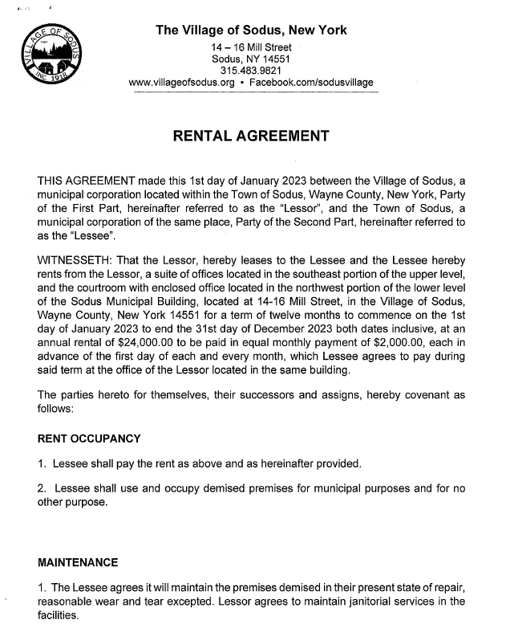

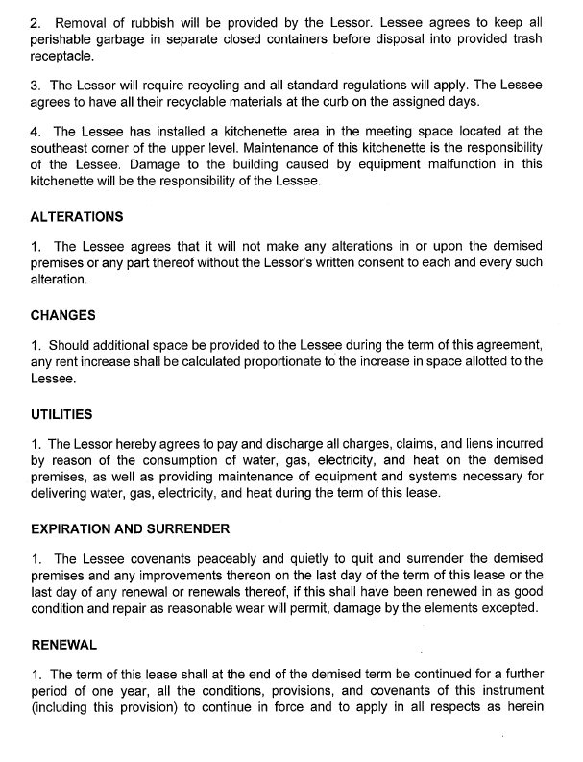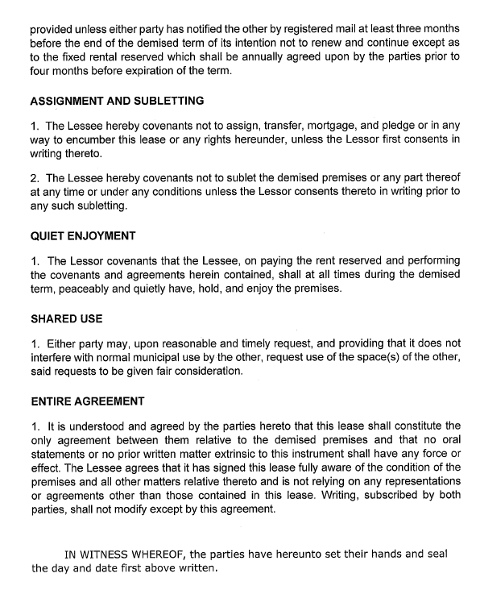
Motion by Councilperson Cathy Willmott to adopt the Rental Agreement Resolution was seconded by Councilperson Chris Tertinek.
Upon roll call the following votes were heard, Scott Johnson, abstained; David LeRoy, aye; Don Ross, aye; Chris Tertinek, aye, Cathy Willmott; aye. Resolution adopted.

Motion by Councilperson Don Ross allowing Lori Diver Sodus Town Clerk to advertise for a public hearing on Tuesday November 29, 2022 at 4:15 PM for Local Law No. 4-2022 to rescind Local Law 2-2022; relating to the override of the tax levy limit for fiscal year 2023 pursuant to general municipal law section 3-c. was seconded by Councilperson Chris Tertinek. Upon roll call the following votes were heard, Scott Johnson, abstained; David LeRoy, aye; Don Ross, aye; Chris Tertinek, aye, Cathy Willmott; aye. Motion carried.

RESOLUTION CREATING HIGHWAY EQUIPMENT CAPITAL RESERVE FUND
RESOLUTION
(9 10-2022)

RESOLVED, that pursuant to Section 6-c of the General Municipal Law, as amended, the Town Board of the Town of Sodus (the “Town”) does hereby establish a Capital Reserve Fund to finance the cost of acquisition of highway equipment. The Supervisor is hereby authorized to deposit moneys of this reserve fund in a separate bank account to be known as the Highway Equipment Capital Reserve Fund (the “Fund”). The Supervisor is authorized to deposit, secure and invest the moneys of this Fund pursuant to General Municipal Law §§10 and 11. No expenditure shall be made from the Fund, except upon authorization of the Town Board, and pursuant to the referendum requirements of General Municipal Law §6-c. This resolution is subject to permissive referendum.

BE IT FURTHER RESOLVED, that Town highway moneys designated for acquisition of equipment may be deposited in the Fund, provided the Town Superintendent of Highways and the Wayne County Superintendent of Highways consent to the establishment of the Fund, and such funds are only expended on order of the Town Superintendent of Highways, upon audit and with consent of the Town Board.

Motion by Councilperson Cathy Willmott to adopt the resolution for creating highway equipment capital reserve fund was seconded by Councilperson Chris Tertinek.
Upon roll call the following votes were heard, Scott Johnson, abstained; David LeRoy, aye; Don Ross, aye; Chris Tertinek, aye, Cathy Willmott; aye. Resolution adopted.

Motion by Councilperson Chris Tertinek to adopt resolution a fund balance transfer from the Highway DA fund to the A fund for $275,000.00 was seconded by Councilperson Cathy Willmott.
Upon roll call the following votes were heard, Scott Johnson, abstained; David LeRoy, aye; Don Ross, aye; Chris Tertinek, aye, Cathy Willmott; aye. Resolution adopted.

DOG RESERVE FUND
RESOLUTION
(5 9-2022)
NOTE: This resolution was on the agenda for this meeting but, it actually was adopted September 29, 2022. The resolution number is listed above from the September meeting.

PREEMPTION ROAD AGREEMENT
RESOLUTION
(10 10-2022) 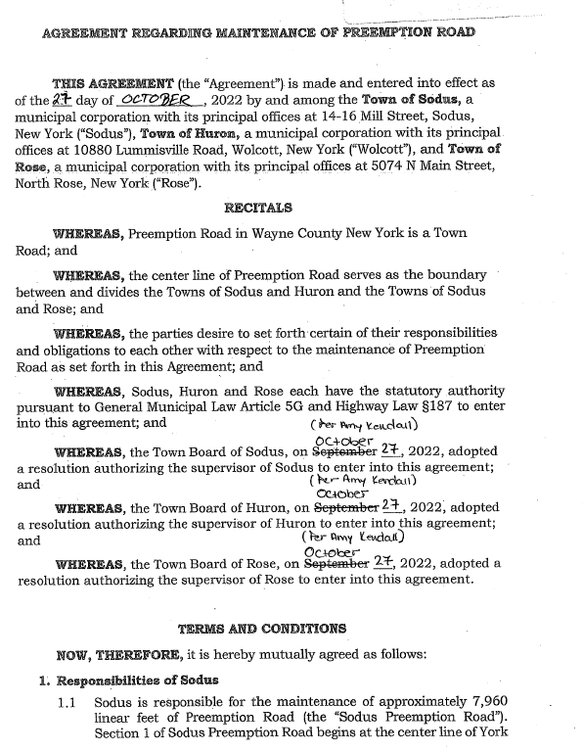
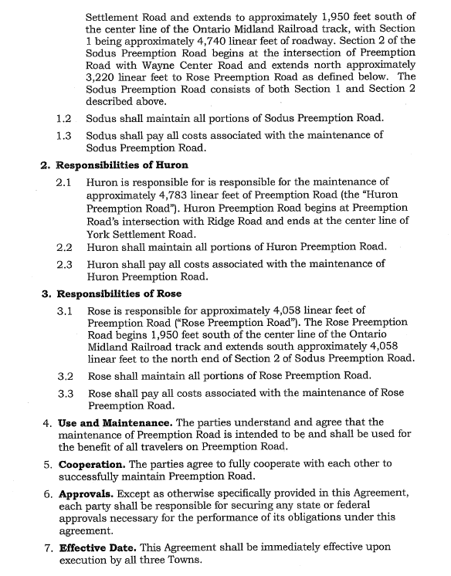
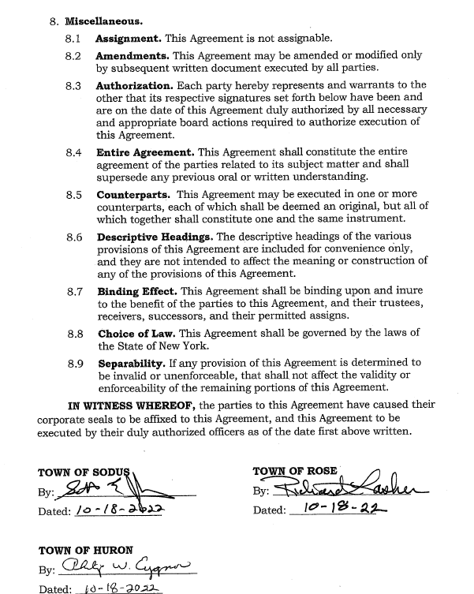

Motion by Councilperson Cathy Willmott to adopt this resolution was seconded by Councilperson Don Ross.
Upon roll call the following votes were heard, Scott Johnson, abstained; David LeRoy, aye; Don Ross, aye; Chris Tertinek, aye, Cathy Willmott; aye. Resolution adopted.

Motion by Councilperson Cathy Willmott to enter into Executive Session regarding medical, financial, credit or employment history of a particular person or corporation or relating to appointment promotion demotion discipline or removal was seconded by Councilperson Don Ross. Upon roll call the following votes were heard, Scott Johnson, aye; David LeRoy, aye; Don Ross, aye; Chris Tertinek, aye, Cathy Willmott; aye, Motion carried. Time: 5:10 PM

Motion by Councilperson Don Ross to exit out of Executive Session and enter into Regular Session was seconded by Councilperson Chris Tertinek.
Upon roll call the following votes were heard, Scott Johnson, aye; David LeRoy, aye; Don Ross, aye; Chris Tertinek, aye, Cathy Willmott; aye, Motion carried.
Time: 5:17 PM

Councilperson Chris Tertinek discussed the speed limit law for 25mph.

Councilperson David LeRoy discussed that the Salt Barn is on track and the RG&E lighting project is still on hold.

Councilperson Cathy Willmott discussed with Supervisor Clerk Bree Crandell health insurance updates.

Councilperson Don Ross motioned to adjourn the Month End Town Board Meeting was seconded by Councilperson Chris Tertinek. Upon roll call the following votes were heard, Scott Johnson, aye; David LeRoy, aye; Don Ross, aye; Chris Tertinek, aye; and Cathy Willmott; absent. Motion carried. 5:24 PM

Minutes Written By:
Lori K. Diver
Sodus Town Clerk, RMC

