**TOWN OF SODUS**

**LEGAL NOTICE**

***PUBLIC HEARING FOR:***

***“THE 2022 PRELIMINARY BUDGET”***

**NOTICE IS HEREBY GIVEN,** that the Preliminary Budget for the Town of Sodus , New York, for the fiscal year beginning January 1, 2023 has been completed and filed in the office of the Town Clerk of the Town of Sodus where it is available for inspection by any interested person at all reasonable hours; and

**FURTHER NOTICE,** is hereby given that the Town Board of the Town of Sodus will meet to review said budget and hold a Public Hearing on Thursday October 28, 2022 at 5:05 p.m. in the upstairs meeting room, 14-16 Mill Street, Sodus, NY 14551, at which time and place any persons may be heard in favor or against any items therein contained; and

**WHEREAS,** pursuant to Town Law, the proposed salaries of the following officers are hereby specified as follows:

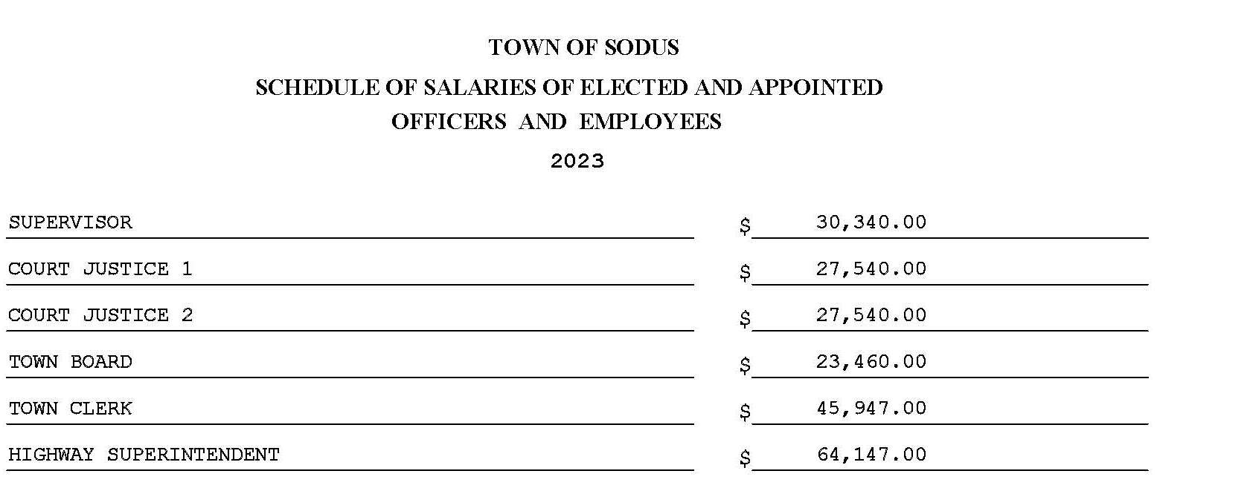

The Sodus Town Board will then meet; immediately following the Public Hearing, to review and propose adoption of the 2023 Town of Sodus Preliminary Budget to the 2023 Town of Sodus Adopted Budget.

All meetings are open to the public.

Date: October 6, 2022

By Order of the Sodus Town Board,

Lori Diver

Sodus Town Clerk, RMC