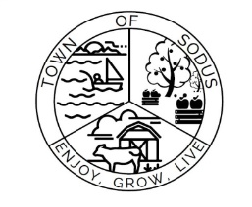
Office: 315-483-6934
Fax: 315-483-4038
Email: townofso@rochester.rr.com
Website: https://townofsodus.net

The Town of Sodus needs to make sure property owners in a proposed water district want water. Whether you live in the proposed district full time or only during the summers, you can sign the petition. According to the law, the Town has to have the signatures of owners of 50% of the total value of the property in the district (including part-time residents), as well as signatures of owners of 50% of the property owned by resident owners. Contact us for more information at 315-483-6934.

Thank you,
Town of Sodus

