Sodus Town Board Agenda
July 30, 2026
4:00 PM Month End Town Board Meeting
Open with Pledge Allegiance
Roll Call: (Lori Diver)
Supervisor Johnson, Councilperson Tertinek, Councilperson Pickering, Councilperson Willmott, Councilperson Conklin
Public Comments:

Minutes:
- Motion to file June 9, 2026 meeting minutes.
- Motion to file June 25, 2026 meeting minutes.

- Motion to file Supervisor’s Report

- Motion to file Town Clerk’s Report

- Resolution to Approve Bills Abstract #13-2026

- Public Works Committee: Councilperson Dale Pickering
(Highway, Drainage)
- Motion to file Highway Superintendent’s Report

- Buildings and Grounds Committee: Councilperson Chris Tertinek
(Town Property, Animal Control, Code Enforcement, Flood Damage, Cemeteries)
- Motion to file Code Enforcement Report - Frank Gahr
- Motion to file Dog Control Officers Reports - Kyle Kephart & Tammy Burns
- Flood Damage Prevention - Chris Tertinek
- Cemetery Committee update - Sal Vittozzi

- Recreation/Environmental Committee: Councilperson Cathy Willmott
(Recreation, Assessor)
- Motion to file Sodus Recreation Director’s Report-Amanda Burman
- Motion to file Assessor’s Report – Nathan Mack

- Public Safety Committee: Councilperson Josh Conklin
(Fire, Ambulance, Emergency Preparedness, Camp Beechwood, Celebrations)
- Motion to file Camp Beachwood/Sodus Groundskeeper Report – Sal Vittozzi

- Town Hall Committee: Supervisor Scott Johnson
(Personnel, Town Council, Court, Assessor, Building Inspector, Boards/Committees, Insurances, Finance, Environmental)

Correspondence & Information

- Copy of Ag & Markets Dog Control Officer Inspection report dated 6/16/2026 (emailed).

- Resolution authorizing Wayne County to send money collected for Town of Sodus sales tax; to be paid directly to the Town of Sodus pursuant to law section 1262 of the Tax Law, this shall be effective for all calendar year or years subsequent to its enactment.
First____________________ Second_____________________

- Resolution to surplus Tripp-Lite Surge UPS Battery Backup located in the Town Clerk’s office SN# 9905JYOBC705900562 Series:AGBC5756 and to dispose to e-waste.
First____________________ Second_____________________

- Resolution to surplus Town Clerk’s Brother Printer Model HL-L2390DW Serial No.U64967BON870332 and to dispose to e-waste.
First____________________ Second_____________________

- Motion to enter into Executive Session regarding medical, financial, credit or employment history of a particular person or corporation or relating to appointment promotion demotion discipline or removal.
First______________ Seconded_______________________
Time____________

- Motion to exit out of Executive Session.
First______________ Seconded_______________________
Time____________

- Motion to adjourn.
First______________ Seconded____________________
Time ____________

MINUTES
Minutes of the Month End Town Board Meeting July 30, 2026 at 4:00 PM held in person at the Town of Sodus courtroom 14-16 Mill St. Sodus, NY.
All meetings are open to the public.

Present: Scott Johnson, Supervisor
Chris Tertinek, Deputy Supervisor-Councilperson
Cathy Willmott, Councilperson
Josh Conklin, Councilperson

Recording Secretary: Lori Diver, Town Clerk

Absent: Dale Pickering, Councilperson

Others Present: Sal Vittozzi, Camp Beechwood Caretaker
Bree Crandell, Supervisor Clerk
Amanda Burman, Recreation Director
Casey Carpenter, Times of Wayne County Reporter

Supervisor Scott Johnson called the Month End Town Board Meeting to order commencing at 4:00 PM in the upstairs meeting room with the Pledge of Allegiance. Lori Diver opened with roll call. All Town Board members were present with the exception of Councilperson Dale Pickering who was absent.

NOTICE: All monthly reports and minutes were reported at Month End Town Board Meeting due to Town Clerk who had a WLB Town Clerk software failure earlier in the month. The Sodus Town Board agreed to do all reports at this meeting to help give her time to prepare reports.

PUBLIC SPEAKERS:
N/A

PUBLIC COMMENTS:
N/A

MINUTES
Minutes from June 9, 2026 was presented. Councilperson Josh Conklin motioned to file these Minutes, which was seconded by Councilperson Cathy Willmott. Upon roll call the following votes were heard, Supervisor Scott Johnson, aye, Chris Tertinek aye; Dale Pickering, absent; Cathy Willmott, aye; and Josh Conklin, aye. Motion carried.

Minutes from June 25, 2026 was presented. Councilperson Josh Conklin motioned to file these Minutes, which was seconded by Councilperson Chris Tertinek. Upon roll call the following votes were heard, Supervisor Scott Johnson, aye, Chris Tertinek aye; Dale Pickering, absent; Cathy Willmott, aye; and Josh Conklin, aye. Motion carried.

SUPERVISOR’S REPORT
The Supervisor’s monthly report was presented for June 2026. Councilperson Cathy Willmott motioned to file this report, which was seconded by Councilperson Josh Conklin. Upon roll call the following votes were heard, Supervisor Scott Johnson, aye, Chris Tertinek aye; Dale Pickering, absent; Cathy Willmott, aye; and Josh Conklin, aye. Motion carried.

TOWN CLERK’S REPORT
The Town Clerk’s Report, Town Clerk’s bank statements for audit and bank register for June 2026 was presented.
Note: bank statement and bank register are listed in detail with Town Clerk cash book for 2026. For security reasons and confidentiality, it cannot be published in the Minutes.
Councilperson Chris Tertinek motioned to file these reports was seconded by Councilperson Josh Conklin. Upon roll call the following votes were heard, Supervisor Scott Johnson, aye, Chris Tertinek aye; Dale Pickering, absent; Cathy Willmott, aye; and Josh Conklin, aye. Motion carried.

ABSTRACT
RESOLUTION TO PAY ABSTRACT NO. 13-2026
(10 07-2026)
WHEREAS, the following bills were presented for payment on Abstract 13-2026:
General 299-327 $ 24,011.88
CMI-Parks 011-011 $ 40.54
Trust & Agency 024-025 $ 1,872.89
Highway 249-265 $ 287,737.72
GRAND TOTAL: $ 313,663.03

NOW BE IT RESOLVED, Councilperson Josh Conklin motioned to approve payment of these bills as reviewed for Abstract No. 13-2026, which was seconded by Councilperson Cathy Willmott. Upon roll call the following votes were heard, Supervisor Scott Johnson, aye, Chris Tertinek aye; Dale Pickering, absent; Cathy Willmott, aye; and Josh Conklin, aye. Resolution Adopted.

PUBLIC WORKS COMMITTEE: Councilperson Dale Pickering, Chair
(Highway, Drainage)
HIGHWAY REPORT:
(Jared Laird – Highway Superintendent)
Councilperson Cathy Willmott motioned to file the monthly June 2026 Highway report was seconded by Councilperson Josh Conklin. Upon roll call the following votes were heard, Supervisor Scott Johnson, aye, Chris Tertinek aye; Dale Pickering, absent; Cathy Willmott, aye; and Josh Conklin, aye. Motion carried.

DRAINAGE:
N/A

BUILDINGS AND GROUNDS COMMITTEE: Councilperson Chris Tertinek, Chair
(Town Property, Animal Control, Flood Damage Prevention, Cemeteries)
CODE ENFORCEMENT REPORT:
Frank Gahr- CEO
Councilperson Cathy Willmott motioned to file the monthly June 2026 Code Enforcement Report was seconded by Councilperson Josh Conklin. Upon roll call the following votes were heard, Supervisor Scott Johnson, aye, Chris Tertinek aye; Dale Pickering, absent; Cathy Willmott, aye; and Josh Conklin, aye. Motion carried.
Councilman Tertinek Summary CEO Report:
July 30, 2026 - 4:00 pm Board Meeting (Chris Tertinek)
2026 June
Overview of Code Enforcement (Frank Gahr)
YTD
31 Permits issued. 157
83 Total inspections (including final). 319
$3,765.97 fees collected. $17,183.29
$503,385.58 construction cost. $3,850,137.09
20 letters written. 96

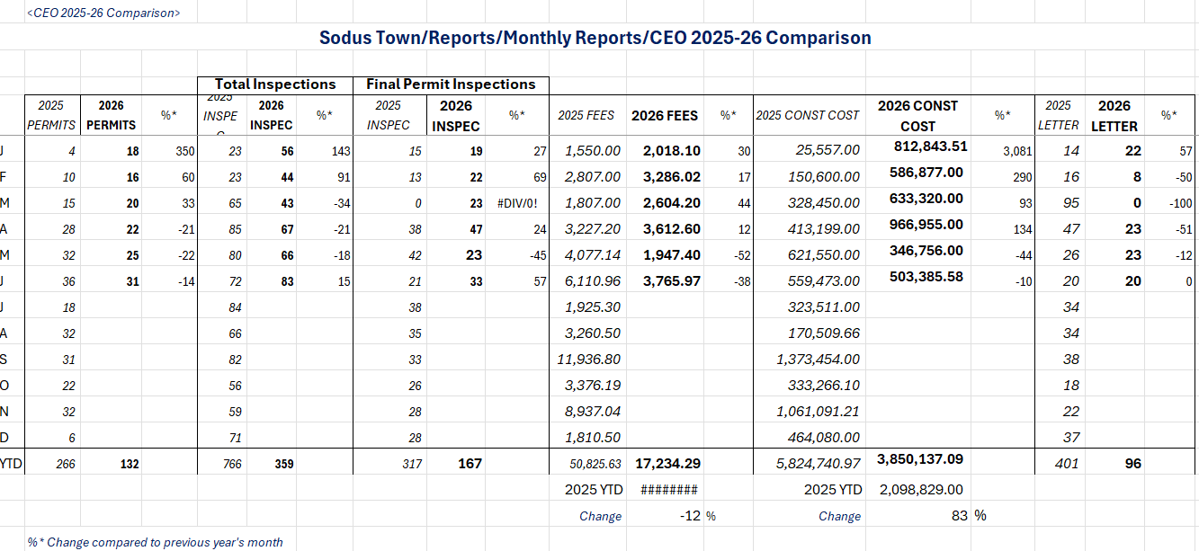

DOG CONTROL REPORT:
Kyle, Kephart-Primary DCO
Tamara Burns-Backup DCO
Councilperson Cathy Willmott motioned to file the monthly June 2026 Dog Control reports, was seconded by Councilperson Josh Conklin. Upon roll call the following votes were heard, Supervisor Scott Johnson, aye, Chris Tertinek aye; Dale Pickering, absent; Cathy Willmott, aye; and Josh Conklin, aye. Motion carried.
(NOTE: DCO documentation behind typed Minutes)

Councilperson Chris Tertinek Summary of DCO Report Below:
2026 June
Overview of Dog Control (Kyle Gephart and Tammy Burns)
12 DCO Actions
0 Dog bite
0 Dog transported
1 Running at Large
2 Complaint
5 Administrative
4 Other

Call distribution. YTD 2026 YTD 2025
3 Village of Sodus 7 13
0 Village of Sodus Point 3 4
9 Town of Sodus 42 14
0 Out of Town 1 0
53 31

FLOOD DAMAGE PREVENTION REPORT-Code 69:
Chris Tertinek, Councilperson
Lake Level (ASL = Above Sea Level)
Lake Ontario has crested at 247.44 ASL on 5/29/26 and again on 6/19/26
Lake at 247.3’ ASL at the end of June. About ½” lower than end of May.
At the end of June 2026, about 11” higher than end of June 2025.
The end of June 2026 level is about 12” higher than historic average.
Long term forecast for 25 December 2026 is 245.1’ ASL. About 6” higher than long-time average, and about 16” higher than 25 December 2025.

CEMETERY COMMITTEE UPDATE:
(Councilperson Chris Tertinek-Sal Vittozzi)
Councilperson Chris Tertinek called on Sal Vittozzi to discuss the Cemetery Committee updates. Sal discussed the committee has almost completely updated in completing the final work in the Joy Cemetery.

RECREATION-ASSESSOR OFFICE: Councilman Cathy Willmott
(Recreation and Assessor’s Office)
Recreation Report
(Amanda Burman , Recreation Director)
Councilperson Cathy Willmott motioned to file the monthly June 2026 report from Recreation Director Amanda Burman was seconded by Councilperson Josh Conklin. Upon roll call the following votes were heard, Supervisor Scott Johnson, aye, Chris Tertinek aye; Dale Pickering, absent; Cathy Willmott, aye; and Josh Conklin, aye. Motion carried.

Assessor’s Report
(Nathan Mack, Assessor)
Councilperson Josh Conklin motioned to file the monthly Assessor’s report for June 2026 Sole Assessor Nathan Mack was seconded by Councilperson Chris Tertinek. Upon roll call the following votes were heard, Supervisor Scott Johnson, aye, Chris Tertinek aye; Dale Pickering, absent; Cathy Willmott, aye; and Josh Conklin, aye. Motion carried.

PUBLIC SAFETY/DRAINAGE/ENVIRONMENT COMMITTEE: Councilperson Josh Conklin, Chair (Fire, Ambulance, Emergency Preparedness, Camp Beechwood, Wayne County Water Authority)
Councilperson Josh Conklin stated the Sodus Rolling Stove’s Food Truck events are going well.
Camp Beechwood/Sodus Groundskeeper Report
(Sal Vittozzi-Caretaker-Sodus Town Groundkeeper)
Councilperson Josh Conklin motioned to file the monthly June 2026 report of Camp Beechwood-Parks & Cemeteries from Sal Vittozzi, Sodus Town Groundskeeper-Caretaker was seconded by Councilperson Chris Tertinek. Upon roll call the following votes were heard, Supervisor Scott Johnson, aye, Chris Tertinek aye; Dale Pickering, absent; Cathy Willmott, aye; and Josh Conklin, aye. Motion carried.

TOWN HALL COMMITTEE: Scott Johnson, Supervisor
(Personnel, Clerks, Justices, Assessor, Building Inspector, Town Council, Boards, Insurances, Finance)
N/A
Supervisor Scott Johnson, Camp Beechwood Caretaker and the Sodus Town Board would like to thank Bill Stevens with WS Excavating and Duane Wessie with Wessie Masonry LLC for volunteering their time and help to save the John Faulks Pavillion at Camp Beechwood by moving it to a safe location. With the severe erosion at Beechwood, the pavilion was very close to going over the edge into Lake Ontario. Both Wessie and Stevens volunteered to help with their equipment to place the pavilion in a safe location within Beechwood and away from the edge of the bank. A HUGE KUDOS TO ALL THAT HELPED!

Copy of Ag & Markets Dog Control Officer Inspection report dated June 16, 2026 (emailed).
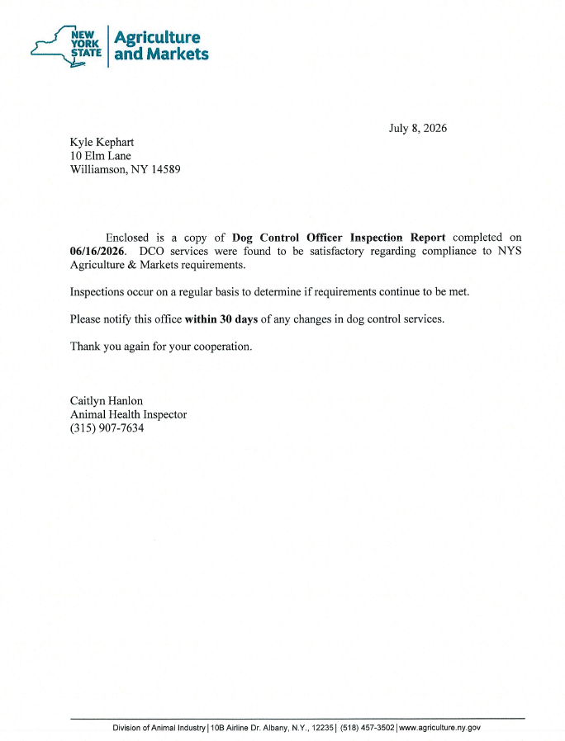
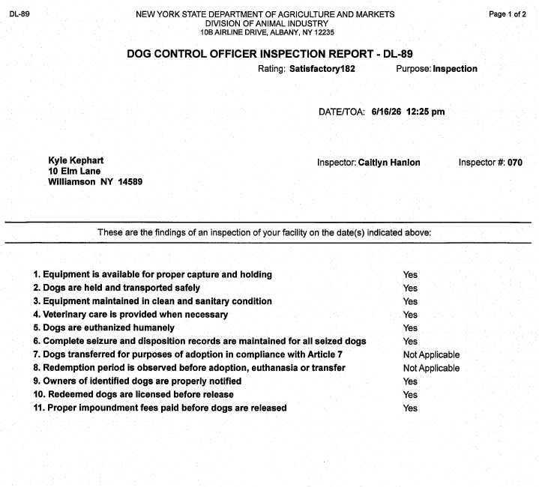

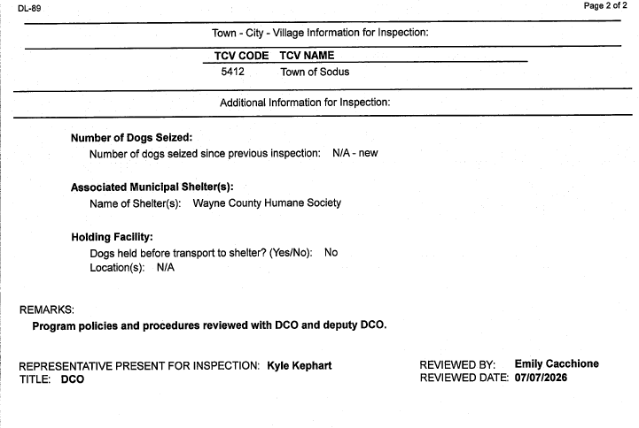

SALES TAX COLLECTED BY WAYNE COUNTY
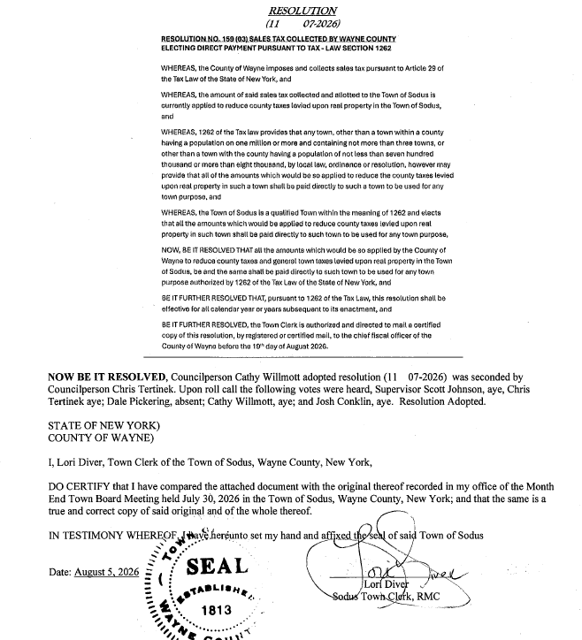

RESOLUTION
SURPLUS TRIPP-LITE SURGE UPS BATTERY BACKUP IN TOWN CLERK”S OFFICE
(12 07-2026)
NOW BE IT RESOLVED, Councilperson Cathy Willmott motioned to surplus Tripp-Lite Surge UPS Battery Backup located in the Town Clerk’s office SN# 9905JYOBC705900562 Series: AGBC5756 and to dispose to e-waste was seconded by Councilperson Chris Tertinek. Upon roll call the following votes were heard, Supervisor Scott Johnson, aye, Chris Tertinek aye; Dale Pickering, absent; Cathy Willmott, aye; and Josh Conklin, aye. Resolution Adopted.

RESOLUTION
SURPLUS TOWN CLERKS BROTHER PRINTER
(13 07-2026)
NOW BE IT RESOLVED, Councilperson Chris Tertinek motioned to surplus Brother Printer Model HL-L2390DW Serial NO. U64967BON870332 and to dispose to e-waste was seconded by Councilperson Cathy Willmott. Upon roll call the following votes were heard, Supervisor Scott Johnson, aye, Chris Tertinek aye; Dale Pickering, absent; Cathy Willmott, aye; and Josh Conklin, aye. Resolution Adopted.

Supervisor Scott Johnson stated the next meeting for Union Negotiations is August 10, 2026.

Councilperson Cathy Wilmott stated she, Bree Crandell and Lori Diver met with Jeremy Chiarelli and Abbey Krause with Gallagher, a Broker for Health Insurance proposals for the Town of Sodus to discuss prospective plans for the upcoming 2027 calendar year. Gallagher will follow through with an email on updated rates for the Town of Sodus to review.

Councilperson Cathy Willmott motioned to enter into Executive Session regarding medical, financial, credit or employment history of a particular person or corporation or relating to appointment promotion demotion discipline or removal was seconded by Councilperson Josh Conklin. Upon roll call the following votes were heard, Supervisor Scott Johnson, aye, Chris Tertinek aye; Dale Pickering, absent; Cathy Willmott, aye; and Josh Conklin, aye. Motion carried.
Time: 4:18 PM

Councilperson Josh Conklin motioned to exit out of Executive Session and enter into regular session was seconded by Councilperson Cathy Willmott. Upon roll call the following votes were heard, Supervisor Scott Johnson, aye, Chris Tertinek aye; Dale Pickering, absent; Cathy Willmott, aye; and Josh Conklin, aye. Motion carried.
Time: 4:40 PM

Councilperson Josh Conklin motioned to adjourn the Month End Town Board Meeting was seconded by Councilperson Chris Tertinek. Upon roll call the following votes were heard, Supervisor Scott Johnson, aye, Chris Tertinek aye; Dale Pickering, absent; and Cathy Willmott, aye; and Josh Conklin, aye. Motion carried.

Meeting adjourned at 4:41 PM

Recording Secretary,
Lori K. Diver
Sodus Town Clerk, RMC

Note: Reports and other correspondence are attached in the order of motions and resolutions of Minutes.

