APT Series Manual Trolley – Installation and Safety Instructions

ALR Manual Trolleys are designed to be used on either "Ι" or “H” wide flange beams.
ALR APT Series Trolleys comply with OSHA regulations, ANSI/ASME B30.11 and B30.17 standards.

IMPORTANT SAFETY INSTRUCTIONS
To reduce risk of injury:
- Beam must be properly installed and rated for anticipated loads.
- Do not install trolley on beams of unknown capacity.
- Do not install trolley on damaged or deformed beams.
- ALR trolleys are designed to be used with hoists of the same rated capacity. Never use a hoist with a capacity greater than the capacity of the trolley.
- Never subject trolley to a side pull or load. Load must be centered directly under the hoist / trolley assembly.
- Make sure load is stable and secure before moving.
- Never lift load more than is necessary to safely move it.
- Always follow installation instructions.
- Do not use if under the influence of drugs, alcohol, or medication.

Installation Instructions
(refer to Figure 1)

Trolley must be installed on a beam with minimum clearance (wheels to flange) of 1/16" to maximum of 1/8". Reference "Z" on both sides of the beam.

- To extend trolley width, remove hex nuts. Remove washers from center bolt and place between hanger plate and fixed spacer.

Note: Washers must be moved in sets of two, one on either side of hanger plate, as hanger plate must always remain centered between trolley side plates.

- Once trolley width is spaced properly, install remaining washers on center bolt (same number on both sides) on outside of side plates. Install hex nuts. Do not over tighten nuts. Tighten nuts.

- Re-check wheel clearance "Z" and re-adjust if necessary

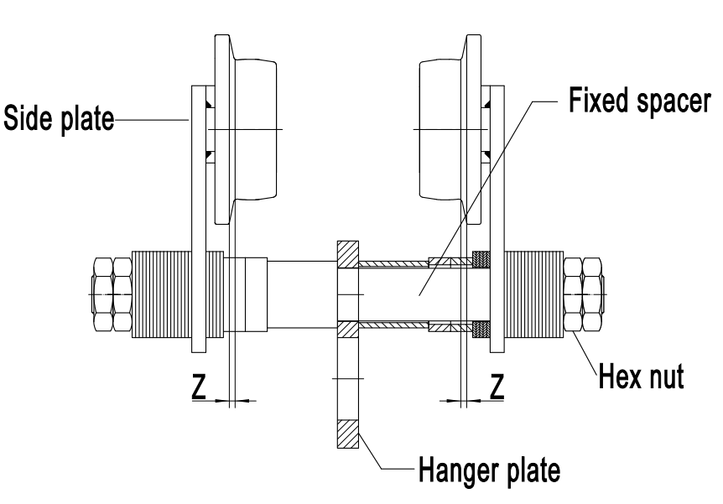

Figure 1

Atlas Lifting & Rigging, LLC
Reno, NV, USA
Ph.: 1-833-ALR-LIFT
www.alrlift.com Effective: July 1st, 2022

Figure 2: SPACER WASHERS
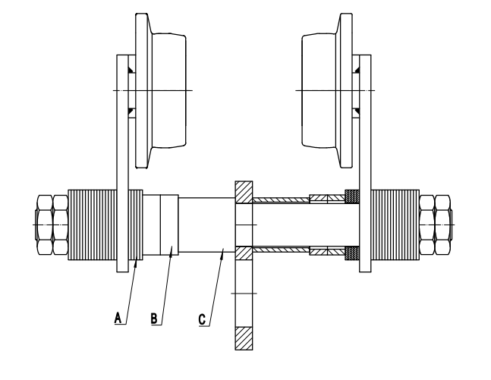
APT Series Plain Trolleys
*CHART FOR ARRANGEMENT OF SPACER WASHERS

* The use of Other than ALR supplied spacer washers may result in trackwheel to beam flange variations and thus the above chart will not apply.
APT Series Plain Trolley: Parts Breakdown
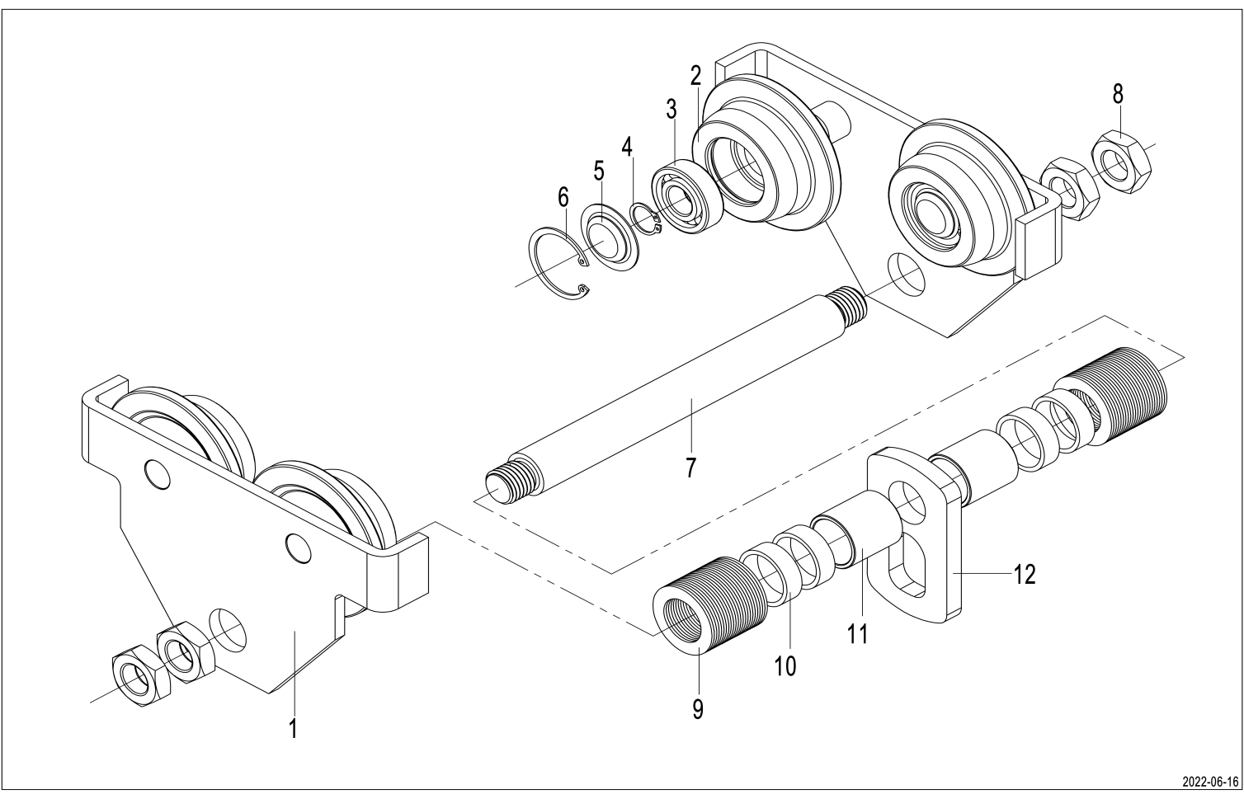

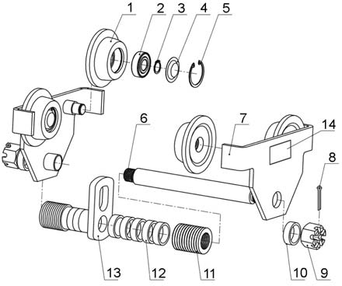

All products sold by Atlas Lifting & Rigging, LLC. are warranted to be free of defects in material and workmanship from date of shipment by Atlas Lifting & Rigging, LLC. If one of our products needs repair of service, please contact Technical Service at 1-833-ALR-LIFT, 8AM to 5PM Anywhere in the US, Monday through Friday.

Warranty Period
The general warranty lasts for the time period specified in the literature included with your product or on the official ALR branded website.
    - ALR products carry a limited warranty which varies in duration based upon the product.
    - Accessories carry a limited warranty of one year from the date of receipt.
    - Consumable items are defined as expendable parts or accessories expected to become inoperable within a reasonable amount of use and are covered by a 90 days limited warranty against manufacturer’s defects.

Who is Covered
This warranty covers only the initial purchaser of the product from the date of delivery.

What is Covered
This warranty covers any defects in workmanship or materials subject to the limitations stated below. This warranty does not cover failures due directly or indirectly to misuse, abuse, negligence or accidents, normal wear-and-tear, improper repair, alterations or lack of maintenance.

How to Get Technical Support
Please contact Technical Service by calling 1-833-ALR-LIFT. Please note that you will be asked to provide proof of initial purchase when calling. If a product requires further inspection, the Technical Service representative will explain and assist with any additional action needed. ALR has Authorized Service Centers located throughout the United States. For the name of an Authorized Service Center in your area call 1-833-ALR-LIFT or use the Service Center Locator on the ALR website.

More Information
ALR is constantly adding new products. For complete, up-to-date product information, check with your local distributor or visit the ALR website.

How State Law Applies
This warranty gives you specific legal rights, subject to applicable state law.

Limitations on This Warranty
ALR LIMITS ALL IMPLIED WARRANTIES TO THE PERIOD OF THE LIMITED WARRANTY FOR EACH PRODUCT. EXCEPT AS STATED HEREIN, ANY IMPLIED WARRANTIES OF MERCHANTABILITY AND FITNESS FOR A PARTICULAR PURPOSE ARE EXCLUDED. SOME STATES DO NOT ALLOW LIMITATIONS ON HOW LONG AN IMPLIED WARRANTY LASTS, SO THE ABOVE LIMITATION MAY NOT APPLY TO YOU.
ALR SHALL IN NO EVENT BE LIABLE FOR DEATH, INJURIES TO PERSONS OR PROPERTY, OR FOR INCIDENTAL, CONTINGENT, SPECIAL, OR CONSEQUENTIAL DAMAGES ARISING FROM THE USE OF OUR PRODUCTS. SOME STATES DO NOT ALLOW THE EXCLUSION OR LIMITATION OF INCIDENTAL OR CONSEQUENTIAL DAMAGES, SO THE ABOVE LIMITATION OR EXCLUSION MAY NOT APPLY TO YOU.

ALR sells through distributors only. The specifications listed in ALR printed materials and on official ALR website are given as general information and are not binding. ALR reserves the right to effect at any time, without prior notice, those alterations to parts, fittings, and accessory equipment which they may deem necessary for any reason whatsoever.

