OWNER’S MANUAL

MANUAL CHAIN HOIST

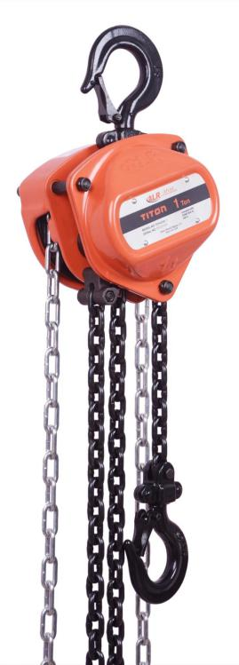
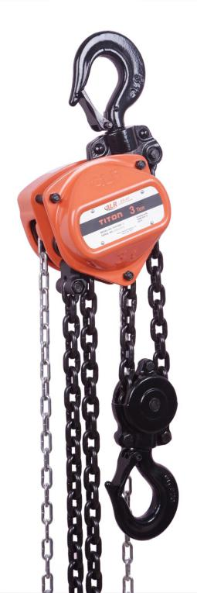

Atlas Lifting & Rigging, LLC Reno, NV, USA
Ph: 1-833-ALR-LIFT
Effective: January 1st, 2021
www.alrlift.com

WARRANTY INFORMATION AND TECHNICAL SERVICE

All products sold by Atlas Lifting & Rigging, LLC are warranted to be free of defects in material and workmanship from date of shipment by Atlas Lifting & Rigging, LLC. If one of our products needs repair of service, please contact Technical Service at 1-833-ALR-LIFT, 8AM to 5PM Anywhere in the US, Monday through Friday.

Warranty Period and Coverage
- ALR products carry a limited warranty of 2 years.
- Accessories carry a limited warranty of one year from the date of receipt.
- This warranty covers only the initial purchaser of the product from the date of delivery.
- This warranty covers any defects in workmanship or materials subject to the limitations stated below.
- This warranty does not cover failures due directly or indirectly to misuse, abuse, negligence or accidents, normal wear-and-tear, improper repair, alterations or lack of maintenance.

Limitations on This Warranty
The product must be used in accordance to ALR recommendations. The product must not have been subjected to misused, abused, neglected, lack of maintenance, negligence or unauthorized repairs or alterations.
Should any defect in material or workmanship occur during the period stated above, the product will be inspected by ALR and at its discretion, ALR will either replace or repair the hoist in question free of charge and delivery F.O.B. Atlas Lifting & Rigging, LLC place of business or customer.
Customer must receive a Return Goods Authorization form from ALR or an Authorized ALR service center prior to shipping product for warranty evaluation. An explanation of the product issues must accompany the product. Product must be returned freight pre-paid. Upon repair, the product will be covered for the remainder of the original warranty period. Other restrictions apply. Please contact Technical Service for additional details of warranty restrictions. If it is determined that the product was misused, abused, neglected, used in a negligent manner or was subject to unauthorized repair or modification, the customer will be responsible for the cost of the return of the product.
Atlas Lifting & Rigging, LLC disclaims any and all other warranties of any kind expressed or implied as to the product’s merchantability or fitness for a particular application. Atlas Lifting & Rigging, LLC will not be liable for death, injuries to persons or property or for incidental, contingent, special or consequential damages, loss or expense arising in connection with the use or inability whatever, regardless of whether damage, loss or expense results from any act by Atlas Lifting & Rigging, LLC whether negligent of willful, or from any other reason.

Technical Support

Please contact Technical Service at 1-833-ALR-LIFT. Please note that you will be asked to provide proof of initial purchase when calling. If a product requires further inspection, the Technical Service representative will explain and assist with any additional action needed.

Table of Contents

Section Page Number

  - Important Information and Warnings 4
  - Term and Summary 4
  - Warning 4
  - Introduction 5
  - Warning Label 6
  - Unpacking 6
  - Content of Carton 6
3.0 Pre-operation Inspection 6
  - Operation 7
  - Introduction 7
  - Safety Procedures 7
  - Care in Use 8
  - Maintenance & Inspection 8
6.0 Storage of Hoist 9
  - Specifications 10
  - Stock Number 11
8.0 Using the Chain Hoist 11
9.0 Hooking the Load 12
10.0 Raising the Load 12
11.0 Hand Chain - Cutting and Installing 13
12.0 Load Chain and Bottom Hook 14
13.0 Load Chain and Bottom Hook Installation 15
14.0 Load Limits 16
15.0 Timing Marks for Gear Replacement 18
  - Replacement Parts 18
  - Manual Chain Hoist Parts 18

Manual chain hoist equipment should not be operated or maintained by any person who has not read and understood all the contents of this operator’s manual. Failure to read and comply with the content of this manual can result in serious bodily injury or death, and or property damage.
1.0 Important Information and Warnings

1.1 Term and Summary
This manual provides important information for personnel involved with the installation, operation and maintenance of this product. Although you may be familiar with this or similar equipment, it is strongly recommended that you read this manual before installing, operating, or maintaining the product.

Danger, Warning, Caution, and Notice
Throughout this manual there are steps and procedures that can present hazardous situations. The following signal words are used to identify the degree or level of hazard seriousness.

DANGER Danger indicates an imminently hazardous situation which, if not avoided, will result in death or serious injury, and property damage.

WARNING Warning indicates an imminently hazardous situation which, if not avoided, could result in death or serious injury ,and property damage.

CAUTION Caution indicates an imminently hazardous situation which, if not avoided, may result in minor or moderate injury, and property damage.

NOTICE Notice is used to notify people of installation, operation, or maintenance information which is important but not directly hazard-related.

1.2 WARNING !!!

- Read and understand the entire owner’s manual before attempting operation. Failure to comply with instructions and warnings may cause serious injury.
- Understand and follow all procedures as set forth in American National Standards titled “Performance Standard for Manually Chain Operated Chain Hoists,” ANSI/ASME HST-3; and “Manually Chain Operated Hoists,” ANSI/ASME B30.21. These standards are available through the American Society of Mechanical Engineers at www.asme.org.
- Do not use until proper training and knowledge have been obtained. This Chain hoist is designed and intended for use by properly trained and experienced personnel only. If you are not familiar with the proper and safe operation of a Chain hoist,
- Do not use this Chain hoist for other than its intended use. If used for other purposes, ALR disclaims any real or implied warranty and holds itself harmless from any injury that may result from that use.
- Do not use If hoist is damaged. do not use until it has been repaired or replaced. Always inspect the Chain hoist for damage prior to use.
- Do not use Chain hoist to lift, support or transport people; or to lift or support loads over people.
- Do not load beyond the rated capacity. See Name Plate.
- Do not operate hoist unless load is centered between top and bottom hooks.
- Do not use the chain as a sling. This may cause damage to the chain.
- Do not use more than one Chain hoist to lift or move a load. If this is unavoidable, each hoist must have the same capacity as the load to be moved.
- Never allow chain to “set” over sharp edges. All pulls or lifts must be made with straight chain that is free of obstacles.
- Do not use hoist if the chain is twisted, kinked or damaged.
- Do not attempt to lengthen or repair load chain.

- Do not use the hoist if either hook is stretched, deformed, or has a broken or missing safety latch. Always replace the safety latch and/or the hook before placing the hoist back in service.
- Do not heat treat and DO not weld any part of the Chain Hoist, especially the load chain.
- Do not leave a load on the Chain Hoist unattended.
- Do not shock load Chain Hoist, chain or hook.
- Do not operate the Chain Hoist unless it is rigged to pull in a straight line from hook to hook, and the frame is allowed to freely swivel on the upper hook.
- Do not wrap the load chain around the load and hook onto itself as a choker chain or bring the load in contact with the Chain Hoist.
- Do not use more than hand power to pull the hand chain.
- Do not point load the hook – ensure hook is correctly position with the load at the optimum position
- Do not use spray lubricates in or near brake discs.
- Do not take up the load chain to the point where the end ring or lower hook becomes jammed against the frame.
- If the Chain hoist is difficult to operate, then the load exceeds the capacity of the hoist. Reduce load or select a hoist of larger capacity.
- On hoists with the overload warning Chain, do not use this device to measure load weight.
- If a load hook has been distorted, due to an overload on the hoist, then the whole hoist may also be damaged. A hoist which has been overloaded must be withdrawn from service immediately and tagged out until checked by a component person.

WARNING SPECIAL NOTE FOR USER:
TWISTING OF CHAIN ALR Chain hoist have multiple falls of load chain. THE LOAD CHAIN MUST BE INSPECTED FOR TWIST PRIOR TO EACH LIFT. If the chain hoist bottom hook has looped through the multi fall of load chain this can create a twist in the load chain that can damage the chain hoist and cause injury.

1.3 Introduction
Congratulations on your ALR Chain Hoist. The ALR Chain Hoist you have chosen is a heavy-duty hoist, designed to retain its operational features under normal operating conditions. This manual contains instructions on installation, safety precautions, general operating procedures, maintenance instructions and parts breakdown. In order to achieve years of satisfactory service from your ALR Chain Hoist a routine of careful operation, regular maintenance and lubrication should be applied as instructed within this ALR manual.
Prior to the operation, installation or maintenance of your ALR Chain Hoist, please read all the contents contained within this manual. At all times only competent and experienced personnel should operate, install or maintain this hoist. Failure to comply with the instructions contained within this manual can result in both physical and/or property damage. In keeping with statutory requirements, and best use for your ALR Chain
We recommended a periodic maintenance check every 12 months via your ALR distributor. ALR’s experienced and competent personnel will perform a complete service including preventative maintenance, genuine spares and repairs service.
On completion of installation, but prior to your ALR Chain Hoist being put into regular service, the following procedures should be carried out –
- Check that all joints and fasteners are tight and secure.
- Operate the hoist with both no load and full load, and check that the operation is smooth at all times.
- Check operation of hoist brake, under light load and full load conditions.
- Traveling units - run throughout the full extent of the runway, ensuring adequate clearance at all times.
- Please ensure your ALR Test Certificate has been stored and the unit(s) have been placed in your lifting register for future reference.

1.4 WARNING LABEL

The warning label illustrated below in Figure 1 is supplied with each hoist shipped from factory. Read and obey all warning attached to this hoist. Label is not shown actual size.

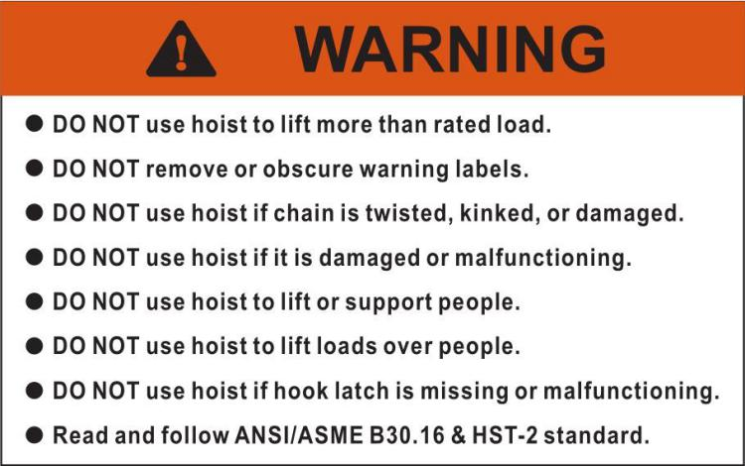

Figure 1 Warning Label Attached to Chain Hoist (shown larger for legibility)

2.0 UNPACKING
Open carton and check for shipping damage. Report any damage immediately to your distributor and shipping agent. Do not discard any shipping material until the Chain Hoist is assembled and running properly. Read this entire instruction manual thoroughly for set-up, maintenance and safety instructions.

2.1 CONTENT OF CARTON
1 Manual Chain Hoist
1 Owner’s Manual
1 Test certificate

3.0 PRE-OPERATION INSPECTION
Your ALR Chain HOIST has been tested, and conforms to ANSI/ASME B30.16 and HST-2 standards.
On completion of installation, but prior to your ALR Chain Hoist being put into regular service, the following procedures should be carried out –
- Check that all joints and fasteners are tight and secure.
- Operate the hoist with both no load and full load, and check that the operation is smooth at all times.
- Check operation of hoist brake, under light load and full load conditions.
- Traveling units - run throughout the full extent of the runway, ensuring adequate clearance at all times.
- Please ensure your ALR Test Certificate has been stored and the unit(s) have been placed in your lifting register for future reference.

4.0 OPERATION
- Face the hand chain wheel side of the hoist.
- To raise the load, pull hand chain clockwise.
- To lower the load, pull hand chain counterclockwise.
NOTE: The clicking sound of the pawl when a load is being raised indicates normal operation.

4.1 Introduction

MANUAL CHAIN HOIST OPERATORS SHALL BE REQUIRED TO READ THE OPERATION SECTION OF THIS MANUAL, THE WARNINGS CONTAINED IN THIS MANUAL, INSTRUCTION AND WARNING LABELS ON THE HOIST OR LIFTING SYSTEM, AND THE OPERATION SECTIONS OF ANSI/ASME B30.16 AND ASME B30.10. THE OPERATOR SHALL ALSO BE REQUIRED TO BE FAMILIAR WITH THE MANUAL CHAIN HOIST AND HOIST CONTROLS BEFORE BEING AUTHORIZED TO OPERATE THE HOIST OR LIFTING SYSTEM.

MANUAL CHAIN HOIST OPERATORS SHOULD BE TRAINED IN PROPER RIGGING PROCEDURES FOR THE ATTACHMENT OF LOADS TO THE HOIST HOOK.

MANUAL CHAIN HOIST OPERATORS SHOULD BE TRAINED TO BE AWARE OF POTENTIAL MALFUNCTIONS OF THE EQUIPMENT THAT REQUIRE ADJUSTMENT OR REPAIR, AND TO BE INSTRUCTED TO STOP OPERATION IF SUCH MALFUNCTIONS OCCUR, AND TO IMMEDIATELY ADVISE THEIR SUPERVISOR SO CORRECTIVE ACTION CAN BE TAKEN.

HOIST OPERATORS SHOULD NOT HAVE A HISTORY OF OR BE PRONE TO SEIZURES, LOSS OF PHYSICAL CONTROL, PHYSICAL DEFECTS, OR EMOTIONAL INSTABILITY THAT COULD RESULT IN ACTIONS OF THE OPERATOR BEING A HAZARD TO THE OPERATOR OR TO OTHERS.

HOIST OPERATORS SHOULD NOT OPERATE A HOIST OR LIFTING SYSTEM WHEN UNDER THE INFLUENCE OF ALCOHOL, DRUGS, OR MEDICATION.
NOTICE
. Read ANSI/ASME B30.16 and ANSI/ASME B30.10.
. Read the Owner’s Manual.
. Read all warning labels attached to manual chain hoist.
4.2 SAFETY PROCEDURES

- The chain hoist must always be rigged to lift in a straight line from hook to hook. The chain hoist must always be free to swivel on the upper hook. Under no conditions should the chain hoist frame be allowed to bear on any support when in use as this would cause bending of the hook or frame and damage the unit.
- When preparing to lift or move a load, be sure that the attachments to both hooks are firmly seated in the saddles of the hooks. Avoid off center loading of any kind especially loading on the tip of the hook. Also observe that the chain hangs straight (without twists) from chain hoist to lower hook.
- When lifting, raise the load only enough to clear the floor or support and check to be sure brake will hold the load and that attachments to the load are firmly seated. Continue the lift only after you are assured the load is free of all obstructions.
- Do not load beyond the rated capacity of the chain hoist. Rated capacity can be achieved with the following hand chain pulls. Since these hand chain pulls can easily be applied by one person, under no circumstances should more than one person operate the hoist hand chain. Overloading can cause immediate failure of some load carrying parts or result in damage causing failure at less than rated capacity. When in doubt use the next larger capacity ALR Chain Hoist.

5.0 CARE IN USE
- Always examine the hoist carefully prior to use - your life and others may be at risk. Look for cracks or damage, particularly with hooks and load chain.
- Keep load chain clean and oiled to prevent undue damage or wear. When in use, avoid dragging the load chain through dirt or mud.
- When the hoist is used outdoors or in a corrosive environment, ensure that it is regularly and adequately lubricated.
- Do not operate the hoist if you do not have a clear view of the bottom hook and the load.

5.1 MAINTENANCE & INSPECTION
The maintenance instructions contained in this manual are intended as a guide to the necessary procedures to be carried out by competent and experienced personnel to prolong the service life of the unit. ALR does not accept responsibility either for the manner in which the instructions in this manual are observed or for any consequence thereof.
To maintain continuous and satisfactory operation, a regular inspection procedure must be initiated so that worn or damaged parts can be replaced before they become unsafe. The intervals of inspection must be determined by the individual application and are based upon the type of service to which the chain hoist will be subjected. The inspection of chain hoists is divided into two general classifications designated as frequent and periodic.

Inspection

General
The inspection procedure is based on ASME B30.16. The following definitions are from ASME B30.16 and pertain to the inspection procedure as follows.

Designated Person – A person selected or assigned as being competent to perform the specific duties.

Qualified Person – A person, who by possession of a recognized degree or certificate of professional standing, or who, by extensive knowledge, training, and experience, has successfully demonstrated the ability to solve or resolve problems relating to the subject matter and work.

Normal Service – that distributed service which involves operation with randomly distributed loads within the rated load limit, or uniform loads less than 65% of rated load for more than 15% of the time.

Heavy Service – that service which involves operation within the rated load limit which exceeds normal service.

Severe Service – that service which involves normal or heavy service with abnormal operating conditions.

Inspection Classification

Initial Inspection – Prior to initial use, all new, altered or modified hoists shall be inspected by a designated person to ensure compliance with the applicable provisions of this manual.

Inspection Classification – the inspection procedure for hoists in regular service is divided into 2 general classifications based on the intervals which inspection should be performed. The intervals in turn depends on the nature of the critical components of the hoist and the degree of their exposure to wear, deterioration, or malfunction. The 2 general classifications are designated as Frequent and Periodic.

Frequent Inspection – Visual examinations by the operator or designated person with intervals per the following criteria.
- Normal service – monthly
- Heavy service – weekly to monthly
- Severe service – daily to weekly
- Special or infrequent service – as recommended by a qualified person before and after each occurrence.

Periodic Inspection – Visual inspection by a designated person with intervals per the following criteria.
- Normal service – monthly
- Heavy service – weekly to monthly
- Severe service – daily to weekly
- Special or infrequent service – as recommended by a qualified person before and after each occurrence.

Frequent Inspection – Inspection should be made on a frequent basis as follows. Frequent inspections are observations made during operation for any defects or damage that may appear between period inspections. Evaluation and resolution of the results of frequent inspection shall be made by a designated person so that the manual chain hoist is maintained in a safety working condition.
- All functional operating mechanisms for proper operation and adjustment, maladjustment and unusual sounds.
- Manual chain hoist brake system for proper operation.
- Hooks and safety latches in accordance with ASME B30.10
- Safety latches operation

Periodic Inspection – Inspection should be made on a periodic basis as follows. Evaluation and resolution of the results of periodic inspection shall be made by a designated person so that the manual chain hoist is maintained in safety working condition.
For inspections where load suspension parts of the hoists are disassembled, a load test per ASME B30.16 must be performed on the manual chain hoist after it is re-assembled and prior to its return to service.
- Requirements of frequent inspection
- Evidence of loose bolts & nuts.
- Evidence of worn, corroded, cracked or distorted parts, such as hook, load pin, gears load chain.
- Evidence of damaged or excessive wear of load sheave and idle heaves.
- Evidence of worn or oid contaminated friction discs, worn pawls & ratchet.
- Nameplate on chain hoist is illegible.
- End connection of load chain.

Occasionally Use Hoist – Chain hoists are used infrequently shall be inspected as follows prior to placing in service.
- Hoist idle more than 1 month but less than 1 year: Inspect per Frequent Inspection criteria.
- Hoist idle more than 1 year: Inspect per Periodic Inspection criteria.

Inspection Methods and Criteria
- The items are based on those listed in ASME B30.16 for the Frequent and Periodic Inspection.
- Frequent Inspection – NOT intended to involve disassembly of the manual chain hoist. Disassembly for further inspection would be required only if Frequent Inspection results so indicate.
Disassembly for further inspection should only be performed by a qualified person trained in the disassembly and re-assembly of the manual chain hoist.
- Periodic Inspection – Disassembly of the chain hoist is required.
Disassembly for further inspection should only be performed by a qualified person trained in the disassembly and re-assembly of the manual chain hoist.

Parts should be from ALR or ALR’s Service Agents. Using ‘commercial’ or other manufacturer’s parts to repair the ALR Chain Hoist may cause load loss. www.alrlift.com or info@alrlift.com
WARNING - TO AVOID INJURY - Use only ALR supplied replacement parts. Parts may look alike, but ALR parts are made of specific materials or processed to achieve specific properties.

6.0 STORAGE OF HOIST
Note: Always store unit in a clean and dry area. Ensure that all repair and maintenance work is carried out by qualified personnel, using only the specified genuine parts from ALR.

If there are any questions or comments, please contact either your local supplier or ALR. ALR can also be reached at our web site: www.ALRLIFT.com.
The ALR TITON-Series Chain Hoists comply with ANSI/ASME B30.16 and HST-2 standards.

Record your purchase information here for quick reference:

Model No.: | Stock No.: | Serial No.:
Purchased From: |  | Date Purchased:

Specifications

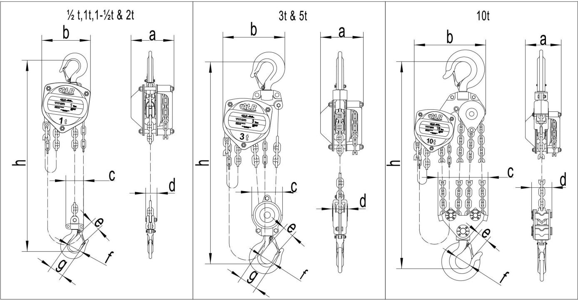

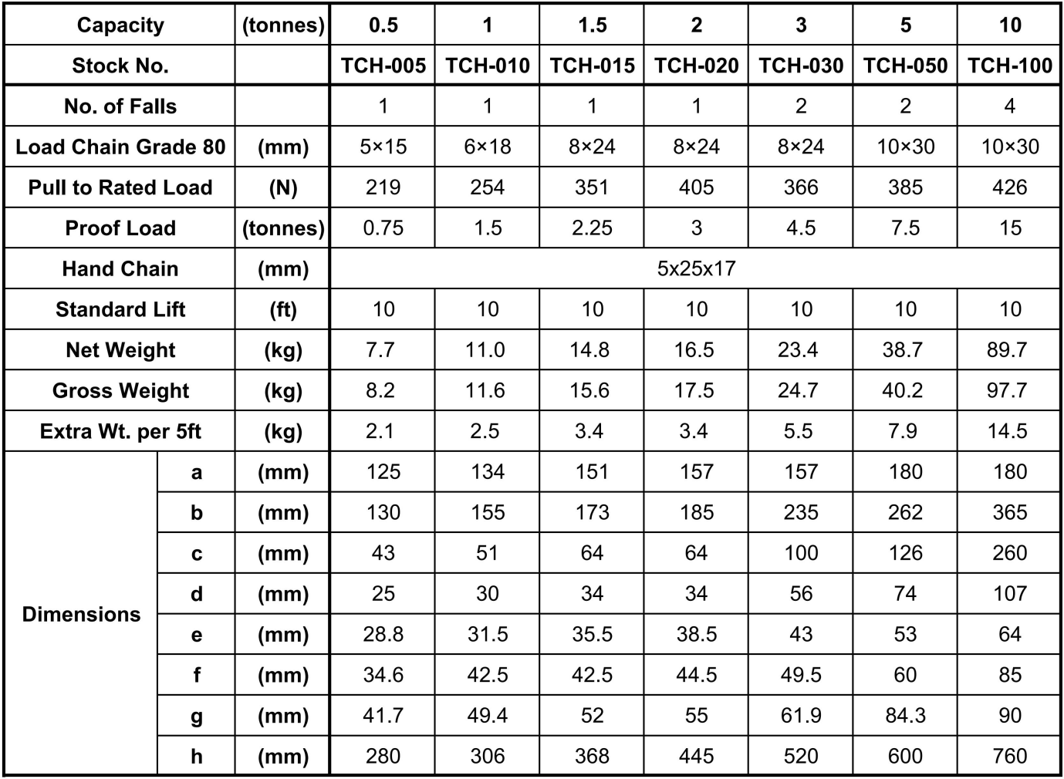

Stock Number

TCH - 010 - 10
Series TCH:
TITON CHAIN HOIST
Capacity Code: 005 = 1/2 Ton
010 = 1 Ton
015 = 1 1/2 Ton
020 = 2 Ton
030 = 3 Ton
050 = 5 Ton
100 = 10 Ton
Lift:
10 = 10ft
15 = 15ft
20 = 20ft
30 = 30ft

8.0 Using the Chain Hoist Prior to Operation
- Support for the hoist may be hook, clevis pin, trolley, or beam clamp. Whatever method of suspension is chosen, the support components must be rated equal to, or greater than the capacity of the chain hoist.
- If the chain hoist has not been used for an extended period of time, check for proper operation before putting into service.
- The brake mechanism must be kept clean and free from dirt, water, and oil. Never allow oil to penetrate the brake mechanism. Always keep your chain hoist clean and store in a clean, dry location.
- Although oiling the chain is not mandatory, a light coat of 30-weight oil applied periodically to the chain will create easier operation and prolong the life of the chain.
- Check the chain for damage and elongation. Replace damaged chain before using the chain hoist.

The load chain supplied with your ALR chain hoist is designed, manufactured, and tested for proper fit and durability. Over a period of time, the chain may need to be replaced. For your own safety, use factory replacement chain only.

Use of other than factory replacement chain may cause serious injury and/or damage to the hoist.

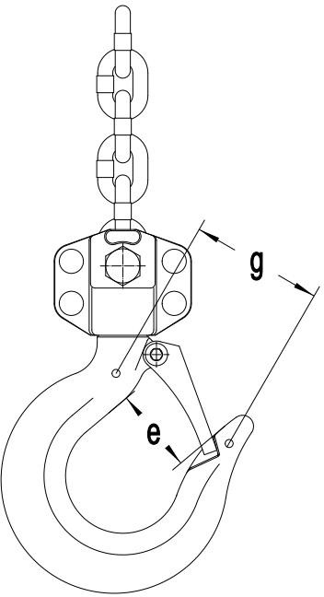
Figure 2

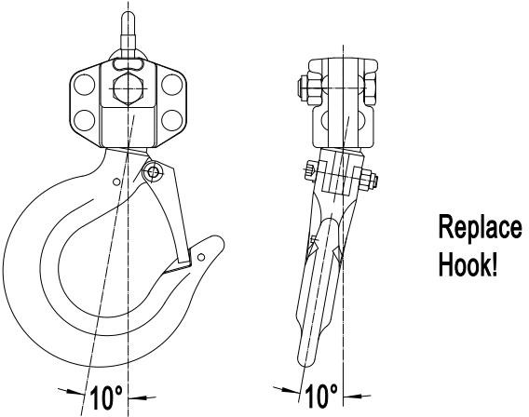

Figure 3

- The top and bottom hooks on your ALR chain hoist are designed to open to warn of an overload. Both top and bottom hooks for 0.5 to 10 ton hoists have two indicator points (g, Figure 2) cast into the hook for measurement. Refer to Table 2 (page 18) to determine if a hook needs to be replaced.
- It is important to check top and bottom hooks for proper opening. If the safety latch no longer contacts the hook opening, replace the hook.

Never side load the top or bottom hook; this practice is dangerous and could lead to serious injury.
- If the vertical angle at the neck of the bottom or top hook reaches 10°, replace the hook (see Figure 3).

9.0 Hooking the Load
- Secure the upper hook.
- Place the bottom hook securely into the object to be lifted.
- Place ropes or chain in the center of the bottom hook, making sure the safety latch is secure. Never load the hook in front of the safety latch. See Figure 4.
- Avoid lifting one load with two hoists. If this is unavoidable, apply equal weight to both hoists and use hoists with the proper lift capacity. Capacity of each hoist must be equal to the total load to be lifted.
- Check that the chain is not twisted at the bottom hook. All welds should face the same direction (Figure 5).

For hoists with two or more falls of chain, make sure the bottom hook is not turned over. This may cause the chain to twist.

10.0 Raising the Load
To raise the load, pull the right side of the hand chain (A, Figure 6) clockwise.
To lower the load, pull the left side of the hand chain (B, Figure 6) counterclockwise.
Important: Make sure the hoist has an adequate length of load chain to raise or lower the load in a safe manner. Do not attempt to lower the hoist beyond its limit.

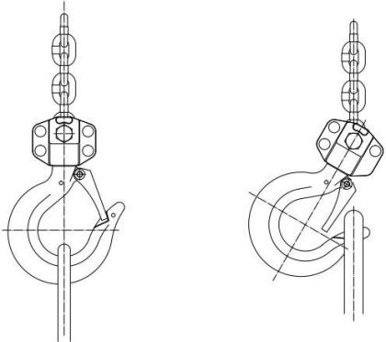

Correct Wrong

Figure 4

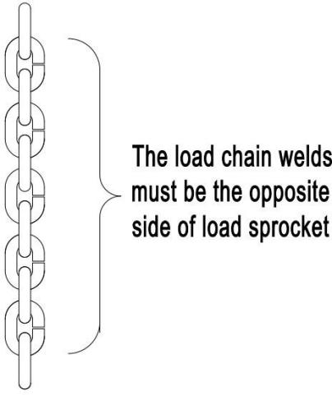
Figure 5
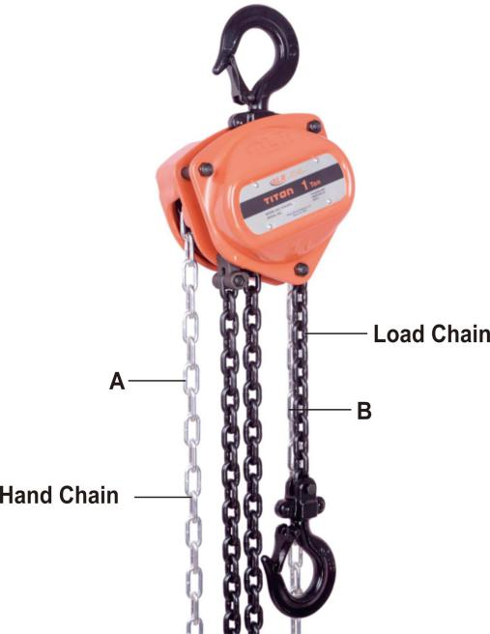

Figure 6

11.0 Hand Chain – Cutting and Installing

To cut the hand chain in order to increase or shorten:

To change the length of the hand chain, the chain must be cut and links added to increase the overall length or links removed to decrease the length. This is done as follows:

- Insert one link lengthwise into the vise (Figure 7). Be sure that the side opposite the weld lies completely below the surface of the vise jaw (about 1/3 of a link). This prevents nicking or cutting the lower part of the link.

- Using a hack saw, cut through the upper part of the link at the weld.

- Loosen the link, reposition the link vertically at the edge of the vise with the level of the cut above the vise jaw (Figure 8).

- Tighten the vise jaw.

- Using an adjustable wrench, twist the link horizontally from front to back. (Figure 9) Open just far enough to insert (or remove) a second chain link.

Note: Chain length is now ready to lengthen or shorten.

- Insert or remove the second end link at the opening in the first end link.

- Using an adjustable wrench, twist the link horizontally until the link is in the original closed position. See Figure 10.

Do not push the link inward from the curved ends. This will distort the link. Check that the link is closed and free of twist.

- If installing entire new chain, insert the end of the hand chain into the groove at the top of the hand chain wheel (see Figure 11). Rotate the hand chain wheel and pull the chain through.

- Re-weld the link at the cut.

- Grind off excess on the weld so that it is smooth.

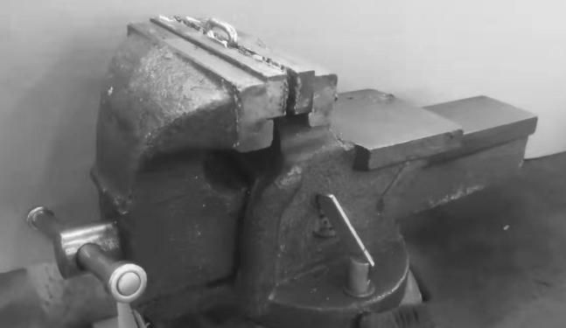
Figure 7

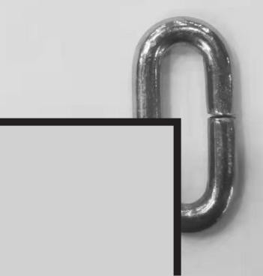
Figure 8

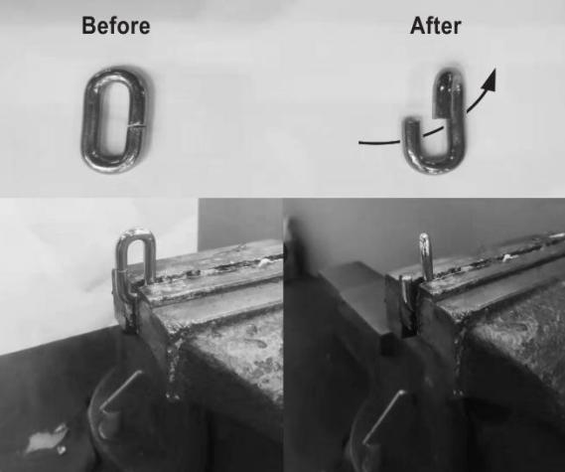
Figure 9

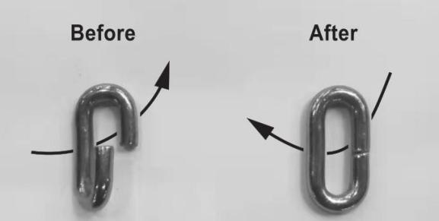
Figure 10

12.0 Load Chain and Bottom Hook

Load Chain Inspection (all models)
Over time, the load chain will wear or elongate. This can cause damage to the hoist, breakage, or non- engagement of the load sheave.

Do not operate the hoist with a twisted, kinked or damaged load chain. Do not splice the load chain. Check the chain for excessive wear or stretch. Failure to comply may cause serious injury.

- Test the hoist under load in both the lifting and lowering directions, observing the operation of chain and sprockets. Chain should feed smoothly into and away from the sprockets.
- If the chain binds, jumps, or is noisy, make sure it is clean and properly lubricated. If the trouble persists, inspect the chain and mating parts for wear, distortion, or other damage.
- Clean the chain before inspection. Examine for gouges, nicks, weld splatter, corrosion, and distorted links. Slacken the chain and move adjacent links to one side, looking for wear at the contact points. If you see wear or suspect stretching, measure the chain as follows:
  - Select an unworn, unstretched length of chain (i.e. at the slack end).
  - Suspend the chain vertically under tension and, using a caliper type gauge, measure the outside length of several links about 12 to 24 inches.
  - Measure the same number of links in used sections and calculate the percentage of the increase in length.
- If the length of used chain exceeds 2-1/2 percent of the unused chain, replace the chain. (See “Load Limits” on page 18 for specific link measurements.)

Do not add to the load chain. Replace the entire chain. Failure to comply may cause serious injury.

Load Chain Removal (all models)

Remove the old load chain as follows while referring to Figure 12:
- Remove the cotter pin (A) and the chain anchor pin
(C) on the chain anchor (D), allowing the end of the chain to fall free.
- Pull the hand chain (Fig. 6) until the load chain is completely removed from the gear assembly.

Attaching Load Chain to Load Chain Sprocket (all models)

Install the new load chain onto the load chain sprocket as follows, referring to Fig. 11:
- Position the load chain sprocket by rotating the hand chain wheel so that the wide and narrow grooves show.
- Insert the load chain into the sprocket grooves so that the chain will wind up and back over the sprocket. Welds must face away from the sprocket.

Rotate the hand chain wheel so that the load chain falls six to eight inches at the back of the sprocket.
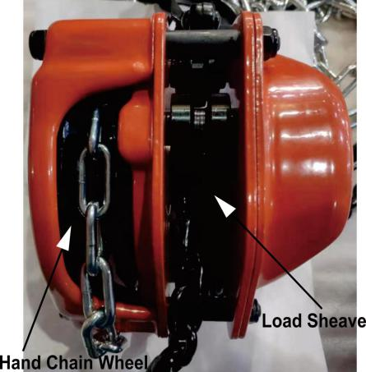

Figure 11

Referring to Figure 12:
- Insert one end of the chain link (B) into the
chain anchor (D).
- Insert the chain anchor pin (C) through the chain anchor (D) and chain link (B) and secure with the cotter pin (A).

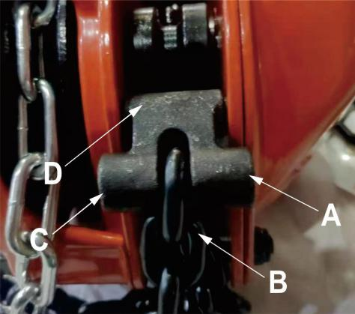

Figure 12
Continue with Load Chain and Bottom Hook Installation on the following page, proceeding to the section that applies to your hoist: 1/2- to 2-Ton , 3- to 5-Ton hoists, or 10-Ton Hoists.

13.0 Load Chain and Bottom Hook Installation
The following procedure assumes that the load chain has been attached to the chain anchor (A, Figure 12) and fed through the load chain sprocket as described in the previous section. This section completes the load chain and bottom hook installation.

Chain Installation – 0.5Ton - to 2Ton Hoists
- Referring to Figure 13:
- Remove lock nut and bolt (D) from lower hook.
- Insert the last chain link (C) into lower hook slot.
- Re-insert bolt through lower hook slot and chain link.
- Install lock nut onto bolt and tighten.

Chain Installation – 3- to 5-Ton Hoists
Referring to Figure 14:
- After installing the load chain into load chain sprocket (B), run the remaining chain through your hand to remove any twist. The last link of the chain must be in the same direction as the first. If not, cut off the last link.
- Insert the last link into pulley of lower hook (C).
- Pull load chain through and up from underside of pulley (C,D).
- Remove lock nut and chain anchor pin in upper hook slot (E).
- Insert the last link into upper hook slot.
- Check that load chain is not twisted.

Chain Installation – 10-Ton Hoist
Referring to Figure 15:
- After installing the load chain into the load chain sprocket (B), run the remaining chain through your hand to remove any twist. The last link of the chain must be in the same direction as the first. If not, cut off the last link.
- Insert the last link into the left side pulley of the lower hook (C).
- Pull the load chain through and up from the underside of the pulley (C, D).
- Insert the last link into the right hand pulley of the upper hook, moving the chain up, then around and down (D, E). Check that the load chain is not twisted and welds face away from the pulley.
- Insert the last link into the right side pulley of the lower hook, pulling around, then up from the underside of the pulley (E, F). Check that the load chain is not twisted and welds face away from the pulley.
- Remove the cotter pin and chain anchor pin in the
upper hook slot (G).
- Insert the last link into the upper hook slot.
- Check that the load chain is not twisted.

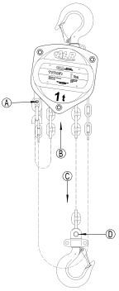

Figure 13
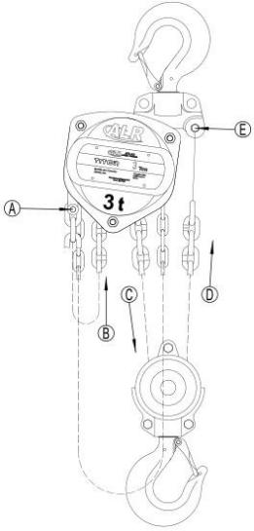
Figure 14

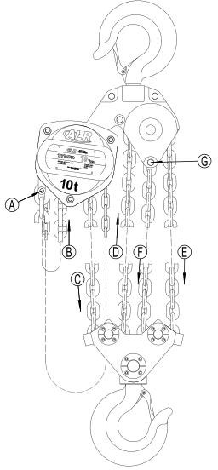
Figure 15
Re-position the chain anchor pin back through the upper hook slot and the last chain link and secure with the cotter pin.

Load Limits
  - Load Chain

Capacity | 9 Links Normal | 9 Links Limit
0.5 ton | 5.30" | 5.47"
1 ton | 6.38" | 6.57"
1.5 ton | 8.50" | 8.75"
2 ton | 8.50" | 8.75"
3 ton | 8.50" | 8.75"
5 ton | 10.63" | 10.95"
10 ton | 10.63" | 10.95"

Table 1
Carefully inspect the entire load chain. As illustrated in Figure 16, measure nine consecutive links with callipers to measure the length. Check every three feet and especially where excessive wear is indicated. Any load chain that shows noticeable deformation or heat influence must be replaced with a new one. Never extend load chain by welding a second piece to the original.

  - Hooks (Top & Bottom)

Capacit y | “g” Norm | “g” Limit | “e” Norm | “e” Limit
0.5 ton | 1.64" | 1.81" | 1.13" | 1.25"
1 ton | 1.94" | 2.14" | 1.24" | 1.36"
1.5 ton | 2.05" | 2.25" | 1.40" | 1.54"
2 ton | 2.17" | 2.38" | 1.52" | 1.67"
3 ton | 2.44" | 2.68" | 1.69" | 1.86"
5 ton | 3.32" | 3.65" | 2.09" | 2.30"
10 ton | 3.54" | 3.90" | 2.52" | 2.77"

Table 2
See Figure 17. Replace the hook when the “e” or “g” measurement is wider than “e” or “g” Limit in the table above. Never heat-treat the hook or attach anything to the hook by welding.

Brake disc
Replacement limits for brake disc.

Capacity | Load chain  column | D  (in) | d  (in) | tn  (in) | tv  (in)
0.5 ton | 1 | 1.54" | 0.87" | 0.10" | 0.06"
1 ton | 1 | 2.36" | 1.20" | 0.08" | 0.04"
1.5 ton | 1 | 2.68" | 1.40" | 0.08" | 0.04"
2 ton | 1 | 2.68" | 1.40" | 0.08" | 0.04"
3 ton | 2 | 2.68" | 1.40" | 0.08" | 0.04"
5 ton | 2 | 3.35" | 1.79" | 0.10" | 0.06"
10 ton | 4 | 3.35" | 1.79" | 0.10" | 0.06"
Table 4
d = inner diameter D = outer diameter
tn = normal measurement tv = replacement limit

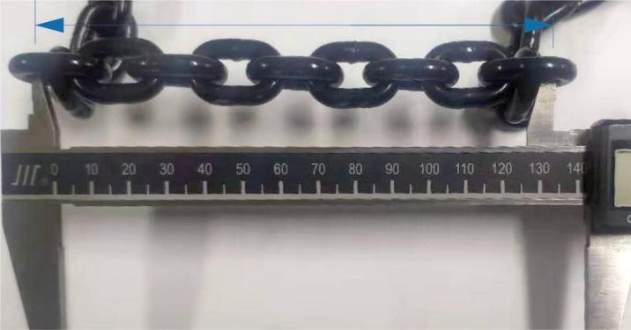

Figure 16

Figure 17

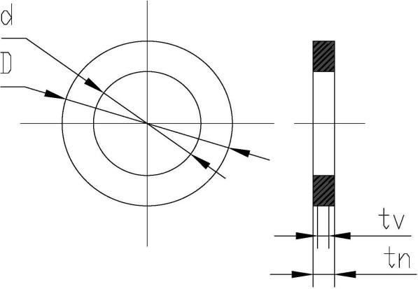
Figure 18

15.0 Timing Marks for Spur Gear Replacement
If the spur gears #12 on the TITON chain hoist need replacement or removal for any reason, make sure they are re- installed correctly. Figure 19 shows the proper orientation of the timing marks when meshing the gears.

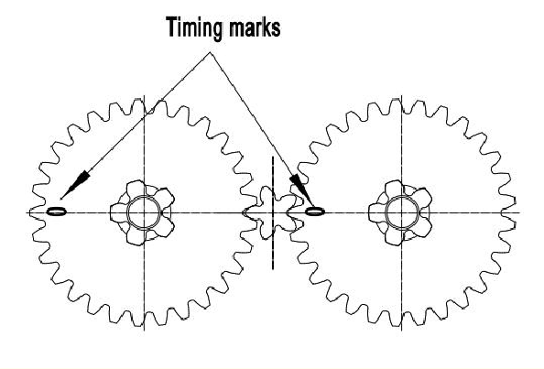

Figure 19

Replacement Parts
When ordering Parts, please provide the Hoist model number, and serial number located on the hoist name plate (see Figure 20 below).
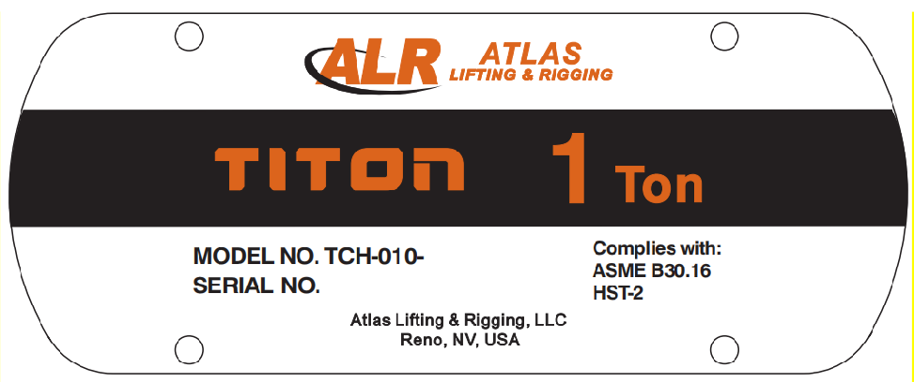
Figure 20 TITON Name Plate

Manual Chain Hoist Parts

Replacement parts are listed on the following pages. To order parts or reach our service department, call 1-833- ALR-LIFT, Monday through Friday (see our website for business hours, www.ALRLIFT.com). Having the Model Number and Serial Number of your machine available when you call will allow us to serve you quickly and accurately.

TITON Chain Hoist Parts Breakdown
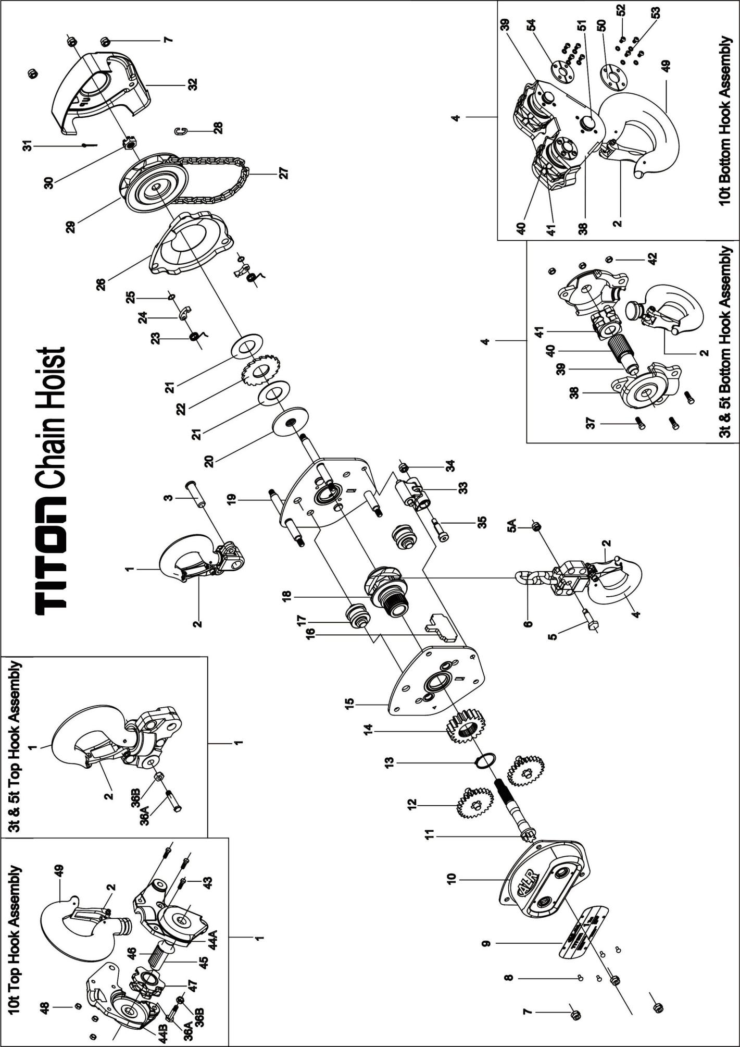

Parts List: TITON Manual Chain Hoist (1/2 Ton to 10 Ton)

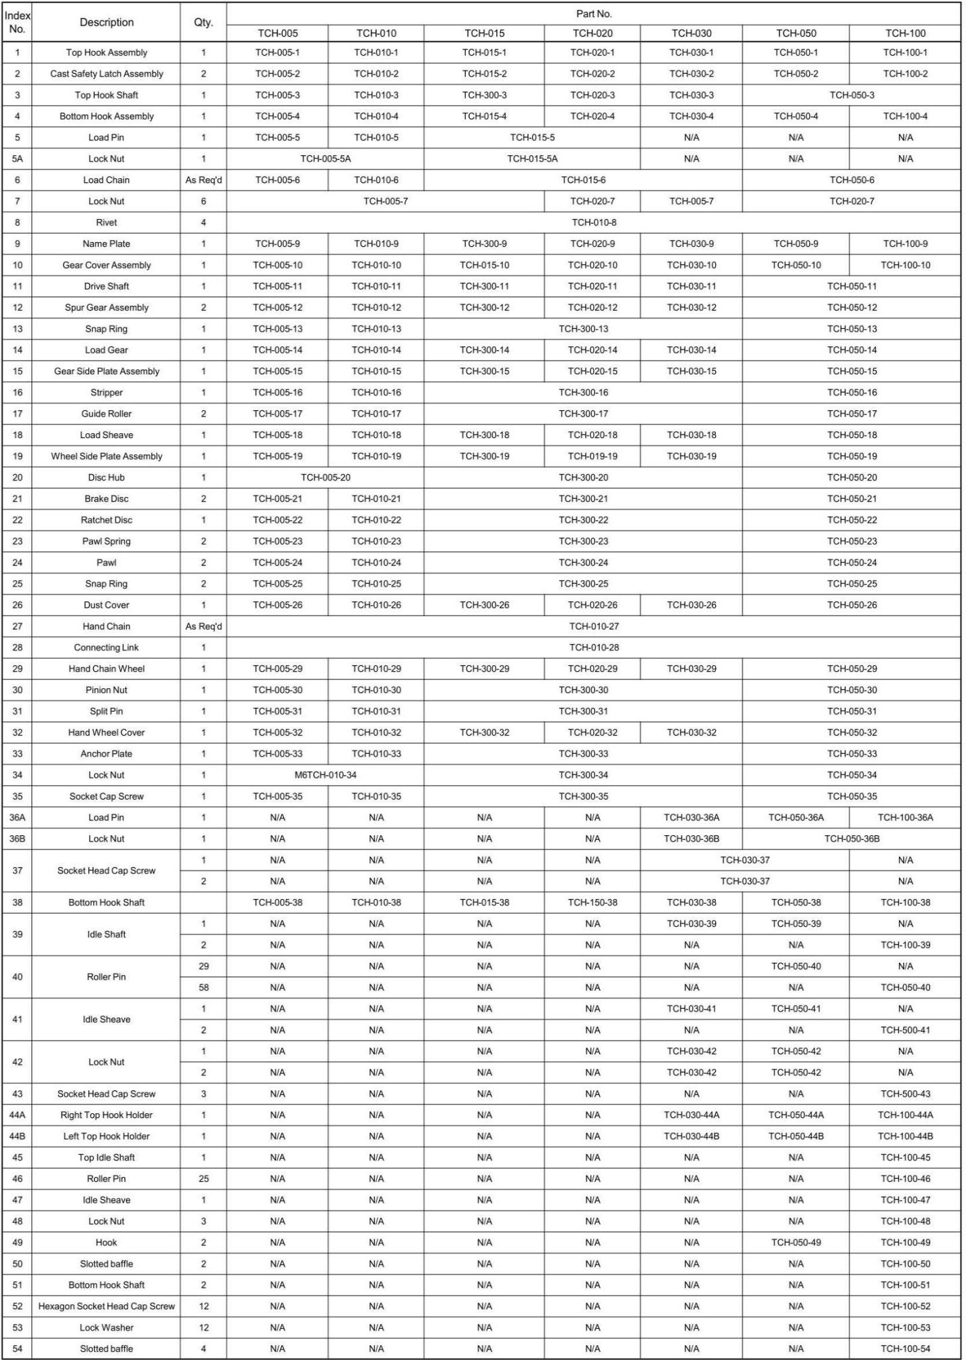

Record your purchase and installation information here

Purchased from: Date:
Serial Number: Model Number: TCH- Stock Number:
Location Installed:
Date Installed: Date in Service:

Strength - Safety – Reliability
Atlas Lifting & Rigging, LLC

WWW.ALRLIFT.COM 1-833-ALR-LIFT

