**Teacher Guide**

**Pre-Reading**

Teachers:

1. Read the Will Rogers quote that precedes the story. Tell the students that Will Rogers was an American humorist, actor, and writer. Instruct them to find his ethnicity, his place of birth and how it influenced his life, and his major accomplishments. Helpful links: <http://www.biography.com/people/will-rogers-40870>, http://www.cmgww.com/historic/rogers/ and http://www.willrogers.com/ .
2. Instruct the students to write a paragraph in which they define or interpret Rogers’ statement. They should begin by stating the phrase to be defined. The paragraph should include their personal thoughts on the phrase. It may be helpful to give students sentence stems such as “What the author means is…,” “This statement makes me think…,” or “I (don’t) agree with this statement, because…”

**Extension for Christian Classrooms:**  Readaloud **Psalm 1:1-2** *Happy are those who*

*reject the advice of evil people, who do not follow the example of sinners or join those who have no use for God. Instead, they find joy in obeying the Law of the Lord, and they study it day and night.* Will Rogers was giving the advice that we should not do things that we are ashamed of. Psalm 1:1 gives us some very specific advice that will help us make good decisions in life, decisions that we are not ashamed of later. Discuss this passage.

**Introduction**

Teachers:

Introduce the story by reading the brief introduction following the title. Use the discussion questions below to guide the class discussion.

1. Can you think of some possible unexpected results?
2. Can you think of any other tricks or skills that you might teach a pet?
3. Have you ever told someone a secret with unexpected results?

**Reading the Story**

Teachers:

1. Instruct the students to write a journal reflection comparing the characters of Mom and Dad.
2. Instruct the students to keep a list of unfamiliar words or phrases and figurative language in their reading journal and ...

* Share the words and phrases in small groups or with a reading buddy. Tell them to try to determine the meanings by reading in context.
* Look up the words in a dictionary and determine if they were right about the meanings? Have them write a synonym for some of the words and phrases.

Note: Words and synonyms may be added to classroom word walls.

**Post-Reading**

**Discussion:**

1. Utilize the questions in *Discover and Discuss: The animal as a character,* page 87*.*
2. Ask: What qualities make a good pet for children? Have them compare the kinds of care different pets require.
3. Discuss Sophie and Noah. Ask the students: What characteristics do Sophie and Noah have? Tell them to support their statements with evidence in the story.
4. Mrs. Cavendish named her parrot for famous authors. Ask: What do you think is a good name for a parrot? Why?
5. Ask: If you come home and see clues that someone has entered the house without your knowledge, what should you do? What are some possible indicators of unauthorized entry?

**Extension for Christian Classrooms**

1. We find birds mentioned several times in the Bible. Read **Luke 12:6** *Are not five sparrows sold for two pennies? And not one of them is forgotten before God. But the very hairs of your head are all numbered. Do not fear therefore; you are of more value than many sparrows.*
2. What is the lesson we learn from this passage? (God takes care of the little birds which aren’t worth much. He knows everything about you, so you don’t need to worry. He will take care of you.)
3. Find other passages that mention birds. Read them and discuss the lessons we learn from studying the birds in the Bible. Two examples follow:
4. **Job12:7 and 9** *Ask . . .the birds of the heavens, and they will tell you . . . Who among all these does not know that the hand of Jehovah has done this?* (God is the creator)
5. **Jeremiah 8:7** *Even the stork in the sky knows its seasons; The turtledove and the swift and the thrush keep to the time of their return*. (Even the birds know our wisdom and knowledge comes from God.)
6. **Bible Verse to Memorize**: **Isaiah 40:31** *But those who hope in the Lord will renew their strength. They will soar on wings like eagles; they will run and not grow weary, they will walk and not be faint.*

**Activities:**

Let the students collaborate with a reading buddy or in a small group to determine if the story supports Rogers’s statement. Instruct them to write an independent paragraph giving their opinion supported with reasons and information.

**Reading Extensions and Enrichment**

1. **Connecting Across the Curriculum with Mathematics and the Arts**

Teachers: Instruct students to follow your directions for constructing an **origami** parrot, (Directions included at end of lesson plan) **or** have students follow the written directions to construct the parrot.

1. **Project #1**

Teachers: Let the students work in small groups to construct a concept map about parrots. Begin by writing the word ***parrot*** in the center of the poster or plain paper.

* Brainstorm related concepts and put those on the paper with the central concept.
* Connect the concepts by drawing arrows and using words to describe relationships.
* Symbols and images may be used if desired.

**Hint**: It may be helpful to use post it notes while organizing the map.

For more information, see https://library.usu.edu/instruct/tutorials/cm/CMinstruction2.htm .

1. **Writing Project #2**

Teachers: Instruct students to write a limerick poem or a monorhyme. The limerick should have five lines with the first, second, and fifth lines rhyming with one another and the third and fourth rhyming with each other to form the pattern AABBA. Limericks usually have a distinct rhythm too. For more information, see http://www.poetry4kids.com/blog/lessons/how-to-write-a-limerick/. A monorhyme is a poem in which the end rhyme of each line is the same. Students should write a minimum of four lines.

1. **Project #3**

Teachers: Instruct the students to write a brief story from the burglar’s point of view. Possible questions to answer: How did he or she enter the house? Then what happened? Why and how did the burglar leave? Tell them to choose a character and publish on Voki.com. (Limited amount of text on voki) Link: http://www.voki.com/create.php.

1. **Imagination Project #4**

Teachers: Conduct Synectics Thinking Activity using the word **Pet.** (Directions included at the end of lesson plan.)

**Closure**

Instruct the students to complete one of the following sentence stems:

* Today I stopped learning because…
* Today I was confused about…
* Today I learned…
* One awesome thing today was…

**Parrot**

**Materials:** Origami paper (available online or at hobby stores), scissors

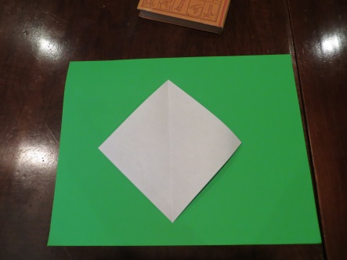 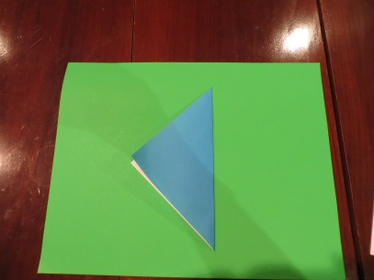 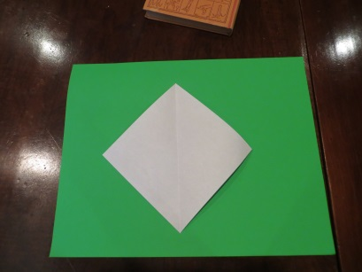

Start with a square Fold in half. Open.

piece of paper.

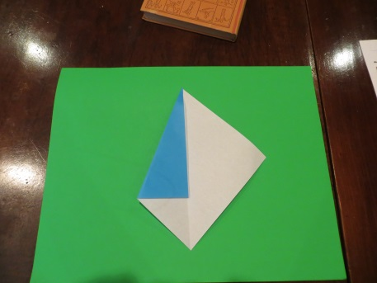 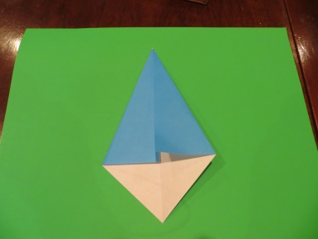

Fold in sides to meet center line.

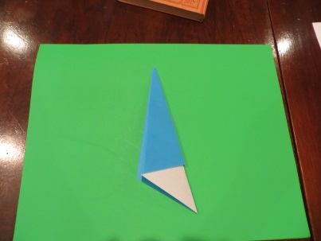 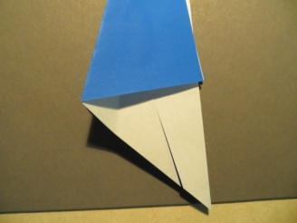 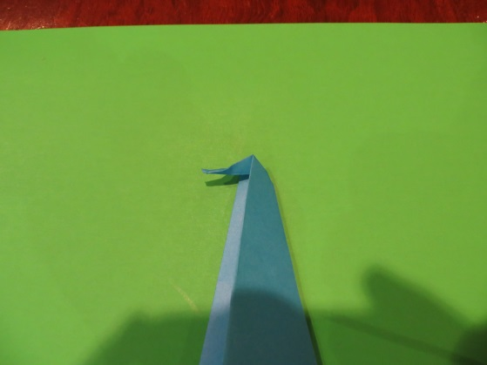 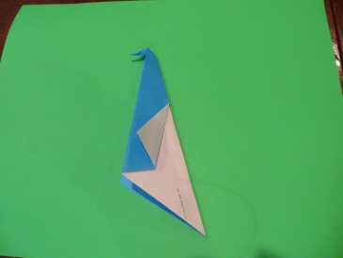

Fold back along Cut upward from Fold top point down. Push down so paper center line. bottom as shown folds inside to form

(about 1 1/2 inch). beak.

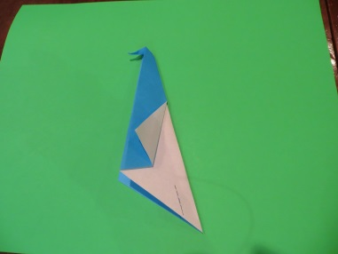 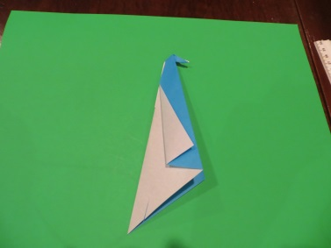 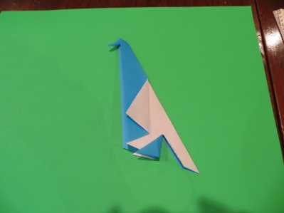 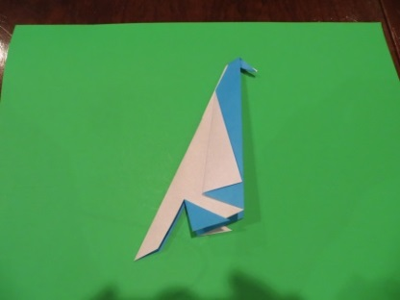

On both sides, fold side points On both sides, fold front cut edge

forward to make wings. forward to form legs.

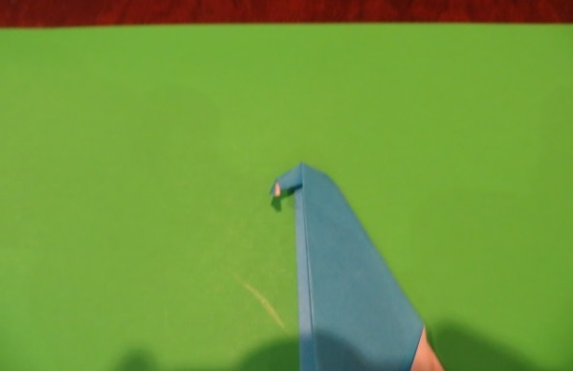 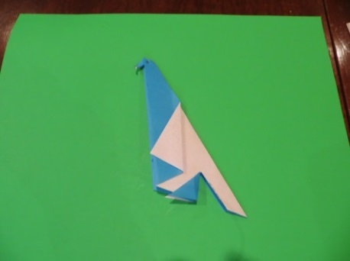

Fold down tip on beak. Draw on eyes to finish the parrot.