NOTICE
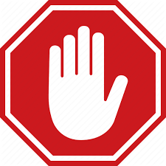
Screening for COVID-19
PLEASE DO NOT ENTER THE BUILDING
WITHOUT ANSWERING THE FOLLOWING QUESTIONS

Do you have any of the following symptoms: fever/feverish, new or exacerbation of chronic cough?

Have you returned from travel outside of New Brunswick since March 24, 2020 or outside of Canada within the last 14 days?

Have you had close contact within the last 14 days with a confirmed case of COVID-19?

If you answered YES to question 1, 2 or 3, self-isolate at home. If you have or develop symptoms, call 811

- Have you had close contact within the last 14 days with a person being tested for COVID-19?

If you answered YES to question 4, you may enter the building however you must self-monitor for symptoms. If symptoms develop, self-isolate at home and call 811.

