The Three Horseshoes

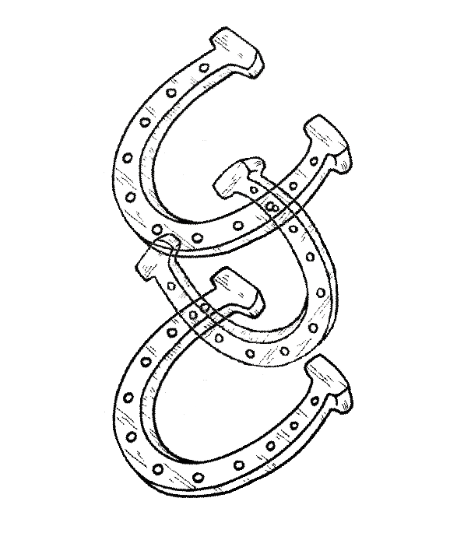

**BAR SNACKS & LIGHT BITES**

SANDWICHES, TOASTIES AND BAGUETTES

All served with mixed side salad and crisps

Sandwich/wrap Toastie Baguette

**Tuna Mayonnaise** £5.50 £6.00 £6.95

**Prawn mayonnaise** £6.00 - £7.50

**Mature farm house Cheddar** £4.00 £4.50 £5.25

**Hand carved ham**  £4.50 £5.25 £6.00

**Ham & cheddar** £5.50 £6.00 £6.95

**Chicken, bacon & Mayonnaise**  £6.00 £6.75 £7.50

**Sausage & caramelised onion** £6.00 £6.75 £7.50

**Brie & Bacon** £5.50 £6.00 £6.95

**Fish finger & Tartar** £5.50 - £6.50

**Coronation chicken** £5.50 - £6.95

JACKET POTATOES Served with a side salad

**Tuna Mayonnaise** £6.95

**Cheese** £5.95

**Baked beans** £6.50 **Add cheese** £6.95

**Chilli con carne** £7.95

**Prawn Mayonnaise** £7.95

**Coronation Chicken** £7.95

Add cheese 50p | Add bacon £1.00

LIGHT BITES

**Camembert**, baked with garlic & rosemary served with red onion chutney & toasted baguette (V) £5.95

**Mozzarella,** tomato, basil, balsamic dressing and salad **(v)** £4.95

**Halloumi Chips** with pitta served with garlic mayo, BBQ OR chilli sauce £5.50

**Parma ham & Melon served with rocket** drizzled with balsamic glaze £5.50

**Prawn Cocktail** with mary rose sauce served with brown bread £7.95

**Peppered salted squid** with a sweet chilli dip £6.50

**Breaded white bait** with buttered brown bread £5.50

**Garlic Bread** made from warm baguette & garlic butter £2.95

Add: Cheddar £0.50

**Breaded button mushrooms** with a garlic mayo (V) £4.95

**Homemade potato wedges**, baked with bacon and cheddar served with sour

cream £6.95

**Share Platter For Two**, garlic bread, squid, breaded mushrooms, scampi, spring rolls…..served with sweet chilli and mayo dips £10.95