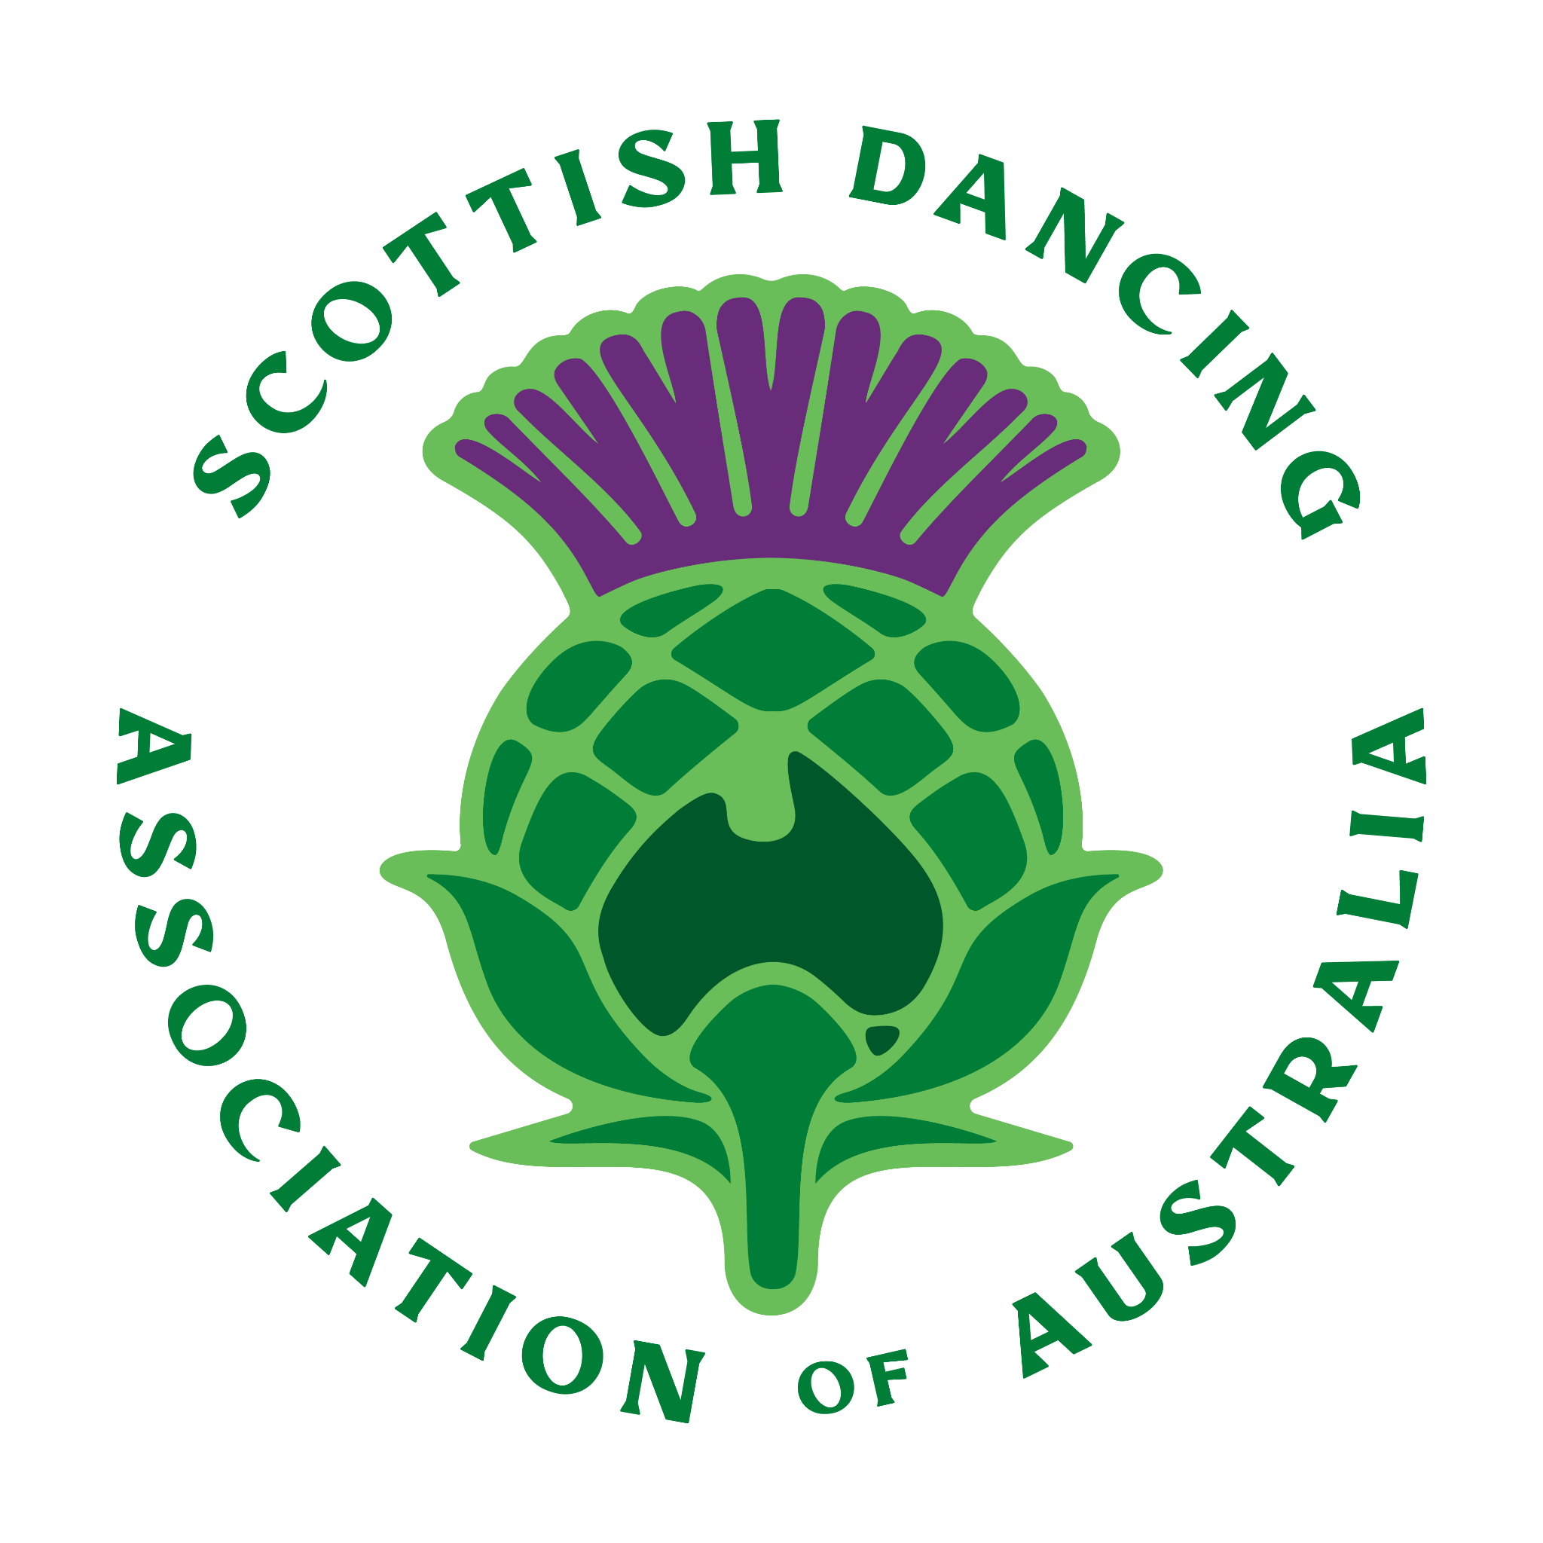

**SCOTTISH DANCING ASSOCIATION OF AUSTRALIA**

CODE OF CONDUCT FOR MEMBERS OF THE SDAA

In this Code “Participant” means any organisation, body, association or individual with full or associate membership; any individual who is a member of an organisation, body, or association with full or associate membership; any person directly connected to a body or individual who is a member of the SDAA.

GENERAL BEHAVIOUR

1. Participants will display honesty, fairness, and equality of opportunity in all relationships.

2. Participants will not engage in behaviour which undermines the status and esteem of Highland Dancing.

3. Participants will recognise the authority of judges and examiners.

4. Participants will recognise the authority of all officials and treat them with courtesy.

5. Participants will treat all other participants with respect and always show sportsmanship.

6. Participants will not discriminate between other participants on the grounds of gender, ethnic background, religion, ability, or sexual preference.

7. Participants should respect the competence of teachers, examiners and judges and should not engage in public criticism of other participants.

8. Participants will not compromise the integrity of any result by seeking to influence any official decision.

9. Participants will respect the confidentiality and privacy of all information as it pertains to participants.

WELL BEING OF DANCERS

10. Participants will recognise the safety and well-being of the dancer and accept that the health of the dancer is always more important than results.

TEACHERS

11. Teachers will provide training for all dancers and the opportunity to participate in exams, competitions, workshops, performances, and other related activities.

12. Teachers will recognise a duty of confidentiality in their relationships with dancers. 13. Teachers will not compromise dancers by advocating an unfair advantage. 14. Teachers will not seek to persuade dancers to change teachers.

15. Teachers will encourage, preserve, and promote Highland Dancing as set down by RSOBHD, ABHDI and SDAA.

QUALIFICATIONS AND EXPERTISE

16. Teachers / Judges / Examiners will undertake continuing professional development to maintain their qualifications and expertise.

FAILURE TO COMPLY

17. Participants, who do not adhere to the above, will be subject to disciplinary action up to and including termination of membership as decided by the Disciplinary Committee.

18. Participants who become aware of conduct which causes concern, should report it to the President or Management Committee member immediately. Any reporting that is done in good faith will not be subject to retaliation, retribution, or other recriminations for making that report.

NAME OF SCHOOL....................................................................................................... (If applicable)

HEREBY ADOPT THIS DOCUMENT ON BEHALF OF ALL TEACHERS WITHIN THIS SCHOOL.

This Code of Ethics to be signed by all teaching faculty within the school. Principal Teacher / SDAA Member

...................................................................................................................... Name and Signature

Additional teachers:

....................................................................................................................... Name and Signature

Additional teachers:

....................................................................................................................... Name and Signature

Please sign and return to membershipsdaa@gmail.com