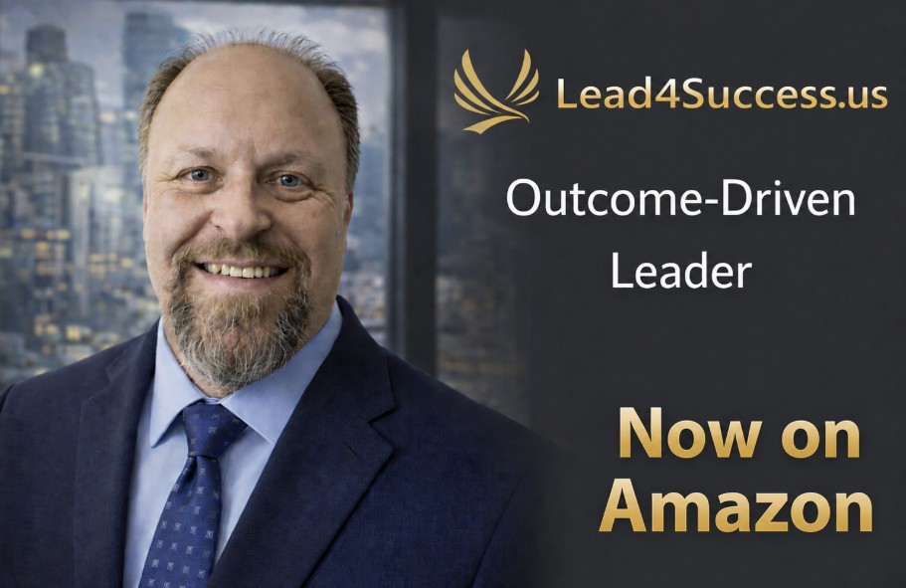
Transforming Leadership Activity Into Measurable Outcomes
Lead4Success.US helps organizations improve leadership effectiveness, employee engagement, accountability, execution, and operational performance through executive coaching, strategic consulting, fractional executive services, keynote speaking, workshops, webinars, and organizational assessments.
Founder Dr. Richard Pater is an executive coach, consultant, keynote speaker, author of 'Outcome-Driven Leader' on Amazon, Lean Six Sigma Black Belt, Change Management Practitioner, and leadership development expert with decades of experience helping organizations achieve measurable results.
Services Include:
• Organizational Assessments
• 45-Day and 90-Day Action Plans
• Fractional CEO/Executive Services / Retainer
• Executive Coaching
• Leadership Development
• Employee Engagement Strategies
• Change Management
• Keynote Speaking, Workshops, Webinars, and Podcasts
Contact:
Dr. Richard Pater
Lead4Success.US
info@lead4success.us

