SpinCoin Whitepaper
FULL DESIGN — Logo, Charts, TOC, Branding

Table of Contents
- 1. Executive Summary
- 2. Problem Statement
- 3. SpinScore Engine
- 4. Truth-Mining Rewards
- 5. Tokenomics
- 6. Governance
- 7. Security Architecture
- 8. Roadmap
- 9. Conclusion

Executive Summary

SpinCoin is a decentralized truth-incentive protocol...

Problem Statement

Modern media ecosystems reward outrage and manipulation...

SpinScore Engine

Evaluates bias, sentiment, framing, and fallacies...

Truth-Mining Rewards

Users earn SPIN by exposing misinformation...

Tokenomics

Supply 1B — structured distribution...
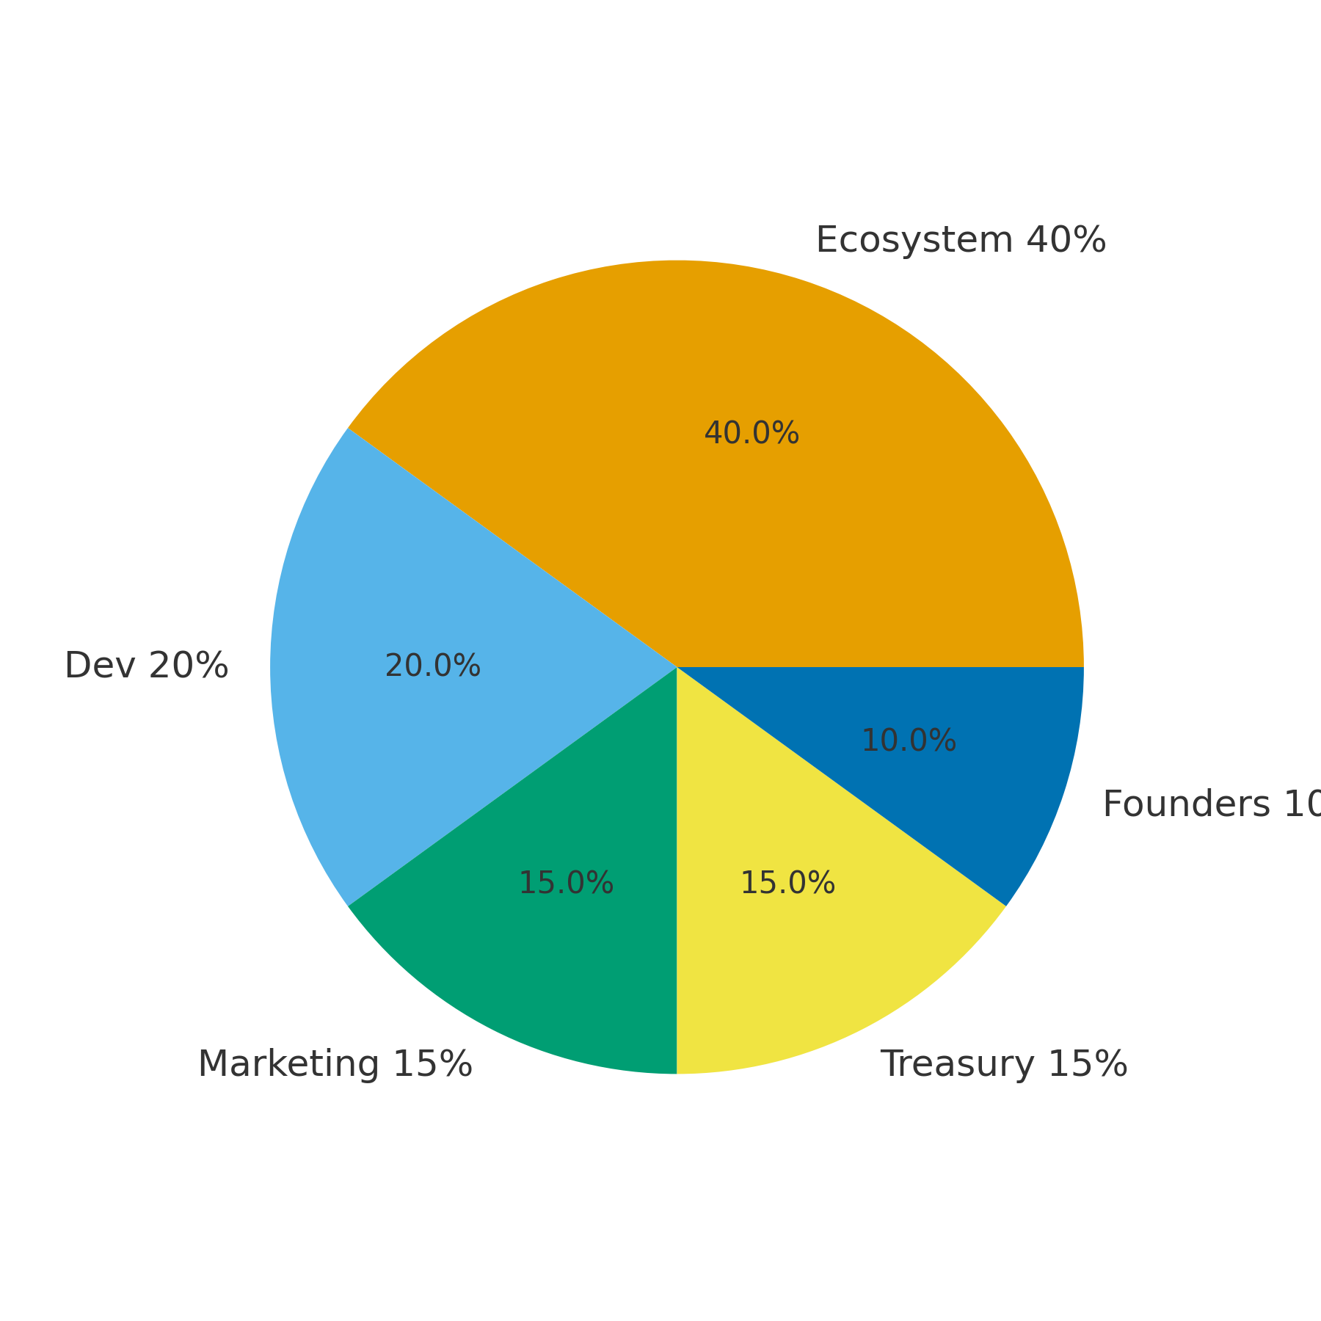

Governance

DAO community voting...

Security Architecture

Encrypted identity and adversarial AI...

Roadmap

Phase 1 → Phase 2 → Phase 3 → Phase 4...
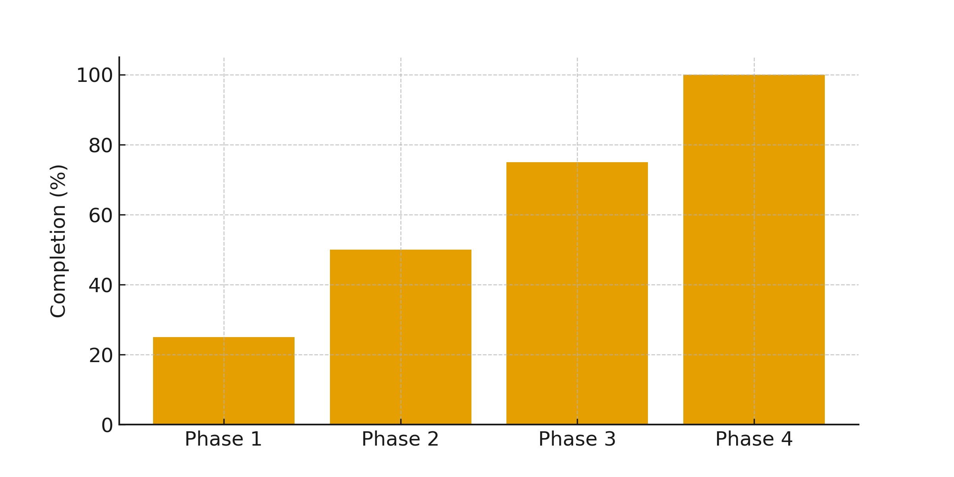

Conclusion

SpinCoin reframes truth as a global asset.

