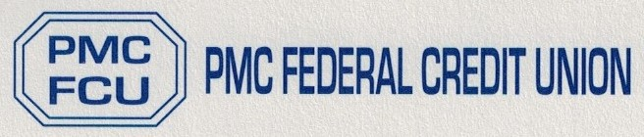

To our valued members:

We are here for you! At this time, LVH-Pocono has limited access within the medical center from the outside. If you are not in house and need to make a withdrawal from your account, please call 570-476-3338 to speak to our Teller to have your check mailed to you or if you have a friend or family member working in house to pick up for you.
We are currently working on our regular scheduled hours 7:00 am – 4:00 pm. However, in the event things change, we will update you via email and website www.pmcfcu.org.
Feel free to contact me with any questions or concerns at afrailey_pmcfcu@verizon.net.
Stay vigilant in following the CDC recommendations to help decrease the spread of disease.

Best Regards,

Annette Frailey
Manager/Financial Officer
PMC Federal Credit Union

