

**CCPA PRIVACY POLICY**

**Introduction**

California Consumer Privacy Act (CCPA), also called AB 375 is a privacy law for the residents of California, United States. This privacy act bestows on California residents the right to know what personal information is collected about them and how it is collected. They also have the right to erase their personal information if they decide to and have the power to say “no” to sell their personal information as well.

L2B Media respects all these rights and strictly abides by all the rules entailed.

**How we collect data and use it**

We gather your data when you choose to share your information with us while signing for any online resources, from customer relationship management system or from surveys we conduct for better understanding of both our audience and the market. Our business partners may also provide us with such information. We only seek the information that is needed as in the case of blogs- just your name and email address. L2B Media gives you an option to not accept the cookies. We, however, don’t use cookies to capture data.

We take data protection very seriously and are extremely diligent and swift when it comes to data privacy. Not just our data team but all our teams have been trained in data protection. Every new employee is walked through data privacy compliance as well. We choose to be transparent. We respect your privacy and all the data we collect is to provide you a better experience and for business purposes. For kids below the age of 13, Guardian’s consent will be needed to opt-in.

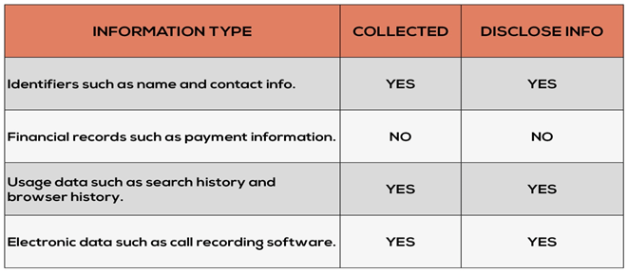

We use data to work out our marketing strategies and to drive results in various marketing services such as lead generation, account based marketing, and for evaluating digital channels. We derive the data through website, registration forms and social media platforms accessed on computer, tablet as well as mobile.

**How to know it’s you**

For obvious reasons, it’s crucial for us to know that you are the one who has raised the request for data move, change or deletion. In such cases, it’s best to confirm the identity with the way we obtained the information initially. For instance, if you signed in for the newsletter with an email, we would confirm your identity with an email via you from the same email address.

**Non-discrimination**

We won’t discriminate customers on any basis, regardless of whether you choose to opt-out or not. It’s completely a matter of your choice and your choice matters! We promise to give our customers a fair treatment.

**Your rights under CCPA**

* The right to know what personal information is collected, used, shared or sold, both as to the categories and specific pieces of personal information;
* The right to delete personal information held by businesses and by extension, a business’s service provider;
* The right to opt-out of sale of personal information. Consumers are able to direct a business that sells personal information to stop selling that information. Children under the age of 16 must provide opt in consent, with a parent or guardian consenting for children under 13.
* The right to non-discrimination in terms of price or service when a consumer exercises a privacy right under CCPA.

**Exercise your right**

We understand if you choose to know, move, opt-out or erase your personal information.

You can mail us at – [info@l2bmedia.com](mailto:info@l2bmedia.com)

**We will be prompt with the response!**

To opt-out or get your data erased, Click on- **Opt Out/Erase my Data**

If you are not okay with sharing your personal information for business purposes, Click on- **Do not Sell My Personal Information.**

**Reach out to us –**

Email- **info@L2bmedia.com**

Address- **16-4, ITPL Main Rd, near Ryan International School, Kundalahalli, Brookefield, Bengaluru, Karnataka 560037**