LIFE SAFETY AND FUEL FIRED APPLIANCES

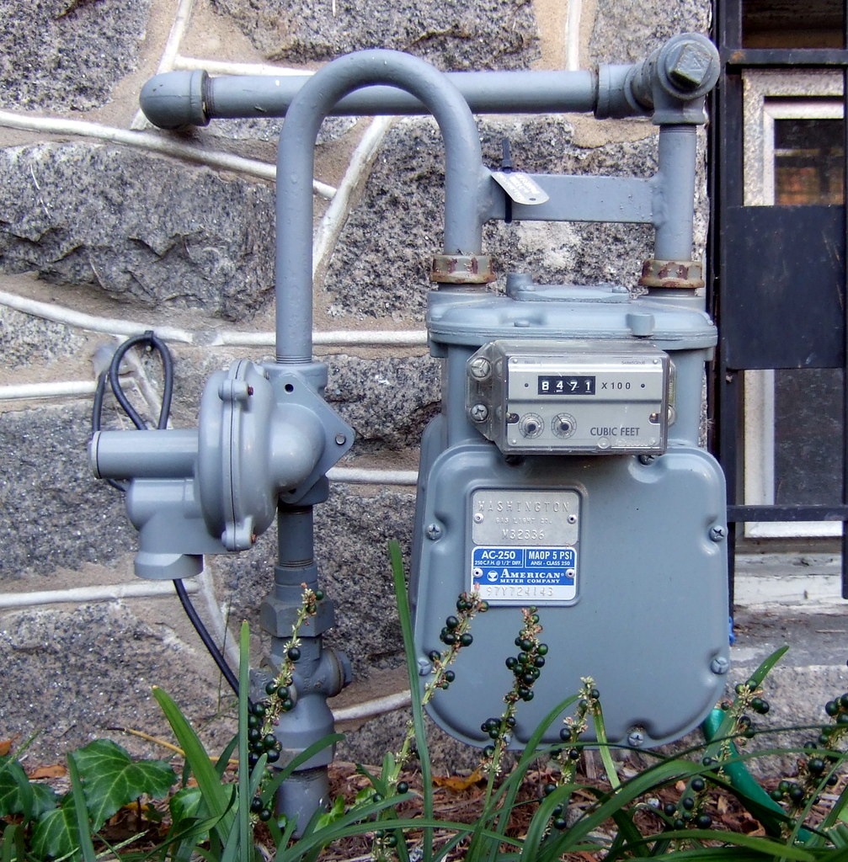

JIM PILLOW, INSTRUCTOR

MCP, CBO, CFM

November 14, 2024

8:00 a.m. to 4:00 P.M.

Sponsored by Tennessee Plumbing and Mechanical Inspectors

(TPMIA)

**GREATER DICKSON GAS AUTHORITY**

**TRAINING ROOM**

**605 EAST WALNUT STREET**

**DICKSON, TN. 37055**

SFMO Recertification 7 hours # 3508

ICC Recertification 7 hours # 43587

Course Free to TPMI Members

TPMIA annual membership is $100 per organization

This course is an excellent course for inspectors trying to prepare for the International Mechanical Code or the Residential Mechanical Code Certification Exams. It is also an excellent review for gas inspectors preparing for examinations. Based on the 2018 IFGC and 2018 IRC

REGISTRATION FORM

To schandler@gdga.com

Name: ___ _______________________________________

Jurisdiction: ________________________________________________________

Address: ___________________________________________________________

Phone: _________________________ Email: ______________________________

Fax: _______________________________________________________________

No charge to TPMIA members but students should pre-register, to insure adequate class handout materials. Dues may be paid at the door.

Students should bring the 2018 IFGC, a highlighter, red Flair marker, and a good sense of humor.