

*St. Mary Menomonee Falls enjoys a long tradition of hosting top quality boys’ and girls’ basketball tournaments.*

2024-2025 TOURNAMENT DATES

All tournaments are played Thurs, Sat, Sun unless otherwise noted

* - Denotes Sat, Sun, Mon tournament

# [6](https://forms.gle/8aAtnj8tvqrGoizD8)[th](https://forms.gle/8aAtnj8tvqrGoizD8) [Grade Boys](https://forms.gle/8aAtnj8tvqrGoizD8)

# [8](https://forms.gle/LdcApfXftQEdgMMi8)[th](https://forms.gle/LdcApfXftQEdgMMi8) [Grade Boys (A)](https://forms.gle/LdcApfXftQEdgMMi8)

# [7](https://forms.gle/nU5bHYX1iYkMSgpQA)[th](https://forms.gle/nU5bHYX1iYkMSgpQA) [Grade Boys (A)](https://forms.gle/nU5bHYX1iYkMSgpQA)

# [5](https://forms.gle/yP1u2rbsSGBJrgxX6)[th](https://forms.gle/yP1u2rbsSGBJrgxX6) [Grade Boys](https://forms.gle/yP1u2rbsSGBJrgxX6)

# [5](https://forms.gle/MQSBTZpZE6YXz3aXA)[th](https://forms.gle/MQSBTZpZE6YXz3aXA) [Grade Girls](https://forms.gle/MQSBTZpZE6YXz3aXA)

# [8](https://forms.gle/1jPBuG7dfB7cGDkS6)[th](https://forms.gle/1jPBuG7dfB7cGDkS6) [Grade Boys (B)](https://forms.gle/1jPBuG7dfB7cGDkS6)

# [7](https://forms.gle/22LasGX6yQn7v6Z17)[th](https://forms.gle/22LasGX6yQn7v6Z17) [Grade Girls (A)](https://forms.gle/22LasGX6yQn7v6Z17)

December 12th,14-15

January 9th,11-12

January 16th, 18-19

January 23rd, 25-26** February 1st-3rd*

February 6th, 8-9

February 27th, Mar.1-2

Click hyperlinks for the tournament entry forms

# GAME TIMES

Thursday/Monday games start at 5:30 - last game at 8:30 Saturday games start at 6:00 - last game at 9:00

Sunday games usually start at 1:00 - last game at 4:00

*Sunday start times may deviate slightly if significant conflicts occur*

*\* -* Denotes Saturday - Monday scheduling

** - Denotes Sunday games starting at 3pm due to School’s Open House

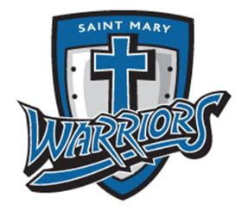



# TOURNAMENT RULES

* Traditional 8-team bracket, when possible.
* Three games guaranteed
* Notre Dame/Don Bosco Basketball League rules except for clock rules.
* Games will consist of two 18 minute halves with running clock. Clock will stop in the last 2 minutes of the 2nd half, unless the score difference is greater than 15 points.
* Schools may not combine teams. Tournament roster MUST match league roster
* Teams must verify their availability for date and times listed.
* Games will not be rescheduled after brackets are set .
* B team status or league record will allow entry in B tournaments
* If school is cancelled the day of a tournament, that day’s games will typically be rescheduled unless notified that games are still on.

# AWARDS

* Team Championship Trophy to 1st Place
* Individual Medals for 1st Place, 2nd Place and Consolation Champions
* Free popcorn for each player

**ENTRY FEE -** $200 

Please click the hyperlink on the previous page to submit the online tournament entry form. Once tournament entry is confirmed, **please send a check within one week of confirmation,** made payable to “St. Mary’s Athletics”, and sent to:

Mike Micallef

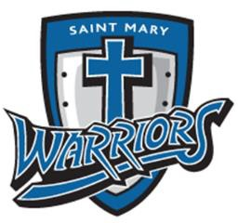11335 N. Ashbury Woods Dr.

Mequon, WI 53097

Please email [stmarybbtourney@gmail.com](mailto:stmarybbtourney@gmail.com) with any questions.