35th Annual

ST. LUCY / DAN BIESACK MEMORIAL

BASKETBALL TOURNAMENT

for

6th, 7th & 8th Grade Boys
and
6th & 7th Girls Teams

Sponsored by: St. Lucy Athletic Association &

All Saints Athletic Association

January 3rd – 7th, 2022 ( 7thGirls)
January 8th -14th ( 6th Girls)
January 3rd – 7th, 2022 ( 6th Boys)
January 10th -14th (8th Boys)
January 17th -21st (7th Boys)

Registration Deadline:

Wednesday, November 30, 2022

Tournament Locations:

St. Lucy Gym (Boys)

All Saints Gym (Girls)

Tournament Dates

January 3rd – 21st^{th}

Tournament Divisions

6th Grade Boys 5/6th Grade Girls
7th Grade Boys 7th Grade Girls
8th Grade Boys

Entry Information
Entry Fee - $140.00

Please make checks payable to St. Lucy Athletic Association.
Entries must be received by Wednesday, November 30, 2022

Entries will be taken on a first-come, first-served basis.
We will take the first 8 teams in each grade level.

Send team rosters and entry fee to:
St. Lucy School
St. Lucy / ASCS Dan Biesack Tournament
3035 Drexel Avenue
Racine, WI 53403

E-mail to msepanski@yahoo.com may be considered if payment is promptly
made at St. Lucy School or dropped off at the above address

Site Location and Contact Information

St. Lucy Gym
3035 Drexel Avenue
Racine, WI 53403
Contact: Matthew Sepanski- msepanski@yahoo.com

All Saints Gym (Hosted by All Saints)
4500 22nd Avenue
Kenosha, WI 53142
Contact – Matthew Sepanski – msepanski@yahoo.com


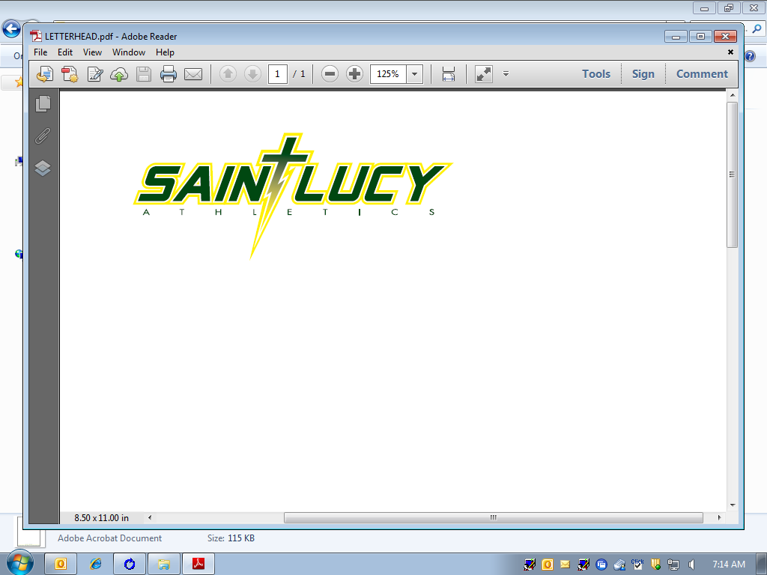

RULES FOR THE TOURNAMENT PLAY

1. Only players already on team league rosters are eligible to
participate. No All-star teams.

2. Games will consist of 2 – 16 minute halves in length
with the clock running throughout the game except: during
time-outs, injuries, shooting fouls and on all whistles during
the last two minutes of each half. A 15 point slaughter rule
will also be used.

3. Teams are permitted 3 time-outs per game. 1 additional for OT

4. Alternating possession in lieu of jump balls is in effect.

5. The bonus rule for free throws will go into effect on the 7th
team foul per half. Double bonus will be shot on the 10th
team foul.

6. Free throws for offensive fouls will not be shot.

7. The 3-second in the lane violation rule will be in effect.

8. 6th, 7th and 8th grade boys and girls may play zone or man-to-man
defense.

9. 6th,7th and 8th grade boys and girls may press at any time.

10. In the event of a tie game, over-time periods will be three
minutes in length.

11. All teams are guaranteed 2 games.

12. All other rules will follow SSPL Rules.

12. If behind schedule, games will start 5 minutes after completion of last game.
13. Technical fouls – Team awarded 2 points and possession.

NOTES

Locker rooms facilities are not available.

The host gym will supply 4 practice balls for warm ups. Please
Do not bring your own basketballs. You will be asked to
remove them from the facilities.

Trophies will be awarded to first, second, third

Pool play with any bracket under the required 8 teams.

Double elimination for all 8 teams brackets

Any further questions, please contact:

Matthew Sepanski (St. Lucy)
Matthew Sepanski – msepanski@yahoo.com
Cell — (262)554.7478
St. Lucy School
3035 Drexel Avenue
Racine, WI 53403

TEAM ROSTER

School:___________________________________

Contact Email:_____________________________

Grade: _______ Boys Girls

Roster may be emailed to: msepanski@yahoo.com (grade and team in subject line)

PLEASE TYPE OR PRINT

NUMBER LAST NAME, FIRST NAME

1. ___________________ _______________________________________________________
2. ___________________ _______________________________________________________
3. ___________________ _______________________________________________________
4. ___________________ _______________________________________________________
5. ___________________ _______________________________________________________
6. ___________________ _______________________________________________________
7. ___________________ _______________________________________________________
8. ___________________ _______________________________________________________
9. ___________________ _______________________________________________________
10. ___________________ _______________________________________________________
11. ___________________ _______________________________________________________
12. ___________________ _______________________________________________________
13. ___________________ _______________________________________________________
14. ___________________ _______________________________________________________
15. ___________________ _______________________________________________________

ENTRIES MUST BE RECEIVED BY:
Wednesday, November 30, 202

ENTRY FEE $140.00

PLEASE MAKE CHECK PAYABLE AND MAIL TO:
ST. LUCY ATHLETIC ASSOCIATION
3035 Drexel Avenue

Racine, WI 53406

35th ANNUAL DAN BIESKACK MEMORIAL TOURNAMENT
TEAM ROSTER

ENTRIES MUST BE RECEIVED BY Wednesday,November 30th.

Each grade level will be seeded 1 through 8 according to ability and their regular league schedule, if league schedule permits. Indicate your team’s ability 1(low) and 5 (high):

Circle: 1 2 3 4 5

Circle One:
5th Grade Boys 6th Grade Boys 7th Grade Boys 8th Grade Boys
5th Grade Girls 6th Grade Girls 7th Grade Girls 8th Grade Girls

School name:_______________________ School colors:_________________________________

School nickname:_________________ Principal:______________________ Phone:______________

Coach:_________________________________________________Phone:_______________________

Address:____________________________________ City:_________________________ Zip:______

Coach’s Email Address ________________________________________________________________

Assistant Coaches:

PLEASE DESIGNATE DATES & TIMES DIFFICULT FOR YOU TO PLAY BELOW. WE WILL TRY, BUT CAN NOT PROMISE IF THERE ARE TOO MANY DATES AND/OR TIMES:

Date:__________________________ Time:_________________________

Date:__________________________ Time:_________________________

Remember to fill out team roster

