
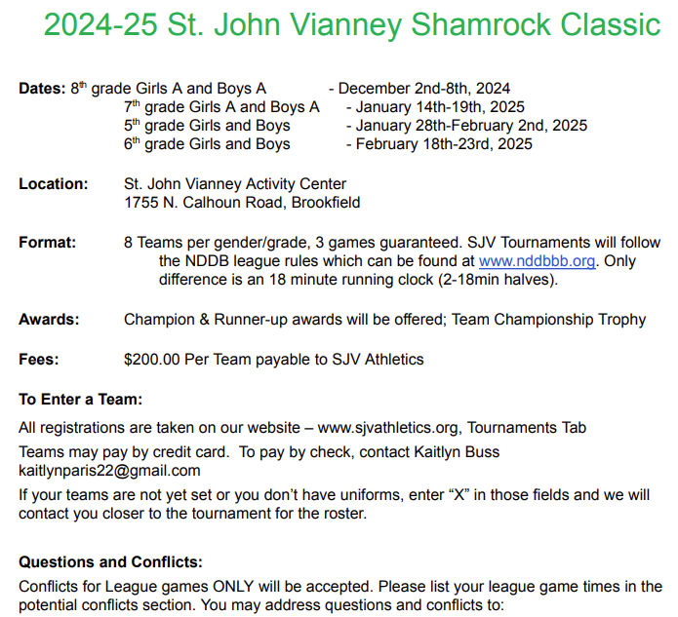
Joe: Fenlon-jfenlon530@gmail.com
Scott: Sbrandt007@yahoo.com

