Leadership in the Public Sector: Final Model

Carter Lukes

PUBA 710

Introduction
Change is an expected challenge that will be faced personally and professionally throughout one’s life. This change can portray itself in many ways, it could be preemptive to address a future problem, or it could be long overdue. To assist in these challenges many theories of change have been developed to help leaders navigate possible struggles. Models like the Burke-Litwin have been tested, edited, and then tested again to reflect the change process more accurately. Other models have taken a simpler or more complicated approach to accurately visualize the factors of change. Through these individual theories a leader can identify which model aligns with their values, use it accurately to generate needed change and assist their work. Throughout this paper, more information will be provided on the importance of change, the difference between public and private leadership, and ending with a new model of change.

Why Change Matters
Change has been a necessary component to the maturation of societies, organizations and even individuals. This is a necessity due to the nature of our world and its ever altering and changing perspectives, ideals, challenges, and results. Without change, history would not be created, nations would not exist, and leaders would not be leaders. To dissect this concept into macro, mezzo, and micro levels we can see how change is important throughout all our lives. Without change the United States would not exist, the American Colonies would not have challenged their lack of representation and continued to be governed from a monarch a sea away. Through the mezzo level, we see how individuals can leverage their community to create an improved situation for various populations. Non-profit executives creating a much-needed program in the county, or local representatives advocating for improved infrastructure all cause great change to their area. Lastly, with the micro level, each leader has chosen a moment of change that has impacted their goals and values throughout life. This could be a change that called a leader to finally act and support their views. What we see from an individual level is how change can generate more change, either positive or negative. Without change, leaders are not motivated, action is not taken, and lives just persist without any goals or direction.

Public vs Private Leadership
Leadership is not a singular action that an individual can simply accomplish. It is a toolkit of knowledge, skills and expertise that culminate in providing proper direction and support, at the appropriate time, to individuals who need it. Leadership will look different depending on the individual, and the setting. The leadership of a college football star will look different than the leadership of a grassroots advocate organizing for change. With this, leadership will vary between public and private sectors. These main differences can be seen through the mission and vision of the individual and the organization. Within the public sector we generally see a service provided to the public or specific groups of individuals. This person focused endeavor is core to the public sector and often the professionals employed in this arena. Often workers within the public sector recognize the need to aid the public and it is core to their professional values. Mentioned through the Jossey-Bass reader on public and nonprofit leadership is, “…leadership is a service to the people, end consumers, society, and the public interest…”(Van Wart, 2010, pg. 89). To the contrary, private leadership is focused on supporting a specific group of investors or executives, or to gain larger profit margins. The methods to achieve this goal can involve supporting public interest, however there are situations in which a good is sacrificed to obtain a higher profit. An example of this can be seen in pharmaceutical companies that create insulin, a lifesaving resource for some, but often marked up significantly to achieve a needed profit (Miller, 2023). This is the noted difference between some public and private leaders, the variance of who will be gaining from the work accomplished, and what propels these leaders.

While the why behind the leadership may vary between public and private leadership, their goals should be the same when leading a team. Leadership requires interpersonal interactions, based in trust and understanding to achieve an effective outcome. Leadership without trust from individuals can result in poor execution and ineffectiveness in mission completion. We can see this fact through the Jossey-Bass reader on non-profit and public leadership, which details skills of effective leadership. “The measure of leadership is not the quality of the head but the tone of the body. The signs of outstanding leadership appear primarily among the followers” (Perry, 2010, pg. 2). This signifies that leadership will not be shown through the individual, but collective accomplishments. This group function will be accomplished best through interpersonal connections, trust, and communication.

Theory of Change
The intent of this model presented is to display how the outside environment has a larger impact on many of the factors in change, and how the generated change then impacts the outside environment. This concept is not new to many models, but they often do a poor job of describing what exists in the external environment or don’t fully display its impact. The Birke-Litwin model for instance, does identify the external environment as one of its considerations, but it is only connected to a limited selection of variables. In other examples, like the Kennell Model of Change, the external environment is listed, but does so in a general way. The creation of this model aims to address these pitfalls. A leader can pick up this model and identify strengths, weaknesses, and bias in their goals for change.

Much of this intention was motivated by California Representative, Katie Porter and her Memoir, titled I Swear Politics is Messier than my Minivan. Through this book Katie Porter details her life from a young age, to completing her higher education, then eventually serving as a United States Representative sitting on multiple committees. What was most motivating through this book was Katie Porter’s ability to tie her current actions to previous experiences which have informed her actions today. Throughout the book each story is met with a personal history lesson displaying where this belief comes from and why it is valuable to Katie Porter and others. Katie Porter has spent much of her time researching and advocating against corporate greed and supporting consumer protections. This goal can be traced back partially to her childhood when her family experienced financial troubles after crop prices dropped significantly, hurting the income of the family farm. For an undergraduate assignment, she went on to investigate a local Iowa town that was being bought off by a larger company. Then researching personal bankruptcy during her time at Harvard with Elizabeth Warren (Porter, K. 2023). Each of these examples provided the needed background, personal experience, and values that she must be aware of while engaging in leadership. These experiences motivate her to achieve her personal goals to improve consumer protections and will influence how she chooses to lead throughout her time as a United States Representative.

The model is designed to work from the top of the page down and assist the individual in identifying how outside factors affect their perspective of desired change. The model begins with the top 5 boxes to describe the many factors that are involved within the outside environment: values and beliefs, available resources, previous experience, and potential bias. All these factors have a direct impact throughout the change process and recognizing these factors will be needed. As we move down the model, these 5 starting factors have a direct impact with how someone can “Recognize the Need.” This section can help a leader identify appropriate strategies and goals that will be used later. As an example, if a leader is looking to address poor test scores in a community, they could identify the problem as being poor curriculum. As they are utilizing this model they may note a lack of community resources for tutoring, which could then change the recognized need. This model is designed to be edited as a leader applies the model to their issue. We continue down toward the middle of the page into the “Action Area” of the model. This is where many of the early noted factors begin to condense and impact the work a leader does. In this section Strategize, Act, Measure and Review are the noted steps. These work in a cyclical manner until the needed change is achieved. A leader will begin by strategizing what they wish to accomplish, then move into the action phase where they execute their idea. After this, assessment is needed to see if change is accomplished. If the desired change is not accomplished, a leader will need to review their strategies and try again. If the desired change is achieved, this will affect the outside environment, previous experience, or bias, cycling back to the top of the model.

To provide an example on how a leader can use this model, personal experience is provided to show its design in use. In my current role I operate as a graduate assistant for social fraternities at my university and we are looking to change our office policy regarding social functions. This change is motivated due to a noticeable increase in conduct cases regarding our organizations and other examples of risky behavior. The leaders within the office and fraternity community came together to discuss how to properly address the needed change.

There have been many compounding factors that have led to students not abiding by these policies including social norms and other groups not being held accountable to these rules. Additionally, there were resources students did not have access to, or were aware of. Each leader identified that safety and responsibility were values important to the community. These leaders vocalized their personal bias and how it related to addressing the problem. Certain leaders had previous experience with other fraternity social policy and applied it to our collective information. With the variables of the outside environment noted, we recognized the need to change policy to be more feasible for students while also providing additional resources to aid their safety. We have interacted with students directly to discuss these changes in policy and expectations to allow for student-led implementation. Additional resources are also being researched or created so this policy will be easier for students to follow. As the writing of this, we are moving into the “Act” phase of the model. Students will begin to test out the new changes to policy, try newly provided resources, and work shop additional barriers with office staff members. After students attempt these changes the office will measure its impact by directly connecting and debriefing with students. Should students feel these changes are valuable, and we see a decrease in social related conduct cases, our efforts will be a success. If the change has yet to be seen, we will review our work and re-strategize. If the change is successful, it will then impact our own previous experience, personal bias, and available resources.

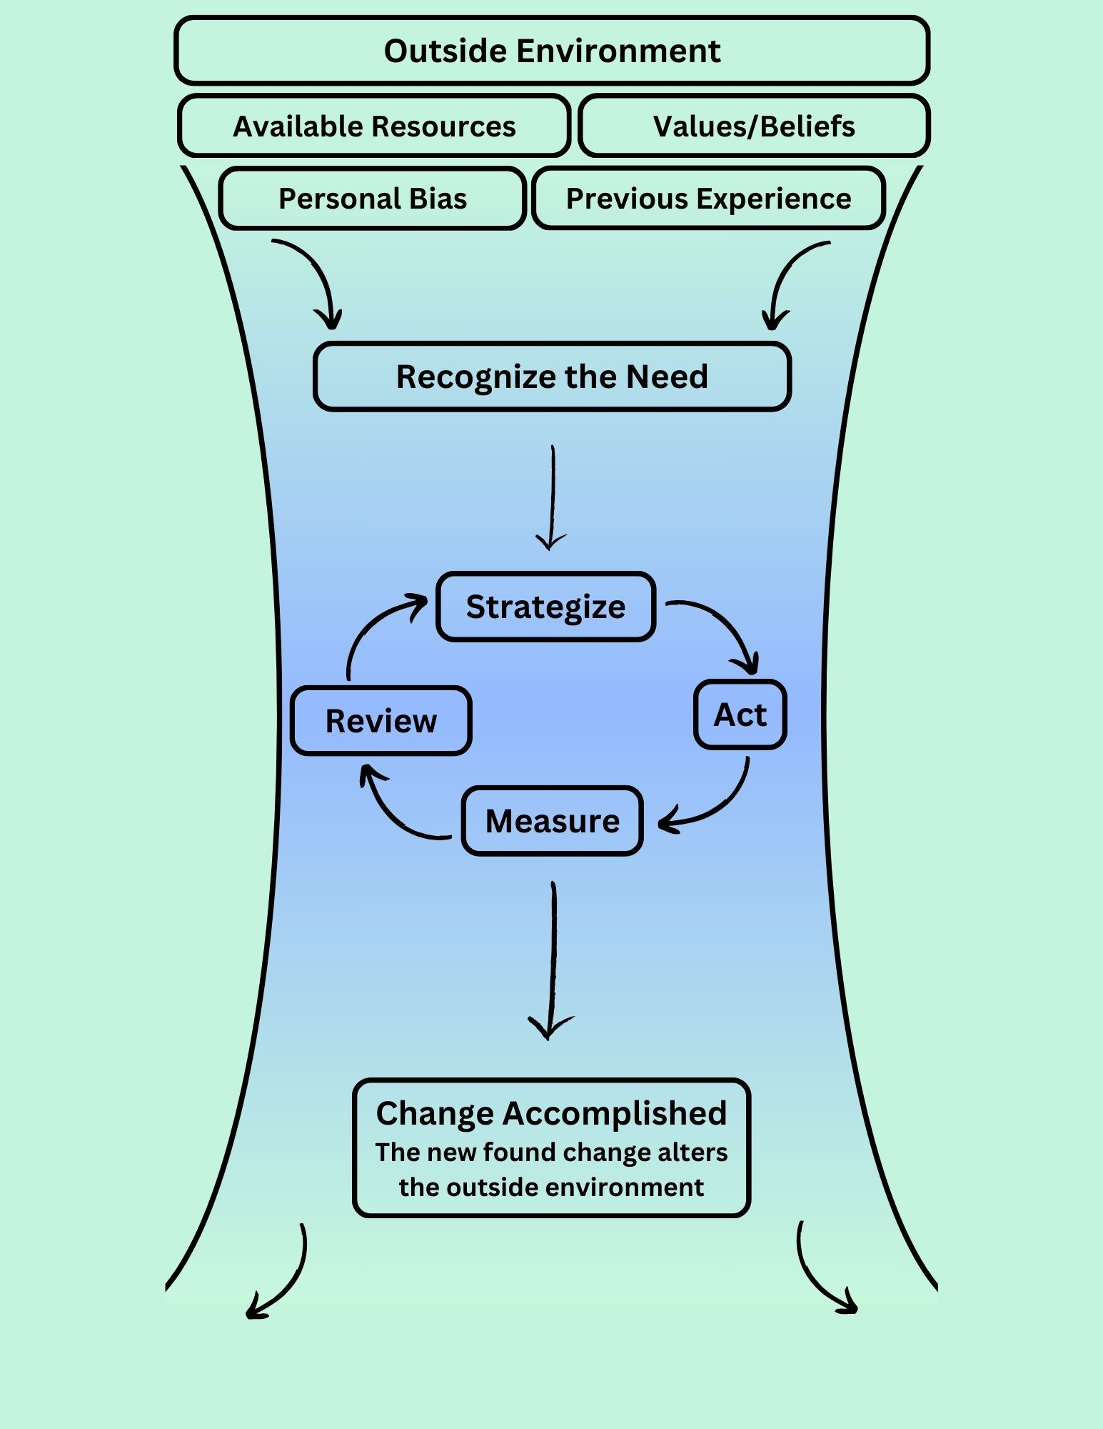
Below is the model and an outline of this example applied to the same structure.
Figure 1: Lukes Model of Change

Outside Environment
- Social norms of students.
- Operations of other student organizations on campus.
- Social Policy of similar institutions.
Available Resources
- Students were not aware of, or utilizing resources.
Values and Beliefs
- Responsibility.
- Safety.
- Student led.
Personal Bias
- Various perspectives on implementation or accountability of policy.
Previous Experience
- Previous institutional knowledge.
- Knowledge from other institutions.

Recognizing the Need
- Policy should be more manageable for students to abide by.
- Additional resources are needed to make this easier for students.
- This policy change will be effective if championed by students.

Strategize
- Edit policy that is easier for students to follow.
- Find or create resources for students to utilize.
- Support students as they work to improve safety on their campus.
Act
- Students follow and enforce appropriate social policy.
- Students utilize new resources to improve safety on their campus.
Measure
- Debriefs are conducted with students to understand additional or unseen barriers.
- Decrease in conduct related cases for fraternities.
Review
- Did the edited policies make it easier for students while increasing safety?
- Did the new resources aid students?
- Did a student-led model work or is more administrative input needed?
- Did we accomplish the change needed?

Conclusion
Through this, change has been described to show its importance. This change motivates leaders towards action, and to accomplish their goals. Leaders will use their toolkit of skills to the betterment of their area and create change specific to their arena. With leaders like Katie Porter, positive change can be generated and will be by remembering how our outside environment affects us regularly. With models that focus on the background, change can be generated to create a positive future.

References

Burke, W. & Litwin, G. (1992). Birke-Litewin model – organizational performance and change. [Image]. eCampus.

Kennell. Kennell change model. [Image]. eCampus.

Miller, B. (Mar. 2nd, 2023). After decades of profiteering, insuling manufacturers finally cut the price. Lown Institute. https://lowninstitute.org/after-decades-of-profiteering-insulin-manufacturer-finally-cuts-the-price/#:~:text=Over%20the%20last%2020%20years,get%20the%20medication%20they%20needed.

Porter, K. (2023). I Swear, politics is messier than my minivan. Crown New York.

Perry, J. L. (2010). Aspirations for Leaders in the Nonprofit and Public Sector: Editor Introduction. In J. L. Perry (Eds). The jossey-bass reader on non-profit and public leadership. (pg. 2) Jossey-Bass.

Van Wart, M. (2010). The Public Sector Leadership Theory. In J. L. Perry (Eds). The jossey-bass reader on non-profit and public leadership. (pg. 89) Jossey-Bass.

